CHIEF DIRECTORATE: INTERNATIONAL RELATIONS

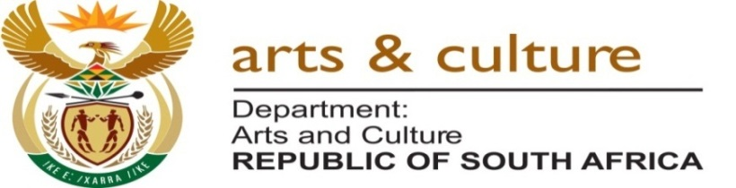

FEEDBACK TO PORTFOLIO COMMITTEE 2016

FEEDBACK TO ARTS AND CULTURE PORFOLIO COMMITTEE 2016
CULTURAL SEASONS | STATUS | DATES | PROJECTS
SA-FRANCE SEASONS | Completed | 2013-2014 | The SA-France Seasons came to an end in December 2013. The Seasons with France was in line with the Department of Arts and Culture’s Mzansi Golden Economy strategy which aims to raise the profile of the arts, culture and heritage sector within the country and abroad, in an effort to create jobs, open up new markets and build sustainable livelihoods for those in the creative industries. Over 1000 SA artists visited France in 2013 on project ranging from science and technology, various d genres of arts and culture, sport and tourism. There was strong focus on institutional. Individual and company collaborations as most project funded were paired with the French counterpart to realise sustainability. The digitization of the Rivonia Trial dictabels is one such projects that emanates from the Seasons. A tourism has indicated that the Seasons with France increased the tourism from France by more than 10%. It is estimated that close to 1,400 jobs were created, based on report information received from partners. The spread of jobs during the French Season in South Africa reached beyond the participants, as many technicians, administrators and other industry-related practitioners benefitted from these projects.  The duration and earnings from the different jobs has not been calculated due to a lack of information provided by project partners. It is clear however, that some jobs created were for a ‘one-off’ performance, while other jobs extended over a much longer period.
SA-UK SEASONS | Completed | 2014-2015 | The two-year long SA UK Seasons ends on 31 March 2016. 1151 South Africans artists participated in the Seasons with 113 Productions and 1051 Performance events. The artistic genres varied from music, fashion, film, theatre, dance, visual art and literature with a focus on youth and skills development. Audience attendance at SA events was over 474 956. Highlights included the Glascow Commonwealth Games in partnership with SASR, the Edinburgh Festival, Mandela Day and the London Jazz Festival.
SA-CHINA | Completed | 2014-2015 | The two-year long SA China Seasons ended in December 2015, when the China year in SA was closed on the fringes of the FOCAC summit. China in 2014 hosted 112 SA artists including technicians during the SA State Year/ Cultural Seasons in China, and SA hosted double that number in 2015 during the China Year in SA. 90% of participants were youth. The following genres were presented: music, writers/poets, dance, and traditional music. Highlights included joint productions staged in ballet and a conference on creative industries.
SA-RUSSIA |  | 2016-2017 | SA and Russia has agreed to host a reciprocal Seasons in 2016 and 2017. DAC has already received an invitation from Russia to send a technical delegation to Russia to discuss the content and modalities for the implementation. The technical team will thereafter develop and programme of implementation and schedule of events for the two year programme. The visit will take place in the first quarter of 2016.
SA-ALGERIA |  | 2016 | The proposal for reciprocal Seasons was made to Algeria by the Minister during a meeting with his Algerian counterpart during his working visit to Algeria in 2015. The DAC has requested DIRCO to compile a Note Verbal so as to formalise the proposal. The two countries will then constitute a steering committee that with discuss and agree on the way forward and the implementation programme .
AFRICA MONTH |  | 2016 | Africa Month in 2015 hosted 34 countries that participated in programmes of different genres and cultural dialogues that spread across all nine provinces in May 2015 under the theme “We Are Africa”. In partnership with the Reference Group of 12 experts representing different regions and organisations in the continent, Africa Month presented an opportunity for South Africans to reconnect and recommit themselves in support of all government interventions to develop a better Africa and a better world.  Preparation for the 2016 edition is underway. Different Committees are re-grouping and provinces approached to develop a month long programme of filled with activities, flagship projects, events and dialogues to promote Pan Africanism and Renaissance. SA to partner with the African Union Commission as a lead advocate for hosting Africa Month in different countries.

