Consolidated Legal Clinic Report



Quarter 3
2015/2016

CONTENTS
- Executive Summary
- Strategic Objectives and Compliance
- Legal Clinics and Statistics

- Executive Summary
The department is tasked in the third quarter to conduct 27 legal clinics. In this respect the Legal Department has exceeded the quarterly targets by conducting 36 legal clinics. The department has achieved and exceeded the annual target of conducting 90 outreach and legal clinics this financial year. In total the department has conducted 128 outreach and legal clinics.
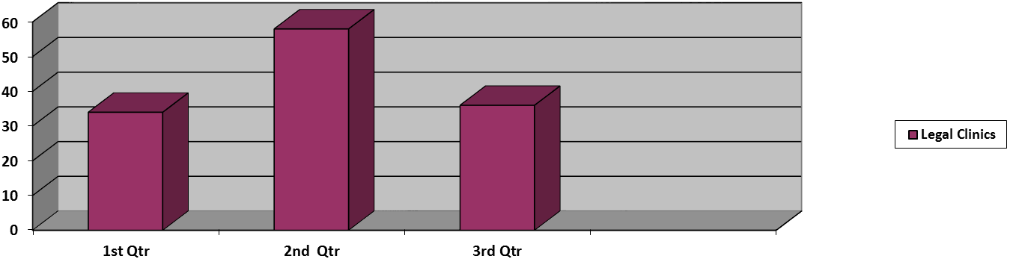

The table hereunder shows the highest number of legal clinics being held by Northern Cape and the North West province.
Ranking | Province | No of legal clinics
1 | NC | 08
2 | NW | 07
3 | MP | 06
4 | LP | 05
5 | GP | 04
6 | FS | 0
7 | WC | 03
8 | KZN | 02
9 | EC | 01

The table below indicate the number of files opened during the outreach and legal clinics in Q1, Q2 and Q3.
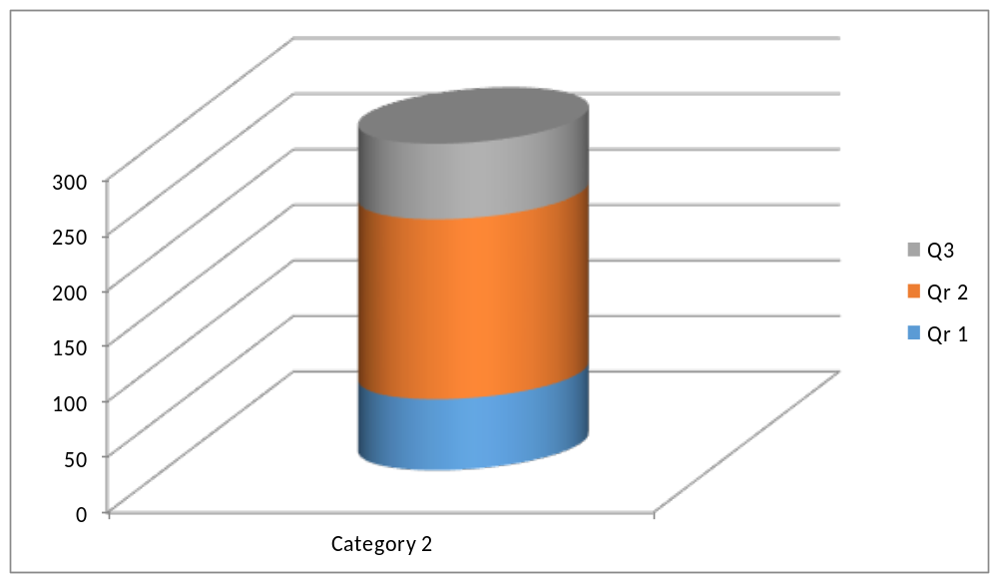
A total of 68 files were opened during the legal clinics conducted this Quarter . The decline in files opened during this quarter as compared to Q2 is as a result of Legal Officers attending various invitations from stakeholders for the 16 Days of No violence against women and children Campaign.

- Strategic Objectives and Compliance
The Legal Department is tasked as per Strategic Objective 2 as detailed hereunder, to hold 27 outreach and legal clinics this quarter.
Strategic Objective 2: To protect and promote gender equality by engaging with relevant stakeholders to educate and raise awareness of issues of gender equality. Challenge patriarchal perceptions and stereotypes and take action against infringements of gender rights through the implementation of appropriate redress

As highlighted in the Strategic objective, the purpose of the conducting legal clinics is to educate and raise awareness of issues of gender equality. In the second quarter a total number of 68 files were opened during the legal-outreach clinic. Limpopo (33), Mpumalanga (15) and the North West (14) provinces opened a significant number of files at the outreach-legal clinics with the Gauteng (5) and Eastern Cape (1) opening a few. The Western Cape, KwaZulu-Natal and the Northern Cape outreach and legal clinics unfortunately did not have complaints opened. The opening of files at outreach and legal clinics is totally dependent on whether attendees have complaints.

- Legal Clinics and Statistics
Free State: 0 legal Clinics
Date | District & Town | Urban / Rural | Number of attendees | Race | Gender | Subject of discussion | Stakeholders | Files opened from legal clinic
0 | 0 | 0 | 0 | 0 | 0 | 0 | 0 | 0
Gauteng: 4 Legal clinics

Date | District & Town | Urban / Rural | Number of attendees | Race | Gender | Subject of discussion | Stakeholders | Files opened from legal clinic
29-10-2015 | Stinkwater village  Hamanskraal | Rural | 27 | All African/ | Females  18 Males  9 Males | Human rights clinic . | SAHRC, IEC, CGE, PPSA, Legal Aid SA, DOJ, Public Service Commission, PANSALB, GCIS, Thusong Community service centre. | 0
09-12-2015 | Poortjie in West Rand | Semi-rural | 78 | All African | Male=26  Female=52 | GBV & all forms of abuse | SAPS,Health, Lehcu projects, DSD, Orange Farm Advise centre | 05
10-12-2015 | Ratanda in Sedibeng | Semi-rural | 157 | All African | Male=13  Female=144 | GBV & all forms of abuse | SAPS, DSD, SANCA, HIV/AIDS Ward coordinators | 00
11-12-2015 | Suurman Hammanskraal | Semi-rural | 63 | All African | Male=45  Female=18 | GBV & all forms of abuse | SAPS, CPF, Religious sector | 00
North West: 7 legal clinics

Date | District & Town | Urban / Rural | Number of attendees | Race | Gender | Subject of discussion | Stakeholders | Files opened from legal clinic
22 October 2015 | Rustenburg Local Municipality  -Phatsima township | Urban (although it is regarded as a township, the area is not developed and does not have resources) | 30 | All Africans | 09 males  21 females | CGE’s mandate functions & programmes. GBV & the right to freedom & security of the person. | Phatsima Legal Advice Centre | 0
28 October 2015 | Tswaing Local Municipality | Rural | 65 | All Africans | 28 males 37 females | Maintenance & the Law. Estate & Succession Law. | DSD | 10
18 November 2015 | Atamelang Township – Tswaing Local Municipality | Urban | 82 | All Africans | 24 males  58 females | CGE’s mandate, functions & programmes.  Sexual Violence & the Law. Customary Law & the Bill of Rights | DSD, CDWs, HBC, COCTA & the Local Municipality. | 02
26 November 2015 | Vrisgewacht Village  Tswaing Local Municipality | Rural | 59 | All Africans | 20 males  39 females | GBV & the Law.  The right to freedom & security of the person. | DOH, DSD, HBC’s, DPSA | 02
01 December 2015 | Chief’s Court in Taung– Dr Ruth Segomotsi Mompati Local Municipality | Rural | 46 | All Africans | 30 males  16 females | CGE’s mandate, functions & programmes.  Maintenance & the Law. GBV & the Law. | DSD, SAPS, Thutuzela, Dept of Correctional Services | 0
03 December 2015 | Manzilpark  Dr Kenneth Kaunda District Municipality | Urban | 32 | 30 Africans  2 Coloureds | 11 males  21 females | GBV & the Law.  The right to freedom & security of the person. | SAPS | 0
04 December 2015 | Tigane  Dr Kenneth Kaunda District Municipality | Township | 86 | All Africans | 59 females  27 males | GBV & the Law.  The right to freedom & security of the person.  What does the 16 Days Campaign mean? | None | 0

Northern Cape: 8 legal Clinics

Date | District & Town | Urban / Rural | Number of attendees | Race | Gender | Subject of discussion | Stakeholders | Files opened from legal clinic
4/11/2015 | Warrenton, Ikhutseng | Rural | 60 | Indian: 1  African: 57  White:0  Coloured:2 | Males: 14  Females: 46 | Domestic Violence, Partnership agreements, Women Empowerment, Gender Discrimination | SAHRC, IEC, IPID, Community members | 0
5/11/2015 | Hartswater | Rural | 37 | Indian:0  White:0  Coloured: 1  African: 36 | Males: 13  Females: 24 | The mandate of the CGE, maintenance, the equality act. | SAHRC, IEC, IPID, OPP, NGO’s, Community members | 0
12/11/2015 | Windsorton | Rural | 32 | Indian:0  White:0  Coloured: 1  African: 31 | Males:1  Females: 31  Total:32 | Domestic Violence, Partnership agreements, Women Empowerment, Gender Discrimination | Department of Social Development, Department of Health | 0
17/11/2015 | Prieska | Rural | 47 | Indian:0  White:0  Coloured: 0  African: 47 | Male:22  Female:25  Total:47 | Gender Based Violence, Divorce, Women empowerment | Department of Social Development, The Local Municipality, CDW’s | 0
18/11/2015 | Niekershoop | Rural | 42 | Indian:0  White:1  Coloured: 40  African: 1 | Male:2  Female: 40  Total:42 | Gender Based Violence, Divorce, Women empowerment | SAPS, Department of Education | 0
25/11/2015 | Galeshewe | Rural | 65 | Indian:0  White: 0  Coloured: 5  African: 60 | Male:21  Female: 44  Total:65 | Equality and the Equality Act, PEPUDA | Chapter 9 Institutions | 0
26/11/2015 | Bendell | Rural | 53 | Indian:0  White: 0  Coloured: 0  African: 53 | Male: 38  Female: 15 | Gender Based Violence, Gender Discrimination | Community members | 0
27/11/2015 | Mapoteng | Rural | 46 | Indians: 0  Whites: 0  Coloureds: 0  Africans: 46 | Males: 27  Females: 19 | Domestic Violence, Gender Discrimination | Community members | 0

Kwazulu Natal: 2 Legal Clinics

Date | District & Town | Urban / Rural | Number of attendees | Race | Gender | Subject of discussion | Stakeholders | Files opened from legal clinic
3 November 2015 | Pietermaritzburg, KwaZulu Natal | Urban | 8 | Indian (Muslim) | Female=8 | Legal rights in Muslim marriages & Gender Based Violence | Gift of the Givers KwaZulu Natal | 0
17 November 2015 | Bergville, KwaZulu Natal | Rural | 44 | Africans | Male -8  Female-36 | Forced and Early Child Marriages | Amazizi Traditional Authority, Office of the Public Protector, SAPS | 0

Eastern Cape: 1 legal Clinics
Date | District & Town | Urban / Rural | Number of attendees | Race | Gender | Subject of discussion | Stakeholders | Files opened from legal clinic
2 November 2015 | Ngcobo | Rural | 45 | All African | Women- 36  Males- 9 | How Traditional Leaders can assist in reporting GBV | DOJ and NPA | 1

Limpopo: 5 legal clinics
Date | District & Town | Urban / Rural | Number of attendees | Race | Gender | Subject of discussion | Stakeholders | Files opened from legal clinic
20 October 2015 | FetaKgomo district, Ga-Sekhukhune | rural | 137 | Africans | Females:143  Males:3 | Domestic violence, Estates, Maintenance and Customary marriages. | none | 17
06 November 2015 | Kruger National Park, Mopani rest camp | Urban | 59 | Africans:58  White:1 | Females:38  Males:21 | Estates, Maintenance and Customary marriages. | none | 05
11November 2015 | Greater Tubatse Municipality, Dresden Village. | Urban | 99 | African | Females:79  Males:20 | Domestic violence, Estates, Maintenance and Customary Marriages. | none | 05
20 November 2015 | Waterberg District, Mapela Village | Rural | 32 | African | Females:32 | Customary marriages, Estates, Gender based Violence and Maintenance | Nkunzi Development Association | 05
24 November 2015 | Capricorn District, Ga-phoffu village | Rural | 139 | African | Females:96  Male:43 | Maintenance, Estates and Customary marriages. | The department of Labour, the department of social development and Public Protector South Africa | 01

Mpumalanga: 6 legal clinics

Date | District & Town |  | Urban / Rural | Number of attendees | Race | Gender | Subject of discussion | Stakeholders | Files opened from legal clinic
20/10/2015 | Carolina, Gert Sibande District |  | Rural | 69 | African | 57 Female  12 Male | Customary Marriages, Domestic Violence, Maintenance, widowhood and the CGE Mandate | COGTA, word committee members | 8
22/10/2015 | Waterval Boven, Emakhazeni Local Municipality. |  | Rural | 47 | African | 30 Female  17 Male | CGE Mandate, Maintenance, Domestic Violence, Customary Marriages and early Child Marriages. | Makhezeni Municipality | 5
30/10/2015 |  | Grootvlei, Gerd Sibande Discrict Municipality | Rural | 29 | African- 27  White- 2 | 29 Female  8 Male | CGE Mandate, Customary Marriages, maintenance and Domestic Violence | Sassa and CWP | 0
20/11/2015 | KwaMhlanga, Nkangala District |  | Rural | 62 | African | 58 Female  4 Male | Domestic Violence, early child marriages, Customary Marriages, Maintenance |  | 2
25/11/2015 | Mbombela, Enhlanzeni district |  | Urban | 24 | 6- White  Africans- 18 | 23 Male  1 Female | CGE Mandate, Early Child marriages, Sexual Offences | Nelspruit community Forum | 0
30/11/2015 | Driefontein |  | Rural | 43 | African | 8 Male  35 Female | CGE Mandate, Domestic Violence, sexual offences, Early Child marriages and maintenance. | Mkhondo advice Center. | 0

Western Cape: 3 legal clinics

Date | District & Town | Urban / Rural | Number of attendees | Race | Gender | Subject of discussion | Stakeholders | Files opened from legal clinic
13 October 2015 | Overberg District  Hermanus | Semi-rural | 74 | 70 African  4 Coloured | 49 Females  25 Males | Citizenship rights | Department of Home Affairs, Public Protector, Department of Social Development, Department of Labour, SAPS, Department of Health. | 0 |  |  | 0
15 October 2015 | Cape Winelands District  Stellenbosch | Semi-rural | 26 | 25 African  1 Coloured | 13 Females  13 Males | Accessing government services | Department of Local Government, SAPS, SASSA and Department of Agriculture | 0
02 November 2015 | Cape Winelands District, Rawsonville | Rural | 15 | 14 Coloured  1 African | 6 Females  9 Males | Gender-based Violence | Public Protector, Department of Social Development, SAPS and Department of Health. | 0

The following issues were raised across the provinces:

- The visibility of the CGE in rural areas and as such it was recommended that the CGE conducts legal clinics on Saturdays also to ensure that persons who are at work (especially at farming areas) are informed of the mandate of the CGE.
- Early child marriages. It was highlighted that there is fear to report such matters as the culprits are community members and as such there is fear of victimisation especially if the Legal system were to fail to prosecute the culprits.
- Maintenance complaints were raised mostly by young women and it was argued that maintenance monies are not paid expeditiously by the Maintenance courts.
- Rape by intimate partner/ spouse: It became clear at the outreach- legal clinics that there was lack of understanding on what constitute rape and whether an intimate partner/ spouse can be charged for such a offence if such an offence was committed against the other intimate partner/spouse.
- Access to justice: communities at remote areas raised concerns that they are far from services of the SAPS as well as magisterial courts are far from them and as a result they are unable to make a follow up on cases.
- Poverty and crime related matters were raised.

4. Conclusion

The department has achieved its annual target of outreach-legal clinics. The legal-outreach clinics have contributed to the number of files that were opened during this financial year. This measure has ensured the visibility of the Commission to members of the community and also afforded the department the opportunity to determine the gender complaints that are a trend in rural areas. In the fourth quarter the department shall continue to hold outreach-legal clinics in the quest of addressing gender inequality in South Africa.
.

