SANCB – Provincial Involvement 2015

Stakeholder Management

Business Events Tradeshow partnership with Provincial and City Convention Bureau including Business Events Unit within Provincial and City Tourism Organisations
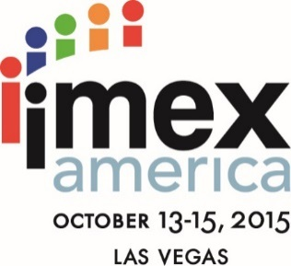
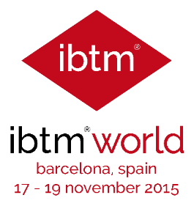
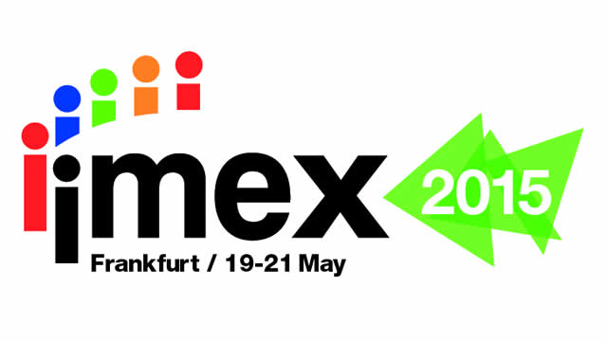
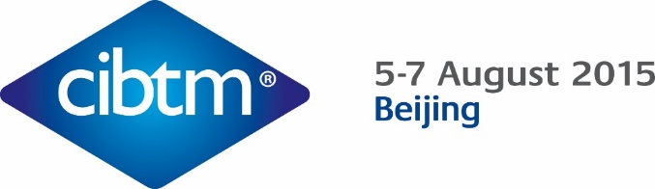

Trade Show | Stand Size | Number of Stand Sharers | Subsidy | Total Number of Pre Scheduled Appointments: SA Pavilion | SANCB: Number of Pre Scheduled Appointments | Number of Group Presentations | Number of Leads Generated | Leads: Number of Delegates | Estimated Economic Impact | Number of Event Days
IMEX Frankfurt 2015 | 200 m² | 27 STAND SHARERS  - 1 Professional Conference Organiser (PCO)  - 8 Destination Management Companies (DMC)  - 4 Convention Centre  - 6 Hotels / Hotel Groups  - 6 Convention Bureaus / Tourism Boards  - 1 Airline (SAA)  - 1 Luxury Train  Convention Bureaus / Business Events Units  - Mpumalanga Tourism and Parks Agency  - Gauteng Convention Bureau  - Johannesburg Convention Bureau  - Cape Town and Western Cape Convention Bureau  - Tshwane Convention Bureau  - Durban Convention Bureau | Subsidy to stand sharer: R230k | - 499 Pre Scheduled Meetings | - 46 Pre Scheduled Meetings | - 15 Group Destination Presentations: 186 Hosted Buyers | - 25 Qualified Leads Generated | - 44 500 | - R170 702 000 | - 137
IBTM China 2015 | 72 m² | 4 Stand Sharers  - 2 Convention Bureaus  - 1 Destination Management Company (DMC)  - 1 Airline (SAA)  Convention Bureaus  - Joburg convention Bureau  - Tshwane Convention Bureau | Subsidy to stand sharer: R500k | - 45 Pre Scheduled Meetings | - 28 Pre Scheduled Meetings | - None. The show does not offer group presentations to exhibitors | - 22 Qualified Leads Generated | - 6 000 | - R134 256 000 | - 138
IMEX America 2015 | 200 m² | 26 Stand Sharers  - 8 Hotels / Hotel Groups  - 5 Convention Bureaus  - 4 Convention Centres  - 8 Destination Management Companies (DMC)  - 1 Airline (SAA)  (4 TIP Programme Participants)  Convention Bureaus  - Durban and KZN Convention Bureau  - Joburg Convention Bureau  - Gauteng Convention Bureau  - Cape Town and Western Cape Convention Bureau  - Tshwane Convention Bureau | Subsidy to stand sharer: R230k | - 354 Pre Scheduled Meetings | - 26 Pre Scheduled Meetings | - 8 Group Destination Presentations: 45 Hosted Buyers | - 18 Qualified Leads Generated | - 16 490 | - R 301 180 000 | - 198
IBTM World | 200 m² | 19 Stand Sharers  - 2 Hotel Groups  - 2 Convention Centres  - 7 Convention Bureaus / Tourism Organisations  - 6 Destination Management Companies (DMC)  - 1 Luxury Train  - 1 Airline (SAA)  Convention Bureaus / Business Events Units  - Durban and KZN Convention Bureau  - Joburg Convention Bureau  - Gauteng Convention Bureau  - Cape Town and Western Cape Convention Bureau  - Tshwane Convention Bureau  - Northern Cape Tourism Authority  - Mpumalanga Tourism and Parks Agency | Subsidy to stand sharer: R230k | - 451 Pre Scheduled Meetings | - 64 Pre Scheduled Meetings | - 9 Group Destination Presentations: 63 Hosted Buyers | - 55 Qualified Leads Generated | - 25 274 | - R 298 835 200 | - 224

Note: Meetings Africa Hosted Buyers are sourced from these trade shows

Business Events Coordinating Forum

The Business Events Coordinating Forum (BECF) is a forum consisting of the heads of all the Convention Bureaus and Business Events units of the City and Provincial Tourism Authorities in South Africa. The BECF is recognised by the SA Tourism Board, the South Africa National Convention Bureau’s Marketing Sub Committee and the SA Tourism Marketing Working Committee. The forum developed and agreed on the minimum criteria for the establishment of Convention Bureaus and Business Events units in SA. The Forum meets 4 time per year including 1 telephonic meeting annually. The SANCB already capacitated provinces like Limpopo, North West, Northern Cape and Mpumalanga to establish fully fledged Convention Bureaus to enable these provinces to secure business for their destinations. Capacity assistance is provided to provinces that does not have Convention Bureaus to bid for conferences and incentives. The NCB is also working closely with all provinces in creating marketing opportunities at international trade shows which is critical to sourcing leads for their destinations.

The Coordinating Forum consists of the following members:
- Gauteng Convention Bureau
- Joburg Convention Bureau
- Tshwane Convention Bureau
- Cape Town and Western Cape Convention Bureau
- Durban KZN Convention Bureau
- Nelson Mandela Bay Tourism – Business Events Unit
- Northern Cape Tourism Authority – Business Events Unit
- Mpumalanga Parks and Tourism - Business Events Unit
- North West Parks and Tourism Board
- Limpopo Tourism Agency

The key objectives of the Forum is to:
- Ensure a more coordination approach to bidding for international business events.
- Maximise resources in the bidding process for meetings, incentives, conferences and exhibitions.
- Improve the coordination between all Convention Bureaus and Business Events Units in the bidding process.
- Ensure that South African destinations do not bid against each other internationally.
- Improve budget reach by coordinating sales activities.
- Lead sharing initiatives to maximise SA’s changes of securing business events for the country.

Annual calendar of engagement platforms for the BECF
Event | Description | Annual Date
Meetings Africa Exhibitor Briefing Sessions | Briefing sessions with provinces on Meetings Africa and how to maximise on the show | End of January
Meetings Africa | Local Tradeshow  - First BBEF meeting for the year | February
1st BECF meeting at Meetings Africa | 1st BECF meeting for the year | End of February
Southern African Association for the Conference Industry (SAACI) Annual Conference | 2nd BEFC meeting for the year | May/June
IMEX Frankfurt Exhibitor Briefing | Briefing with BECF on maximising their participation in the IMEX Trade Show | March
IMEX Frankfurt | Tradeshow | April/May
IBTM China – Exhibitor Briefing | Briefing with BECF on maximising their participation in the IBTM China Trade Show | July
IBTM China | Tradeshow | August
IMEX America – Exhibitor Briefing | Briefing with BECF on maximising their participation in the IMEX Trade Show | September
IMEX America | Trade Show | October
IBTM World, Barcelona – Exhibitor Briefing | Briefing with BECF on maximising their participation in the IBTM World Trade Show | October
IBTM World, Barcelona | Trade Show | November
3rd BECF meeting | Planning for Meetings Africa | November

Minimum Criteria for Qualified Convention Bureaus
- A Convention Bureau (CB) shall be recognised by its local and/or provincial government through its local and/or provincial tourism authority/organisation/agency.
- Non-profit: Qualified CB’s shall be Non for Profit Organisations/Agencies.
- Staff Members: Qualified CB’s shall have a minimum of three (3) dedicated staff members to qualify for CB status.
- Dedicated Sales and Marketing Budget: A qualified CB shall have a minimum marketing budget of R2 million.
- Industry Membership: A qualified CB shall be a member of ICCA, SITE, SAACI (EXSA – optional)

International Business Event Trade Show Participation: Qualified CB’s shall attend and participate in Meetings Africa and at least two (2) international Sales and Marketing platforms:
- Meetings Africa
- IMEX – Frankfurt, Germany
- IMEX America – Las Vegas
- IBTM World – Barcelona, Spain
- IBTM China, Beijing, China

Current Qualified CB’s in SA according to the criteria:
- Durban KZN CB
- Cape Town and Western Cape CB
- Johannesburg CB
- Tshwane CB
- Gauteng CB

Minimum Requirements for Business Events Units
- Recognition: The Business Events (BE) units must be recognised by its local and/or provincial government through its local and/or provincial tourism authority/organisation/agency.
- Non-profit: Qualified BE shall be Non for Profit Organisations/Agencies
- Staff Members: Qualified BE shall have a dedicated staff members for BE to qualify for BE Unit status.
- Dedicated Sales and Marketing Budget: A qualified BE Unit shall have a dedicated budget line item for BE in their organisation/authority/agency
- Optional Industry Membership: A qualified BE Unit be encouraged to be a member of at least one (1) international / national BE business event industry association or organisation. Membership of international industry associations are not a prerequisite.
- International Business Event Trade Show Participation: Qualified BE Units shall participate in Meetings Africa.
- Participations and attendance in international trade shows are recommended but it is not a prerequisite.
- The CC agreed prospective BE Units shall meet at least four (4) of the five minimum requirements to be recognised as a Qualified BE Unit.

Current Qualified BE Units are:
- Nelson Mandela Bay Tourism
- Limpopo
- Mpumalanga
- Northern Cape
- North West Province

Regional Distribution

INFRASTRUCTURE REQUIREMENTS
The geographic spread of business events are directly linked to the infrastructure requirements of the conferences, incentives and exhibitions that destinations host. These infrastructure requirements relates to venue capacities, air access and transportation. These elements are used by clients to determine the viability of hosting a business event in a destination. The hosting capabilities of a province determines its ability to positions itself against the event requirements.

INTERNATIONAL ASSOCIATION CONFERENCES
According to the International Congress and Convention Association’s (ICCA) database data for the period 2010 – 2015 the following cities (Apart from Johannesburg, Cape Town and Durban) hosted international association conferences that met ICCA’s ranking criteria:
- Port Elizabeth: 8 International association conferences
- Grahamstown: 10 International association conferences
- Sun City: 18 International association conferences
- Bloemfontein: 4 International association conferences

PRE AND POST TOURS
Research conducted on the conference segment showed that on average an international conference delegate stays 4 days extra in SA for Pre or Post Tour activities when attending a business event in SA. The NCB utilise Delegate Boosting as a means to promote geographic spread of Pre and Post Tours to all 9 provinces. The NCB also utilises bid books as a tool to promote activities and tourist attractions across SA even though the submission might be for a metropolitan area.
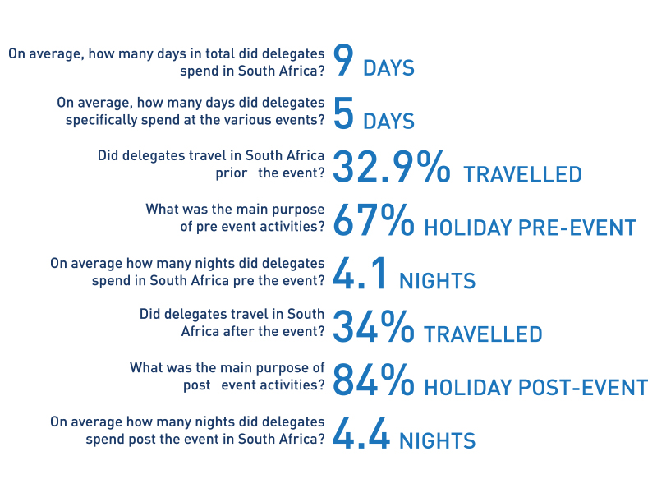
MEETINGS AFRICA
The NCB utilises Meetings Africa’s Pre and Post Tour programmes to promote geographic spread and works closely with the provincial and city convention bureaus on the development of these itineraries ensuring the inclusion of SMME’s in the programmes.

INCENTIVE TRAVEL
The majority of incentive travel to SA combines a metropolitan area with wildlife or adventure experiences. This itinerary combinations ensures the geographic spread of incentive business to smaller provinces.

SECTOR STRATEGY
The business events strategy for SA identified the key sectors that each province should target when sourcing potential business for their destinations. This sector strategy ensures that each province plays to their strengths and that the leads are distributed according to identified sectors.

