04 August 2015

ANALYSIS OF 2015/16 FIRST QAURTER PERFORMANCE OUTCOMES OF USAASA, SENTECH, BBI AND SITA

- Introduction

The Public Finance Management Act, provides explicit reporting obligations to the Chief Executive Officers and Board of Directors of State Owned Companies (SOCs). To this end, the 2009 National Treasury’s Guide for Accounting Officers summarises these obligations as follows:

- Provide frequent updates on the implementation of operational plan and programme,
- Report on divisional or departmental service delivery performance;
- Report on maintenance of effective, efficient and transparent systems of financial and risk management and internal control, as well as for the effective, efficient, economical and transparent use of departmental resources; and
- Transparently reflect effective management in respect of revenues, expenditure, assets and liabilities of the organisation

In line with the above statement, the aim of this research is to provide an overview or summary of the Quarter 1(01 April-30 June) performance of the following entities, Sentech, Universal Access and Service Agency of South Africa (USAASA), State Information Technology Agency (SITA) and Broadband Infraco (BBI).The analysis also compares the first quarter performance of each entity between current financial year (2015/16) and the previous financial year (2014/15).

- UNIVERSAL SERVICE AND ACCESS AGENCY OF SOUTH AFRICA 2015/16

The Universal Service and Access Agency of South Africa (“the Agency”) is established in terms of the Electronic Communications Act (ECA) with a sole mandate to promote the goals of universal access and universal service. The Agency is accountable to Parliament and the general public. Its status as a public body is affirmed through Schedule 3A of the Public Finance Management Act.

During the first quarter of 2015/16 financial year, at the beginning of the quarter, USAASA had twenty-two (22) planned targets for the quarter under review and majority of the targets were achieved as planned. In this regard Sixteen (16) or 73% of the targets were achieved whilst 4 which the Agency counts as partially achieved is in this research counts as targets not achieved, and therefore these 4 targets have been added to 2 (10%) to make a total of 6 or 27.2% were not achieved in this quarter.

Cautionary note: It is important for Parliament to enquiry why USAASA has not achieved its important target, which is the research to Review and track RSA national policies and regulation impacting universal access and service and make submissions and participate in the formulation process, where applicable

USAF 2015/16

There critical targets which has been missed due to delays were experienced due to the ETV legal matter which was only concluded on the 25th of June. The court has affirmed the amendments to the BDM policy that was gazetted on the 18th of March 2015.08.03

- Overall Conclusion on USAASA

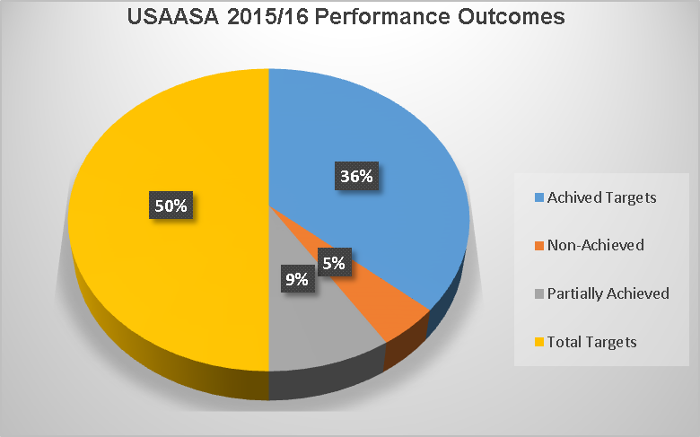

Below: Pie graph of achieved/non-achieved targets

The trend over last two financial years indicates an excellent work done by USAASA which is to achieve targets in a given quarter. Targets not achieved mainly relate to issues that are beyond USAASA’s operational reach Digital Terrestrial Televising (DTT).

- SENTECH 2015/16

SENTECH SOC Limited is a state owned company that provides common carrier open access broadcast signal distribution and telecommunications services to the broadcasting and telecommunications industries and the public at large. The strategic objectives of the company are derived from policies, legislation and regulations that inform the operations of the communications industry in general, the broadcasting sector in particular, the Regulator and state-owned companies.

This report aims to reflect on the activities that the company undertook during the quarter 1 2014/15 and 2015/16 in pursuit of the objectives that were set out in the company’s corporate plan for the 2014/15 and 2015/15 MTEF period (2015-2019).

  - Overall performance 2014/15 and 2015/16 Financial Years
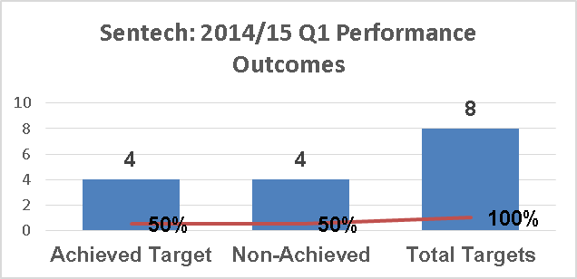

Source: own graph

In the previous financial year (2014/15) during the first quarter, Sentech had 8 targets as laid out in the corporate plan. The graph below depicts the performance of the company targets against the set targets, where 50% of targets were achieved, whilst another 50% was not achieved.

During the first quarter of 2015/16 financial year, at the beginning of the quarter, Sentech had twelve (12) planned targets for the quarter under review. In this regard five (5) of 42% of the targets were achieved whilst 3 (25%) which counts as partially achieved according to Sentech. However, as indicated above, the partially achieved targets is in this research counted as targets not achieved, and therefore 4 has been added to make a total of 7 or 58 % of targets were not achieved in this quarter.
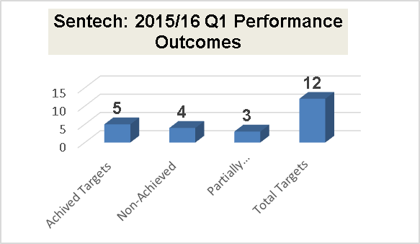

Source: own graph
There are also other initiatives that have been communicated or undertaken in this quarter:

- SENTECH has completed an ASO Plan and communicated this to major stakeholders including, but not limited to, USAASA, ICASA, Department of Communications, etc.
- The D2D migration project plan has been presented to the Shareholder and forms part of the MTEF funds request to the National Treasury for the 2016/2017 Financial Year.
- DTT Tariff affordability for Community Broadcasters-SENTECH is engaging Community Broadcasters in attempt to find a solution together with Department of Communications.

Cautionary note: The estimated incremental cost for dual illumination for the FY2016 is R131m, and the funds allocated amount to R99m, thus leaving a funding deficit of R32m. Parliament

  - Overall Conclusion on Sentech

The trend over last two financial years indicates an even spread of targets either not achieved and those achieved. There is slight decline of achieved targets between the two quarters as illustrated by both graphs below. Parliament must monitor, how government respond to the financial shortfall (Department of Telecommunications and Postal Services, Department of Communications and the National Treasury) as this has negative financial implication to Sentech’s operation budget.

- Broadband Infraco 2015/16

Broadband Infraco is the only State Owned Company (SOC) whose exclusive mandate is to plan, design and roll-out the foundational ICT infrastructure which enables high-speed, high-data, broadband communications. This infrastructure when utilised appropriately within public (health; education; service delivery) and private markets (intermediaries), will unlock improved and affordable broadband connectivity across all areas of South Africa including under-serviced areas. This will lead to innovation, market efficiencies and reduce the price of telephony as a whole, thereby leading South Africa into a high-technology first world economy.

  - Overall performance 2014/15 and 2015/16 Financial Years

During the first quarter of 2015/16 financial year, at the beginning of the quarter, BBI had sixteen (16) planned targets for the quarter under review. In this regard five (5) or 31% of the targets were achieved, one (1) not achieved target, whilst 10 (62.5%) which counts as partially achieved according to BBI. However, the partially achieved shall be counted as targets not achieved, and therefore 1 has been added to 10 to make a total 11 or 69 % of targets were not achieved in this quarter.

However, during the first quarter of 2014/15 financial year, at the beginning of the quarter, BBI had seventeen (17) planned targets for the quarter under review. In this regard seven (7) of the targets were achieved whilst 10 were considered to be on track.

  - Overall Conclusion on BBI

The trend over last two financial years indicates an even spread of targets either not achieved and those achieved. There is slight problem in the allocation of non-achieved targets, it appears to either be on track, in progress or partially achieved. In future Parliament must monitor how targets are measured to ensure constancy as well to ensure that where an entity has not reached it set goals for a given quarterly, those non-achieved targets are reflected as such.

- STATE INFORMATION TECHNOLOGY AGENCY (SITA)

SITA was established in 1999 to consolidate and coordinate the State’s information technology resources in order to achieve cost savings through scale, increase delivery capabilities and enhance interoperability. SITA is committed to leveraging Information Technology (IT) as a strategic resource for government, managing the IT procurement and delivery process to ensure that the Government gets value for money, and using IT to support the delivery of e-Government services to all citizens.

In short, SITA is the IT business for the largest employer and consumer of IT products and services in South Africa, the government. Furthermore, the Act separates SITA's services into mandatory services (i.e. SITA must provide), and non-mandatory services (i.e. SITA may provide).

  - Overall performance 2015/16 Financial Year
    - Table 1. Summary of performance: 1st Quarter 2015/16

QUARTER 1 | Targets | Achieved | % Achieved | Not Achieved | % Non-Achieved
Financial | 4 | 3 | 75% | 1 | 25%
Customer | 12 | 6 | 50% | 6 | 50%
Internal Process | 5 | 2 | 40% | 3 | 60%
Learning and Growth | 1 | 1 | 100% | 0 | 0%
Total | 22 | 12 | 54.5% | 10 | 45.5%

SITA (2015)

2014/15 Progress Outcomes as per divisional/ departmental

Objective 1: Achieve sound financial management

During the 2014/15 financial year, there were a total of five (5) targets for Objective one, however, SITA only managed to achieve just one (1) target or 10%.

On Customers: Objective 2: Enhance efficiency of Government business processes
During the 2014/15 financial year, there were a total of five (5) targets for Objective one, however, SITA only managed to achieve just one (1) target or 10%.

Strategic Objective 3- 8: Enable Citizen Convenience, Improve Security of Government Data assets : Improve Customer Satisfaction, Improve Government Data Management, : Drive Economies Of Scale In The Acquisition Of Large ICT Goods And Services

During the 2014/15 financial year, there were a total of eighteen (18) targets for Objective one, however, none of those targets set for the quarter were achieved which means the service delivery performance outcome of the quarter was just 0%.

Strategic Objectives: Establish effective governance practice (which is Internal Process there are 8 strategic objectives), Modernisation of internal SITA facilities to Eradicate Fraud and Corruption

During the 2014/15 financial year, a combine total of eight (8) strategic objectives) were planned with each strategic objective having its own target. However, at the end of the quarter, none of those targets set for the quarter were achieved which means the service delivery performance outcome of the quarter was just 0%.

    - Table 2. – Summary of performance: 1st Quarter 2014/15
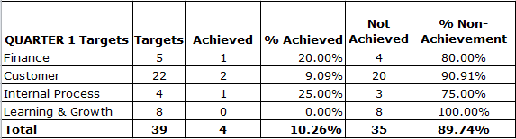

Source: SITA(2015)

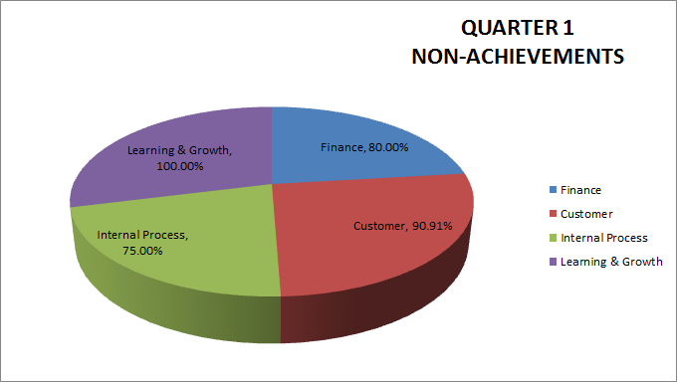

  - Overall Conclusion on SITA

The trend over last two financial years indicates entity has improved from achieving a target rate of 10% in the previous financial year to the current 54% achieved in the 2015/16 financial year. In future Parliament must monitor how SITA performs in the next three remaining quarters to ensure that indeed SITA becomes the preferred IT agency of government and also delivers on e-government mandate.

Public Finance Management Act, Act No.1 of 1999 as amended
Electronic Communications Act , Act No.36 of 2005 as amended
Public Finance Management Act (Act No. 1 of 1999)
Broadband Infraco (2013/14) Annual Report
State of Information Technology Agency, Act No.88 of 1998, as amended

