REQUEST FOR ENDORSEMENT AND SUPPORT

Prepared for
The Portfolio Committee on Small Business Development



Prepared by

33 KELLY ROAD
JET PARK
TEL: 011 397 3362
CELL: 0781619561
E-mail – ngxumisa@mcvsa.co.za

Table of Contents
- Background 4
  - Company background 4
  - The road that well-travelled 4
- The Status of South African Exports 6
  - The importance of exports in an economy 6
  - The current status of South African exports 6
  - Challenges in export development 6
  - South Africa’s opportunities in the Global economy 6
- Our input to South African Exports 7
- Overview of our export management division 7
  - Our vision 8
  - The target market 8
  - The services that we render 9
  - Advantages our services will bring to the South African companies 10
- The value our services will bring to the South African Economy 11
- Request for support 12
- Conclusion 13

1. Background

1.1 Company Background
MCV International Forwarding (Pty) Ltd; a member of the South African Association of Freight Forwarders (SAAFF) and Worldwide Agents Network (3F) is a 100% black woman owned and controlled company that was conceived in 2011. This company was formed in 2011 on the realisation that companies of South African Origin have a very insignificant role in International trade. The market share was negible at 0.05%. Our vision is to assist South African companies through consulting and freight forwarding services to enter into the international market for competitiveness which will benefit the South African economy by growth and in turn job creation. Since its inception, the company provides the following services:
- Pre- import and Pre- export services – This includes importer/ exported registration, tariff determination, import and export permit applications, preferential trade certificates, AGOA certificates and advice on Industrial rebates and bonded warehouse management.
- Freight Forwarding Services- This includes Sea Freight, Air Freight and Cross border.
- Post Clearance services – This includes Refund claims for the 5th and 6th schedule rebates, managing rebate stores, managing bonded warehouses and co-ordinating Customs audits.
- Export training – Our courses include Introduction to exports, Product costing, Export planning, Export pricing, Inco-terms 2010, International Marketing, Export finance etc.
1.2 The road well-travelled
The last four years have been a long haul but also very rewarding. MCV is a member of the South African Association of Freight Forwarders as well as the Freight Forwarders Family, an international freight forwarders network. This network provides partners in more than 50 international countries. MCV clients include:
- Bally gaming in the gaming industry
- Sharpshell Industrial Solutions for hazardous cargo
- Afric Oil in the fuel industry and
- The Department of Trade and Industry for Training and Exhibitions
MCV has conducted export awareness workshops on behalf of the Department of Trade and Industry in various districts such as Thohoyandou, Tzaneen, Modimolle, and Richards Bay among others.
MCV has handled cargo for exhibition on behalf of the DTI to China, Las Vegas, Switzerland and others. MCV has also participated in the preparation of contingency plan for global exporter passport training workshop that was facilitated by Dr Andre Gouws.

2. The Status of the South African Exports

2.1 The importance of exports in an economy – general
Exports play an important role in every economy, influencing the level of economic growth, employment and the balance of payments.
2.2 The current status of South African exports
South African exports were at $90 612 104 in 2014 as compared to $95 224 782 in 2013. South African imports were at $99 892 783 in 2014 as compared to 103 461 277 in 2013. The below graph shows movement in South African exports and imports on an annual basis.
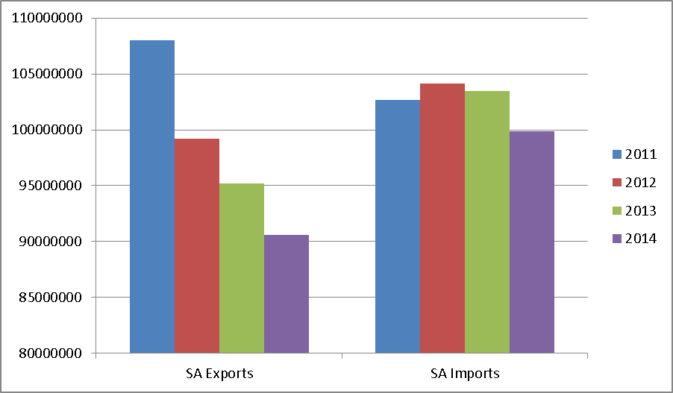

Of this 46% goes to raw material and 10% goes to motor vehicles, 3% to fruit and the balance is shared among other commodities.
The chat below shows Brics countries’ share of exports in the global market. As per below chart, South Africa’s share in global exports is currently sitting at 0.504%.

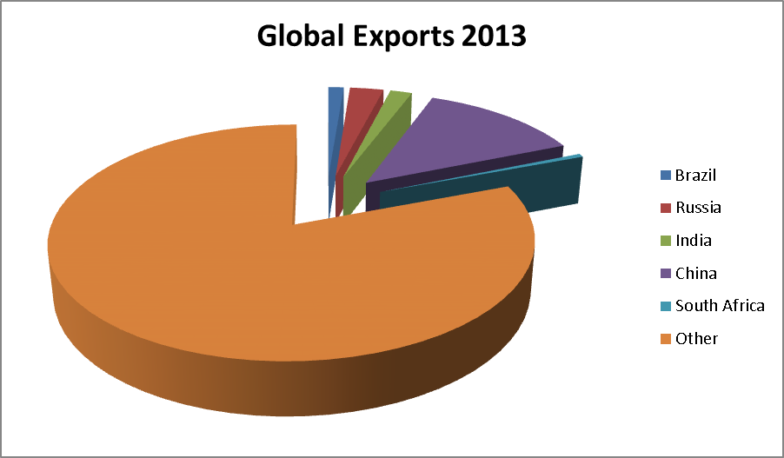
2.3 South Africa’s opportunities in the Global Economy

Following the lifting of sanctions in the early 1990s South Africa has more opportunities to maximise its exports and therefore developing its economy and creating jobs. Preferential trade agreements were entered into so as to place products of a South African origin at an advantage in the global market. These preferential agreements include the SADC, the European Union Trade agreement and the agreement between the EFTA states and SACU states. South Africa was also given an opportunity to export qualifying products to USA under AGOA.
The South African government recognises the importance of exports in economic development as it is stated in the National Development Plan that one of the key elements for employment creation is
- Promoting exports and competitiveness as well as
- Increasing Global Market Share
MCV have realised that international trade is still a challenge to most of South African companies. The main facts that affect our country export growth are:
- Companies still do not have an idea of procedures to follow before you approach an international market.
- How to prepare your team and your product to meet the international standards
- Flexibility towards international requirements
- Production capacity to meet international demand.
- Cultural and language differences
- Pricing
It was a logical step to actively expand MCV Operations to cater for the role that exports will play in increasing the country's global competitiveness.

3. Our input to South African Export developmentAfrican Economy

MCV has established an Export Management division to bridge the gap between aspiring exporters and international buyers and distributors. Our aim is to be the point of reference between the exporters and the markets by helping exporters understand, pre-empt and mitigate the risks relating to exports. We will act as an external sales department for local companies enabling these companies to establish their presence in the international market.
We have engaged a few stakeholders such as the Black Business Council, Farmers unions, Business Chambers and the concept has been widely welcome. We are in the process of sourcing financial assistance to kick-start with this concept through SEFA, Identity Partners, and the private sector.
4. Overview of the services to be rendered by MCV Export Management Division

    - Study of Producer/ manufacturer’s export readiness: Our Company assists manufacturers and producers in determining their export readiness. We do this through:



- Identifying the product fitness to the various export markets as international markets have different requirements that need to be met in order for them to purchase the product. This assists companies in improving on the quality of the product in order to meet international requirements.
- We determine company managers understanding of activities in foreign market.
- We determine the capacity of the company in order to meet the international demand and provide solutions in order to meet the international demand.
- Analysis of potential risks and advice on how to mitigate the risks.
- Analysis of weak points and strong points of the client.


    - Market research and analysis- This encompasses all methods of gathering information to determine target market’s potential for your company and its products. Market research involves a comprehensive overview of the market making it possible to identify market niches for your export products. It helps you determine growth prospects and restrictions in entering that market. Our market research and information analysis will answer the client’s most popular questions with regards to the target market such as:
- What is the size of the market?
- Who are the major players in the market?
- What market entry strategy should you adopt?
- What are the risks associated with the market?
- How stable is their economy?
- Is the target market accessible?

    - Export plan development – We assist companies in developing their export plan. We conduct market research, in house market entry feasibility and creation of market entry strategy. Export plan is an extension of your business plan. This allows the client to evaluate potential risks and benefits for the business as well as the capability of the business to serve the international market. This assists companies in determining their current status and applying the necessary improvements in order to meet the international requirements.

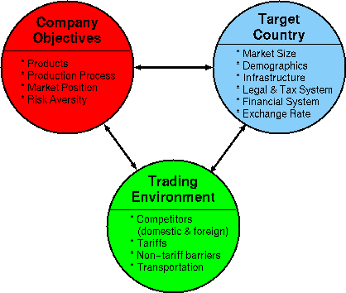

    - Market entry – Trade partner prospecting and analysis, market visits; negotiation of terms and contract implementation; appointment of distributors and confirmation of first orders. We promote customer’s products in the export market. We ensure than potential customers are interested in meeting you to discuss possible co-operation.

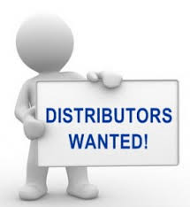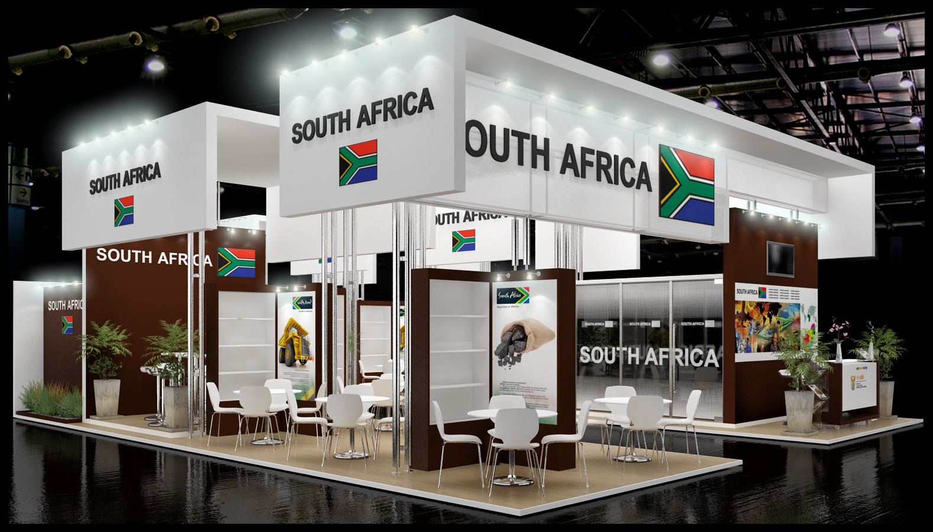

    - Trade partner management- Managing and soliciting future orders, management of shipping and customs clearance, additional market visits, relationship management. Support in obtaining all types of certificates and licences required. Order management. Continuous monitoring of the market and support in marketing activities.

    - Product sourcing – We source products as per international buyers requirements from the local market at a reasonable price and ensure that the required quality is delivered at the right time.
We can find the right quality of the product required at the right price and through our labelling department are able to use your own name and brand in the product if the brand has already been established to meet the buyers’ market demands.

5. Deliverables

Our research shows that 70% of exports in exporting countries is from small businesses. The success of these exports was because, when the small businesses started exporting, they made use of the services of Export management companies until the small companies are strong enough to export on their own. Utilising the services of an Export management company is of advantage because of the following reasons:
- The small business’s involvement in the export process will be minimal, therefore they concentrate on domestic business.
- The exporter has limited liability for product marketing problems as MCV will carry the risk.
- Management and staff learn as they go about international marketing.
- The exporter can field-test his products for export potential.
- MCV will provide close monitoring and supervision to ensure that the exporter will be able to export on his own within a period of three years.
- We have professional staff with experience in International Trade and International Marketing.
Indirect exporting is an advantage for developing countries as similar products from different producers are able to be consolidated to meet international demand. This methodology encourages partnership and unity among producers. Indirect exporting also caters for those companies and co-operatives with members who do not have the necessary skill to enter the international market as they will also export through the Export Management Company.
MCV does not only cater for export ready companies, but we assist companies to know and understand the requirements of the international market and provide recommendations on how to meet international standards. This is done at our export readiness testing phase.
Our target is to increase South Africa’s share in the global market by 0.1% per annum in the first two years and there after increase the share by 0.3%. This will be done by targeting the markets with a high population and are easily accessible. This will also be achieved by ensuring that a minimum of three different products is introduced to the international market each year.

The below table shows in deliverables in detail:
Objective | Activity | Deliverable
- Empower producer/manufacturer for export readiness | Conducting analysis of Producer/ manufacturer’s export readiness | Number of “new” products that will have made it to the international arena through assistance by MCV.
- Empower producer/manufacturer for export readiness |  | Number of products that meet the International Standards requirements.
- Empower producer/manufacturer for export readiness | Conducting training for producers and manufacturers | Number of training workshops
- Empower producer/manufacturer for export readiness | Conducting training for producers and manufacturers | Raised level of knowledge (amongst trained producers/manufactures) of foreign markets and capability to mitigate risks in the market
- Market research and analysis | Conducting market research on behalf of companies to determine niche areas for various and viability of the market | Market research results leading to informed decision about entering a market (or not).
- Enabling the producers and manufacturers to enter the export industry | Export plan development | Number of companies assisted through export plan development
 | Assisting companies in market entry and ensuring long lasting relationships | Number of companies that enter the export market and their staying ability
 |  | Number of certificates and licences acquired
 |  | Number of companies assisted in soliciting new orders and their worth
- Product sourcing | Assisting both local and international markets in sourcing products | Number and value of local products sold internationally with MCVs assistance.
- Job creation | Job creation | Number of people employed by companies assisted by MCV in establishing their business within the export arena

5. Request for support and endorsement

In line with Steven Covey’s “Habit 4 of Highly Effective People”, MCV’s approach to business is a “think win-win” approach. This is evident from the fact that our approach will benefit government, job seekers, small business and MCV. The benefit to government will be in economic development and job creation. The benefit to small business will be in terms of growth and active participation in the export market. Finally to MCV it will be the growth and empowerment of women and black entrepreneurs within business.
Given the above we seek support and endorsement from government as we feel that this project is in line with government’s drive of increasing participation by black owned companies in the export arena. What makes our offering unique is that it takes the export trade from end to end thus ensuring that small business and co-operatives are taken care of throughout the value chain of export trade.
One of the ways through which government can render support can be through financial assistance of small businesses when they seek services of MCV which will cost these companies. This could be on a Rand-to-Rand basis or a percentage of the cost of the service that MCV will render to these companies. These suggestions are not exhaustive, government can also identify and suggest other innovative ways of supporting this venture and MCV will be open to those.

We also request that the Committee consider introducing legislation that will encourage formation of export management companies in South Africa so as to support SMMEs and Co-ops and fast track exportation of South African Products. Our research has shown that the impact of introducing Export management companies has always been positive in other countries. A few examples will be the introduction of Sogo Shoshas in Japan, the introduction of the Export Trading Companies Act of 1982 in USA.
9. Conclusion

MCV fully supports the “Vukuzenzele” campaign by government which encourages South Africans to stand up and make things happen. This we have demonstrated through coming up with a concept that explores an area that is not fully explored by black small companies. In return we will be helping other small companies to grow the economy in the specified sector.
Note that an Export management Company does not take ownership of the product they promote but only act as an external sales department for the local company in the International Market. Export Management Company provides mentorship to developing businesses until they are strong enough to export on their own.
We believe this will go a long way towards job creation and making sure that we have a representative number of black companies contributing significantly in the export trade arena. This will in turn increase the slice of South African exports and ultimately change South Africa from being a consuming country to a producing and exporting country thus increase the economy.

Trade Map – Trade Statistics for International Business Development.

