REPORT OF THE PORTFOLIO COMMITTEE ON HEALTH ON THE STRATEGIC PLAN (2015/16 to 2019/20), ANNUAL PERFORMANCE PLAN (2015/16 to 2017/18) AND BUDGET VOTE 16 OF THE DEPARTMENT OF HEALTH, DATED 29 APRIL 2015

BACKGROUND

The Portfolio Committee on Health, having considered the Strategic Plan, Annual Performance Plan (APP) and budget allocations of the National Department of Health and its entities (National Health Laboratory Services, Compensation Commissioner for Occupational Diseases, South African Medical Research Council, Office of the Health Standards Compliance and the Council for Medical Schemes) and in terms of the Public Finance Management Act (PFMA) of 1999, reports as follows:

INTRODUCTION

The Constitution of South Africa (Act No. 108 of 1996) recognizes that Parliament has an important role to play in overseeing the performance of government departments and public entities. In terms of section 10(c) of the Money Bills Amendment Procedure and Related Matters Act (Act No. 9 of 2009), updated strategic plans must be tabled in Parliament after the adoption of the fiscal framework. It is important to ensure that the strategic plan is tabled within the stipulated period as the plan provides information for the budget review process of the Portfolio Committee.

This report details the findings and recommendations of the Committee after engaging the Department and its entities as well as receiving analysis of the Auditor General of South Africa and the Financial and Fiscal Commission on the Strategic Plan and Annual Performance Plan of the Department.

CONSIDERATION OF TABLED STRATEGIC PLAN AND ANNUAL PERFORMANCE PLAN AND BUDGET ALLOCATIONS

On 17 April 2015, the Portfolio Committee engaged the Director General and relevant Executive Managers of the Department of Health on the strategic plan, annual performance plan and budget allocation of the Department.

OVERVIEW OF THE DEPARTMENT OF HEALTH

The Department of Health derives its mandate from the Constitution of the Republic of South Africa and the National Health Act, No. 61 of 2003. The department also aligns its strategic plan to the National Development Plan (NDP) 2030 which envisages a health system that works for everyone and produces positive health outcomes, and is accessible to all. By 2030, South Africa should have:

- Raised the life expectancy of South Africans to at least 70 years;
- Produced a generation of under-20s that is largely free of HIV;
- Reduced the burden of disease;
- Achieved an infant mortality rate of less than 20 deaths per thousand live births, including an under-5 mortality rate of less than 30 per thousand;
- Achieved a significant shift in equity, efficiency and quality of health service provision;
- Achieved universal coverage; and
- Significantly reduced the social determinants of disease and adverse ecological factors.

Over the medium term, the Department has the following planned policy initiatives:

- Facilitate implementation of the NHI

This Green Paper on NHI outlines a phased NHI project to provide improved access to quality health services for all citizens, irrespective of their financial circumstances. Comprehensive healthcare will be provided through accredited and contracted public and private providers, with a strong focus on health promotion and prevention services at the community and household level. The piloting of the NHI is currently being financed by two conditional grants, National Health Grant (NHG), and the National Health Insurance Grant (NHIG).

- Establishment of South Africa Health Products Regulatory Authority (SAHPRA)

The Medicines and Related Substances Amendment Bill [6 of 2014] aims to create SAHPRA. SAHPRA is intended to bring the medical devices industry, cosmetics and foodstuffs as well as pharmaceuticals under the jurisdiction of the Authority. SAHPRA will be established as a Section 3A public entity.

- Traditional medicine

The Department aims to establish a Traditional Health Practitioners Council through a Traditional Health Practitioners Bill. The Bill will bring an end to the Interim Traditional Health Practitioners Council which was established in terms of Act 22 of 2007.

- Operation Phakisa and Ideal Clinic Initiative

Through Operation Phakisa, the Ideal Clinic Realisation and Maintenance programme was launched in 2013 with the aim of transforming all primary health care facilities into Ideal Clinics which will provide good quality health care. An Ideal Clinic is described as a clinic with good infrastructure, adequate staff, adequate medicines and supplies, good administrative processes and adequate bulk supplies that use applicable clinical policies, protocols and guidelines.

  - Situation Analysis

In line with government’s outcome-based approach, an increased life expectancy for all South Africans is the highest impact that the health sector seeks to attain. In improving health outcomes, the sector should focus on strengthening the effectiveness of the health system. In the main, the health sector has achieved significant milestones through the strategic interventions implemented over the years. Below are some of the health sector achievements in critical indicators, as reported in the 2015 - 2020 Strategic Plan of the Department of Health:

- Life expectancy

According to the Rapid Mortality Surveillance Report of 2013, the overall life expectancy of all South Africans has increased from 57.1 years in 2009 to 62.2 years in 2013.

- HIV/AIDS and TB

South Africa continues to be home to the world’s largest number of people living with HIV, estimated to be 6.4 million. Levels of HIV and TB co-infection are very high, with as many as 70% of patients having HIV-associated TB. There were just under 300 000 new TB cases reported in 2013, down from more than 389 000 new TB cases reported in 2011. There has been a rapid scale up of ART services resulting in a four-fold increase in the number of people receiving ART between 2009 and 2012. The HIV Counselling and Testing (HCT) campaign resulted in approximately 13 million tests for HIV and over three million people screened for TB. PMTCT services are widely available.

- Maternal and Child Health

The neonatal mortality rate (NMR) declined from 14 deaths per 1 000 live births between 2009 and 2011 to 11 deaths per 1000 live births in 2013 (NSDA target: 12 deaths per 1 000 live births). The infant mortality rate (IMR) has decreased from 40 deaths per 1 000 live births in 2009 to 29 deaths per 1 000 live births in 2013 (NSDA target: 35 deaths per 1 000 live births). The under-5 mortality rate (U5MR) has decreased from 56 deaths per 1 000 live births in 2009 to 41 deaths per 1 000 live births in 2013 (NSDA target: 50 deaths per 1 000 live births).The maternal mortality rate (MMR) has decreased from 310 deaths per 100 000 to 269 deaths per 100 000 live births in 2013.

- Violence and Injuries

Violence and injuries are one of the leading cause of death in South Africa. The health sector recognizes the need for the implementation of a comprehensive and intersectoral response to combat violence and injury, and significantly reduce the country’s injury death rate.

- Non-communicable diseases

Increased prevalence of NCDs contributes at least 33% to the burden of disease. In addition to the common factors for NCDs such as tobacco use, physical inactivity, unhealthy diets and excessive alcohol use; evidence shows that there is increased vulnerability of South Africans to mental disorders. The National Mental Health Policy and Strategic Plan 2013-2020 sets to transform mental health services. The Department recognizes the need for multidimensional interventions to be implemented with other sectors to address the socio-economic determinants of mental disorders.

- Communicable diseases

The influenza vaccination programme will continue vaccinating high risk individuals to mitigate the impact of the disease. In achieving malaria elimination by 2018, South Africa will work closely with its neighbouring countries: Mozambique, Swaziland and Zimbabwe in regional malaria initiatives.

  - Department of Health Strategic Plan (2015-2020)

The Department’s strategic goals are to:

- Prevent disease and reduce its burden and promote health;
- Make progress towards universal health coverage through the development of the National Health Insurance scheme, and improve the readiness of the health facilities for its implementation;
- Re-engineer primary healthcare by: increasing the number of ward based outreach teams (WBOT), contracting general practitioners, and district specialist teams; and expanding school health services;
- Improve health facility planning by implementing norms and standards;
- Improve financial management by improving capacity, contract management, revenue collection and supply chain management reforms;
- Develop an efficient health management information system for improved decision making;
- Improve the quality of care by setting and monitoring national norms and standards, improving system for user feedback, increasing safety in health care, and by improving clinical governance; and
- Improve human resources for health by ensuring adequate training and accountability measures.

The activities of the Department are organised in six programmes, comprising: Programme 1 – Administration; Programme 2 – National Health Insurance, Health Planning and Systems Enablement; Programme 3 – HIV and AIDS, Tuberculosis, Maternal and Child Health; Programme 4 – Primary Health Care Services; Programme 5 – Hospitals, Tertiary Health services and Human Resource Development; and Programme 6 – Health Regulation and Compliance Management.

  - Department of Health Annual Performance Plan (2015/16)

Programme 1: Administration

The purpose of the administration programme is overall management of the department and providing centralised support services.

Strategic Objectives:

- Ensure effective financial management and accountability by improving audit outcomes.
- Fully implement the Departmental Information Communication Technology (ICT) Service Continuity Plan by the 31st March 2018.
- Provide support for effective communication by developing an integrated communication strategy and implementation plan.
- Ensure efficient and responsive human resource services through the implementation of efficient recruitment processes and responsive human resource support programmes

Some of the targets for 2015/16 under Programme 1 include:

- Achieving unqualified audit opinion from the Auditor General;
- Ensure that all provinces submit reports against the non-negotiable items on a monthly basis;
- Ensure that the average recruitment process turnaround time is four months;
- Develop an integrated communication strategy and implementation plan; and
- Develop a National Health litigation Strategy (quarterly target).

The Department highlighted the following issues that could affect expenditure:

- Job grading and back pay of Assistant and Deputy Directors which will carry through the MTEF.
- Maintenance and repairs of security systems in Civitas and information systems, this will run over two financial years (2014/15 and 2015/16).
- Backlog in payments of office accommodation to be addressed during 2015/16. This could amount to about R50 million.
- In the current financial year, the Auditor General fees are expected to grow by 10%.

Programme 2: National Health Insurance, Health Planning and Systems enablement

The purpose of this programme is to improve access to quality health services through the development and implementation of policies to achieve universal coverage, health financing reform, integrated health systems planning, reporting, monitoring and evaluation and research.

Strategic Objectives:

- Achieve universal health coverage through the implementation of the National Health Insurance.
- Establish a national stock management surveillance centre to improve medicine availability.
- Improve the contracting and supply of medicines.
- Implement the strategy to address antimicrobial resistance (AMR)
- Regulate African Traditional Practitioners
- Strengthen revenue collection by incentivising hospitals to maximise revenue generation.
- Implement eHealth Strategy of South Africa through the development of the system design of patient information systems and implantation.
- Develop and implement a national research strategic plan.
- Develop and implement an integrated monitoring and evaluation plan aligned to health outcomes and outputs contained in the Health Sector Strategy
- Domestication of international treaties and implementation of multilateral cooperation on areas of mutual and measurable benefit.
- Implementation of bilateral cooperation on areas of mutual and measurable benefit.
- Review annual dispensing fee.
- Publish and implement single exit price adjustment annually.
- Develop regulations pertaining to uniform patient fee schedule (UPFS)
- Develop a central registry for the funded and unfunded patients.
- Number of provincial annual performance plans aligned to the National Health system priorities.
- Implement patient quality of care survey tool
- Conduct a national survey to measure patient quality of care.

Below are selected targets for the current financial year (2015/16):

- To ensure the finalisation and publication of the White Paper on NHI;
- Ensure that the funding modality for the NHI is developed;
- Ensure that 10 central hospitals, 17 tertiary hospitals and 25 regional hospitals have functional electronic stock management systems;
- 500 000 patients receiving medicines through the centralised chronic medicine dispensing and distribution system;
- Establish a Council for Traditional Practitioners;
- Ensure that the review process of the Hospital Level Adult Essential Medicines List (EML) and Standard Treatment Guidelines is completed;
- 12 medicines reviews conducted for the Tertiary and Quaternary EML;
- Develop and implement a Revenue Retention Model at central hospitals;
- 175 facilities per quarter are implementing improved patient administration and web based information systems; and
- Ensure that all 9 Provincial APPs are reviewed and feedback provided to ensure alignment of health sector plans to National Health System Priorities.

Additional areas that could present budget pressures:

- Deterioration in the exchange rate will have implications on the annual contribution to the World Health Organisation and also the setting up of the Health Attaché’s Office in Cuba.
- Allocate additional funds to sector wide procurement.
- Funds were received for the Demographic Health Survey of about R30 million whilst the need is in excess of R80 million.

Programme 3: HIV/AIDS, TB and Maternal and Child Health

The purpose of this programme is to decrease the burden of disease related to the HIV and TB epidemics; to minimise maternal and child mortality and morbidity; and to optimise good health for children, adolescents and women. This is done through the three overarching strategies of setting policies, guidelines, norms, standards and targets; supporting the implementation of these; and monitoring and evaluating the outcomes and impact of his implementation.

Strategic Objectives:

- To reduce the maternal mortality ratio to under 100 per 100 000 live births.
- To reduce the neonatal mortality rate to under 6 per 1000 live births.
- To improve the access to sexual and reproductive health services by expanding the availability of contraceptives.
- Expand the Prevention of Mother to Child Transmission (PMTCT) coverage to pregnant women by ensuring all HIV positive Antenatal clients are placed on ARVs and reducing the positivity rate to below 1%.
- To reduce under-five mortality rate to less than 23 per 1, 000 live births by promoting early childhood development.
- To protect girl learners against cervical cancer
- To undertake a massive TB screening campaign
- To improve access to treatment.
- Strengthen patient retention in treatment and care
- To scale up combination of prevention interventions to reduce new infections including HCT, male medical circumcision and condom distribution
- Increase the number of HIV positive people on ARVs
- Monitor implementation of maternal neonatal and Women’s health programme using standardised dashboard reports.
- Develop training manual for the implantation of contraception and fertility planning (CFP) policy.
- Develop pharmacovigilance system for adverse events for contraceptive implants.
- Develop cervical cancer control policy.
- Develop breast cancer policy.

Selected targets under Programme 3 for the current financial year (2015/16):

- To ensure that quarterly performance reports on Maternal, Neonatal and Women’s Health programme are produced and feedback provided to each provincial Department of Health;
- Track progress on the implementation of mother-to-child-transmission of HIV in all provincial DoH;
- Ensure that four quarterly reports are produced on the implementation of the HIV and AIDS programme;
- Ensure that four quarterly reports are produced on the implementation of the HIV and AIDS Conditional Grant;
- Ensure that quarterly reports are produced on the implementation of child health programmes;
- 75% of inmates screened for TB annually;
- 60% of mines providing routine TB screening; and
- 462 000 community members in peri-mining districts are screened for TB.

Additional key indicators targets under Programme 3 over the medium term:

- To reduce under-five mortality rate to less than 23 per 1,000 live births by decreasing under-five years’ diarrhoea and severe acute malnutrition case fatality rates to 3.2% and 10%, respectively by 2015/16.
- To increase the proportion of antenatal patients attending a health facility before 20 weeks of pregnancy from 44% in 2012/13 to at least 65% in 2016/17.
- To increase the percentage of mothers and babies who receive post-natal care within 6 days of delivery from 65.1% in 2012/13 to at least 90% in 2016/17.

The Department reported the following:

- Increase in transfer for HIV and AIDS conditional grant over the MTEF.

Programme 4: Primary Health Care

The purpose of this programme is develop and oversee implementation of legislation, policies, systems and norms and standards for a uniform district health system, environmental health, communicable and non-communicable disease, health promotion and nutrition.

Strategic Objectives:

- Improve district governance and strengthen management and leadership of the district health system.
- Improve access to community based primary health care services.
- Improve quality of services at primary health care facilities.
- Improve environmental health services in all 52 districts and metropolitan municipalities in the country.
- Establish a national health commission to address the social determinants of health.
- Reduce risk factors and improve management for non-communicable diseases by implementing the strategic plan for NCDs 2012-2017.
- Improve access to and quality of mental health services in South Africa.
- Improve access to disability and rehabilitation services through the implementation of the framework and model for rehabilitation and disability services.
- Prevent avoidable blindness.
- Eliminate Malaria by 2018, so that there are zero local cases of malaria in South Africa.
- Strengthen preparedness and core response capacities for public health emergencies in line with International Health Regulations.
- Improve South Africa’s response with regard to influenza prevention and control.
- Establish a coordinated diseases surveillance system for notifiable medical conditions (NMC)
- Conduct annual national HIV antenatal prevalence survey.

Selected targets under Programme 4 for the current financial year (2015/16):

- Ensure that 15 districts has uniform management structures for primary health care facilities;
- 1000 health care facilities with functional clinic committees;
- 2000 functional Ward Based Primary Health Care Outreach Teams;
- 500 primary health care facilities qualifies as Ideal Clinics;
- 20 municipalities meet environmental health norms and standards;
- Ensure that a national Hand Hygiene strategy is developed;
- Ensure that a framework for the National Health Commission is developed;
- 8 million people screened for high blood pressure;
- 8 million people screened for raised blood glucose levels;
- 28% (16.5% prevalence) of people screened for mental disorders;
- 28% (16.5% prevalence) of people treated for mental disorders;
- 16% of mental health inpatient units are attached to designated district and regional hospitals; and
- Ensure that the 2015 National Antenatal HIV Prevalence Report is produced.

The Department highlighted the following new activity:

- Transfer of Port Health Services from provincial Health Departments amounting to R118 million.

Programme 5: Hospitals, Tertiary Health Services and Human Resource Development

The purpose of this programme is to develop policies, delivery models and clinical protocols for hospitals and emergency medical services. Ensure alignment of academic medical centres with health workforce programmes, training of health professionals and to ensure the planning of health infrastructure to meet the health needs of the country.

Strategic Objectives:

- Increase capacity of central hospitals to strengthen local decision making and accountability to facilitate semi-autonomy of ten central hospitals.
- Ensure equitable access to tertiary service through implementation of Tertiary services.
- Ensure quality health care by improving compliance with National Core Standards at all central, tertiary, regional and specialises hospitals.
- Develop health workforce staffing norms and standards.
- To improve quality of health infrastructure in South Africa.
- To strengthen monitoring of infrastructure projects.
- Ensure access to and efficient effective delivery of quality Emergency Medical Services (EMS).
- To provide food analysis services.
- Improve management of health facilities at all levels of care through the health leadership and management academy.
- Publish policy on education and training of EMS personnel.
- Develop regulations for Emergency Care Centres.
- Develop a monitoring system to effectively measure turnaround time of tests conducted at Forensic Chemistry Laboratories.
- Regulations for the rendering of Forensic Pathology Services promulgated.
- Publish scope of practice guidelines for the rendering of Forensic Pathology Services.

Selected targets under Programme 5 for the current financial year (2015/16):

- Ensure that 10 tertiary hospitals have full delegated authority;
- Four tertiary hospitals (Pietersburg, Frere, Kimberley and Ngwelezane) providing full package of Tertiary 1 services;
- Ensure full compliance with the National Core Standards in 8 Central hospitals and 5 Tertiary hospitals;
- 1000 facilities benchmarked against PHC staffing normative guides;
- Ensure that a nursing and midwifery educators’ training and development programme is developed;
- 198 facilities maintained, repaired and refurbished in the NHI Districts;
- 310 facilities maintained, repaired and refurbished outside the NHI Districts;
- 35 clinics and Community Health Centres constructed and revitalised;
- Two hospitals constructed and revitalised;
- 37 new facilities comply with gazetted infrastructure norms and standards;
- Ensure that EMS Regulations and compliance checklist are gazetted;
- Establish a coaching mentoring and training programme for health managers;
- A monitoring system is developed and implemented at 4 Forensic Laboratories; and
- Review the Regulations regarding the rendering of Forensic Pathology Services.

The Department highlighted the following budget pressures:

- Shifting some of the capital budget to goods and services may present budget pressures.
- Budget cut regarding the indirect health facility revitalisation grant of about R107.8 million.
- The office of the Chief Nursing Services is in the process of being set up.

Programme 6: Health Regulation and Compliance Management

The purpose of this programme is to regulate procurement of medicines and pharmaceutical supplies, including food control and the trade in health products and health technology. Promote accountability and compliance by regulatory bodies and public entities for effective governance and quality of health care.

Strategic objectives:

- Establish the South African Health Product Regulatory Authority (SAHPRA).
- Establish Institute of Regulatory Science.
- To develop the policy and legislative framework for occupational health and compensation.
- To establish an occupational health cluster.
- To provide occupational health and compensation services through the development of One Stop Service centres in provinces.
- To establish the National Public Health Institute of South Africa for disease and injury surveillance.
- Improve oversight and corporate governance practices by establishing effective governance structures, policies and tools.
- Regulate medical devices, IVDs, cosmetics and expand on regulation of Complementary medicines.
- Improve registration turnaround times of ARVs, TB oncology and vaccines to treat and prevent high burden of diseases.
- Establish a Memorandum of Understanding (MOU) with the Department of Agriculture, Fisheries and Forestry.
- Develop Regulations for cosmetic products.
- Develop and implement dashboard to monitor entities performance and compliance to legislative prescripts.
- Develop a reporting template to enable feedback to the executive authority.

Selected targets under Programme 6 for the current financial year (2015/16):

- To ensure the promulgation of the SAHPRA Act and development of the transitional plan from MCC to SAHPRA;
- Develop a business plan for the establishment of the Institute of Regulatory Science is drafted and approved;
- Ensure the establishment of One Stop Service Centres in Northern Cape and Limpopo;
- To ensure gazetted legislation on NAPHISA;
- Four health entities and six statutory professional councils are fully functional and compliant to good governance practices;
- Ten dashboards developed and piloted to monitor entities performance and compliance;
- Draft regulations and guidelines for medical devices and IVDs are developed;
- 55% of priority medicines registered, with new chemical entity (NCE) registered within 22 months and generics in 18 months;
- 8000 number of applications certified at Medical Bureau Occupational Diseases as compensable disease claims;
- 3000 number of compensable disease claims paid by CCOD other than pensioners; and
- Ensure that three new boards (Health Professionals Council of SA, NHLS and the Interim Traditional Health Practitioners Council of SA) are appointed, inducted and trained.

BUDGET ANALYSIS

The Department receives R36.5 billion for 2015/16, up from R33.6 billion in the previous financial year (2014/15). This is an increase in nominal terms of 8.5 per cent and 3.49 per cent in real terms.

Table 1: Health Budget for 2015/16
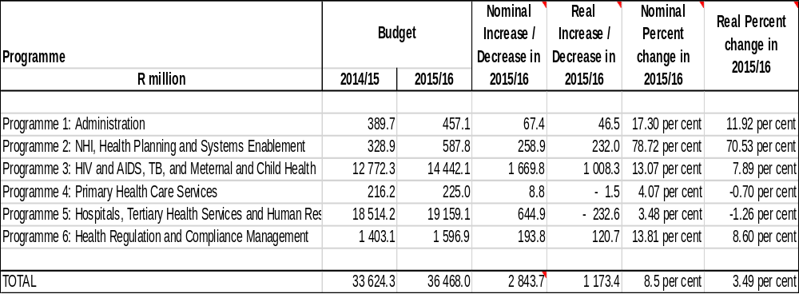

The two largest programmes namely Programme 5: Hospitals, Tertiary Services and Human Resource Development and Programme 3: HIV and AIDS, TB, Maternal and Child Health jointly constitute 92.1 per cent of the total budget in 2015/16. These two programmes receive 81.4 per cent (R2.3 billion) of the R2.8 billion increase in the budget.

The smallest allocation is for Programme 4: Primary Health Care Services which declines in real terms (-0.7 per cent). Less than one per cent (0.62 per cent) of the department’s total budget is allocated to this programme (R225 million), which is approximately 4 per cent more than it received in the previous year (R216.2 million).

In terms of economic classification, the bulk of the Health Budget (R33.4 billion or 91.7 per cent) consists of transfers and subsidies to provinces and municipalities, and departmental agencies and accounts. This figure includes R171.1 million to non- profit institutions (down from R206 million) and R1.4 billion to departmental agencies and accounts (up from R1.2 billion).

Current payments constitute a total value of R2.4 billion, which represents 6.5 per cent of the total budget allocation. Most of the current expenditure is allocated to Goods and Services, taking up 67.2 per cent of the total current payments. Expenditure items that receive the largest share of the goods and services budget are Contractors at R341.5 million, Consultants and professional services: Business and advisory services at R123.1 million, Medical Supplies at R189.3 million and Medicine at R196.2 million.

A significant increase in payments for capital assets is budgeted for, from R298.4 million in 2014/15 to R668 million in 2015/16. Buildings and other fixed structures nearly triples from R188.0 million to R562 million. Machinery and equipment increases from R100.7 million to R105.5 million (4.6 per cent nominal increase) in 2015/16.

Over the medium term the department’s focus will remain on increasing life expectancy, improving quality of life via the expansion of the HIV and AIDS programme, revitalising public health facilities and providing specialised tertiary health services. R1.4 billion of the R2.4 billion cabinet approved budget reductions will be effected on most of the conditional allocations to provincial departments of health over the medium term. The department will have to “find efficiencies, particular with regard to provision of infrastructure

Certain functions have also shifted. The National Health Laboratory Services (NHLS) funding is being amended so that the national function for training and research is funded directly by the national Department of Health and will no longer be paid for by fees charged to provinces. This will result in prices for tests being either reduced or not increasing by as big a margin. The Port Health function is being shifted from provinces to the national Department of Health, resulting in R380 million being shifted from the provincial equitable share to the national Department of Health over the medium term.

- The HIV and AIDS programme will receive a Cabinet approved additional allocation of R1.2 billion in 2017/18.
- The Department’s infrastructure spending is funded through two conditional grants: the provincially delivered health facilities revitalisation grant and the nationally delivered health facility revitalisation component of the national health grant.
- Due to underspending in the health facilities revitalisation component of the national health allocation in kind to provinces, R411.6 million will be reprioritised to other areas such as for new equipment and staff in the four Forensic Chemistry Laboratories, Port Health and the Office of Health Standards Compliance (OHSC).
- There are currently 8 mega projects being implemented by national or provincial departments, each with a cost of over R1 billion, funded by conditional grants.
- There are currently 50 large infrastructure projects (cost of more than R250.0 million, but less than R1 billion) being implemented by the national or provincial departments funded by the conditional grants, totalling R9 billion over the medium term.
- Small projects such as those to construct and upgrade clinics, as well as the installation of doctors consultation rooms in NHI pilot districts amongst others, will total R8 billion over the medium term.
- Slow spending on the NHI conditional grants especially due to the difficulty in contracting general practitioners has resulted in Cabinet reducing the allocation by R355.3 million to R884.1 million over the medium term.
- R82.1 million has been earmarked over the medium term for the diagnosis-related group project.

- PROGRAMMES ANALYSIS

Programme 1: Administration

Table 2: Programme 1- Administration

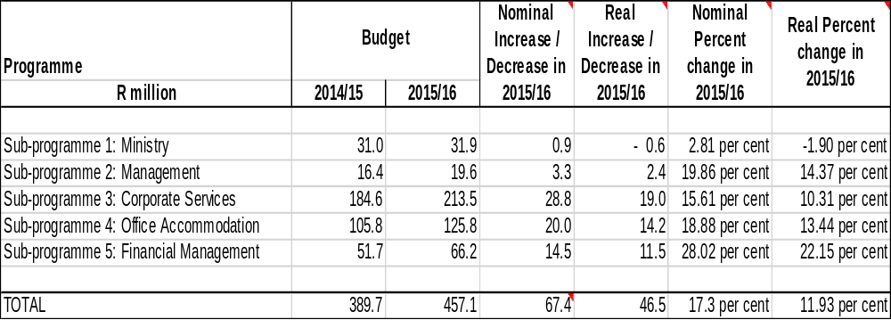

The purpose of the Administration Programme is overall management of the Department and providing centralised support services. The Programme budget increases by 17.3 per cent in nominal terms (but in real terms by 11.9 per cent) from R389.7 million in 2014/15 to R457.1 million in 2015/16. The largest sub-programme is Corporate Services, of which the allocation increases by 15.6 per cent in nominal terms and by 10.3 per cent in real terms. Office Accommodation receives 27.5 per cent of the programme budget and increases, from R105.8 million in 2014/15 to R125.8 million (up nominally by 18.9 per cent or 22.2 per cent in real terms) in 2015/16.

In terms of economic classification, 97.9 per cent of the budget is allocated to current payments. Compensation of Employees amounts to R177.1 million while R270.3 million is allocated to Goods and Services. This includes R119.9 million for Operating leases.

Programme 2: National Health Insurance, Health Planning and Systems Enablement

Table 3: Programme 2 - NHI, Health Planning and Systems Enablement
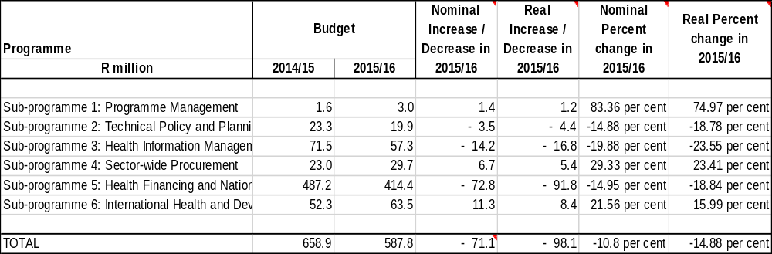

The National Health Insurance (NHI), Health Planning and Systems Enablement Programme aims to improve access to quality health services through planning, integration of health systems, reporting, monitoring and evaluation, and research.

This Programme budget decreases by 10.8 per cent in nominal terms (or 14.9 per cent in real terms) from the 2014/15 financial year, due largely to decreased funding for the NHI sub-programme. The NHI sub-programme decreased by 14.9 per cent nominally and 18.8 per cent in real terms. The NHI sub-programme receives the largest portion of the Programme 2’s budget, at 70.5 per cent (R414.4 million) to develop and implement policies, legislation and frameworks for expansion of health insurance to the broader population, amongst other things. The decrease in this sub-programme is due to the slow progress with contracting General Practitioners (GPs) which has been attributed to the poor working conditions and lack of accommodation in clinics.

  - Programme 3: HIV and AIDS, TB, Maternal and Child Health

Table 4: Programme 3 - HIV and AIDS, TB, Maternal and Child Health
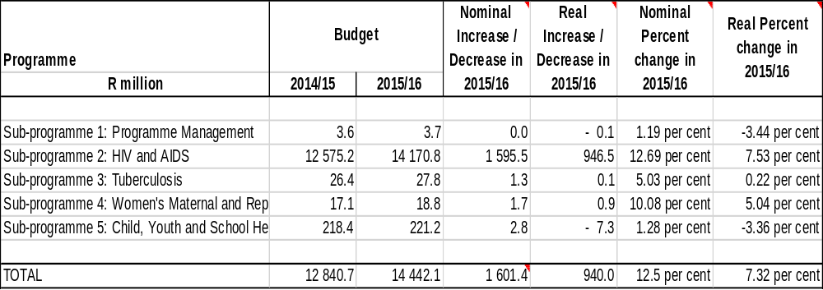

The aim of this programme is to coordinate, manage and fund HIV and AIDS, Tuberculosis (TB) and maternal and child health programmes. It aims to reduce infant, child and youth morbidity as well as maternal mortality. It also aims to increase the TB cure rate.

A large proportion, 98.1 per cent of this programme’s budget is allocated to the HIV and AIDS sub-programme, amounting to R14.2 billion in 2015/16. This represents a nominal increase of 12.7 per cent or 7.5 per cent in real terms compared to the 2014/15 allocation. The remaining four sub-programmes combined receive less than 2.0 per cent of the programme’s budget. Despite the small budget allocated to these programmes, these are also stated priorities of the department including women’s health, children’s health and TB.

The Women’s Maternal and Reproductive Health sub-programme programme is responsible for amongst other interventions, deploying obstetric ambulances, establishing Kangaroo Mother Care facilities, midwifery education and training, and strengthening infant feeding practices. This sub-programme received less than 1 (0.13) per cent of the programme budget remaining the same as the previous financial year.

The Child, Youth and School Health sub-programme increases from R218.4 million to R221.2 million (1.3 per cent in nominal terms) and much of the budget funds the roll-out of the Human Papilloma Virus (HPV) Vaccine. This sub-programme develops and monitors policies and guidelines, and sets norms and standards for child health. Over the medium term, key initiatives will be implemented in line with the maternal and child health strategic plan. These include the continued rollout of the integrated school health programme to cover all learning phases, prioritising under-served and under-resourced schools, and strengthening the immunisation programme. Child mortality rates, which include neonatal- (NMR), infant- (IMR) and under-5 mortality (U5MR), in South Africa have declined, thought at various rates. This is a positive outcome emanating from the scale-up of prevention of mother to child transmission of HIV, the rollout of antiretroviral therapy, new child vaccines (pneumococcus and rotavirus) and other child survival programmes. However, acute malnutrition remains a challenge contributing to child mortality.

  - Programme 4: Primary Health Care Services

Table 5: Programme 4 - Primary Health Care Services
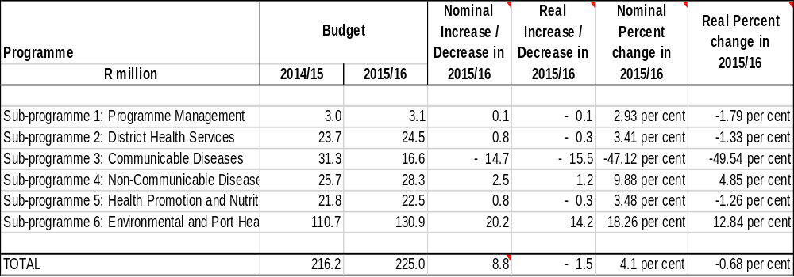

The Primary Health Care Services programme aims to develop and implement a uniform district health system and to develop policy for district health services. This Programme’s budget increased by 4.1 per cent in nominal terms in 2015/16, but in real terms decreases by 0.7 per cent. In 2015/16, the allocation for Environmental and Port Health Services increases by 18.3 per cent in nominal terms (or 12.8 per cent in real terms) from R110.7 million to R130.9 million. The budget allocation for Communicable Diseases decreases by 47.1 per cent in nominal terms (or 49.6 per cent in real terms) from R31.3 million to R16.6 million.

The Non-Communicable Diseases sub-programme receives R28.3 million in 2015/16 representing 12.6 per cent of the programme’s budget allocation. This sub-programme, amongst others, assists provinces in implementing and monitoring chronic diseases, disability, elderly people, oral health, mental health and substance abuse.

  - Programme 5: Hospitals, Tertiary Health Services and Human Resources Development

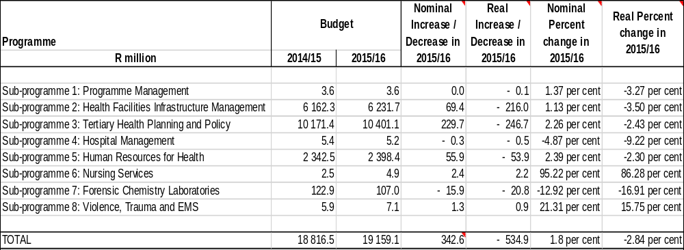
Table 6: Programme 5 - Hospitals, Tertiary Health Services and Human Resources Development

The aim of the Hospitals, Tertiary Health Services and Human Resources Development Programme is to accelerate the delivery of health infrastructure. It also aims to strengthen human resource capacity in the health sector. The 2015/16 budget for this programme has increased by 1.8 per cent in nominal terms, declining by 2.8 per cent in real terms.

The Forensic Chemistry Laboratories sub-programme allocation declines by 12.9 per cent in nominal terms and 16.9 per cent in real terms from R122.9 million to R107 million in 2015/16.

The Hospital Management sub-programme allocation declined in both nominal (4.9 per cent) and real terms (9.2 per cent) in 2015/16. The Nursing sub-programme allocation has nearly doubled from R2.5 million to R4.9 million.

  - Programme 6: Health Regulation and Compliance Management

Table 7: Health Regulation and Compliance Management
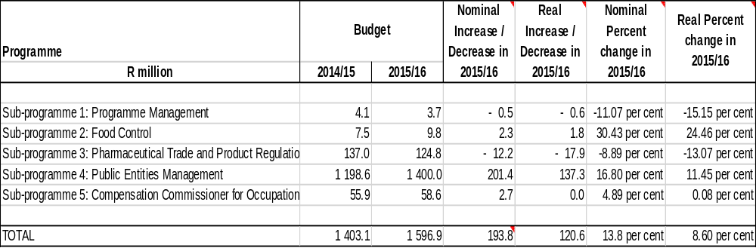

The Health Regulation and Compliance Management programme aims to, amongst other things, reduce the time taken for medicines to reach the market, and establish a National Public Health Institute. The programme budget has increased by 13.8 per cent in nominal terms from R1.4 billion in 2014/15 to R1.6 billion in 2015/16.

87.7 per cent of the programme budget is allocated to the Public Entities Management sub-programme (R1.4 billion). The Office for Health Standards Compliance sub-programme falls away with the establishment of the Office of Health Standards Compliance as a Section 3A entity with the promulgation of the National Health Amendment Act, No. 12 of 2013.

BUDGET PRESSURES

The following were reported as budget pressures on the Department:

- Job grading and back pay of Assistant and Deputy Directors which will carry through the MTEF.
- Maintenance and repairs of security systems in Civitas and information systems, which will run over two financial years (2014/15 and 2015/16).
- Backlog in payments of office accommodation to be addressed during 2015/16, estimated to R50 million.
- In the current financial year, the Auditor General fees are expected to grow by 10%.
- Deterioration in the exchange rate will have implications on the annual contribution to the World Health Organisation and also the setting up of the Health Attaché’s Office in Cuba.
- There will be a need to allocate additional funds to sector wide procurement.
- Funds received for the Demographic Health Survey of about R30 million, the need is in excess of R80 million.
- Shifting some of the capital budget to goods and services may present budget pressures.
- Budget cut of approximately R107.8 million of the indirect health facility revitalisation grant.
- The office of the Chief Nursing Services is in the process of being set up and may present budget pressures.

CONSIDERATION OF THE ANNUAL PERFORMANCE PLANS OF ENTITIES

List of Entities supporting the Department:

- National Health Laboratory Service (NHLS);
- Compensation Commissioner for Occupational Diseases (CCOD);
- South African Medical Research Council (SAMRC);
- Office of Health Standards Compliance (OHSC); and
- Council for Medical Schemes (CMS).

National Health Laboratory Services (NHLS)

The National Health Laboratory Service (NHLS) was created by the National Health Laboratory Act (No. 37 of 2000) to provide laboratory and diagnostic services to public health facilities in South Africa. The NHLS also provides health science training and education, and supports health research. It is the largest provider of diagnostic pathology services in South Africa, servicing over 80 per cent of the population through its 268 laboratories countrywide.

Situation analysis

The NHLS identifies a number of Strengths, Weaknesses, Opportunities and Threats. These include:

Strengths
- Strong academic base and sustainable partnerships.
- Only operational platform for training pathologists.
- National pathology laboratory footprint.

Weaknesses
- Liquidity and cash flow.
- Difficulty in attracting and retaining scarce skills.
- High dropout and failure rate of pathologists and technologists.

Opportunities
- National Health Insurance (NHI).
- Global budget to replace fee for service.
- Value chain ownership.

Threats
- Creditors’ delay in payments that exceed 120 days.
- Negative provincial perceptions of NHLS.

The NHLS has identified seven strategic objectives over the next 5 years:

- Enhance systems, structures and governance
- Be a strategic information hub for public health benefit
- Enhance teaching and training
- Support research and development
- Improve stakeholder alignment and engagement
- Enhance employee engagement (organisation that grows its staff)
- Support new funding model for financial sustainability and revenue generation

Budget analysis

Several changes have been made to the NHLS budget. The National Department of Health and Treasury have agreed to the change in funding in certain national functions such as the National Institute of Communicable Disease (NICD), National Institute of Occupational Health (NIOH), National Cancer Register, teaching and training. In terms of training of teaching and training, this function will be partially funded by a transfer from the Department of Health over the MTEF period. Whilst the Department estimated that the total cost of the National functions is R755 million, National Treasury has only approved an amount of R678.5 million.

In terms of tariff changes, the direct funding of the National functions will result in the NHLS having to collect 9.06 per cent less in fee revenue, however, as there was no tariff adjustment in the 2014/15 financial year, the NHLS is still applying the 13/14 tariffs. As such the NHLS Board has requested a 5.6 per cent increase for the 15/16 financial year. The net effect of these changes is that there will be a reduction of 3.97 per cent across the board that will be affected due to the substitution of funding sources.

The NHLS budget increases by 17.7 per cent from R5.0 billion (2014/15) to R6.1 billion in 2015/16. In addition to the budget, R741.3 million will be allocated over the Medium Term Expenditure Framework (MTEF) period for the surveillance of communicable diseases in Africa through the NICD. A further R332 million will be allocated to NIOH. The NHLS receives a transfer of R2.1 billion from the National Department of Health. Financial reform was instituted in the form of a transfer from the Department of Health to NICD, NIOH to pay for teaching, training and research. This will result in a reduction of tariffs as these functions were previously cross-subsidised by the revenue generated from laboratory tests.

Compensation Commissioner for Occupational Diseases (CCOD)

The Compensation Commissioner for Occupational Diseases (CCOD) is established in terms of the Occupational Diseases in Mines and Works Act (No. 78 of 1973). It compensates miners and ex-miners (or their estate) for impairment of lungs or respiratory organs. In the case where a miner has died, it compensates the beneficiaries of the former miner.

Situation analysis

The Compensation Commissioner for Occupational Disease (CCOD) has one national office based in Johannesburg that covers South Africa and the SADC region. The administration costs, mainly the personnel and operation cots of the CCOD are provided from the budget of the National Department of Health. The fund compensated current and ex-workers for impairment or diseases of the cardio-respiratory system and reimbursement for loss of earnings during TB treatment. The Medical Bureau for Occupational Diseases (MBOD) provides facilities for medical examinations of current or ex-workers as well as the assessment and certification process of claimants. NIOH provides pathology services for the MBOD through autopsy examinations of the cardio-respiratory organs of deceased current and ex-workers as well as occupational hygiene, clinical and surveillance services.

Management undertook a file verification exercise in 2014 of the approximately 200 000 CCOD files and found a considerable amount of missing data and missing documents in the files.

The CCOD identified the following as legacy issues:

- Multiple policy and legal frameworks across Departments of Labour, Health and Mineral Resources.
- Non-functioning governance structure (Risk Committee).
- Lack of management capacity.
- Lack of specialised skills.
- Lack of financial records.
- Inadequate infrastructure (buildings, information technology and equipment).
- There is no registry and no quantification of claimant numbers.
- Poor turn-around times for claims.
- No valuation of Compensation Fund since and annual reports and audited financial statements since 2010/11.
- Minimal stakeholder interaction.
- No database and surveillance system for diseases.

The following were identified as achievements:

- Workshops on legislative amendments conducted with stakeholders.
- There is verification of records within the Compensation Fund.
- There is some stability in senior management.
- The vacancy rate is now at 6%.
- There are functioning governance committees.
- Integration of Medical Bureau for Occupational Diseases and Compensation Fund activities.
- There is provision of decentralised services.
- There is improved stakeholder communication and consultation.
- The CCOD is working with the Presidency on the distressed mining communities initiatives.
- The CCOD is working with Provincial Departments of Health and neighbouring countries for enhanced service delivery.

The CCOD identified the following four strategic objectives:

- Develop, gazette, and implement the Policy and Legislative Framework for Occupational Health and Compensation;
- Enhance the governance and management of the CCOD;
- Provide occupational health and compensation services through the development of One Stop Services Centres in provinces; and
- Ensure the effective and efficient management of the Compensation Fund.

Budget analysis

The CCOD’s budget for 2015/16 is R171.9 million, up 3.5% from the previous financial year (R165.9 million).

South African Medical Research Council (SAMRC)

The South African Medical Research Council Act, No. 58 of 1991(as amended) mandates the South African Medical Research Council (SAMRC) to amongst others conduct ‘research, development and technology transfer, to promote the improvement of the health and quality of life of the population of the Republic.’

The vision of the SAMRC is building a healthy nation through research and innovation and the its mission is to improve the nation’s health and quality of life by conducting and funding relevant and responsive health research, development, innovation and research translation.

Situational Analysis

In 2012, the SAMRC released a comprehensive report entitled: Revitalising the MRC - Current state of the organisation and a proposal for the way forward. The following are some of the challenges identified in the report:

- Pulling in different directions, lack of a common vision;
- Leadership vacuum;
- Erosion of staff confidence in the SAMRC’s management;
- Unclear vision or identifiable legacy; and
- Frustrating procurement and finance department procedures.

The same report also proposed remedial actions namely:

- Reorganising the SAMRC to become a modern research agency;
- Efficiency and effectiveness of the SAMRC’s administration;
- Creation of a Research Quality Assurance Department; and
- Revising the supply chain management procedures.

Over the years the SAMRC has conducted a number of clinical trials, epidemiological research and surveys that provide essential information that can be used by government to achieve its objectives. Amongst others, these include:

- Burden of Disease (BOD);
- Comparative Risk Assessment (CRA);
- Perinatal Problem Identification Programme (PPIP); and
- South African Community Network on Drug Use (SACENDU).

The SAMRC identified the following as strategic objectives:

- Administer health research effectively and efficiently
- Lead the generation of new knowledge
- Support innovation and technology development to improve health
- Build capacity for the long term sustainability of the country’s health research.

Budget analysis

The budget of three programmes namely: Administration, Core Research and Innovation and Technology grew compared to the Capacity Development which shows decline in real rand terms. From 2013/14 the SAMRC received R90 million funding from the Economic Competitiveness Support Package (ECSP). Subsequently, the funding has increased from R100 million to R150 million for 2015/16.

Over the MTEF period (2015/16 to 2017/18) the SAMRC’s budget will increase by 6.9% annually. Also important is that between 2011/12 to 2014/15 its budget grew at an average of 12.6% from R580 million to R828 million. During this financial year (2015/16), the SAMRC’s budget is expected to increase by 23% from 2014/15 to 2015/16 due to the additional Economic Competiveness Support Package allocation of R50 million and R35 million leverage funding from the National Institute of Health (NIH). In addition, SAMRC is to receive R623.9 million from the National Department of Health to enable it to meet its obligation of conducting ‘research, development and technology transfer, to promote the improvement of the health and quality of life of the population of the Republic.

Office of Health Standards Compliance (OHSC)

The mandate of the OHSC is to protect and promote the health and safety of users of health services by:

- Monitoring and enforcing compliance by health establishments with norms and standards prescribed by the Minister in relation to the national health system and
- Ensuring consideration, investigation and disposal of complaints relating to non-compliance with prescribed norms and standards in a procedurally fair, economical and expeditious manner

This mandate contributes to two distinct but interdependent regulatory outcomes which are:

- Reduction in avoidable mortality, morbidity and harm within health establishments through reliable and safe health services and
- Improvements in the availability, responsiveness and acceptability of health services users.

The vision of the OHSC is safe and quality healthcare for all South Africans and the mission is to act independently, impartially, fairly and fearlessly on behalf of the people of South Africa in guiding, monitoring and enforcing health care safety and quality standards in health establishments.

Key Policy mandates

- National policy on quality

The policy identifies mechanisms for improving the quality of healthcare in both public and private sectors. It highlights the need to focus capacity building efforts and quality initiatives on health professionals, communities, patients and the broader healthcare delivery system.

- Batho Pele and the Patient’s Rights Charter

In addition to health-specific policies and legislation, Batho Pele principles govern all public services including healthcare delivery. The specific commitment of the health sector to this basic policy of government was the development and extensive promulgation of the “Patient’s Rights Charter” which is re-iterated in the National Core Standards.

- National Core Standards for Health Establishments

In 2008 the Office of Standards Compliance within the NDoH developed and piloted a set of National Core standards (NCS) which form basic requirements for quality and safe care. The NCS set the benchmark for quality improvement in public health establishments’ standards, defined as “an expected level of performance”.

- National Health Insurance (NHI)

The proposed NHI is a system for ensuring solidarity in the delivery of good quality services, accessible to all South Africans. An effective and well-functioning quality health system with effective implementation of set standards and norms is therefore essential for the successful execution of NHI. The OHSC will therefore play an important role in setting and maintaining a high level of standards in healthcare in the country.

The OHSC identified the following as strategic objectives:

- Health establishments comply with norms and standards;
- Patient and community complaints regarding poor care and situations of concerns are heard and responded to;
- The quality and safety of healthcare is progressively improved through effective communication and collaboration between the OHSC and users, providers and other entities; and
- Efficient and effective high performing organization that is responsive and publicly accountable.

Budget analysis

The OHSC receives R88.9 million for 2015/16 from R76.95 million in the previous financial year, expected to increase to R100.5 million in 2016/17 and R125.7 million in 2017/18. The bulk of the total budget is allocated to Compliance Inspection and Corporate Services, receiving 38.8 per cent and 28.8 per cent, respectively. Significant increases in allocations are expected under the Ombud office, increasing to R2.5 million in 2015/16 as well as Complaints Management increasing from R3.9 million to R7 million. These two programmes are still in the process of being established.

Council for Medical Schemes (CMS)

The Council for Medical Schemes was created in terms of the Medical Schemes Act, 131 of 1998. The purpose of the CMS is to regulate the private healthcare industry, medical schemes, administrators, brokers and managed care brokers.
Section 7 of the Act confers the following functions on the Council:
- Protect the interest of the beneficiaries at all times;
- Control and co-ordinated the functioning of medical schemes in a manner that is complementary with the national health policy;
- Make recommendations to the Minister on criteria for the measurement of quality and outcomes of the relevant health services provided by the medical schemes and such other services as the council may from time to time determine;
- Investigate complaints and settle disputes in relation to the affairs of medical schemes as provided for in this Act;
- Collect and disseminate information about private health care;
- Make rules, not inconsistent with the provisions of the Act for the purpose of the performance of its functions and the exercise of its powers;
- Advise the Minister on may matter concerning medical schemes and
- Perform any other functions conferred on the Council by the Minister or by the Act.

The CMS has identified strategic goals which are informed by the National Development Plan Vision 2030 and also to the National Department of Health strategic goals for 2014-2019. The strategic goals of the CMS are as follows:
- To ensure that access to good quality medical scheme cover is maximised
- Medical schemes are properly governed, are responsive to the environment and beneficiaries are informed and protected.
- CMS is responsive to the needs of the environment by being an effective and efficient organisation.
- CMS provides influential strategic advice and support for the development and implementation of strategic health policy, including support to the National Health Insurance development process.

The CMS has identified the following strategic focus for the next five years:
- Strengthening regulatory mandate, amendment of the Medical Schemes Act and regulations, measuring the quality and outcomes of healthcare in medical aid schemes
- Assessment of the value add of managed care in the medical scheme environment
- Development of a beneficiary registry to facilitate the collection of data
- The development of an alternative benefit framework
- An evaluation of the adequacy of the current solvency framework
- To enhance the effectiveness of the council and its committees
- To improve the visibility and reach of CMS brand
- To develop an information technology (IT) information systems and knowledge management to improve efficiencies in the organisation
- Continuous improvement of CMS as an employer of choice and
- Adequate and sustainable funding of the operations of CMS

    - Programme analysis

Programme 1: Office of the CEO

Sub- Programme 1.1: CEO and Registrar

The CEO is the accounting officer of the Council as he is responsible for overseeing its activities. Furthermore, the CEO exercises legislated powers to regulate medical schemes administrators, brokers, and managed care organisations as Registrar. Its strategic indicator is to ensure that 100% of all quarterly performance indicators are met or exceeded by the units. Another strategic objective is linked with the Office of the CFO and aims for an unqualified report issued by the Auditor General on the annual financial statements by 31 July each year. The Office of the CFO which reports to the Office of the CEO has the following strategic objective – to be an effective, efficient and transparent financial management system.

Sub-Programme: Information and Communication Technology (ICT) and Knowledge Management (KM)

The purpose of this sub-programme is to serve the Council’s business units by providing technology that enables and makes the information available to stakeholders.

Some of the Sub-programme targets for 2015/16 include:

- Reducing security risks;
- Ensuring knowledge and records management;
- Increase the server uptime to 99%;’
- Rollout benefit options and scheme registration system;
- Development of new system for collection of Statutory Return Utilisation Data;
- Creating a medical scheme beneficiary registry; and
- Assist the National Department of Health with the development and hosting of Single Exit Price System for drugs (medicines).

Programme 2: Strategy Office

The purpose of this sub-programme is to engage in projects to provide information to the ministry on strategic health reform matters to achieve government’s objective of an equitable and sustainable healthcare financing system in support of universal access and to provide support to the office on clinical matters. The purpose of the clinical unit is to ensure that access to good quality medical scheme cover is maximised and that regulated entities are properly governed, through prospective and retrospective regulation.

The strategic objectives:

- Prescribed Minimum Benefit (PMB) definitions
- Provide clinical opinions

Programme 3: Accreditation

The aim of this programme is to ensure that brokers and broker organisations, administrations and managed care organisations are accredited and have the necessary skills, capacity and infrastructure including financial ability to perform as per the provision of the Medical Scheme Act. Below are the targets for the current financial year (2015/16):

- 5192 brokers’ accreditation applications processed within 30 days;
- 16 Managed Care Organisation (MCOs) applications processed down from 27 in 2014/15; and
- 13 Administrators and self-administered schemes accredited within three (3) months.

Programme 4: Research and Monitoring

This programmes collects and analyses data to monitor, evaluate and report on trends in medical schemes. It also investigates clinical aspects of complaints and develop recommendations to improve regulatory policy and practice. For the current financial year, it has the following targets:

- 4 number of quarterly reports per year;
- 4 research projects finalised per year; and
- 1 non-financial report per year.

Programme 5: Stakeholder Relations

The aim of this programme is to promote awareness and understanding of medical schemes and all stakeholders including the public. Targets include:

- 18 number of training and awareness sessions per year;
- 1 publication of CMS’s annual report by 31 August; and;
- 75% of CMS positive feedback received through media monitoring tool.

Programme 6: Compliance

This programme analyses, reviews and investigates information on transgressions of the Medical Schemes Act (No. 131 of 1998). Its targets for the current financial year are:

- 45 number of enforcement interventions; and
- 72 number of governance interventions implemented per year.

Programme 7: Benefits Management Unit

This programme reviews and approves changes to contributions paid by members and benefits offered by schemes. The following characterises the Unit:

- The Unit has 9 staff members; and
- 212 rule amendments processed per year.

Programme 8: Legal Services Unit

This programme provides legal advice and representation. Its targets include:

- 100 written or verbal legal opinions per year; and
- 20 court cases where court papers are filed (same as last year).

Programme 9: Financial Supervision Unit

The purpose of this Unit is to serve and protect the beneficiaries of medical schemes, the Registrar’s Office and the Trustees by analysing and reporting on the financial performance of medical schemes and adherence to the requirements of the Act. Its strategic objective is to monitor and promote the financial soundness of the medical schemes.

    - Budget

Table 8: CMS Budget for 2015/16

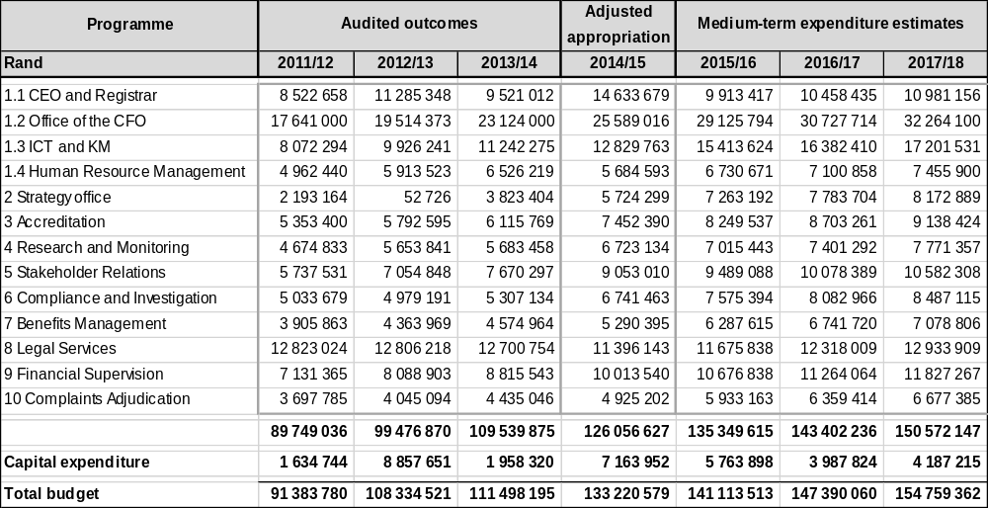

The CMS budget increases by 6.2 per cent from R133.2 million (2014/15) to R141.4 million in 2015/16. The second biggest portion of the budget of about 18.19% is spent on other expenditure. 7.34% of the total budget is dedicated to rental and 2.84% is used for consultancy. The Council has the total staff compliment of 115. Budget allocation for CEO and Registrar sub-programme decreased from R14.6 million to R9.9 million. Office of the CFO sub-programme budget increased from R25 million to R29 million. ICT and Knowledge management Unit increased from 12 million to R15 million.

The economic classification

- Compensation of employees increased from R77 million to R87 million;
- Salaries and wages increased from R74 million to R84 million;
- Consultancy fees decreased from 8 million to R4 million;
- Travel and subsistence increased from R2 million to R 3 million;
- Legal fees remain the same at R8 million;

Income

- Levy on medical schemes increased from R107.8 million to R121.9 million;
- Interest received from the investment decreased from R2.2 million to R2 million;
- Accreditation fees increased from R5.5 million to R5.8 million;
- Grants received decreased from R4 million to R2 million;

FINANCIAL AND FISCAL COMMISSION (FFC) ON THE ANNUAL PERFORMANCE PLAN OF THE DEPARTMENT

According to the FFC South Africa has significant inequities in the distribution of healthcare funding. However, improvements were noted in many indicators, including access to Primary Health Care (PHC) services, increased life expectancy, increased number of ARV (antiretroviral) recipients, and infant and child mortality has dropped.

The FFC noted that the Department demonstrates better alignment between long-term strategic goals and short-term performance. The budget prioritises key aspects of the strategic plans such as NHI pilot implementation and PHC. However, Programme 1 which is responsible for improving audit outcomes requires more attention given the prevalence of poor audit opinions. Financial performance of provinces and oversight need improvement. The FFC noted that intergovernmental arrangements for mobilizing and combining public and private service delivery capacity are key transition measures towards the establishment of the NHI.

The FFC recommends that provincial government increase their allocation to PHC funding, to be in line with the minimum norms and standards for the PHC package set by the Department of Health.

AUDITOR-GENERAL OF SOUTH AFRICA

The Auditor-General of South Africa (AGSA) conducted its interim audit on predetermined objectives of the annual performance plan (2015/16) of the Department of Health. The AGSA selected Programme 3 – HIV/AIDS, TB, Maternal and Child Care and Programme 5 – Hospitals, Tertiary Health Services and Human Resource Development. The AGSA reviewed the indicators and targets for usefulness and reported that the findings were satisfactorily addressed within the final APP.

COMMITTEE OBSERVATIONS AND FINDINGS

Having considered the strategic plan, the annual performance plan and the budget of the Department and entities for 2015/16, this section summarizes the Committee’s observations:

Findings on the Department

- The Committee again noted that most of the indicators had annual targets and not quarterly targets as required. This poses a challenge for the Committee to properly play its oversight role.
- The Auditor General of South Africa (AGSA) has in recent years found that the validity, accuracy and completeness of certain performance information and deviations from planned targets provided in the Department’s Annual Reports could not be properly audited. The Committee raised concerns about the accuracy and quality of data used in the monitoring and evaluation of the department’s targets.
- The Committee is greatly concerned that provincial Health Departments are not performing well in terms of financial audit outcomes.
- The Committee noted with concern that there is a lack of information on the performance of the NHI pilot sites.
- The slow progress in contracting General Practitioners in the NHI pilot districts was a concern to the Committee.
- The budget reduction of R1.4 billion on most conditional allocations to provincial departments of health over the MTEF period concerned the Committee.
- The Committee was concerned about the delays in ensuring that there is a nursing training framework to improve the quality of nursing training and practice.
- Primary Health Care is not sufficiently funded in provinces in line with norms and standards. The Committee was concerned regarding the status of the process of reviewing these norms and standards.
- The Committee raised its concern around the lack of systems to assess the impact of the distribution and usage of condoms.
- The Committee noted that Port Health Services were transferred from provinces to the National Department of Health and currently budgeted for, the Committee was concerned about the lack of resources at the ports of entry.
- There is a lack of information on infrastructure projects that the Department is implementing.
- The Committee was concerned on whether there was value for money in NGOs funded by the Department.
- The Committee was concerned about the slow response rate of Emergency Medical Services particularly in rural areas.
- The Committee noted that there was slow progress in integrating the services of Community Health Workers (CHWs) in most provinces.
- Mental health care is not receiving required attention with regards to access, infrastructure, training, human resources, budget and community awareness strategies.
- During deliberations on the Medicines and Related Substances Amendment Bill [6 of 2014], the Committee considered that the scope of SAHPRA not to include regulation of cosmetics and foodstuffs.
- The Committee was concerned about whether the Traditional Health Practitioners Council falls under the ambit of the National Department of Health.
- The Committee observed that community awareness campaigns on HIV/AIDS prevention require strengthening.

Findings on Entities

NHLS
- The Committee observed that the provincial debts owed to the NHLS continues to be a major challenge for the entity.
- The NHLS is faced with high staff turnover particularly pathologists and technologists, coupled with high failure rates of pathologists, this concerned the Committee.
- Maintaining and updating the Cancer Register is one of the indicators of the NHLS. The Committee was concerned on whether the Register was updated.

CCOD
- The Committee observed that the CCOD does not have a clear plan of action for the tracing of ex-miners.
- The Committee was concerned about the vacancy rate, especially in strategic posts within the CCOD.
- The CCOD lacks an action plan to clear the backlog of financial statements that were not audited since 2010/11 financial year.
- The Committee noted that the CCOD does not have a clear plan with regard to the compensation of beneficiaries.
- The Committee was concerned about the timeframe set for the amendment of the CCOD legislation, whilst the CCOD is operating under the constraints of the old Act, the Occupational Diseases in Mines and Works Act (Act 73 of 1973).
- The Committee notes the slow establishment of the One Stop Service Centres.

SAMRC
- The Committee was concerned about the timeframe set for the review of the South African Medical Research Council Act (Act 58 of 1991).
- The Committee observed that the SAMRC does not have timeframes set to address transformation within the Council as this is a government imperative.
- The Committee noted that the SAMRC does not have a dedicated NHI unit.

OHSC
- The Committee was concerned that the OHSC has not conducted inspections in mental health institutions.
- The Committee was concerned about the excessive use of consultants within the OHSC.

CMS
- The Committee noted gaps in the communication strategies used by the CMS to empower communities about its role and services offered.
- The Committee was concerned about the excessive usage of consultants within the CMS.

- RECOMMENDATIONS

Having considered the annual performance plans of the Department and entities, the Committee recommends as follows:

- Ensure that the APP of the Department and entities reflect quarterly targets and not annual targets to enable the Committee to perform effective oversight.
- The Department should present a turnaround plan to address the recurring issue related to quality of data as reported by the Auditor General over the past three years.
- There is a need for the Department to work in conjunction with National Treasury in developing systems to support provinces to achieve improved financial audit outcomes (clean administration).
- Ensure that the Department briefs the Committee on progress and challenges related to the NHI pilot districts including challenges related to the contracting of GPs.
- Ensure the acceleration of nursing training in the context of the current curriculum while the new nursing training framework is being developed.
- That the Department reports to the Committee on the extent of the implementation of norms and standards for Primary Health Care in ensuring that funding is sufficiently allocated.
- The Department should conduct an impact assessment on the distribution and usage of condoms in order to ascertain the effectiveness of the programme and its impact on disease prevention.
- The Department should ensure that ports of entry are fully equipped and resourced to render effective services.
- That the Department furnish the Committee with a status report on planned and current infrastructure projects.
- That the Department should provide a report on the list of NGOs funded and their scope of work.
- The Department should develop systems and measures to address challenges related to Emergency Medical Services particularly in rural areas.
- That the Department presents a Community Health Care Workers’ (CHWs) Policy and progress made by provinces towards absorbing all the CHWs.
- That the Department presents to the Committee the mental health strategy, with special emphasis on budget, access, infrastructure, human resources, training of health personnel as well as community awareness programmes.
- The Department should ensure that there is increased intake of medical students at universities in dealing with the shortages of medical professionals.
- That the Department strengthens its Public Private Partnerships which are key towards the establishment of the NHI.
- The Department should provide clarity on whether the Traditional Health Practitioners Council falls under its ambit.
- The Department should strengthen community awareness campaigns on HIV/AIDS prevention.

NHLS
- The NHLS should develop and implement strategies for the attraction and retention of scarce skills.
- The NHLS must investigate or implement effective measures to enable improved pathologists pass rates.
- The NHLS should develop strategies to recover the provincial debts.
- The NHLS should ensure that the Cancer Register is updated.

CCOD
- The CCOD should develop and present to the Committee a plan of action for the tracing of ex-miners.
- The CCOD should ensure the filling of vacant post particularly strategic positions to ensure improved performance of the entity.
- The CCOD’s financial statements should be audited dating back from 2010/11 financial year.
- The CCOD should fast track the review of the legislation to improve its functionality.
- The CCOD should accelerate the establishment of One Stop Service Centres in feeder areas.

SAMRC
- The SAMRC prioritizes the planned TB survey as this will be in line with the Department’s planned TB Campaign.
- The SAMRC should shorten the process of amending the SAMRC Act (Act 58 of 1991) so that it is in line with the Constitution.
- The SAMRC to set timeframes for implementation of the transformation agenda.
- The SAMRC should ensure that NHI becomes a part of its research agenda.

OHSC
- The OHSC should consider the use of unemployed university graduates in place of consultants.
- The OHSC should prioritise visiting mental health institutions as most of these institutions need attention.

CMS
- The CMS should ensure that its communication strategies are improved and also look into the use of the different languages so that communities are empowered on services offered by the CMS.
- The CMS should consider the use of unemployed university graduates in place of consultants.

Unless otherwise indicated, the National Department of Health should respond to the recommendations within three months from the day the report is adopted by the House.

Report to be considered.

