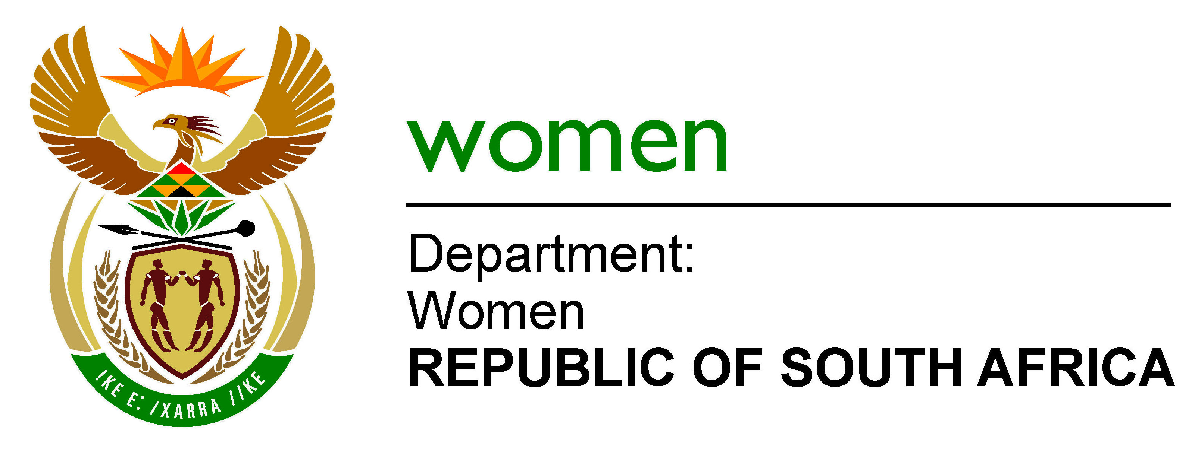

TRANSITIONAL ARRANGEMENTS: DEPARTMENT OF WOMEN

Prior to the NMOS 2014 project, the former Department of Women, Children and People with Disabilities (DWCPD) comprised the following Programmes:
- Administration;
- Womens Empowerment and Gender Equality;
- Children’s Rights and Responsibilities; and
- Rights of People with Disabilities.

With the appointment of the Minister in The Presidency responsible for Women, the Department of Women was established with an amended mandate to lead, coordinate and oversee the transformation agenda on women’s socio-economic empowerment, rights and equality through mainstreaming, monitoring and evaluation.

Accordingly, the functions and responsibilities related to support for the rights of people with disabilities and children were transferred to the Department of Social Development (DSD). To support the principle of ‘resources follow function, 20 employees and three (3) funded vacancies from Programmes 3 and 4 were transferred to the DSD together with accompanying funding. In addition thereto, four (4) employees from Programme 1 were also transferred. In addition thereto, it was also agreed that only the monetary equivalent in respect of eight (8) Administration posts would be transferred to the DSD with effect from 1 April 2015.

To finalise the NMOS 2014 process, the Minister for Public Service and Administration (MPSA) determined that all the Women Empowerment, Gender Equality and Corporate Services functions, resources and concomitant posts and staff be transferred to the Department of Women with effect from 1 October 2014. The MPSA also concurred with a start-up organisational structure for the Department of Women.

Concurrent therewith, the Director-General of National Treasury granted approval to the Department of Women to implement the following budget programme structure with effect from the 2014 Adjusted Estimates of National Expenditure (in terms of which adjusted appropriations were made to the Department in the AENE 2014):
- Programme 1: Administration;
- Programme 2: Social, Political and Economic Participation and Empowerment;
- Programme 3: Research, Policy Coordination and Knowledge Management; and
- Programme 4: Monitoring, Evaluation and Outreach.

This is the structure that the department will use to develop its strategic objectives. The start-up organisational structure for the Department of Women comprises a post establishment of 118 posts (in comparison with 145 posts of the former DWCPD). However, the start-up organisational structure was informed by a NMOS principle that the structure could not be redesigned and no additional posts could be created. Accordingly, the start-up structure still reflects the Branch: Womens Empowerment and Gender Equality and sub programmes related to Advocacy and Mainstreaming, Institutional Support and Capacity Building, and Monitoring and Evaluation.

As a transitional arrangement and to ensure alignment between available incumbents and the budget programme structure, the following arrangement has been effected:
- Programme 1: Administration-
- Ministry;
- Management;
- Financial management; and
- Corporate Management.

- Programme 2: Social, Political and Economic Participation and Empowerment-
- Branch: Gender Mainstreaming;
- Social Empowerment; and
- Economic Empowerment.

- Programme 3: Research, Policy Coordination and Knowledge Management-
- Research and Policy Development; and
- Knowledge Management.

- Programme 4: Monitoring, Evaluation and Outreach-
- Monitoring and Evaluation;
- Communication (outreach); and
- Stakeholder Coordination and International Relations.

The current posts establishment of the respective Programmes can be illustrated as follows:

Programme | Filled | Vacant | Total
Programme 1: Administration | 70 | 18 | 88
Programme 2: Social, Political and Economic Participation and Empowerment | 10 | 2 | 12
Programme 3: Research, Policy Coordination and Knowledge Management | 4 | - | 4
Programme 4: Monitoring, Evaluation and Outreach | 11 | 3 | 14
Total | 95 | 23 | 118

In the course of the Department’s strategic planning processes, an ideal organisational design was drafted that would enable the Department to adequately respond to its new mandate and strategic intentions. However, when the design was submitted to the Department of Public Service and Administration (DPSA) for consultation, their response was that the Department should plan to execute its functions with an efficient and effective internal organisation and well developed human resources within available funds – regardless that the mandate of the Department of Women is radically different from that of the former DWCPD.

In the interim, the Department of Women shall pursue the transitional arrangement indicated above whilst a more appropriate organisational design is developed in consultation with the DPSA. This process shall include a reprioritisation of Administration posts which may entail the downgrading of posts within Administration in favour of three core programmes.

This will enable the department to institutionalise the new strategic goals and objectives through performance management systems.

The Department is in the process of sourcing a service provider to conduct a realignment of human resources and roles to the new organisational mandate of the Department, and this process shall support the reassignment and development of employees on the basis of their prevailing skills and competencies. This will be followed by the final placement of employees.

The main consideration in the transitional arrangements is the alignment of the current resources with the new strategic direction.

_____________________
Ms O Ngoma-Diseko
Acting Director-General
Date:

