
Tourism Portfolio
17 October 2014
PFMA audit outcomes of the 2013-14 financial year
PC

CONTENTS
1. Introduction 1
2. Audit opinion history 3
3. Key focus areas 4
4. Drivers of internal control 11
5. Other matters of interest 11
6. Other reports 12
7. Combined Assurance on Risk Management in the Public Sector 12
8. Commitments from the previous portfolio committee 13
9. Commitments from the Portfolio committee 13

- Introduction
1.1 Reputation promise of the Auditor-General of South Africa
The Auditor-General has a constitutional mandate and, as the Supreme Audit Institution (SAI) of South Africa, it exists to strengthen our country’s democracy by enabling oversight, accountability and governance in the public sector through auditing, thereby building public confidence.

1.2 Purpose of document
The purpose of this briefing document is for the Auditor-General of South Africa (AGSA) to provide an overview of the audit outcomes and other findings in respect of the Department of Tourism (NDT) and South African Tourism (SAT) for the 2013/14 financial year.

1.3 Overview
Part A of schedule 4 of the constitution of the Republic of South Africa, 1996, lists tourism as a functional area of concurrent national and provincial legislative competence.

The Tourism Act, 1993 (Act No 72 of 1993), makes provision for the promotion of tourism to and in the Republic and for the further regulation and rationalisation of the tourism industry, measures aimed at the maintenance and enhancement of the standards of facilities and services hired out or made available to tourists; and the coordination and rationalisation, as far as practicable, of the activities of persons who are active in the tourism industry.

Change in Executive Authority
There was a change in the Executive Authority which was announced by the President on the 25 May after the national elections.

Aim of the vote
The National Department of Tourism is mandated to create conditions for the sustainable growth and development of tourism in South Africa. The Tourism Act makes provision for the promotion of tourism to and in the Republic and for regulation and rationalisation of the tourism sector, including measures aimed at the enhancement and maintenance of the standards of facilities and services utilised by tourists; and the co-ordination and rationalisation of the activities of those who are active in the tourism sector.
SAT is mandated in terms of the Tourism Act to market South Africa internationally and domestically as a preferred tourism destination, and to ensure that tourist and services aim to be of the highest standard. SAT is also required to monitor and evaluate the performance to the tourism sector.

Vision
NDT:
A catalyst for tourism growth and development in South Africa.

Mission
NDT:
A strategy focused department, committed to create a conducive environment for growing and developing tourism through:
- Innovation;
- Strategic partnerships and collaboration;
- Providing information and knowledge management service; and
- Strengthening institutional capacity.

Strategic goals
NDT:
The department’s strategic goals over the medium term are to:
- Achieve good corporate and cooperative governance.
- Improve impact of tourism on the livelihood of all South Africans.
- Tourism priorities integrated within other sector departments, provincial and local government’s planning.
- Improved Tourism Sector Research, Information and Knowledge Management.
- Increased contribution of the tourism sector to inclusive economic growth.
- Improved levels of competitiveness and sustainability in the tourism sector.
- Strengthened regional, Africa and international collaboration and partnerships.

1.4 Organisational structure of NDT
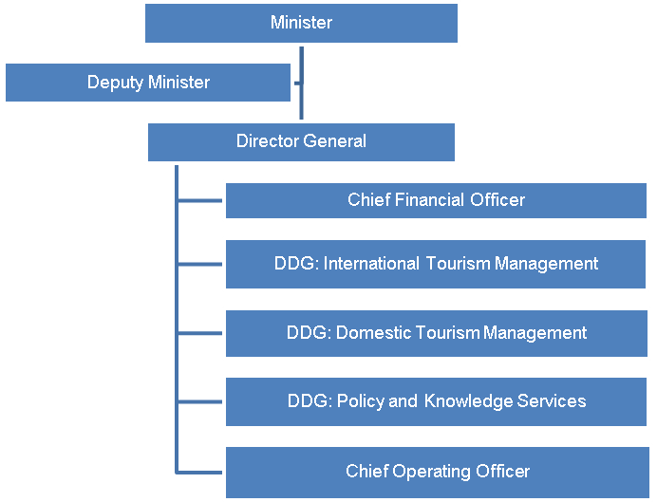

1.5 Funding
The department is primarily funded through funds appropriated in terms of the annual Appropriation Act (and the Adjustments Appropriation Act), the final appropriation for the 2013/14 amounted to R1 520 574 000 (2012/13: R1 374 143 000) while
SAT is primarily funded through annual government grants and subsidies, for 2013/14 amounting to R846 333 000 (2012/13: R754 953 695)

- Audit opinion history
AUDIT OPINIONS |  | 09/10 |  | 10/11 | 11/12 | 12/13 | 13/14
- Department of Tourism |  | N/A
- South African Tourism
OTHER MATTERS |  | 09/10 |  | 10/11 | 11/12 | 12/13 | 13/14
Predetermined objectives
- Department of Tourism |  | N/A
- South African Tourism
Compliance with laws and regulations
- Department of Tourism |  | N/A |  | ü | ü | ü
- South African Tourism |  |  |  | ü | ü |  | ü
AUDIT OPINION LEGEND
 | CLEAN AUDIT OPINION: No findings on PDO and Compliance
 | UNQUALIFIED with findings on PDO and Compliance
 | QUALIFIED AUDIT OPINION (with/without findings)
 | DISCLAIMER/ADVERSE AUDIT OPINION
N/A | New department

- Key focus areas
Auditee
Department of Tourism |       Supply chain  management  Good  Predetermined  objectives  Intervention  required  Human resources  management  Good  Information  technology  controls  Concerning  Material errors/  omissions in AFS  submitted for audit  Good  Financial health  Good
South African Tourism | Concerning  Predetermined  objectives  Intervention  required  Supply chain  management  Concerning  Material errors/  omissions in AFS  submitted for audit  Good  Financial health  Good  Human resources  management  Good  Information  technology  controls  Concerning

  - Supply chain management
Entity | Finding | Root cause | Recommendation
South African Tourism | A deviation was approved by the Accounting Authority even though it was not impractical to invite competitive bids, in contravention of Treasury regulation 16A6.4.  The contract mentioned above was awarded to a close family member of a person employed by the public entity however the person with the conflict of interest did not recuse himself from the procurement process relating to that contract which is in contravention of Treasury Regulation 16A8.4. | Consequence management should be implemented for staff members who do not comply with applicable laws and regulations.  Slow response and lack of accountability by senior management involved in the performance reporting process. | Senior management involved in the compliance monitoring process need to review declarations and ask all conflicted officials to remove themselves from the procurement process.  Proper processes should be in place to ensure that procurement and contract management is properly planned.

  - Predetermined objectives
Entity | Finding | Root cause | Recommendation
Department of Tourism | Material misstatements in the annual performance report submitted for auditing on the reported performance information. These were subsequently corrected. | The department did not implement a process to ensure that the annual performance report is accurate, complete and supported by reliable information. | The department should Implement a process to ensure that the annual performance report is accurate and complete and supported by reliable information. This will ensure that no material adjustments have to be made to the performance reports after submission for auditing.
South African Tourism | Material misstatements in the annual performance report submitted for auditing on the reported performance information. These were subsequently corrected. | The public entity did not implement a process to ensure that the annual performance report is accurate, complete and supported by reliable information. | The public entity should Implement a process to ensure that the annual performance report is accurate and complete and supported by reliable information. This will ensure that no material adjustments have to be made to the performance reports after submission for auditing.

  - Information technology controls
Entity | Finding | Root cause | Recommendation
Department of Tourism | User access management:  - User account administration procedures for the EDMS was insufficiently designed as it did not address how users should be created, modified and removed from the system.  - The dormant user accounts for employees who had resigned from the department were also identified on EDMS.  Program change management:  - The EDMS program change management documentation in use was making reference to the Department of environmental affairs and tourism which had since been split. | Management oversight in ensuring the department’s user account administration documentation contains all the required control elements.  Lack of resources aligned and tasked with the responsibility of updating system documentation. | The Director: IT should revise the department’s user account administration documentation to include how user accounts should be created, modified and deleted. The document should also state who is responsible for reviewing dormant /inactive user accounts.  The Director: IT should find resources to update the EDMS documentation to reflect the current environment of the department.
South African Tourism | Security management:  - The Linux operating system audit logs were not regularly reviewed by IT management. The absence of reviewing of important events increases the risk that unauthorised system and user actions may not be detected and resolved in a timely manner.  - The Linux operating system administrator has the ability to login with the privileged root user account. Direct access to log in with the root on the command line may result in a lack of accountability due to the inability of identifying the warm bodied user that utilised the root account.  - The Linux operating system password parameters were not appropriately configured. Inadequately defined logical access controls increases the risk that unauthorised users could gain access to the operating system and have the ability to amend data which may result in potential financial misstatement or loss.  - The Oracle database password parameters were not appropriately configured. Inadequately defined logical access controls increases the risk that unauthorised users gain access to the system and have the ability to process transactions or change data which may result in potential financial misstatement or loss.  - Changes to the firewall configurations were not dealt with according to the IT change management process, which requires changes to be requested by completing change control request forms and submitting them to the change control committee or business information systems (BIS) manager for approval. Firewall configurations that are not formally managed could create an opportunity for malicious configurations to be implemented.  - There was no evidence indicating that the firewall configurations were periodically reviewed to ensure that they remained effective in controlling the traffic flow. If the firewall logs are not reviewed, unauthorised activities may not be detected timely and firewall configurations that were implemented for a short term may only be changed when a breach of security has occurred.  - The firewall logging functionality was enabled to log the activities taking place on the firewall. However, there was no evidence indicating that the logs were reviewed and acted upon where action needed to be taken.  Information technology service continuity:  - The organisation’s disaster recovery plan did not reflect the existence of a contract with Global Continuity for the provision of a disaster recovery facility in the event that a disaster. It did not indicate how the contract should be implemented in the event of a disaster. Lack of an implementable disaster recovery plan to facilitate efficient resumption of the business operations after a disaster may harm the reputation of the organization. | The infrequent review of the operating system and database audit logs could be attributed to resource constraints within the ICT department.  Direct access using the root command line could be attributed to Linux operating system administrator not disabling the direct root account access due to SA Tourism not being aware of the security risk posed.  Inadequately configured password parameters on the Oracle database and Linux operating system could be attributed to management oversight with regards to the implementation of security policy.  The IT security policy in which firewall management was addressed was not aligned to the change management policy.  The firewall policy did not require the firewall configurations to be reviewed other than when new services were installed, and the policy did not require the firewall logs to be regularly reviewed to detect irregularities that should be followed up.  The disaster recovery plan was due for review on 14 March 2013 but was apparently not reviewed. . | IT management should identify and allocate additional resources to enable the ICT department to perform the periodic review audit logs.  IT management should ensure that the ability to directly logon onto the UNIX operating system, supporting the Oracle E-Business Suite application, using the root accounts should be disabled.  IT management should ensure that Oracle database and Linux operating system password parameters be appropriately configured as required by the security policies.  The BIS manager should improve the firewall management controls in the IT security policy to address the risks identified in the finding and communicate such controls to the service provider for implementation. Adherence to the controls should be monitored by SA Tourism.  The IBS manager should ensure that the disaster recovery plan is reviewed and updated in line with the provisions of the contract with Global Continuity.

- Drivers of internal controls
Drivers of internal control
Entity | Leadership |  |  |  |  |  | Financial & performance management |  |  |  |  | Governance
Entity | Effective leadership culture | Oversight responsibility | HR management | Policies and procedures | Action plans | IT governance | Proper record keeping | Processing and reconciling controls | Reporting | Compliance | IT systems controls | Risk management | Internal audit | Audit committee
Department Tourism
South African Tourism

- Other matters of interest
(a) Fruitless and wasteful expenditure:
Auditee |  | Fruitless and Wasteful expenditure
 |  | Movement | Amount  R  2014 | Amount  R  2013
1 | Department of Tourism |  | 648 000 | 108 000
2 | South African Tourism |  | 0 | 1 045 596

(c) Irregular expenditure:
Auditee |  | Irregular expenditure
 |  | Movement | Amount  R  2014 | Amount  R  2013
1 | Department of Tourism |  | 0 | 34 000
2 | South African Tourism |  | 196 693 | 17 460 289

- Other reports
Investigations
- No investigations are currently underway by the AGSA.
Performance audits
- No performance audits are currently underway by the AGSA.

- Combined Assurance on Risk Management in the Public Sector
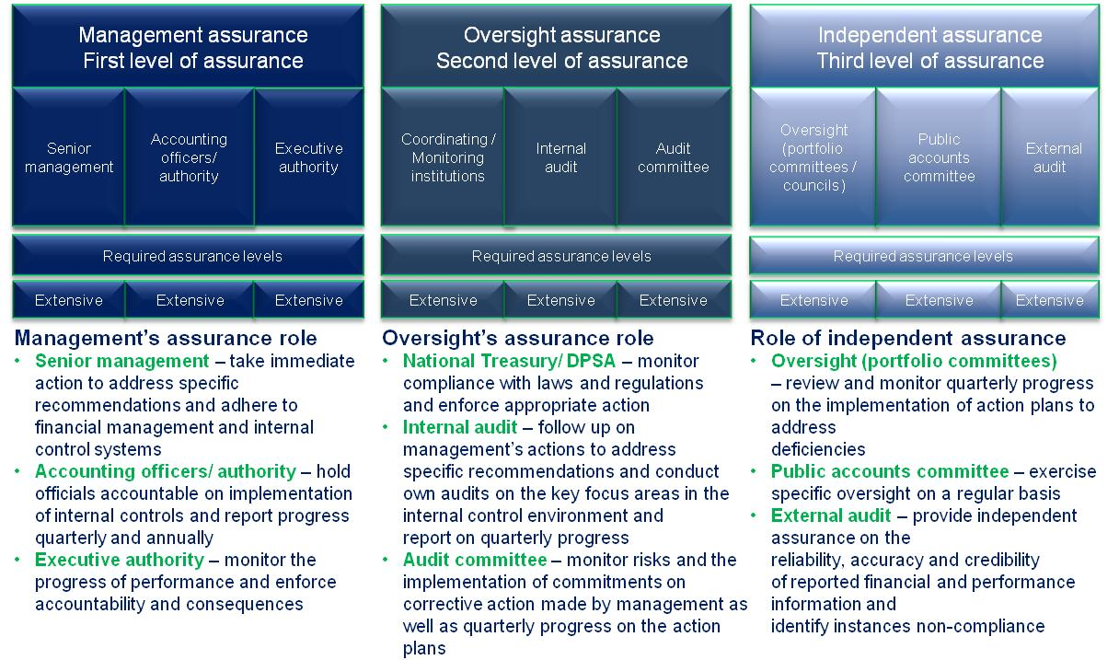
- Commitments from the previous portfolio committee
The following commitements were in progress and tracked by the previous portfolio committee:
- Follow up with the NDT and SAT whether the commitments made are adequately monitored and tracked;
- Assist the department in driving the agenda of becoming one of the top 20 tourism destinations in the world;

- Commitments from the Portfolio committee
- PC to be updated on the controls being implemented by both NDT and SAT to address the misstatements in the predetermined objectives
- During the budget debate the following matters were raised and the PC should obtain feedback on these matters
- The portfolio committee members raised in respect of the local government and municipalities role in maintaining the tourist attractions.
- Minister was asked to implement an inter departmental task force to address the challenges of tourism.
- The possible decrease in long-haul travelers due to the new VISA requirements.
- The budget not being sufficient to achieve the mandate of the portfolio.

