
Statistics South Africa
16 October 2014
PFMA audit outcomes of the 2013-14 financial year
PC

CONTENTS
1. Introduction 2
2. Audit opinion history 4
3. Key focus areas 5
4. Drivers of internal control 6
5. Other matters of interest 7
6. Other reports 7
7. Combined Assurance on Risk Management in the Public Sector 8
8. Commitments from the previous portfolio committee 9

- Introduction
1.1 Reputation promise of the Auditor-General of South Africa
The Auditor-General has a constitutional mandate and, as the Supreme Audit Institution (SAI) of South Africa, it exists to strengthen our country’s democracy by enabling oversight, accountability and governance in the public sector through auditing, thereby building public confidence.

1.2 Purpose of document
The purpose of this briefing document is for the Auditor-General of South Africa (AGSA) to provide an overview of the audit outcomes and other findings in respect of Statistics South Africa (Stats SA) for the 2013/14 financial year.

1.3 Overview
Statistics South Africa is a national government department accountable to the Minister in the Presidency: National Planning Commission. The activities of the department are regulated by the Statistics Act (Act No. 6 of 1999), which mandates the department to advance the production, dissemination, use and coordination of official and other statistics to assist organs of state, businesses, other organisations and the public in planning, monitoring, and decision making. The act also requires that the department coordinate statistical production among organs of state in line with the purpose of official statistics and statistical principles.

Change in Executive Authority
There was a change in the Executive Authority which was announced by the President on the 25th of May after the national elections.

Aim of the vote
Statistics South Africa is mandated to advance the production, dissemination, use and coordination of official and other statistics to assist organs of state, businesses, other organisations and the public in planning, monitoring, and decision making.

Vision
Stats SA’s vision is to be “Your leading partner in quality statistics”.

Mission
Stats SA’s mission is “To lead and partner in statistical production systems for evidence-based decisions”

Strategic goals
The department’s strategic goals over the medium term are to:
- Expand the statistical information base by increasing its depth, breadth and geographic spread;
- Enhance public confidence and trust in statistics;
- Improve productivity and service delivery;
- Lead the development and coordination of statistical production within the SANSS;
- Invest in the learning and growth of the organisation; and
- Promote international cooperation and participation in statistics.

1.4 Organisational structure

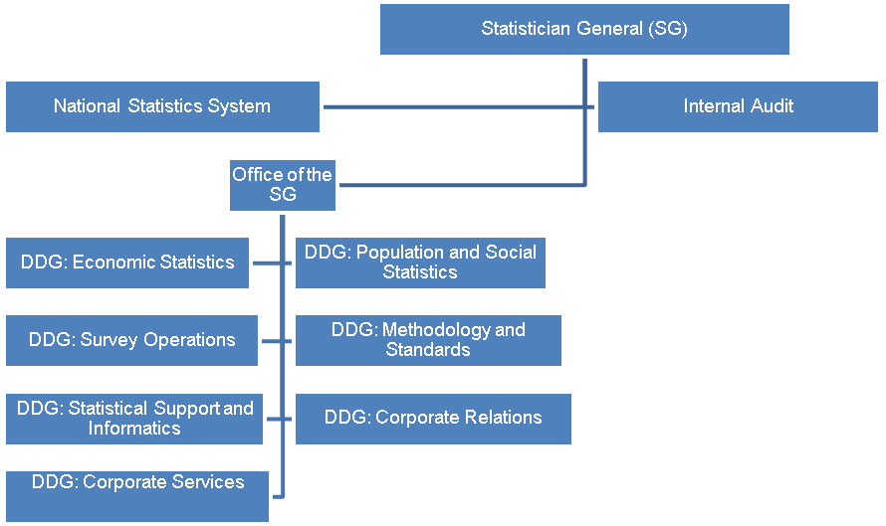

1.5 Funding
The department is primarily funded through funds appropriated in terms of the annual Appropriation Act (and the Adjustments Appropriation Act), the final appropriation for the 2013/14 amounted to R1 741 646 000 (2012/13: R1 761 652 000).
- Audit opinion history
AUDIT OPINIONS | 09/10 | 10/11 | 11/12 | 12/13 | 13/14
Annual financial statements
OTHER MATTERS | 09/10 | 10/11 | 11/12 | 12/13 | 13/14
Predetermined objectives |  |  |  | ü
Compliance with laws and regulations | ü | ü | ü | ü

AUDIT OPINION LEGEND
CLEAN AUDIT OPINION: No findings on PDO and Compliance
UNQUALIFIED with findings on PDO and Compliance
QUALIFIED AUDIT OPINION (with/without findings)
DISCLAIMER/ADVERSE AUDIT OPINION

- Key focus areas
Auditee | 
National Treasury |     Concerning  Predetermined  objectives  Intervention  required  Supply chain  management  Concerning  Material errors/  omissions in AS  submitted for audit  Good  Financial health  Good  [Type a quote from the document or the summary of an interesting point. You can position the text box anywhere in the document. Use the Drawing Tools tab to change the formatting of the pull quote text box.]  Human resources  management  Concerning  Information  technology  controls  Concerning
  - Predetermined objectives
Entity | Finding | Root cause | Recommendation
Stats SA | The annual performance reports submitted for auditing contained material misstatements. These were subsequently corrected. | Executive managers did not adequately review the reported performance before submitting to the strategy division for consolidation | Strengthen performance and consequence management by holding executive managers accountable for the quality of performance reports through the performance management system as committed to in the prior year to avoid repeat findings.
3.2 Financial health
Financial health – although there are no unfavourable indicators for Statistics SA, the ability to deliver services is negatively affected by funding constraints due to unfunded mandates (Master Sample Survey and Living Condition Survey). In 2013-14 financial year Master Sample Survey was funded from the vacancy savings and this can in future become problematic to the department once all the vacancies have been filled. The vacancy rate currently is 10% and the actual expenditure for the Master Sample Survey in 2013-14 was R4, 5 million and the estimated cost for both mandates in 2014-15 is R87,5 million. The minister committed to discuss the funding matter with management and National Treasury.

3.3 Human resources
Although there were no material human resource management matters were identified, however the following matters need attention:

Twenty seven positions in senior management were vacant for more than 12 months and 15 positions were not advertised within 6 months. The vacant positions have affected service delivery as evidenced by some of the targets not being achieved due to human resource constraints. This was as a result of delays in recruitment processes.

3.4 Supply chain management
No material SCM matters were identified, however the following matters needs attention:

- Non declaration of interest by suppliers in service of other state institutions
- Twent six officials of other state institutions with interest in suppliers of the department did not disclose their interest.
- The department does not have resources to identify suppliers/service providers who are misrepresented facts on the SBD 4 forms by not declaring that they are employed by other state institutions.
- Performance of other remunerative work by employees
- Twenty four officials with an interest in suppliers to other state institutions did not obtain approval to perform or engage in remunerative work outside their employment.
- Management does not have resources to identify the non-compliance. They have though implemented plans to address the above matter and have also included consequence management practices should staff not comply.

3.4 Information technology
Management is in the process of aligning all processes and implementation deliverables with the requirements specified in phase two, as they have met all the requirements of phase one. The assessment is based on the design of the IT governance framework, which was approved by Cabinet in November 2012. The phase one of the framework was required to be implemented by March 2014, as such; the assessment does not include the test of implementation.

The delays were experienced by Stats SA management as they forwarded the draft Personnel and Salary (PERSAL) policy to the Stats SA policy coordination for review in August 2013, and management was still awaiting response before it can be forwarded to executive committee for approval.

Stats SA management was in the process of developing a business continuity plan; however, the process could not be concluded due to resource constraints.

- Drivers of internal controls
Drivers of internal control
Entity | Leadership |  |  |  |  |  | Financial & performance management |  |  |  |  | Governance
Entity | Effective leadership culture | Oversight responsibility | HR management | Policies and procedures | Action plans | IT governance | Proper record keeping | Processing and reconciling controls | Reporting | Compliance | IT systems controls | Risk management | Internal audit | Audit committee
Statistics South Africa

- Other matters of interest
(a) Fruitless and wasteful expenditure:
Auditee |  | Fruitless and Wasteful expenditure
 |  | Movement | Amount  R  2014 | Amount  R  2013
1 | Statistics South Africa |  | 7 138 000 | 5 000 000

(c) Irregular expenditure:
Auditee |  | Irregular expenditure
 |  | Movement | Amount  R  2014 | Amount  R  2013
1 | Statistics South Africa |  | 7 339 000 | 7 148 000

- Other reports
Investigations
- No investigations are currently underway by the AGSA.
Performance audits
- No performance audits are currently underway by the AGSA.

- Combined Assurance on Risk Management in the Public Sector
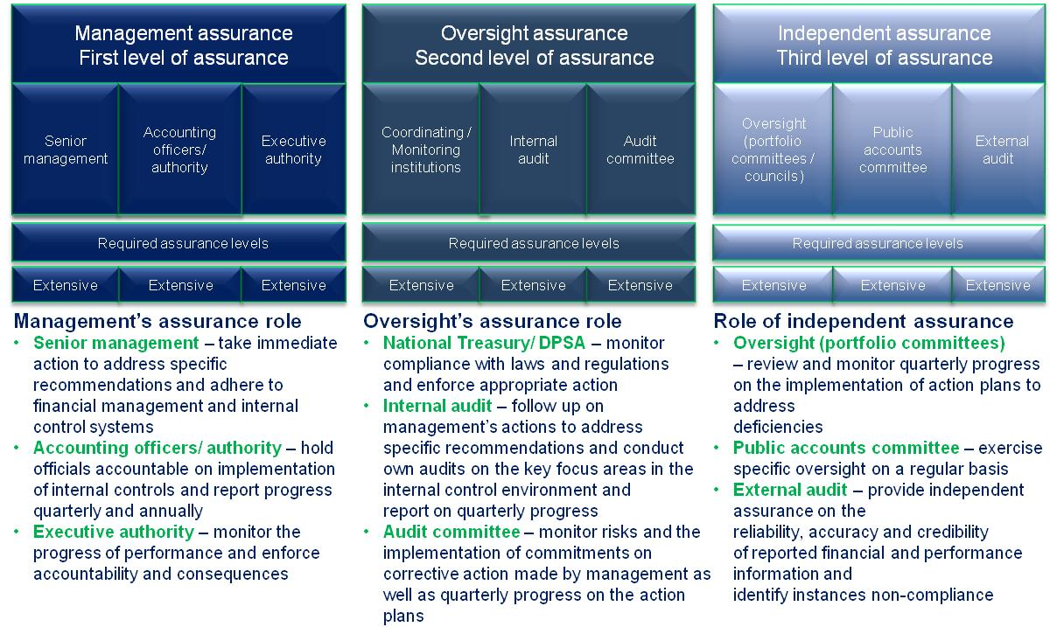
Commitments required from the Portfolio Committee

Budget
- The department will need funds once the vacancies are filled, as the funds for such vacancies were previously used to fund the unfunded mandates.
PDO’s
- Materials misstatements were identified misstatements in the annual performance report submitted for auditing on the reported performance information of Programme 5: Statistical Support and Informatics. This is a repeat finding.
- The action plans implemented to address the prior year findings did not work effective as evidenced by this repeat finding of material misstatement

