
Department of International Relations and Cooperation
15 October 2014
PFMA audit outcomes of the 2013-14 financial year
PC

CONTENTS
1. Introduction 1
2. Audit opinion history 3
3. Key focus areas 4
4. Drivers of internal control 11
5. Other matters of interest 11
6. Other reports 12
7. Combined Assurance on Risk Management in the Public Sector 12
8. Commitments from the previous portfolio committee 13

- Introduction
1.1 Reputation promise of the Auditor-General of South Africa
The Auditor-General has a constitutional mandate and, as the Supreme Audit Institution (SAI) of South Africa, it exists to strengthen our country’s democracy by enabling oversight, accountability and governance in the public sector through auditing, thereby building public confidence.

1.2 Purpose of document
The purpose of this briefing document is for the Auditor-General of South Africa (AGSA) to provide an overview of the audit outcomes and other findings in respect of the Department of International Relations and Cooperation (DIRCO) for the 2013/14 financial year.

1.3 Overview
According to the Constitution, the president is ultimately responsible for the foreign policy and international relations of South Africa. It is the prerogative of the president to appoint heads of mission, to receive foreign heads of mission, to conduct state to state relations, and to negotiate and sign all international agreements.

International agreements that are not of a technical, administrative or executive nature will only bind the country after being approved by Parliament. Parliament also approves the country’s ratification of or accession to multilateral agreements. All international agreements must be tabled in Parliament for information purposes.

The Minister of International Relations and Cooperation is entrusted with the formulation, promotion, execution and daily conduct of South Africa’s foreign policy.

The department’s overall mandate is to work for the realisation of South Africa’s foreign policy objectives. This is done by:
- coordinating and aligning South Africa’s international relations abroad
- monitoring developments in the international environment
- communicating government’s policy positions
- developing and advising government on policy options, creating mechanisms and avenues for achieving objectives
- protecting South Africa’s sovereignty and territorial integrity
- contributing to the creation of an enabling international environment for South African business
- sourcing developmental assistance
- assisting South African citizens abroad.

Aim of the vote
Formulate, coordinate, implement and manage South Africa's foreign policy and international relations programmes.

Vision
An African Continent, which is prosperous, peaceful, democratic, non-racial, non-sexist and united, and which contributes to a world that is just and equitable.

Mission
To promote South Africa’s national interests and values, the African Renaissance and the creation of a better world for all.

Strategic goals
The department’s strategic goals over the medium term are to:
- Through bilateral and multilateral interactions protect and promote South African National interests and values
- Conduct and co-ordinate South Africa’s international relations and promote its foreign policy objectives
- Monitor international developments and advise government on foreign policy and related domestic matters
- Protect South Africa’s sovereignty and territorial integrity
- Contribute to the formulation of international law and enhance respect for the provisions thereof
- Promote multilateralism to secure a rules based international system
- Maintain a modern, effective and excellence driven department
- Provide consular services to South African nationals abroad
- Provide a world class and uniquely South African State Protocol service

1.4 Organisational structure
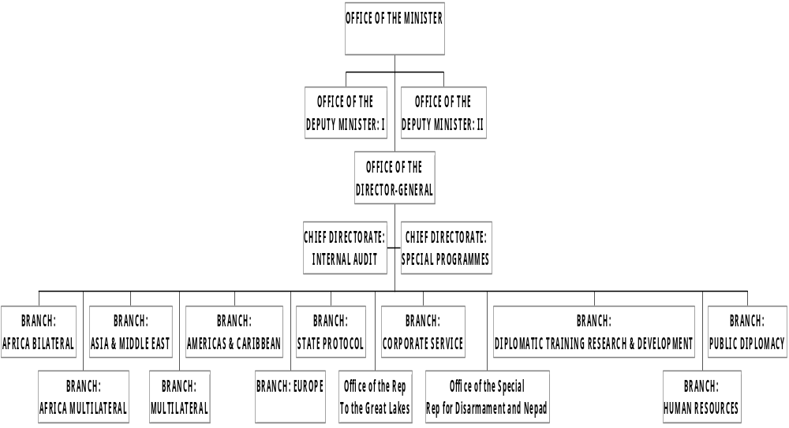

1.5 Funding
The department is primarily funded through funds appropriated in terms of the annual Appropriation Act (and the Adjustments Appropriation Act), the final appropriation for the 2013/14 amounted to R5 754 646 000 (2012/13: R5 271 525 000).
- Audit opinion history
AUDIT OPINIONS | 09/10 | 10/11 | 11/12 | 12/13 | 13/14
- Department of International Relations and Cooperation (DIRCO)
- African Renaissance and International Cooperation Fund (ARF)
QUALIFICATION ISSUES | 09/10 | 10/11 | 11/12 | 12/13 | 13/14
Department of International Relations and Cooperation
- Assets |  |  |  |  | ü
OTHER MATTERS | 09/10 | 10/11 | 11/12 | 12/13 | 13/14
Predetermined objectives
- Department of International Relations and Cooperation (DIRCO) |  | ü | ü | ü
- African Renaissance and International Cooperation Fund (ARF) |  | ü | ü | ü | ü
Compliance with laws and regulations
- Department of International Relations and Cooperation (DIRCO) | ü | ü | ü | ü | ü
- African Renaissance and International Cooperation Fund (ARF) | ü | ü | ü | ü | ü

AUDIT OPINION LEGEND
 | CLEAN AUDIT OPINION: No findings on PDO and Compliance
 | UNQUALIFIED with findings on PDO and Compliance
 | QUALIFIED AUDIT OPINION (with/without findings)
 | DISCLAIMER/ADVERSE AUDIT OPINION
N/A | New department

- Key focus areas
Auditee | 
Department of International Relations and Cooperation |       C  Supply chain  management  Intervention  required  Predetermined  objectives  Good  Human resources  management  Concerning  Information  Technology  Controls  Concerning  Material errors/omissions in AFS submitted for audit  Intervention required  Financial health  Good  Material errors/omissions in AFS submitted for audit  Intervention required
African Renaissance and International Cooperation Fund | C  Supply chain  management  Intervention  required  Predetermined  objectives  Concerning  Human resources  management  Concerning  Information  Technology  Controls  Concerning  Financial health  Good

  - Supply chain management
Entity | Finding | Root cause | Recommendation
Department of International Relations and Cooperation | The accounting officer did not take effective steps to prevent irregular expenditure as per the requirements of section 38(1)(c)(ii) of the PFMA and Treasury Regulation (TR) 9.1.1  Contracts and quotations were awarded to bidders who did not submit a declaration on whether they are employed by the state or connected to any person employed by the state, which is prescribed in order to comply with TR 16A8.3. | The Chief Director: Supply Chain Management did not adequately review and monitor compliance with the supply chain management (SCM) prescripts due to a lack of accountability.  There is a lack of consequences by management in respect of employees that continuously fail to comply with the SCM prescripts. | The accounting officer should take effective and appropriate steps to prevent irregular and expenditure by ensuring that SCM legislations is adhered to.  Appropriate disciplinary steps should be taken against officials who make or permit irregular expenditure as required by section 38(1) (h) (iii) of the PFMA and Treasury Regulation 9.1.3.  On a monthly basis the procurement officer should prepare a list of expenses which may constitute irregular expenditure. The CFO and accounting officer should review the report and take immediate corrective actions to create a culture of compliance.  The performance of the supply chain management unit must be assessed under the supervision of the accounting officer and the CFO on a monthly basis to determine if there is any non-compliance with SCM legislation and SCM internal policy and corrective actions should be taken immediately.
Department of International Relations and Cooperation | Competitive bidding processes and request for three quotations were not always *followed, as prescribed by Treasury Regulation 16A6.1.
African Renaissance and International Cooperation Fund | The accounting authority did not take effective steps to prevent irregular expenditure as per the requirements of section 51(1)(b)(ii) of the PFMA.  The entity did not take adequate and effective steps to ensure compliance with National Treasury Practice Note No. 8 of 2007/08. Supply chain management prescripts were not followed and deviations were not properly motivated. | Management did not have sufficient monitoring controls in place to enforce compliance with laws and regulations. | The accounting authority should ensure that the shared principle policies and procedures adopted at the advisory committee meeting on 4 March 2014 are implemented to ensure compliance.  Management should implement monitoring controls whereby all awards will be reviewed to ensure that the necessary SCM documents have been obtained prior to making an award in order to detect instances of non-compliance by the relevant officials.  Appropriate action should be taken against the officials not following the SCM prescripts.
  - Predetermined objectives
Entity | Finding | Root cause | Recommendation
African Renaissance and International Cooperation Fund | Material misstatements in the annual performance report submitted for auditing on the reported performance information. These were subsequently corrected. | The accounting authority did not strengthen oversight over the activities of the ARF and implement processes for effective reviews and monitoring of the performance reporting process, including the corrective actions to address the audit findings | The accounting authority should implement a process to ensure that the annual performance report is consistent with the planned targets. This will ensure that no material adjustments have to be made to the performance reports after submission for auditing.

  - Human resources management
Entity | Finding | Root cause | Recommendation
Department of International Relations and Cooperation  African Renaissance and International Cooperation Fund | Internal control deficiencies were noted in HR management in the following areas:  - Certification of employees on the payroll report not performed before the payment date.  - Medical certificates not provided for the sick leave taken as required by Determination and Directive on Leave of Absence in the Public  - No assessment of employees who are conditionally granted incapacity leave as required by Determination and Directive on Leave of Absence in the Public Services  - Incapacity leave conditionally granted exceeds 30 days and not approved within 30 days as required by Determination and Directive on Leave of Absence in the Public Service  The accounting authority did not ensure that there is an approved delegation of authority, including terms of references for both the Advisory committee and Secretariat which clearly sets out the delegated powers and duties. | - The Chief Director: Financial Management did not ensure that all payroll reports are submitted to respective divisions on time and also did not ensure that the reports are certified before payment was made due to a lack of accountability and consequences.  - There is inadequate monitoring and follow up on the implementation of human resources policies by the Chief Director: Human Resources due to a lack of accountability and consequences.  This was due to an overall lack of accountability by the accounting authority | - The Chief Director: Financial Management should ensure that the payroll reports are sent to the divisions before payment date to allow time to detect and fix any inaccuracies.  - There should be consequences for staff not adhering to the requirements.  - The Chief Director: Human Resource enhance the monitoring controls on sick leave to ensure that leave transactions comply with the medical certificate requirements when sick leave for more than two occasions during the eight week cycle is taken and there are consequences for staff not adhering to the requirements.  - The Chief Director: Human Resource should also timeously execute the investigations into the nature and extent of the employees’ illness or injury to justify whether the employees qualify for the incapacity leave or not.  - The Chief Director: Human Resources should ensure that the Department complies with the Determination and Directive on leave of absence in the public service of August 2012 paragraph 15.8 on incapacity leave and ensure that investigations are conducted within 30 days.  The Advisory Committee should take appropriate steps to ensure that the terms of reference of the Advisory Committee and the Secretariat are approved and implemented.
  - Information technology controls
Entity | Finding | Root cause | Recommendation
Department of International Relations and Cooperation | Deficiencies were noted in the ICT control environment in the following areas:  - Security management.  - User access management controls were not effective  - Disaster recovery plan was inadequately documented.  - Significant backup failures were experienced at times | - Lack of ICT management oversight in ensuring that the active directory (AD) system administrators amend the AD settings in accordance with the recently approved policy and procedures  - Policies and procedures governing how the password settings should be configured on the NUQ and HardCat systems had not been communicated to the application system administrators  - The financial systems senior management did not take full responsibility to ensure that the prior year audit recommendations are implemented by the due date.  - System had been inadequately developed and configured to meet the department’s need and system administrators and users of the system are not knowledgeable about the purpose of the system. | - ICT management should ensure that the AD system administrators amend system configurations in accordance with the recently approved policies and procedures.  - All financial systems senior management in consultation with the ICT management should ensure that the user account management procedures are amended to include the monitoring aspects during the review of the procedures.  - Furthermore, senior management should take reasonable steps to ensure adherence to the procedures, failure to do so, disciplinary action processes should be initiated.  - All financial systems senior management should document a segregation of duties matrix (which depicts how system functions should be allocated to users) in consultation with National Treasury, if necessary, to complement the user account management procedures. This matrix will assist the system controller to identify any conflicting rights when users request access to the system.  - The ICT management should ensure that the DRP solution is sourced as a matter of urgency to address the backup management process. Once the DRP solution has been sourced, the policies and procedures should be updated to conform to the solution.
  - Material errors/ommissions in submitted annual financial statements
Entity | Finding | Root cause | Recommendation
Department of International Relations and Cooperation | The financial statements submitted for auditing were not prepared in accordance with the prescribed financial reporting framework as required by section 40(1) (b) of the Public Finance Management Act. Material misstatements on assets identified by the auditors in the submitted financial statement were not corrected resulting in the financial statements receiving a qualified audit opinion. | - There is a lack of a proper review by the Chief Financial Officer over the financial reporting processes resulting in a numbers of errors that have remained undetected in the financial statements issued on 31 May 2014 due to a lack of discipline by all involved in this process.  - Processes implemented to address this issue are inadequate and have limited to no impact.  - The entire oversight over the compilation and review of the financial reporting process requires substantial improvement.  - The Chief Financial Officer has not implemented a consequence management process to address the issues of continuous non-performance by staff.  - There are notable gaps in terms of the skills, competencies and knowledge of the department’s finance team with regard to the application of the modified cash standard even though some staff have attended training. | - The Chief Financial Officer should include the 'asset clean up' as one of the key performance indicators for the Chief Director: Supply Chain Management and if targets are not met there should be consequences.  - The recruitment and selection of the finance staff needs to be enhanced to ensure that sufficiently skilled and experienced staff members are employed by the department.  - The finance team should be sent on further training to enhance their understanding of the Modified Cash Standard including the disclosure requirements.  - Management should ensure that annual financial statements are prepared regularly. It is critical that a full and proper set of financial statements (including all disclosure notes) are prepared on a monthly basis.  - These annual financial statements should be reviewed by the governance structures i.e. management, internal audit and audit committee.
African Renaissance and International Cooperation Fund | The financial statements submitted for auditing were not prepared in accordance with the prescribed financial reporting framework as required by section 55(1) (b) of the Public Finance Management Act. Material misstatements on payables, irregular expenditure, related parties and receivables identified by the auditors in the submitted financial statement were subsequently corrected resulting in the financial statements receiving an unqualified audit opinion. | - There is a lack of a proper review over the financial reporting processes resulting in a numbers of errors that have remained undetected in the financial statements issued on 31 May 2014 due to a lack of discipline by all involved in this process.  - Processes implemented to address this issue are inadequate and have limited to no impact.  - The entire oversight over the compilation and review of the financial reporting process requires substantial improvement.  - The Chief Financial Officer has not implemented a consequence management process to address the issues of continuous non-performance by staff. | - The Chief Director: Financial Management should confirm all amounts reported on the financial statements to the underlying supporting documents and schedules and ensure that the GRAP requirements are adhered to.  - The Chief Financial Officer should perform a proper review of the financial statements and ensure that consequence management processes are implemented for staff not doing their allocated job responsibilities.
  - Financial health status
There were no matters to report on the financial health status.
Drivers of internal controls
Drivers of internal control
Entity | Leadership |  |  |  |  |  | Financial & performance management |  |  |  |  | Governance
Entity | Effective leadership culture | Oversight responsibility | HR management | Policies and procedures | Action plans | IT governance | Proper record keeping | Processing and reconciling controls | Reporting | Compliance | IT systems controls | Risk management | Internal audit | Audit committee
Department of International Relations and Cooperation
African Renaissance and International Cooperation Fund

- Other matters of interest
(a) Fruitless and wasteful expenditure:
Auditee |  | Fruitless and Wasteful expenditure
 |  | Movement | Amount  R  2014 | Amount  R  2013
1 | Department of International Relations and Cooperation |  | 665 000 | 1 063 000

(c) Irregular expenditure:
Auditee |  | Irregular expenditure
 |  | Movement | Amount  R  2014 | Amount  R  2013
1 | Department of International Relations and Cooperation |  | 34 219 000 | 10 876 000
2 | African Renaissance and International Cooperation Fund |  | 25 085 000 | 592 574 000

- Other reports
Investigations
- An investigation (by internal audit) was performed on the administrative processes in the South African High Commission in Ghana. The investigation concluded on 31 October 2013 and resulted in disciplinary proceedings being instituted against one employee. These proceedings are currently in progress.
- An investigation was performed by an external firm on the irregular expenditure reported
in the 2012-13 annual report. The investigation was concluded in January 2014.
Recommendations based on the findings of the investigation were subsequently
implemented.
- No performance audits are currently underway by the AGSA.

- Combined Assurance on Risk Management in the Public Sector
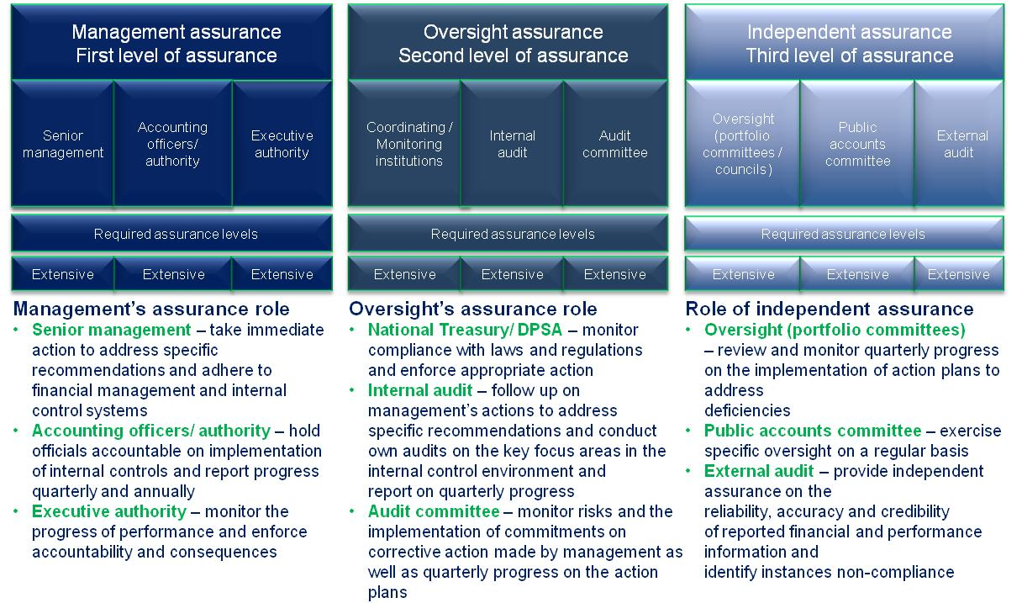
- Commitments from the previous portfolio committee
The following commitments were in progress and tracked by the previous portfolio committee meeting:
- The Portfolio Committee expects feedback from the department on the following:
- Commitment by the department to resolve the asset issues especially in the missions.
- Investigation on the administration processes/alleged procurement irregularities in the South African High Commission in Accra.
- Investigation on the alleged procurement irregularities in the ARF.

