
Transport Portfolio
14 October 2014
PFMA audit outcomes of the 2013-14 financial year
PC

CONTENTS
1. Introduction 1
2. Audit opinion history 2
3. Key focus areas 4
4. Drivers of internal control 11
5. Other matters of interest 12
6. Other reports 13
7. Combined Assurance on Risk Management in the Public Sector 14
8. Commitments from the previous portfolio committee 14

- Introduction
1.1 Reputation promise of the Auditor-General of South Africa
The Auditor-General has a constitutional mandate and, as the Supreme Audit Institution (SAI) of South Africa, it exists to strengthen our country’s democracy by enabling oversight, accountability and governance in the public sector through auditing, thereby building public confidence.

1.2 Purpose of document
The purpose of this briefing document is for the Auditor-General of South Africa (AGSA) to provide an overview of the audit outcomes and other findings in respect of the Transport portfolio for the 2013-14 financial year.

1.3 Overview
Improvements:
Unqualified with findings to unqualified with no findings
- Road Traffic Infringement Agency (RTIA)

Unchanged:
Unqualified with no findings
- Driving License Card Account (DLCA)
- Road Accident Fund (RAF)
- South African Civil Aviation Authority (SACAA)

Unchanged:
Unqualified with findings
- Department of Transport
- Cross-Border Road Transport Agency (CBRTA)
- Railway Safety Regulator (RSR)
- SA Maritime Safety Authority (SAMSA)
- South African National Roads Agency Limited (SANRAL)
- Ports Regulator of South Africa
- Passenger Rail Agency of South Africa (PRASA)

Regressed:
Unqualified with findings to Qualified
- Road Traffic Management Corporation (RTMC)
RTMC’s regression is due to property, plant and equipment: The entity did not maintain an updated asset register in accordance with the requirements of the standards of GRAP. This impacted on the amount recognised as property, plant and equipment. Consequentially, property, plant and equipment were understated by R 3,145,149.

1.4. Organisational structure

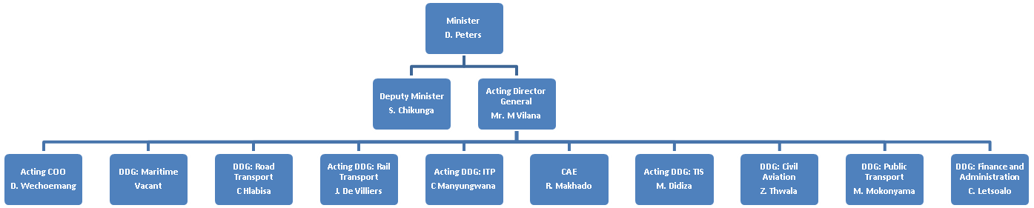

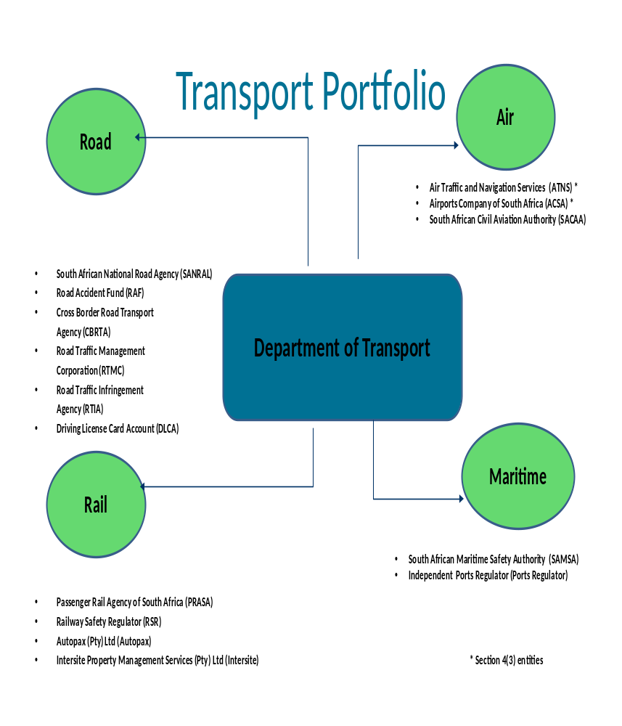

1.5 Funding

The department is primarily funded through funds appropriated in terms of the annual Appropriation Act (and the Adjustments Appropriation Act), the final appropriation for 2013-14 amounted to R42 401 340 000 (2012-13: R39 647 228 000) and spent R43 036 844 000 which represents 101.5% of funding spent. (2012-13: R39 328 215 000, 99.2%)
- Audit opinion history

AUDIT OPINIONS |  |  | 09/10 |  | 10/11 | 11/12 | 12/13 | 13/14
- Department of Transport
- South African National Roads Agency Ltd
- Railway Safety Regulator
- South African Civil Aviation Authority
- South African Maritime Safety Authority
- Road Traffic Management Corporation
- Ports Regulator
- Road Traffic Infringement Agency |  |  | N/A
- Road Accident Fund
- Cross Border Road Transport Agency
- Driving Licence Card Account
- Passenger Rail Agency of South Africa
AUDIT OPINION LEGEND
 | CLEAN AUDIT OPINION: No findings on PDO and Compliance
 | UNQUALIFIED with findings on PDO and Compliance
 | QUALIFIED AUDIT OPINION (with/without findings)
 | DISCLAIMER/ADVERSE AUDIT OPINION
N/A | New entity
QUALIFICATION ISSUES |  |  | 09/10 |  | 10/11 | 11/12 | 12/13 | 13/14
Road Traffic Management Coporation
- Financial sustainability |  |  | ü
- Assets, Receivables |  |  |  |  | ü
- Assets |  |  |  |  |  |  |  | ü
Road Traffic Infringement Agency
- Revenue, Receivables, Irregular Expenditure |  |  |  |  | ü
Cross Border Road Transport Agency
- Revenue, Receivables |  |  | ü |  | ü | ü
OTHER MATTERS |  |  | 09/10 |  | 10/11 | 11/12 | 12/13 | 13/14
Predetermined objectives
- Department of Transport |  |  | ü |  | ü |  |  | ü
- South African National Roads Agency Ltd.
- Railway Safety Regulator |  |  | ü
- South African Civil Aviation Authority |  |  | ü |  | ü
- South African Maritime Safety Authority |  |  |  |  | ü | ü |  | ü
- Road Traffic Management Corporation |  |  | ü |  | ü | ü | ü | ü
- Ports Regulator
- Road Traffic Infringement Agency |  |  |  |  | ü | ü
- Road Accident Fund
- Cross Border Road Transport Agency |  |  | ü |  | ü | ü |  | ü
- Drivers Licence Card Account |  |  | ü |  | ü
- PRASA
Compliance with laws and regulations
- Department of Transport |  |  |  |  | ü | ü | ü | ü
- South African National Roads Agency Ltd. |  |  |  |  |  |  | ü | ü
- Railway Safety Regulator |  |  | ü |  | ü | ü | ü | ü
- South African Civil Aviation Authority |  |  | ü |  | ü | ü
- South African Maritime Safety Authority |  |  | ü |  | ü | ü | ü | ü
- Road Traffic Management Corporation |  |  | ü |  | ü | ü | ü | ü
- Ports Regulator |  |  | ü |  | ü | ü | ü | ü
- Road Traffic Infringement Agency |  |  |  |  | ü | ü | ü
- Road Accident Fund |  |  |  |  | ü | ü
- Cross Border Road Transport Agency |  |  | ü |  | ü | ü | ü | ü
- Drivers Licence Card Account |  |  | ü |  | ü | ü
- PRASA |  |  | ü |  | ü | ü | ü | ü
2.1 Significant emphasis of matters
- South African National Roads Agency Ltd – Alternative tariff revenue to the amount of R1, 1 billion for Gauteng Open Tolling has not been recognised. In management’s judgement it is not probable that that the economic benefits associated with the transaction will flow to the entity.
- SAMSA – Uncertainty as to whether entity will be able to fund its future obligations as the entity incurred a deficit during the course of the financial year resulting in a reduction in its cash reserves.
- Cross Border Road Transport Agency – Significant uncertainty (The cross-border hauliers are challenging the new fees for cross border road permits. The outcome might have an impact on CBRTA’s ability to generate the budgeted revenue levels).
- Drivers Licence Card Account - Significant uncertainty (service provider lawsuits regarding the validity of the contracts to manufacture driver’s license cards and prepayments of R9 million that relate to assets which have not yet been delivered).

- Key focus areas
3.1 Predetermined Objectives
Entity | Finding | Root cause | Recommendation
Cross-Border Road Transport Agency | A total of 50% of the indicators were not verifiable.  Significantly important targets were not reliable when compared to the source information and evidence provided. | There was inadequate review performed on the annual performance report  This was due to the fact that there were inadequate reviews by the responsible executives on the evidence submitted against the reported targets. | Management should ensure that there are adequate reviews that are performed to confirm that targets are in line with the SMART principle.  Management should ensure that there are adequate reviews done on the evidence submitted by the responsible executives.
Department of Transport | Performance indicators were not well defined and targets were not specific | Lack of oversight by management to ensure that indicators are well defined.  Reviews of the Annual Performance Plan were not effective. | Management should develop Technical Indicator Descriptions and define each performance indicator to ensure that performance indicators are clear and easy to understand.  Management should ensure that there are adequate reviews that are performed to confirm that targets are in line with the SMART principle.
Department of Transport | The reported performance information was not valid, accurate and complete when compared to the source information or evidence provided. | This was due to a lack of standard operating procedures or documented system descriptions for the accurate recording of actual achievements and technical indicator descriptions for the accurate measurement, recording and monitoring of performance. | Management should ensure that there are controls in place so that independent confirmation can be performed to ensure that information reported by public entities is valid, accurate and complete.
Road Traffic Management Corporation | Performance indicators were not well defined and were not verifiable | Management did not adhere to the requirements of the Framework for Programme Performance Information (FMPPI) due to a lack of proper systems and processes and technical indicator descriptions. | Management should ensure that targets meet the "SMART" criteria to enable tracking and monitoring of actual performance against targets  This will assist the agency in the achievement of its targets as well as accurate calculation of variances for targets not achieved.
Road Traffic Management Corporation | Reasons for variances between planned actual achievements reported in the annual performance report were not given | This was due to a lack of documented and approved policies and procedures to address reporting requirements and limited review of the presentation of the annual performance report by management. | Management should evaluate all the predetermined objectives reflected in the annual report and provide reasons for all major differences between the planned target and the actual output. These reasons should be supported by adequate and reliable corroborating evidence.
Road Traffic Management Corporation | Significant important targets were not reliable when compared to the source information or evidence provided. | This was due to a lack of standard operating procedures or documented system descriptions for the accurate recording of actual achievements and a lack of technical indicator descriptions for the accurate measurement, recording and monitoring of performance, monitoring of the completeness of source documentation in support of actual achievements. | Management should design and implement systems and procedures that will ensure that reported performance information is supported by reliable evidence and that sufficient monitoring and evaluation takes place throughout the year.  Management should review all supporting evidence to ensure that it agrees with the reported performance for all targets
South African Maritime Safety Authority | Performance targets were not specific, measurable and time bound. The indicators were not well defined. | There was inadequate review performed on the annual performance plan. | Management should ensure that targets meet the "SMART" criteria to enable tracking and monitoring of actual performance against targets
South African Maritime Safety Authority | Significant important targets were not reliable when compared to the source information or evidence provided.  The reported performance information was not valid, accurate and complete when compared to the source information or evidence provided. | This was due to the fact that the entity could not provide sufficient appropriate evidence in support of the reported performance information.  This was due to the fact that there were inadequate reviews by the responsible executives on the evidence submitted against the reported targets. | The accounting authority should ensure that prior to programme performance indicators being approved for both the strategic plan and annual performance plan, there are adequate reviews that are performed to confirm that targets are in line with the SMART principle.  The accounting authority should familiarise themselves with the National Treasury Framework for Strategic plans and annual performance plans.
3.2 Supply Chain Management
Entity | Finding | Root cause | Recommendation
Department of Transport | The non-compliance matter was related to extension of IT contracts beyond the limit set in the National Treasury Practice Note. | Lack of coordination around project management between the various tiers of government. | The deviation from applicable bidding process should be applicable only in exceptional circumstances.  The deviation from normal bidding process should be motivated.
SAMSA | Contracts were extended or modified without the approval of a properly delegated official. | Management did not understand which laws and regulations they should comply with when there are unsolicited bids this was as a result of inadequate training. | Established controls and processes must be adhered to at all times when procuring goods and services. Consideration should be given to ensure that the officials in the SCM unit are adequately trained on the latest applicable prescripts.
SANRAL | The entitity awarded contracts to bidders based on points that were not calculated in accordance with the requirements of the Preferential Procurement Policy Framework Act and its regulations | Management did not exercise oversight responsibility of ensuring the contracts were awarded to bidders based on preference points that were allocated in accordance with the requirements of the Preferential Procurement Policy Framework Act and its regulations. | Management should comply with the Preferential Procurement Policy Framework Act No.5 of 2000 in awarding contracts.
SANRAL | The entity did not request three quotations, as prescribed | Management did not put effective controls in place to ensure compliance with internal policies with regards supply chain management. | Management should ensure that supply chain management policies are complied with regards to sourcing of quotations
SANRAL | SANRAL awarded a construction contract to a contractor that did not qualify for the contract in accordance with Construction Industry Development Board (CIDB) regulations 17 | Management did not exercise proper oversight responsibility regarding compliance and related internal controls over the evaluation of tenders in terms of CIDB regulations.  There was no proper review of the tender process to ensure bids are evaluated based on the specifications set in the tender specification documents. | Management should be specific on tender invitations to ensure that bidders who are capable of being registered on a higher grading within 21 working days from the closing date of submissions of tenders will be eligible for evaluation, to ensure that evaluations are done in a manner that is fair and transparent
SANRAL | The bid adjudication of SANRAL was not always done by a committee which was composed in accordance with the policies of the entity as required by Treasury Regulations 16A6.2 (a), (b), (c) | Management did not effectively exercise oversight responsibility regarding the constituency of committees to perform tender evaluations to ensure compliance with the Treasury regulations, PFMA and Supply Chain Management policy. | Management should capacitate its supply chain unit to ensure involvement of supply chain specialist in the procurement processes.  Keep complete records pertaining to SCM awards process from initiation to completion to ensure compliance monitoring and reporting role
PRASA | A contract amounting to R3,5 billion for the purchase of locomotives was awarded to a bidder. The evaluation criteria used was not fully consistent with the criteria stipulated in the request for proposal. | Inadequate monitoring controls to ensure adherence to the internal policies and procedures as well as compliance with laws and regulations. | Management should improve oversight on SCM processes to ensure compliance to laws and regulations governing the tender process.
PRASA | The performance bond of R307 million (10%) of the contract amount, excluding the value-added tax (VAT), was issued in favour of PRASA four months after the contract for the purchase of locomotives had been signed. This is after PRASA had paid a deposit of R460 million (15%) of the contract amount, excluding VAT, to the bidder. This is contrary to the requirements of the PRASA SCM policy which states that “performance security must be provided prior to concluding the contract with the Agency”. | Inadequate monitoring controls to ensure adherence to the internal policies and procedures as well as compliance with laws and regulations. | Management should improve oversight on SCM processes to ensure compliance to laws and regulations governing the tender process.

  - Human resources management
Entity | Finding | Root cause | Recommendation
Department of Transport |  | Lack of effective HR management to ensure that adequate and sufficiently skilled resources are in place | The advertising and filling of vacant posts should be prioritised in the Department. The prescribed recruitment processes should be followed at all times.
  The vacant posts were not advertised within 6 months after becoming vacant and not filled within 12 months.
  New appointee did not have the required qualifications and experience for the position.
  The prescribed selection and approval processes were not followed for the appointment.

  - Information technology controls
An analysis of the IT audit outcomes indicated that the portfolio had designed the IT controls they had committed to in the previous cycle; however, these controls were not implemented, and as a result they still experienced challenges with IT management controls that provide assurance of the confidentiality, integrity and availability of financial information.

  - Financial Health Status
Entity | Finding
SAMSA | Uncertainty as to whether entity will be able to fund its future obligations as the entity incurred a deficit during the course of the financial year resulting in a reduction in its cash reserves.
Department of Transport | This relates to the Electronic National Traffic Information System (eNaTIS) maintenance and operations cost that was not included in the budget.
Road Accident Fund | The entity has a net deficit position and revenue is insufficient to pay claims expenditure
Cross-border Road Transport Agency | Significant uncertainty (The cross-border hauliers are challenging the new fees for cross border road permits. The outcome might have an impact on CBRTA’s ability to generate the budgeted revenue levels).
Drivers Licence Card Account | Significant uncertainty (service provider lawsuits regarding the validity of the contracts to manufacture driver’s license cards and prepayments of R9 million that relate to assets which have not yet been delivered).

  - Material Mistatements to Financial Statements
Entity | Finding | Root cause | Recommendation
Department of Transport | Disclosure Note – Irregular Expenditure, Commitments, Provision, Accruals, Prepayments, Related Parties | This was as a result of a lack of training on the new modified Cash Standard. | Training on the Modified Cash standard should be provided to staff members.
Passenger Rail Agency of South Africa | Account balance – property, plant and equipment; Investment property  Class of Transactions – Other Income | This was mainly due to staff members not applying the requirements of the financial reporting framework and National Treasury due to a lack of skills and training on the applicable financial reporting framework. | Management should capacitate the finance department with the appropriate skills to prepare credible financial statements and conduct a full review of the financial statements.
Ports Regulator of South Africa | Disclosure Note – comparison of actual and budgeted amounts and related party disclosures | Internal controls implemented were not effective in ensuring that the financial statements submitted for auditing were free from misstatements in the disclosure notes. This is due to officials preparing financial statements not having an understanding of the requirements of the financial reporting framework | Management should take ownership of financial statements preparation to ensure that they are free from material misstatements. Officials responsible for the preparation of financial statements should be trained in order to have a proper understanding of the financial reporting framework
Railway Safety Regulator | Disclosure Note – operating lease disclosure | The annual financial statements were not adequately reviewed to ensure that there were prepared in terms of the requirements of the applicable reporting framework and disclosure notes as required by PFMA. | Internal controls to gather information required for disclosure notes should be developed and implemented. Management should put in place the internal controls like reviewing to ensure that financial statements are accurate and complete.
RTMC | Account Balances – Trade and other Payables; Receivables; Intangible assets  Class of Transactions – Revenue AARTO infringement fees | Lack of oversight responsibility and proper review regarding the financial statements preparation and related internal controls. This is due to management's over reliance on consultants to prepare the financial statements and lack of capacity within the finance department. | Management should capacitate the finance department with the appropriate skills to prepare credible financial statements and conduct a full review of the financial statements.
South African Maritime Safety Authority | Class of Transactions –Expenses  Disclosure Note – Irregular Expenditure, Related Parties, Provision, Fruitless and wasteful | The annual financial statements were not adequately reviewed to ensure that there were prepared in terms of the requirements of the applicable reporting framework and disclosure notes as required by PFMA. This was due to lack of knowledge and skills of the requirements of the applicable financial reporting framework. | Officials responsible for the preparation of financial statements should be trained in the financial reporting framework. The internal audit and audit committee should review on a quarterly basis internal controls in place to gather information required to prepare financial statements including disclosure notes.
The South African National Roads Agency Limited | Account Balances – Inventory, Pavement structure,  Class of transactions- understatement of the violation processing revenue  Disclosure Notes – Irregular Expenditure, Fair value information disclosure note, Reserves note to AFS, risk management, | Internal controls implemented were not effective in ensuring that the financial statements submitted for auditing were free from misstatements in the disclosure notes. This is due to officials preparing financial statements not having an understanding of the requirements of the financial reporting framework and inadequate training. The entity does not have internal controls in place to gather information required for disclosure notes. | Management should take ownership of financial statements preparation to ensure that they are free from material misstatements. Officials responsible for the preparation of financial statements should be trained in order to have a proper understanding of the financial reporting framework. Internal controls to gather information required for disclosure notes should be developed and implemented. Management should perform detailed reviews of the financial statements to ensure that they are accurate and complete.

- Drivers of internal controls
Drivers of internal control
Entity | Leadership |  |  |  |  |  | Financial and performance management |  |  |  |  | Governance
 | Effective leadership culture | Oversight responsibility | HR management | Policies and procedures | Action plans | IT governance | Proper record keeping | Processing and reconciling controls | Reporting | Compliance | IT systems controls | Risk management | Internal audit | Audit committee
Department of Transport
SANRAL
RAF
DLCA
SAMSA
CBRTA
PRASA
RSR
SACAA
RTIA
Ports Regulator
RTMC

Legend Drivers | Good | Causing Concern | Intervention required

- Other matters of interest
(a) Unauthorised expenditure:

Auditee |  | Irregular expenditure
 |  | Movement | Amount  R  2014 | Amount  R  2013
1 | Department of Transport |  | R768 355 000* | R0
*: The unauthorised expenditure was as a result of the Electronic National Traffic Information System (eNaTIS) maintenance and operations cost that was not included in the budget.

(b) Fruitless and wasteful expenditure:
Auditee |  | Fruitless and Wasteful expenditure
 |  | Movement | Amount  R  2014 | Amount  R  2013
1 | Department of Transport |  | R1 294 000* | R683 000
2 | Cross-Border Road Transport Agency |  | R2 224 | R11 689
3 | Railway Safety Regulator |  | R92 | R2 157
4 | Road Accident Fund |  | R30 441 | R202 226 000
5 | Road Traffic Management Corporation |  | R161 372 | R59 838 427
6 | SA Civil Aviation Authority |  | R231 549 | R2 714 435
7 | SA Maritime Safety Authority |  | R1 112 000** | R0
*: DOT- relates to services paid for but not delivered and an overseas trip that was undertaken that exceeded the authorization.
**SAMSA- relates to the lease of the building that was not cancelled beforethe entity occupied the new building.

(c) Irregular expenditure:
Auditee |  | Irregular expenditure
 |  | Movement | Amount  R  2014 | Amount  R  2013
1 | Department of Transport |  | R1 121 695 000* | R 56 545 000
2 | Cross-Border Road Transport Agency |  | R827 753 | R 920 010
3 | Driving License Card Trading Account (DLCTA) |  | R710 000 | R 000
4 | Road Accident Fund |  | R18 457 | R 4 327 000
5 | Road Traffic Management Corporation |  | R3 268 675 | R209 592 634
6 | SA Civil Aviation Authority |  | R154 002 | R1 887 134
7 | South African National Roads Agency |  | R1 541 309 000** | R3 305 711
8 | SA Maritime Safety Authority |  | R28 846 828*** | R6 214 000
*: DOT - All of the irregular expenditure identified is supply chain management related.
**:.SANRAL – All of the irregular expenditure identified is supply chain management related.
***: SAMSA - All of the irregular expenditure identified is supply chain management related.

- Other reports

- Investigations
CBRTA – An investigation is being conducted into certain permits to determine the validity of those permits.
Department of Transport – Various investigations are being conducted to evaluate compliance with supply chain management practice notes and regulations in the awarding of certain tenders. The investigations aims to establish whether there were any gross irregularities in the tender process.
SAMSA – An investigation pertaining to a fraudulent request for change of banking details is being conducted.
SANRAL – A forensic investigation to investigate allegations of irregularities and maladministration by a resident engineer; discrepancies in the BBBEE credentials claimed by a company and the details submitted for CIDB registration and fraudulent use of the entity’s name and logo.

- Combined Assurance on Risk Management in the Public Sector

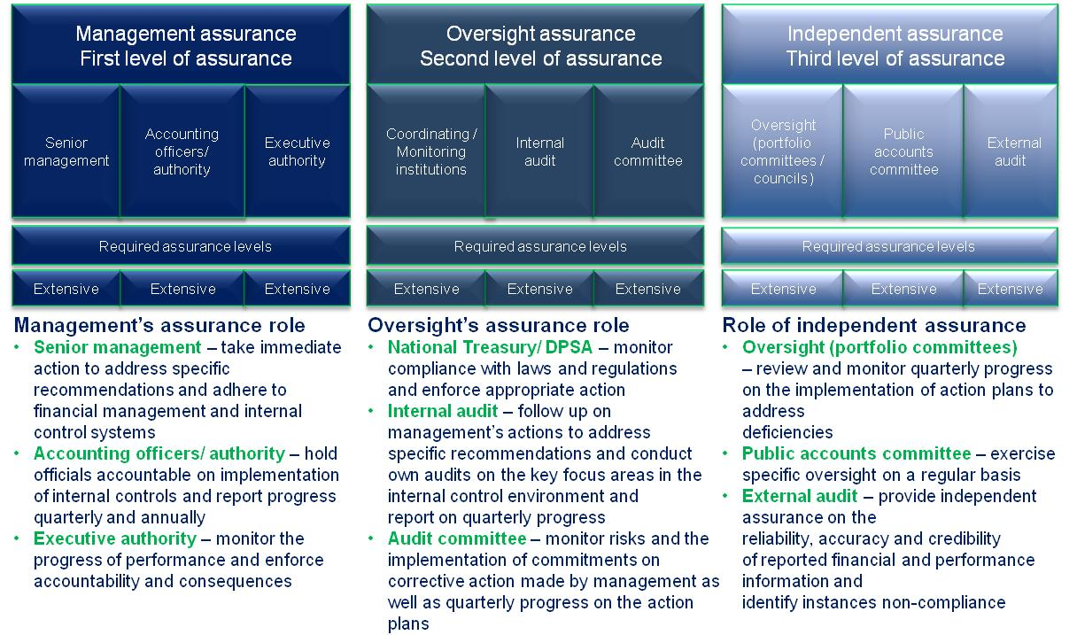

- Commitments from the previous portfolio committee

The following commitments should be actioned by the portfolio committee:
Commitment | Detail
Vacancy rate would decrease at the department | - The department of transport has a vacancy rate of 25%. The Minister committed to ensure that the filling of key posts will be made a priority in the Department. This is intended to support the whole process of restructuring and oversight over public entities. Portfolio Committee to monitor the progress on management of key vacancies within the Portfolio
The implementation of the action plan to address the audit findings on predetermined objectives reporting and non compliance with SCM practices on all entities | - The Minister would monitor the action plans of the entities and department within the portfolio and implementation of the joint action plan emanating from the CEO forum to address the transversal and critical audit findings impacting the portfolio. Portfolio Committee to call individual entities and the department to account on actions taken to address significant audit matters.
To monitor the progress in the transfer back of the eNatis system from the service provider to the Portfolio | - The Minister will monitor the progress of the transfer plan to take back the eNatis system from the service provider. Portfolio Committee to request regular feedback on the progress made to take over the system from the service provider
To monitor the process with regards to oversight over the public entities and request regular feedback on key concerns at these entities | - This will assist in driving the corrective action to address audit findings.  - The Minister committed to meet the AC chairpersons and the Chairpersons of the Boards of the entities on a regular basis to evaluate feedback received from the entities against their AC chairpersons.  - Portfolio Committee to encourage the Department to provide feedback on significant matters within the Portfolio.

STATUS LEGEND
Fully implemented and functioning
In progress
Not implemented and not functioning
- SCOPA resolutions
No previous SCOPA resolutions regarding the department or the public entities in the portfolio were identified which were applicable to the 2013-14 financial year.

