Vote 10: National Treasury

8 May 2014

The primary function of the National Treasury is to support economic growth and development, promote good governance and social progress through fostering accountable, economical, efficient, equitable and sustainable management of public finances. A concomitant commitment to maintain macroeconomic and financial sector stability and ensure effective regulation of the economy is delineated in the department’s legislative mandate.

The Strategic goals of the department outline its plan, for realising its mandate over the medium term. These goals are critical in informing the structure of the department’s programmes.

In this regard, the department lists the following strategic objectives:

- Prepare, finance, publish and monitor the execution of the annual national budget to provide accurate and clear financial information and associated indicators of service delivery and performance;
- Improve techniques employed to monitor and analyse public expenditure by further refining applicable financial management frameworks and policies to ensure the appropriate use of available public financial resources for social and economic development, and infrastructure investment;
- Contribute to improved capacity in the areas of financial management and resource planning in government through various skills development programmes tailored for these purposes;
- Contribute to the development of a stable and robust financial sector that leads to continued economic stability and growth by continuing to monitor financial sector performance and developing financial sector policies and regulatory frameworks;
- Support infrastructure and urban development through various programmes including the Infrastructure Development Improvement Programme, the Neighbourhood Development Partnership Programme and the Cities Support Programme, amongst others;
- Promote public private partnerships as a financing alternative for development, where feasible; and
- Enhance supply chain management in government through the establishment of the Chief Procurement Office, which will provide a blueprint for addressing supply chain principles in order to reduce wastage and maximise value in the public sector.

To give effect to its strategic goals, the department is structured into the following programmes:

- Administration;
- Economic Policy, Tax, Financial Regulation and Research;
- Public Finance and Budget Management;
- Asset and Liability Management;
- Financial Systems and Accounting;
- International Financial Relations;
- Civil and Military Pensions, Contributions to Funds and Other Benefits;
- Technical Support and Development Finance;
- Revenue Administration; and
- Financial Intelligence and State Security.

In the department’s Strategic Plan 2012/16, the Minister of Finance, Pravin Gordhan, notes the transition of the department’s Medium Term Expenditure Framework towards economic growth, investment and job creation.

This was reflected in the department’s restructuring of its programme architecture in 2011 from nine programmes to the present ten programmes. Specifically, the creation of a specialised programme to deal with economic policy, tax, financial regulation and research, appears to be particularly relevant in assisting the department in fulfilling its mandate.

Policy Priorities for 2014/15

National Treasury continues to commit itself to aligning its policy priorities with those delineated in the National Development Plan (NDP). In order for the objectives of the NDP to be realised, a stable and enabling macroeconomic platform is required to achieve sustainable growth and employment creation.

In his 2014 budget speech, Minister of Finance Pravin Gordhan stressed the importance of the NDP by stating that it “reflects the priorities underpinning the 2014 budget, and prepares the ground for the next phase of our economic and social transformation”. The Minister remarked that in order to make “more rapid progress in creating jobs and reducing poverty, we have to grow our economy at 5 per cent a year or more”.

National Treasury recognises the need to cut wasteful expenditure and drive efficiencies throughout all national departments to enforce the self-imposed debt ceilings. The process of fiscal consolidation is well underway and the National Treasury will be conducting regular spending reviews to examine programme performance and value-for-money.
In addition, the Minister stated that the introduction of regulations will strengthen the National Treasury’s oversight of public entities by requiring compliance with reporting requirements for expenditure, revenue, borrowing and performance.

Issue for consideration:

How does the department envisage striking the balance between cost containment and service delivery, given the massive infrastructure investment that is still needed and the widespread service delivery protests experienced in the country over the last year?

Public Sector wage bill growth has been one of the major concerns relating to government expenditure over the past few years, currently accounting for 39.5 per cent of non-interest expenditure. Given government’s commitment to fiscal consolidation and the fact that CPI is forecasted to be 6.2 per cent in 2014/15, does government still expect to contain public sector wage settlements to 6.4 per cent during the next round of negotiations with labour unions, given that labour unions generally adopt a strategy of negotiating for wage settlements of CPI plus 1 per cent?

Budget Analysis

Table: Budget Allocations
Programme | Budget |  |  |  | Nominal Rand change | Real Rand change | Nominal % change | Real % change
R million | 2012/13 | 2013/14 | 2014/15 | 2015/16 | 2013/14-2014/15 |  | 2013/14-2014/15
Administration | 296.7 | 356.4 | 343.1 | 360.5 | -13.3 | -31.8 | -3.74% | -8.93%
Economic Policy, Tax, Financial Regulation and Research | 111.2 | 133.9 | 138.9 | 146.3 | 5.0 | -2.5 | 3.72% | -1.87%
Public Finance and Budget Management | 232.8 | 231.3 | 262.8 | 276.7 | 31.5 | 17.3 | 13.63% | 7.50%
Asset and Liability Management | 278.2 | 2 994.0 | 3 342.1 | 3 117.9 | 348.1 | 167.9 | 11.63% | 5.61%
Financial Systems and Accounting | 639.3 | 734.7 | 761.6 | 790.5 | 26.9 | -14.2 | 3.66% | -1.93%
International Financial Relations | 1 003.1 | 1 092.0 | 1 179.8 | 1 235.2 | 87.8 | 24.2 | 8.04% | 2.22%
Civil and Military Pensions, Contributions to Funds and Other Benefits | 3 343.6 | 3 497.0 | 3 717.8 | 3 962.9 | 220.8 | 20.3 | 6.31% | 0.58%
Technical Support and Development Finance | 1 982.6 | 2 484.0 | 3 712.2 | 3 206.9 | 1 228.3 | 1 028.1 | 49.45% | 41.39%
Revenue Administration | 9 149.4 | 9 534.4 | 9 440.3 | 9 898.7 1 | -94.1 | -603.2 | -0.99% | -6.33%
Financial Intelligence and State Security | 3 982.1 | 4 174.6 | 4 336.3 | 4 524.8 | 161.8 | -72.1 | 3.87% | -1.73%
TOTAL | 21 019.0 | 25 232.3 | 27 234.9 | 17 621.7 | 2 002.7 | 534.0 | 7.94% | 2.12%
(Source: National Treasury 2014 – Vote 10: National Treasury)

The overall budget for National Treasury has increased by 7.94 per cent for the 2014/15 financial year. A significant driver of this growth is a result of the 49.45 per cent increase in the budget for the Technical Support and Development Finance programme.

Other notable changes include a 11.63 per cent increase in the budget for the Asset and Liability Management programme; as well as a 13.63 per cent increase in planned expenditure for the Public Finance and Budget Management programme.

The following detailed programme analysis will assess the relationship, since 2009, between the growth in a programme’s budget and the extent to which the programme has achieved its set targets.

This will effectively enable the committee to gauge which programmes have represented value for public money over the stipulated period. This is aimed at empowering the committee by providing the appropriate historical context in which the department’s budgetary allocations for 2014/15 can be scrutinised.

Programme Analysis
Programme 1: Administration

Table: Programme 1 Budget Allocations
 | 2009/10 | 2010/11 | 2011/12 | 2012/13 |  |  | 2013/14 |  |  | 2014/15 | 2009/10 - 2014/15
 | Audited outcome  R' 000 | Audited outcome  R' 000 | Audited outcome  R' 000 | Adjusted appropriation  R' 000 | Shortfall on planned Q1 - Q4 expenditure R' 000 | % Variance | Adjusted appropriation  R' 000 | Shortfall on planned  Q1 – Q3 expenditure R' 000 | % Variance | Budget estimate R' 000 | Compound average annual growth rate (%)
 | 242 800 | 248 700 | 281 067 | 321 138 | 23 036 | 7.2% | 356 400 | 32 575 | 12.3% | 343 100 | 9.07%
Nominal growth in budget allocation (yoy %) | 19.2% | 2.4% | 2.3% | 26.2% |  |  | 10.98% |  |  | -3.73%
Real growth in budget allocation (yoy %) | 12.1% | -1.9% | -2.7% | 20.5% |  |  | 5.00% |  |  | -8.92% | 2.80%
Planned targets achieved | 92% (11 out of 12) | 95% (18 out of 19) | 92% (11 out of 12) | 32% (15 out of 47)
(Source: National Treasury 2009 - 2014)

Growth in the budget for the Administration programme has been erratic since 2009. Periods of positive real growth in budget allocations (see 2009/10) have been followed by periods of negative real growth (see 2010/11 – 2011/12). The budget increase in 2012/13 was the last significant increase as it has been followed by a moderate increase in real growth in 2013/14 with an estimated 8.92 per cent decrease in budget in real terms for the 2014/15 financial year.

Whilst the proposed budget for 2014/15 has been reduced in real terms by 8.92 per cent in comparison to the previous year, it is still 9 per cent higher than the 2009 budget after taking inflation into account.

Notably, the negative real budget growth from 2009/10 – 2011/12 was accompanied by a high standard of service delivery as exemplified by the percentage of planned targets achieved over the period. In this regard, the budget allocation for the programme since the 2009/10 financial year has been sufficient.

Figure 1: Budget Growth versus Planned Targets Achieved
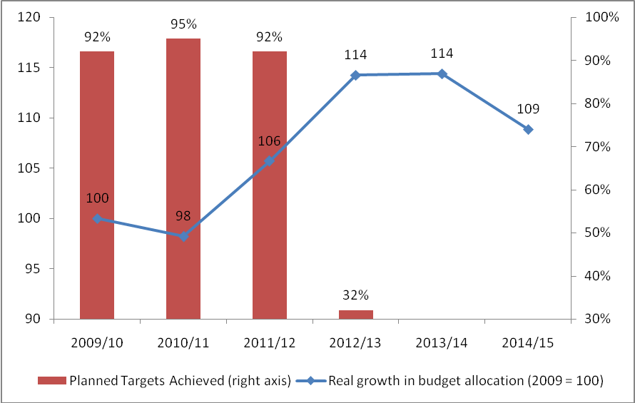

(Source: National Treasury 2009 - 2014)

However, the fact that nearly 7.2 per cent of the allocated budget for 2012/13 went unspent is a matter of concern. In addition, the 3rd Quarter Expenditure Report for the 2013/14 financial year indicates that the department has yet to spend 12.3 per cent of its budget for that period. The significant shortfalls require a detailed explanation by the department.

Issue for consideration:

- What are reasons for the shortfall on planned expenditure in Programme 1 over the last few years? How does the department intend to rectify these occurrences?

The most significant decreases in the budget for 2014/15 occur in the Internal Audit sub-programme which decreases by R7.044 million, constituting a 32.2 per cent decrease. Another significant decrease can be seen in the Office Accommodation sub-programme, which has its budget reduced by R6.028 million (6.63 per cent reduction). This is significant given that this sub-programme represents the 2nd largest expenditure category within the Administration programme. The Enterprise Wide Risk Management sub-programme also had its budget reduced by R8.647 million (26.57 per cent reduction).

The department explains that the focus of the expenditure in this programme is on building capacity in the internal audit, ICT and human resource functions. The 59 vacant posts as at the end of November 2013 were due to natural attrition according to the department. The department expects to fill these vacancies over the medium term which may assist the department in reducing the shortfalls experience in planned expenditure in each quarter since the majority of the budget in this programme is spend on the compensation of employees.

The department explains that its project to refurbish its office accommodation is running behind schedule and is expected to be completed in 2014/15. The department explains that as this project is concluded, so too will expenditure in the Office Accommodation sub programme.

Issue for consideration:

- Given that Programme 1 appears to record persistent shortfalls in planned expenditure due to unfilled vacancies, how does the department plan to reduce the number of vacancies in the programme on a consistent basis?
- How will the department ensure that service delivery standards are not compromised by the significant reductions in budget to various sub-programmes?

Programme 2: Economic Policy, Tax, Financial Regulation and Research

Table: Programme 2 Budget Allocations
 | 2009/10 | 2010/11 | 2011/12 | 2012/13 |  |  | 2013/14 |  |  | 2014/15 | 2009/10 - 2014/15
 | Audited outcome  R' 000 | Audited outcome  R' 000 | Audited outcome  R' 000 | Adjusted appropriation  R' 000 | Shortfall on planned Q1 - Q4 expenditure R' 000 | % Variance | Adjusted appropriation  R' 000 | Shortfall on planned  Q1 – Q3 expenditure R' 000 | % Variance | Budget estimate R' 000 | Compound average annual growth rate (%)
 | 71 900 | 86 100 | 210 364 | 122 508 | 11 274 | 9.2% | 133 900 | 7 675 | 9.50% | 138 900 | 10.16%
Nominal growth in budget allocation (yoy %) | 1.6% | 19.7% | 144.3% | -41.8% |  |  | 9.30% |  |  | 3.73%
Real growth in budget allocation (yoy %) | -5.5% | 15.4% | 139.3% | -47.5% |  |  | 3.40% |  |  | -1.86% | 3.82%
Planned targets achieved | 75% (15 out of 20) | 74% (14 out of 19 | 72% (23 out of 32)) | 69% (9 out of 13)
(Source: National Treasury 2009 - 2014)

After a 144.3% increase in the budget for the Economic Policy, Tax, Financial Regulation and Research programme in 2011/12, the budget was sharply reduced the following year following under-expenditure of 33.2 per cent. The shortfall on Q1 – Q4 planned expenditure was vastly improved in 2012/13 at 9.2 per cent. The programme’s budget was increased in 2013/14 by 9.3 per cent with a similar variance in planned expenditure as of the end of Q3 of 9.5 per cent. The budget proposed for the 2014/15 financial year represents an increase of 3.73 per cent.

The increase in expenditure is intended to fund future research projects on subjects focusing on Financial Sector Policy, Tax Policy and Economic Policy.

The proposed budget for 2014/15 represents a 49 per cent real increase in comparison to the budget of 2009 after taking inflation into account.

Figure 2: Budget Growth versus Planned Targets Achieved
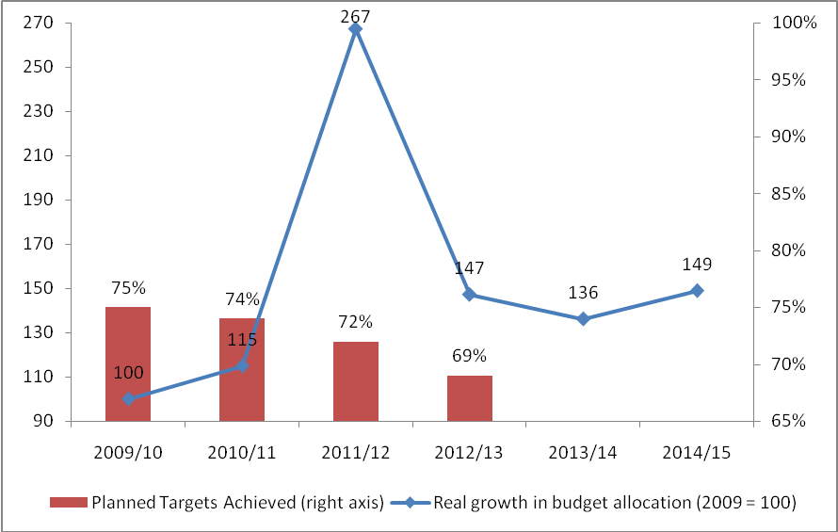

(Source: National Treasury 2009 - 2014)

The department states that the bulk of the spending in the programme is on the compensation of employees and therefore the persistent shortfalls in planned expenditure are likely to stem from the vacant posts that exist primarily in the legal tax design unit. The mismatch between the planned expenditure targets for the programme and actual expenditure is a matter of concern.

Issue for consideration:

- Given that programme 2 has a recent history of relatively significant under-expenditure due to unfilled vacancies, how does the department intend to fill these vacancies with appropriate candidates and furthermore, how does the department justify the need for additional funding in excess of inflationary requirements?

The most significant increases in the budget for 2014/15 can be found in the Financial Sector Policy and Tax Policy sub-programmes, which increase by R3.77 million and R5.68 million, constituting a 14.4 per cent and 23.5 per cent increase. This is significant given that these sub-programmes represent the top two largest expenditure categories within the Economic Policy, Tax, Financial Regulation and Research programme.

The department explains that about 64% of the programme’s expenditure is dedicated to the Financial Sector policy, Tax policy and Economic policy sub programmes. As a result, more than half of the programmes expenditure is on compensation of employees whilst a further 19.9% is on goods and services. Nearly half of spending on goods and services will be on consultants and professional services; with expenditure on consultants set to decrease by R4.97 million (26.5 per cent) between 2013/14 and 2014/15.

The programme has a funded establishment of 129 posts and is committed to increasing the capacity of the relevant employees. As at 30 September 2012, the department had 25 vacancies in this programme which it considered to be due to natural attrition as all 25 positions had been vacant for less than a year. As at the end of November 2013, the number of vacant posts had grown to 29. The department again states that it intends to fill all vacancies due to a growth in capacity. The persistent vacancies does however appear to be a problem which the department continues to struggle.

Issue for consideration:

- The department should provide an explanation as to the persistent vacancies in programme 2. Despite reassurances in each of the last two years that the vacancies would be filled, this is yet to happen.

The department does not mention a specific target with regard to the use of consultants in 2013/14. The department should provide such a target with specific reference to what it would consider to be the optimal mix between research conducted in-house versus research outsourced.

Issue for consideration:

- The department should provide a consultant expenditure target to the committee with specific reference to what it would consider to be the optimal mix between research conducted in-house versus research outsourced. Furthermore, the department should highlight any existing capacity constraints within the programme and detail to the committee the impact of these constraints on service delivery.

Programme 3: Public Finance and Budget Management

Table: Programme 3 Budget Allocations
 | 2009/10 | 2010/11 | 2011/12 | 2012/13 |  |  | 2013/14 |  |  | 2014/15 | 2009/10 - 2014/15
 | Audited outcome  R' 000 | Audited outcome  R' 000 | Audited outcome  R' 000 | Adjusted appropriation  R' 000 | Shortfall on planned Q1 - Q4 expenditure R' 000 | % Variance | Adjusted appropriation  R' 000 | Shortfall on planned  Q1 – Q3 expenditure R' 000 | % Variance | Budget estimate R' 000 | Compound average annual growth rate (%)
 | 145 400 | 160 300 | 209 878 | 247 315 | 20 375 | 8.4% | 231 300 | 18 575 | 13.00% | 262 800 | 8.97%
Nominal growth in budget allocation (yoy %) | 1.9% | 10.2% | 30.9% | 17.8% |  |  | -6.48% |  |  | 13.62%
Real growth in budget allocation (yoy %) | -5.2% | 5.9% | 25.9% | 12.1% |  |  | -11.52% |  |  | 7.49% | 2.71%
Planned targets achieved | 69% (29 out of 42) | 74% (29 out of 39) | 74% (40 out of 58) | 69% (9 out of 13)
(Source: National Treasury 2009 - 2014)

Subsequent to the modest growth in the budget in the allocations to the Public Finance and Budget Management programme, the programme allocation increased significantly, recording a 25.9 per cent and 12.1 per cent real increase for 2011/12 and 2012/13, respectively. In contrast to the above inflation increases in recent years, the budget for 2013/14 represented a 11.52 per cent real reduction in planned expenditure in comparison to the previous year. This reduction can be explained through a severe cut in the budget for the Programme Management for Public Finance and Budget Management sub programme. The remaining four sub programmes recorded above-inflation increases for the 2013/14 financial year. Historically, under-expenditure in this programme appears to have been relatively small in comparison to other programmes, although the shortfall in planned expenditure for 2012/13 was 8.4 per cent and for the first three quarters of 2013/14 was R18.575 million which is a variation of 13 per cent on the expenditure target.

The proposed budget for 2014/15 represents a 7.49 per cent real increase in comparison to the budget of 2013/14.

The increase in budget for the programme is well spread across the five sub-programmes with the only sub-programme receiving a reduction in its allocation being the Financial and Fiscal Commission.

Again, compensation of employees is responsible for the vast majority of the spending in this programme (85.4 per cent).

Figure 3: Budget Growth versus Planned Targets Achieved
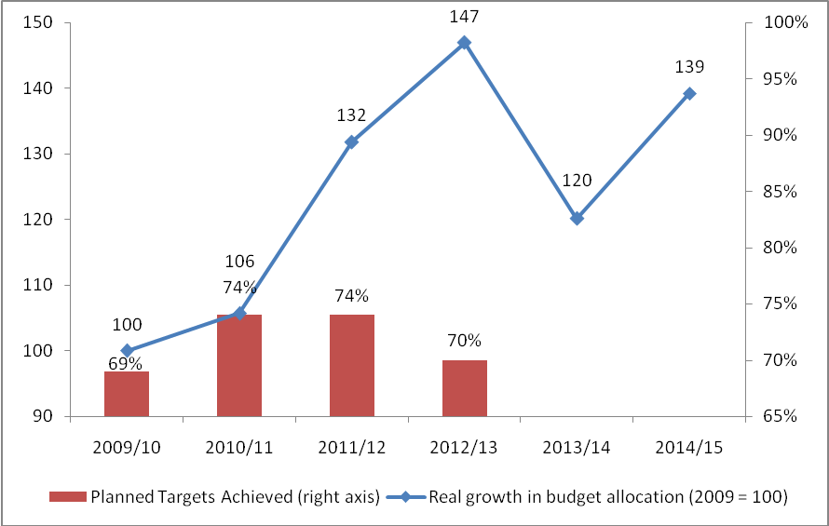

(Source: National Treasury 2009 - 2014)

Expenditure priorities in the medium term will be on improving the provision of financial management, budgeting and expenditure management support, including the oversight of civil pension reforms, to the national, provincial and local spheres of government by building capacity within the programme, mainly at the senior management level.

The programme had 47 vacancies as at the end of November 2013 due to a lack of capacity in the relatively newly established (late 2011/12) public service pensions and benefits unit.

Issue for consideration:

- The department should detail their plan to boost capacity within key units so as to fill the 47 vacancies that exist within the programme.

Last year, transfers to the FFC were reduced by R2.5 million, which represents 6.7% of its 2012/13 budget, whilst this year the FFC has had another budget cut, albeit smaller, of R79 000.

Issue for consideration:

- The department should explain what impact the reduction in the budget for the FFC is likely to have on the entity in terms of it being able to fulfil its constitutional mandate. The Committee should invite the FFC to report on their budgetary requirements and the potential impact the budget decreases have had and are likely to have on the institution.

Programme 4: Asset and Liability Management

Table: Programme 4 Budget Allocations
 | 2009/10 | 2010/11 | 2011/12 | 2012/13 |  |  | 2013/14 |  |  | 2014/15 | 2009/10 - 2014/15
 | Audited outcome  R' 000 | Audited outcome  R' 000 | Audited outcome  R' 000 | Adjusted appropriation  R' 000 | Shortfall on planned Q1 - Q4 expenditure R' 000 | % Variance | Adjusted appropriation  R' 000 | Shortfall on planned  Q1 – Q3 expenditure R' 000 | % Variance | Budget estimate R' 000 | Compound average annual growth rate (%)
 | 31 053 | 20 814 | 825 860 | 282 807 | 4 602 | 1.6% | 2 994 000 | 5 850 | 8.80% | 3 342 100 | 62.81%
Nominal growth in budget allocation (yoy %) | -50.0% | -33.0% | 3867.8% | -65.8% |  |  | 958.67% |  |  | 11.63%
Real growth in budget allocation (yoy %) | -57.1% | -37.3% | 3862.8% | -71.5% |  |  | 901.58% |  |  | 5.61% | 53.45%
Planned targets achieved | 74% (26 out of 35) | 96% (46 out of 48) | 84% (48 out of 57) | 69% (9 out of 13)
(Source: National Treasury 2009 - 2014)

The budget allocations for the Asset and Liability Management programme have been highly volatile since 2009 as a result of the intermittent recapitalisation requirements of Eskom, the Land and Agricultural Development Bank of South Africa, Postbank, as well as the Development Bank of Southern Africa. These funding requirements fall under the Financial Investments sub programme.

Expenditure on the remaining five sub programmes is largely inconsequential in comparison to the allocations for Financial Investments. Nevertheless, these sub programmes have increased modestly since 2009 and are set to be kept relatively stable in the 2014/15 financial year.

The 2011/12 and 2013/14 financial years can be viewed as years in which large scale recapitalisation was required, as is the case for the upcoming year.

In 2013/14, R800 million was transferred to the Land and Agricultural Development Bank as part of the R3.5 billion in capital injections allocated to the entity over the period 2009/10 – 2014/15. The rest of the R2.9 billion in capital transfers budgeted for in this sub programme will be made up of transfers to Postbank and the DBSA. A further R2.8 billion is to be set aside to meet the funding requirements of these entities over the medium term.

Over the 2014/15 – 2015/16 period, the Financial Investments sub-programme is set to provide R800 million over the medium term for the further recapitalisation of the Land and Agricultural Development Bank of South Africa, R481 million for the recapitalisation of Postbank and R7.9 billion for the recapitalisation of the Development Bank of Southern Africa. The department states that the recapitalisation of these state owned entities is expected to end in 2015/16, which explains the significant decrease projected in programme expenditure post 2015/16.

The programme is fully staffed.

Issue for consideration:

- The department should update the committee on the status of the recapitalisation of the Land and Agricultural Development Bank of South Africa, Postbank and Development Bank of Southern Africa. What are the risks associated with each entity in terms of requiring further financial support beyond 2015/16?

Given the weighting of the Financial Investments sub programme, the figure below highlighting the growth in the real budget allocations for this programme, should therefore be understood as representing the fluctuating recapitalisation needs of the aforementioned entities.

Figure 4: Budget Growth versus Planned Targets Achieved
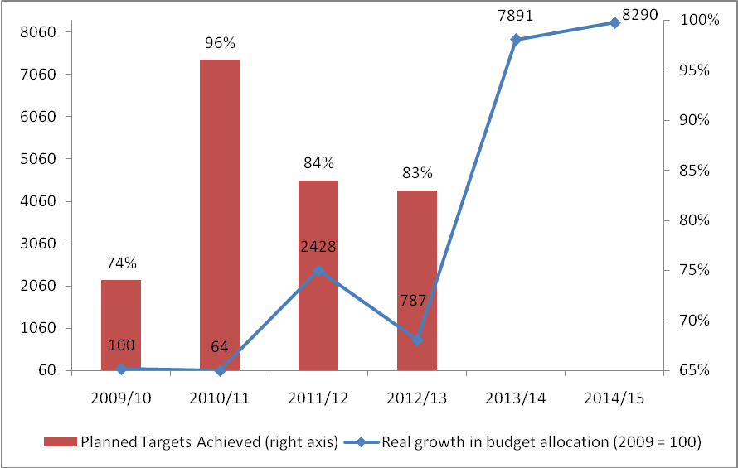

(Source: National Treasury 2009 - 2014)

Programme 5: Financial Systems and Accounting

Table: Programme 5 Budget Allocations
 | 2009/10 | 2010/11 | 2011/12 | 2012/13 |  |  | 2013/14 |  |  | 2014/15 | 2009/10 - 2014/15
 | Audited outcome  R' 000 | Audited outcome  R' 000 | Audited outcome  R' 000 | Adjusted appropriation  R' 000 | Shortfall on planned Q1 - Q4 expenditure R' 000 | % Variance | Adjusted appropriation  R' 000 | Shortfall on planned  Q1 – Q3 expenditure R' 000 | % Variance | Budget estimate R' 000 | Compound average annual growth rate (%)
 | 542 700 | 559 100 | 608 020 | 686 335 | 46 898 | 6.8% | 734 700 | 142 150 | 29.10% | 761 600 | 9.76%
Nominal growth in budget allocation (yoy %) | 99.0% | 3.0% | 8.7% | 12.9% |  |  | 7.05% |  |  | 3.66%
Real growth in budget allocation (yoy %) | 91.9% | -1.3% | 3.7% | 7.2% |  |  | 1.27% |  |  | -1.93% | 3.45%
Planned targets achieved | 94% (30 out of 32) | 90% (35 out of 39) | 69% (33 out of 48) | 54% (29 out of 54)
(Source: National Treasury 2009 - 2014)

Following an increase of almost 100% of the budget for the Financial Systems and Accounting programme in 2009/10, the budget remained relatively stable in real terms up until 2012/13 where the budget grew by 7.2 per cent in real terms. The adjusted appropriation in the subsequent year was then increased by 1.27 per cent in real terms only to be decreased in 2014/15 by 1.93 per cent in real terms.

The budget for 2014/15 is 8 per cent greater than the budget of 2009 in real terms.

In 2011/12, the programme exhibited under-expenditure of 17 per cent, which amounted to just over R100 million. In 2012/13 the shortfall on planned expenditure was 6.8 per cent and as of the end of the third quarter of 2013/14, the shortfall on planned expenditure was 29.1 per cent.

Issue for consideration:

- The department should provide an explanation for the volatility in actual expenditure in relation to planned expenditure?

Figure 5: Budget Growth versus Planned Targets Achieved
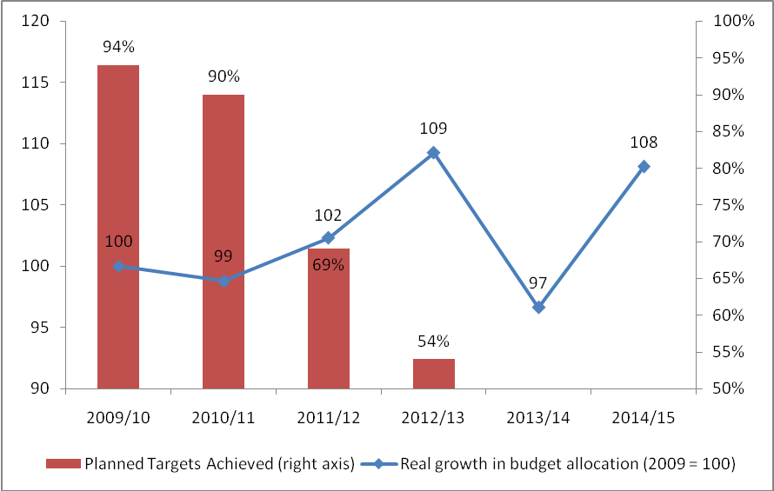

(Source: National Treasury 2009 - 2014)

The most significant increase in the budget for 2014/15 relates to the Office of the Chief Procurement Officer sub-programme which increases by R7.69 million, resulting in a 17.8 per cent increase. The Office of the Chief Procurement Officer sub-programme was established in 2013/14 to improve procurement systems in government and combat fraud, corruption, wasteful expenditure and to bring about efficiency and cost effectiveness of procurement across government. This sub-programme will be capacitated gradually over the medium term due to budgetary constraints, which the department plans to manage by reprioritising funds where possible. This sub-programme makes up a relatively small proportion (6.7 per cent) of the overall budget for the programme.

The largest portion of the budget goes to the Financial Systems sub-programme which accounts for approximately 57.1 per cent of the overall budget. Growth in this sub-programme is relatively flat (1.4 per cent) for 2014/15, which is significantly less than the inflation forecast for 2014 of 6.2 per cent.

The core objectives of the programme are predominantly addressed through this sub-programme. These objectives include improving the regulatory framework for all spheres of government, as well as building capacity to ensure compliance with legislation and reporting policies.
The vast majority of the budget for this sub-programme (91.9 per cent) is to be spent on upgrading the existing financial management, supply chain and human resource systems which the department states are ageing and fragmented. The department explains that in September 2013, the integrated financial management system steering committee took the decision to upgrade the aforementioned systems by delivering a single commercial, over the shelf packaged system. The roll out of the system has been fast tracked and the department have explained that new contracts will be entered into at the beginning of 2014/15 in this regard.

Issue for consideration:

- What is the status of the rollout of the upgrading of the existing financial management, supply chain and human resource systems? What are the deadlines attached to the rollout and have the contracts mentioned in the 2014 Estimates of National Expenditure been concluded as planned?

Programme 6: International Financial Relations

Table: Programme 6 Budget Allocations

 | 2009/10 | 2010/11 | 2011/12 | 2012/13 |  |  | 2013/14 |  |  | 2014/15 | 2009/10 - 2014/15
 | Audited outcome  R' 000 | Audited outcome  R' 000 | Audited outcome  R' 000 | Adjusted appropriation  R' 000 | Shortfall on planned Q1 - Q4 expenditure R' 000 | % Variance | Adjusted appropriation  R' 000 | Shortfall on planned  Q1 – Q3 expenditure R' 000 | % Variance | Budget estimate R' 000 | Compound average annual growth rate (%)
 | 576 400 | 558 700 | 876 839 | 1 040 498 | 38 718 | 3.7% | 1 092 000 | 3 300 | 10.50% | 1 179 800 | 10.16%
Nominal growth in budget allocation (yoy %) | - | -3.1% | 56.9% | 18.7% |  |  | 4.95% |  |  | 8.04%
Real growth in budget allocation (yoy %) | - | -7.4% | 51.9% | 13.0% |  |  | -0.71% |  |  | 2.21% | 3.82%
Planned targets achieved | 88% (7 out of 8) | 100% (4 out of 4) | 100% (5 out of 5) | 54% (13 out of 24)
(Source: National Treasury 2009 - 2014)

Following a reduction in the budget for this programme in 2010/11, allocations were increased by 56.9 per cent in real terms in 2011/12 followed by gradually diminishing increases in 2012/13 and 2013/14. The budget allocation for 2014/15 represents a 2.21 per cent increase in real terms and appears to represent the levelling off of the budget for this programme at a level 58 per cent larger than the 2009/10 budget after accounting for inflation.

Shortfalls on planned expenditure have been relatively modest in recent years although the 10.5 per cent shortfall as at the end of Q3 in 2013/14 may represent a reversal of this trend. A similar trend was however evident in 2012/13 where a similar shortfall was realised only to be reduced to 3.7 per cent by the end of Q4.

Issue for consideration:

- The department should provide a detailed explanation regarding the trend of recording significant shortfalls on third quarter planned expenditure followed by a substantial reduction in the shortfall by the end of the fourth quarter.

Figure 6: Budget Growth versus Planned Targets Achieved
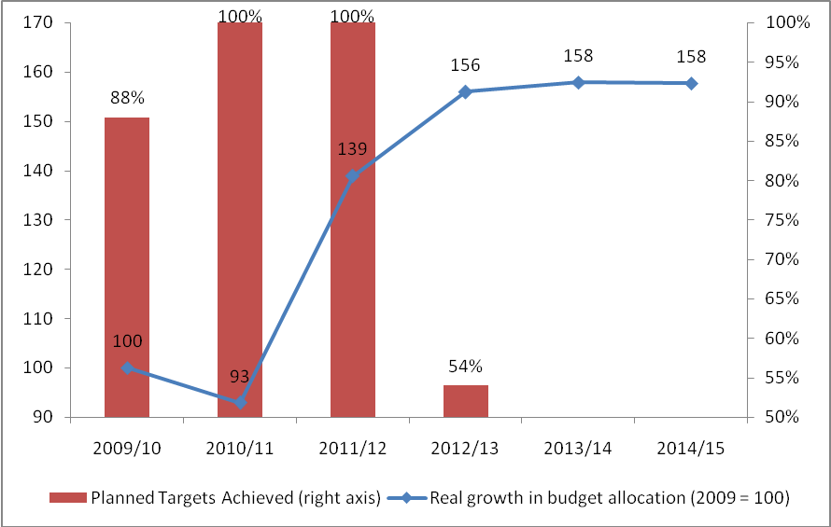

(Source: National Treasury 2009 - 2014)

The department reports that 95 per cent of the programme’s expenditure is allocated for transfer payments to foreign governments and international organisations to meet the country’s international obligations and for payments for financial assets for the equity purchase of shares.

The primary financial obligations of the programme in the 2014/15 financial year are the transfer payments made to the common monetary area compensation to pay for Rand circulation in neighbouring countries, the African Development Bank and African Development Fund to recapitalise the entities and buy shares, and the replenishment of the African Development Fund.

Transfers towards Common Monetary Area Compensation increase by R8.99 million or 1.5 per cent to R622.84 million for the upcoming financial year.

Transfers to the African Development Bank and African Development Fund increase by R36.59 million (91 per cent increase) in 2014/15 after an increase of R26.6 million (11.4 per cent increase) in 2013/14.

A final issue for consideration is the fact that the department has increased its allocation for compensation of employees by 11.95 per cent in 2014.15 after an increase of 21.3% in 2013/14. Both increases are in excess of inflationary measures.

Issue for consideration:

- The department should provide the committee with an update report on the progress of the African Development Bank and African Development Fund.

Programme 7: Civil and Military Pensions, Contributions to Funds and Other Benefits

Table: Programme 7 Budget Allocations
 | 2009/10 | 2010/11 | 2011/12 | 2012/13 |  |  | 2013/14 |  |  | 2014/15 | 2009/10 - 2014/15
 | Audited outcome  R' 000 | Audited outcome  R' 000 | Audited outcome  R' 000 | Adjusted appropriation  R' 000 | Shortfall on planned Q1 - Q4 expenditure R' 000 | % Variance | Adjusted appropriation  R' 000 | Shortfall on planned  Q1 – Q3 expenditure R' 000 | % Variance | Budget estimate R' 000 | Compound average annual growth rate (%)
 | 4 955 100 | 2 697 800 | 3 776 909 | 3 345 872 | 8 157 | 0.2% | 3 497 000 | -1 475 | -3.80% | 3 717 800 | 9.79%
Nominal growth in budget allocation (yoy %) | 112.6% | -45.6% | 40.0% | -11.4% |  |  | 4.52% |  |  | 6.31%
Real growth in budget allocation (yoy %) | 105.5% | -49.9% | 35.0% | -17.1% |  |  | -1.12% |  |  | 0.58% | 3.47%
Planned targets achieved | 33% (2 out of 6) | 78% (7 out of 9) | 50% (5 out of 10) | 69% (9 out of 13)
(Source: National Treasury 2009 - 2014)

After the budget allocation of 2009/10 was increased by 105.5 per cent in real terms from 2008/09, the budgets for subsequent years fluctuated from large decreases in 2010/11 (45.6 per cent nominal) to increases in 2011/12 (40 per cent nominal).

In fact, the 2010/11 allocation represented a halving of the budget, followed by a 35 per cent real increase in 2011/12 before another reduction of 17.1 per cent in real terms in 2012/13. The 2013/14 budget allocation was therefore the exception to the rule in that it represented a significantly smaller decrease in real terms of just 1.12 per cent in relation to the previous year.

In accordance with the precedent set in 2013/14, the 2014/15 budget allocation has grown by only 0.58 per cent in real terms resulting in relatively flat budget growth.

As Figure 7 uses the relatively larger 2009/10 budget as its base, all subsequent budgets appear to be significantly discounted allocations. The budgets for 2013/14 and 2014/15 represent a 42 per cent reduction in the 2009/10 budget after accounting for inflation.

Figure 7: Budget Growth versus Planned Targets Achieved
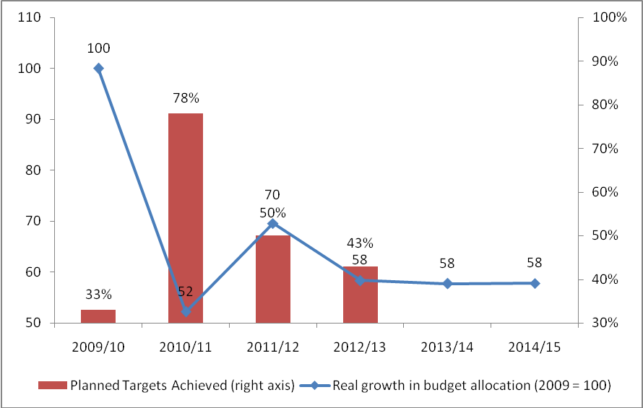

(Source: National Treasury 2009 - 2014)

Shortfalls in planned expenditure appear to be minimal. As of the end of Q3 2013/14, the programme had spent 3.8 per cent more than its expenditure benchmark.

Given that 98.4 per cent of the programme’s budget is expended through transfer payments to households, 46.2 per cent of which goes towards post-retirement medical scheme contributions, the under-expenditure of the past, reflecting substantive backlogs in benefit payments appears to have been resolved.

The department emphasises this point in the 2014 Estimates of National Expenditure where it states that the spending between 2010/11 and 2013/14 reduced the backlog of applications for benefits, such as the injury on duty benefits, by 78.3 per cent.

A noteworthy spending priority highlighted by the department is its ongoing modernisation project which has managed to automate 30 per cent of the core processes and has a total cost of R614 million.

Issue for consideration:

- The department should provide a detailed progress report to the committee regarding the modernisation project being undertaken.

Programme 8: Technical Support and Development Finance

Table: Programme 8 Budget Allocations
 | 2009/10 | 2010/11 | 2011/12 | 2012/13 |  |  | 2013/14 |  |  | 2014/15 | 2009/10 - 2014/15
 | Audited outcome  R' 000 | Audited outcome  R' 000 | Audited outcome  R' 000 | Adjusted appropriation  R' 000 | Shortfall on planned Q1 - Q4 expenditure R' 000 | % Variance | Adjusted appropriation  R' 000 | Shortfall on planned  Q1 – Q3 expenditure R' 000 | % Variance | Budget estimate R' 000 | Compound average annual growth rate (%)
 | 5 310 700 | 1 471 300 | 4 641 940 | 1 999 636 | 5 345 | 0.3% | 2 484 000 | 23 850 | 18.60% | 3 712 200 | 19.59%
Nominal growth in budget allocation (yoy %) | - | -72.3% | 215.5% | -56.9% |  |  | 24.22% |  |  | 49.44%
Real growth in budget allocation (yoy %) | - | -76.6% | 210.5% | -62.6% |  |  | 17.52% |  |  | 41.39% | 12.72%
Planned targets achieved |  |  | 85% (11 out of 13) | 75% (15 out of 20)
(Source: National Treasury 2009 - 2014)

Budget allocations for the Technical Support and Development Finance programme have been highly volatile due to the funding of various projects over recent years. An example would be the once off R4.2 billion provincial transfer for the Gautrain loan in 2009/10.

The programme increased by 17.52 per cent in 2013/14 and is set to increase by another 41.39 per cent in 2014/15, in real terms in both cases. The sub-programme responsible for driving the growth in the budget of the programme is the Employment Creation Facilitation sub-programme.

The implementation of the Jobs Fund though the Employment Creation Facilitation Fund sub-programme has been the primary contributor to the volatility in the budget for programme 8. The sub-programme accounts for 51 per cent of total expenditure in programme 8. Funding for the jobs fund though the Employment Creation Facilitation Fund sub-programme increased in 2013/14 by R666.1 million, representing a 107 per cent real increase from 2012/13. In 2014/15, the sub-programme’s budget increases by R945 million to R1.9 billion.

The sub-programme’s budget is forecasted to decrease by R572 million in 2015/16 and stabilise thereafter. In total, the department explain that R9 billion has been allocated to the Jobs Fund with the aim of creating 150 000 jobs over its lifespan. The fund is being implemented through the Development Bank of Southern Africa and as of the end of Q3 2013/14, had approved 89 projects to the value of R4.5 billion.

Issue for consideration:

- The department should report back to the committee and explain how many permanent jobs have been created by the Jobs Fund to date including specific examples of projects that have been particularly successful. In comparison to other incentives available to the department, how does the Jobs Fund compare in terms of the cost per one job created.

The Local Government Financial Management and Skills Development Grant, Neighbourhood Development Partnership Grant and Employment Creation Facilitation Fund sub-programmes together account for 77.4 per cent of the total expenditure in the programme.

The under-expenditure in this programme in recent years appears to have been addressed as of 2012/13. The 2013/14 Q3 expenditure report indicates under-expenditure of 18.6 per cent. It is worth noting that in the case of many government grants, a disproportionate share of allocated funds are transferred in the final quarter of the financial year. The large shortfalls in planned expenditure at the end of Q3 are therefore not a good indicator of end of financial year shortfalls.

A central spending priority in 2014/15 will be on supporting infrastructure development through the neighbourhood development partnership grant and integrated cities development grant. The objective of these grants is to develop skills in infrastructure development in aspiring artisans, technicians, engineers and other specialists.

Due to the importance of these sub-programmes in fulfilling the objectives of the NDP, the department should explain to the committee how it intends to ensure that funds allocated to these noteworthy initiatives are utilised to achieve these objectives.

Issue for consideration:

- The department should explain to the committee how it intends to ensure that funds allocated to the Neighbourhood Development Partnership Grant and integrated cities development grant are utilised to achieve their objectives. These grants directly fund initiatives aimed at achieving critical objectives outlined in the NDP and highlighted by the President in the State of the Nation Address as well as the Minister of Finance in his budget speech. The department should therefore present a detailed report outlining the following information:

- How has under expenditure on these grants affected the development of infrastructure specialists?
- What interventions have been made in cases where funds have not been as effectively utilised as intended?

As a result of the high base provided by the budget allocation for 2009/10 as a result of the Gautrain loan, the budget for 2014/15 represents 54 per cent of the budget for 2009/10 in real terms.

Figure 8: Budget Growth versus Planned Targets Achieved
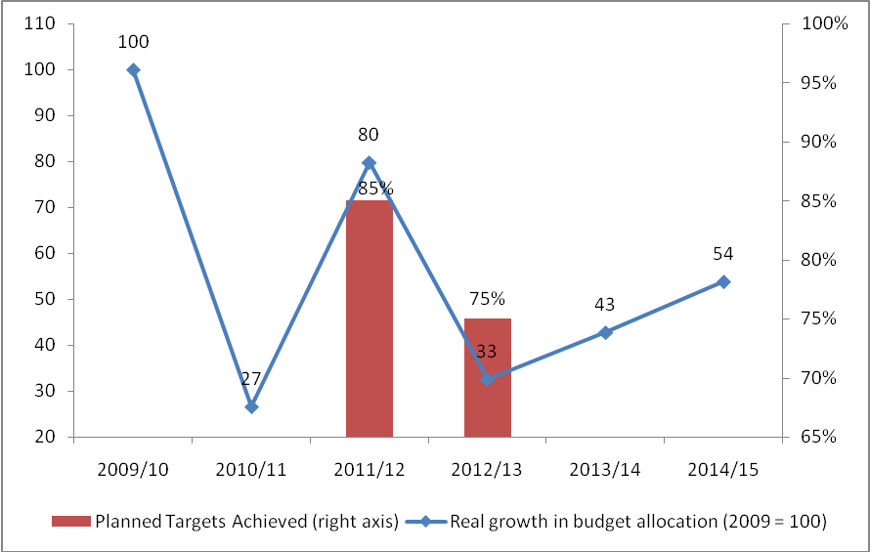

(Source: National Treasury 2009 - 2014)
Programme 9: Revenue Administration

Table: Programme 9 Budget Allocations
 | 2009/10 | 2010/11 | 2011/12 | 2012/13 |  |  | 2013/14 |  |  | 2014/15 | 2009/10 - 2014/15
 | Audited outcome  R' 000 | Audited outcome  R' 000 | Audited outcome  R' 000 | Adjusted appropriation  R' 000 | Shortfall on planned Q1 - Q4 expenditure R' 000 | % Variance | Adjusted appropriation  R' 000 | Shortfall on planned  Q1 – Q3 expenditure R' 000 | % Variance | Budget estimate R' 000 | Compound average annual growth rate (%)
 | 7 148 400 | 8 142 200 | 8 653 573 | 9 149 374 | - | - | 9 534 400 | - | - | 9 440 300 | 8.44%
Nominal growth in budget allocation (yoy %) | - | 13.9% | 6.3% | 5.7% |  |  | 4.21% |  |  | -0.99%
Real growth in budget allocation (yoy %) | - | 9.6% | 1.3% | 0.0% |  |  | -1.41% |  |  | -6.33% | 2.20%
(Source: National Treasury 2009 - 2014)

The entire allocation of the Revenue Administration programme is transferred to the South African Revenue Service (SARS) to provide core tax administration services and maintain IT services that support its operations. The Revenue Administration programme receives the largest budget in the department amounting to R9.5 billion or 37.3 per cent in 2013/14 and R9.44 billion or 34.6 per cent in 2014/15.

Following a 9.6% real increase in the budget allocation for transfers to SARS in 2010/11, the allocations have remained flat since with a marginal reduction (-1.41%) in real terms for the 2013/14 financial year. The allocation for 2014/15 has been reduced by 6.33 per cent in real terms and represents a tightening of the budget.

The department has indicated that, the increase in 2010/11 was primarily due to “heightened border control activities, the start of specific customs projects, the graduate recruitment programme and the modernisation of Information and Communication Technologies (ICT) systems”.

The subsequent moderate increases are illustrated in Figure 9, which shows that the budget allocation for 2013/14 represented a 9% increase on the 2009/10 budget in real terms. Given the proposed real reduction in budget for the upcoming year, the budget in 2014/15 is 2 per cent greater than the budget in 2009/10 in real terms.

Figure 9: Budget Growth versus Planned Targets Achieved
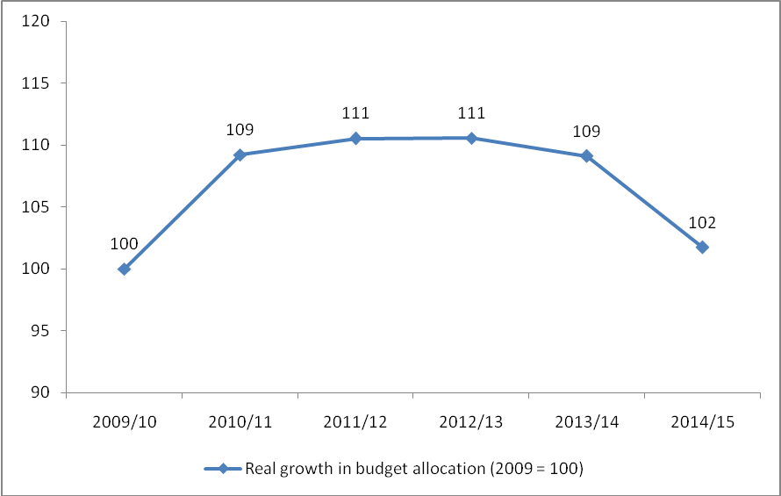

(Source: National Treasury 2009 - 2014)

The budget tightening is explained by the department as being the result of a Cabinet approved baseline reduction of R1.4 billion on the transfer over the medium term. The department explains that the reduction is unlikely to have a negative impact on the performance of the entity due to the fact that the entity has accumulated adequate accumulated surplus to cover its operations.

Programme 10: Financial Intelligence and State Security

Table: Programme 10 Budget Allocations
 | 2009/10 | 2010/11 | 2011/12 | 2012/13 |  |  | 2013/14 |  |  | 2014/15 | 2009/10 - 2014/15
 | Audited outcome  R' 000 | Audited outcome  R' 000 | Audited outcome  R' 000 | Adjusted appropriation  R' 000 | Shortfall on planned Q1 - Q4 expenditure R' 000 | % Variance | Adjusted appropriation  R' 000 | Shortfall on planned  Q1 – Q3 expenditure R' 000 | % Variance | Budget estimate R' 000 | Compound average annual growth rate (%)
 | 3 193 900 | 3 488 200 | 3 755 021 | 3 982 121 | - | - | 4 174 600 | - | - | 4 366 300 | 9.54%
Nominal growth in budget allocation (yoy %) | - | 9.2% | 7.6% | 6.0% |  |  | 4.83% |  |  | 4.59%
Real growth in budget allocation (yoy %) | - | 4.9% | 2.6% | 0.3% |  |  | -0.82% |  |  | -1.05% | 3.25%
(Source: National Treasury 2009 - 2014)

The Financial Intelligence and State Security programme is set to have the second largest budget in the department in 2014/15 at R4.37 billion.

The purpose of the programme is centred around the “combating of money laundering activities and terror financing activates”. The legislation giving power to the sub-programme is the Financial Intelligence Centre Act (no.38, 2001).

In this regard, the programme is comprised of two sub-programmes, namely the Financial Intelligence Centre and the Secret Services. In 2014/15, R4.17 billion or 96.1 per cent of the budget for this programme will be transferred to the South African Secret Services Account, up from 91.4 per cent in 2013/14.

Due to the substantial size of the South African Secret Services budget allocation (grown from 13.8 per cent of National Treasury’s budget in 2013/14 to 15.29 per cent in 2014/15); an analysis of its real growth trend is appropriate.

Issue for consideration:

- The department should provide a progress report on the service delivery implementation and performance of the institution, as well as provide a report on the monitoring mechanisms that are applied in this regard.
.
Since 2009/10 and prior to the 2013/14 financial year, the budget allocation for the South African Secret Services (SASS) has consistently increased at levels above inflation. After 2012/13, the budget has begun to retract marginally in real terms.

The compound average annual growth rate of the programme across the period 2010/11 – 2014/15 has been 9.54 per cent.

Figure 10 captures the trends mentioned above by revealing that the budget allocation for the 2014/15 is 5 per cent higher than it was in 2009/10 after accounting for inflation.

Figure 10: Budget Growth versus Planned Targets Achieved
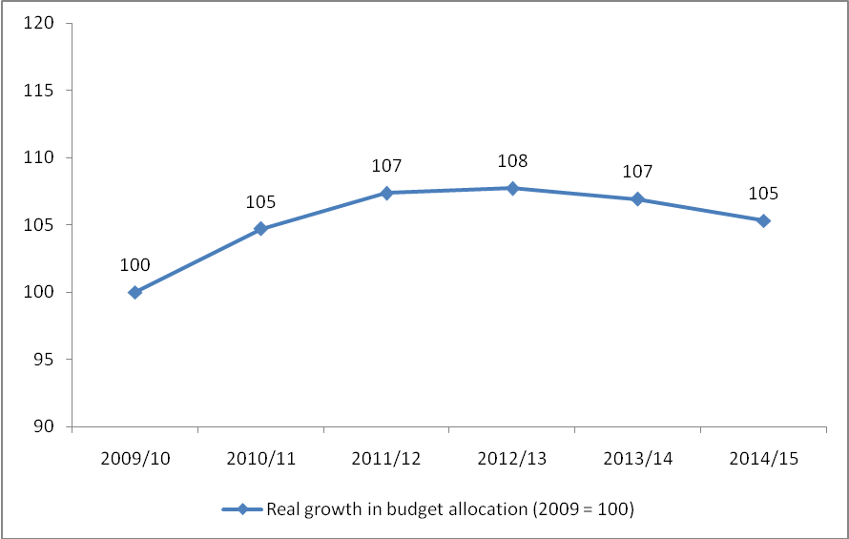

(Source: National Treasury 2009 - 2014)

Further analysis explains the reduction in budget for the SASS in recent years. In 2012/13, the department indicated that it would embark upon a gradual reduction in the allocation to the SASS over the medium term starting. The reduction in real terms is set to continue, as the department has committed to reducing the transfer to the SASS over the medium term such that the average growth rate in the budget will be 4.9 per cent, which is less than the forecasted inflation rate.

Key Issues for Consideration by Parliament

- How does the department envisage striking the balance between cost containment and service delivery, given the massive infrastructure investment that is still needed and the widespread service delivery protests experienced in the country over the last year?

- Public Sector wage bill growth has been the one of the major concerns in government expenditure over the past years, currently accounting for 39.5 per cent of non-interest expenditure. Given government’s commitment to fiscal consolidation and the fact that CPI is forecasted to be 6.2 per cent in 2014/15, does government still expect to contain public sector wage settlements to 6.4 per cent during the next round of negotiations with labour unions, given that labour unions generally adopt a strategy of negotiating for wage settlements of CPI plus 1 per cent?

Programme 1: Administration

- What are reasons for the shortfall on planned expenditure in Programme 1 over the last few years? How does the department intend to rectify these occurrences?

- Given that Programme 1 appears to record persistent shortfalls in planned expenditure due to unfilled vacancies, how does the department plan to reduce the number of vacancies in the programme on a consistent basis?

- How will the department ensure that service delivery standards are not compromised by the significant reductions in budget to various sub-programmes?

Programme 2: Economic Policy, Tax, Financial Regulation and Research

- Given that programme 2 has a recent history of relatively significant under-expenditure due to unfilled vacancies, how does the department intend to fill these vacancies with appropriate candidates and furthermore, how does the department justify the need for additional funding in excess of inflationary requirements?

- The department should provide an explanation as to the persistent vacancies in programme 2. Despite reassurances in each of the last two years that the vacancies would be filled, this is yet to happen.

- The department should provide a consultant expenditure target to the committee with specific reference to what it would consider to be the optimal mix between research conducted in-house versus research outsourced. Furthermore, the department should highlight any existing capacity constraints within the programme and detail to the committee the impact of these constraints on service delivery.

Programme 3: Public Finance and Budget Management

- The department should detail their plan to boost capacity within key units so as to fill the 47 vacancies that exist within the programme.

- The department should explain what impact the reduction in the budget for the FFC is likely to have on the entity in terms of it being able to fulfil its constitutional mandate. The Committee should invite the FFC to report on their budgetary requirements and the potential impact the budget decreases have had and are likely to have on the institution.

Programme 4: Asset and Liability Management

- The department should update the committee on the status of the recapitalisation of the Land and Agricultural Development Bank of South Africa, Postbank and Development Bank of Southern Africa. What are the risks associated with each entity in terms of requiring further financial support beyond 2015/16?

Programme 5: Financial Systems and Accounting

- The department should provide an explanation for the volatility in actual expenditure in relation to planned expenditure?

- What is the status of the rollout of the upgrading of the existing financial management, supply chain and human resource systems? What are the deadlines attached to the rollout and have the contracts mentioned in the 2014 Estimates of National Expenditure been concluded as planned?

Programme 6: International Financial Relations

- The department should provide a detailed explanation regarding the trend of recording significant shortfalls on third quarter planned expenditure followed by a substantial reduction in the shortfall by the end of the fourth quarter.

- The department should provide the committee with an update report on the progress of the African Development Bank and African Development Fund.

Programme 7: Civil and Military Pensions, Contributions to Funds and Other Benefits

- The department should provide a detailed progress report to the committee regarding the modernisation project being undertaken.

Programme 8: Technical Support and Development Finance

- The department should report back to the committee and explain how many permanent jobs have been created by the Jobs Fund to date including specific examples of projects that have been particularly successful. In comparison to other incentives available to the department, how does the Jobs Fund compare in terms of the cost per one job created.

- The department should explain to the committee how it intends to ensure that funds allocated to the Neighbourhood Development Partnership Grant and integrated cities development grant are utilised to achieve their objectives. These grants directly fund initiatives aimed at achieving critical objectives outlined in the NDP and highlighted by the President in the State of the Nation Address as well as the Minister of Finance in his budget speech. The department should therefore present a detailed report outlining the following information:
  - How has under expenditure on these grants affected the development of infrastructure specialists?
  - What interventions have been made in cases where funds have not been as effectively utilised as intended?

Programme 9: Revenue Administration

- None

Programme 10: Financial Intelligence and State Security

- The department should provide a progress report on the service delivery implementation and performance of the institution, as well as provide a report on the monitoring mechanisms that are applied in this regard.

References

Auditor-General South Africa (2013). Consolidated general report on the audit outcomes of Local Government 2010/11. Pretoria, Auditor-General South Africa.

Gordhan, P J. (2014). Budget Speech on 26 February, Cape Town, Parliament of South Africa.

National Treasury (2013). 4th Quarter Expenditure Report 2012/13, Pretoria, National Treasury.

National Treasury (2014). 3rd Quarter Expenditure Report 2013/14, Pretoria, National Treasury.

National Treasury (2012). Annual Performance Plan 2012/16, Pretoria, National Treasury.

National Treasury (2010). Annual Report 2009/10, Pretoria, National Treasury.

National Treasury (2011). Annual Report 2010/11, Pretoria, National Treasury.

National Treasury (2012). Annual Report 2011/12, Pretoria, National Treasury.

National Treasury (2013). Annual Report 2012/13, Pretoria, National Treasury.

National Treasury (2010). Budget 2010: Estimates of National Expenditure, Pretoria, National Treasury.

National Treasury (2013). Budget 2013: Estimates of National Expenditure, Pretoria, National Treasury.

National Treasury (2014). Budget 2013: Estimates of National Expenditure, Pretoria, National Treasury.

National Treasury (2012). Strategic Plan 2012/13-2015/16, Pretoria, National Treasury.

National Treasury (2014).
National Treasury, ibid.
National Treasury (2012).
National Treasury (2010).
National Planning Commission (2012).
Budget Speech (2014).
Budget Speech (2014).
With Reference to all subsequent tables: Figures for 2009/10 - 2014/15 have been taken from National Treasury’s Estimates of National Expenditure and Adjusted Estimates of National Expenditure (2008/09-2014/15). In addition, shortfall on planned expenditure figures for 2012/13 and 2013/14 have been taken from National Treasury’s 2012/13 Q4 and 2013/14 Q3 Quarterly Expenditure Reports.
The department’s programme 1 achieved 32 per cent of its performance targets in their entirety throughout the 2012/13 financial year. This outcome is partially as a result of the methodology employed in the reporting of performance information. Ambiguous performance information, relating to specific performance targets, resulted in several targets being recorded as not achieved.
National Treasury (2014).
National Treasury (2014).
National Treasury (2014).
National Treasury (2014).
National Treasury (2014).
National Treasury (2014).
ibid.
National Treasury (2014).
The department’s programme 5 achieved 54 per cent of its performance targets in their entirety throughout the 2012/13 financial year. This outcome is partially as a result of the methodology employed in the reporting of performance information. Ambiguous performance information, relating to specific performance targets, resulted in several targets being recorded as not achieved.
National Treasury (2014).
The department’s programme 6 achieved 54 per cent of its performance targets in their entirety throughout the 2012/13 financial year. This outcome is partially as a result of the methodology employed in the reporting of performance information. Ambiguous performance information, relating to specific performance targets, resulted in several targets being recorded as not achieved.
National Treasury (2014).
National Treasury (2014).
National Treasury, ibid.
National Treasury (2014).
Ibid.
National Treasury (2014).
Ibid.
National Treasury (2014).
National Treasury (2013).
No planned targets are given in the Annual Report for Programme 9
National Treasury (2014).
National Treasury (2014).
No planned targets are given in the Annual Report for Programme 10.

