Table of Contents
- ACKNOWLEDGEMENTS 3
ii. ABBREVIATIONS 4
iii. MAP OF AFRICA 11
iv. Key Country Facts 12
v. MESSAGE FROM THE PRESIDENT OF THE REPUBLIC OF SOUTH AFRICA 15
vi. FOREWORD BY THE FOCAL POINT: MINISTER FOR PUBLIC SERVICE AND ADMINISTRATION ................................................................................................................18
1. EXECUTIVE SUMMARY 20
1.2 SUMMARY OF KEY RESPONSES 22
2 INTRODUCTION 29
3 PROGRESS ON THEMATIC AREAS 31
3.1 DEMOCRACY AND POLITICAL GOVERNANCE 31
3.1.1 Improving public participation and access to information 31
3.1.2 Public Consultation, education and feedback in policy making 37
3.1.3 Reducing crime and violence in general and particularly against women and children 38
3.1.4 Awareness campaigns and access to justice for the full enjoyment of human rights / Access to information on human rights and institutions of Justice 40
3.1.5 Institutionalisation of Democracy and Good Governance 42
3.1.6 Strengthening the institution of traditional leadership 45
3.1.7 Intensifying the fight against corruption/ tackling corruption 46
3.2 ECONOMIC GOVERNANCE AND MANAGEMENT 49
3.2.1 Public Expenditure Management Capacity Development 49
3.2.2 Improving economic integration in SADC 51
3.2.3 Unemployment 54
3.3 CORPORATE GOVERNANCE 64
3.3.1 Companies legislation and transformation 64
3.3.2 The planning and conduct of companies in the private sector 68
3.3.3 Key institutions and certain social groups need to become more effective 69
3.3.4 Consumers and shareholder activism to assert their rights 71
3.3.5 Governance within civil society 71
3.4 SOCIO-ECONOMIC DEVELOPMENT 72
3.4.1 Increasing the pace of land reform and access to rural land 72
3.4.2 Combating HIV and AIDS and other communicable deseases 74
3.4.3 Improving access to and outcomes of the education system at all levels 93
3.4.4 Ensuring affordable access to shelter, water and sanitation to all citizen (basic services), especially the rural poor 97
3.4.5 Addressing Service Delivery Challenges 99
3.4.6 Poverty and Inequality 103
4. CROSS-CUTTING ISSUES 108
4.1 Xenophobia 108
4.2 Racism 110
5. Matrix..................................................................................................................................112
6. List of References 139

i. ACKNOWLEDGEMENTS
The African Peer Review Mechanism (APRM) National Governing Council (NGC) of the Republic of South Africa hereby acknowledges the active role played by representatives of government, civil society, and all participants in the national and provincial consultative workshops. We wish to acknowledge, in particular, the following institutions:
a) South African Council of Churches
b) South African NGO Coalition
c) South African Civics Organization
d) NEPAD Business Foundation
e) Academia and Professionals
f) Congress of South African Trade Unions
g) Business Unity South Africa
h) Congress of Traditional Leaders of South Africa
i) Women’s National Coalition
J) National Children’s Rights Committee
k) South African Youth Council
l) Disabled People of South Africa
m) Heritage, Indigenous Knowledge, Arts and Culture Institutions
Many of the civil society organizations listed above are affiliated to the African Union’s Economic, Social and Cultural Council (ECOSOCC) South African Chapter. We also wish to acknowledge and thank the various authors who wrote different sections of the report as well as the convenor of the writing team and editor of the entire report. The NGC further acknowledges the role played by the Government of the Republic of South Africa and the Business sector in the activities of the APRM in general and their contributions during the preparation of this report.
Special thanks also go to the South African Human Rights Commission (SAHRC) and the Parliament of the Republic of South Africa for consistently making sure that policy issues relating to the fight against racism and xenophobia are confronted and addressed. Racism and xenophobia are the two cross-cutting issues South Africa was tasked to isolate for more examination during the third APRM progress reporting period in 2013. Based on the work of the SAHRC and Parliament of the Republic of South Africa (as well as provincial legislatures) we are able to report progress as well as the remaining challenges on these issues.

ii. ABBREVIATIONS

AA Affirmative Action

AFCON Africa Cup of Nations

AfDB African Development Bank

AG Auditor - General

AIDS Acquired Immune Deficiency Syndrome

ANC African National Congress

APR Forum African Peer Review Forum

APR Panel African Peer Review Mechanism Panel of Eminent Persons

APRM African Peer Review Mechanism

ART Anti Retroviral Treatment

ATAF African Tax Administration Forum

AU African Union

B – BBEE Broad-Based Black Economic Empowerment

BCOCC Border Control Operational Coordinating Committee

BBC Black Business Council

BEE Black Economic Empowerment

BRICS Brazil, Russia, India, China and South Africa

BURS Botswana Unified Revenue Service

BUSA Business Unity South Africa

CAPAM Commonwealth Association of Public Administration and Management

CCMA Commission for Conciliation, Mediation and Arbitration

CDW Community Development Workers

CETA Construction Education Training Authority

CIP Compulsory Induction Programme

CIPC Companies and Intellectual Property Commission

CMSA Chamber of Mines of South Africa

COGTA Co-operative Governance and Traditional Affairs

COMESA Common Market for Eastern and Southern Africa

CONTRALESA Congress of Traditional Leaders of South Africa

COSATU Congress of South African Trade Unions

CPA Consumer Protection Act

CPF Community Police Forum

CRDS Comprehensive Rural Development Strategy

CSG Child Support Grant

CSO Civil Society Organization

CSTC Care and Support for Teaching and Learning Framework

CSTL Care and Support for Teaching and Learning

DAC Department of Arts and Culture

DAFF Department of Agriculture, Forestry and Fisheries

DBSA Development Bank of Southern Africa

DCS Department of Correctional Services

DHA Department of Home Affairs

DHET Department of Higher Education and Training

DoJCD Department of Justice and Constitutional Development

DoT Department of Transport

DEA Department of Environmental Affairs

DED Department of Economic Development

DMR Department of Mineral Resources

DPME Department of Peformance Management and Evaluation

DPSA Department of Public Service and Administration

DRC Democratic Republic of the Congo

DTCA Dutch Tax and Customs Administration

DTI Department of Trade and Industry

DWA Department of Water Affairs

EAC East African Community

ECD Early Childhood Development

ECOSOCC Economic, Social and Cultural Council

ECOSOCC-SA Economic, Social and Cultural Council-South Africa

EDD Economic Development Department

EIA Environmental Impact Assessment Barometer

EPC Environment Policy Committee

ERF Economic Reporting Formats

FEDUSA Federation of Unions of South Africa

FET Further Education and Training

FTA Free Trade Area

FTE Full Time Equivalent

EPWP Expanded Public Works Programme

GDACE Gauteng Department of Agriculture, Environment and Conservation

HCT HIV Counselling and Testing

HIV Human Immuno Virus

HLFA High Level Forum on Aid

HSGIC Heads of State and Government Implementation Committee

HSRC Human Sciences Research Council

IACF Inter Agency Clearing Forum

IBSA India, Brazil, South Africa

ICD Independent Complaints Directorate

IDASA Institute for Democracy in Africa

IDP Integrated Development Plan

IDP Framework Inter Departmental Governance Framework

IJR Institute for Justice and Reconciliation

ILO International Labour Organisation

IMF International Monetary Fund

INTOSAI International Organization of Supreme Audit Institutions

IPAP Industrial Policy Action Plan

IT Information Technology

I-TECH International Training and Education Center for Health

LABSA Legal Aid Board of South Africa

LEDs Local Economic Development Plans

LGMR Local Government Municipal Regulations

LGTAS Local Government Turn Around Strategy

MDGs Millennium Development Goals

MEC Member of the Executive Council

MED Ministry of Economic Development

MIGDETT Mining Industry Growth, Development and Employment Task Team

MINTECH Minister and Technical Committee

MIP Massified Induction Programme

MISA Municipal Infrastructure Support Agency

MoU Memorandum of Understanding

MPAT Management Performance Assessment Tool

MPSA Minister for Public Service and Administration

MRDLR Ministry of Rural Development and Land Reform

MTSF Medium Term Strategic Framework

NACF National Anti- corruption Forum

NACH National Anti-Corruption Hotline

NACTU National Council of Trade Unions

NAFCOC National African Chamber of Commerce and Industry

NAP National Action Plan

NAPWA National Assossiciation of People Living with AIDS

NARYSEC National Rural Youth Service Corps

NCC National Consumer Commission

NCOP National Council of Provinces

NCT National Consumer Tribunal

NDoH National Department of Health

NDP National Development Plan

NEDLAC National Economic Development and Labour Council

NEDP National Export Development Programme

NEPAD New Partnership for Africa’s Development

NFAR National Forum Against Racism

NFWF National Framework on Ward Funding

NGC National Governing Council

NGP New Growth Path

NHI National Health Insurance

NHLS National Health Laboratory Services

NPA National Prosecution Authority

DPME Department of Performance Monitoring and Evaluation

NSDA Negotiated Service Delivery Agreement

NSP National Strategic Plan

NT National Treasury

OAU Organisation of African Unity

OECD Organization for Economic Co- operation and Development

ORWRDP Oliphant’s River Water Resource Development Project

PAIA Promotion of Access to Information Act

PALAMA Public Administration Leadership and Management Academy

PCCA Prevention and Combating Crime Act

PERFAR United States Presidential Emergency Plan for AIDS Relief

PFMA Public Finance Management Act

PGCs Provincial Governing Councils

PGDS Provincial Growth and Development Strategies

PHC Primary Health Care

PICI Presidential Infrastructure Championship Initiative

PIDA Programme for Infrastructure Development in Africa

PLHIV People Living with HIV

PMTCT Prevention of Mother to Child Transmission

PoA Programme of Action

PRC Programme Review Committee of the South African AIDS Council

PSACU Public Sector Anti – Corruption Unit

PSC Public Service Commission

PSCBC Public Service Coordination and Bargaining Council

RADP Recapitalisation and Development Program

RDP Reconstruction and Development Program

RoO Rules of Origin (RoO)

RSA Republic of South Africa

SACU Southern African Customs Union

SADC Southern African Development Community

SADC FTA Southern African Development Community Free Trade Agreement

SAHRC South African Human Rights Commission

SAIEA South African Institute for Environment Assessments

SAIRR South African Institute of Race Relations

SAMBF South African Mining and Biodiversity Forum

SANAC South African National AIDS Council

SONA State of the Nation Address

SAPS South African Police Service

SARS South African Revenue Service

SAWLA South African Women Lawyers Association

SCM Supply Chain Management

SCOA Standard Charts of Accounts

SFSA Speakers’ Forum of South Africa

SGB School Governing Body

SMME Small, Medium, and Micro Enterprises

SPS Single Public Service

SRA Swaziland Revenue Authority

SRC Seychelles Revenue Commission

STATS SA Statistics South Africa

STIs Sexually Transmitted Infections

SWPN Strategic Waters Partners Network

TB Tuberculosis

TKC Trans-Kalahari Corridor

TTCs Thuthuzela Care Centres

TTT Technical Task Team

TWC Term of Office of Ward Committee

UIF Unemployment Insurance Fund

UN United Nations

UNCAC United Nations Convention against Corruption

UNDP United Nations Development Programme

UNESCO United Nations Education, Science and Cultural Organisation

UNISA University of South Africa

URP Urban Renewal Programme

VOD Victim Offender Dialogue

VRESAP Vaal River Eastern Sub-system Augmentation Project

VSS Victims of Crime Survey

WBWS Willing-Buyer Willing-Seller

WWTW Waste Water Treatment Works

iii. MAP OF AFRICA

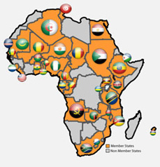

iv. KEY COUNTRY FACTS

Population
Census 2011 reflects that the total population of South Africa is 51,770,560. This figure indicates that the population size of South Africa has increased noticeably from 40, 6 million in 1996 to 51, 8 million in 2011.

The graph below reflects that overall, more than three quarters of the population is black Africans. It was 77, 4% in 1996 and increased to 79% in 2001. In 2011 the population of Black Africans had increased slightly to 79, 2% while the percentage share of the Indian/Asian population remained constant. The percentage of the white population has declined slightly from 10, 9% in 1996 to 9, 6% in 2001 and 8, 7% in 2011.

Population distribution by population group and sex

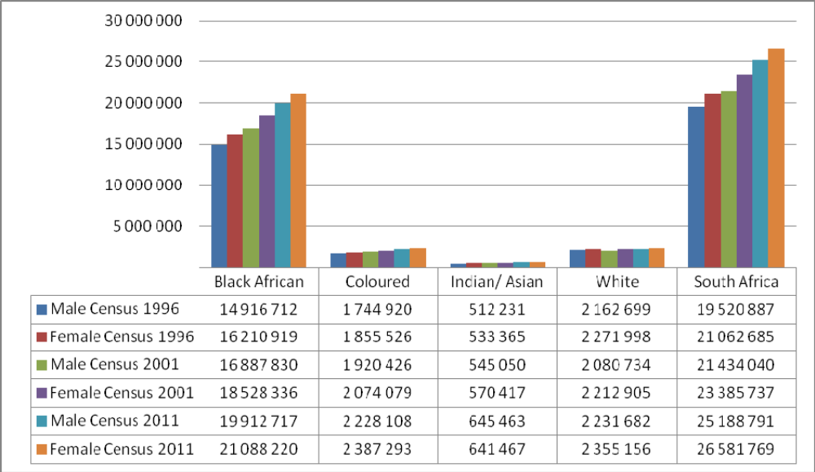
Source: Census 2011

Number of households in South Africa: Census 1996, 2001 and 2011 and Community Survey 2007
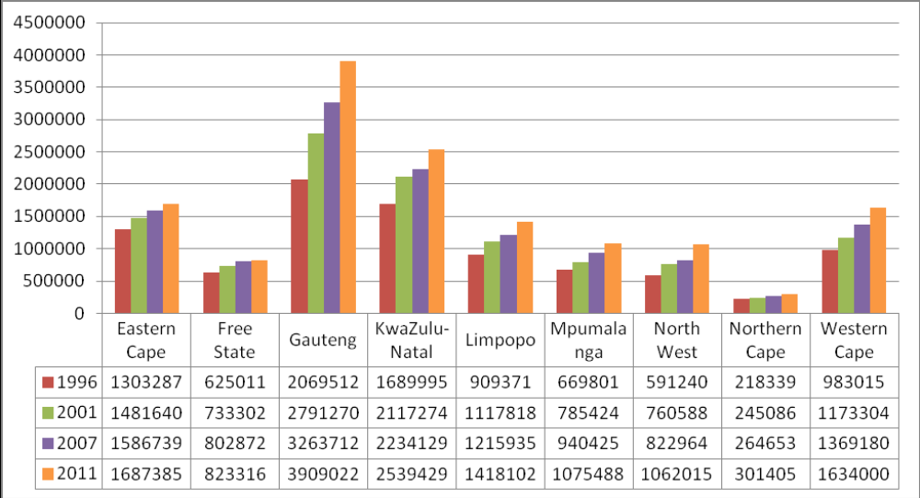
Source: Census 2011

Official languages
South African Official languages
isiZulu | 22,7%
IsiXhosa | 16%
Afrikaans | 13,5%
Sesotho sa Leboa | 9,1%
English | 9,6%
Setswana | 8%
Sesotho | 7,6%
Xitsonga | 4,5%
siSwati | 2,5%
Tshivenda | 2,4%
isiNdebele | 2,1%
Other | 0,5%
Source: Census 2011

Key factors contributing to GDP growth in South Africa
Commodity | %
Agriculture | 2.2%
Mining | 10%
Manufacturing | 12.3%
Electricity and Water | 2.6%
Construction | 3.9%
Wholesale retail and motor trade | 16.2%
transport, storage and communication | 9%
Finance, real estate and business services | 21.2%
Government services: | 16.7%
Personal services | 5.9%

Source: 2012 GDP data from Statistics SA

v. MESSAGE FROM THE PRESIDENT OF THE REPUBLIC OF SOUTH AFRICA
Once again, we are honoured as the government of the Republic of South Africa to present the Third Progress Report on the implementation of the APRM Program Action in 2013, a year of the anniversary of the first 10 years of the APRM. The year 2013 is important to the whole African continent as it also marks the first 50 years since the formation of the Organization of African Unity (OAU), and the 11 years of the formation of the African Union (AU).
During February 2013, South Africa was honoured to have hosted the Africa Cup of Nations Cup. All these events have special meaning and significance to us as a country as they are important landmarks of our involvement in building a united Africa guided by the values of democracy, peace and prosperity. As Africans, we all strive to achieve continental socio-economic renewal that can have a positive impact on the lives of our people. The APRM is therefore a mechanism which allows us to do introspection on the progress we have made and reflect on challenges that still lie ahead in pursuit of development, all the while learning from each other’s successes and complexities.
Given the relative and historically determined similarities of our social and economic circumstances as a continent, the APRM is the most effective tool for sharing our experiences. The APRM is an indigenous instrument conceived in Africa by Africans to promote and encourage the revitalisation of political democracy, economic development and achieve socio-economic progress.
This is our Third Report since we tabled our first Country Review Report for peer review at the Committee of Heads of State and Government of participating countries of the African Peer Review Mechanism (APR Forum) in July 2007, in Accra, Ghana. In recognition of the imperatives of good governance for development, the Sixth Summit of the Heads of State and Government Implementation Committee (HSGIC) of the New Partnership for Africa's Development (NEPAD), held in March 2003 in Abuja, Nigeria, adopted the Memorandum of Understanding (MOU) on the APRM. The Mechanism, which is turning out to be one of the most innovative aspects of NEPAD, is an instrument voluntarily acceded to by member states of the AU as a self-monitoring initiative for good governance.
South Africa is committed to the APRM as an instrument created by African leaders for self assessment and to focus efforts on entrenching democratic values and good governance. South Africa stands ready to contribute and commit to the objectives of the APRM as demonstrated not only by compliance with the reporting requirements of the mechanism but by honouring our responsibility to implement the Plan of Action that is intended to achieve objectives of good governance. South Africa has demonstrated in practice, our support for peace and stability in many parts of the continent as part of attempts at ensuring that the foundations for economic development as envisaged in the mechanism are in place. Accordingly, in all the instances where we have had to lend support to development, peace building and good governance we come in as part of a collective effort of African states.
The Report covers the period from October 2010 to January 2013. This period saw numerous positive developments as well as new challenges which we confront in this report openly and advance plans that government has put in place to address these challenges. We found it interesting to note that according to The Economist’s Democracy Index, The World Bank’s Governance Indicator Report, and The Institute of Race Relations Rainbow Index, South Africa achieved better scores in the areas of political stability, good citizenship, and poverty alleviation over the period 2009 – 2011.Of course, the indices also show a slight decrease recently and most notable is the decline in key areas such as the control of corruption, civil liberties, and the ability of government to provide quality public services. We consider the critique from these indices as part of the body of information which informs our strategies. As the Report shows a lot of work has been done in all the areas including the areas of decline indicated in the indices.
Among the positive developments in this reporting period are the successful local government elections held in May 2011. Like the national and provincial elections in 2009, they were declared free and fair. In 2012 the African continent celebrated together with us the first centenary celebrations of the ruling African National Congress (ANC) – one of the oldest liberation movements on the African continent. The centenary celebrations of the ANC marked a 100 years since the birth of an organised and unified fight for democracy and independence across the continent. This precipitated into various forms across the continent and slowly, democracy was hard-won by Africans. Our democracy has given birth to inclusive social and economic development, with the electoral wishes of the majority forming the mandate of governments in a new age.
This is important because without a strong ruling party endowed with rich historical experience; our democracy could have been weak. Since the dawn of democracy, under the leadership of the ANC, South Africa continues to advance and strive for a state that preserves human dignity, the independence of the judiciary, and the recognition of the supremacy of the constitution and the rule of law.
Our government also wants to acknowledge the service delivery challenges, instances of xenophobia and violence against women and children. These are challenges which have persisted over the three reporting periods and our government has developed robust mechanisms to root them out. It is in this context that various measures are being instituted to clean and strengthen the police, mobilise communities against xenophobia and violence against women and children, as well as capacitate the judiciary and oversight institutions.
I wish to conclude by acknowledging the role played by the former Ministers of Public Service and Administration in laying the foundation to the APRM report writing process. The late Minister of Public Service and Administration, Mr Roy Padayachee, in his capacity as the APRM Focal Point, a responsibility that comes with this portfolio, served in this position till his last day on earth. His sudden death was not only shocking but is a big loss to all people of the continent. I wish to acknowledge Minister Lindiwe Sisulu, who took over from the late Minister Padayachee, and has been instrumental in canvassing continued support not only for the production of this Report with various stakeholders, but also convening numerous engagements at various levels of government in recognition of their central role in the implementation of the National Programme of Action.

Thank you very much.

JACOB G. ZUMA
PRESIDENT OF THE REPUBLIC OF SOUTH AFRICA
January 2014

vi. FOREWORD BY THE FOCAL POINT: MINISTER FOR PUBLIC SERVICE AND ADMINISTRATION
As South Africa’s Focal point and the Chairperson of the National Governing Council of the African Peer Review Mechanism, in South Africa, I wish to confirm that the APRM programme is as vibrant in the country now as it was at the time we acceded to this voluntary instrument in 2003. Structures of the APRM remain well organised and functioning, poised to deal with issues as per the Programme of Action (PoA). Community meetings organised around the programme of the APRM are still attended by large numbers of people, confirming popular participation in APRM affairs. Of course, this is so within the context of our vibrant democracy which is characterised by healthy and strong relations between formal government structures, business, labour and organs of civil society.
We are working hard to ensure an improvement in the participation of civil society in general, local government in particular (a sphere of government very important in the implementation of the PoA), as well as the NGO sector in the APRM. In the process of developing this Report, we held consultative conferences in the nine provinces of the country and provided an opportunity for all the sectors to make inputs in the APRM processes. Attendance during provincial consultative conferences was impressive. In provinces, inclusive consultation processes started at district municipal levels right up to provincial level.
We are determined to popularise and extend the inclusivity of APRM consultative processes so that the voices of people are accorded the necessary space. This Report is, therefore, not a reflection of elites, but a product of engagements by South Africans talking about their own experiences. We have given all relevant sectors an opportunity, through their representatives, to make inputs to the report.
However, there are important lessons we have learned in the process. The first relates to the experience of implementing the PoA and the second relates to the report writing process. At the level of implementation, one of the important lessons is about strengthening co-ordination, i.e. identifying synergies among various programs and projects in the various spheres of government in order to fully realise the impact intended by the APRM. It is going to be very important, going forward, to strengthen the institutionalisation of the APRM in all spheres of government and to monitor and strengthen relations with civil society organizations. With regard to our APRM reporting, as part of the institutionalisation of the APRM, dedicated research capacity is important so that the report writing process can be faster and more detailed on important issues.
As the Report shows, there is a strong fit between South Africa’s own agenda for improved governance and development and what the APRM has required of it, thus making the APRM a necessary catalyst for the achievement of long-set goals. We are committed to using the APRM so that South Africa benefits from the possibilities it opens for a ‘sea change’ in attitude towards governance and the internalisation of basic values of justice, equity, transparency and accountability. This particular Report provides an outline of how we are dealing with persistent challenges of corruption, lack of capacity and skills in public finance management, violence against women, children and vulnerable groups, poverty and unemployment as well as xenophobia and racism.
I wish to conclude by echoing Professor Adedeji in underlining that the APRM is “not a scorecard that highlights the pass or failure for a given country. It is a mutually agreed instrument for self-monitoring by participating governments through which participating countries will consider seriously the impact of their domestic policies on both internal political stability and economic growth, as well as on neighbouring countries”.
It is because of this reason that we commit with eagerness and enthusiasm to the APRM processes and are looking forward to the next country review.

L.N. Sisulu, MP
FOCAL POINT AND MINISTER FOR PUBLIC SERVICE AND ADMINISTRATION
January 2014

- EXECUTIVE SUMMARY
This Report covers the period October 2010 to January 2013. Like the previous two reports of 2009 and 2010, this Report does not provide every detail regarding the activities undertaken, progress made and challenges experienced in all areas of democracy and political governance, economic management, corporate governance and socio-economic development. The Report is limited to progress made in key areas of concern and specific issues raised in each thematic area and in line with objectives defined in the various thematic areas. Most importantly, it is a progress report which also explains further the issues raised in the previous two reports.
Significant progress has been made in addressing the key issues raised in the NPoA to improve the state of governance in South Africa. This Report focuses on the following issues raised in the NPoA:
- Racism, sexism, marginalisation, crime, lack of awareness and poor access to information impair the full enjoyment of human rights;
- Racism prevents many citizens from realising their human potential and contributes to unequal access to valued goods and services and reproduces acute social inequities;
- Violence and crime in general and against women and children, in particular, as well as the need for active engagement of all communities in the fight against crime and violence;
- Marginalised and vulnerable groups experience difficulties in making use of the institutions of justice;
- Civil society structures seek increased opportunities to contribute to and participate in the delivery and monitoring of public services;
- Corruption undermines national integrity;
- Inadequate public consultation, education and feedback in policy making;
- Underdeveloped capacity and skills in public expenditure management and monitoring;
- Blockages to service delivery;
- Lack of deeper economic integration within the SADC;
- Unemployment;
- Company legislation is not transformative and needs to be reviewed;
- Key institutions and certain social groups are underdeveloped and need to become more effective;
- Consumers and shareholders fail to assert their rights, are ill-informed and inactive;
- Governance in civil society needs development;
- No consensus among stakeholders on definitions and measurements of poverty;
- The need for more effective land use that contributes to sustainable livelihoods, especially for the rural poor;
- The need to build capacity to implement the programs of the developmental state;
- Strategies for ensuring children’s nutrition, health and development need improvement;
- There are challenges of crime and violence, particularly against women and children;
- An integrated and holistic approach to combating HIV and AIDS will be appropriately resourced;
- An integrated and holistic approach to combating TB, malaria and other communicable diseases needs strengthening and deepening;
- Without universal access to basic rights and services, citizens cannot participate in and benefit from socio-economic development; and
- Weaknesses in civil society reduce their participation in, and impact on socio-economic development processes and outcomes, and ensuring their increased contribution to South Africa’s national development imperatives.

1.2. SUMMARY OF KEY RESPONSES

- Democracy and Political Governance
The overarching objectives in this area, include among others, greater political participation, pluralism, transparency, accountability and freedoms for citizenry to participate and entrench democratic governance processes. The involvement and participation of civil society as well as the protection of human rights are very key imperatives. Hence, the Report explains, using examples drawn from provincial and local governments, how spaces of public participation are being broadened in South Africa’s democracy. This is over and above popular participation through election processes, including the May 2011 local government polls and the numerous by-elections held during the reporting period. There is continuity in the use and consolidation of forums such as izimbizo (public meetings), as well as participatory processes connected to the Integrated Development Plans (IDPs) and Local Economic Development Plans (LEDs) at municipal levels, as well as participatory Provincial Growth and Development Strategies (PGDS). These initiatives continue to serve as the basis for participation of communities and organs of civil society in the planning and implementation of government programmes. The activities of these forums and initiatives were reported in the 1st and 2nd Progress Reports. This Report underlines attempts to broaden and refine activities intended to deepen public participation on an on-going basis. It explains the new methods that have been designed and are being experimented with in order to make public participation more effective.
It is important at this point to also explain, briefly, how public participation is understood, based on consultations in the various provinces and from contributions of government, civil society, business and labour in South Africa. It is generally understood to infer a process wherein the people of South Africa exercise their collective and individual rights and take initiatives to make their stake and have their voices heard in decision-making processes. This is an important prerequisite for good governance. Good governance is understood in this Report to entail, “the existence of efficient and accountable institutions – political, judicial, administrative, economic, corporate – and entrenched rules that promote development, human rights, respect the rule of law and ensure that people are free to participate in, and be heard on, decisions that affect their lives”.
This section of the Report discusses the violent protests that were prevalent during the reporting period. It puts the violent protests in the context of service delivery challenges and public participation and critically engages with the idea that protests are part of ‘a continuum of participatory strategies’ marginalised communities can use to get their demands attended to. The Report explains that relooking and expanding existing forums of public participation so that communities feel the dialogic nature of democracy in the country, remains an important solution.
What is new over this reporting period are some of the strategies and initiatives intended to mainstream public participation and the development of models, informed by research, on international best practices to make public participation more effective and robust. The section also identifies the petition system which has been established in the Gauteng and KwaZulu-Natal legislatures as an additional avenue of addressing issues that tend to cause public discontent.
The Community Development Workers Programme provides ambulatory workers that move from location to another helping the needy access essential government services, as part of government efforts to come closer to citizens. Community Development Workers (CDWs) ensure that communities receive some form of basic education or information on policy matters and that feedback to communities is provided in much more understandable forms. The 2nd Report indicated the need to strengthen the capacity of CDWs in order to improve their efficacy. During the reporting period, the departments of Public Service and Administration (DPSA) and the organized labour have played a vital role in ensuring the proper capacitation of the CDWs through special training and customized capacity building.
Numerous other avenues for citizen participation in and access to government services remain open. Key among these include parliamentary and committee hearings, where citizens are engaged in conversations about policy, legislative and oversight measures, offering them an opportunity to voice their concerns and make inputs towards the improvement of their lives. The formal processes for petitioning government and its agencies have become prominent ways in which citizens alert government to their needs and gaps in government service provision. Government’s outreach programmes are designed to inform and listen to citizens, and they provide a useful platform for letting government know about how citizens experience the impact of its plans and programmes. Often a lot of weaknesses are identified and processes to design corrective actions begin after these engagements. Through these measures, government combines citizen participation, education and feedback on policy issues affecting their lives.
The country is also expanding the programme on fostering social cohesion in order to entrench the values of human dignity, peaceful co-existence and human solidarity to root out the evils of xenophobia and racism in South African society. The Department of Arts and Culture leads the Social Cohesion program of government and receives impetus and guidance from the Presidency. A Social Cohesion Summit was held in Kliptown, Johannesburg, in June 2012, where key stakeholders engaged in wide-ranging dialogue about the factors that impinge on progress towards deeper social cohesion and national unity in the country. The Presidency is also in the process of introducing a new Ministerial programme on Social Cohesion in the PoA which will come into effect in 2014 to give this issue further strategic focus and demonstrate government’s commitment towards fostering peace and reconciliation. The details on the issues raised are elaborated in the report.
Government, in partnership with civil society and business, has intensified the fight against corruption, making it a lot more prominent in public discourses and actions. There is clear determination and political will at the highest level to live up to the standards of greater transparency and accountability in the governance of the country. Numerous new initiatives by both government and civil society have been launched since 2010. These included Corruption Watch that was initiated by the Congress of South African Trade Unions (COSATU), Business Unity South Africa’s (BUSA) and the National Anti-Corruption Forum (NACF). These complement the government’s National Anti-Corruption Hotline (NACH), managed by the Public Service Commission (PSC) on behalf of the state.
The Report also discusses access to information and the role of mass media in enhancing popular participation in democratic governance, especially, in providing knowledge and information, in order to hold public leadership accountable. The implementation of government programmes creates a compulsory requirement for government departments not only to consult the citizens but also to provide feedback on the achievement of the articulated objectives. All government departments are obliged in terms of the White Paper on Batho Pele to submit Citizen Feedback Reports to the Office of the Public Service Commission (PSC) on annual basis. Even though such are developed for compliance purposes, access to information on government programmes remains an integral requirement for governance.
On the growing institutionalisation of democracy, the Report covers issues of public consultation, education and feedback in policy making. Citizens, as financiers of government through the statutory duty to pay taxes, are “co-owners” of the government policies and spaces should be expanded for their participation, education and feedback to enhance their voice in the decisions of the State (Yang and Callahan, 2005; Kondlo 2011:923; Omolo 2010:48).
- Economic Governance and Management
With regard to economic governance and management, the Report acknowledges that the country continues to be confronted by an acute lack of capacity, especially, financial expertise to manage social programmes, public spending and facilitation of the delivery of services at the provincial, district and local levels. Even though the 2011/2012 Audit outcomes reflect that the country is making progress as the number of entities and departments reporting clean audits as a key indicator of sound public finance management increase year-on-year, this is occurring at a slow pace. The Report underlines the strategic interventions by National Treasury (NT), the Auditor-General (AG) and the Public Administration Leadership and Management Academy (PALAMA) in building sound financial management capacity in the public sector and in improving audit outcomes in the three spheres of government. It explains the initiatives to institutionalise the capacity to manage public expenditure and improve audit outcomes. The PALAMA also co-hosted the Conference of the Commonwealth Association of Public Administration and Management (CAPAM), focused on examining the role of leadership and management practices at all levels of government, fostering a culture of responsive leadership and management accountability, and training and development for state delivery capacity enhancement. The exchange of lessons and experiences and the outcomes of the conference are being fed into the public service system in order to contribute to responsive leadership and accountability.
Extensively, progress has been made with regard to increasing the number of people in employment despite a continued high level of unemployment. The total number of people employed in the economy reached 13.1 million by the 4th Quarter of 2010. The unemployment statistics as contained in the Quarterly Labour Force Surveys conducted by Statistics South Africa (Stats SA) show that in the 4th Quarter of 2010 (October-December) the rate of unemployment had declined slightly and was measured at 24.0%. In 2011, the unemployment rate remained relatively stable with marginal changes downwards. In the 1st Quarter (January-March 2011) the rate went up, reaching 25.0%; in the 2nd Quarter (April-June 2011) the rate rose slightly against to 25.7%. In the 3rd (July-September 2011) and 4th (October-December 2011) quarters the unemployment rate started declining again to 25.0% and 23.9%, respectively. Employment levels increased by 2.8% year on year and reached a level of 13, 5 million by the end of the 4th quarter 2011. In 2012, the unemployment statistics followed a similar trend as the previous year, however total employment continued to increase and reached 13.7 million people and had not fully recovered from the global economic crisis of 2008. Increasing levels of employment can be attributed to targeted government measures like investment in infrastructure development, new incentives for job-creating business ventures and the energetic attraction of private sector investment.
In the hope of creating a conducive environment for improved economic outcomes through a strong domestic mining, services, manufacturing sector, competitiveness and increased capacity for entrepreneurship, South Africa’s support for economic integration of the Southern African Development Community (SADC) and Southern African Customs Union (SACU) has been remarkable during the reporting period. South Africa intensified its participation at regional and bilateral levels in order to advance market access, industrialisation and broad economic objectives. While the Industrial Policy Action Plan (IPAP) under the Department of Trade and Industry (DTI) has started producing positive outcomes in regard to an expanding exporter base. The National Export Development Programme (NEDP) is being used to further improve this. South Africa has also made efforts to strengthen trade and economic integration in Africa through the Tripartite Initiative made up of SADC, the East African Community (EAC) and the Community of East and Southern Africa (COMESA) which was launched in South Africa in 2011.
The lack of adequate infrastructure in Southern Africa is a limitation to trade and investment growth. South Africa’s contribution in this area is represented by the leadership provided by the President in galvanising development financing for implementation of priority infrastructure projects along the North-South Corridor, as defined under the Presidential Infrastructure Championship Initiative (PICI) – a sub-programme of NEPAD’s Programme for Infrastructure Development in Africa (PIDA), with a primary focus on rail and road. The role of public enterprises in extending the huge infrastructure work within South Africa to the region is notable.
In the period, there have been some changes to the manner in which business is organised. Chief among this was the change of leadership at BUSA, which represents the majority of organised business in the country. This has given rise to a closer working relationship and better understanding between government and business. There have been changes also in the Black Business Council (BBC), which have the potential of strengthening government-business partnerships in promoting economic redistribution through black economic empowerment. Coordination and harmonisation of thinking and planning between government, business and labour through the National Economic Development and Labour Council (NEDLAC) processes have continued.
- Corporate Governance
This section covers legislations and new institutions set up during the period of reporting to govern and oversee economic organisation in South Africa and how they are used as the primary means through which to attain transformation in the private sector. The new Companies Act of 2008, whose implementation began on 1 May 2011, will take time to have its benefits fully realised but represents a major step forward towards stimulating private sector growth and impact on development. By integrating corporate business standards into one regulatory regime, the Act eases compliance and streamlines company registration – a process which allows growth of small business. The Act sets up the Companies Tribunal, the Takeover Regulation Panel, the Financial Reporting Standards Council and the Companies and Intellectual Property Commission (CIPRC). The significance of these institutions is that they allow aspects of the implementation of the Companies Act to be overseen by bodies whose mandate is to monitor special issues. These are discussed in detail in the Report.
To deal with the challenges of Black Economic Empowerment (BEE), in 2011 Parliament signed off the Draft Amendments to the Broad-Based BEE (B-BBEE) Codes of Good Practice and in 2012 - such amendments became part of the B-BBEE Act. These sought to deal with complexities and blockages in the previous framework, which had the effect of limiting black economic empowerment and thus constrain the expansion of economic ownership to previously excluded sections of society. The changes are meant to simplify and accelerate the implementation of the B-BBEE codes as they stand. However, the Report is cautious about the likely trickle-down effects of B-BBEE given the country’s experiences with BEE.
Important institutions dealing with the planning and conduct of companies in the private sector have also been established. The significance of the National Consumer Tribunal (NCT), established in terms of the National Credit Act, No. 34 of 2005 and the introduction of the Consumer Protection Act on 1 April 2011 is that they have helped to enhance consumer rights. However, the challenge in implementing the legislation is limited citizen awareness due to inadequate public education about consumer rights and obligations emanating from the legislation. The annual Consumer Week for 2013 was widely publicised with the intention of reinforcing consumer knowledge and activism in local communities as part of on-going consumer education campaigns.
Governance in civil society organisations as part of corporate governance is a very important area for the survival and implementation of funded projects in communities. Without strong civil society organizations, practising sound economic management, the corporate governance regime in South Africa is likely to be weak.
- Socio-economic development
For rural communities the key to socio-economic development is access to land. Therefore increasing the pace of land reform is a priority for government. Land reform in the form of restitution and redistribution is a key enabler of rural development, a catalyst for expanded economic participation and a boon for social justice. There is general consensus that land reform is slow due to protracted processes of land purchasing and the bureaucratic nature of the processes of settling land claims. In response to this challenge government has put in place strategies and plans aimed at fast-tracking land restitution and redistribution. Government has also reviewed the Willing-Buyer Seller (WBWS) to land reform with the intention of increasing the pace of land reform.
Among the bold steps government has taken is to make investments that ensure sustainability of existing land reform projects through the recently launched Recapitalisation and Development Programme (RADP). The programme is intended to revitalise and resuscitate land reform farms in distress and revive defunct irrigation schemes in the former homelands. More than 595 farms under the RADP are now at advanced stages of revitalisation and the potential impact of this on agricultural production and the participation of previously marginalised communities are huge. Measurable progress recorded under the Recapitalisation programme includes targeting specific agricultural sectors such the sugar cane farming, red meat industry, poultry farming across the country.
In relation to health, government finalised the strategic framework used to guide the work of the National Department of Health (NDoH) during the period of reporting. In implementation of the NDoH strategic framework government has developed a 10 Point Plan for 2009-2014. The Plan prioritises, amongst others, the fight against HIV/AIDS. Subsequently, the country unveiled a new National Strategic Plan (NSP) on HIV/AIDS and TB for the period 2012 – 2016, which was officially launched by President Jacob Zuma on World AIDS Day in 2011. The Provincial Implementation Programme was launched by Deputy President Kgalema Motlanthe on World TB Day on the 24 March 2012. There has been a steady decline in the rate of new HIV infections and in the prevalence of AIDS in general. The decline in the rate of mortality as the result of HIV/AIDS infection is due to various government interventions that are implemented in partnership with other stakeholders.
In addition, South Africa has launched an innovative single-dose Anti- Retroviral (ARV) regime. This single-dose regime will make it much easier for HIV/AIDS patients to use treatment necessary for prolonging their lives. Approximately 180 000 HIV-positive patients are benefitting from medication and this is set to expand in the coming years.
In the education sector government increased investments aimed improving both basic and higher education as critical drivers for socio-economic development. At the level of basic education government has created the National Education Evaluation and Development Unit (NEEDU) as a systemic monitoring unit to improve governance. In addition, government continues to focus on ensuring that every child is given a good start early in life through the provision of quality Early Childhood Development (ECD). Furthermore, a task team has been assigned the responsibility of strengthening the National Mathematics, Science and Technology Strategy whose aim is to increase learners’ success rate in these subjects, while increasing the capacity and numbers of teachers in these fields.
Although government has made measureable progress in improving basic education it has acknowledged that challenges remain and it has intensified interventions aimed at addressing these. Some of these challenges include the number of pupils still faced with a lack of proper learning facilities, the poor rate of literacy and numeracy among junior primary school pupils, teaching skills shortages (i.e. mathematics and science), and the delivery of learning material in some instances.
In relation to higher education government has focussed on increasing the production of honours, masters and doctoral graduates needed to support innovation and knowledge production in our economy.
During the period of reporting South Africa faced a noticeable increase in service delivery protests. In response to these protests and other related delivery challenges government has intensified mechanisms aimed at improving synergies among and between national, provincial and local government levels in order to improve service delivery. South Africa’s vision 2030 strives for continuous improvement through performance monitoring and evaluation. The establishment of the Department of Performance Monitoring and Evaluation and the Planning Commission in 2010 was a clear demonstration of Government's commitment to ensure that government performance makes meaningful impact in the lives of its people. The government of South Africa is working tirelessly with partners to achieve desired outcomes and to improve service delivery through changing the way government works. Government is doing this through a set of focused priorities such as :priority setting through Medium Term Strategic Framework; implementation of the National Development Plan, robust monitoring and evaluation related to the achievement of outcomes, institutional performance monitoring, monitoring of frontline service delivery; evaluation and supporting change and transformation through innovative and appropriate solutions, interventions and results-oriented approach across the three spheres and other organs of state.
South Africa has made significant strides in reducing poverty through income transfers, poverty supporting programmes and through access to basic services, health care and education. This is evident in feedback provided by the Anti-Poverty Strategy Discussion Document and the 3rd Country Millennium Development Goals (MDGs) Report which note that South Africa has experienced a remarkable decline in poverty owing largely to a significant income transfer programme, massive reallocation of pro-poor expenditure in basic services such as housing, water, electricity and sanitation.
Notwithstanding remarkable progress made by the country towards poverty alleviation and general socio-economic development, the major challenges remain. These include the triple and cyclic challenge of poverty, unemployment and inequality. Some studies show that South Africa remains one of the most inequitable countries in the world.

2. INTRODUCTION
The important role of the APRM as a programme of NEPAD which focuses on good governance cannot be overemphasised, as the success of NEPAD and the AU hinges on it. The Report, therefore, covers progress made by South Africa to realise national and continent-wide commitments to good governance imperatives of the AU, using the APRM programme of NEPAD as a benchmark. South Africa’s Third Report on the implementation of the APRM National Programme of Action (NPoA) provides perspectives of government, civil society, organised labour and business on progress made in the implementation of the NPoA and challenges that are being addressed in order to advance the strategic objectives of the APRM for the period October 2010 – January 2013.
The Report is a product of much wider consultation with stakeholders and interested parties in the APRM, across the country. The data used in the Report emanates largely from internal documents of government departments and agencies, cluster reports, as well as annual reports of government. Additional information was gathered during the provincial consultations with a variety of stakeholders and civil society organizations. The research team conducted desk-top research which included the perusal of reports published by research institutions such as the Human Sciences Research Council (HSRC), the South African Institute of Race Relations (SAIRR), the Institute for Justice and Reconciliation (IJR). The research team also reviewed journal articles, newspapers and reports on the matters reflected upon and some of them were drawn from notable institutions, and some from the internet. Sources used have been acknowledged in the body of the Report and in the list of references at the end. The report writing team comprised of a variety of experts from mainly organs of civil society and government, bringing together diverse skills and knowledge. The benefits of this and its challenges have strengthened the quality of this Report. The editor pulled the expertise and the variety of data together to produce this Report on what has been done towards the implementation of the APRM Programme of Action.
The Report is divided into three parts. Part A is the Executive Summary; Part B is the main report which covers progress made and challenges encountered under the four thematic areas of the APRM; and Part C is the Matrix which specifies the objectives and progress achieved against each of the thematic areas: democracy and political governance; economic governance and management; corporate governance; socio-economic development.
This Report shows that a great deal of interventions have been made during the period under review across the range of issues, from economic governance through the provision of essential public services to dealing with the nagging questions of racism and xenophobia. The Report details in a systematic manner how these interventions are owned by the country by assessing them against the country’s long-set goals because such ownership is critically important for sustained policy action. It shows that there are positive outcomes across the board. But there also remain many challenges confronted during the implementation of the APRM NPoA. So, the Report suggests that there is mixture of progress and remaining challenges that the country is pleased to report as work to create a better life for all continues.

3. PROGRESS ON THEMATIC AREAS

3.1 DEMOCRACY AND POLITICAL GOVERNANCE

3.1.1 Improving public participation and access to information
Transparency and accountability are regarded as the basis for good democratic governance. Other components of democratic good governance include constitutionally guaranteed access to information that enable citizens to monitor and hold government accountable as well as a vigilant media and civil society that serve as building block for a strong liberal democracy.

During the reporting period, national and provincial government has continued to strengthen and implement systems to promote civil society participation in government programmes. Opportunities have been created through platforms such as the development of the Green/White papers, petitions, outreach programmes, State of the Nation Address (SONA) and budget vote where representatives from civil society organisations are invited to participate.
Although platforms are created, there are challenges which include, among others:
- Poor turnout during public hearings in certain areas and on certain issues. In some cases, this has to do with the perceived relevance of government services relative to citizens’ needs and the weak role of civil society formations in representing citizen’s interests in these forums;
- Weak publicity and communication about the public- hearings process in general and specific events in particular, which is what both legislatures and civil society need to enhance;
- The relatively poor awareness among citizens of government decision making processes, public resources and abilities as well as the importance of participatory processes, resulting in the domination of processes by the middle-class that is able to organise itself into NGOs, business and other similar interest groups; and
- There are challenges of physical access in some cases owing to travelling distances to the seats of legislature or meeting places, despite the initiatives by legislatures to bring themselves closer to communities by holding sittings in various localities across the country.
During the reporting period, there has been an increase in the number of hotlines for citizen communication with government in both national and provincial levels. The multiplication of the hotlines is a response to the need to be responsive to citizens’ needs, expectations and concerns. Notwithstanding the increased number of government hotlines, there is evidence that some of these are not linked or integrated with one another. This is an indication of a lack of coordination which exacerbates the incapacity of government to the manage data, measure the level of duplication, and determine the speed at which service delivery challenges are resolved. This in turn affects the overall achievement of the objective of establishing hotlines. The establishment of a central hotline system at national level and for each province will ease the process of escalating reported cases to the relevant institutions and also ensure that cases are resolved within reasonable time. Reported cases of corruption and responses thereof, are examined elaborately in section 3.1.7 below.
The establishment of the Presidential Hotline which serves as an important source of information for government wide performance monitoring and evaluation, and for monitoring the impact of government on citizens, promotes a well coordinated response mechanism to citizen problems. The hotline has enabled government to track issues that are important to citizens as well as keeping citizens informed about the responses to such issues.
At the level of political democracy, South Africa has, in broad terms, a dual model of democracy through which citizens can participate. These are:
Representative Democracy through which voters participate in voting processes to elect public representatives to advance their interests and needs; and
Participatory Democracy whereby citizens are enabled to participate in decision making processes of government, implementation of programmes and evaluation of government performance using forums such as izimbizo (public meetings) and these platforms give citizens back their voices in ensuring that their interests and needs are served.
The diagram below shows areas where there is concurrence of competencies amongst the three spheres of government in terms of Schedule 4 of the Constitution, as well as how citizens interface with the spheres of government, as an expression of their participation in decision-making processes.
Inter-sphere concurrence of competencies
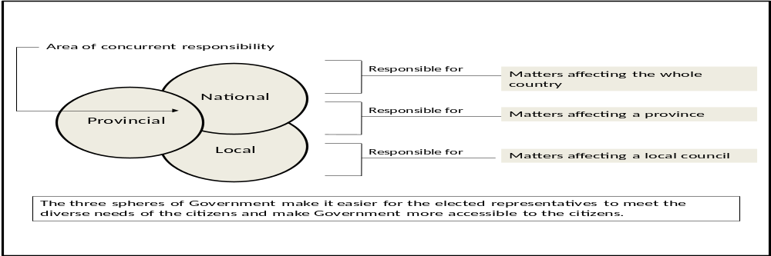
Source: Chakras Consulting: Final draft institutional review report – Public Participation Intervention, Gauteng Legislature, 2011

South Africa’s commitment to a people-centered democracy through public participation is demonstrating cumulative improvement. The Public Service Monitoring and Evaluation Report of the Public Service Commission, published in February 2011 showed a trend of consolidation when it comes to public participation. As the report indicates, “the most popular way of interacting with the public” is izimbizo which are utilized by seven (78%) provinces, followed by ward committees (67%), steering committee meetings and public meetings (56%). Emerging from these statistics are strengths of public participation which vary, of course, from province to province. For instance, Free State and KwaZulu-Natal appear good in using the institution of traditional leadership to make the messages of government more accessible and encourage attendance of public participation forums. The Western Cape and the Northern Cape have used client satisfaction surveys to obtain inputs and suggestions for improvements from the public. The sharing of best practice, experience and innovations among provinces and local government is what is now being encouraged.

Apart from the consolidation of forums such as izimbizo, as well as initiatives such as the IDPs, LEDs, PGDS, the work of the national parliament and provincial legislatures, in 2011- 2012, to develop public participation operational models and implementation strategies is injecting new ideas and approaches in the whole system of public participation.
In September 2011, the Speakers‘ Forum of South Africa (SFSA), under the guidance of the Parliamentary Speaker‘s Reference Group, commissioned the development of the Oversight Model of the South African Legislative Sector through a Project Team that was established for this purpose. The purpose of the Model is to define oversight for the South African legislative sector. “It [also] establishes a baseline for systems; mechanisms; and tools for conducting oversight. It further standardizes practices on oversight guided by its prescripts in response to public sector planning; policy making; budgeting; and performance”. The redefinition of the legislature’s oversight role, as advanced by the model, creates an opportunity for the strengthening of public participation.
This is so given that the oversight model casts the legislature not only in terms of the desirability of ensuring the smooth functioning of the country’s constitutional order, as a totality, but as having a very specific responsibility for overall government performance. This responsibility finds expression in the Constitutional provision that requires parliament to have mechanisms that ensure “the fulfillment of the values of accountability, responsiveness and openness enshrined in the Constitution”.
During the current reporting period, the impetus of innovation and design of new models for public participation has been spearheaded by the Gauteng Provincial Legislature and supported by the national parliament. The Free State, the Eastern Cape and KwaZulu-Natal legislatures, on the other hand, have provided examples of innovations, especially the use of the institution of traditional leadership and local government, to re-ignite the spark of public participation in policy processes and programmers. The lessons from provincial legislatures are likely to give the entire country direction regarding the mainstreaming of public participation in state institutions.

In all provinces public participation mechanisms include the budget hearings, the Public Participation Forums (established), Speaker’s Forums, and Women’s Parliament, Taking the Legislature to the People, Public Participation Week, Youth Parliament, Religious Parliament, sectoral Parliament, Children’s Parliament, and Traditional Leaders’ Parliament. Notwithstanding these initiatives there are notable challenges including the lack of participation of minority communities, especially whites, in legislative processes and the impact of limited public resources for ensuring full public participation. Furthermore, there are also some challenges at the level of attendance of public education workshops, and the absence of educational materials. There is also the challenge of lack of familiarity with the issues that get discussed in some of the public fora, taking into account the levels of illiteracy, particularly in less privileged semi-urban and rural areas.

Another important development is that some legislatures such as KwaZulu-Natal and Gauteng have passed legislation which provides for the submission of petitions by members of the public and have also established dedicated petition standing committees to receive petitions and deliberate on them. The impact of this initiative in helping communities have their voice heard and also hold political leaders to account is potentially great.

In the Public Service Commission Monitoring and Evaluation Report (2011), provincial use of various public participation forums is represented in the following way:

The Utilisation of Public Participation Forums
Description | EC | FS | GP | KZN | LP | MP | NC | NW | WC | % Provinces
- Izimbizo | - . |  |  |  |  |  |  |  |  | 78%
- Councillor and Ward Committees |  |  |  |  |  |  |  |  |  | 67%
- Provincial Steering Committees |  |  |  |  |  |  |  |  |  | 56%
- Public meetings |  |  |  |  |  |  |  |  |  | 56%
- Support Organisation |  |  |  |  |  |  |  |  |  | 44%
- Speakers Forums |  |  |  |  |  |  |  |  |  | 44%
- Workshops |  |  |  |  |  |  |  |  |  | 33%
- Traditional Leadership |  |  |  |  |  |  |  |  |  | 22%
- Client Satisfaction Surveys |  |  |  |  |  |  |  |  |  | 22%
- Lekgotla |  |  |  |  |  |  |  |  |  | 10%
TOTAL | 2 | 6 | 6 | 4 | 3 | 3 | 5 | 4 | 6
Source: Public Service Commission Monitoring and Evaluation Report, 2011.

As indicated in the table above, certain provinces have strengths in the organization and effective implementation of certain forums. Forums of public participation, such as izimbizo, need serious review and strengthening. At national level this review focuses on issues such as: access to information before izimbizo, also enhancing stakeholder consultation beyond these public meetings, choice of appropriate venues, choice of suitable times for all public participation forums and ensuring follow-up and feed-back on issues raised. Research was commissioned to identify solutions so that the quality of discussion and scope of issues raised in these forums is satisfactory to affected communities. The research has already identified actionable items, which now inform the agenda of government in improving public participation.

In addition government introduced a system of Frontline Service Delivery Monitoring in 2011. The front line monitoring system conducts unannounced visits to selected service delivery points and facilities. The monitoring processes are undertaken in conjunction with offices of the Premiers, using a questionnaire based on a set of standards drawn from the lists set by service delivery departments. During these unannounced visits, citizens found at the facility are interviewed on their perceptions of services rendered, and issues such as cleanliness, attitude of frontline staff towards citizens, queuing arrangements, et cetera, are assessed, and improvement plans developed.

For its part, government is also fully cognisant of the fact that levels of protests which have occurred are not only due to poor service delivery, but are sometimes due to lack of information or even misinformation. The ineffectiveness of public participation and feedback mechanisms cannot be ruled out as an underlying factor. The diagram below represents the escalation of protests over the years, thus underlining the urgency of the need to improve forums of public participation and access to relevant information.
Service Delivery Protests, 2004-2012.
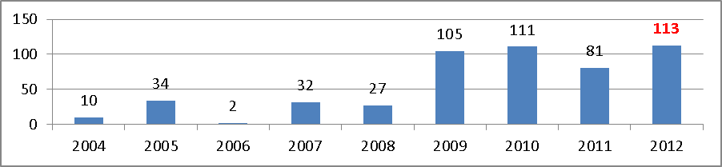
Source: Municipal IQ Municipal Hotspots Monitor.
The figure above shows that there has been a dramatic surge of service delivery protests since 2009, with the highest number of protests recorded in 2012 (Municipal IQ, 2012). Dealing with the challenge of service delivery is discussed elaborately in paragraph 3.4.5 under the theme on “Socio-economic development”. What is implied in the picture presented in graph above is that there is a need to get the voices of people heard in policy implementation processes, hence the commitment to expand platforms for dialogue, assess their effectiveness and improve levels of accountability.
The local government sphere is very important regarding the above hence government is currently improving the effectiveness of the ward system. Apart from developing the National Framework on Ward Funding and the Local Government Municipal Regulations for the Term of Office of Ward Committee Members, government has ensured that Ward Committee members are resourced for more active participation and are able to support their elected ward councillors to better serve their communities. There has been on-going capacity building of Community Development Workers (CDWs) and evaluation of the implementation of the CDW Programme, which begun in 2013. In addition to this, the implementation of the CDW Master Plan at both national and provincial levels in 2013 enhances the effectiveness of the programme.
During the current reporting period, social dialogue through the NEDLAC processes has also continued to provide the much needed platform for dialogue among social partners – government, labour and business on socio-economic and capacity development challenges. Besides the intervention of social partners through NEDLAC, which led to adoption of a Framework for South Africa’s Response to the Global Economic Crisis, as was indicated in the previous report, a strong social contract has now developed and involves broader cross-constituency negotiations in troubled sectors such as mining and agriculture. The main goal is to improve inclusivity and preparedness of the partners to enter into “genuine conversation” about the problems afflicting South Africa.
Recent labour unrest in the mining and agricultural sectors, especially the tragic killing by the police of 34 miners during a violent mineworkers strike at Lonmin’s Marikana mine on 16 August 2012, have rekindled the desire among organised business, civil society, labour and government to work on a more effective process of social dialogue. For instance, soon after the Marikana crisis, the NEDLAC community constituency (civil society at NEDLAC), together with business, government and labour, set up a task team that came up with proposals to support distressed mining communities. Among issues addressed was how to improve human settlements in the mining sector in South Africa. Currently the task team is working on the modalities of how to improve human habitation in and around the mining communities. There has also been an increased interest in the retraining of police officers on how to handle violent situations in protests and public demonstrations.
Media and civil society organizations (CSOs) have in the reporting period become more outspoken on corruption, inefficiencies in government, and threats to press freedom, thus raising welcome public scrutiny of government. This has also helped stimulate public debate about desired improvements in government and in its relations with business, labor and citizens. But this dialogue has been limited to mainly sections of the middle class with access to technologies and telephones to participate. There has also been an over - exaggeration of problems and an under-reporting of responses to them.

The Rainbow Index, developed by the South African Institute of Race Relations (SAIRR) to track the country’s performance on ten social, economic, and political indicators that reveals that South Africa’s score on the pillar on vigilant media and civil society decreased from 61% in 2009/10 to 56% in 2010/11. This seems to be due, to “the hostile rhetoric by government officials, the adoption of the Film and Publications Act, the pro-ANC bias of the SABC”, and “latent threats (renewed in June 2011) to withdraw state advertising from critical newspapers. The implementation of the Protection of State Information Bill and the proposed media tribunal could see the country downgraded again”. However, the same downgrading can be attributed to the fact that the South African government is open to public criticism and it often is the first one to criticize its own performance in public platforms including through the often hard-hitting reports of the Auditor-General, performance monitoring and evaluation reports and in public engagements.

Government’s use of the media, both private and public, has remained strong. This ranges from public communication and engagement in public debates by ensuring that government officials are enthusiastically involved in public discourses through the media, explaining government positions to the public and enabling a culture of balanced debates to the use of the new media in the form of social media portals. Facebook and twitter profiles of The Presidency and several departments are among the highest subscribed in South Africa today and these convey government information on a daily basis. The government websites remain a major source for stories in the media.

Despite these challenges, the media in its variety, in particular, has remained an important pillar of support for public participation. For instance, the increase in community radio stations and television broadcasting in line with constitutional provisions of access to information helps many communities to be up to date with the politics of their surroundings as well as the spaces that are available for their participation. Provincial and municipal governments make an extensive use of community and vernacular radio stations to communicate and discuss matters relating to government programmes with people through phone-in programmes in their own languages.

3.1.2 Public Consultation, education and feedback in policy making
The Constitution of South Africa has provisions which make public participation obligatory within all spheres of government to enhance democratic governance. Increasing participation by civil society structures in policy development, implementation including monitoring and evaluation of government performance is a reflection that they are increasingly becoming knowledgeable about their rights and can therefore hold government accountable.
The increase in the number of civil society structures such as ward committees, School Governing Bodies (SGBs), indicates improvement in the role of civil society in governance processes. The implementation of government programmes creates a compulsory requirement for government departments not only to consult the citizens but also provide feedback on the achievement of the articulated objectives. In terms of the White Paper on Batho Pele, all government departments have an obligation to generate Citizen Feedback Reports on an annual basis. Even though such reports are developed for compliance purposes, they do provide access to information on government programmes required for public participation and enhancement of governance.
The institutionalization of standard capacity development programmes amongst civil society structures is aimed at improving governance processes. This builds on initiatives involving the intensified implementation of the Intergovernmental Relations Framework and the utilization of the Thusong community service centers to ensure improved, accessible and efficient delivery of government services. The Department of Public Service and Administration (DPSA) continues to play a critical role in ensuring that the Thusong service centers are connected to information and communications technologies so that walk-in citizens can access the wide-range of government services available through e-government. The implementation of the Maponya Urban Thusong service centre in Soweto is being used as a benchmark. In addition, IDPs, LED processes, NEDLAC, Provincial Growth Development Strategies (PGDS’s), the National Council of Provinces (NCOP), the Constituency processes, and public hearings are all part of a long list of forums and interventions that provide space for dialogue and contribute to feedback in policy making. These cater for various stakeholders and different levels of society.
In general the social contract between the state and the citizens needs to be continuously nurtured. In particular, consultation as well as constant feedback sessions with communities are a vital element which need strengthening. Citizens need to be consulted, not only about the level and quality of the public services they receive but also about the timeframes and possible delays. Consultation and feedback are crucial for sound economic as well as political governance and management. There are currently weaknesses and challenges in these areas, which South Africa continues to address.
    - Reducing crime and violence in general and particularly against women and children
The widely reported cases of crime and violence against women and children are a serious concern to many South Africans. More concerning is that these kinds of crimes are contact crimes and happen in homes and are mostly committed by people who are known to the victims. This challenge requires that communities work together with the law enforcement agencies to raise awareness, give information on preventive and mitigation measures, on the justice system and apprehension of criminals. Government is now leading multi-stakeholder initiatives to root-out violence against women and children. Government institutions are increasingly becoming firmer in dealing with crime and violence within the ambits of the law. On its own, the criminal justice system will not be able to eliminate the scourge of crime in our society, hence the emphasis on collective action by all social partners.
With regards to gender-based violence, it is worth reporting that the re-establishment of the Family Violence Child Protection and Sexual Offences Units within the police force was instituted in 2010. Nationally there are 176 established Family Violence Child Protection and Sexual Offences Units attached to all police clusters in the South African Police Service (SAPS). In support of the investigation of such crimes, over 2000 Forensic Social Workers were appointed to deal with crimes against children in order to provide expert evidence in court. Since the re-establishment of Family Violence Child Protection and Sexual Offences unit, there has been a marked increase in conviction rates for offences related to gender based violence and child abuse, resulting in a combined 36 225 years of general imprisonments; 695 of which have been life imprisonments.
South Africans continue to work collectively to find lasting solutions to the challenge of sexual violence, which is often felt by the most vulnerable groups in the communities. Government recently announced the establishment of a task team to investigate the resuscitation of Sexual Offences Courts that showed impressive conviction rates in certain parts of the country during piloting phase. The task team objective was to ensure that Sexual Offences Courts are accessible to the broader South African public in both rural and urban areas.
The introduction of the Thuthuzela Care Centres (TCCs) as one-stop facilities has strengthened South Africa’s anti-rape strategy. The aim is to reduce secondary trauma for the victims, improve conviction rates, and reduce the time it takes to finalise cases. To date, the implementation of the model has improved the process of reporting and prosecution of rape cases and other sexual offences. This is helping reduce secondary trauma to survivors as the entire process takes place in a dignified and friendly environment. The re-introduction of family violence, child protection and sexual offences units in the police, as well as the establishment of the inter-sectoral task team to look into the viability of prioritizing such cases through specialized sexual offences courts should strengthen efforts to combat crime.
The approval of the Prevention and Combating of Trafficking in Persons Bill 7 of 2010 by the National Assembly has strengthened the fight against human trafficking and assists in protecting vulnerable groups especially women and children. Other initiatives in this regard include the establishment of Provincial Task Teams on Human Trafficking. Part of their role is to research the trends, develop prevention strategies and support the prosecution of human trafficking cases. Systems have been put in place to tighten the monitoring of incidents of human trafficking. For example efforts to improve the efficiency of the criminal justice system received a major boost through the adoption of various lower court inter-sectoral case flow management practices and guidelines.
There are numerous initiatives in the various provinces, intended to reduce crime. In the Western Cape, for instance, the expanded Partnership Programme with Community Police Forums aimed at strengthening civilian oversight roles is growing. Rural women in KZN, through a provincial flagship program called Sukuma Sakhe (meaning ‘stand up – let’s build’) took the responsibility of conscientising their 'girl children' about the challenges of HIV/AIDS, human trafficking, gender inequality as well as conscientising them about their rights and economic empowerment through IDPs at municipal government level. Sukuma Sakhe is a province-wide initiative aimed at ensuring equitable service delivery. The programme operates at ward level and involves councilors and brings together traditional leaders church leaders and other community leaders in Victim-Offender Dialogues (VOD).
Government anti-crime partnerships and strategies currently being implemented are significantly contributing towards the reduction of crime levels across the country. The levels of crime continue to drop and, according to independent studies, more people are beginning to feel safe. There is an increase of 8% in the public appreciation of how government is performing in reducing crime levels when compared to five years ago (32% in November 2007 to 40% in November 2012). These findings are in line with the 2011/12 (SAPS) National Crime Statistics Report of government. Recent statistics shows that 38% believed that the level of violent crime has decreased in their area of residence compared to 33% who said that crime had increased but there is also a 29 percentage group which believed that crime has stayed the same during the period 2009 -2011.
The rehabilitation of offenders programme contributes towards reduced levels of crime by limiting the number of repeat offenders. Rehabilitation equips inmates with skills required to enhance their re-integration into society and prepares them to sustain themselves without reverting back to crime.
The National Council Against Gender-Based Violence was also established during the reporting period. This is a high-level multi-sectoral national response to the scourge of gender-based violence. The council involves a number of organisations which include government, religious leaders, traditional, women movement, academia and civil society. The Council has the following responsibilities:
- To drive the implementation of the 365 Days Action Plan;
- To advise government on policy and intervention programmes;
- Strengthen national partnerships in the fight against gender-based violence;
- Create and strengthen international partnerships; and
- Monitor and report progress on initiatives aimed at addressing gender-based violence.
During the reporting period, government took further steps as it established the Inter-Ministerial Committee on Violence Against Women and Children comprised of Ministers of Women, Children and People with Disabilities, Justice and Constitutional Development, Health, Home Affairs, Police and Basic Education. Its objective is to investigate the root causes of violence in general, and in particular, violence against women and children and to develop a comprehensive strategy to deal with the scourge of violence against women and children.
It is acknowledged that government has enacted various pieces of legislation to provide better protection for women and children, and it has been realised that there was a need to move from policy to action and provide stronger focus than ever before on prevention and early intervention to support women and children against the scourge.
    - Awareness campaigns and access to justice for the full enjoyment of human rights / Access to information on human rights and institutions of Justice
The national effort towards the progressive realisation of the right of access to information is critical to awareness raising and access to justice. For this reason, the DAC (on behalf of DoJCD) has translated the South African Constitution into eleven official languages. The SAHRC has, among the many interventions, developed a community tool on access to information aimed at simplifying how the Promotion of Access to Information Act (PAIA) and this helps to enable communities to effectively assert their right of access to information. The community tool is also designed to be a training guide and to create a better understanding of PAIA and further enable community members to continue participating in training sessions in their respective communities. The development of this tool ensures that awareness on PAIA is sustained and that communities are empowered to the extent that the dependence on the Commission is minimized.
Access to justice entails access to courts, police stations, and other semi-judicial tribunals meant to dispense justice to the nation. One of the key success factors is the growing transformation of the justice system in order to improve access to justice by a large section of the under-privileged and vulnerable groups in society. To this end demographic representation of society in the courts and in the legal profession has been ensured. Two hundred and forty-three (243) of the judges on the various courts are now of indigenous Africans who can speak many indigenous languages; this constitutes 50% African judges on the various courts. However, the representation of women remains a challenge which government is working on finding solutions to.
At the basic and more direct level, access to justice by the poor majority is affected by the proximity of the courts and other justice facilities in the townships and villages where they reside. There has been an increase in the knowledge and use of Equality Courts, which focus on the enforcement of equality principles in the constitution in order to undo the colonial and apartheid legacy of entrenched racial and gender inequality regarding access to justice. The use of these courts brings the judicial system closer to communities for whom pursuing the ordinary justice system is often unaffordable, lengthy and cumbersome. The DoJCD has a programme for extending these services to township and rural areas. It has further established twenty-three additional Small Claims Courts in different provinces, which enable people to institute civil claims to the value of R12 000, without the need for legal representation. This brings the number of these courts to two hundred and forty seven (247) at the end of March 2012. Courts that were built in the traditionally black areas and rural villages as branches of courts situated in towns are being rehabilitated so that they have measurable jurisdiction and sufficient capacity to function as full-service courts. Twenty-four of the ninety branch courts were identified for rehabilitation into full-service courts by 2014. Fifteen of the twenty four of them have already been converted into full-service courts.
The South African government also intends to enhance access to justice by providing a speedier and less formal and less expensive resolution of disputes through institutionalisation and regulation of Traditional Courts. It has developed the Traditional Courts Bill whose objective is to affirm the recognition of the traditional justice system and its values based on restorative justice and reconciliation, as well as to provide for the structuring of the traditional courts in line with constitutional values and principles. It also aims at enhancing customary laws and customs of communities observing such systems. The courts would have jurisdiction over divorce or separations, custody and guardianship of minor children, validity and interpretation of wills. Although the Bill expressly provides for full and equal participation in the proceedings of the courts by women and observance of rules of natural justice, it has been highly criticised for its potential to allow the discrimination against women, especially their right to directly participate in the courts. The robust public participation and consultation processes which have ensued will hopefully resolve these issues and strengthen the bill.
The Legal Aid Board of South Africa (LABSA) provides professional legal advice and representation for those who cannot afford private legal practice. It focuses on family matters, evictions, employment issues, contracts, deceased estates, litigations and criminal cases. The Legal Aid Board delivers through Justice Centres, co-operation agreements and agency agreements. In the financial year 2011/12 it received 428653 new matters and finalised 402459 through 64 Justice Centres and Satellite Offices.
One of the DoJCD’s strategic objectives is to raise public awareness about a variety of matters relating to opportunities for accessing the justice system. It has, in partnership with the South African Women Lawyers Association (SAWLA) invested in television and radio programmes, in all official languages, with an overall listenership of 1 765 000.
The National Consumer Commission, an agency for the Department of Trade and Industry, amongst others, provides standards for consumer information and protection, prohibits certain unfair marketing and business practices as well as ensures the consistent legislation and enforcement framework in consumer transactions.
Another vehicle is the Commission for Conciliation, Mediation and Arbitration (CCMA). It was established to, among others, conciliate workplace disputes, arbitrate disputes that remain unresolved after conciliation and facilitate the establishment of workplace forums and statutory councils. The CCMA exists in all the provinces and has nineteen offices in various towns. However, there remains a challenge of accessibility of CCMA offices, especially to rural communities. Currently there are efforts to review legislation and the purpose is to facilitate the resolution of disputes and improve both the efficiency and accessibility of the CCMA.
    - Institutionalisation of Democracy and Good Governance
Long-term planning for development as a mechanism to give meaning to freedom is a major effort aimed at consolidating South Africa’s democracy. To this end, the establishment of the National Planning Commission in 2010 was followed by nation-wide consultation and the release of the National Planning Commission Diagnostic Report in June 2011 which sets out South Africa's achievements and shortcomings since 1994. The diagnostic report identified major developmental challenges as follows:
- Unemployment;
- Quality of school education for black people;
- Spatial divides limit inclusive development;
- Unsustainable economy;
- Quality of public health;
- Uneven public service;
- Escalation of corruption; and
- The class structure in South Africa
The NDP, commonly known as Vision 2030, was developed as an inclusive response to these issues. It is the master plan for the country and enjoys widespread support. Its central imperatives are the eradication of poverty and inequality, while unlocking the country’s full developmental potential. It is the country's long term vision to inform all strategic plans. The NDP is being implemented in a phased approach spanning seventeen years. The year 2013 marks the beginning of the implementation phase. Government is currently in the process of aligning the long term plans of departments with the NDP, identifying areas where policy change is required to ensure consistency and coherence. The Department of Performance Monitoring and Evaluation together with the National Treasury leads the process of developing an aligned 2014-2019 Medium Strategic Framework (MTSF). This new MTSF provides the first five year implementation plan for the NDP supported by the New Growth Path (NGP) and Industrial Policy Action Plan (IPAP). This planning alignment will further inform strategic plans and annual performance plans of all national and provincial departments.
.
The government has undertaken efforts to ensure that executive administrators are accountable and possess the capacity to manage and carryout administrative responsibilities effectively. To that effect, a Management Performance Assessment Tool (MPAT) was developed and approved by cabinet for implementation since 2011. The overall objective of MPAT is to benchmark good management practices by assessing the quality of management practices over a comprehensive range of management areas such as strategic planning, supply chain, financial management and others. The tool was first piloted during 2011 where 103 National and Provincial Departments participated. It was rolled-out in 2012 to all 156 national and provincial departments. Processes are underway to develop a similar tool for municipalities called the Municipal Assessment Tool (MAT) Local Government Management Improvement Model (LGMIM) which is being currently piloted in ten municipalities. However, unlike MPAT, MAT LGMIM will also include the assessment of service delivery.
During the reporting period, the South African government adopted the outcomes-based approach to monitoring and evaluation (see the figure below). Based on this, the Presidency further identified 12 outcomes and Ministers signed performance agreements with the President based on these outcomes to serve as a yardstick upon which their performance will be measured during the term of office. The Ministers in turn signed performance agreements with provincial MEC's and mayors. These two categories submit quarterly reports to the Presidency for monitoring of progress towards the achievement of agreed targets in the performance agreements. Government also ensured that the new Ministries established during the 2009 reporting period, are capacitated with personnel and infrastructure so that they achieve the objectives and commitments made in the performance agreements. Two more outcomes were added to the list, namely, social security and social cohesion and will become effective from 2014 onwards.
The manner in which performance agreements cascade within government is outlined in the diagram/figure below.
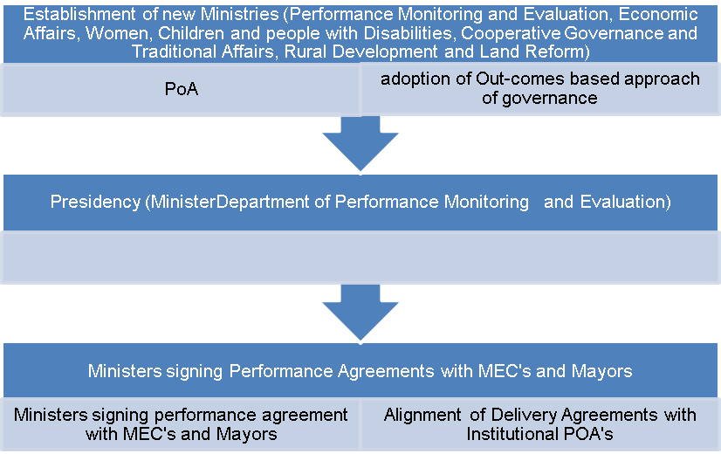
Source: Department of Performance Monitoring and Evaluation.
As a result of this management framework, the Ministry of Women, Children and Persons with Disabilities, for instance, has recorded significant progress since it was established. The Ministry has entered into bilateral agreements with other government departments such as the Department of Agriculture, Tourism, Energy, etc to ensure coordinated support for women participation in the mainstream economy. In terms of policy, the Ministry has developed the Women Empowerment and Gender Equality Bill which was gazetted in September 2012. The Bill addresses the following:
- The elimination of all forms of discrimination against women and girls, and women and girls with disabilities;
- The elimination of all practices that violate the rights of women to social, political, economic and cultural freedoms;
- Equal participation of women in the economy;
- Equal representation of women in position of decision-making (50/50) in private sectors and all spheres of government;
- Public, private and civil society guidelines for gender equality/ women empowerment, and provide feedback on areas of weakness; and
- Monitoring of all legislations that address inequalities, discrimination against women, violence against women, access to services and economic empowerment.
The Ministry further participated in national and international events convened to reaffirm the country's commitment to promote and realise the rights of women, children and people with disabilities. The Ministry also convened a dialogue on challenges faced by young children and a conference on homophobia as well as a series of dialogues on challenges faced by the youth.
Although South Africa is making efforts to ensure realisation of rights of women, children and persons with disability, the escalating abuse of women, children, the elderly, gay and lesbians remains a challenge. The new ministry dedicated to this section of the population is being strengthened in order to address the persistent challenges.
During the reporting period, the Ministry of Rural Development and Land Reform has reviewed and developed a number of legislation to ensure that land contributes to sustainability of rural livelihoods. This is discussed elaborately in the theme on socio-economic development.
During the reporting period, the Ministry of Economic Development crafted strategies and established independent bodies to guide, monitor and oversee infrastructure development. The establishment of the Presidential Infrastructure Commission as well as Infrastructure and Economic Development projects place South Africa in pole position for leading regional and continental integration.
The Ministry of Military Veterans, also registered progress during the reporting period as it developed the Military Veterans' legislation which provides for the governance of affairs of the military veterans in terms of democratic principles of the State.
In 2009, the Ministry of Corporative Governance and Traditional Affairs launched Operation Clean Audit 2014 to strengthen capacity and accountability of the municipal managers and to improve the municipal audit performance. The Local Government Turn Around Strategy (LGTAS) was also developed to improve service delivery initiatives at local government level. The implementation of the strategy requires multiple stakeholder participation, including the private sector, State Owned Enterprises (SOEs), NGO's and Community Based Organisations (CBOs). Furthermore, the Ministry also played a significant role in preparation for the 2011 Local Government elections held in 278 municipalities.
During the reporting period, the Ministry also developed and reviewed a number of legislations to ensure effective cooperation across spheres of government so as to significantly improve service delivery and development. These include:
- Green Paper on Cooperative Governance;
- Draft White Paper on Local Government;
- Monitoring, Support and Intervention Bill whose purpose is to deal with section 100 of Constitution which relates to national interventions in the provinces and section 139 of the Constitution which relates to provincial interventions in the municipalities; and
- The Traditional Affairs Bill which is aimed at ensuring an integrated approach in dealing with matters relating to the traditional affairs.
To strengthen the public service, government, through the Ministry of Public Service and Administration is moving towards the establishment of the Single Public Service Bill which aims at addressing the challenge of incompatible norms and standards across spheres of government. This challenge has also been identified in the NDP Diagnostic report. The objective is to have the machinery of state across the three spheres of government strategically aligned and harmonized to ensure necessary complementarities in order to fulfil the goals of the developmental state and in particular, the pressing and urgent service delivery needs. The Single Public Service would also promote mobility of staff between the spheres of government thereby facilitating optimal deployment of skills.
    - Strengthening the institution of traditional leadership
The institution of traditional leadership continues to play a critical role in the South African constitutional democracy as it provides a platform for meaningful participation by rural communities. Among the important developments during the reporting period, one can cite the following:
- The recognition of indigenous community of the Khoi-San and their Institutions: The National Traditional Affairs Bill of 2011 recognised Khoi-San community leadership positions and provides for the functions of Khoi-San leaders and their institutions. It seeks to establish a national framework, norms and standards to define the role of Khoi-San leadership within the new system of democratic governance. The Khoi-San National Council in collaboration with the CONTRALESA, the organisation of traditional leadership, played a major role in lobbying for this policy alignment.

- The Seriti Commission Report on the Remuneration of Public Office Bearers confirmed that Traditional Leaders are public office bearers and that they should be allocated tools of trade which will resource their institutions to work better. In compliance with this report, the Department of Traditional Affairs, House of Traditional Leaders and CONTRALESA established a task team to draft a workbook on tools of trade for all traditional institutions. On the 25 July 2012, the commission report announced a salary scale for traditional leaders across the country, for Kings, Queens, amaKhosi, and iziNduna. The recommendations of the Commission are currently being implemented.

- Extension of the mandate for traditional institutions by the DoJC is contained in the provisions of the Traditional Courts Bill of 2012. The Bill recommends that traditional courts be integrated into traditional councils to adjudicate over disputes in local communities. It also provides that Traditional Councils should lead reform in the development of customary law in furtherance of the main objective to affirm the recognition of the traditional justice system and its values, based on restorative justice and reconciliation and to align the structuring and functioning of traditional courts with constitutional imperatives.
As alluded to in section 3.1.2 above, when the NCOP was conducting public hearing the Bill was challenged by a number of NGO’s, demanding its withdrawal, while the National House of Traditional Leaders was giving full support to the Bill. There is now already some activity intended to test the value of certain provisions of the Bill. The Department of Correctional Services, for instance, has initiated a programme in line with the provision of this Bill, called Victim Offenders Dialogues in which traditional leaders play a major part in providing a structure for community reconciliation.
    - Intensifying the fight against corruption/ tackling corruption
South Africa, in its NDP or the Vision 2030, indicates that there is a high level of corruption in the country which could undermine the rule of law and socio-economic transformation. However, there is a need to probe deeper into facts and perceptions in this area in order to strengthen civil society and government interventions. Government has crafted several pieces of legislations intended to ensure integrity of the public sector. The integrity and anti-corruption regulatory framework is found in several pieces of legislation such as the PFMA, PAIA, the Prevention and Combating of Corruption Act (PCCA), the Protected Disclosures Act (PDA), Public Service Anti-Corruption Strategy, and Local Government Anti-Corruption Strategy.
The state’s capacity to combat corruption has also been strengthened by the constitutional court’s decision that the independence of the Directorate for Priority Crime Investigation (also known as the Hawks) established in 2009 to prevent, combat and investigate national priority offences including serious corruption, was not sufficiently protected. The court ordered the South African Parliament to remedy the situation in September 2012 to ensure that the Directorate has the necessary structural and operational independence to fulfil its mandate without undue interference. This is in line with South Africa’s constitution as well as international agreements that South Africa has signed which require the creation of independent anti-corruption entities.
In addition to strengthening state’s capacity to combat corruption through the Directorate referred to above, the President announced the launching of the Public Sector Anti-Corruption Unit (PSACU) located in the Department of Public Service and Administration, whose main focus would be to monitor the investigation of corruption cases reported to them by other government departments and ensure that disciplinary measures are effectively taken against those found guilty and that the state recovers money lost as a result of corruption-related misconduct.
Further to the monitoring and co-ordinating capacity that PSACU provides, government departments are expected to have minimum anti-corruption capacity to enable them to trace and identify corruption as well as deal with it in the shortest possible time. Capacity is, however, uneven among the departments at both the national and provincial levels, a challenge that affects the effective combating of corruption in the country.
The National Anti-Corruption Hotline (NACH), established in 2004 continues to be one of the main mechanisms through which the South African public reports allegations of corruption in the public sector. It is managed by the PSC which investigates selected allegations even though it focuses mainly on capturing data and referring complaints to government departments and other investigating agencies while monitoring feedback and reporting on the effectiveness of the hotline. The NACH has proved effective as a reporting mechanism and would probably be even more effective due to its more active promotion by the PSC, the Ministry of Public Service and Administration and, to a limited extent, other state institutions. The PSC manages the Hotline on behalf of the state. It periodically analyses the number of cases received since its inception. The Commission states that for the period 2004/05 to 2010/11 the NACH received 106799 calls of which 7922 were of alleged corruption.
There has, however, been an increase in the establishment of hotlines in government departments and agencies, thus making it difficult to have a global view of the magnitude of the reality or perception of corruption. Some government departments have also not been effective in investigating allegations referred to them and providing feedback to the Public Service Commission and this subtracts from the public trust in the hotline.
In May 2011, South Africa issued an instruction to all institutions requiring pre-planning of procurement above R 500 000 to enable monitoring national and provincial treasuries, the publishing of names and total bid prices of all bids received in order to enhance transparency. There is also provision for the verification of the names of the directors/trustees/shareholders of the preferred bidder against the institution’s staff establishment prior to the award of any bid, to manage possible conflict of interest. In terms of the instruction, institutions are compelled to ensure that tax matters of preferred bidders are in order and that the names of preferred bidders and their directors/trustees/major shareholders are not listed on the Register for Tender Defaulters and the Database of Restricted Suppliers. It is also expected that bids in excess of the value of R 10 million may only be advertised and awarded after the relevant treasury has verified that budgets exist and that such goods and services are aligned with the targets/outputs indicated in the strategic plan of the institution. Written confirmation by internal or external auditors must be sought prior to the award of any bid in excess of R10 million to the Bid Adjudication Committee and should indicate that the bid specifications were unbiased, that the bid evaluation process was conducted in terms of stipulated criteria. The instruction further imposed thresholds for expansion or variation of orders against the original contract of construction related contracts to a maximum of 20% of the original contract value or R20 million, whichever is the lower amount and 15% or R15 million, whichever is the lower amount, for all other contracts.
In January 2012 an independent non-profit anti-corruption mechanism was established led by civil society including the leading trade union federation, COSATU, named Corruption Watch. Its aim is to enable ordinary South Africans to report any corruption they witness in both the private and public sectors. Corruption Watch investigates selected cases on the basis of their impact on society and hand over findings to authorities. The Corruption Watch monitors progress on cases submitted to the government and mobilises communities and use the media to expose corruption. Allegations of corruption are made to Corruption Watch through their website, an SMS line, social media, email or post.
In addition to the above measures, BUSA, an association of private sector businesses as well as a key stakeholder on the NACF, has created an Anti-Corruption Working Group whose task is to assist business to deal with corruption and its negative effects on the business environment and society in general. BUSA has adopted a programme that includes the following projects:
Development of a code of integrity | A code of integrity which describes business practices, standards and steps to be taken in order to commit to and join in the fight against corruption.
Development of a Guide on Anti-Corruption Measures (for SMME) | A booklet for small and medium enterprises on anticorruption legislation and measures to protect themselves and know what to do when confronted with corruption from external players.
Development of Anticorruption Brochure for Foreign investors. | An overview over Anti-Corruption legislation, measures to be taken if confronted with corruption etc.
Furthermore in 2012 BUSA posted on YouTube an Orientation Programme for new entrants in the business environment outlining different types of corruption as well as Key Tools for Promoting Business Integrity and Ensuring Transparency and Accountability in the Market Place.
Some successes have been registered by the anti-corruption machinery, especially in uncovering corrupt practices. In 2010, the DSD uncovered fraud in the administration of social grants and terminated 32 687 fraudulent payments valued at R180 million. In 2011, R44 million was recovered from public servants who illegally benefited from a housing subsidy scheme aimed at assisting poor people. As has been reported in the previous report, South Africa established the Asset Forfeiture Unit and asserts successfully seized by the unit and forfeited to the state are deposited into the Criminal Asset Recovery Account. The Unit has, as at 2013, seized assets valued at more than R541million, R61million of which has already been forfeited to the State and would be routed back to the fight against crime and corruption. A R150 million of this amount was approved for the work of the Anti-Corruption Task Team referred to in the previous report, comprising of the Hawks, the Special Investigating Unit and the NPA.
  - ECONOMIC GOVERNANCE AND MANAGEMENT
As stated above, one of the major achievements of the South African government, during this reporting period was the adoption of the NGP in 2010 and NDP in 2012. Both the NDP and the NGP outlines strategic interventions that are necessary to facilitate a paradigm shift in the country’s development thinking from over-reliance on government to co-dependence and joint action. It promotes the building of an efficient state with capacity to transform the economy. More importantly it provides a long term vision to achieve a number of policy objectives.
    - Public Expenditure Management Capacity Development
The 2011/2012 Audit outcomes reflect that the country’s progress towards a clean audit is occurring at a snail’s pace and they also reflect that there has been an increase in the number of annual financial statements that received financially qualified opinions with 25 regressions (12 departments and 13 public entities) and only 21 improvements. An indication has been given that the root cause of adverse, disclaimers and qualified audit opinions are ineffective internal controls, weak checks and balances for all key financial processes, poor reporting and weak validation. This impugns the credibility of financial reporting.
Hence the NDP underlines the need to re-skill and re-orientate public servants on the basics of key legislations such as the PSA and PFMA. There is hope that the situation is going to improve given the commitment the provincial leadership (premiers) has made in 2013, to improve internal governance systems, through the recruitment of suitably qualified officials, the up-skilling of the workforce and the maximization of compliance with ethics and standard operating procedures.
Since the last reporting period, South Africa has taken proactive steps to encourage and enforce training and/or re-training for government officials. The National Treasury (NT) and Auditor-General (AG) have intensified their efforts to build sound financial management capacity in the public sector and concurrently improve audit outcomes in the three spheres of governments. To maintain the credibility of the South African government in promoting sound public financial management across the national, provincial and municipal departments, PALAMA has introduced courses which cover public expenditure management skills. These include training courses on Standard Charts of Accounts (SCOA) and Economic Reporting Formats (ERF) for Practitioners. This particular course is aimed at practitioners in the national and provincial governments. The typical target audience is financial management staff, typically in the Chief Financial Officer’s office (payment, receipt, banking, taxation, debt and suspense accounts etc.), Supply Chain Management (SCM) officials (demand, acquisition, logistics, disposal), Asset management officials, system controllers, budget officials (preparation of departmental budgets) as reflected in the table below.
In terms of institutionalisation of the capacity to manage public expenditure and improve audit outcomes, PALAMA, as the public service institution for leadership development, has

facilitated training for public service employees in both the national and provincial departments as reflected in the table below.
Training and Skills Development
Number | Course name | Number of officials trained in both national and provincial departments.
1. | Management (SCOA, SCM, and others | 5 874
2. | Induction | 25 167
3. | Leadership | 10 628
 | Administration (good governance, ethics and Anti corruption | 4 773
Source: PALAMA Annual Report, 2012.
In 2012, the academy introduced a Compulsory Induction Programme in the public service which seeks to instil among public servants the knowledge and understanding of the intrinsic values and building blocks of a democratic state emanating from the Constitution, the Bill of Rights and other related legislation. The CIP replaces the Massified Induction Programme, which targeted all newly appointed public servants before completion of their terms of probation. The programme included Public Expenditure Management and Finance as important components.
The PALAMA has further co-hosted the conference on CAPAM, which examined the role of leadership and management practices at all levels of government, fostering a culture of responsive leadership and management accountability, training and development for state delivery capacity enhancement.
Although South Africa’s ranking in the Open Budget Survey for 2012 declined by two positions, it is the second best-scored country on overall budget transparency and accountability processes in the 2012 Open Budget Index. The Open Budget Survey assesses whether the central government in each country surveyed makes eight key budget documents available to the public, as well as whether the data contained in these documents is comprehensive, timely, and useful. The Survey uses widely accepted criteria to assess each country’s budget transparency including those generated by international organizations like the International Monetary Fund (IMF), the Organization for Economic Co-operation and Development (OECD), and the International Organization of Supreme Audit Institutions (INTOSAI). The country has regressed from 92 in 2010 to 90 in 2012. Though this is a marginal shift it is an important indication that the country is still doing well and should stay on the right course. With political will coupled with more effort the country’s transparency and accountability can still improve more significantly. This affirms the country’s efforts over the years to improve the efficiency, the developmental orientation, the transparency and inclusiveness of the budget process.
Municipal IQ’s data records and analysis confirmed the linkage between lacklustre municipal financial management and their inability to provide adequate public service, which typically leads to service delivery protests. Research studies suggest that discontent remains a prevalent and disquieting social phenomenon that makes all the more urgent for government to address inequality, unemployment and poverty, as well as lagging service delivery.
Studies by the Municipal IQ and the Institute for Democracy in Africa (IDASA) acknowledge progress made with regard to transparency in the budgeting processes enabling the legislatures, civil society and the public to find information for their engagement in the budget debates. But the following gaps remain:
- The absence of a legal requirement for the publication of contingent liabilities between spheres of government;
- Guarantees and extra-budgetary activities remains a major gap in South Africa’s transparency requirements;
- Legislation aimed at empowering and enabling Parliament and provincial legislatures to amend budgets is still outstanding; and
- There is legislation that details executive transparency requirements, but none when it comes to any one body tasked with policing these requirements.
Improving public financial management, multi stakeholder participation, and systems that enforce the integration and cooperation between the public sector, Universities and private sector are important for enhancing improved accountability, transparency and skills in public sector expenditure management.
    - Improving economic integration in SADC
Regional integration is imperative to South Africa’s co-existence with its neighbours not only for reasons of transformation, stability, security, and economic development, but to ensure the strengthening of trade as well as facilitating people to people cooperation.
The 2008 SADC Summit set a number of goals intended to address these challenges, including the expansion of markets, achieving economies of scale, and enhancing competitiveness as a platform to participle in the global economy. The following were part of the plan:
- To eliminate tariffs and trade barriers among member states.
- President Zuma actively champions the North-South Corridor initiative and South Africa also supports the Programme for Infrastructure Development in Africa (PIDA).
- South Africa proposed the establishment of the BRICS Development Bank which has been accepted by the BRICS members to address infrastructure and industrial development on the continent
- The Department of Trade and Industry houses the Spatial Development Initiative which is involved in project preparation and packaging.
- The Department of Trade and Industry has an established focal point to address non-tariff barriers through an online reporting website www.nontariffbarriers.org.
- South Africa has achieved its tariff liberalization commitments with the exception of sensitive goods listed under SADC.
- SADC was established as an FTA in 2008 and member states have undertaken commitment to liberalise tariffs on substantially all trade. South Africa and SACU have achieved their tariff liberalisation commitments with the exception of sensitive goods;
- SACU has achieved a zero percent tariffs amongst its own members.
Furthermore, the SACU has plans to grow its regional programmes with the intention to deepening its integration agenda. SACU’s key focus is on:
- Developing regional industrial policy;
- Cross-border trade facilitation initiatives;
- Review of the revenue arrangement;
- Establishing common institutions within an agreed policy framework; and
- Promoting unified trade negotiations.
It is not just geographical spheres which overlap between the two regional organisations, but also their strategic agendas. South Africa is an active champion of this agenda and has embarked on a number of initiatives to harmonize policy space and assist both SACU and SADC in this respect. For instance, it has ratified the Agreement of the African Tax Administration Forum (ATAF) and deposited the Instrument of Ratification with the Forum’s interim Secretariat, thus confirming its commitment to building efficient and effective tax administration in Africa. It is anticipated that ATAF will be granted international recognition soon and will become an independent international institution with the secretariat hosted in South Africa.
South Africa’s expansion in global and continental relations has resulted in a greater need for international technical cooperation that, in turn, requires an expanded international role and a proactive approach by SARS. This is reflected in the further development of its international relations work over the course of the past financial year 2011/12.
In 2011/12, SARS signed Memoranda of Co-operation with the Botswana Unified Revenue Service (BURS), the Dutch Tax and Customs Administration (DTCA), the Seychelles Revenue Commission (SRC) and the Swaziland Revenue Authority (SRA). These agreements serve as the foundation for close co-operation and sharing of expertise and best practice between administrations.
In keeping with its commitment to developing tax and customs capacity on the continent, SARS continued to provide assistance to other African administrations in the form of workshops, study visits and attachments. As part of its outreach and capacity building initiatives, SARS introduced a Capacity Building Programme under which it hosted events on taxation in the mining sector, customs modernisation and investigation and audit. SACU has adopted a regional customs policy, which lays the basis for the implementation of the trade facilitation programme. This policy seeks to promote the common strategic objectives of facilitating legitimate trade. The key pillars of the policy include Customs Legislation; Risk Management; Trade Partnerships; Standard Operating Procedures; and Customs Information Technology (IT) Connectivity.

Guided by the Trade Policy and Strategy Framework and in support of its industrial development objectives, the Department of Trade and Industry (DTI) played a prominent role in efforts to strengthen trade and economic integration in Africa. Within the SACU Council, a work programme on industrial development has been agreed to. Eight sectors have been identified for cross-border complementarities and value-chains. These sectors are: agro-processing, leather & leather products, automobiles, clothing & textiles, renewable and alternative energies, mineral beneficiation, pharmaceuticals. The agro-processing sector is currently a pilot case. Additionally, a process has been initiated to develop a common SACU position on the Rules of Origin (RoO) for clothing and textiles in relation to the SADC. This will form the basis of a common negotiation mechanism for future agreements that SACU enters into.
In SADC, the view was successfully advanced that focus should be given to consolidating the Free Trade Agreement (FTA), rather than moving towards a customs union. SADC has also adopted a regional industrial development policy framework that aims to promote cooperation between Member States through the development of regional value-chains.
As part of advancing development and regional integration in Southern Africa and Africa, a summit was hosted where negotiations to have the T-FTA were launched. The summit adopted a developmental integration agenda premised on three pillars, i) market integration through the Tripartite Free Trade Agreement; ii) industrial development to promote development and employment; and iii) infrastructure development. South Africa’s position regarding timing, scope and broad principles to boost intra-Africa trade was accepted in the African Union (AU) Summit in January 2012. The South African position proposes a gradual and functional approach to continental integration that builds on regional efforts such as the T-FTA. This work was undertaken based on the recognition that the continent has become the biggest opportunity for South Africa, and the country, therefore, has to position itself to assist with the regeneration and industrialization of Africa.
The lack of adequate infrastructure in Southern Africa is a limitation to trade and investment growth. In order to address this, the South African President is leading the development, financing and implementation of priority projects on rail and road networks along the North South Corridor under the Presidential Infrastructure Championship Initiative (PICI), which is a sub-programme of the NEPAD’s Programme for Infrastructure Development in Africa (PIDA). These projects promote regional interconnectivity and accelerate the rate of trade in the region. In an updated report presented at the AU Summit in July 2012, President Zuma highlighted that, of the nine priority projects that South Africa is championing, seven are now in pre-finance phase, while two are fully funded and in implementation phase and only require monitoring going forward. Through this initiative, the Presidency coordinates the support coming from the Development Bank Southern Africa (DBSA), Industrial Development Corporation (IDC), NT, private sector and other stakeholders. This is a huge catalyst for acceleration in the integration process.
In the period under review, SADC Heads of State also approved the SADC Infrastructure Master Plan. The plan is to be implemented over a 15 year period and will serve as a key strategy to guide the setting up of efficient and cost-effective trans-boundary infrastructure connecting all SADC member states in the areas of energy, water, ICT and transport. The new plan will put emphasis on the cross border infrastructure that South Africa identifies in its own Strategic Infrastructure Plan.
Diplomatic engagements with key countries in the region have intensified, leading to growth in a number of bilateral relations with political significance both for the regional stability agenda and South Africa’s economic interests. MoUs were signed with partner countries in Africa. The DTI provided the economic content for eight government-to-government engagements. Six trade and investment facilitation missions were undertaken, and technical co-operation arrangements were facilitated with three African country partners. With the Department of International Relations and Co-operation (DIRCO), the DTI led efforts to improve co-ordination of South Africa’s infrastructure development programme on the continent, notably in respect of the North-South Corridor under the NEPAD framework.
Further, diversification of the South African economy from its heavy dependence on commodity to manufactured exports, together with the improvement of regional integration and investment into new economic infrastructure that facilitates intra-African trade, is crucial to respond to the current global economic developments. It is for these reasons that South Africa is playing a prominent role in efforts to strengthen trade and economic integration in Africa – hence the Tripartite Initiative made up of SADC, the EAC and COMESA was launched in South Africa 2011. Such efforts suggest that while South Africa’s economic links with traditional developed countries remain important, its prospects for growth and development will increasingly depend on diversifying and strengthening its economic links with dynamic economies of the South, particularly those of Southern Africa.
    - Unemployment
Since 1994, extensive efforts have been undertaken to address the root causes of unemployment as well as to create greater opportunities for job creation to absorb the unemployed. To a large extent, South Africa suffers from structural unemployment resulting from a mismatch between workers skills and the skills needed for available jobs due to factors like the inappropriate quality of education.
In addition, South Africa has a competitive advantage in the primary and secondary sectors (agriculture, mining and manufacturing); however data reflects that the country has shifted rapidly to the tertiary sector where high skills and experience are in demand. The country’s continued over-reliance on the extractive and capital intensive industries in such sectors as energy, metals and chemicals has partly exacerbated the unemployment problem.
At the time of submission of the country’s Second Report on the Implementation of its APRM Programme of Action in September 2010, it was reported that the unemployment rate was 25.3%. The Quarterly Labour Force Surveys by Statistics South Africa (Stats SA) show that in the fourth quarter of 2010 (October-December) the rate of unemployment had decreased slightly and was measured at 24.0%. However, the total number of people employed in the economy reached 13.1 million by the fourth quarter 2010.

In 2011, the unemployment rate remained relatively stable with marginal changes. In the first quarter (January-March 2011) the rate was at 25.0%; in the second quarter (April-June 2011) the rate stood at 25.7%. In the third (July-September 2011) and fourth (October-December 2011) quarters the unemployment rate was 25.0% and 23.9% respectively. In 2012, the unemployment statistics followed a similar trend as the previous year in 2012. However in the same period total employment continued to increase and reached 13.7 million people. Owing to the recent global financial and economic recession that started in 2008 these figures, though encouraging have not reached the 14 million peak that the country witness before the economic crisis. In the first and second quarters of 2012 the recorded unemployment rate was 25.2% and 24.9% respectively, in the third quarter of the same year it reached 25.5% and 24.9% respectively.

The figures below present schematic representations of the unemployment rate by province, gender and population group as well as by age group based on the results of Census 2012. In addition the figures below are sourced from the Quarterly Labour Force Survey which is the source of official labour market statistics in the country.

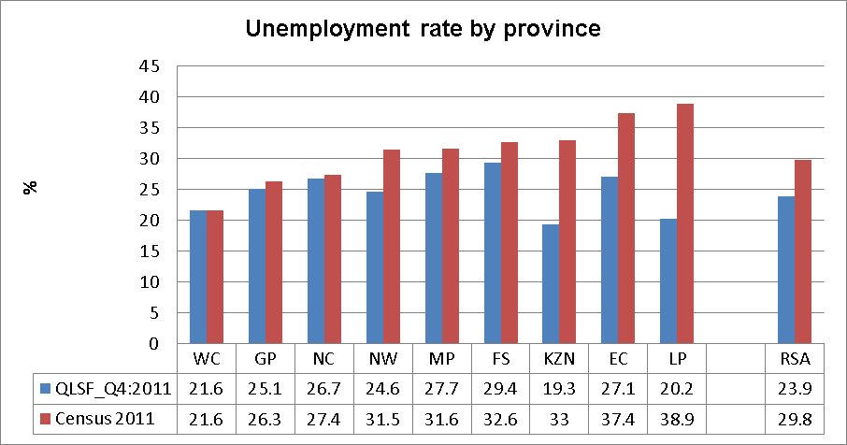

Source: Stats SA, Census 2012.

The figure above indicates that the difference in the unemployment rate between Census 2012 and QLFS_Q42011 is the largest in Kwa-Zulu Natal, Eastern Cape and Limpopo. In these provinces, the informal sector accounts for a larger share of total employment compared to the other provinces, and this sector is known to generate short-term/casual jobs. The difference in the reference periods for employment in Census 2012 and the QLSF means that such jobs are more likely to have been captured in the QLFS than in Census 2012.
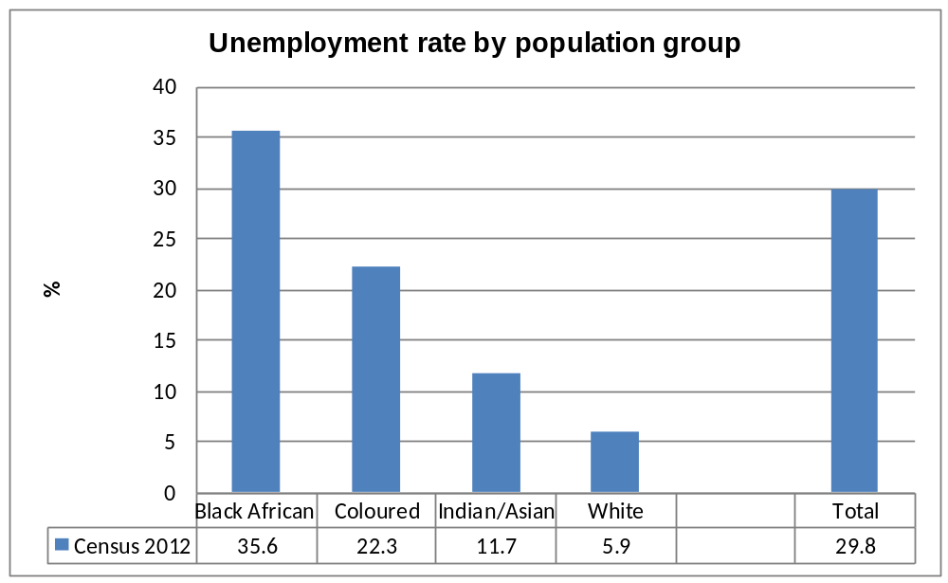
=

Source: Stats SA, Census 2012.

The figure above reveals that the unemployment rate among the black African population groups is the highest, while among the white population it is lowest.

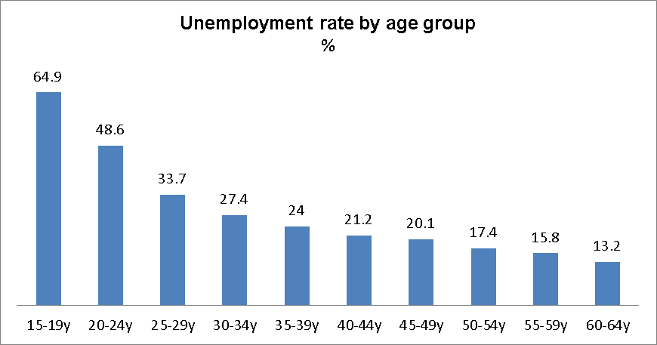
Source: Stats_SA, Census 2012
During the period under review, the government has intensified its focus on measures aimed at job creation and reduction of unemployment. In November 2010, the government released the Framework of the NGP aimed at enhancing growth, employment creation and equity. The policy’s main target is the creation of five million jobs over the next ten years. The NGP reflects government’s renewed commitment to prioritising employment creation in all economic policies. In order to grow employment by five million jobs by 2020, the NGP identifies areas that have the potential to create jobs on a large scale and absorb the unemployed. These areas have been termed ‘job drivers’ and are as follows: infrastructure development, agriculture, mining and beneficiation, the green economy, manufacturing sectors as well as tourism.
There are two main factors that will affect the attainment of the target of five million new jobs. These factors are the rate of economic growth and the employment intensity of that growth. Employment intensity refers to the rate of growth in employment relative to the rate of growth in GDP. In order for the target to be met, it will be imperative to not only maximise growth but also to ensure that growth generates more employment, particularly in the private sector.
Therefore, the employment intensity of growth must be kept between 0, 5 and 0, 8, while the rate of growth in GDP should rise to between 4% and 7% per annum in order to meet the target. Supporting the jobs drivers through appropriate measures is important to encourage more employment-intensive growth. Furthermore, the NDP released in 2012 proposes the creation of eleven million more jobs by 2030, among others by expanding the public works programme, lowering the cost of doing business and help match unemployed workers to jobs.

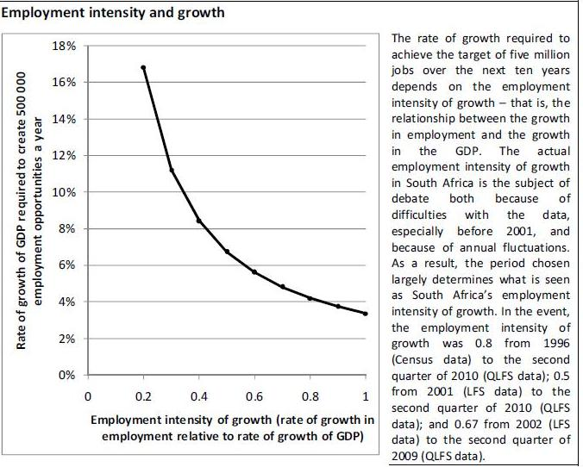
Source: Department of Economic Development, New Growth Path. 2010
The President of the Republic declared the year 2011 as the year of job creation through meaningful economic transformation and inclusive growth. All government departments, at all spheres, as well as the private sector were called upon to align their programmes to job creation imperative so as to bolster the creation of work opportunities for the unemployed. A Presidential Job Summit was held in 2011. This summit provided a platform for assessment of the role the private sector could play in partnership with government in the creation of decent jobs. In addition, a Presidential Labour Summit on Job Creation was convened in 2011 in order to engage labour federations towards a partnership for job creation. At this summit, the parties agreed on a target of creating five million jobs by 2020, in line with the NGP.
The above 2020 targets have a biased focus towards the youth as a sector. This is aimed at addressing youth unemployment. In the long-term, government has identified the need for a process to ensure that retirement funds contribute to boosting domestic resource mobilisation through savings and investment in developmental projects with a potential for decent work on a mass scale. The parties to the Labour Summit further committed themselves to supporting skills development, the recognition of prior learning as well as intensified efforts to accelerate employment creation.
Government remains committed to effectively addressing the challenge of unemployment which at the time of reporting stood at 24.9%. As such, government continues to implement programmes geared towards creating job opportunities which will reduce the rate of unemployment. The progress registered in the implementation of programmes aimed at reducing unemployment is given hereunder.
The Extended Public Works Programme (EPWP) provides poverty and income relief through temporary work for the unemployed. The immediate goal of the first phase of the EPWP, launched in 2004, was the creation of at least one million work opportunities. In the 2010/2011 financial year 607 612 work opportunities and 203 690 Full Time Equivalent (FTE) jobs were created. Sixty-two percent (62%) of the beneficiaries were women, fifty-one (51%) were youth and 0.45% were people with disabilities. In the 2011/2012 financial year 843 459 work opportunities and 251 127 FTE jobs were created. Of these beneficiaries, sixty percent (60%) were women; fifty percent (50%) were youth and 0, 19% were people with disabilities.
The Community Works Programme (CWP) is a government-led initiative aimed at creating employment through social development projects at the local level to supplement existing livelihood strategies by providing regular and predictable work opportunities of at least two days a week or eight days a month. In the 2010/2011 financial year, the CWP recorded a total of 89, 689 participants who benefited from the programme and had been implemented in fifty-six sites (56) across all nine provinces, covering forty-five (45) municipalities and four hundred and seventeen (417) wards country-wide.
During the 2011/ 2012 financial year, the CWP created 105 218 work opportunities across the country, in sixty-three (63) municipalities and five hundred and twenty-nine (529) wards. Sixty-nine percent (69%) of the participants during this period were women and fifty-four percent (54%) were young people. For the 2012/2013 financial year, government made an allocation of R1, 4 billion to the CWP. By the end of October 2012, 114 383 out of 171 500 work opportunities had already been provided. Of the work opportunities provided, seventy-one percent (71%) had been allocated to women, fifty-two percent (52%) to young people and 0, 78% to people with disabilities.
Another important intervention is the Jobs Fund, launched in June 2011, with an initial amount of R9 billion for the first three years. Managed by the Development Bank of Southern Africa (DBSA), the Fund aims to enhance employment creation in the country by co-financing projects by public, private and non-governmental organisations that will significantly contribute to job creation. The Fund considers proposals that perform competitively within the following four areas (also referred to as funding windows), namely: Enterprise Development; Infrastructure Investment; Support for Work Seekers and Institutional Capacity Building.
The Enterprise Development funding window aims to lower the cost and risk barriers that inhibit the development of innovative, private sector-led enterprise models, partnerships, ideas and projects that could lead to sustainable job creation. This window looks for initiatives that develop innovative commercial approaches to long-term job creation in ways that combine profitability with high social impact. The infrastructure window co-finances light infrastructure investment projects that are necessary to unlock job creation potential in a particular area. Within the Support for Work Seekers funding window, there are Jobs Fund co-financed projects that directly link active work-seekers, especially the youth, to formal sector opportunities and job placement. This window specifically targets initiatives aimed at facilitating rapid access to employment and work-related training for unemployed people, with a special focus on the youth.
The initiatives that receive funding are those that can clearly demonstrate the potential to ultimately place work-seekers in jobs through the provision of training, entrepreneurial development, and job placement services. Given that institutional weaknesses may at times inhibit the creation of jobs, the institutional capacity building funding window seeks to support initiatives that will improve operational efficiencies, remove barriers to doing business and catalyse innovation thereby increasing the potential for job creation. The objective is to assist organisations that can influence the demand for labour and that can improve the efficiency of the labour market. The goal is to unlock institutional barriers to job creation.
By December 2012, the Jobs Fund had approved fifty-four projects, twenty-seven of which had signed agreements for funding totalling more than R1 billion. In December 2012, the Fund made its third call for funding proposals, in the areas of Enterprise Development and Infrastructure. This means that we must wait a few years before making a judgement on the efficacy of the Fund.
The PICC was established in 2011 in order to meet the twin goals of developing infrastructure that enables and fosters economic growth on the one hand, and creates a significant number of new jobs simultaneously. The infrastructure development is intended to create new jobs in construction, operations and maintenance sectors.
South Africa has an acute problem of youth unemployment that requires a multi-pronged strategy to raise employment and support inclusion and social cohesion. High youth unemployment means young people are not acquiring the necessary skills or experience needed to drive the economy forward.

This above situation inhibits the country’s economic development and imposes a larger burden on the state to provide social assistance. Stats SA figures for the third quarter of 2012 show that about 42% (21 million) of the population are between the ages 14 to 35 and 71% of all unemployed people come from this age ground. Unemployment among youth now stands at 36%, meaning that about 3.3 million youth are neither employed nor studying. Unemployment among young black people is 65%, up from 56% in 2008.

The Number of Unemployed Young People (15 - 24) not enrolled in Educational Institutions

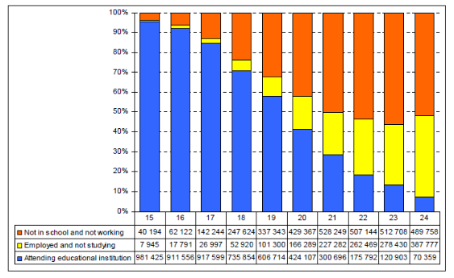

The high rate of youth unemployment is attributed to a number of factors, including:

- Employers regard unskilled, inexperienced jobseekers as a risky investment;
- Schooling is not a reliable signal of capabilities, and low school quality leads to poor workplace learning capacity; and
- Employers consider entry-level wages to be too high relative to the risk of hiring these inexperienced workers.

In addressing these challenges government has put in place both short-and long-term strategies that encompass increasing demand for labour, improving education and skills, and labour market interventions that improve the employability of young people, these include:

- The National Youth Development Agency (NYDA) drafted the Integrated Youth Development Strategy (IYDS) as a holistic response to addressing the socio-economic needs of young people in South Africa. It is aligned with key national policy frameworks such as the National Youth Policy (NYP), the National Industrial Policy Framework (NIPF), the Industrial Policy Action Plan (IPAP) and the NGP. It focuses on six thematic areas derived from the NYP, namely: Economic Participation, Education and Skills Development, Health and Wellbeing, Social Cohesion and National Youth Service, Sports & Recreation and Youth Work. The Integrated Youth Development Strategy is currently a draft under review and is not government policy yet.

- The scaling up of the National Youth Service scheme (NYS) using key government projects such as Extended Public Works Programme and working with NGOs like City Year SA to increase their skills and employability and to provide structured work opportunities for young unemployed people;

- The National Rural Youth Service Corps (NARYSEC) by the Department of Rural Development and Land Reform is designed to uplift the rural youth by providing opportunities for them to be employable through skills development. Over 7 500 young people were recruited by December 2012;

- The Department of Arts and Culture’s Mzansi Golden Economy Strategy has introduced a number of high impact programmes targeting youth and women in the arts. These include the Indoni, My Heritage My Pride programme and the Trendsetter Initiative which aims to provide young people with life skills training, education and encouragement to appreciate who they are, their heritage and their culture;

- In broadening participation in the economy, a review of the National Co-operatives Strategy and Co-operatives Act has taken place, following which Cabinet approved the revised National Co-operatives Strategy. The Co-operatives Amendment Bill was introduced in parliament in 2012 for debate and, once approved will create a few institutions to enable the flourishing of co-operatives. These are the Co-operatives Advisory Council; Co-operatives Development Agency; and Co-operatives Academy

The NYDA is a government agency established by the NYDA Act (Act 54 of 2008) to tackle youth development issues and to be a custodian of youth matters generally. It is designed to work in partnership with government, private sector and civil society to achieve this. It also mobilises and distributes funding for programmes that support the development of young people. It focuses also on the training of artisans in various technical fields such as bricklaying, plumbing and boiler-making – a move to increase skills in traditionally neglected sectors of the economy.

The value of loans disbursed through microfinance, and group SME lending over the past three year has created approximately 74 000 jobs for young people. The NYDA has managed to issue 9 913 micro and SME loans during the period under review. These efforts are geared towards providing access to financing, especially microloans, which have proven to be the main drivers for economic participation by young people in South Africa. It also managed to issue 9 899 microloans to youth entrepreneurs and 14 SME loans, which included the funding of social entrepreneurs. The financing of entrepreneurship has the potential of providing jobs for unemployed youth. It is, therefore, critical for the agency to continue funding young entrepreneurs as a means of creating self-employment for them. It has to work a lot better and cover a lot larger numbers of young entrepreneurs with a potential to make a real difference in this regard.

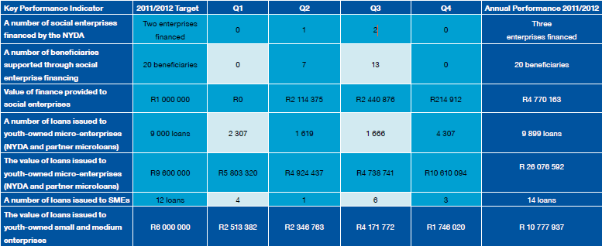
*The above figures taken from the NYDA 2011/12 Annual Report.

As part of reducing unemployment among the youth in South Africa, the NYDA has initiated and implemented programmes which include the design of self-employment jobs through financing youth enterprises, providing services that promote job creation through business support programmes and placement of young people in the job market. During the 2011/2012 period, a total of 12 579 opportunities for self-employment and job placement were increased for young people. Most new jobs were created through the financing of micro-enterprises and business support, which accounted for 91, 9% of all jobs created by the NYDA in the year under review.

The NYDA administers the National Youth Fund (NYF) for bursary and youth projects. The NYF raised funding of R71, 5 million from its partnerships with the public and private sectors, and international organisations. Of the total funding raised for the fund, more than half, R46 722 300, came from the private sector. Some 124 bursaries and scholarships were issued to young people from the fund and R802 258 was spent on youth-initiated projects across the country.

  - CORPORATE GOVERNANCE

    - Companies legislation and transformation
Transformation in South Africa’s context is in part premised on the need to fundamentally expand economic inclusion of previously disadvantaged communities who are, by numbers, mostly the black majority. Post-apartheid economic policies seek to give practical expression to this noble goal.
In pursuit of transformation, the new Companies Act of 2008 seeks primarily to facilitate the ease of doing business in relation to the formalisation of corporate entities, and the enabling of a supportive environment for efficient growth of well-governed, credible businesses. By creating a single regulatory regime for all businesses, the Act eases the regulatory burden and streamlines company registration – a process which promotes the growth of small business. This is evidenced by the increase in the number of new companies registered since the implementation of the Act on 1 May 2011 as compared to the same period prior to the Act. This allows formalised entrepreneurs to access finance and other resources only available to the incorporated form.
The Act also set up the Companies Tribunal, Takeover Regulation Panel, Financial Reporting Standards Council and the Companies and Intellectual Property Commission to promote, implement and monitor the implementation of provisions of the Act. The Companies Tribunal, which will adjudicate disputes between companies, is expected to reduce regulatory compliance costs and provide redress quickly. The Financial Reporting and Standards Council is expected to align the country’s development and application of financial standards, with a focus on IFRS for SMEs, meant to ensure that financial management standards are in line with global standards while remaining sensitive to local conditions.
In 2011, Parliament signed the Draft Amendments to the B-BBEE Codes of Good Practice, and in 2012 such amendments became part of the B-BBEE Act, necessitated by experiences of complexity with the previous framework. The changes are meant to simplify and accelerate the implementation of the B-BBEE codes as they stand. These codes primarily enhance the assimilation of SMMEs, who are black owned and managed, in the value chain, thereby facilitating skills development and broader economic empowerment. In the 2012 Employment Equity Commission Report, the levels of compliance in relation to management have improved over time.
Employment Equity Figures for 2012.
Indicator | B-BBEE Target | Current Level
Top Management | 40% | 30.8%
Senior Management | 60% | 38.4%
Middle Management | 75% | 55.6%
Source: Empowerment Equity Commission Report 2012.
The studies show that there has been a sound year-on-year development in the seven pillars of Black Economic Empowerment including ownership, management control, employment equity, skills development, preferential procurement, enterprise development and socio-economic development. Under long term conditions, profitability of companies that are compliant with B-BBEE codes is likely to increase, according to an Empowerdex Report 2006.
To improve legislative implementation, government has continued to strengthen institutions tasked with monitoring regulatory compliance and enforcing such regulations. The B-BBEE Codes of Good Practice emerged in February 2007 as an implementation framework for the B-BBEE policy and legislation. After the implementation thereof, institutional mechanisms were established for the monitoring and evaluation of B-BBEE in the entire economy. In an effort to comply with the B-BBEE policy, companies have employed the services of Verification Agencies (VAs). Due to verification practices having varied from agency to agency, resulting in confusion in the market, certain revisions were required. Consequently, in the interests of harmonising accreditation and verifications practices, the DTI and the South African National Accreditation System (SANAS) have put in place a process of phasing out certificates issued by non-accredited VAs.
The DTI established a B-BBEE Website and IT Portal (http://bee.thedti.gov.za/ ) aimed at making legal requirements of B-BBEE available to clients and assist them in understanding the B-BBEE Scorecards, accessing a national registry of company B-BBEE profiles, sourcing B-BBEE-compliant companies for networking purposes and reporting fronting practices, amongst others. A search engine facility also provides clients with easy-to-access information, while a central repository of legal and related documents serves to keep the public informed of the regulatory framework governing B-BBEE in the country. Through external verification agency, Empowerdex, it is possible now to report that compliance on B-BBEE Codes has increased across the seven pillars of Black Economic Empowerment from 2011 to 2012.
In 2011, BUSA commissioned a study which looked at the demographic profile and pace of transformation of JSE listed companies. The study found that out of the board positions of 2 835 executive, non-executive and independent non-executive directors of 289 companies listed on the main board of the JSE as at 23 March 2011, 6.7 % of the EAP were white males who account for:
- 52% of all board positions;
- 71.6 of executive directors;
- 42% of non-executive directors;
- 43.5% of independent non-executive directors;
- 51.4% of chairpersons;
- 76.2% of CEOs; and
- 75.7% of CFOs.

With regard to gender equity, the BUSA study found the following:

- There is a disturbingly low level of representation of all women on the boards of JSE companies, especially in the roles of chairpersons and executive directors, including CEOs and CFOs.
- There were 397 female directors at the time of completion of the study. The percentage of female directors was 14%. The percentage of black female directors was 10.2%.
- There were 67 female executive directors. The percentage of female executive directors was 7.4%. The percentage of black female executive directors was 2.4%.
- There were 129 female non-executive directors. The percentage of female non-executive directors was 12.9%. The percentage of black female non-executive directors was 10.2%.
- There were 207 independent non-executive directors. The percentage of female independent non-executive directors was 21.1%. The percentage of black female non-executive directors was 17.4%.
- There were 12 female chairpersons. The percentage of female chairpersons was 4.3%. The percentage of black female chairpersons was 3.9%.
- There were eight female CEOs. The percentage of female CEOs was 2.8%. The percentage of black female CEOs was 1.2%
- There were 27 female CFOs. The percentage of female CFOs was 10.9%. The percentage of black female CFOs was 2.8%.

However, concerns regarding the trickle-down and ownership effects of B-BBEE persist. The perception is that the system has created a situation where the same small pool of individuals and companies from the historically disadvantaged groups are recycled in B-BBEE beneficiation processes.
The CIPC, which became fully operational on 1 May 2011, has improved responsiveness which is the primary purpose of the Companies Act. This is done through improved compliance monitoring and dealing with contraventions of financial reporting standards. On this basis, it makes recommendations to the Financial Reporting Standards Council (FRSC). Contraventions of financial reporting standards pose serious threats to the credibility of businesses in the economy.
The NCT was established in terms of the National Credit Act, No. 34 of 2005 to ensure equity in the credit market and balance the respective rights and responsibilities of credit providers and consumers. The Tribunal hears cases of non-compliance with the National Credit Act, makes orders and provides redress to consumers. Consumers and credit providers may appeal to the NCT against any decisions of the National Credit Regulator (NCR). Decisions of the Tribunal may be appealed to either a full panel of the Tribunal or High Court.
The introduction of the Consumer Protection Act on 1 April 2011 has seen the Tribunal adjudicate on credit-related matters and other concerns in terms of the National Credit Act. Matters involving wider consumer issues have been brought before the Tribunal. Worth noting were the first CPA matters heard during the 4th quarter of 2012. During the reporting period, there was a steady increase of matters brought before the Tribunal and it is expected that this increase will continue into the foreseeable future. It is to be noted that 100% of the CPA cases that the Tribunal is currently tasked with, require adjudication by a panel of three members. This is different from the NCA matters that the Tribunal is tasked with, where the majority of matters can be resolved by a single Tribunal member, sitting alone. Reporting on adjudication by the media has given the Tribunal exposure to the public who have become more aware that they do have recourse to the law. The Tribunal’s recent CPA decisions have contributed significantly to this awareness.
Consent order applications relating to more than 7 000 consumer credit agreements, with a combined value of more than R200 million were dealt with by the NCT during the reporting period. The consent orders granted in these applications resulted in consumers being in a position to retain both immovable and movable property whilst servicing their credit agreements in a responsible manner. The broader impact of adjudication has seen precedents being set by various judgements handed down by the NCT on various sections of the NCA and the CPA. The NCT is at the forefront of interpreting the new CPA thereby taking on the responsibility that comes with interpreting new legislation in the absence of precedents. In the 2011/12 period, the NCT received 2 205 case applications versus 1 382 in the 2010/11 period, nearly 100 per cent growth.
The NCC is established in terms the Consumer Protection Act of 2008, as an organ of state within the public administration, and as an institution outside public service with jurisdiction throughout the Republic of South Africa. The NCC is charged with the responsibility to enforce and carry out the functions assigned to it in terms of the Act, which aims to promote a fair, accessible and sustainable marketplace for consumer products and services, and for that purpose establish national norms and standards relating to consumer protection and promote a consistent legislation and enforcement framework relating to consumer transactions.
    - The planning and conduct of companies in the private sector
The Consumer Protection Act established the NCC, which acts robustly in protecting the rights of consumers and helps uplift the service and quality standards for consumers in South Africa. South African consumers are among the best protected in the world and this contributes significantly to consumer confidence. The business sector is already showing compliance with consumer laws and this is reflected in the number of consent orders and conciliation processes that the regulator has concluded with companies to date.
The new Companies Act of 2008 also established a Companies Tribunal, which will adjudicate disputes between companies on matters referred to it by the CIPC regarding the violation of the Act. The introduction of the Tribunal provides a speedy and cost-effective redress mechanism, reducing the cost to companies by minimizing time spent had the dispute been referred to normal courts.
With international developments in intellectual property law, there is a need to develop the Intellectual Property Policy Framework to include provisions that will facilitate access to medicine and education, exceptions, and interface between competition/consumer law and intellectual property. It is important that the policy addresses developmental and industrial policy imperatives. A draft policy has been developed for wider consultation with the public.
One of the challenges in implementing legislation is raising awareness and educating the public about the rights and obligations emanating from the legislation. Also, accessing rural communities for consultation purposes remains a challenge that must be overcome. To improve access to rural communities, the DTI entered into a Memorandum of Agreement (MoU) with the Congress of Traditional Leaders of South Africa (CONTRALESA).
The CONTRALESA has undertaken to work with Government to facilitate outreach programmes to rural communities. The launch of the partnership was followed by a rollout programme in the North West, Northern Cape and Mpumalanga, which will continue through to other provinces in the next financial year. Major campaigns will be held in all provinces and will be followed by the deployment of field workers to facilitate access to government services, including field workers who will assist indigenous communities to register indigenous rights as recognized in terms of the amendments to the Intellectual Property Laws Amendment Bill. Upon its adoption the DTI’s responsibility relating to the oversight of the public entities and statutory institutions reporting to it will be strengthened through continuous engagement at strategic and operational levels. The Minister held individual engagements with the Commissioners and their deputies as well as the Chairpersons of Boards and/or Tribunals on strategic priorities and challenges. The Director-General, Deputy Directors-General and Senior officials engaged with officials from the various entities to regularly discuss issues pertaining to the implementation of policies and programmes as well as budget allocation. The department also intervened in situations where governance problems were identified as a risk by conducting independent investigations and taking decisive action based on the findings and recommendations. It generally works collaboratively with these entities for their own stability.
In compliance with the corporate governance principles as identified in the King III Report, the DTI encouraged continued disclosure of personal interest by members charged with governance responsibility within these institutions and took action against those who did not adhere. Some opinion markers have observed that “There is always a link between good governance and compliance with the law. Good governance is not something that exists separately from the law hence it is entirely inappropriate to unhinge governance from law.”
Successful businesses are sustainable businesses. As a cornerstone of sustainability, sound ethics and leadership are increasingly proving their worth as drivers of competitive advantage. There is growing awareness in South Africa that there needs to be more programmes to assist organisations to achieve their corporate objectives while educating consumers on the Companies Act of 2008 to keep corporates accountable to the communities, to South Africa and the continent.
    - Key institutions and certain social groups need to become more effective
The Public Protector of South Africa has been a prominent institution during this reporting period and has been afforded space and resources to work more effectively in support of our Constitutional democracy. Its constitutional mandate is to investigate any conduct in state affairs, or in the public administration in any sphere of government, that is alleged to be improper or results in any impropriety or prejudice, to report on that conduct, and to take appropriate remedial action.
In the period under review, a new Public Protector was appointed to re-align the organisation’s structure to expedite the finalisation of cases. The Public Protector regularly hosts Good Governance Weeks, which include a conference that brings together institutions that support democracy and other oversight bodies to forge a common understanding of good governance and to map out a platform for good governance and oversight work going forward. This initiative has resulted in greater public awareness and use of the Public Protector, evidenced by a greater number of finalised cases, speedier resolution, and reduction in referred cases. The impact of finalised cases continues to change the livelihoods of communities for the better and in the same way it helps the state to address its administrative deficiencies with a view to avoiding recurrences.
Notably, in support of advancing legal capabilities of other Chapter 9 institutions, the Public Protector investigated complaints relating to maladministration, financial impropriety and conduct in the affairs of the Commission for Gender Equality. The Public Protector’s remedial action was that the National Assembly amends the Commission for Gender Equality Act to bring it in line with the Constitution and that the current organisational requirements of the Commission be improved to ultimately strengthen it’s functioning as a Chapter 9 institution.
Through an extensive stakeholder consultation process undertaken in all nine provinces of South Africa, the investigation of alleged violation of the Prevention and Combating of Corrupt Activities Act was set as a priority. As a result, the capacity to resolve and address issues of corporate governance in the deployment of state resources, procurement and service delivery were prioritised, especially where corruption or impropriety is rampant and a private sector link is present.
The empowerment of women is a crucial indicator of transformation of state owned enterprises and the private sector. The number of women in executive leadership positions in the public sector continues to grow, reflecting the government’s commitment to the empowerment of women and less so in the private sector. Overall, the aggregate growth in women in leadership positions has slowed since 2010 due to reduced transformative gains in the private sector.

 | 2010 | 2011
CEOs/MDs | 4.5% | 4.4%
Chairpersons | 6.0% | 5.3%
Directorships | 16.6% | 15.8%
Executive Managers | 19.3% | 21.6%

Source: Women in Leadership Census 2011, Businesswomen’s Association of South Africa

The Chamber of Mines of South Africa (COMSA) is the premier organisation responsible for collective advocacy in the mining sector in South Africa and acts as a joint industry platform. Recently the mining sector has undergone increased public and political scrutiny in the period under review due to incidents of labour disputes and unrest. Under its Environment Programme, the COMSA works within government and private sector forums such as the Environmental Policy Committee (EPC), the South African Mining and Biodiversity Forum (SAMBF), the Department of Water Affairs and the Chamber of Mines Liaison Forum (DWA/COM Liaison). The primary responsibility of this collective body is to implement programmes promoting environmental sustainability, amongst others.
In the period under review, the Gauteng Department of Agriculture, Environment and Conservation (GDACE) produced a new “Mining and Environmental Impact Guide” to reflect changes in legislation and policies at all levels of government. This guide further provided recent and detailed information regarding the impacts of the mining industry on the environment. The GDACE reviews mining licence applications and approval processes in order to ensure that the environmental rights of the inhabitants of the Gauteng Province are protected. The Guide illustrates all the potential environmental aspects that are associated with the evaluation and exploitation of minerals and alerts GDACE of biodiversity issues and sensitive areas. A regional NGO, OSISA, recently launched a three year project on ‘Promoting Social and Environmental Accountability in the Southern Africa Mining Sector’, with South Africa being one of the case studies. The aim is to develop CSOs’ knowledge-based advocacy and engagement with key stakeholders in the mining sector in order to increase social and environmental accountability.
The adoption and genesis of the King III Code of Corporate Governance instituted integrated reporting, which is qualitatively different from triple bottom line and sustainability reporting. Integrated reporting, which is being adopted by companies in South Africa, is a concise communication mechanism on how an organisation’s strategy, governance, performance and prospects lead to the creation of value over the short, medium and long term. Integrated reports provide all stakeholders of an organisation with an intimate view of how the company will create value over time. The requirement under King III institutionalises this stakeholder-centric methodology for reporting a company’s value produced in any period under review.
    - Consumers and shareholder activism to assert their rights
The CPA was signed into law on 29 April 2009. The Act constitutes an overarching framework for consumer protection with one of its purposes being preventing exploitation or harm to consumers. The implications for business are significant. South African consumers are now amongst the most protected consumers in the world (Holland, 2011). The intention behind the legislation is to promote a culture of consumer rights and responsibilities, as well as to encourage business innovation and enhanced performance. In addition, it is hoped that the new legislation will improve access to, and the quality of information that will enable consumers to make informed choices and protect them from hazardous goods. Accordingly, non-compliance by suppliers can mean hefty fines, serving a jail sentence or both.
The North Gauteng High Court recently ruled that low and medium capacity municipalities will no longer be exempt from the CPA and that the Minister of Trade and Industry has until July 2013 to publish a notice to that effect. This empowers residents to hold municipalities accountable. Businesses are aware of and are applying the directives under the CPA. Additionally, its application in the public sector will create greater service delivery. The level of public awareness of their rights has improved significantly, allowing the protection of consumers and strengthening of consumer activism. Consumer Weeks are widely publicised with the intention of reinforcing consumer knowledge and activism in local communities as part of on-going consumer education campaigns.
Ethics Institute of South Africa hosted their 3rd annual Ethics Conference on 11 March 2013, bringing together participants from public and private sectors to discuss trends in the observation of ethics in South Africa. It emerged that a lot of work needs to done in order remove what delegates identified as the cause of a lack of ethics and these include the apartheid legacy, lack of moral leadership in all sectors and high levels of corruption. The Ethics Conference is a mechanism to develop a general awareness of and standard for ethical practice in South Africa with the potential for wide acceptance and application.
    - Governance within civil society
Governance in civil society organisations is of paramount importance in the survival and implementation of funded projects in communities. A methodology to ensure a systematic approach to governing the affairs of these institutions helps beneficiaries by assuring the longevity of the institution up to the exit point for the beneficiary. Legal instruments such as the Non Profit Act and the provisions under the Social Welfare Act provide a basis for service description, and not structural governance and corporate form.
Traditional funding sources for NGOs are diminishing and grants are being reduced due to various external and internal factors. Externally, the fact that South Africa is viewed as a middle income economy has resulted in decreased funding opportunities. In South Africa’s domestic environment, rising operating costs, mounting debt, and the inability of some CSOs to sustain the same level of work as they use to, are some of the challenges that are worsening the funding crisis. The level of flexibility in doing work has decreased tremendously. CSOs have to stick to the business plans (funding proposals) as presented and agreed upon with their funding partners. There is also a decline in the number of skilled employees as the state and other sectors continue to recruit key personnel from the NGO sector. In addition, the global funding crisis precipated by the 2008 financial and economic crisis limits the ability of CSOs to apply corporate governance standards under the King III. In this environment CSOs find the King III reporting requirements onerous, given the size of the organisation and the priority for the use of funds in a particular way.
Civil society formations also oppose King III on the basis of its inapplicability, given civil society’s objective of social rather than financial profit. So, the sector launched an Independent Code of Governance for Non-profit Organisations in South Africa on 25 July 2012 which was supported by umbrella organisations representing the majority of NPOs. To ensure broader application, the King III implementing body set up a Special Committee to address the concerns of Non-profit organisations and highlight the relevance of its obligations and Code to the sector.

The above Committee held consultations in October 2012 and the Institute of Directors-South Africa released special notes on the application of King III for the NPO sector. These consultative and national processes achieved greater discussion around the implementation and understanding of King III as well as on whether the Independent Code of Governance should be applied. On the whole there is consensus in the CSO sector on the desirability of the adoption of some form of corporate governance codes. Over 50 umbrella and independent networks are publicly noted to have adopted the Independent Code of Governance for Non Profit Organisations representing the larger majority of NPOs.

  - SOCIO-ECONOMIC DEVELOPMENT

    - Increasing the pace of land reform and access to rural land
In South Africa the year 2013 marks the centenary of the 1913 Land Act.The Act was enacted on 19 June 1913. The Land Act provisions limited African land ownership to 7% which was later increased to 13% through the 1936 Native Trust and Land Act of South Africa. The Act restricted black people from buying or occupying land except as employees of white people. It however gave white people ownership of 87% of land and leaving black people to scramble for a mere 13% of land. It is against this backdrop that black people found themselves displaced in their own land. The Act made life extremely difficult for black people until the Commission of Restitution of Land Rights was established in 1994 to provide equitable redress to victims of racially motivated land dispossession, in line with the provisions of the Restitution of Land Rights Act, 1994 (Act No. 22 of 1994).
The civil society, labour, business and the government are all fully aware of the challenges in the area of land reform. For its part, government has embarked on numerous bold steps to mitigate and reverse the negative impact of this Act. In relation to progress in terms of government performance in this area, it is worth noting that between 2009 and 2011, approximately 823 300 hectares of land were acquired and allocated to 20 290 beneficiaries through the redistribution programme. About 76 368 land claims relating to 2.9 million hectares of land were settled. Furthermore, 595 farms were rehabilitated through the redistribution programme by rebuilding the infrastructure.
Other bold steps government has taken include the huge investments made with the intention to ensure the sustainability of existing land reform projects hence the launch of the Recapitalisation and Development Programme. The programme is intended to revitalise and resuscitate land reform farms in distress as well as defunct irrigation schemes in the former homelands. More than 595 farms under the Recapitalisation and Development Programme (RADP) are now at various stages of development. Progress recorded under Recapitalisation includes sugar cane in KwaZulu-Natal, red meat in Free State, North West and Northern Cape, poultry in North West, Gauteng and Mpumalanga and citrus in Eastern Cape, Limpopo and Western Cape. There is however a need for stronger monitoring and support for the Recapitalisation and Development Programme in order to track levels of effectiveness.
Furthermore, smallholder support programmes are being reviewed and a smallholder plan has been developed in line with New Growth Path targets. These plans are supported by a diverse array of agro-processing programmes under IPAP, including support for the soya bean processing, canning, bio fuels, furniture, and food processing industries, as well as small-scale maize milling in rural areas.
In relation to policy aimed at addressing back-logs in land restitution and redistribution, government has initiated interventions such as the:
- The Development of the Tenure Bill which is meant to address effective and efficient implementation of measures dealing with rights of the vulnerable persons residing on farms;
- The Green Paper on Land Reform was developed to configure a single coherent four-tier system of land tenure which ensures that all South African have reasonable access to land with secure rights in order to fulfil their basic needs of housing and productive livelihoods;
- The establishment of Land Allocation Control Committee aimed to improve the coordination between support and acquisition;
- Review of the “Willing seller willing buyer” model;
- Parliament is reviewing the cut-off date for the lodgement of claims post the December 31, 1998 deadline. Upon approval the process would afford the citizen who could not register their applications prior the 1998 deadline including the indigenous Khoi and San people, the opportunity to do so;
- Spatial planning and Land Use Bill, (April 2011) seeks to achieve coherent regulatory framework for spatial planning, land use management and land development; and
- The implementation of the CRDP programme in November 2010, resulted, as mentioned above, in the rehabilitation of unproductive small scale and commercial farms through building infrastructure
However, it is important to note that the few amendments and shifts in government policy are informed by the apparent history of delays in land reform processes and the evident collapse of some land reform projects. It is government’s carefully considered view that the WBWS policy model has frustrated efforts to fast-track land reform, distorted the market, made land price negotiations excruciatingly prolonged and is increasingly making land reform financially untenable for the State. For example, if the willing buyer-willing seller model is pursued, R80 billion will be required to meet government land reform targets. Additional challenges that have undermined successful implementation include beneficiary selection as well as fragmented beneficiary support, land administration and governance, especially in communal areas.
The Green Paper on Land Reform provides a comprehensive policy framework within which to locate the initiatives indicated above in order to improve the pace and quality of land reform in South Africa. The consultation process on the Green Paper on Land Reform has been completed. The Department of Rural Development, in partnership with key stakeholders, is analysing the public and written comments. It is expected that the draft policy will be presented soon.
Monitoring of progress and impact of the new initiatives is going to be very important given the sensitivity and importance of resolving the land question in former settler colonies like South Africa.
    - Combating HIV and AIDS and other communicable diseases
During the reporting period, the strategic framework used to guide the work of the National Department of Health is the 10 Point Plan for 2009-2014. The Plan prioritizes, amongst others, HIV&AIDS. In operationalising the Plan, the Minister of Health also signed the Negotiated Service Delivery Agreement (NSDA) 2010- 2014 with various Ministers in Cabinet and with all the 9 Members of Executive Councils (MECs) for health in the nine provinces to ensure that the health sector can implement the NSDA.
The National Health Council is the implementing forum for the NSDA and is meeting at regular intervals to provide leadership to the health sector. In steering the country’s efforts towards the NSDA 2010-2014, the galvanization of the health sector is focused on advocacy and community mobilization through campaigns and is aimed at promoting and securing health. Three successful campaigns were implemented in keeping with this theme - the HIV counseling and testing (HCT) campaign, community-based TB campaigns, and immunization campaigns.
In April 2010, the President launched the HCT campaign. By the end of the financial year 2010/2011 a total of 9.7 million people had agreed to be tested. This watershed moment marked a threefold increase from the previous trends. By March 2011, the country’s antiretroviral (ARV) treatment programme had reached a total of 1, 4 million people since its inception. The community-based approach for combating TB incorporated an active case-finding programme to trace people diagnosed with TB, screen their family members and counsel them for HIV in their homes. This campaign reached more than 20 000 families by the end of March 2011.
As of January 2013 more than 20 million South Africans know their HIV status and have undergone counselling. Approximately 1, 6 million South Africans are on the ARV treatment programme. However, the recent Human Sciences Research Council (HSRC) 2012 survey revealed that over 2 million people were on antiretroviral (ARV) treatment by mid-2012. This dramatic increase of ARV treatment coverage in the country has had a major impact on the survival of people living with HIV, which was more prominent in the older age groups. These increases even at provincial level are attributable to increased access to ART based on investments that government made in ART treatment.
This has been achieved by increasing ARV sites from 490 in February 2010 to 3000 in April 2012. There has also been an increase in the number of nurses certified to initiate ARV treatment from 250 in February 2010 to 10 000 in April 2012.
Within the same period Government conducted 320 000 medical male circumcisions, as an effective mechanism of limiting the spread of HIV by men. There are efforts to reduce mother-to-child transmission. Government has reduced transmission of HIV from mother to child from 8% in 2008 to 3,5% in 2011 or even to 2,5% in the case of KZN province; a reduction of over 50% which saw 30 000 babies being saved from contracting HIV from their mothers. A significant reduction in the prices of HIV drugs was also achieved. The NDoH awarded a tender to the value of R4.2 billion over two years for procurement of ARVs. The department amended the usual procurement strategies which resulted in a saving of 53% (R4.4 billion). The benefit of the savings to South Africans is that the health sector will be able to treat more patients with the same resource envelope.
An innovative initiative started by the national Department of Health during the reporting period is the single-dose ARVs, an intervention which was launched in 2013. Approximately 180 000 HIV-positive patients will soon start taking fixed-dose combination antiretroviral (ARV) medication, which involves one tablet instead of three to five pills a day, reducing the risk of patients defaulting from treatment.
The number of people living with HIV in South Africa in 2012 rose from 5.2 million in 2005 to 6.1 million in 2012.The increased number of people living with HIV is attributable to the increased access to Antiretroviral Treatment.
Fig.1. Number of people living with HIV in SA 2004-2012 (Estimates based on Spectrum Model).
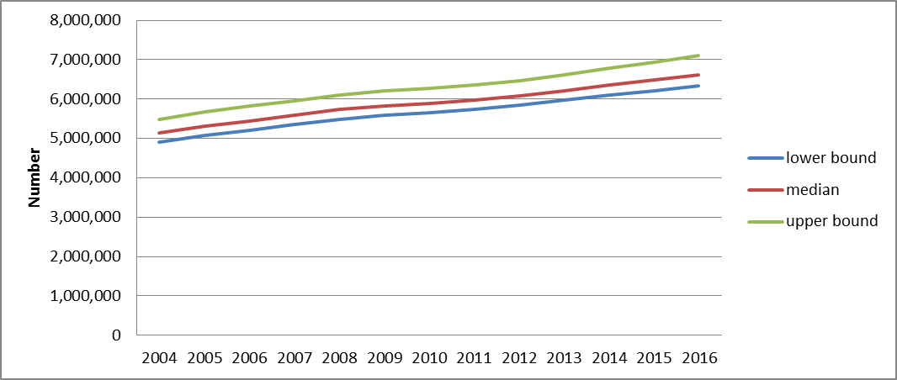
Source: HSRC HIV&AIDS Population Survey 2012.
The results of the HSRC 2012 population survey show that an estimated 6.4 million people are living with HIV&AIDS in 2012. In 2012, three provinces - KwaZulu-Natal, Gauteng and Eastern Cape accounted for over 50% of the proportion of people living with HIV in South Africa. All provinces have more people living with HIV over the years since 2004. The HIV prevalence peaked in females aged 30-34 years at 36.8% among males at 24.2% in the 35-39 year age group. In this survey the prevalence peaked 5 years later for both males and females as compared to the previous three surveys of 2002, 2005 and 2008), which also reflects increased ARV treatment coverage.
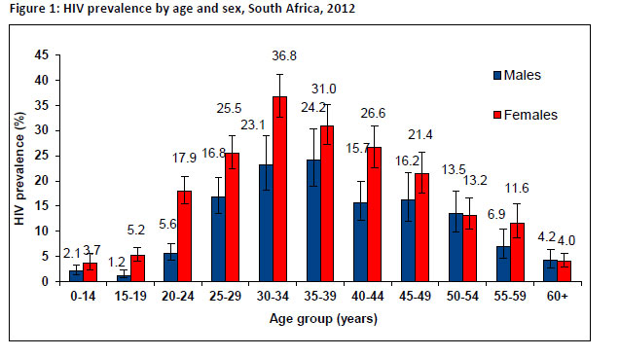Figure 1.1. above shows Prevalence by age and sex, South Africa, 2012.
Source: HSRC HIV&AIDS Population Survey 2012.
A major developmental achievement is that there has been a decline of HIV prevalence among youth aged 15 – 24 years from 10.3% in 2005 to 8.7% in 2008 and 7.3% in 2012. Successive years of prevention of mother to child transmission and youth HIV prevention programmes seem to have had the requisite effect of reduction of HIV prevalence in this age category.
The HIV epidemic remains feminized with the key age group of adults aged 15-49 years the HIV prevalence is 23.3% among females and 13.3% among males. This shows a 10% difference between the sexes which highlights that the brunt of the epidemics is still felt mainly among females.
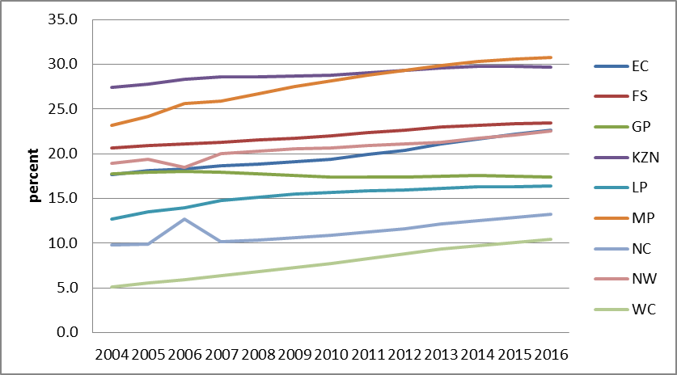
Fig 2. Above reflect Provincial increases in Prevalence of people living with HIV (Mpumalanga, KwaZulu-Natal and Eastern Cape account for 50% prevalence of PLHIV) 2012.
Source: HSRC HIV&AIDS Population Survey 2012.
In 2012, three provinces-KwaZulu-Natal, Gauteng and Eastern Cape accounted for over 50% of the number of PLHIV in South Africa. This is largely because KZN and Gauteng are the most populous provinces in South Africa. The estimated prevalence of HIV (the proportion of people living with HIV in the country) increased from 10.6% in the 2008 HIV Household Survey, to 12.3% in 2012.
An encouraging finding is that more South Africans are aware of their HIV status (see Fig 3). This is largely due to the success of the HIV Counselling and Testing Campaign (HCT) launched by the Presidency in November 2009. However females are substantially aware of their HIV status than males due to additional effects of the Prevention of Mother to Child Transmission (PMTCT) programme.

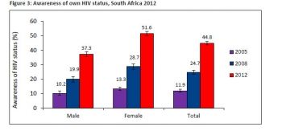
Fig 3. Awareness of own HIV Status, South Africa 2012.
Source: HSRC HIV&AIDS Population Survey 2012.
A disturbing finding is that HIV prevalence among unmarried persons is twice that of married persons, 19, 2% compared with 9.8%. The proportion of unmarried persons in South Africa is high at 69.4% of the population aged 16 years (the legal age of marriage) and older. As the table below shows, people who are unmarried are more likely to report having multiple sexual partners within the last 12 months.

Sex | Married with 2+ partners | Unmarried with 2+ partners (%)
Males | 5.4 | 28.7
Female | <1 | 7.2
Total | 3 | 17.9
Table 1. Multiple sexual partnerships in the last 12 months by marital status by sex, South Africa 2012.
Source: HSRC HIV&AIDS Population Survey 2012.
A pillar of national prevention programme is condom promotion and distribution. In 2012 there was a decline in condom use in all age groups, although for young males the aged 15-24 years the proportion reporting condom use at last sex remained high 67, 4%. This is also the group that reported the highest proportion of multiple sexual partnerships at 34.6%.
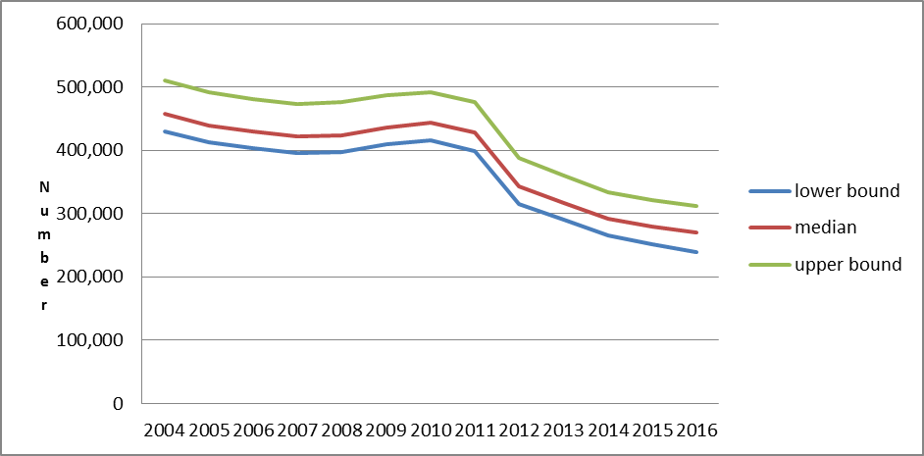
Fig 4. New Infections national 2004-2016.
Source: NDOH/ UNAIDS Spectrum Modelling 2012.
The positive finding in South Africa’s HIV&AIDS response is that there were significant declines in HIV incidence in South Africa between 2004 and 2012. In 2012, there were an estimated 370,000 new HIV infections in South Africa compared to 540,000 new infections in 2004. The rate of new HIV infections (HIV incidence) dropped from 2% in 2004 to 1.4% in 2012 – representing a 30% reduction. Spectrum estimates that the number of new HIV incidents has dropped by a quarter between 2004 and 2012, from 460,000 to 350,000, and is expected to gradually decline to 270,000 by 2016.
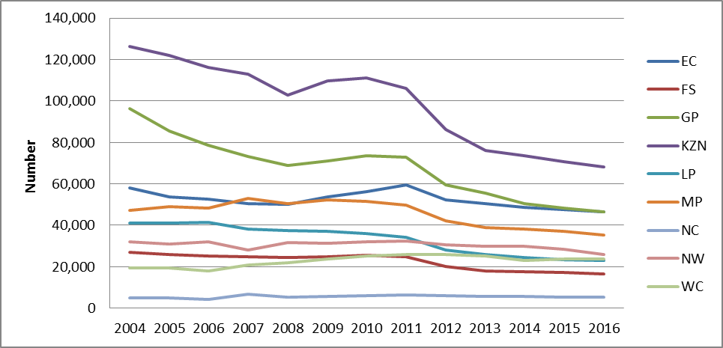
Fig 5. New Infections by Province SA 2004-2016.
Source: NDOH/ UNAIDS Spectrum Modelling 2012.
Nearly all provinces observed a decline in number of new infections, especially Gauteng (38%), KwaZulu-Natal (32%), Limpopo (32%) and Free State (26%). Three provinces-Mpumalanga, North West and Eastern Cape experienced modest rates of decline in the number of new infections at 11%, 6% and 5% respectively. However, two provinces, namely Western Cape and Northern Cape registered a 32% and 20% increase in new infections respectively. Migration and structural factors related to activities associated with the extractive and construction industries are ecologically correlated with this increase and call for structural interventions in HIV Prevention programmes and involvement of government departments in economic cluster of government departments, beyond Health.
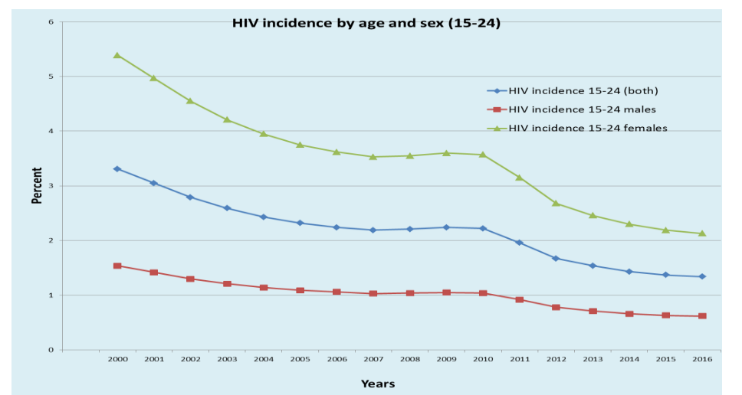
Fig 6. Shows new Infections among the young people 15-24 years.
Source: NDOH/ UNAIDS Spectrum Modelling 2012.
The success of the HIV Response as indicated before is among young people. Not only is there a decline in prevalence among young people 15-24 years but there is also a decline in incidence (new infections). HIV incidence for 15-24 years (the percentage of susceptible HIV negative people who become infected each year) declined from 2.2% in 2009 to 1.7% in 2012 and is estimated to drop to 1.3% by 2016. In 2012 there were approximately 170,000 new infections among young people 15-24 years. The number of new HIV infections among young women (15-24 years) dropped by nearly a quarter from 160,000 in 2004 to 120,000 in 2012. The biggest declines were registered in Gauteng and KwaZulu-Natal. However, the gap between the number of infections among young women and men remains wide. The data shows that young women are particularly affected (130,000 women versus 40,000 men).

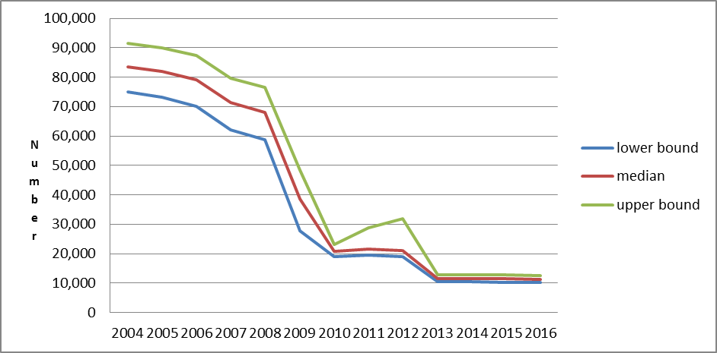
Fig7: Number of new HIV infections in children 0-14 years - National (2004 - 2016).
Source: NDOH/ UNAIDS Spectrum Modelling 2012.
This demographic success is even more pronounced in the reduction in new infections among children 0-14 years. The number of new HIV infections among children was reduced by 75% from 2004 to 2012 as services to prevent mother-to-child transmission of HIV 83% in 2012 increased. This increase in services enabled almost 240,000 pregnant women living with HIV to access medicines to keep their babies free from HIV (see Fig 7).
Due to these interventions and services, the rate of mother to child transmission has dropped by about 77%. Mother to child transmission rates dropped from 15% plus levels in 2004 to sub 2% levels for at least half of the provinces in 2012 (Gauteng, Mpumalanga, Northern Cape, North West and the Western Cape Provinces). Nationally it is expected to decline to approx 2% from 2013 onwards.

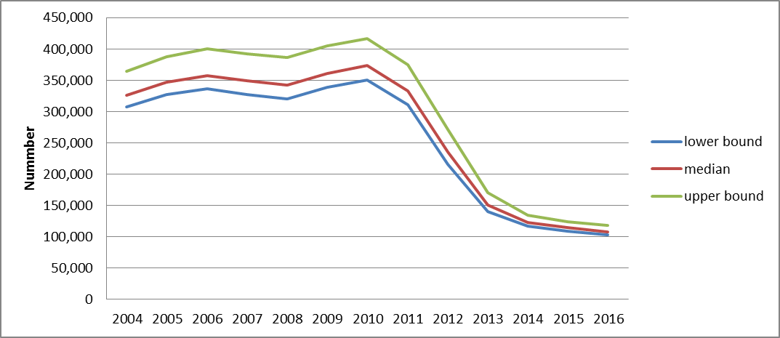
Fig 8: Annual AIDS Deaths – National (2004 – 2016).
Source: Statistics South Africa, 2012.
An even more significant demographic impact and success of the HIV&AIDS response has been the drop in AIDS related deaths over time. South Africa saw a reduction of at least 30% in the number of AIDS related deaths (all age groups) since 2004. The estimated number of deaths declined from 330,000 [310,000-360,000] in 2004 to 240,000 [210,000-270,000] in 2012.

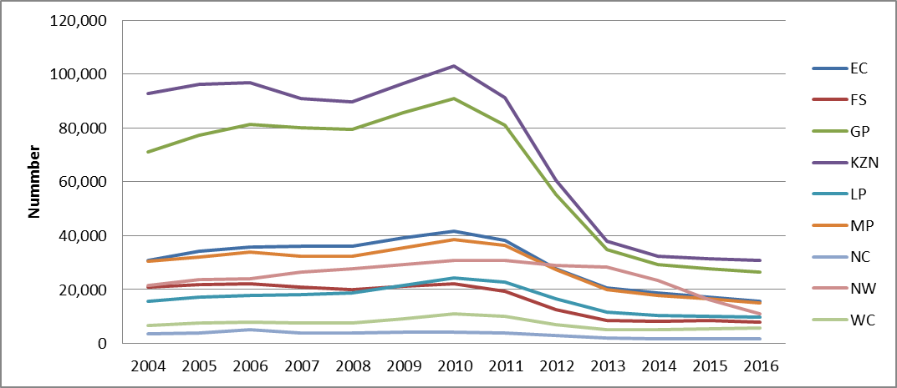
Fig 9: Annual AIDS deaths – Provincial (2004 – 2016).
Source: Statistics South Africa, 2012.
Furthermore, another finding of economic and demographic significance is that in 2012, KwaZulu-Natal and Gauteng provinces averted the highest number of AIDS deaths. During the period 2010-2012, AIDS related deaths fell by nearly 40% in Free State, KwaZulu-Natal, Gauteng and Western Cape provinces, respectively. The Provinces of Mpumalanga, Northern Cape, Eastern Cape and Limpopo had an average of 30% in AIDS related deaths reduction. AIDS related deaths among children aged 0-14 years decreased by over 60% in Gauteng, Free State and the Western Cape.
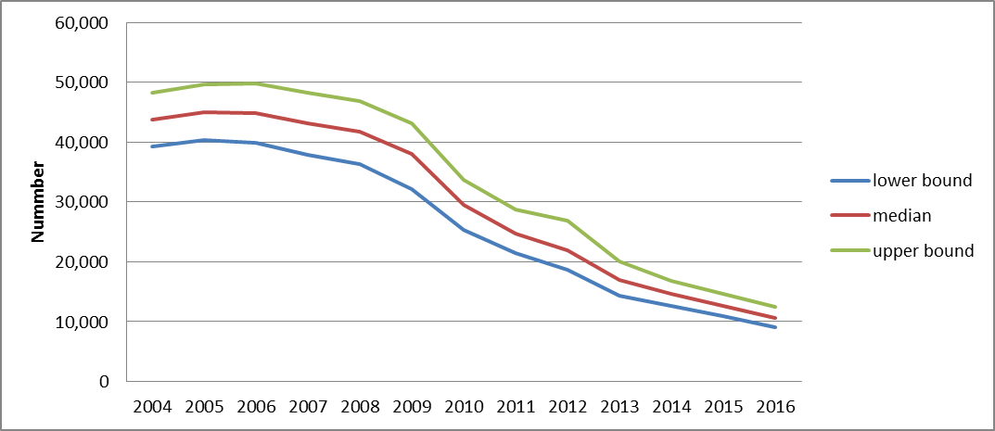
Fig 10. AIDS Related Deaths among Children 0-14 years.
Source: Statistics South Africa, 2012.
The incidents of AIDS related deaths among children aged 0-14 years declined by a higher percentage compared to the adult age groups. Among children 0-14 years, AIDS related deaths fell by 50% between 2004 and 2012. About 20,000 AIDS related deaths occurred among children in 2012 compared to 40,000 in 2004 (Fig 10).
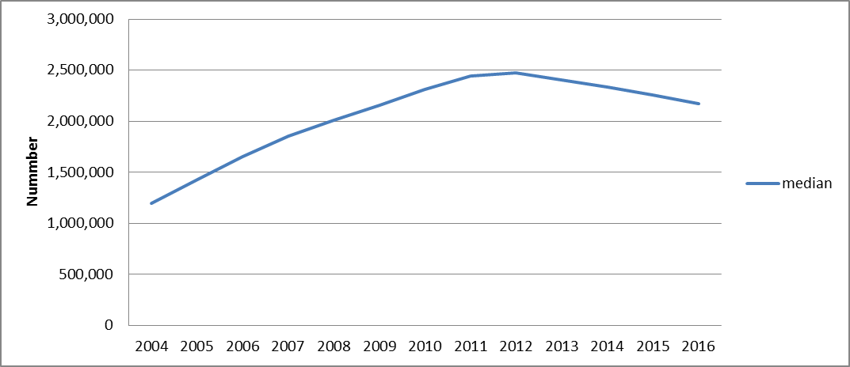
Fig 11: Number of AIDS Orphans.
Source: Statistics South Africa, 2012.
The decline in the prevalence and incidence among children is validated by a plateau in the number of AIDS orphans at 2 500 000 in 2012. It is projected that this number will decrease with to an average approximating 2 000 000 by 2016.

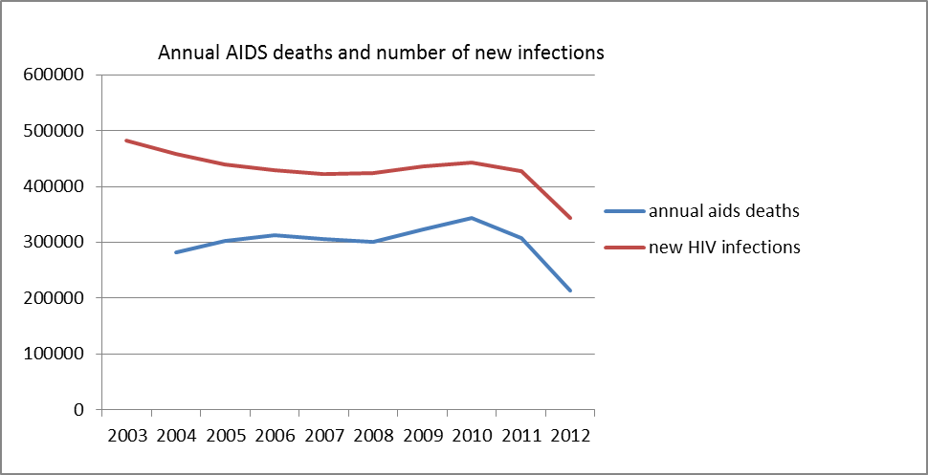
Fig 12: Decline in AIDS Deaths and New Infection.
Source: Statistics South Africa, 2012.
The above figure 12 indicates the decline in both AIDS deaths and new infections at national level. These figures indicate that South Africa is on its way towards reduction in AIDS deaths and new HIV Infections and that the country has made tremendous progress in curbing the spread of this scourge. Part of South Africa incremental but noticeable success can be attributed to the combination of health related outputs of Adult ART coverage 82% [78%-85], PMTCT Coverage = 83% [75%-90%] and Child (0-14 years) = 63% [57-69], respectively.
In addition to the previously stated initiatives, the government of South Africa has ensured that the public service as an engine for delivery is responsive to the challenge of HIV&AIDS. For example, since the launch of the National Strategic Plan (NSP) 2012-2016 programme, the Government Employees Medical Scheme (GEMS) has reported a month to month growth on the HIV disease management programme (HIV DMP).

The tables below show the number of members registered on the HIV programme from January 2012 to September 2013 as a total and percentage growth. On average there has been about 1% growth per month from 1 January 2012-to September 2013 period of NSP implementation. The total number people on HIV Disease management programme is 101, 908 as at September 2013.

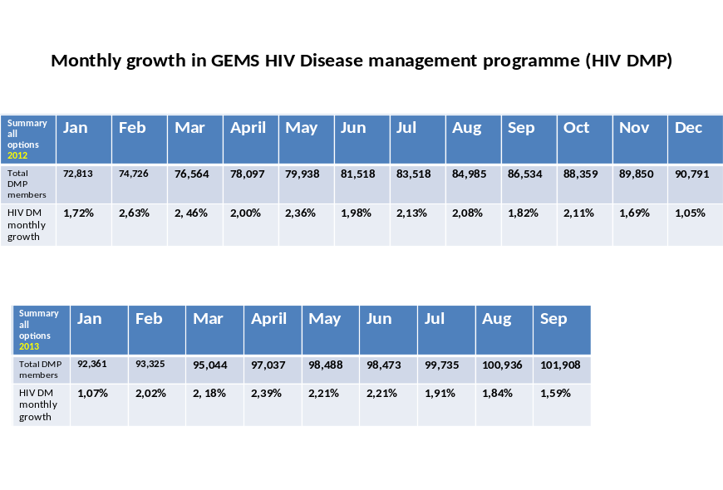
Tables 2&3: Monthly growth in Government Employee Medical Scheme (GEMS) HIV Disease management programme (HIV DMP) 2012-2013.

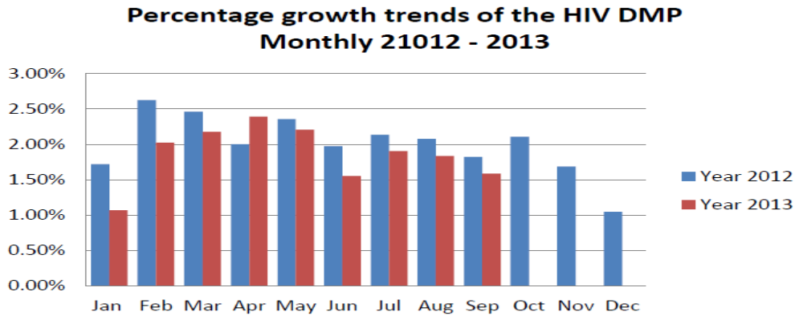
Fig 13. Percentage growth trends of the HIV DMP per month for 2012 and 2013 calendar years.
Source: GEMS Annual HIV&AIDS Preliminary Report.

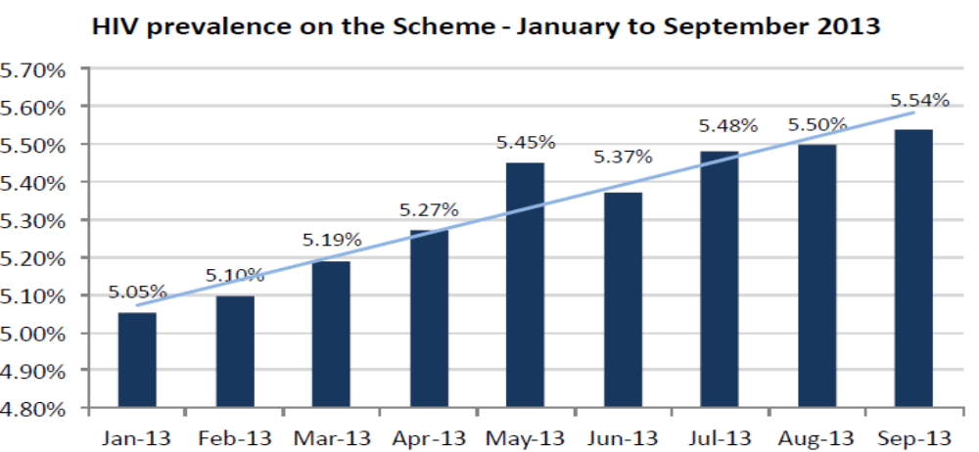
Fig14. Growth trends in HIV Prevalence among GEMS members.
Source: GEMS Annual HIV&AIDS Preliminary Report.

In the second year of the NSP implementation 2013 there was a demonstrable growth in the percentage of membership of the GEMS who are HIV positive.

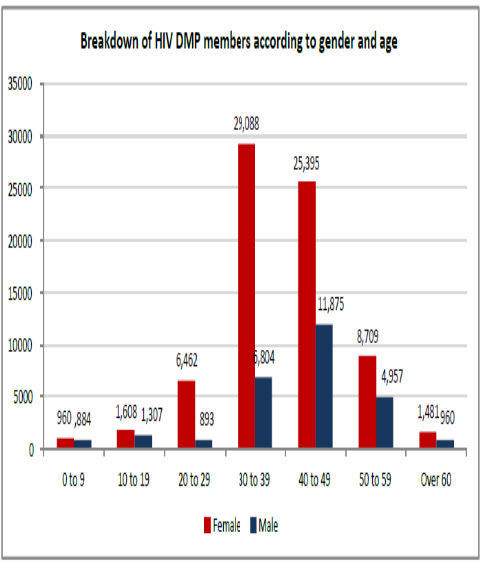
Fig 15. Comparison of the Mean age of HIV positive individuals in GEMS and South Africa.
Source: GEMS Annual HIV&AIDS Preliminary Report and HSRC HIV&AIDS Population Survey 2012.

The median age of HIV positive individuals on GEMS Disease management programme is the 30-39 age group with correlated to the national one as reported by HRSC in 2012. (See figure5 above). This implies that the Public Service has an unprecedented number of people (women in particular) who are HIV positive and who are on treatment. The DPSA has partnered with NAPWA and the Futures group to establish a forum of HIV positive employees to ensure treatment adherence and support.

As indicated above, the total number of GEMS members on ART is 101.908 with the bulk of them being professionals on the Emerald option. Sapphire and Beryl are lower categories in the employee salary scale. Ruby and Onyx’s are higher options that are usually taken by senior managers. The ecological correlation of the GEMS members on ART and their membership options indicate that we have most of our professionals on ART followed by middle to senior management categories on ART pre-ART and MTCPT and PEP programmes.

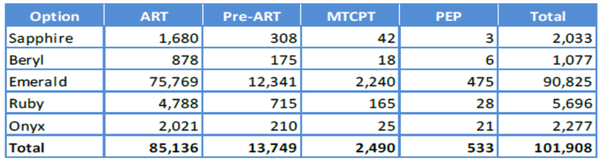
Table 5: GEMS member on ART, PreART, MTCT and PEP according to benefit options.
Percentage of members registering directly on the Anti Retroviral Therapy (ART) programme. Source: Government Employee Medical Aid Scheme.

The table 6 below shows the proportion of members who joined the HIV DMP and registered directly in the ART programme. These members would have had a CD4 count less than 350 at enrolment.

Table 6: Table indication increase in treatment coverage in the first two years on NSP implementation.
Source: GEMS Annual HIV&AIDS Preliminary Report.

A significant achievement in year two of the NSP implementation phase as observed from table 7 below is that late enrolment has been decreasing since January 2013.This reflects pro-activity on the part of the programme with regard to early testing and early enrolment as promoted through the HCT campaign.

Table7: Significant decrease in the percentage of GEMS members with late enrolment of CD4 count below 200/mm3. Source: GEMS.

Furthermore, government has recorded significant progress in dealing with HIV&AIDS as result of the HCT campaign as reflected in the number of people on pre-ART who are initiating treatment. This increase has been significant during this reporting period.

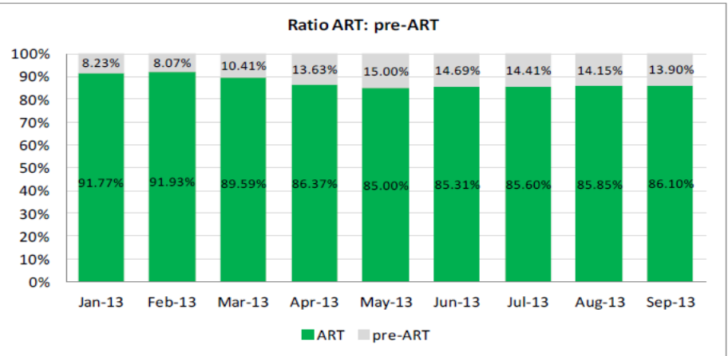
Fig. 6. Increase in proportion of GEMS members on ART and Pre-ART in year 2 of NSP implementation.
Source: GEMS.

In January 2012, there were 18, 908 members already on Fixed Dose Combination. This accounted for 30.7% of members on ART’s. This number has grown incrementally since then as illustrated in table 8 below. As of September 2013 there are 51,141 members authorized for FDC, which accounts for 60. 07% of members on ART.

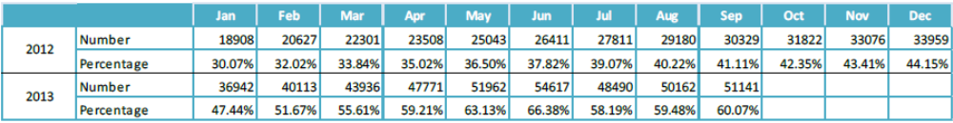
Table 8: Increase in the number and proportion of GEMS members on Fixed Dose Combination in first two years of implementation of the NSP.
Source: GEMS.

In addition to the above interventions, South Africa has made remarkable progress in its attempts at mainstreaming HIV&AIDS programmes across government. During the reporting period, several projects were successfully implemented as part of the broader HIV&AIDS mainstreaming work in national and provincial departments. Some department’s advocacy programmes had to be conducted to intensify their involvement in the HIV&AIDS response based on their unique mandates without which the HIV&AIDS response will remain inadequate, ineffective and unsustainable. Some of these departments include; department of Labour, Correctional Services, department of Public Service and Administration, Justice and Constitutional Development, department of Environmental Affairs, the department of Basic Education, department of Higher Education, the National Prosecuting Authority, and the department of Peformance Monitoring and Evaluation.

The Department of Labour has developed its first two operational plans with major emphasis on the HCT campaign, promotion of treatment through disease management programmes as well as maternity protection through the piloting of the Child Care Facility in its premises. In addition, the Department of Labour updated the Code of Good Practice on management of HIV&AIDS in the work place and developed HIV&AIDS Technical Advisory Guide for all employers in the Public and Private Sector, including social partners from labor and community organizations. This Technical Advisory Guide calls for all stakeholders to mainstream HIV&AIDS in line with the NSP 2012-2016, to manage HIV&AIDS as both a work place and a developmental issue in line with the ILO Recommendation 200 of 2010.

Futhermore, the department has prioritised the inspection of world of work to comply with the technical Assistance Guidelines for the financial year 2013-2014. Advocacy is ongoing this year to include the entities attached to the department like Productivity SA and NEDLAC to mainstream HIV&AIDS in their core mandates. However, some of the emerging policy issues in relation to the work and programmes of the department include, maternity protection based on the call by Tshwane Declaration, the Policy Dialogue on Economic Empowerment Policy Framework which forms part of the ILO led East Africa and Southern Africa Programme of Economic Empowerment along major transport corridors. The latter programme is undertaken in collaboration with ILO, SANAC, DPSA, DoT, DoC, DED, National Treasury, DTI, DMR, DPE and DE. Civil Society partners participating include the three Trade Union Federations COSATU, NACTU, and FEDUSA. In addition, the Business sector organisations BUSA, BBC, and NAFCOC also participate. The latter act as a service provider to raise capacity of local communities along transport corridors. Some of the achievements of this programme include the surveys on the effectiveness of economic empowerment in various transports corridors that include Harrismith and Ventersburg, in the Free State; Gauteng the City of Tshwane, Mpumalanga-Nkomazi Municipality to Lebombo border Post, North West’s Ramotshere Moiloa Municipality to Skilpad Border post, and the Western Cape Beufort West Municipalities.

The Department of Correctional Services is also actively involved in attempts to mainstream HIV&AIDS in its work. During the first year of implementation of the NSP 2012-2016 to date, the department of Correctional Services in collaboration with the Department of Health and other partners have developed Guidelines for the Management of TB, HIV and STIs in Correctional Facilities which was launched by the Ministers of Health and Correctional Services in 2013. Furthermore, 347 Health Care Professionals have been trained on the guidelines by the department. In addition, in order to strengthen health care provision the department has established partnerships with organizations such as TB/HIV Care Association, Aurum Institute, Population Council of South Africa, Foot-ballers for Life, International Training and Education Centre for Health (I-TECH), Hospice Palliative Care Association of South Africa and the Right to Care organisation. The Population Council has conducted a baseline assessment to determine HIV PEP service provision and related gaps in order to inform the department’s policy review. The policy to address sexual abuse of inmates in DCS facilities was approved in 2013.This policy deals with prevention, detection, monitoring and responding to sexual violence incidents against inmates.
Strengthening government’s attempts at addressing the HIV/AIDS pandemic through mainstreaming has also been prioritised by the Department of Public Service and Administration. The DPSA is charged with the responsibility of coordination of the implementation of the HIV&AIDS and TB management policy for the Public Service which is aligned with the NSP 2012-2016. The department is also the focal department at SADC on mainstreaming HIV&AIDS into development. The department is the anchor department at the PSCBC on labour relations matters relating HIV&AIDS.
The DPSA has for the past two years drafted the Public Administration Management Bill (PAM Bill) which is to provide better coordination of the Administration across all three spheres of government and provides for the Minister for Public Service to set common norms and standards for all spheres of government. This coordination framework is similar to the one approved at the first SANAC Plenary meeting in Pietermaritzburg in October 2012. Consultation on the PAM Bill and its implications was discussed among different stakeholders including government departments at the Government Technical Task Team (GTT), the Inter-Departmental Committee for Human Resources Management and Development and at the National AIDS conference.

Currently, the DPSA is in the process of approving the formation of Inter-departmental Committees at the District and Local Municipal Level. These will be convened by district and local municipal administration (municipal managers). These structures will coordinate the activities of government departments at all levels, especially where these departments have a presence in a particular municipal demarcated zone. These will include national, provincial and municipal government departments. All the activities and related outputs of the government departments will be accounted for at the level of the local and district municipalities within the context of the Integrated Development Plan. This approach towards the mainstreaming of HIV&AIDS is a clear indication of a management and governance framework of the disease that seeks to link the causes and effects of the pandemic within a developmental context.

The Inter-Departmental Committees at the Provincial level will continue to be convened by the Offices of the Premier and at the National Level by the DPSA. Consultation with SALGA on Framework has begun and is ongoing between DPSA, SALGA, SANAC and Future group. The practical piloting of this model has begun at the eHlanzeni District Municipality. The coordination model, will be mediated by assessing the epidemic at a local municipal level in the “Know Your Epidemic” (KYE) model. This model will entail the development of the local municipal response specific to the dynamics of local conditions upon which the pandemic takes place and will be guided by the spatial mapping of socio-economic and environmental factors. This approach will be binding to government departments based on existing laws, policies and programmes and the “Know Your Response” (KYR) component of the model. The coordination of the programme will also be enhanced by the assessment of government and non-government stakeholders including state owned companies and civil society organisations, business, labour and NGOs. This assessment will incorporate evaluation of their capacity and mandates in the “Know Your Institutions and Capacity” (KYI&C) model.

It is envisaged that by March 2014 all government departments in eHlanzeni, all government entities and other SANAC sectors will have a clear understanding of the epidemic. This understanding will entail an assessment of their response capacity based on their core mandate as well as provide a clear understanding of other stakeholder’s roles and capacities. All these will be synthesized into a local municipal HIV&AIDS response which the municipality can the implement based on the current IDP. The IDP governance framework provides for revision and amendment as and when need arises. Once done in eHlanzeni, this model will be piloted in all municipalities and will be facilitated by SALGA, COGTA in consultation with the DPSA which will set norms and standards of Public Administration at all spheres of government. This model will particularly be valuable for the Metropolitan Municipalities’ HIV&AIDS and TB responses as eight of the 15 cities where HIV is most prevalent in Sub Saharan Africa are in South Africa.

The Department of Justice and Constitutional Development has been involved in the management of Project 107 (a Project aimed at investigating the legal options related to sex work). Part of Project 107 is reformulation of sub-objectives under Objective 4 of the NSP 2012-2016. This includes the rendering public services related to comprehensive management of gender based violence. The Project 107 is largely the responsibility of a government entity called the Law Reform Commission. It will investigate options to sex work. The Law Reform Commission has conducted preliminary investigations and has compiled a report. This report is currently being studied by the Department and will be made available once this is completed and outstanding issues have been clarified with Acting Commissioner. The Objective 4 of the NSP 2012-2016 was reworked after the initial presentation to Cabinet. This work has now been completed and the Objective four is being implemented by various SANAC sectors according to their comparative advantage.

The work of overseeing policy advice and programme implementation is done by the Technical Task Team which was established after the NSP 2012-2016 approval by Cabinet. The Technical Task team is chaired by the SANAC CEO and the Deputy Minister of Justice. The membership of the task team is made of the senior officials from the Department of Justice, and civil society organizations. Furthermore, HIV&AIDS and TB were mainstreamed into the legislative and policy work of the Department with both the dimensions of gender sensitivity and human rights factored into this work. The department facilitated the signing of the Trafficking in Persons Act which has particular gender sensitive provisions of protection of women and children against trafficking. This has been signed into law by the President of the republic during this year (year 2 of the NSP 2012-2016 implementation).

The Department has concluded the report into the reopening of sexual offences courts. This was commissioned out of the increased case cycle time which was proven to lengthen the rendering of legal justice service to members of the community who were sexually violated. This report was launched by the department in 2013. This report will inform the policy and programme implementation processes to be followed to ensure that the sexual offences courts are reopened. Fifty percent (50%) of sexual offences courts will be established by end of November 2013. So far 22 out of the planned sexual offences courts have been established.

The Department of Environmental Affairs is undertaking advocacy on the SADC project on HIV&AIDS mainstreaming into Environmental Impact Assessments. DPSA as a focal department at SADC has been advocating for this in South Africa among senior managers at Environmental Affairs, MinTech and working groups 2 and 7 of the MinTech Groups.
The project aims to incorporate HIV&AIDS epidemic and its impact on society with its gender and human rights dimensions into feasibility studies that are legally mandatory before major capital projects are constructed, implemented and/or decommissioned. These studies Environmental Impact Assessment studies have traditionally focusing on the geophysical environmental impacts of projects on biodiversity, heritage impact, and aesthetic impact on its surroundings without taking into account the socio-economic dynamics of projects such as human rights, gender based violence and HIV&AIDS impact.

Some of the achievements of the department of environmental affairs in relation to HIV&AIDS include the development of a operational plan for year one whose main focus was advocacy and capacity development work. Three capacity development workshops were conducted by the DPSA in Partnership with UNDP and SAIEA (South African Institute for Environment Assessments). These were targeting managers in the Department of Environmental Affairs to incorporate HIV into the Environmental Impact Assessment studies of individual projects and the impact of cumulative impacts of many projects through Strategic Environmental Assessments.
The second workshop was aimed at training several Universities to begin to train Environmental Management specialists, and mainstream this into their curricula. Universities of Pretoria, North West, Stellenbosch, UNISA and Cape Town were trained. The University of North West has begun offering training short courses in this regard. The UNDP and SAIEA trained about 200 environmental management specialist who are already in the field to ensure that they incorporate the impact of HIV&AIDS in the social impact assessments of their feasibility studies.
A guideline on Integrating HIV&AIDS and gender issues into Environmental Assessments was developed in partnership with SAIEA, IOM, UNDP and SADC. It was launched in Tunis, Tunisia in 2013. The African Development Bank (AfDB) and the African Union Commission adopted this guideline to inform their practices and policy work respectively. South Africa was represented by a delegation including representatives from DPSA, SANAC, UNDP country office and Department of Environmental Affairs. Each country is now expected to “domesticate” this guideline and align its provisions with country specific policy and legislative framework.
The other partners in the above project include the department of Public Enterprises which is responsible for development of EIS for major capital projects of the Strategic Infrastructure Development Projects. This Department liaises with other departments to fast track EIA processes through a specialized unit. It is this forum of departments that will be engaged to ensure that the Strategic Infrastructure Development Plans don’t come with the “micro-epidemics” that are associated with major capital projects throughout the world.
The Department of Health has Guidelines on Environmental Impact Assessments which have been developed in partnership with the Department of Environmental Affairs in 2010. These guidelines, the new guidelines launched by the UNDP, the legislative analysis using the EIOA Barometer, and the emerging legislation need to be considered will be harmonized into a legal and policy framework which will ensure that HIV&AIDS programmes are coordinated and streamlined across all spheres of government and national councils.
In relation to HIV&AIDS, the Department of Basic Education provided leadership in areas of policy development, scaling up of programmes and establishment of systems for implementation, monitoring and evaluation. In relation to policy work, the department drafted and consulted on the National policy on HIV, STIs and TB for the schooling system. The department further approved peer educator and peer mentor manuals; approved the CSTL MER Framework; and the Guidelines for the Implementation of Peer Education Programmes for Learners in South African Schools. Most of this policy work was done in consultation with national stake holders, SADC, UNESCO, Futures group and other national stakeholders.
On the other hand, the Department of Higher Education successfully launched the First things First campaign as part of the national HCT campaign targeting University Students. In year two of the NSP, the Department is institutionalizing campus health facilities targeting both staff and students in order to promote HIV treatment within the context of comprehensive employee health and wellness, primary health care as well as occupational health and safety.
The Department has been granted R23 million to be utilised in mainstreaming HIV&AIDS into the curricula of different faculties and disciplines in all higher education centers. The DPSA and UNDP will be working with the department to provide capacity. This exercise will be done within the context of the Gender Sensitive Rights Based HIV&AIDS Mainstreaming Guidelines approved by Minister for Public Service to support government departments.

The department is also supporting the DPSA in the development of Public Sector HIV&AIDS Capacity Development Plans to increase the capacity of the Public Sector in responding efficiently and effectively to the HIV&AIDS and TB epidemics at all spheres of government. Furthermore, the department is also working with three Universities (Pretoria, Wits and UCT) on Capacity Development for M&E of HIV&AIDS for all.

The National Prosecuting Authority has historically piloted and ran the multidisciplinary facilities for women and children who are sexually violated. These facilities are mainly funded by donor resources. In year one and two of the implementation of the NSP, most of advocacy for government resources was done through engagement with National Treasury. All Thuthuzela centers are now fully funded by National Treasury. This work has been highly prioritised in Government and is overseen by Director-Generals Inter Departmental Committee to ensure effective implementation. This is a further reflection of South Africa’s commitment to a rights based gender sensitive response to the HIV&AIDS pandemic.

In relation to and in response to its core mandate, the Department of Peformance Monitoring and Evaluation has ensured that each of the 164 national and provincial department have an outcome allocated to it some shared outcomes based on the Service Delivery Framework. In the first year of the NSP 2012-2016, HIV&AIDS mainstreaming indicators for each government department to report on were developed. All government departments are obliged to report to both the DPSA and the DPME on the implementation of their mainstreamed HIV&AIDS operational plans.

In relation to other communicable diseases, targeted interventions were implemented to improve child health. Highly successful measles and polio campaigns were conducted to protect South African children against these two preventable diseases. Furthermore, 89.4% of South African children under the age of one year were fully immunized and 72% were provided with pneumococcal conjugate and rotavirus vaccines to protect them against pneumonia and diarrhea.

With regards to communicable diseases, there has been a decrease in malaria incidents per 1000 local population which was at risk from 0.6 in 2010/2011 to 0.48 in 2011/12. These achievements came as a result of strengthened malaria information systems which are utilized for early prevention strategies. These were complimented by improved collaboration on malaria control with neighboring countries like Zimbabwe, Botswana and Mozambique.
Attainment of the vision of a Long and Healthy Life for All South Africans requires a strengthened and well performing health system. Key priority areas in which progress was made in strengthening health systems included, amongst many others: re-orienting the system towards Primary Health Care (PHC), development of a National Health Insurance (NHI) policy, reduction in the price of antiretroviral medicines and improving financial management.
    - Improving access to and outcomes of the education system at all levels
Education continues to be a key priority of government. Expanding access to education and reducing illiteracy has the potential to accelerate socio-economic development more than any other intervention. Quality education is a critical ingredient in the on-going efforts to address the legacy of apartheid that still pervades many aspects of South Africa’s social set-up. The adage that, “Education is the great equaliser”, derives from a statement by former President Nelson Mandela informs the policy and principles of government towards education. Therefore, quality education is greatly needed in SA to deal with challenges of inequality, poverty and unemployment.
Specific challenges that still confront Basic Education include:
- Frequent curriculum changes leading to poor teacher mastery of content and methodology, leading to learners that are ill-prepared for the next class;
- Provision of learning/teaching material is inadequate and inequitably distributed, with rural schools being the worst affected;
- Infrastructure resources including technology, libraries and laboratories are in short supply, more so in rural areas and schools in informal settlements;
- There is not enough attention being paid to educator remuneration;
- The twin challenge of poor school leadership and management; and inadequate parent participation; and
- School safety and abuse of drugs in school.
The above factors, when combined contribute to poor learner performance, especially in mathematics, science and technology. Government has initiated efforts to strengthen the National Mathematics, Science and Technology Strategy with the aim of increasing learner performance in these subjects, while increasing the capacity and numbers of teachers in this field.
Through the Dinaledi Schools Programme, the Department of Basic Education has identified 500 schools country-wide that have excelled in Mathematics and Science. The aim of this programme is to increase the number of learners in Mathematics and Science in Grade 12, improve success rates through the provision of learner and educator support material, as well as to encourage successful matriculates to enrol for technical disciplines such as engineering at institutions of higher learning.
The Integrated Strategic Planning Framework for Teacher Development in South Africa was launched in 2011. This strategic framework is a collaborative effort of the DBE, the DHET, teacher unions, the Education Labour Relations Council (ELRC), the South African Council for Educators, the Education, Training and Development Practices Sector Education and Training Authority (ETDPSETA) and the Higher Education South African Education Deans’ Forum (HESAEDF). The Framework outlines a 15-year roll-out of improved and expanded teacher education and development opportunities with the aim of improving the quality of teaching and learning in schools.
It is envisaged that the Plan will respond to the following challenges: educators’ poor subject knowledge and pedagogic content knowledge, inadequate and weak system to accurately identify systemic and individual educator development needs, insufficient numbers of educators to meet system requirements, lack of support to educators at the local level and education system capacity constraints. Further concerns in relation to education included the quality of education programmes, poor coordination and lack of coherence in the teacher education and development system.
The National Curriculum and Assessment Policy Statements (CAPS) were introduced in September 2011 to strengthen the national curriculum statements with a view to improving the quality of teaching and learning in schools. One hundred and fifty thousand (150,000) educators and 2051 subject advisers have been capacitated on the implementation of CAPS. The 2012 roll-out of CAPS was Grades 1-3 and 10 and Grades 4-6 will be covered in 2013.
In terms of the National Senior Certificate (NSC) results, there has been a significant improvement and performance increase was at 73.9% which indicated 3.7% increase from 2011 results (70.2%) and in 2010 it was 67.8%. A process of standardizing NCS results in line with international standards was undertaken. An international evaluation on selected subjects was undertaken with reputable institutions such as Cambridge international examination, Scots Qualification authority and Board of studies in New Wales. The process was also meant to set benchmark with Higher Education sector in SA.
The Umalusi convened its own standardization on the performance of subjects to ensure consistency of performance with the previous years and out of the 58 subjects 41 were accepted, 12 were taken down and 5 were adjusted. Other interventions have been introduced to deal specifically with the measurement of learner performance. The other is the Annual National Assessments procedure that was instituted in Grades 1-3 to help monitor learner performance in literacy and numeracy. Approximately six million learners in 19,000 schools underwent assessments for Grades 1-6 and Grade 9 in 2011/2012. In addition, government has established the institution of the National Education Evaluation and Development Unit (NEEDU) which will focus on systemic monitoring of the overall provisioning of basic education, including governance.
Plans are underway to re-open some teacher training colleges to increase the training of Foundation Phase teachers. This initiative has started in Mpumalanga province, with an intake of 100 student teachers in the Foundation Phase class in 2013.
To further intensify South Africa’s efforts to promote universal primary education, the Ministry of Women, Children and People with Disabilities initiated the “Access to Education for All Children” campaign to promote the interests of orphans and vulnerable children in education. This campaign is also aimed at promoting the integration of learners with special needs into the mainstream education system as part of Inclusive Education Policy (IEP). Government subsequently aims to conduct an audit of special schools with the view to address various challenges that have been reported.
Government continues to focus on ensuring that every child is given a good start early in life through the provision of quality Early Childhood Development. Currently, 432 727 children are subsidized at a cost of R12 to R15 per day in registered ECD facilities.
Government is also paying special attention to school’s infrastructural base since this has the potential to inhibit teaching and learning. As part of governments attempts to improve infrastructure in schools, specific attention and priority has been turned towards the eradication of mud schools as well as the provision of adequate water and sanitation.
Furthermore, a Norms and Standards Regulatory Framework for Public Schools has been initiated with the aim of ensuring that appropriate school infrastructure is developed across the country. In the meanwhile, a recapitalization grant of technical secondary schools is being considered. This will lead to the refurbishment of two hundred and fifty nine (259) workshops at these schools and the training of a minimum of one thousand five hundred (1,500) technology teachers.
As mentioned earlier, during the reporting period, the DBE has established the National Education Evaluation Unit and the National Education Evaluation Bill was gazetted for comments in December 2011. The objective of the Bill is to evaluate how provincial and national departments monitor and evaluate schools progress, performance, assess quality of school leadership, and management as well as educator support processes. It is envisaged that this will result in the identification of critical factors that inhibit and/or advance school improvement and achievement in relation to specific sector goals.
Efforts have been made to ensure that learners attend classes in habitable environments. The introduction of the Accelerated School Improvement and Development Initiative (ASIDI) has been introduced to eradicate inappropriate school infrastructure; provide basic water, sanitation and electrification of schools. The inclusion of the programme in the Presidential Infrastructure Coordinating Committee is meant to accelerate the provision of basic school infrastructure and pursue alternative models. An MOU was signed with Development Bank of Southern Africa in 2011 to fast track the building of schools infrastructure in identified areas.
In 2011-12, the implementation of the above initiative has resulted in the provision of water to 55 schools, sanitation to 115 schools and electrification of 48 schools. Furthermore, the increase in the grant from R 93, 215 million of 2011-12 to R324, 098 million will solve the challenges experienced with contractors, which have resulted in the delay in altering the infrastructure impasse.
In July 2011, the DBE, organized labour, BUSA and NEDLAC signed an Accord on Basic Education. This is a partnership through which all education players, stakeholders and social partners, committed to support the drive to achieve quality teaching and learning in South Africa. This included the idea of adopting a school to provide direct support on the specific challenge(s) they encounter. The adopt-a-school campaign emerged in the context of a rallying call to make education a societal priority.
The Accord identified as a major challenge in education the need to improve the quality of basic education in the country. It outlines the importance of performance in the schooling system as being a fundamental to the skills base needed for economic growth and development. The Accord commits all parties to:
- Working together to change the mindset among educators, learners and parents in order to rebuild dysfunctional parts of the basic educations system;
- To adopt poor-performing schools and implement whole school development programme interventions, with individual businesses working collectively; and
- That trade unions or community based organisations should assist schools to develop proper governance, high standards of teaching, basic schools-level discipline and an adequate supply of essentials i.e. text and work books.
This is done through the guidance of a protocol developed and approved by the Minister of Basic Education and key social partners in education who participate in the Quality Learning and teaching Campaign (QLTC). At the heart of the Accord is the need for partnership and creating space for social partners to realise government’s Outcome 1: Improved Quality of Basic Education and to ultimately produce fully functional schools marked by effective leaderships and management; teachers in class and on time, teaching and the availability and the use of learning and teaching support materials.
The IDC in November 2011 approved a revised CSI educational focus to support an inclusive intervention targeting selected schools across the county in support of the NEDLAC Accord on Basic Education. Plans are afoot by the IDC to adopt schools within the country by 2013.
The DHET has focussed on increasing the country’s production of Honours, Master’s and Doctoral graduates needed to support innovation and knowledge production in our economy. In 2011, close to 9 000 FETs and Universities of Technology graduates were placed in workplaces for experiential training. In addition, 4200 students were placed in workplaces whilst studying. Thirty FET Colleges participated in the training of the NARYSEC youth. In addition, a training programme in Community House Building (NQF 2) and Civil and Construction (NQF 3) has been initiated in partnership with the DBSA and the Construction Education and Training Authority (CETA).
Two new universities, in Mpumalanga and Northern Cape, are being established and the technical ground work like the identification of sites with campus and academic architectural plans to this end was completed in 2012. University education infrastructure expansion and upgrading will also take place in the coming years in order to improve teaching, research, accommodation and support services.
The DHE is working with the deans of engineering, animal and human health, natural and physical science and teacher education faculties to increase the enrolment, success and throughput in identified scarce skills categories. Substantial funds have been allocated to deal with resource constraints through an infrastructure and efficiency grant. An amount of R1, 3 billion for the 2012-13 and 2013-14 financial years has been set aside for these study fields across all institutions.
In spite of the great strides in delivering quality education, there are still enduring challenges. The recent (2012) example of shortage of textbooks in Limpopo and Eastern Cape provinces underlines the need to strengthen mechanisms of delivery and monitoring.
    - Ensuring affordable access to shelter, water and sanitation to all citizen (basic services), especially the rural poor
One of the key indicators of sustainable development is the improved quality of life of all citizens. Access to shelter, water and sanitation are important contributors to the key indicators of an improving quality of life.
Access to water use licenses is crucial to service delivery and development, especially in rural areas. In pursuit of this goal, nine regional bulk infrastructure projects were completed and 47 municipalities were supported in implementing water conservation and demand management intervention measures to ensure water savings. As a result of the implementation of the Accelerated Community Infrastructure Programme, a total of 62,945,297 cubic meters of water was saved against the planned three million cubic meters. Eight hundred and ten (810) municipal waste water treatment and 914 water treatment facilities were assessed during the 2010/2011 financial year, in order to ensure that they meet the required standards.
Private sector and government have also improved their partnership by establishing partnership platforms which address water access challenges in communities. In order to enhance environmental sustainability, in 2011, the government formed a partnership with the private sector in an attempt to close the water volume gap by 2030. This platform, called the Strategic Water Partners Network (SWPN), is an informal public and private sector collaboration mechanism that is implementing projects which are expected to set a precedent in promoting investment in the water sector. Representative companies come from the mining, energy, resources and beer sectors.
The South African government continues to extend land tenure to the poor through a compendium of residential housing schemes. During the reporting period, hundreds of units were constructed. However, this is eroded by the fact that the same recipients of the scheme sell their allocated houses and return to informal settlements because of the heavy burden of high electricity costs, rates and services. It remains to be seen if the municipal subsidy of R275 per month for the poorest households will enhance retention of government provided houses. A strong programme and institutional mechanism for social housing delivery has been put in place. Informal settlement upgrading is getting the requisite support and resources and plans are being put in place to acquire appropriately located land for housing development.
The partial accreditation of eight municipalities towards the full assignment of the housing function will assist with integrated planning for services, infrastructure and housing linked by transport corridors to the dominant economic nodes. A key challenge relates to financial restructuring of housing programmes and institutional relationships among the three spheres of government
Government’s infrastructure development also notched up some important achievements with the development and approval by Cabinet of the Integrated Resource Plan and the Independent Systems Market Operator Bill, with the latter aimed to stimulate greater private investment in electricity generation. Importantly, almost 102 000 additional poor households are reported to have been given electricity connections. In addition 6 regional bulk water projects have been constructed, 8 dams have been rehabilitated and over 3000 water license applications have been finalised.
In reflecting on service delivery achievements, this must be done in the context of the achievements made since 1994. In 1994 only 59% of our people had access to clean and safe drinking water. Eighteen years later, we have progressed to a national average of 94.7 % access to basic water services for all South Africans – an increase of 35.7%. The backlog now stands at 5.3%, or some 710 000 households compared to 3.9 million households in 1994.
Out of the seven water resources infrastructure augmentation projects, the Vaal River Eastern Sub-System Augmentation Project (VRESAP) was completed during the reporting period. The remaining six are underway and at various stages of implementation. Four dams and two conveyance projects have been rehabilitated bringing the total of rehabilitated dams to 28 since the programme’s inception.
To ensure the continued availability of bulk water, the infrastructure has to be maintained. Therefore a few augmentation projects were identified and prioritized for implementation during the medium term, 2009/10 to 2013/14 financial years. In terms of progress for the year under review, the following can be reported:
- The Oliphant’s River Water Resources Development Project Phase 2A (ORWRDP), the construction of the dam wall on the far left side is already at the required height and the balustrade is being placed. The construction of the dam wall is making good progress towards completion in 2013;
- The construction of the bulk distribution system (BDS) phase 2C, which is the pipeline from the dam to Steelpoort, has commenced. This phase is on track and is one of the links of the total bulk distribution system which will transfer water from the De Hoop and Flag Boshielo dams for domestic and industrial users. Its completion is still scheduled for March 2014;
- The construction of the Mokolo-Crocodile water augmentation project is set to be commissioned and the water delivery is expected by the end of 2013. The implementation agreements as well as water supply agreements have been signed by Exxaro and Eskom. The water supply to the Local Municipality of Lephalale will be augmented;
- The construction of the Mooi Mgeni Transfer Scheme Phase 2 began in February 2011 and it is expected to be completed in 2015. The first delivery of water was targeted for April 2013;
- The draft agreement on Lesotho Highlands Water Project Phase 2 (LHWP) was submitted for approval by governments of Republic of South Africa and Lesotho;
- The implementation of other water augmentation schemes - the Vaal River Eastern Sub-System, Komati Water Augmentation Scheme, is on schedule;
- To ensure water quality, three Waste Water Treatment Works (WWTW) and four Water Treatment Works (WTW) were completed. Four water supply schemes were also completed;
- The NWRI maintenance programme ensures the availability of water supply for domestic use. The following progress can be reported;
- The rehabilitation of nine out of twenty five national dams was completed. Work on the remaining ones will continue in the new financial year; and
- A total of one hundred and ninety five (195) dams were identified for improved safety. Dams with walls above the 5m height and the capacity of more than 50 000 m³ were also identified.
    - Addressing Service Delivery Challenges
Great strides have been made in addressing service delivery challenges within the country. This is evident in the steps undertaken to ensure all citizens have access to affordable basic services, especially, shelter, water and electricity (as explained in paragraph 3.4.4. above). In further improving the rate of service delivery, mechanisms have been put in place to improve coordination among departments at national, provincial and local government levels. Mechanisms to improve coordination within the entire government are discussed in paragraph 3.1.5 ‘Institutionalising democracy’ under the theme ‘Democracy and Political Governance’. However, there is still a challenge of coordinated monitoring and evaluation systems and following up on the results of evaluation. The levels of satisfaction with the delivery of services still show limited improvement during the reporting period as indicated in the figure below.
Satisfaction with service delivery by local municipalities, by selected metropolitan area: 2011.

Area Agree Disagree don’t know
Bloemfontein 53% 48% 0%
Cape Town 57% 38% 4%
Durban 35% 57% 8%
East London 32% 60% 8%
East Rand 41% 48% 11%
Johannesburg 43% 51% 6%
Port Elizabeth 29% 65% 5%
Pretoria 44% 50% 6%
Soweto 42% 49% 9%
Vaal Triangle 17% 67% 16%
West Rand 34% 62% 4%
South Africa 41% 51% 7%

Source: TNS Research Surveys, Press release, 6 March 2011.

The survey measured citizens’ satisfaction with the services by government. The gap between those dissatisfied and satisfied is still not more than 10% and in some metros the levels of satisfaction with service delivery are quite high and, of course, in others the situation is a cause for concern. In 2012, the situation seems to have deteriorated and the increase in the number of service delivery protests suggests growing public discontent. The figure below shows the number of service delivery protests recorded
‘Service-delivery’ protests - Major Service delivery protests, 2004–2012.

Year Protests
2004 - 10
2005 - 34
2006 - 2
2007 - 32
2008 - 27
2009 - 105
2010 - 111
2011 - 81
2012 - 113
Source: Municipal IQ, Hotspots Monitor, 17 September 2012.

The table above suggests a steady increase in public protests over government services between 2004 and 2008. This exposition of discontent in 2009 coincided with the election year. This is on top of many smaller and less publicised pickets mostly concerned with local issues ranging from ward committees deficiencies, the malfunctioning of public facilities, the breakdown of water or energy services, long housing allocation lists, and lack of councillor access and accountability. There were also special protests around questions of demarcation and geographical location of municipalities. These last longer, thus prolonging the damage to social pacts and order in these communities. In total, there was a 710% increase in public protests between 2004 and 2011. This is both an indication of the scale of public anger, but is also a signal of the extent of public participation and activism on the part of citizens.

Protests convey useful messages to government and other organs of society about the pressures that people at community level, especially in poor areas on the periphery of major towns, face on a daily basis. They provide a useful sense of the state of socio-economy in these areas, revealing for instance, that while a lot of progress has been registered in the state provision of basic services, there remain huge backlogs. Some are directed against perceived corruption, sudden enrichment and conspicuous consumption by municipal councillors and staff. They can indicate the exact nature of the problems both in terms of areas of services in short supply and the causes such as poor leadership and inefficient municipal service units. They are almost always a way in which citizens demand responsiveness on the part of their political leaders and parties, pointing to a growing gap between them and their followers. This is why a lot of protests are actually about political alienation, political conflicts and intra- and inter-party issues.

On a general scale, it appears that the protests are staged by three groups namely the poor in municipal areas; disaffected youth, trade unions and workers organised outside of the ambit of trade unions. These protests are classified into broad categories namely:

- Systemic where they relate to maladministration ; fraud, nepotism and corruption;
- Structural when structural factors that impinge on healthcare, unemployment and land issues are considered;
- Governance involving weak leadership; erosion of public confidence in leadership and ineffective public participation; and
- Opportunism where there is the pursuit of private gain at the expense of the common good.
Discontent can also be an unintended consequence of initiatives to bring government closer to the people through the Community Development Workers Programme and other similar initiatives. Initiatives such as CDWS have unintended consequences that exacerbates delivery protest in the sense that they create an expectation of improved service delivery which raises expectations for speedy provision of services. However, in instances where these expectations are not met or there is a perception of failure this may result in increased service delivery protests. In relation to these protests, some of the challenges highlighted during consultations in preparation of this report in the provinces include inaccessibility and poor visibility of CDWs in some areas, poor police support for community policing forums and failure of government to provide stipends for volunteers.
During provincial consultations referred to above, some of the issues highlighted were: lack of good governance, poorly skilled public officials, poor quality of services rendered, inadequate flow of communication from government to communities, poor awareness of procedures for demanding citizens’ rights, inadequate consciousness of citizens’ rights; and inaccessibility of government officials.
As part of a comprehensive strategy to curb service delivery protests, the Department of Cooperative Governance and Traditional Affairs (COGTA) is re-energising the implementation of the Local Government Turnaround Strategy (LGTS) of 2009. This strategy is aimed at expediting the solutions of local problems and the strengthening of local governance. Government envisages that this strategy will restore the confidence of the citizenry in municipalities as primary delivery organs of development as well as rebuild and improve the basic requirements for a functional, responsive, accountable, effective and efficient developmental local government.

There have been noticeable improvements in the efficient and effective management of local government programmes in areas such as: operational and capital budgets, in the strength of leadership and effectiveness of management in a number of provinces due to improved implementation of the turn-around strategy. It is envisaged that as the functioning of local government improves in terms of service delivery, this will limit and reduce the number of public service delivery protests.
In the last two APRM country progress, South Africa suggested that efforts to improve service delivery must be enhanced through better cooperation between government, civil society and organised labour. Therefore, a lot of work to strengthen this cooperation is underway and is discussed in paragraph 3.1.5 on ‘institutionalisation of democracy’.
Government has come up with interventions to address the challenge of access for all the peoples of South Africa, especially those living in rural areas. Initiatives such as the roll-out of 171 Thusong one-stop integrated community development centres help to empower the poor and disadvantaged through access to information, services and resources from government, non-governmental organisations, parastatal entities and business to engage government for the improvement of people’s lives. They provide timely and thorough information on facilities, departments and services. They usually host officials from key departments like Home Affairs, Labour, South African Social Security Agency (SASS), Social Development, Government Communication and Information Service (GCIS), Health, Post Office, Police as well as libraries, NGOs and community based organisations.
The Integrated Development Planning (IDP) is identified as one of the key tools for arriving at decisions on important policy and programmatic matters at municipal matters. It guides municipal management on what pivotal matters need to be addressed and partnerships that must be built. The IDPS are as effective as the people who use them and the way in which they are applied. This is a major problem. Failure to apply all the principles of integrated and participatory development planning as well as to fully implement the plans has the effect of rupturing the trust between citizens and government authorities who jointly work on the plans.
During this period under review, the Municipal Infrastructure Support Agency (MISA), a new government entity under the Department of Cooperative Governance and Traditional Affairs was established. MISA seeks to support municipalities to effectively spend the Municipal Infrastructure Grant (MIG), a conditional grant allocated to specific municipalities according to government’s policy priorities. In principle, this focuses on the infrastructure required for basic levels of service; targeted assistance to the poor; maximum economic benefits; decentralisation of spending authority within national standards; efficient use of funds; reinforcing local, provincial and national development objectives; and predictability and transparency. Among key challenges identified that MISA is now focused include poor planning in procurement processes.
Further, during this reporting period government set the target of improving the quality of life of 500 000 households by 2014 through the upgrading of informal settlements. This is to provide security of tenure and access to essential services closer to economic and other social amenities through:
- Accelerated delivery of housing opportunities;
- Access to basic services;
- More efficient land use; and
- An improved property market.
It has also emerged from consultations and research that South Africa really battles with the task to establish the right “ethos of service delivery”. Research suggests that when citizens are informed about the time, level and quality of public services they will receive, they are unlikely to have unrealistic expectations and unnecessary disappointments.
    - Poverty and Inequality
The eradication of poverty is a major problem in post-apartheid South Africa and underlines a number of other major challenges. The challenge is to build on the foundations already in place so as to reduce and eventually eradicate poverty completely. For its part, government recognizes that poverty and inequality remain high, and has set as one of its priorities to eradicate poverty and inequality. There have been concerted efforts to also incorporate UN Millennium Development Goals (MDGs) in government’s work through various avenues of the national programme implementation, such as the Cluster System and individual departments and agencies. Under the current administration, MDGs are being pursued through the Medium-Term Strategic Framework (MTEF: 2009- 2014) and Government Plan of Action, translating the five priorities outlined in the ANC Manifesto and the 12 Outcomes of Government.
The Government’s MTEF identifies development challenges facing South Africa and outlines the medium-term strategy for improving living conditions of all South Africans. MTSF guides planning and resource allocation across all spheres of government. It identifies the following five development objectives:
- Halving poverty and unemployment by 2014;
- Ensuring a more equitable distribution of the benefits of economic growth and reducing inequality;
- Improving the nation’s health profile and skills base and ensuring universal access to basic services;
- Building a nation that is free of all forms of racism, sexism, tribalism and xenophobia; and
- Improving the safety of citizens by reducing incidents of crime and corruption.

The strategic priorities for the current MTSF are:
- Speeding up growth and transforming the economy to create decent work and sustainable livelihoods;
- Massively building economic and social infrastructure;
- Comprehensive rural development linked to land and agrarian reform and food security.

Within this framework, government has developed and is implementing a comprehensive government-wide development strategy directing all its energy towards the achievement of these priorities according to principles aforementioned. However, structural distortions in the economy, weaknesses in the state and the global economic crisis are already acting as constraints to this process, resulting in lower than expected outcomes coming out year-on-year. The MTSF allows government to constantly adjust its plans and alter its activities to respond to this objective reality.

The MTSF gives practical effect to the 2008 Anti-Poverty Strategy through which government explicitly spelt out decisive interventions to address the scourge of poverty. It also seeks to change the trajectory of the anti-poverty initiatives. It attempts to strengthen the resolve to reverse, and reduce the incidence of poverty as well as prevent the recurrence of poverty (or what is famously known as the ‘intergenerational transmission’ of poverty).
Both the Anti-Poverty Strategy Discussion Document and the Third Country MDG Report note that South Africa has experienced a remarkable decline in poverty owing largely to a significant income transfer programme, massive reallocation of pro-poor expenditure, for example on housing, water, electricity and sanitation.

Based on two essential measures, namely the proportion of the population who live below the thresholds of $1 up to $2.50 per day, and the poverty gap ratio, it is clear that the proportion of people experiencing absolute poverty has declined. Applying this measure, South Africa has reduced the population living below the poverty line of a $1 per day from 11.3% in 2000 to 5% by 2006. This figure has come down even more since 2006, although figures are not fully certain. The unfortunate reality, however, is that even during the reporting period, despite the progress made females are still disproportionately affected by poverty. According to the MDG Report, “whilst poverty has been halved for both males and females, the proportion of females living below $1 (PPP) per day remains high compared to that of males: 12.0% (females) and 10.0% (males) in 2000; and 5.3% (females) and 4.8% (males) in 2006. The same pattern is found when other poverty lines such as $1.25, $2, and $2.5 per day are used”.

When it comes to income distribution, available data shows that the average real incomes of South Africans have been increasing steadily for all population groups. The growth in per capita income has come both from wages through increased employment and social grants. Not only did individuals across the whole spectrum experience positive income growth but those at the very bottom of distribution experience a greater increase than those from the 30th to the 70th percentile. On the other hand, except for part of the period, income growth for the poor amongst Africans was not in general greater than that for the non-poor. In other words, overall, those at the top of the income distribution on average benefit more than those at the bottom. What this confirms is that income growth has not necessarily resulted in a decline in South Africa’s historically high levels of inequality. A comparison of aggregate Gini coefficients (the most widely used measure of inequality) shows that, in fact, levels of inequality have widened, thus making South Africa one of the most unequal societies in the world. This suggests a deep problem of structural inequalities with a long history in the foundation of the modern South African economy.
One of the variables that contribute to high levels of poverty is unemployment, in particular among the youth. “The level of unemployment in South Africa officially decreased in the fourth quarter of 2012 by 0.1%, down from 25% to 24.9% (2012 Fourth Quarter Labour Survey). Sadly though, while any reduction in the unemployment rate is good news, in truth this marginal change reflects more an increase in the number of discouraged work seekers (youths who are no longer looking for work), than an actual increase in employment”. Even those who are employed are not fully immune from poverty, particularly for the one-worker households in the lower-income categories owing in large measure to low levels of school education as the supply of low-skilled workers far outstrips the demand.
Therefore, government has introduced a wide array of interventions aimed at addressing the challenge of poverty in a comprehensive manner. These constitute a policy package used to ensure poverty decline. These include measures designed to stimulate job creation including assistance to entrepreneurs involved in job-creating ventures and assistance to the unemployed who are battling poverty.
The single most important driver of the decline in poverty is government’s social security assistance programme. From 2, 5 million beneficiaries in 1999 to just over 12 million in 2007, the social grant system is the largest form of government support for the poor. The largest by far is in the form of the Child Support Grant (CSG), which reached 7,8 million beneficiaries in 2007 compared to 34 000 in 1999. The table below shows the increase in the number of beneficiaries between 1997 and 2009. This trend has continued up to the present.
The rapid expansion of the social security system lies at the heart of growth in expenditure levels of the poor.

Table: Numbers of beneficiaries of social grants in 1997 and 2009
 | 1997 | 2009
Old-age grant | 1737 682 | 2 414 183
Disability grant | 737 322 | 1 281 556
Child-support grant | 362 631 | 8 825 824
Total | 2 b37 635 | 12 521 568
Source: Based on Van der Berg and Siebrits (2010)

Various studies have confirmed that this support is well targeted and contributes considerably to poverty reduction. 62% of the total of social grants went to the poorest 40% of households.
Another important anti-poverty intervention is the Expanded Public Works Programme (EPWP), which includes the Home-Based Community Care and Food for Waste Programmes. It provides poverty and income relief through temporary work for the unemployed. The programme “was launched in April 2004 to promote economic growth and create sustainable development. The immediate goal of the EPWP Phase 1 was to help alleviate unemployment by creating at least 1 million work opportunities, of which at least 40% of beneficiaries will be women, 30% youth and 2% people with disabilities”. The target of 1 million job opportunities was attained in 2008. Details of progress made and impact of the Expanded Public Works Programme are elaborated in paragraph 3.2.3 “Unemployment’ in the thematic area on Economic Governance and Management.
Social Sector: No. of Work opportunities
 | Total | Municipal | Provincial
2009-2010 | 80,000 | 2,744 | 77,256
2010-2011 | 96,000 | 3,293 | 92,707
2011-2012 | 132,000 | 4,527 | 127,473
2012-2013 | 187,000 | 6,414 | 180,586
2013-2014 | 255,000 | 8,746 | 246,254
Source: Department of Public Works

By the end of December 2011, the Environment and Culture Sector of the EPWP had created a cumulative 307 731 work opportunities and 74 114 Full-Time Equivalent (FTE) jobs since 2009 across the country. Initiatives to improve employment opportunities and economic livelihoods include the implementation of the aquaculture programme and the Inland Fisheries programme that were launched in 2012. The DTI is expanding efforts to support agro-processing in rural areas, e.g. local maize milling.
In early 2010, South Africa signed an agreement with the World Bank for fee-based technical assistance (FBTA) to help this country to develop and implement comprehensive rural development and land reforms. This also provided for South-South experience sharing and learning, with a view to strengthen rural development initiatives. As part of this South-South experience sharing, a hi-powered delegation of government studied closely the evolution of Chinese rural development and poverty reduction strategies including rural land reform, rural industrialization and job creation, integrated rural-urban development, and China’s system for national monitoring and evaluation of rural development. The same has been done in a number of other successful developing countries. Lessons learned have been used in the continuous rethinking and strengthening of programmes in this area.
There are many other initiatives that government, working with a plethora of social partners, has introduced to deal with the challenge of poverty, unemployment and inequality (some already covered in 3.2.1.3). They are as follows:
- The Department of Trade and Industry’s (DTI) provides financial support to qualifying companies in various sectors of the economy, which is offered for various economic activities, including manufacturing, business competitiveness, export development and market access, as well as foreign direct investment;
- The Finance for Small Businesses and Small Medium Enterprise Development programme, a grant programme offering financial help to tourism-related projects;
- The Department of Agriculture, Forestry and Fisheries (DAFF) introduced a complementary agro-processing strategy;
- The Department of Science and Technology (DST) supports a range of demonstration agronomy and aquaculture projects that utilise new knowledge or technologies in supporting the development of sustainable livelihoods;
- Assistance is provided to small and micro enterprises and communities that require support for a simplified Environment Impact Analysis (EIA) process as part of Industrial Policy Action Plan 2;
- The introductions of Special Economic Zones (SEZ) Bill which will help address socio-economic problems like unemployment among the country’s youth. Underlying the Bill is the assumption, based on the experiences of the world's fastest growing economies like China, India and Brazil, that industrial development is key to growing the country's economy and creating employment opportunities, as well as generally bettering the lives of people.
The re-industrialisation of the South African economy is central to long-term growth and development strategy to curb poverty, inequality and unemployment. A host of sectoral and cross-cutting initiatives are being implemented under Industrial Policy Action Plan 2 (IPAP 2). IPAP 2011/12-2013/14 was introduced in February 2011 and is being systematically implemented. To support IPAP II, the new Manufacturing Competitiveness Enhancement Programme (MCEP) was introduced in 2012. The programme provides R25 billion over the six years for a variety of programmes. In addition, the Automotive Investment Scheme (AIS) has seen the approval of 92 projects (seven final car producers and 85 component manufactures). The projected investment resulting from these approvals is close to about R9 billion based on incentives of R2, 5 billion, creating over 7000 jobs both directly and indirectly.
To deal more effectively with poverty, better coordination between civil society organisations, on the one hand, and between national, provincial and local spheres of government, on the other, is needed. This relates to interventions dealing with poverty and unemployment. Innovative interventions have been made in certain provinces such as KwaZulu-Natal to identify and reach the poorest of the poor so that services are more accessible to them. In KwaZulu-Natal, a Provincial Index of Multiple Deprivation is used to rank wards according to levels of disadvantage scored. This then informs strategies of tackling access to service provision. This kind of evidence-based policy innovation still needs to be widely shared among provinces.
- CROSS-CUTTING ISSUES

  - Xenophobia
A number of explanations have been put forward for the outbreak of violence in South African communities where foreign nationals live side-by-side with locals. The explanations have come both from government agencies, and through the popular press, ‘with differing levels of credibility and social scientific validity’ (HSRC 2008). These range from explanations which suggest external manipulation through a ‘third force’, criminal instigation, a dislike and fear of foreign Africans, to poverty and the competition for scarce resources in poor communities. The attacks, which started in Alexandra in May 2008, subsequently spread to other areas in and around Johannesburg, including Cleveland, Diepsloot, Hillbrow, Tembisa, Primrose, Ivory Park and Thokoza. Reports of xenophobic violence were widespread in other provinces such as Kwazulu-Natal, Mpumalanga, and the Western Cape. What complicates the picture is that evidence abounds that violence is not only targeting foreign African nationals, but also certain South Africans, like the ‘Shangaans’, and non-Nguni speakers in certain communities.
Therefore, South Africa is confronting a complex challenge of xenophobic attitudes sometimes accompanied by conflict and violence. First, the question is whether the label ‘xenophobia’ is the correct one? Secondly, are the ramifications of this phenomenon uniquely South African? The country has condemned xenophobia not only because it is an embarrassment – but mainly because it is an affront to South Africa’s moral conscience. South Africa government is putting measures in place to deal with root causes of xenophobia.
Government aims to ensure domestic peace and security and out rightly condemns any acts of violence against persons of any race, creed or colour. Xenophobic violence, wherever it has occurred, has been strongly criticised by the government and organs of civil society. That is why the Report of the Task Team of Members of Parliament, ‘Probing Violence and Attacks on foreign nationals’, in pursuance of a National Assembly resolution agreed that “xenophobic attitudes do exist among some South African citizens and could have been exploited to initiate the violence and attacks on foreign nationals. Xenophobia is largely based on unfounded and unverified fears as well as the inclination to stereotype foreigners as the cause of social and economic problems in the host country. However, xenophobia is not confined only to foreigners it can also be directed at local citizens, unknown to a specific grouping, or perceived to behave in a manner unknown to a specific grouping”.
With the assistance of universities, research councils and research NGOs, the government has carefully studied xenophobia in the country hence the strengthening of interventions to support community building initiatives. The implications of xenophobic violence for policy makers, civic groups and stakeholders have all been documented and are used to inform the refinement of sharp and carefully focussed interventions. The review and strengthening of the campaign of the South African Human Rights Commission on “Rolling Back Xenophobia” and the allocation of the necessary resources for this purpose is one of the solutions being implemented. In addition to this, numerous NGOs and other civil society organizations, including the churches are playing a role in maximizing education and awareness within South Africa to combat xenophobic tendencies/attitudes and actions. The Department of Arts and Culture has during the reporting period hosted about 49 community dialogues across the country to encourage nation building, social cohesion and the fight against xenophobia and racism in our communities. The National Social Cohesion summit, which the President defined as a mechanism to bind society together, including foreigners and nationals, was an important development in July 2012 – it focussed on strategic initiatives to deal with xenophobia in South African society.
It is clear from the existing evidence that many South Africans still have misperceptions, stereotypes and uncertainties about the presence of foreigners in the country. An important problem is that many South Africans fail to make any distinction between the different categories of migrants in the country. Many people tend to classify all foreigners in the same way, be they refugees, illegals, economic migrants or unauthorised migrants. All the different categories of migrants, however, have their own set of rights and entitlements. The obligations of government vary according to each category. Officials dealing with migrants are not always able to differentiate between the various categories of migrants with the result that asylum seekers or refugees at times cannot access the services they are entitled to.
Socio-economic circumstances precipitate some resentment towards foreigners who in certain sections of the labour market seem to be favoured by employers because they work hard for much lower wages than are offered to citizens. The competition for jobs and resources – with South Africa’s education system being weaker than its neighbours – sometimes finds that foreigners are better qualified and willing to be paid less. These incidents are commonplace globally. Most importantly, it appears that ordinary South African citizens would like to have their perspectives seriously considered or their voices heard on how to deal with the issues of the influx of foreigners in the country. This is why government and civil society continue to organise dialogues, summits and workshops to open space for participation by people at grassroots levels in the discussions around the sources of xenophobia, solutions and management thereof of immigrants, towards the development a co-formulated migration strategies which will have majority buy-in.
Just as it is important to hold a national debate on the many dimensions and aspects of migration policy, so it is also critical for these discussions to take place at the grassroots level. The attacks on foreigners will not end nor will re-integration take place until communities have satisfied themselves that their grievances, questions and concerns have been discussed and addressed. Non-South African citizens need to be encouraged to participate in these forums.
One of the triggers of violence is the occupation of national housing stock by non-South African citizens. RDP houses were constructed to enable South African citizens to reside in them. The sale or rental of RDP houses to non-South African citizens exacerbates the housing shortage, compounds the pressure on informal settlements and foments community tensions around housing. Hence government is auditing the occupation of RDP housing and will take steps to ensure that only South Africans occupy this form of public shelter. Non-South African citizens are welcome to acquire property through the usual commercial means or to take temporary accommodation until such a time as they are able to move into their private residences.
Government has seriously increased efforts to protect South Africa’s borders and points-of-entry. No migration policy or strategy aimed at alleviating xenophobic tensions can work if the national borders are porous and people can come and go as they please. Such a lack of control leads to abuse, corruption and heightens the vulnerability of people who reside in the country illegally.
  - Racism
The divisions along race, ethnicity, class, political party membership, ideology and even province in South African society remain entrenched. Racism on which was founded the colonial and apartheid systems and the inherited structure of society that remains to this day, is a huge challenge. A lot of work is in progress dealing with this. Interventions include the contribution to the global fight against racism, which found the most obvious expression in South Africa’s hosting and actively participating in the UN’s World Conference against Racism in 2000. The promotion of non-racism efforts formed part of nation-building and national reconciliation processes in the 1990s, and continued in various kinds of inter-racial dialogues in the 2000s. The illegalisation of racism through a raft of laws has empowered organs of civil society and citizens to seek legal recourse against racist acts. South Africa has made it popular to commit to non-racism across sections of society. The removal of racial divisions in the provision of services has continued to this day, recent cases of public schools excluding blacks using the language of instruction and private holiday venues using subtle ways to apply racial exclusion have been subjected to public scorn by citizens and government. Recent incidents of racism on university campuses that were previously white-dominated have also been met with scorn and interventions by authorities have sought to balance punitive justice and corrective action in order to build racial tolerance as part of ethos of society. There are reported incidents of racism on commercial farms and a few white farmers have been successfully convicted over racially-motivated crimes.
The Institute for Justice and Reconciliation’s Reconciliation Barometer, 2011, using survey research methods, examines the biggest divisions in our country. It shows that 18% of South Africans associate most strongly with others who speak the same language, 19% with those of the same ethnic group and 19% of the same race. In other words it confirms the view that race still matters very much in South Africa, of course not discounting the significant progress in uniting the country and confronting racism, using legal instruments and positive interventions by civil society organizations.
The Reconciliation Barometer 2011 also emphasizes that recently the biggest divisions’ in South Africa is the gap between rich and poor’ – or income inequality. On top of strong association by language, ethnic and racial identities, association by income group is an emerging source of divide. Hence, the South African Human Rights Commission’s Equality Report, 2012 refers to an element of classism which complicates the picture of racism in South Africa, but still underlines that race is still the dominant factor in inter- group experiences and relations.
The South African Human Rights Commission’s Equality Report examines levels of inequality and the picture is still racially stewed – where the poor majority is still black and the richest and well-off still whites. What is of particular importance in the report is continuing black experience of subtle racism, some of which can be dismissed as insignificant, until it escalates to extreme violations of human rights. As a result the South African government, in partnership with civil society, is trying to find more innovative measures to detect and confront subtle but emotionally hurting forms of racism which afflict the day to day living of many black people. Such instruments and mechanisms as the Equality Court and policy documents such the National Action Plan (to combat racism, racial discrimination, xenophobia and related intolerances) can only aid in the general fight against these scourges. The challenges which continue to affect the functioning and implementation of these, represent a significant impediment against efforts to combat racism and ensure that victims of discrimination in general find access to justice, as provided for in the Constitution.
There are indications in the SAHRC Equality Report that a number of attempts had been made to develop non-racism through the National Forum Against Racism (NFAR). The NAFAR was provided with support and resources. The secretariat of the NFAR was based at the Department of Justice and Constitutional Development. There was indeed a concerted effort in this regard, and resources were availed for the Steering Committee of the NFAR to produce the draft NAP. Amongst those who formed part of the Steering Committee, were representatives from government departments, civil society and Chapter 9 institutions. However, since then, and after a draft was sent for editing, it seems that the process fell off the radar of the government priority list.
The continued absence of an adopted NAP in South Africa represents a weakness in the efforts of this country to fight racism and related intolerance, and it deprives victims of racism of a useful instrument, which forms part of international best practices in fighting racism

- MATRIX
DEMOCRACY AND POLITICAL GOVERNANCE

Expected output | Required action | Time frame | Progress | Remarks
Objective 2: Constitutional democracy, including competition and opportunity for choice, the rule of law, citizens rights and supremacy of the Constitution
Civil society structures seek increased opportunities to contribute, to participate in the delivery and monitoring of public services | Enhance and improve the effectiveness of national and local social dialogue forums | Continuous | The country continues to strengthen public participation and states responsiveness to public demand for quality services. These include increased capacity and reach of the Community Development Workers Programme and a Social Cohesion Summit held in June 2012 provided a platform for engagement on racism and diversity management | National Social Dialogue Forums have been very innovative and responsive to the country’s challenges as was demonstrated by the adoption of the Framework for South Africa’s Response to The Global Economic Crisis at NEDLAC
 | Enhance and improve the effectiveness of government outreach systems and mechanisms | Continuous | Multi-stakeholder forums and programmes such as Izimbizo (utilised by 78% of the country’s Provinces, followed by ward committees (67%), steering committee meetings and public meetings (56%), the Speakers Forum of South Africa (SFSA), Women’s Parliament, Youth Parliament, Children’s Parliament, Traditional Leaders Parliament and Public Participation Week are indicative of a continued attempt by government to ensure that it engages communities in ensuring improvement of the quality of service it provides | In September 2011, the Parliamentary Reference Group developed a parliamentary oversight model to establish standards to ensure public sector planning; policy making; budgeting and performance of government
 |  |  | During the reporting period, there has been an increase in the number of hotlines for citizen communication with government in both national and provincial levels. The multiplication of the hotlines is a response to the need to be responsive to citizens’ needs, expectations and concerns | Notwithstanding the increased number of government hotlines, there is evidence that some of these are not linked or integrated with one another. This is an indication of a lack of coordination which exacerbates the incapacity of government to the manage data, measure the level of duplication, and determine the speed at which service delivery challenges are resolved
 | Strengthen community radio stations and African language radio stations | Continuous | The government continues to ensure san open environment for community radio stations and increased support to African language radio stations | During the period of reporting there has been a noticeable rise in the number of community radio stations
 | National conversation on the role of the media in reporting, discussions and debates based on factual objective and verifiable sources of information | Continuous | The institutional and constitutional guarantees for a free media have ensured continued debate on contested aspects of media freedom, expression and regulation  The Rainbow Index, developed by the South African Institute of Race Relations (SAIRR) to track the country’s performance on ten social, economic, and political indicators that reveals that South Africa’s score on the pillar on vigilant media and civil society decreased from 61% in 2009/10 to 56% in 2010/11 | However, the same downgrading can be attributed to the fact that the South African government is open to public criticism and it often is the first one to criticize its own performance in public platforms including through the often hard-hitting reports of the Auditor-General, performance monitoring and evaluation reports and in public engagements
Objective 3: To promote and protect economic, social and cultural rights and civil and political rights as enshrined in African and other international human rights instruments
Racism, sexism, marginalisation, lack of awareness and poor access to information impair the full enjoyment of human rights | Know your rights campaign | Continuous | The Department of Arts and Culture translated the South African Constitution into the eleven official languages  The South African Human Rights Commission (SAHRC) has developed a community tool aimed at simplifying the Promotion of Access to Information Act (PAIA) | This was done on behalf of the Department of Justice and Constitutional Development
 | Special focus in know your rights campaign on literacy and empowering vulnerable groups such as women, farm workers , people with disabilities, children , refugees | Continuous | The Institute for Justice and Reconciliation’s Reconciliation Barometer, 2011, using survey research methods, examines the biggest divisions in our country. It shows that 18% of South Africans associate most strongly with others who speak the same language, 19% with those of the same ethnic group and 19% of the same race. In other words it confirms the view that race still matters very much in South Africa, of course not discounting the significant progress in uniting the country and confronting racism, using legal instruments and positive interventions by civil society organizations  The Reconciliation Barometer 2011 also emphasizes that recently the biggest divisions’ in South Africa is the gap between rich and poor’ – or income inequality. On top of strong association by language, ethnic and racial identities, association by income group is an emerging source of divide. Hence, the South African Human Rights Commission’s Equality Report, 2012 refers to an element of classism which complicates the picture of racism in South Africa, but still underlines that race is still the dominant factor in inter- group experiences and relations. | South Africa has made it popular to commit to non-racism across sections of society. The removal of racial divisions in the provision of services has continued to this day, recent cases of public schools excluding blacks using the language of instruction and private holiday venues using subtle ways to apply racial exclusion have been subjected to public scorn by citizens and government  Recent incidents of racism on university campuses that were previously white-dominated have also been met with scorn and interventions by authorities have sought to balance punitive justice and corrective action in order to build racial tolerance as part of ethos of society.  There are reported incidents of racism on commercial farms and a few white farmers have been successfully convicted over racially-motivated crimes.
 | Anti-trafficking project focusing on women and children and targeting perpetrators | Continuous | The Prevention and Combating of Trafficking in Persons Bill 7 of 2010 has been approved | The government has further established the Provincial Task Teams on Human Trafficking. The legislation and forums are aimed at protecting the vulnerable groups such women and children
 | Promote traditional leadership and cultural practices and ensure strategic alignment between traditional leadership systems and institutions within broader social system | Continuous | The government has established forums aimed at promoting and enhancing the role of traditional leaders such as Traditional Leaders Parliament  The government has developed a National Traditional Affairs Bill of 2011 aimed at increasing synergy between institution of traditional leadership and the broader legal and social system  The recognition of indigenous community of the Khoi-San and their Institutions: The National Traditional Affairs Bill of 2011 recognised Khoi-San community leadership positions and provides for the functions of Khoi-San leaders and their institutions. It seeks to establish a national framework, norms and standards to define the role of Khoi-San leadership within the new system of democratic governance | Various Provinces have dedicated departments dealing with matters relating to the institution of traditional leadership  The Seriti Commission report for the remuneration of Public Office Bearers had confirmed that traditional leaders are public office bearers and should be allocated resources to ensure that they discharge their mandate effectively
 | Strengthen Chapter 9 institutions dealing with racism | Continuous | The government has taken steps towards improving access to justice and strengthening institutions dealing with racism by raising awareness of the role of Equality Courts
Objective 6: Fighting corruption in the political sphere
Corruption undermines national integrity systems | Awareness raising with respect to anticorruption legislation, codes of conduct, enforcement and implementation in all sectors and across spheres | Continuous | South Africa’s integrity and anti-corruption regulatory framework is found in several pieces of legislation such as the PFMA, PAIA, the Prevention and Combating of Corruption Act (PCCA), the Protected Disclosures Act (PDA), Public Service Anti-Corruption Strategy, and Local Government Anti-Corruption Strategy.  Review of the public Sector Anticorruption strategy of 2002 has been done  King 3 ethics committee recommendations are widely circulated  In 2010, the DSD uncovered fraud in the administration of social grants and terminated 32 687 fraudulent payments valued at R180 million. In 2011, R44 million was recovered from public servants who illegally benefited from a housing subsidy scheme aimed at assisting poor people. As has been reported in the previous report, South Africa established the Asset Forfeiture Unit and asserts successfully seized by the unit and forfeited to the state are deposited into the Criminal Asset Recovery Account. The Unit has, as at 2013, seized assets valued at more than R541million, R61million of which has already been forfeited to the State and would be routed back to the fight against crime and corruption | There is a need for a centralised institution that monitors corruption across all levels of government
 | Review Protected Disclosure Act | Continuous | The level of improvement in the implementation of Disclosure requirement by senior management in the public service has improved.
Objective 7: Promotion and protection of the rights of women
Violence and crime in particular against women and children | Identify and strengthen anticrime and violence strategies currently underway in all three spheres of government | Continuous | Increase in conviction rates of cases on violence against women and children | Since the re-establishment of Family Violence Child Protection and Sexual Offences unit, there has been a marked increase in conviction rates for offences related to gender based violence and child abuse, resulting in a combined 36 225 years of general imprisonments; 695 of which have been life imprisonments
 |  |  | In relation to gender-based violence, South Africa has re-established the Family Violence Child Protection and Sexual Offences Units within the police force since 2010. Nationally there are 176 established Family Violence Child Protection and Sexual Offences Units attached to all police clusters in the South African Police Service (SAPS)
 |  |  | Approval of the Women empowerment and gender equality bill (August 2012) will strengthen the fight against violence and crimes directed at women.
 |  |  | Inter-ministerial arrangements: re-establishment of Family Violence Child Protection and Sexual Offences unit well advanced
Active engagement of all communities in the fight against crime and violence | Identify and strengthen anti crime and violence strategies in all three spheres of government specifically designed to combat violence against women and children | Continuous | Government anti-crime partnerships and strategies currently being implemented are significantly contributing towards the reduction of crime levels across the country. The levels of crime continue to drop and, according to independent studies, more people are beginning to feel safe. There is an increase of 8% in the public appreciation of how government is performing in reducing crime levels when compared to five years ago (32% in November 2007 to 40% in November 2012 | These findings are in line with the 2011/12 (SAPS) National Crime Statistics Report of government Recent statistics shows that 38% believed that the level of violent crime has decreased in their area of residence compared to 33% who said that crime had increased but there is also a 29 percentage group which believed that crime has stayed the same during the period 2009 -2011
 |  |  | Government has initiated various partnerships to reduce crime. In the Western Cape, for instance, the expanded Partnership Programme with Community Police Forums aimed at strengthening civilian oversight roles is growing. Rural women in KZN, through a provincial flagship program called Sukuma Sakhe (meaning ‘stand up – let’s build’) took the responsibility of conscientising their 'girl children' about the challenges of HIV/AIDS, human trafficking, gender inequality as well as conscientising them about their rights and economic empowerment through IDPs at municipal government level | Sukuma Sakhe is a province-wide initiative aimed at ensuring equitable service delivery. The programme operates at ward level and involves councilors and brings together traditional leaders church leaders and other community leaders in Victim-Offender Dialogues (VOD)
Marginalised and vulnerable groups experience difficulties in making use of the institutions of justice | Alternative dispute resolutions | Continuous | South Africa continues to improve access to justice and transform the judiciary by ensuring that the poor and vulnerable have easy access to justice. To this end demographic representation of society in the courts and in the legal profession has been ensured. Two hundred and forty-three (243) of the judges on the various courts are now of indigenous Africans who can speak many indigenous languages; this constitutes 50% African judges on the various courts  The government has further established twenty-three additional Small Claims Courts in different provinces, which enable people to institute civil claims to the value of R12 000, without the need for legal representation. This brings the number of these courts to two hundred and forty seven (247) at the end of March 2012 | The representation of women in the judiciary remains a challenge which government continuously seeks to address
 | Support programmes for victims of crime | Continuous | The Legal Aid Board of South Africa (LABSA) provides professional legal advice and representation for those who cannot afford private legal practice. It focuses on family matters, evictions, employment issues, contracts, deceased estates, litigations and criminal cases. The Legal Aid Board delivers through Justice Centres, co-operation agreements and agency agreements. In the financial year 2011/12 it received 428653 new matters and finalised 402459 through 64 Justice Centres and Satellite Offices
 | Support programmes for victims of crime | Continuous | Establishment of National Advisory Council on Gender Based Violence to coordinate prevention and response efforts
 | Develop capacity of police force to handle cases of violence and abuse against vulnerable groups including women children, the aged, disabled and refuges | Continuous | In support of the investigation of crimes against vulnerable groups, the government established over 2000 Forensic Social Workers who were appointed to deal with crimes against children in order to provide expert evidence in court
ECONOMIC GOVERNANCE AND MANAGEMENT
Expected output | Required action | Time frame | Progress | Remarks
Objective 1: Promote macro-economic policies that support sustainable development
Blockages to service delivery | Improve service delivery through partnerships | Continuous | In addition to developing the National Framework on Ward Funding and the Local Government Municipal Regulations for the Term of Office of Ward Committee Members, government has ensured that Ward Committee members are resourced for more active participation and are able to support their elected ward councillors to better serve their communities. There has been on-going capacity building of Community Development Workers (CDWs) and evaluation of the implementation of the CDW Programme, which begun in 2013. In addition to this, the implementation of the CDW Master Plan at both national and provincial levels in 2013 enhances the effectiveness of the programme | South Africa experienced a dramatic surge in the level of service delivery protests since 2009, with the highest number of protests recorded in 2012. Government is fully cognisant of the fact that levels of protests which have occurred are not only due to poor service delivery, but are sometimes due to lack of information or even misinformation. The ineffectiveness of public participation and feedback mechanisms cannot be ruled out as an underlying factor.  As part of a comprehensive strategy to curb service delivery protests, the Department of Cooperative Governance and Traditional Affairs (COGTA) is re-energising the implementation of the Local Government Turnaround Strategy (LGTS) of 2009. This strategy is aimed at expediting the solutions of local problems and the strengthening of local governance. Government envisages that this strategy will restore the confidence of the citizenry in municipalities as primary delivery organs of development as well as rebuild and improve the basic requirements for a functional, responsive, accountable, effective and efficient developmental local government
Blockages to service delivery | Combat corruption | Continuous | The National Anti-Corruption Hotline (NACH), established in 2004 continues to be one of the main mechanisms through which the South African public reports allegations of corruption in the public sector  The National Anti-Corruption Hotline continues to be the main mechanism of reporting cases of alleged corruption and according to the Public Service Commission in the period between 2004/05 to 2010/11 the NACH received 106799 calls of which 7922 were of alleged corruption
Blockages to service delivery | Unemployment | Continuous | The Quarterly Labour Force Surveys by Statistics South Africa (Stats SA) show that in the fourth quarter of 2010 (October-December) the rate of unemployment had decreased slightly and was measured at 24.0%. However, the total number of people employed in the economy reached 13.1 million by the fourth quarter 2010  In 2011, the unemployment rate remained relatively stable with marginal changes. In the first quarter (January-March 2011) the rate was at 25.0%; in the second quarter (April-June 2011) the rate stood at 25.7%. In the third (July-September 2011) and fourth (October-December 2011) quarters the unemployment rate was 25.0% and 23.9% respectively. In 2012, the unemployment statistics followed a similar trend as the previous year in 2012. However in the same period total employment continued to increase and reached 13.7 million people | Owing to the recent global financial and economic recession that started in 2008 South Africa’s employment figures, though encouraging have not reached the 14 million peaks that the country witnessed before the economic crisis. In the first and second quarters of 2012 the recorded unemployment rate was 25.2% and 24.9% respectively, in the third quarter of the same year it reached 25.5% and 24.9% respectively
Objective 2: Implement sound transparency and predictable government economic policies
Public Consultation, education and feedback in policy making inadequate | Educating representative structures on how to participate in policy formulation | Continuous | The institutionalization of standard capacity development programmes amongst civil society structures is aimed at improving governance processes. This builds on initiatives involving the intensified implementation of the Intergovernmental Relations Framework and the utilization of the Thusong community service centers to ensure improved, accessible and efficient delivery of government services | The Department of Public Service and Administration (DPSA) continues to play a critical role in ensuring that the Thusong service centers are connected to information and communications technologies so that walk-in citizens can access the wide-range of government services available through e-government. The implementation of the Maponya Urban Thusong service centre in Soweto is being used as a benchmark
Processes for public participation in policy formulation and implementation are improved | Educating government structures on effective consultative policy making and monitoring implementation | Continuous | The government continues to improve and utilize strategies, forums and programmes such as the IDPs, LED processes, NEDLAC, Provincial Growth Development Strategies (PGDS’s), the National Council of Provinces (NCOP), the Constituency processes, and public hearings as part of a long list of forums and interventions that provide space for dialogue and contribute to feedback in policy making. These cater for various stakeholders and different levels of society
Objective 3: Promote sound public finance management
Underdeveloped capacity and skills in public expenditure management | Improved financial management by reduction in the number of qualified audits | Continuous | The 2011/2012 Audit outcomes reflect that the country’s progress towards a clean audit is occurring at a snail’s pace and they also reflect that there has been an increase in the number of annual financial statements that received financially qualified opinions with 25 regressions (12 departments and 13 public entities) and only 21 improvements | This regression is an indication that the root cause of disclaimers and qualified audit opinions are ineffective internal controls, weak checks and balances for all key financial processes, poor reporting and weak validation
Greater efficiency and effectiveness in public expenditure management | Increased awareness of policy cycles and budgeting processes | Continuous | The National Treasury (NT) and Auditor-General (AG) have intensified their efforts to build sound financial management capacity in the public sector and concurrently improve audit outcomes in the three spheres of governments. To maintain the credibility of the South African government in promoting sound public financial management across the national, provincial and municipal departments, PALAMA has introduced courses which cover public expenditure management skills. These include training courses on Standard Charts of Accounts (SCOA) and Economic Reporting Formats (ERF) for Practitioners.
Objective 5: Accelerate regional integration by participating in the harmonisation of monetary, trade and investment
Lack of deeper integration within the SADC | Develop a framework for building productive supply capacity in the region | Continuous | South Africa has achieved its tariff liberalisation commitments with the exception of sensitive goods listed under SADC.  In 2011/12 the South African Revenue Services signed a Memorandum of Cooperation with the Botswana Unified Revenue Service, the Dutch Tax and Customs Administration, the Seychelles Revenue Commission and the Swaziland Revenue Authority.
 |  | Continuous | SACU has achieved a zero percent tariffs amongst its own members
 |  | Continuous | SACU has adopted a regional customs policy, which lays the basis for the implementation of the trade facilitation programme. This policy seeks to promote the common strategic objectives of facilitating legitimate trade. The key pillars of the policy include Customs Legislation; Risk Management; Trade Partnerships; Standard Operating Procedures; and Customs Information Technology (IT) Connectivity.
 |  | Continuous | A process has been initiated to develop a common SACU position on the Rules of Origin (RoO) for clothing and textiles in relation to the SADC. This will form the basis of a common negotiation mechanism for future agreements that SACU enters into.
CORPORATE GOVERNANCE
Objective 1: Promote an enabling environment and effective regulatory framework for economic activities
Expected output | Required action | Time frame | Progress | Remarks
Companies legislations not transformative and needs to be reviewed | Accelerate reform of the Companies Act and enhance public participation in the process to empower vulnerable groups | Continuous | The Companies Amendment Act of 2008 was adopted and implementation began on 1 May 2011. There has been a dramatic increase in the number of companies registered since the implementation of the Act | In pursuit of transformation, the new Companies Act of 2008 seeks primarily to facilitate the ease of doing business in relation to the formalisation of corporate entities, and the enabling of a supportive environment for efficient growth of well-governed, credible businesses. By creating a single regulatory regime for all businesses, the Act eases the regulatory burden and streamlines company registration – a process which promotes the growth of small business
 | Develop compliance monitoring mechanisms | Continuous | The Companies Act also set up the Companies Tribunal, Takeover Regulation Panel, Financial Reporting Standards Council and the Companies and Intellectual Property Commission to promote, implement and monitor the implementation of provisions of the Act. The Companies Tribunal, which will adjudicate disputes between companies
 |  |  | Monitoring institutions – National Consumer Council, National Consumer Tribunal, Companies and Intellectual Property Commission – have been set up or strengthened following the promulgation of the relevant legislation e.g. Consumer Protection Act of 2008 and the Companies Amendment Act of 2008 on 1 May 2011 | In order to ensure improvement in legislative implementation, government has continued to strengthen institutions tasked with monitoring regulatory compliance and enforcing such regulations
Objective3: Promote adoption of codes of business ethics in achieving objectives of the corporation
Key institutions and certain social groups are underdeveloped and need to become more effective | Build technical, analytic and legal capabilities of chapter 9 institutions | Continuous | In support of advancing legal capabilities of other Chapter 9 institutions, the Public Protector investigated complaints relating to maladministration, financial impropriety and conduct in the affairs of the Commission for Gender Equality. The Public Protector’s remedial action was that the National Assembly amends the Commission for Gender Equality Act to bring it in line with the Constitution and that the current organisational requirements of the Commission be improved to ultimately strengthen it’s functioning as a Chapter 9 institution | The Public Protector regularly hosts Good Governance Weeks, which include a conference that brings together institutions that support democracy and other oversight bodies to forge a common understanding of good governance and to map out a platform for good governance and oversight work going forward. This initiative has resulted in greater public awareness and use of the Public Protector, evidenced by a greater number of finalised cases, speedier resolution, and reduction in referred cases. The impact of finalised cases continues to change the livelihoods of communities for the better and in the same way it helps the state to address its administrative deficiencies with a view to avoiding recurrences
 | Support women enterprises | Continuous | Women empowerment is being effected at executive management level but declining at the top of the pyramid i.e. Board, Chair and CEO level  An increase in executive managers from 19.3% to 21.6% of total | The number of women in executive leadership positions in the public sector continues to grow, reflecting the government’s commitment to the empowerment of women and less so in the private sector. Overall, the aggregate growth in women in leadership positions has slowed since 2010 due to reduced transformative gains in the private sector
 | National ethics campaign in government civil society and business | Continuous | Institutions such as Ethics South Africa continue to hold annual discussions which inform all sectors on emerging issues and progress on ethical conduct  In terms of new company legislation elevates the ethics committee to be a board committee that can perform oversight over the company | There is a need to monitor the level of compliance to ethics
Objective 4: Ensuring that corporations treat all their stakeholders (shareholders, employees, communities, suppliers and consumers) in a fair and just manner
Consumers and shareholders fail to assert their rights are ill informed an inactive | Consumer education campaign | Continuous | Efforts have been made to raise and increase awareness on the Consumer Protection Act (CPA) of 2008 amongst citizens through campaigns such as National Consumer Week. This initiative is yielding results as there has been an increased awareness on consumer rights | The CPA was signed into law on 29 April 2009. The Act constitutes an overarching framework for consumer protection with one of its purposes being preventing exploitation or harm to consumers. The implications for business are significant. South African consumers are now amongst the most protected consumers in the world. The intention behind the legislation is to promote a culture of consumer rights and responsibilities, as well as to encourage business innovation and enhanced performance
SOCIO-ECONOMIC DEVELOPMENT
Objective 2: Accelerate socio-economic development to achieve sustainable development and poverty eradication
Expected output | Required action | Time frame | Progress | Remarks
Access to rural land | Rapid implementation of land redistribution, restitution and tenure reform projects | Continuous | Between 2009 and 2011, the government distributed approximately 823 300 hectares of land and allocated these to 20 290 beneficiaries through the land redistribution programme  About 76 368 land claims relating to 2.9 million hectares of land were settled. Furthermore, 595 farms were rehabilitated through the redistribution programme by rebuilding the infrastructure | The Spatial Planning and Land Use Bill of 2011 seek to achieve a coherent regulatory framework for spatial planning, land use management and land development
Objective 3: Strengthen policies, delivery mechanisms and outcomes in key social development areas
Quality access and outcomes of educations systems at all levels need to be improved | Develop a strategy to encourage more student particularly female enrolment in mathematics and science in secondary schools | Continuous | Through the Dinaledi Schools Programme, the Department of Basic Education has identified 500 schools country-wide that have excelled in Mathematics and Science | The aim of the Dinaledi programme is to improve the number of learners in Mathematics and Science in Grade 12 by improving and providing learner and educator support
An integrated and holistic approach to combating HIV and AIDS | Multi-sectoral, collaborative partnerships, strategies and programmes to reduce the prevalence of HIV and the impact of AIDS and other diseases implemented | Continuous | In April 2010, the President launched the HCT campaign. By the end of the financial year 2010/2011 a total of 9.7 million people had agreed to be tested. As of January 2013 more than 20 million South Africans know their HIV status.  Recent figures show that government has been able to counsel and place 1, 6 million South Africans on ARV treatment. However, the recent Human Sciences Research Council (HSRC) 2012 survey revealed that over 2 million people were on antiretroviral (ARV) treatment by mid-2012. This dramatic increase of ARV treatment coverage in the country has had a major impact on the survival of people living with HIV, which was more prominent in the older age groups. These increases even at provincial level are attributable to increased access to ART based on investments that government made in ART treatment.  There has been an increase in the number of ARV sites from 490 in February 2010 to 3000 in April 2012. There has also been an increase in the number of nurses certified to initiate ARV treatment from 250 in February 2010 to 10 000 in April 2012  Government conducted 320 000 medical male circumcisions, as an effective mechanism of limiting the spread of HIV by men. There are efforts to reduce mother-to-child transmission. Government has reduced transmission of HIV from mother to child from 8% in 2008 to 3,5% in 2011 or even to 2,5% in the case of KZN province; a reduction of over 50% which saw 30 000 babies being saved from contracting HIV from their mothers | During the reporting period, the strategic framework used to guide the work of the National Department of Health is the 10 Point Plan for 2009-2014. The Plan prioritizes, amongst others, HIV&AIDS. In operationalising the Plan, the Minister of Health also signed the Negotiated Service Delivery Agreement (NSDA) 2010- 2014 with various Ministers in Cabinet and with all the 9 Members of Executive Councils (MECs) for health in the nine provinces to ensure that the health sector can implement the NSDA.
Objective 4: Ensuring affordable access to water, sanitation, finance(including microfinance) markets, ICT, shelter and land to all citizens especially the poor
Without universal access to basic rights and services citizens cannot participate in and benefit from socio-economic development | Monitoring of current commitments with respect to: Clean drinking water, electricity and sanitation | Continuous | A total of 62,945,297 cubic meters of water was saved against the planned three million cubic meters. Eight hundred and ten (810) municipal waste water treatment and 914 water treatment facilities were assessed during the 2010/2011 financial year, in order to ensure that they meet the required standards | Private sector and government have also improved their partnership by establishing partnership platforms which address water access challenges in communities. In order to enhance environmental sustainability, in 2011, the government formed a partnership with the private sector in an attempt to close the water volume gap by 2030. This platform, called the Strategic Water Partners Network (SWPN), is an informal public and private sector collaboration mechanism that is implementing projects which are expected to set a precedent in promoting investment in the water sector
 |  | Continuous | In relation to water provision South Africa has made remarkable progress to a national average of 94.7 % access to basic water services for all South Africans – an increase of 35.7%. The backlog now stands at 5.3%, or some 710 000 households compared to 3.9 million households in 1994

6. List of References

Books/book chapters/journal articles/unpublished research papers/research reports
Atkinson, D. (2007): ‘Taking to the Streets: has developmental local government failed in South Africa?’ In Buhlungu, S (eds.), et. Al. State of the Nation—South Africa 2007. Cape Town, HSRC Press.
Buccus, I & Hicks, J (2011): ‘Civil society and participatory policy making in South Africa: Gaps and continuities’, in J. Daniel (et al): New South African Review, 2, Wits University Press, Johannesburg.
Hope, KR (2005): ‘Towards Good Governance and Sustainable Development: The African Peer Review Mechanism. Governance International Journal of Policy, Administration and Institutions’, 18(2); also quoted in T. Ngwenya (2007): ‘The African Peer Review Mechanism and Democratic Governance’, in Critical Dialogue: Public Participation in Review, Vol. 3.
Human Sciences Research Council (2008):‘Report on Violence and Xenophobia in South Africa: Developing Consensus, Moving to Action.
Kondlo, K & Maserumule, H (2010): Zuma Administration: Critical Challenges, HSRC Press, Cape Town.
Kondlo, K (2010): ‘Making Participatory Governance Work – Re-inventing Izimbizo forums in South Africa’, Journal of Public Administration, Vol. 45, no. 2.
Thompson, L & Nleya, N (2010): ‘Passivity or protest? Understanding the dimensions of mobilization on rights to services in Khayelitsha, Cape Town’, in Vera S P Coelho and Bettina von Lieres (eds.): Mobilising for democracy – citizen action and the politics of public participation, Zed Book, London.
Tefo, L (2010): ‘Addressing the Challenges of Service Delivery: A Participatory Grassroots Development Approach’ unpublished article, HSRC, Pretoria.

Internet Based Sources
Afesis Corplan: An emerging funding crisis for South African civil society. Afesis. Web. Click here
Arden Finn, Murray Leibrandt & Eva Wegner, ‘Policies for reducing income inequality and poverty in South Africa’ http://transformationaudit.org/blog/wp-content/uploads/2012/02/Chapter-4.pdf
Arden Finn, Murray Leibrandt & Eva Wegner, ‘Policies for reducing income inequality and poverty in South Africa’, http://transformationaudit.org/blog/wp-content/uploads/2012/02/Chapter-4.pdf.
Catherine Wijnberg, ‘Tackling youth unemployment in South Africa’. March 20, 2013. At http://www.ujuh.co.za/opinions/tackling-youth-unemployment-in-south-africa/Chakras Consulting: ‘Final draft institutional review report – Public Participation Intervention’, Johannesburg: Gauteng Legislature, 2011.
CIPRO Report 2012
Conference Review, 2nd Annual Ethics Conference, Ethics Institute of South Africa.
Consumer Protection Act: Precedents and Insights, Candice Holland, 2011. Click here
Eye Witness News: ‘Municipalities urged to fulfil consumer protection.’ EWN. Web. Click here
HSRC Reports on xenophobia – www.hsrc.ac.za
http://www.thedti.gov.za/agencies/companies_tribunal.jsp
http://www.thedti.gov.za/agencies/ncc.jsp
http://www.thedti.gov.za/agencies/nct.jsp
http://www.thedti.gov.za/economic_empowerment/bee.jsp

Government Sources
A People’s Government (2001):‘The People’s Voice: A Review of Public Participation in the Law and Policy-Making Process in South Africa, June 2001.
Department of Correctional Services.
Department of Health, Annual Report for the Financial Year 2010/2011.
Department of Health/UNAIDS, Spectrum Modelling Report, 2012.
Department of Labour (2012):‘Annual Report 2011/2012’, Pretoria: Government Printers.
Department of Public Works (2011):‘Annual Report 2010-2011’, Pretoria: Government Printers.
Department of Public Works official website, at http://www.epwp.gov.za/
Empowerdex Report 2012.
Government Employee Medical Scheme, Annual HIV&AIDS Preliminary Report, 2012.
Human Sciences Research Council reports for the UNHCR, 2005.
Human Sciences Research Council HIV&AIDS Population Survey, 2012.
Millennium Development Goals Country Report, South Africa.
Millennium Development Goals. Country Report 2010. Republic of South Africa. UNDP.
Municipal Infrastructure Grant. National MIG Management Unit Programme Management processes and procedures. 2013. www.cogta.gov.za/mig/docs/1.pdf
National Consumer Tribunal Annual Report, 2011-2012.
NYDA Annual Report, 2011-2012.
Parliament of the Republic of South Africa (2008): ‘Report of the Task Team of Members of Parliament Probing Violence and Attacks on Foreign Nationals.
President Zuma (2011), ‘State of the Nation Address, 2011’, unpublished.
Press Release: Municipal IQ’s Municipal Hotspots results, ‘2012 tally: A Violent and Diverse Year for Service Delivery Protests’, 16 January 2013.
Promoting social and environmental accountability in the mining sector. Open Society Initiative for Southern Africa, OSISA. Web. Click here
Public Protector South Africa Annual Report, 2010.
Public Protector South Africa Annual Report, 2011.
Public Protector South Africa Annual Report, 2012.
Public Service Commission (2011): ‘Seventh Consolidated Public Service Monitoring and Evaluation Report: Evaluation Cycle 2009/2010,’ OPSC, Pretoria.
Public Service Commission (2011):‘Monitoring and Evaluation Report’, OPSC, Pretoria, Feb.
SA Institute of Race Relations: 2012 Survey – Politics and Governance.
See Budget Speech, 2013 – Minister of Finance.
South African Institute of Race Relations (2012):‘Survey: Politics and Government’, SAIRR, Johannesburg.
Speaker’s Forum, South Africa (2011): ‘Oversight Model of the South African Legislative Sector’, Parliament, (Unpublished), Cape Town.
Stats SA (2011), ‘Quarterly Labour Force Survey 2011’, Pretoria: Stat SA.
Stats SA (2012), South Africa Report, Pretoria: Stat SA.
The Independent Code of governance for Non-Profit Organisations in South Africa, c/o Inyathelo, 2012.
The Presidency Annual Report 2011/2012.
.

South African Institute of Race Relations: Press Release, 6 February 2012.
Adedeji, A (2008): ‘NEPAD’s African Peer Review Mechanism: Progress and Prospects’ in John Akokpari et al – The African Union and its Institutions, Centre for Conflict Resolution and Fanele, 2008.
Adedeji, A (2008): ‘NEPAD’s African Peer Review Mechanism: Progress and Prospects’ in J. Akokpari et al: The African Union and its Institutions, Centre for Conflict Resolution.
Hope, KR (2005): ‘Towards Good Governance and Sustainable Development: The African Peer Review Mechanism. Governance International Journal of Policy, Administration and Institutions’, 18(2); also quoted in T. Ngwenya (2007): ‘The African Peer Review Mechanism and Democratic Governance’, in Critical Dialogue: Public Participation in Review, Vol 3, no. 1, p. 54.
Thompson, L & Nleya, N (2010): ‘Passivity or protest? Understanding the dimensions of mobilization on rights to services in Khayelitsha, Cape Town’ in Vera S P Coelho and Bettina von Lieres (eds.): Mobilizing for democracy – citizen action and the politics of public participation, Zed Book, London.
Stats SA, Quarterly Labour Force Survey 2011 and 2012.
Khati, TG (2006): ‘The achievements and challenges of the New Partnership for Africa’s Development’, Africa Insight, vol. 36, no. 2, June 2006, p. 31
Public Service Commission (2011): Seventh Consolidated Public Service Monitoring and Evaluation Report: Evaluation Cycle2009/2010, p. 18
Speaker’s Forum, South Africa (2011): Oversight Model of the South African Legislative Sector, p. 11
A People’s Government, The People’s Voice: A Review of Public Participation in the Law and Policy-Making Process in South Africa, June 2001. p. 6.
Buccus, I & Hicks, J (2011): ‘Civil society and participatory policy making in South Africa: Gaps and continuities’, in J. Daniel (teal): New South African Review, 2, Wits University Press
See K. Kondlo(2010):‘Making Participatory Governance Work – Re-inventing Izimbizo Forums in South Africa’, Journal of Public Administration, Vol. 45, no. 2.
Institute of Race Relations Survey – 2012 Survey: Politics and Government, p?
Ibid, p. 819.
NPA Annual Report 2012/13
NPA Annual Report 2012/13
2012/13 National Crime Statistics Report
A Victims of Crime Survey 2012
The Public Service Commission Third Biennial Report
Treasury Regulation
Ibid
DSD Annual Report
Department of Labour, Annual Report 2011/2012, Government Printers, Pretoria.
The unemployment rate measures the number of people actively looking for a job as a percentage of the labour force.
Statistics SA
Stats SA, Quarterly Labour Force Survey 2011, Stats SA, Pretoria.
The Presidency (2011): ‘State of the Nation Address2011’, the presidency, Pretoria.
As at fourth quarter of 2012
Department of Public Works (2011): Annual Report 2010-2011, government printers, Pretoria.
Department of Public Works (2011): Annual Report 2010-2011, government printers, Pretoria.
Ibid.
Department of Public Works (2011): Annual Report 2010-2011, government printers, Pretoria.
Department of Public Works (2011): Annual Report 2010-2011, government printers, Pretoria.
Department of Public Works (2011): Annual Report 2010-2011, government printers, Pretoria.
NYDA (2012): Annual Report, 2011-2012, government printers, Pretoria.
DTI (2012): ‘CIPRO Report 2012’, CIPRO, Pretoria.
Empowerdex (2012): ‘Report 2012,’ empowerdex, Pretoria.
BUSA Study.
DTI (2012: ‘National Consumer Tribunal Annual Report 2011-2012’, DTI, Pretoria.
Public Protector (2011), South Africa Annual Report, 2011’, public protector, Pretoria.
Municipalities urged to fulfil consumer protection. Eye Witness News, EWN. Web. Click here
Conference Review, 2nd Annual Ethics Conference, Ethics Institute of South Africa
Some facts and figures are derived from the annual reports of the national Department of Health for the Financial Year 2010/2011.
Human Sciences Research Council (HSRC) HIV&AIDS Population Survey 2012.
Human Sciences Research Council (HSRC) HIV&AIDS Population Survey 2012.
Human Sciences Research Council (HSRC) HIV&AIDS Population Survey 2012.
Human Sciences Research Council (HSRC) HIV&AIDS Population Survey 2012.
Human Sciences Research Council (HSRC) HIV&AIDS Population Survey 2012.
Human Sciences Research Council (HSRC) HIV&AIDS Population Survey 2012.
Human Sciences Research Council (HSRC) HIV&AIDS Population Survey 2012.
Human Sciences Research Council (HSRC) HIV&AIDS Population Survey 2012.
See NDOH/UNAIDS Spectrum Modelling Report, 2012.
See NDOH/UNAIDS Spectrum Modelling Report, 2012.
See NDOH/UNAIDS Spectrum Modelling Reports, 2012.
See NDOH/UNAIDS Spectrum Modelling Report, 2012.
See NDOH/UNAIDS Spectrum Modelling Report, 2012.
See NDOH/UNAIDS Spectrum Modelling Report, 2012.
See NDOH/UNAIDS Spectrum Modelling Report, 2012.
See NDOH/UNAIDS Spectrum Modelling Report, 2012.
See NDOH/UNAIDS Spectrum Modelling Report, 2012.
See Statistics South Africa Report, 2012.
Statistics South Africa Report, 2012.
Statistics South Africa Report, 2012.
See Statistics South Africa Report, 2012.
See Statistics South Africa Report, 2012.
See Statistics South Africa Report, 2012.
See Statistics South Africa Report, 2012.
See Statistics South Africa Report, 2012.
See Government Employee Medical Scheme Annual HIV&AIDS Preliminary Report, 2012.
See Government Employee Medical Scheme Annual HIV/AIDS Preliminary Report, 2012.
See Government Employee Medical Scheme Annual HIV/AIDS Preliminary Report, 2012.
See Department of Correctional Services Annual Report, 2012.
United Nations Development Programme, 2012.
The Presidency (2012): ‘Annual Report 2011/2012’, the presidency, Pretoria.
SA Institute of Race Relations: 2012 Survey – Politics and Governance, SAIRR, Johannesburg, p. 811
Atkinson, D. Taking to the Streets: has developmental local government failed in South Africa? In Buhlungu, S, et. Al. State of the Nation—South Africa 2007. Cape Town, HSRC Press.
Municipal Infrastructure Grant. National MIG Management Unit Programme Management processes and procedures. 2013. www.cogta.gov.za/mig/docs/1.pdf
Republic of South Africa (2010):‘Millennium Development Goals. Country Report to the UNDP, The presidency, Pretoria.
K. Kondlo & H. Maserumule (2010): Zuma Administration: Critical Challenges, HSRC Press, Cape Town.
L. Tefo (2010): ‘Addressing the Challenges of Service Delivery: A Participatory Grassroots Development Approach’ unpublished article, HSRC, Pretoria.
These priorities are 1) creation of decent work and sustainable livelihoods; 2) education; 3) health; 4) rural development, food security and land reform; and 5) the fight against crime and corruption.
Millennium Development Goals Country Report, South Africa, p. 27.
Ibid, pp-27-28.
Arden Finn, Murray Leibrandt & Eva Wegner, ‘Policies for reducing income inequality and poverty in South Africa’ at http://transformationaudit.org/blog/wp-content/uploads/2012/02/Chapter-4.pdf
Catherine Wijnberg, ‘Tackling youth unemployment in South Africa’. March 20, 2013. At http://www.ujuh.co.za/opinions/tackling-youth-unemployment-in-south-africa/
Statistical data provided under social security, except where indicated otherwise, is obtained from the research commissioned by the Department of Public Service and Administration on poverty and inequality, as part of the APRM process.
Arden Finn, Murray Leibrandt & Eva Wegner, ‘Policies for reducing income inequality and poverty in South Africa’, p. 76 at; http://transformationaudit.org/blog/wp-content/uploads/2012/02/Chapter-4.pdf.
Department of Public Works official website, at http://www.epwp.gov.za/
Ibid.
Human Sciences Research Council (2008):‘’Report Violence and Xenophobia in South Africa: Developing Consensus, Moving to Action, HSRC, Pretoria.
Ibid, p. 2.
Parliament of the Republic of South Africa (2008): ‘Report of the Task Team of Members of Parliament Probing Violence and Attacks on Foreign Nationals’, National Assembly, Cape Town.
See HSRC Reports on xenophobia – www.hsrc.ac.za
Institute for Justice and Reconciliation (2011): ‘SA Reconciliation Barometer Survey 2011 Report’, IJR, Cape Town, p. 29.

