3. The Budgetary Review and Recommendation Report of the Portfolio Committee on Communications on the Government Communications and Information System (GCIS), dated 31 October 2013

Table of Contents
1 Introduction 5
1.1 Mandate of Committee 5
1.2 The Role and Mandate of the Committee is to: 5
1.3 Description of Core Functions of the Department: 5
1.3.1 Mandate, Vision and Mission 5
1.3.2 The Department’s core functions are to: 6
1.4 Purpose of the BRR Report 6
1.5 Method 6
1.6 Outline of the Contents of the Report 7
2 Overview of the key relevant policy focus areas 7
2.1 2013 State-of-the-Nation Address (SoNA) 7
2.2 Outcome-Based Approach 8
2.2.1 Delivery agreement targets for 2012/13 and 2013/14 8
2.3 Programme Structure Trends 8
2.4 Budget Vote Speech 9
3 Summary of previous key financial and performance recommendations of Committee 10
3.1 2011/12 BRRR Recommendations 10
3.1.1 Summary of key financial and non-financial performance recommendations made by Committee 10
3.2 Evaluation of Responses by Department 11
3.3 2013/14 Committee Budget Report 11
4 Overview and assessment of financial performance 12
4.1 Overview of Vote Allocation and Spending (2009/10 2014/15) 12
4.2 Financial Performance 12
4.2.1 Quarterly Spending Trends 13
4.2.2 Summary 13
4.3 Adjustments 2012/13 16
4.4 Post Adjustment Virement 16
4.5 Final Total and Programme Expenditure 17
4.6 Reported Spending Pressures 18
4.7 Public Entities Reporting to the Department 18
4.7.1 Media Development and Diversity Agency (MDDA) 18
4.8 Auditor General Report: 19
4.8.1 The AG during the 2009/10 19
4.8.2 The AG during the 2011/12 19
4.8.3 The AG during the 2012/13 19
4.9 Financial Performance 2013/14 20
4.9.1 2013/14 Quarterly Spending Trends 21
4.10 2014/15 MTEF Financial Allocations 22
4.10.1 Composition of allocation per main division 22
4.10.2 The economic classification 22
4.11 Concluding Comments on Financial Performance 22
5 Overview and assessment of service delivery performance 23
5.1 Service Delivery Performance for 2012/13 23
5.1.1 Targets based on APP 23
5.1.2 Programme Performance 23
5.1.3 Programme 2: Communication and Content Management 24
5.1.4 Programme 3: Government and Stakeholder Engagement 25
5.1.5 Programme 4: Communication Service Agency 26
5.1.6 Overall Programme Performance 26
5.2 Service Delivery Performance for 2013/14 26
5.3 Other Service Delivery Performance Findings 27
5.3.1 Oversight Visit Reports 27
5.4 Concluding Comments on Service Delivery Performance 27
6 Finance and Service delivery performance assessment 27
7 COMMITTEES Observations and response 27
7.1 Technical Issues 27
7.2 Governance and Operational Issues 28
8 Summary of reporting requests 28
9 Recommendations 28
10 Conclusion 28
11 Appreciation 28
12 Glossary of Terms 30

Introduction
The Portfolio Committee on Communications (the Committee), considered the performance and submission to National Treasury for the medium term period of the Government Communications and Information Systems (the Department), and reports as follows:

Mandate of Committee
In terms of Chapter 4 of the Constitution of the Republic of South Africa, Act 108 of 1996 (the Constitution) gives a mandate to Portfolio Committees to legislate, conduct oversight over the Executive and also facilitate public participation.
According to Section 5 of the Money Bills Amendment Procedure and related Matters Act, the National Assembly Committee’s must annually assess the performance of the Departments. The Committee must submit an annual Budgetary Review and Recommendation Report (BRRR) for the Department in terms of its oversight responsibilities for tabling at National Assembly. The report should be considered by the Committee on Appropriations when it is considering and reporting on the Medium Term Budget Policy Statement (MTBPS) to the House and should be submitted to the Minister of Finance and all relevant Ministers.

The Role and Mandate of the Committee is to:
- Consider legislation referred to it;
- Exercise oversight over the Department and it entities;
- Consider International Agreements referred to it;
- Consider Budget Vote of the two Departments;
- Facilitate public participation process; and
- Consider all matters referred to it in terms of legislation, the Rules of Parliament and resolutions of the House.

Description of Core Functions of the Department:

Mandate, Vision and Mission
Mandate:
The Department is mandated to co-ordinate, guide and advise on government communication, including liaison, development communication and marketing.
Vision:
The pulse of communication excellence in government.
Mission:
Lead the strategic communication of government, ensure coherence of message, and open and extend channels of communication between government and the people, towards a shared vision.
The aim of the Department is to provide a comprehensive communication service on behalf of government to facilitate the involvement of the majority of South Africans in governance, reconstruction and development, nation building and reconciliation.

The Department’s core functions are to:
- Provide strategic leadership in government communication;
- Strengthen the government-wide communication system for effectiveness and proper alignment;
- Learn and explore communication methods and practices to enhance communication;
- Lead and guide the domestic and international marketing of South Africa;
- Build partnerships with strategic stakeholders in pursuit of the Department’s’ vision;
- Operate communication platforms that will keep public servants informed; and
- Operate an efficient, effective and compliant government communication organization.
In an effort to communicate market and publicise government’s infrastructure-led economy as well as the national policy frameworks of government National Growth Path (NGP) and National Development Plan (NDP) in every corner, street and avenue of the country. The Department has developed a five-year National Communication Strategy (NCS) in line with Cabinet and public needs, which was endorsed by Cabinet in 2011.The NCS is developed to drive the communication priorities to the Medium Term Strategy Framework (MTSF) and is updated annually to ensure that it remains relevant and highlights communication priorities that may have arisen in the course of the year. The Strategy is also cascaded down to all national and provincial departments to ensure uniformity. In addition the Department will assist the strategic communications related to the popularisation of the Department of Basic Education’s Bill of Responsibilities which aims at building social cohesion.

Purpose of the BRR Report
According to Section 5 of the Money Bills Amendment Procedure and Related Matters Act, the National Assembly, through its Committees, must annually assess the performance of each national department. The Committee must submit an annual BRRR for each Department that falls under its oversight responsibilities for tabling in the National Assembly. The Standing Committee on Appropriations (SCOA) should consider these when it is considering and reporting on the MTBPS to the House.
The Committee considered the Strategic Plan and Budget of the Department on 15 March 2013. Furthermore, the Committee considered the Department’s Annual Report 2012/13 on 8 October 2013.

Method
For the period under review, the Committee, in exercising its oversight role, interacted with the Department and analysed its 2013-2015 Strategic Plan, the 2012/13 Annual Reporton 8 October 2013, the Auditor-General (AG) Report, the State-of-the-Nation Address (SoNA),NDP, SCOA report, Committee meetings and oversight reports and the 2012/13 Estimates of National Expenditure (ENE).Also considered was the overview of the overall performance of voted funds (Vote 9). Oversight visits by the Committee to GCIS sites were carried out to Northwest and Gauteng June 2012.

Outline of the Contents of the Report
This report is aligned to broader government policy framework, NGP, NDP and the governing party’s priorities (job creation, poverty alleviation, combating crime and corruption, rural development, education and health). It reviews the initiatives taken by the Department to ensure that the priorities of the plan are realised. Furthermore, the report reviews the recommendations made in the previous year’s BRRR to ascertain whether they have been acted upon. It also looks at the recommendations made by the Committee regarding the 2012/13-budget vote report. The report then assesses the financial as well as service delivery performance to ascertain whether the budget allocated to the Department was spent as envisaged in the Annual Performance Plan (APP). Finally, it summarises the observations made by the Committee after considering all necessary documents, presentations and oversight visits before making recommendations aimed at improving service delivery.

Overview of the key relevant policy focus areas

2013 State-of-the-Nation Address (SoNA)
Current governance modes have been shifting increasingly towards a pro-consultation mode which has led to the internalisation and mandating of new communication practices in many jurisdictions. These include the development and use of instruments which promote citizen empowerment such as Bill of Rights and the Promotion of Access to Information Act (PAIA), the use of public performance measures, various forms of e-government and the increased use of government surveys and advertising among others. Government communications are typically thought of as the 'sermons' in a 'carrots, sticks, and sermons' formulation of basic policy instrument types. In his SoNA in February 2013, President Jacob Zuma stated:
“Let me hasten to add that government departments at all levels must work closely with communities and ensure that all concerns are attended to before they escalate. That responsibility remains. We are a caring government.”Furthermore he said, “this “programme of action will be implemented differently as the activities of departments must be aligned with the National Development Plan.”
Although some analysts may argue that the 2013 SoNA did not make any unswerving pronouncements on the Department, however, the articulation by the President can also be used to highlight the Department’s work (programmes and activities) through its direct communication with the citizenry whose resultant interaction acts as an enabling tool that promotes an inclusive information society, whether these are national communication strategy, service delivery complaints, socio-economic environment surveys, research and opinion polls, national communicators forums, media briefings and press conferences. The reference by the president during the SoNA relating to the NDP as a government roadmap dictates governments’ commitment to access to services and jobs; and the Department plays a crucial role in this regard. Moreover, the Department responds to the strategic outcome-oriented goal number 12 as outlined below:
The Department’s strategic outcome-oriented goal to provide a coherent, responsive and cost-effective communication service to all government programmes. This goal directly supports government’s outcomes-based outcome, specifically (12)“an efficient, effective and development-oriented public service and empowered, fair and inclusive citizenship.”

Outcome-Based Approach

Delivery agreement targets for 2012/13 and 2013/14
- Provide responsive, cost-effective, compliant and business-focused corporate services;
- Build people, products, processes and a reliable knowledge base to ensure an effective government communication system;
- Maintain and strengthen a well-functioning communication system that proactively informs and engages the public;
- Provide an efficient and effective production, media bulk-buying and advertising agency for government; and
- Projecting, defending and maintaining the image of government and that of the State.

Programme Structure Trends
Over the years (2009/10 – 2012/13), the Department has undergone a series of structural realignments in order to respond to the changing communications environment necessitated by the technological and broader government developments. This section below will seek to explain these changes in programmes.
2.3.1 During the past three (3) financial years up to 2009/10, the Department was organised into eight programmes:
- Programme 1: Administration;
- Programme 2: Policy and Research;
- Programme 3: Government and Media Liaison;
- Programme 4: Provincial Coordination and Programme Support;
- Programme 5: Communication Service Agency;
- Programme 6: International Marketing and Media Development;
- Programme 7: Government Publication; and
(viii) Programme 8: Communication Resource Centre.
2.3.2 During the 2011/12 Strategic Plan, following an internal organisational review, the Department reviewed its structure into three key core programmes namely:
- Programme 1: Administration;
- Programme 2: Communication and Content Management; and
- Programme 3: Government and Stakeholder Engagement.
2.3.3 Towards the fourth quarter of the 2012/13 financial year, the Department reviewed its programmes from three programmes to four programmes and this necessitated alterations to the names of two of the programmes as follows:
- Programme 1: Administration – remains unchanged;
- Programme 2: Communication and Content Management; is now Content Processing and Dissemination;
- Programme 3: Government and Stakeholder Engagement; is now Intergovernmental Coordination and Stakeholder Management; and
- Programme 4: Communication Service Agency – remains unchanged.
In the 2012/13 financial year, there was yet again a reshuffle in the Department’s programme. The Training and Development Chief Directorate was transferred from Programme 2(the Communication and Content Management Programme) to Programme 1 (Administration), the Corporate Services Sub-programme, which handles department-wide human resource development.
Lastly, following the shifting of International Marketing Council (IMC), now Brand South Africa (BSA), to The Presidency, the Communication Service Agency became a sub-programme of programme 3. (Government and Stakeholder Engagement).And the Media Development and Diversity Agency (MDDA) became the only public entity that is managed by the Department.

Budget Vote Speech
In his Budget Vote Speech of 2013/2014, the Minister of the Presidency Mr. Collins Chabane highlighted a government communication system that mobilises the nation behind the NDP and invited South Africans to work together to address challenges is critical to the achievement of Vision 2030. Further the Ministers emphasised that the Department continues to support the President’s SoNA campaign annually. The post-SoNA Ministerial media briefings implemented by the Department assisted in unpacking implementation of governments’ Programme of Action for 2013/14 and beyond. The Department plans to implement Ministerial Cluster media briefings on a more regular basis throughout the year in providing up to date information to citizens through media.
He further highlighted the Department’s vision to establish partnerships with strategic stakeholders within the three spheres of government, and within the broader society. The achievement of the Department in the past 15 years since inception has utilised a variety of platforms through 3 000 communication projects implemented in the most remote corners of our country and reaching more than 23 million people.
Special emphasis was placed by the Minister about supporting municipalities in their communication, (with preference given to municipalities who are part of Local Government Turnaround Strategy) in order to close the gap between municipalities and communities, which sometimes contributes to the factors behind unlawful protest in some communities. Furthermore, the Department has relocated to new premises called Tshedimosetso House, in Hatfield. These premises will be equipped with state of the art technology that will enable the Department to become more impactful in executing its mandate.
In his closing remarks, the Minister highlighted that over the medium term, expenditure is expected to increase from R396.7 million in 2013/14 to R430.8 million in 2015/16. The increased spending will mainly be in the Administration Programme and will be used for costs of IT and office accommodation. The Department was allocated additional funding of R19.1 million over the medium term. As an additional savings measure approved by Cabinet, The Department’s budget was reduced by R3.9 million in 2013/14, and R8.3 million in 2014/15 and R13.1 million in 2015/16. These reductions have delayed some of the planned expansions of communication services. However, the Department has implemented measures to mitigate any potential adverse effect on the achievement of outputs.

Summary of previous key financial and performance recommendations of Committee

2011/12 BRRR Recommendations

Summary of key financial and non-financial performance recommendations made by Committee
Having assessed the performance of the Department in 2011/12, the Committee recommended that the Minister should:
- continue to encourage all Departments to comply with the Cabinet resolution for centralized government ad spend and also ensure that a certain percentage of that advertising spend goes to community media;
- engage with the Minister of Communications and Minister of Finance on the relocation of functions and budget from the Department of Communications (DoC) to the MDDA through the Department’s budget vote;
- look into the issue of bloated structure of non-executive directors at BSA;
- institute a turnaround strategy for the maximum functionality of Thusong Service Centres (TSCs) across the country;
- provide a detailed report on how much revenue is generated through advertising in GCIS magazines;
- ensure that all monies owed to the Department are paid;
- ensure the development of strategy to deal with all issues raised by the AG (compliance with laws and regulations, supply chain management processes, treasury regulations, Public Finance Management Act (PFMA)) in regard to GCIS and the MDDA;
- develop a strategy to ensure that all persons living with disabilities have access to information;
- ensure compliance with the 2 per cent requirement of employing people living with disabilities;
- ensure that BSA prioritises the marketing of the country as an investment destination;
- together with the Minister of Trade and Industry spearhead the ongoing discussion on the transformation of print media and advertising industry;
- investigate a viable funding model for the transformation of the print media sector;
- ensure that a Green Policy is embedded in the Strategic Plan of the Department and its entities; and
- upon receipt of the letter from the Speaker of the National Assembly communicating the Committee’s recommendations in this report, provide the Committee with timeframes linked to her responses thereto.

Evaluation of Responses by Department
The Minister responded to the recommendations made by the Committee in the document herewith attached as Annexure A. Eight of the 14 recommendations are due to be attended to by the Department during the second (2nd) quarter of the 2013/14 financial year while three (3) of the recommendations were not responded to by Minister, namely:
- look into the issue of bloated structure of non-executive directors at BSA;
- institute a turnaround strategy for the maximum functionality of TSCs across the country; and
- ensure that BSA prioritises the marketing of the country as an investment destination.
One (1) recommendation, namely ‘Transformation of the Print Media’ is set to be completed during the last quarter of this financial year. The remaining three (3) recommendations were adequately responded to, (see attached Annexure A).
The Committee will continue to monitor progress on the recommendations made to the Department through quarterly report briefings.

2013/14 Committee Budget Report
Although the Committee was satisfied with the Department’s Strategic Plan 2013 – 2017; its APP for 2013 – 2014; and MDDA MTEF and APP for the period 2013 – 2017 and accordingly supported its implementation; the Committee did recommend that the Minister:
- must expedite legislation and policy review given the challenges facing community media particularly in terms of transformation;
- should conduct an audit of compliance of national departments about the Committee recommendations that national government departments and state owned entities should include advertising through community media; and
- MDDA provide a breakdown of funding for existing and new community media projects.

Overview and assessment of financial performance

Overview of Vote Allocation and Spending (2009/10 2014/15)
Programme | 2009/10/ | 2010/11/ | 2011/12/ | 2012/13 | 2013/14 | 2014/15
Programme | Final Appropriation | Final Appropriation | Final Appropriation | Final Appropriation | Estimates | Estimates
1. Administration | 80.1 | 89.3 | 121 634 | 194 340 | 132.6 | 139.6
2. Content Processing and Dissemination | 113.5 | 103.3 | 173 633 | 87 840 | 97.0 | 101.6
3. Intergovernmental Coordination and Stakeholder Management | 92.1 | 98.0 | 110 042 | 127 282 | 120.0 | 122.2
4. Communication Service | 48.3 | 61.6 | 36 634 | 51 519 | 47.2 | 49.7
Total | 334 | 352.2 | 441. 942 | 460. 981 | 396.8 | 413.1
The table above seeks to provide an overview of budget allocation and forecast estimate patterns per programme of the Department. The budget for the Department for the coming years is set to decrease. Since the Department is the most critical arm of government responsible for profiling all of government programmes and strengthening communication channels between government and the people, a depleted budget is undesirable given this important role of the Department.
Over the five year review period, a steady increase in government funding was observed between 2009/10 until 2012/13 totalling a budget of R461 million, but decreases from 2013/14, see Graph 1 below.
Graph 1
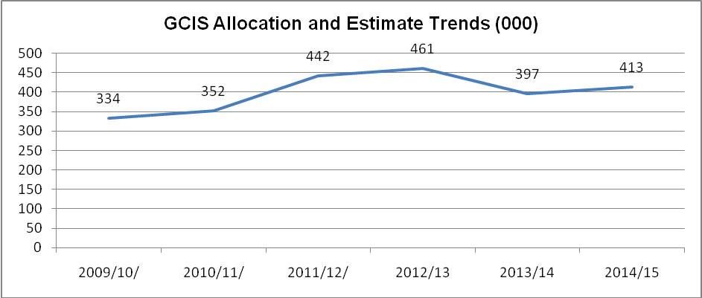

Financial Performance
Despite budget constraints, targets were amended accordingly to respond to the cuts. As a result, the Department has managed to function and deliver on its mandate with aplomb considering that at this time, the Department had undergone programme and organisational changes necessitated by the need to deliver the NCS.

Quarterly Spending Trends

First Quarter Financial Performance 2012/13
The Department spent R93 million or 21.7 per cent of the total available budget by the end of this quarter. Planned expenditure by this point in the year was R102.9 million– equivalent to 24 per cent of the total available budget, resulting in a deviation in total spending of R9.9 million. This deviation is mainly in programme 2: Communication and Content Management (R9.7 million), due to the delayed printing and distribution of the Vuk’uzenzele newspaper. However, it must be noted that, programme 4: Communication Service Agency was ahead of its projected spending by R3.1 million, as a result of payments of billboards for the Infrastructure Campaign as announced during the president’s state of the nation address.

Second Quarter Financial Performance 2012/13
The Department’s spending to 30 September 2012 amounts to R180.236 million or 42.0 per cent of the available budget and 39.1 per cent of the adjusted budget, against projections of R188.270 million. This results in a deviation of R8.034 million mainly in the Communication and Content Management programme that is related to the printing and distribution of the Vuk’uzenzele newspaper. However, it must be noted that, programme 4: Communication Service Agency continues to be ahead of its projected spending by R4.943 million, as a knock-on result of payments of billboards for the Infrastructure Campaign as announced during the President’s SoNA, as well as advertising billboards related to the South African Outdoor Campaign.

Third Quarter Financial Performance 2012/13
The Department spent R271.9 million or 59 per cent of the total available budget by the end of this quarter against planned expenditure of R296.4 million which represents 64.3 per cent of the total available budget. This results in a deviation of R24.5 million the bulk of which is in the Communication and Content Management programme that is related to the production costs of the SA Yearbook.

Fourth Quarter Financial Performance 2012/13
The Department spent R417.769 million or 90.6 per cent of the total available budget by the end of year, resulting in a saving of R43.212 million mainly incurred in the Administration programme directly related to the new building project.

Summary
There is substantial evidence that shows the effectiveness and efficiency of the Department in terms of its allocated budget versus expenditure. But the recent two financial years, 2011/12 and 2012/13, indicate the Department expenditure at 86 per cent in 2012/13 was slightly lower from96 per cent in 2011/12, see Graph 2 below. This increase in under expenditure can be attributed to programme and organisational changes to the Department resulting in a large percentage of unspent budgets when compared to the last 4 financial years.

Graph 2
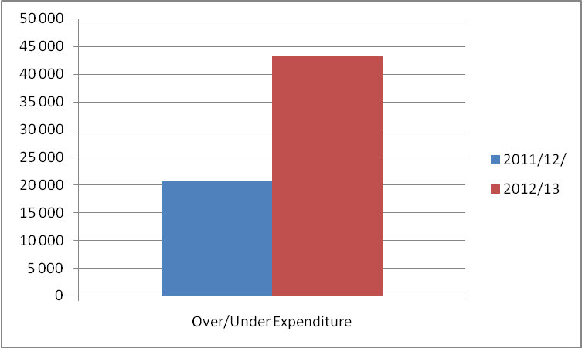

In terms of programme analysis, it is evident as shown in Graphs 3 below that most of the under expenditure can be attributed to Programme One (1) of the Department which has been consistently under spending for financial years 2011/12 and 2012/13 respectively.
Lastly, as per the annual report 2012/13 of the Department, the estimated expenditure is expected to stabilise and increase towards full spend of allocation and this increase will steadily be led by Programme one (1) as projected until financial year 2015/16. The lead by Programme one (1) is justifiable given that it is the largest-funded programme of the Department in financial 2012/13, see Graph 3 next page.
Significant increase in spending in the Administration programme and on operating leases between 2009/10 and 2012/13 was mainly due to the R70 million once-off allocations for the new head office building. Spending on compensation of employees increased significantly in 2012/13 as the Department increased the number of personnel by 5, mainly at salary levels 3-13, in order to implement the national communication strategy, establish the strategic planning and performance management unit, and to allow the department to assist other departments with media bulk buying.

Graph 3
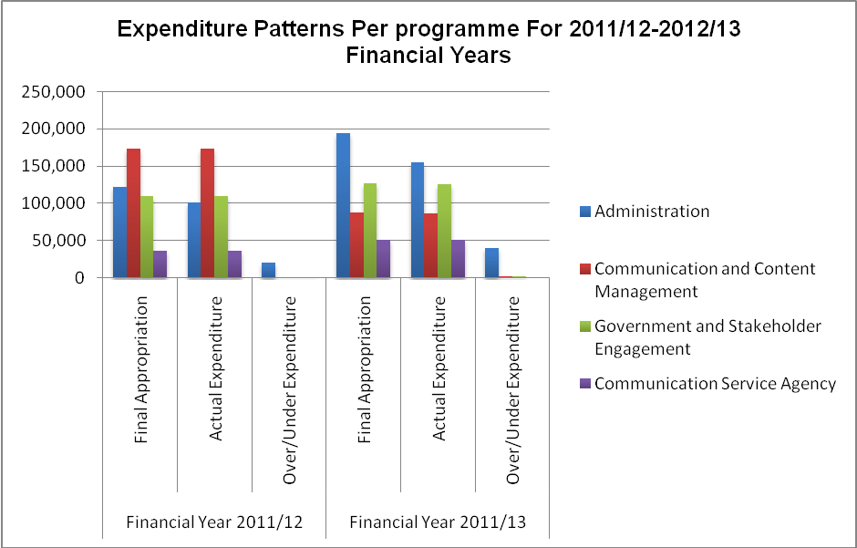
Noticeable programme changes, organisational changes and the Department’s move to new premises are attributable to the goods and services of the Department accounting for most of the total available budget of the Department. For example, the increase in operating payments in 2012/13 for Programme Four (4) is due to the distribution costs for the Vukuzenzele newspaper and the South African Yearbook being shifted from the Content Processing and Dissemination programme to the Marketing, Advertising and Media Buying sub-programme in this programme.
Furthermore, the decrease in budget allocation which impacts on expenditure patterns between 2009/10 and 2012/13 can be attributed to the completion of the 2010 FIFA World Cup event, which accounts for the discontinuation of the allocation for the 2010 Government Communication Project Management sub-programme.It can further be justified that between 2009/10 and 2012/13, spending in Programme Three (3) increased due to advertising activities related to the 2013 Africa Cup of Nations (AFCON) and the clean-up of first generation TSCs for it to improve its ability to deliver services.
Going forward, the spending focus from financial year 2012/13 and over the medium term will be on implementing the NCS approved by Cabinet in 2011. The Department is focusing on ensuring that the strategy’s framework is adopted at the provincial and local government levels. This will also align communication campaign and programmes with the government communication programme.
Moreover, the spending will be on providing for the operating lease, IT, security cards and office furniture related to the new head office building which the Department will occupy in 2013/14 financial year. In conclusion, the Department plans to employ 25 interns each year over the medium term support skills development. The Department receives additional allocation over medium term of R3.4 million, R4.3million and R7.4 million for improved conditions of service. As at 30 September 2012, the Department had 23 vacant positions due to resignations, retirements and transfers to other government Departments. The posts are filled within two months as per departmental policy. The Department had 505 funded posts in 2012/13, of which 24 contract workers are employed in addition to the establishment.

Adjustments 2012/13
Adjustments were witnessed in Programme One (1) for a total amount of R1.9 million as necessitated by the compensation of employees salaries following the Public Service Coordinating Bargaining Council resolution. Furthermore, there was a rollover of R20 million from the 2011/12 financial year and this rollover will cover the costs associated with the relocation of the Department to a new building. Programme Three (3) was adjusted to the total of R10 million in order to accommodate payments for capital assets for the new head office building.

Post Adjustment Virement
Graph 4
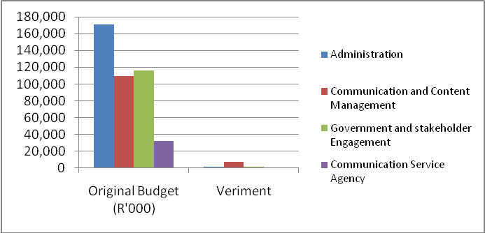
Programme | ENE z(R'000) | Veriment (R'000)
Administration | 192 587 | 1 753
Communication and Content Management | 94 884 | 7 044
Government and stakeholder Engagement | 126 089 | 1 193
Communication Service Agency | 47 421 | 4 098
The above Virement is represented by the net effect of:
- A decrease of R1.2 million in compensation of employees, mainly transfers and subsidies (households) due to the leave gratuity of officials as a result of retirements or leave discounts;
- A net decrease of R46.4 million in goods and services to payments for capital assets in respect of the new head office building as well as Transfers and Subsidies for the payment of TV licenses to the SABC;
- An increase of R744000 in transfers and subsidies of which R61 000 is for paying TV licenses to SABC and R683000 to Households in respect of staff who retired and leave gratification payments; and
- An increase of R46.8 million in the payments for capital assets from goods and services to fund the purchase of capital assets for the new head office building.

Final Total and Programme Expenditure
Of the allocated R429.1 million during the 2012/13 financial year,there was an increase of R31.9 million during the Adjusted Estimates of National Expenditure (AENE), resulting in a total of R461 million in voted funds. A total of R397.2 million was spent, resulting in a variance of R6.7 million (13.8 per cent). The under-spending balance of R43.2 million will be surrendered to the National Revenue Fund (NRF) and, according to the Department; it will request National Treasury to roll-over the under-spending to the 2013/14 financial year. Graph 5 below outlines the expenditure per programme.
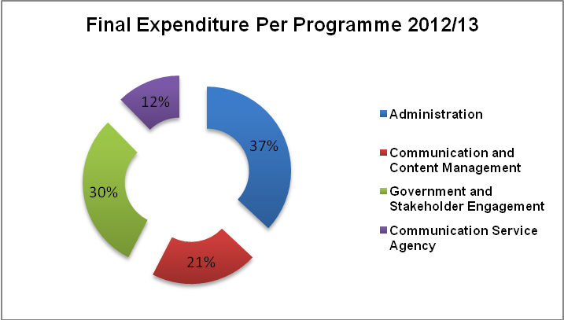
Graph 5

In an era largely driven by Information and Communication Technologies (ICTs) the need for an efficient, effective and responsive government is ever more critical. Treasury is encouraged to consider increased funding for the Department. Now that the Department has settled in its new office premises, it should prioritise investments in trending technologies in its implementation of the NCS in order to effectively communicate with citizenry as per the Minister‘s Annual Report 2012/13 Foreword statement.

Reported Spending Pressures
When analysing Graph 6 below, it is evident that the Department had the least spend during the first and second quarters when compared to last two quarters. Towards the end of the financial year, the Department spent the bulk of its allocation with quarter 4 having the highest expenditure. Such spending patterns need to be corrected so that it eases the pressure on programmes towards the financial year-end. The Financial Management of the Department needs to put systems in place to monitor consistency of spending between the quarters. It should not be interpreted to mean that the Department is merely spending its allocation because of poor planning whereas the plans are submitted and approved before the commencement of a financial year.
Graph 6
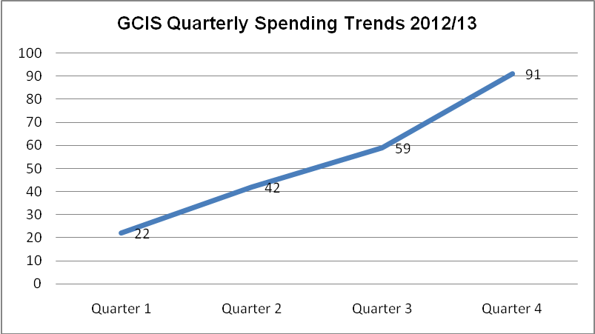

Public Entities Reporting to the Department

Media Development and Diversity Agency (MDDA)
The MDDA Act No. 14 of 2002 established MDDA (the Agency) to create an enabling environment for media development and diversity that is conducive to public discourse and which reflects the needs and aspirations of all South Africans. The Agency is established as an independent body which must be impartial and exercise its powers and perform its duties without fear, favour or prejudice, and without any political or commercial interference (Section 2 of the MDDA Act).It acts through the Board and does not interfere in the editorial content of the media. Accordingly, the President of the Republic appointed the Board to perform its functions and commit to fairness, freedom of expression, openness and accountability; further, to uphold and protect the Constitution and the other laws of the Republic.
For the year under review, the Agency was allocated R50.3 million from the Department, Broadcast and Print media partners in accordance with its budget in terms of the Strategic and Business Plan (SBP) for the MTEF. The Agency continues to adhere to sound financial management as stipulated in the PFMA and the National Treasury Regulations (NTR).
The Agency’s policies are reviewed ideally annually, but practically every second year to ensure that they are aligned to the changed financial and business environment. In between, the Board, whenever necessary, would amend the policies.
The Committee noted that the MDDA has, since its inception, received unqualified audit opinions.

Auditor General Report:
During the two consecutive financial years, (2007/08 and 2008/09) the Department had received a financially unqualified audit with no findings; however, it could not maintain this level. In the subsequent financial years up to the 2012/13, the Department received financially unqualified audits with findings, though limited. It should also be emphasised that these limited findings were the same issues which have been raised repeatedly by the AG and include the following:

The AG during the 2009/10
Leadership: Leadership did not have sufficient monitoring controls to ensure proper implementation of the overall process of planning;

The AG during the 2011/12
Procurement and contract management: it was found that goods and services with transaction value of over R 500000 were not procured by means of a competitive bidding process as per the requirement of the TRs16A6.1 and 16A6.4; and
Human resource management and compensation: Employees were identified who performed remunerative work outside their employment in the Department without written permission from the relevant authority as per the requirement of Section 30 of the Public Service Act of South Africa.

The AG during the 2012/13
Human resource management and compensation: Certain employees were appointed without following a proper process to verify the claims made in their applications in contravention of Public Service Regulation (PSR) 1/VII/D.8.
Leadership: The leadership did not exercise adequate oversight responsibility regarding financial and performance reporting, as well as compliance with laws and regulations.
Financial and performance management: Inadequate monitoring by supervisors resulted in material misstatements in the financial statements, report on predetermined objectives, and noncompliance with laws and regulations.
Investigations: An investigation has been completed with the aim to establish whether procurement and approval processes were followed prior to payments being made to a service provider. The investigation confirmed that no procurement and approval processes were followed prior to payments being made to a service provider. Even though the investigation has been completed the matter has still not been resolved as some of the findings are still being interrogated by both parties. AG findings are tabled below:

DEPARTMENT | 2008/09 | 2009/10 | 2010/11 | 2011/12 | 2012/13
Government Communication and Information System | Financially unqualified with no findings | Financially unqualified with findings | Financially unqualified with findings | Financially unqualified with findings | Financially unqualified with findings

Financial Performance 2013/14
The quarterly report highlights significant achievements by the Department for the period 01 April -30 June 2013. In 2013/14 financial year, management developed and implemented the Department communication strategy and plan that sought to lead some of government’s communication campaigns, while still providing communication support to other departments. This resulted in an increase in the demand of the Department’s services and an overachievement of 18 targets. A total of 109 targets were planned, 96 achieved and 13 not completed. This translates to 88 per cent overall achievements which are listed below:
- Developed 20 campaigns communication strategies for government departments;
- Developed 28 sets of key messages out of the planned target of 12;
- 45 communication contents products developed for political principals and government officials;
- Daily news updates on key government programmes and activities;
- 85 electronic and print products were designed, against the planned target of 45; and
- 13 radio programmes and live link-ups were produced;
- Implemented 803 development communication projects against the planned target of 582;
- Held 991 community and stakeholder liaison visits, against the planned target of 768;
- 71 Izimbizo events were implemented;
- Relocation to Tshedimosetso house;
- Department maintained the vacancy rate of 4,8 per cent;
- 100% of payments (2034) were processed within 30 days;
- The Human Resource Development section arranged compulsory workshops on labour relations to be attended by all staff members;
- Deputy CEO: Content Processing and Dissemination and the Director: Social Media were appointed;
- Ranked in the top 8 departments on the 2012/13 MPAT results released by the Department of Minerals and Energy (DPME);
- Produced 77 daily rapid response reports – an overachievement from the planned target of 20;
- Produced 9 follow-up statements for the post cabinet media briefing and statements;
- Provided on-site media management for the World Economic Forum on Africa; and
- Participated in the preparations for the United States of America (USA) incoming Presidential visit.

2013/14 Quarterly Spending Trends
The Department has a 2013/14 available appropriation of R396.7 million which represents a nominal decrease 13.9 per cent from 2012/13.
The largest element of operational expenditure to the end of quarter 1 in 2013/14 was R50.1 million spent under the Administration programme mainly on goods and services and compensation of employees. The next largest element was R23.1 million under the Intergovernmental and Stakeholder Management programme, followed by R18.2 million under the Content Processing and Dissemination programme, primarily for compensation of employees and goods and services.

Composition of Expenditure
A total of 17.4 per cent of expenditure to this point was under transfers and subsidies, with 82.6 per cent spent on departmental operations.
Graph 7 below seeks to reflect the total percentage of expenditure by the Department; 17.4 per cent of expenditure to this point was under transfers and subsidies, with 82.6 per cent on departmental operations. In terms of Operational expenditure, 45 per cent was on compensation of employees and 46.1 per cent on goods and services. 8.9 per cent of expenditure was on payments to capital assets. Operational expenditure has grown at a nominal rate of 37.1 per cent or R27 million when compared to the same period in 2012/13.
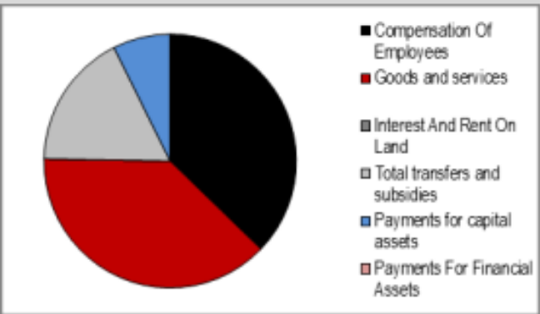
Graph 7: Expenditure Trends Quarter One 2013/14

Rand value growth has been greatest in the Administration programme (Programme 1), mainly driven by increased spending on goods and services. The next highest growth can be attributed to the Intergovernmental Coordination and Stakeholder Management programme (Programme 3) at R23.1 million.
Lastly, the Department has spent R120.8 million to the end of Quarter 1, whilst having scheduled drawings of R115.1 million meaning the Department is ahead of scheduled spending by R5.6 million at this point in the financial year. This is mainly due to expenses related to the Department’s move to the new building.

2014/15 MTEF Financial Allocations

Composition of allocation per main division
In respect of 2014/15 to 2016/17 the Department received budget allocations of R413.1 million, R430.8 million and R456.4 million respectively. With regards to respective programme allocations Programme 1: Administration has been allocated the highest allocations amongst the programmes amounting to R139.6 million in 2014/15, R145 million in 2015/16 and R153.5 million in 2016/17. It is followed by Programme 3: Intergovernmental Coordination and Stakeholder Management with R122.2 million in 2014/15, R127.7 million in 2015/16 and R135.5 million in 2016/14. Programme 2: Content Processing and Dissemination has been allocated R101.6 million in 2014/15, R105.9 million in 2015/16 and R112.1 million in 2016/17. Programme 4: Communication Service Agency has been allocated R49.7 million in 2014/15, R52.2 million in 2015/16 and R55.3million in 2016/17.

The economic classification
Compensation of Employees has been allocated R200.1 million in 2014/15, R212.2 million in 2015/16 and R226.2 million in 2016/17. Goods and Services were allocated R188.8 million in 2014/15, R193.5 million in 2015/16 and R203.8 million in 2016/17. Departmental Agencies and Accounts comprise of R21.8 million in 2014/15, R22.6 million in 2015/16 and R23.8 million in 2016/17. In respect of capital purchases the Department has been allocates R2.3 million in 2014/15, R2.4 million in 2015/16 and R2.5 million in 2016/17.
The Department did not submit requests for additional funds for the MTEF period 2014/15 to 2016/17.

Concluding Comments on Financial Performance
The Department seems to be on track in terms of efficient spending of the allocated budget delivering the expected targets. The Department has demonstrated an expenditure growth (2012/13 to 2013/14) of 37.1 per cent, which is a significant increase. During the same period April to June 2012/13 the Department had only spent 16.5 per cent of its operational budget in contrast to this financial year during the same period where it has spent 26.5 per cent of its operational budget. This is a sign that the Department is on the right track to deliver on its mandate.
Furthermore, now that the Department has settled in the new premises, it can be projected that it will stabilise, fill all the vacant posts and focus on Committee and AG recommendations as means to effectively carry out its mandate.
In conclusion, the Department has managed to over-achieve for most of its deliverables, as was the case the previous financial year, despite the decline in budget allocation and the instability caused by movement to new office premises.

Overview and assessment of service delivery performance

Service Delivery Performance for 2012/13

Targets based on APP
- Achieved 85 of the 111 planned targets;
- 23 per cent of targets not achieved due to lack of funding and in some areas human resource constraints; and
- Extensive face-to-face engagements with the public on government programmes
- Unqualified audit report.
Overall the Department has done extremely well when you consider the nature of its operations and the fact that there is no disjuncture between the set goals based on its past and recent Strategic Reports, the framework of achieving quarterly targets through the APP, to the information as reported at the end of each financial year through the Annual Report.

Programme Performance

Programme 1: Administration
Among others, the Department has received an unqualified audit for the past two consecutive years. It has a process rate of over 99 per cent of invoices received which are processed within 30 days as required by the PFMA. The Department has been able to maintain a vacancy rate at just less than 5 per cent. Furthermore, women made up 53 per cent of senior management while employees with disabilities are at 2, 3 per cent of the total staff complement.
Since relocation to new office building in May 2013, the Department equipped 82 per cent of new headquarters.
More importantly, more than 600 senior officials of government, including mayors and councillors received training in media management and communication skills. The Department was successful in coordinating communications campaigns for a range of events including the SoNA, Brazil, Russia, India, China and South Africa (BRICS) Summit and the International Nelson Mandela Day. Needless to say that this programme managed to achieve more than 95 per cent of its planned targets.
The unachieved targets were due to the fact that they were relocated from their original subprogrammes to different subprogrammes due to the restructuring of the organisation. Lastly, the non-availability of funds and capacity to implement resulted in non-performance of the few under-achieved targets.
In order to mitigate the challenges the Department plans to implement:
- Revised strategic and annual performance plans for 2014/15 onwards to reflect realities of the department;
- Continue to track, monitor and report against implementation of the annual performance plans to identify and correct underperformance; and
- Re-alignment of similar functions for optimum performance.
The underspending of this programme, which is the largest under-expenditure of the Department, is attributed to funds allocated for the new Head Office Building, Tshedimosetso House. These payments will be effected during 2013/14. National Treasury approved funds be rolled over to 2013/14 financial year to fund the infrastructure for the new building.
The restructuring of the organisation which resulted in some sub-programmes being shifted to other programmes may also be the reason for some of the non-achieved targets in this programme.

Programme 2: Communication and Content Management
For the 2012/13 financial year, the programme over-achieved in most of its deliverables notably the publication mentioned above which produced 20.7 million copies, 300 000 above the 20.4 million copies targeted.
- Research insights generated in this programme informed the formulation of communication strategies and plans;
- Research told us what people think of government and what media say about government, helping to make communication relevant and impactful;
- Updated and revitalised longstanding communication platforms including repositioning government news agency as Sanews.gov.za;
- Content convergence delivered government information to more people on more platforms;
- Leveraged government advertising spent to secure better value for money with commercial media and to broaden investment in community and small independent media;
- Offered a range of communication services – editing, audiovisual, photographic, translations, copywriting - to departments and entities; and
- These activities provided consistency and coherence of message even though they severely strained staff across the programme.
Furthermore the Department has over-performed in the following activities:
- Handled 1 226 language services requests;
- Produced 45 000 print & 4 000 DVDs of South Africa Yearbook;
- Produced 20 000 copies of Pocket Guide to SA;
- Produced 20.7 million copies of Vuk’uzenzele, 4 844 braille copies;
- Produced 170 091 copies of Public Sector Manager magazine;
- Produced 60 000 GovComms copies;
- Compiled eight-page newspaper supplement on national orders;
- Held seven Public Sector Manager Forums;
- Drafted strategy on the broader 20 Years of Freedom project and consulted with relevant clusters and communicators;
- Daily news updates and daily coverage;
- Produced four Pulse of Nation research reports;
- Held nine knowledge forums;
- Produced 18 533 set of press clippings;
- Compiled 945 media coverage reports;
- Issued 24 breaking-news alerts;
- Compiled synthesis report on SoNA; and
- Executed 33 distribution projects.
Understandably, in mitigating the non-delivery of the few targets, the Department has cited organisational streamlining which has had an impact on the implementation of the project.

Programme 3: Government and Stakeholder Engagement
This programme was allocated R127.3 million with an actual expenditure of R125.8 million has also seen considerable achievements during the financial year 2012/13 with most of the targets exceeded notably in the Provincial & Local Liaison Clusters and the Media Engagement sub-programmes. Of particular highlight in the former sub-programme is the implementation of 3 010 communications campaigns, 550 more than the planned target as a result of the 2013 ACFON and the BRICS Road shows.
- GCIS worked with departments to support communications for the five priorities;
- Supported the development and review of cluster and departmental communication and communication campaigns to ensure alignment to the national communications framework;
- Facilitated meetings between the media stakeholders and Cabinet to unpack government policies and programme of action;
- Coordinated izimbizo events of political principals to ensure engagement with communities for participatory democracy;
- Through the implementation of development communication outreach campaigns GCIS was able to reach diverse communities particularly those in rural areas; and
- During SoNA 2012 South Africans were made aware of the speech so that they can be informed about government programmes:
  - Public comments were documented and used by the President during his reply; and
  - First ever post SoNA information seminars and izimbizo were held by political principals with higher LSMs to unpack SoNA.
Furthermore the Department had the following key achievements:
- Presented NCS to Provincial Forums;
- Coordinated review of seven cluster communication strategies;
- Developed 37 communication strategies;
- Provided departments and clusters with 45 communication products including key messages, fact sheets, questions and answers, briefing statements, speech notes, leaflets;
- Implemented 3 010 development communication projects;
- 519 reports of marketing events for TSCs;
- Produced 49 electronic My District Today newsletters;
- 3 588 community and stakeholder liaison events;
- Distributed 1 590 100 copies of government material; and
- Consolidated report on 304 public participation events by political principals.
Through this programme the Department reaches just over 23 million South Africans. As stated in Programme 1, some non-achievements were due to the targets being relocated from their original subprogrammes to other subprogrammes due to the restructuring of the organisation described in preceding sections. Lastly, some targets were not achieved due to limited funds and capacity to implement them such as vacancies at Senior Management Service level (SMS).

Programme 4: Communication Service Agency
This programme was allocated R515.2 million and was able to utilise all its budget allocation. This is commendable considering that the non-delivery of the few targets was as a result of lack of funding while the majority of the targets were exceeded resulting in government saving R30.5 million through negotiated discounts emanating from media bulk-buying on behalf of government. It suffices to say therefore that the programme accounts for a considerable bulk of the achievements for the Department during the financial year 2012/13.
- Implemented 200 media-buying campaigns to the value of R220.2 million and saved government R30.5 million through discounts and added value;
- 3 346 media products and services produced;
- 327 events photographically documented;
- 341 events documented on video;
- Handled 926 requests for photographs;
- Handled 333 video footage requests;
- 205 radio programmes and live link-ups produced & transmitted;
- 42 radio adverts produced;
- 359 electronic and print products designed;
- 316 video programme produced; and
- Outsourced satellite broadcast.
The Department has cited under-funding as the main reason in mitigating for non-performance and under-achievement in this programme.

Overall Programme Performance
It should be noted that the consistent change of programme names and shifting of functions between programmes is a concern and does not reflect a position of confidence on the part of the executive and management of the Department. This realignment according to the Department was necessitated by the need to effectively implement the NCS. It is also important to highlight a few of the most noticeable initiatives needing intervention by the Department as outlined below and influenced by the Committee recommendations.

Service Delivery Performance for 2013/14
- The largest element of operational expenditure to the end of quarter 1 in 2013/14 was R50.1 million spent under the Administration programme mainly on goods and services and compensation of employees. The next largest element was R23.1 million under the Intergovernmental and Stakeholder Management programme, followed by R18.2 million under the Content Processing and Dissemination programme, primarily for compensation of employees and goods and services.
- Management has developed and implemented the Department communication strategy and plan that sought to lead some of governments’ communication campaigns, while still providing communication support to other departments. This resulted in the demand for the Department’s services and an overachievement of 18 targets. In conclusion, there is an overall 88 per cent achievement of targets or 96 of 109 targets in the 1st Quarter.

Other Service Delivery Performance Findings

Oversight Visit Reports
It should be noted that the Committee did not undertake oversight visits during the financial year 2013/14. The last oversight related to the Department was in June 2012. The recommendations by the Committee and responses by the Department are noted in Section 3 of this report.

Concluding Comments on Service Delivery Performance
The work of the Department is commendable and is the reflection of government’s commitment to service delivery. It is evident that the Department is a critical component for communicating government’s policies and service delivery initiatives. As such more financial commitment is necessary to sustain current initiatives but more importantly to ensure that the Department continues to provide an innovative service delivery underpinned by technological developments as previously stated by the Minister and the acting Chief Executive Officer (CEO) in their opening remarks of the 2012/13 Annual Report.

Finance and Service delivery performance assessment
Despite the continuing trend of under-expenditure in Programme One (1), it is evident that the Department is on a positive path to expand its service delivery programmes in line with outcome-oriented goal 12 of government. Indeed the Department is fully committing to its strategic outcome-oriented goal to provide a coherent, responsive and cost-effective communication service to all government programmes which directly supports government’s outcomes-based outcome number 12 “an efficient, effective and development-oriented public service and empowered, fair and inclusive citizenship.”
Budgetary constraints necessitated by global economic crisis have meant that the Department like many other government departments, cuts back on spending but alternatively shared skills across programmes and identify areas to reduce spending while maintaining outputs and postponing implementation of certain elements of the NCS.
That said the actual and expected expenditure trends as reflected in the Annual Report are a testament of the financial crisis and qualify the projection of service delivery of the Department going forward. Indeed the Department can do with a larger apportionment of the national budget in order to ensure interactive engagement between the public and the State as a primary catalytic strategy for a citizen-oriented government.

COMMITTEES Observations and response

Technical Issues
- The late appointment of the Chief Financial Officer (CFO) may have been the cause for the lack of monitoring of expenditure during this financial year. It is expected that the non-expenditure will be reduced significantly in the coming financial year.
- A turnaround strategy related to the TSCs maximum functionality across the country should be made a priority by the Department.
- The audit compliance of national departments and state-owned entities with respect to advertising through community media should be treated with urgency given that the Department can derive savings by utilising this platform for advertisements.
- The shifting of functions between programmes and the renaming of some of the programmes that carries along with it a financial burden, should be minimised. This was also echoed by the AG’s report of the Department that such transformation will always have an impact on agreed targets which must be revised as a result of changes.

Governance and Operational Issues
Reflecting on the AG’s findings, assessment of the performance management systems in order to circumvent non-delivery of programmes, particularly within programmes Two (2) and Three (3) of the Department is important.

Summary of reporting requests
See Annexure 1A and 1B attached.

Recommendations
The Committee recommends that the Minister should:
- Ensure that all government departments (national, provincial and local) contribute a certain percentage of their ad spent to the community media as defined by the MDDA Act 14 of 2002;
- Spearhead a mechanism which will result in policy clarity on which is the best Department to implement the TSCs in order to deliver maximum service to the people;
- Ensure that the 2011 Committee recommendation regarding the current appropriation under Vote 27 of the DoC for supporting community radio station, is migrated to Vote 9 GCIS which will be allocated to the MDDA;and
- Commission an audit on the effective delivery of all the Department’s publications to ensure they reach the intended market and are of value.

Conclusion
The Department should be commended for fulfilling its mandate and over-achievement in most of its programmes. It should be further encouraged to improve in areas where there is still room for improvement. It is clear that the Department is on a positive path to expand on delivery of its mandate in the coming financial years.

Appreciation
The Committee would like to thank the Minister in the Presidency, Mr Collins Chabane and his Deputy, Mr Obed Bapela, as well as the Acting Chief Executive Officer, Ms Phumla Williams, and the Board Members of MDDA, Executive Management and staff of the entities of the Department. The Committee also wishes to thank its committee support staff, Committee Secretaries, Mr Thembinkosi Ngoma and Ms Teboho Sepanya, the Researcher, Mr Sandile Nene, the Content Advisor, Mr Mbombo Maleka and the Committee Assistant, Mr Edward Vos for their professional support, commitment and dedication to their work. The Chairperson wishes to thank all the Members of the Committee for their active participation during the process of engagement and deliberations and their constructive recommendations reflected in this report.

Report to be considered.

Glossary of Terms
AENE | Adjusted Estimate of National Expenditure
AFCON | African Cup of Nations
AG | Auditor-General
APP | Annual Performance Plan
BRICS | Brazil, Russia, India, China and South Africa
BSA | Brand South Africa
CEO | Chief Executive Officer
CFO | Chief Financial Officer
DPME | Department of Minerals and Energy
ENE | Estimates of National Expenditure
GCIS | Government Communication and Information System
ICT | Information Communication Technology
ICTs | Information Communication Technologies
IMC | International Marketing Council
IPAP | Industrial Policy Action Plan
LSM | Living Standards Measures
MDDA | Media Development and Diversity Agency
MPAT | Measurement Performance Assessment Tool
MTBPS | Medium Term Budget Policy Statement
MTSF | Medium Term Strategy Framework
NCS | National Communication Strategy
NDP | National Development Plan
NRF | National Revenue Fund
NTR | National Treasury Regulations
PAIA | Promotion of Access to Information Act
PSR | Public Service Regulations
SABC | South African Broadcasting Corporation
SBP | Strategic and Business Plan
SCOA | Standing Committee on Appropriations
SMS | Senior Management Servie
SoNA | State-of-the-Nation Address
TRs | Treasury Regulations
TSCs | Thusong Service Centres
USA | United States of America

National Treasury (2013). Estimates of National Expenditure, pg 155
Adjusted Estimates of National Expenditure(2012)
National Treasury Practice Notes 6 and 8(2007-08) issued in terms of Section 76(4)(c)of the PFMA.
BRRR(2011) Portfolio Committee on Communications.

