
Health portfolio
9 October 2013
PFMA audit outcomes of the 2012-13 financial year for
PC

CONTENTS
1. Introduction 2
2. Audit opinion history 3
3. Key focus areas 5
4. Drivers of internal control 11
5. Other matters of interest 12
6. Other reports 13
7. Combined Assurance on Risk Management in the Public Sector 14
8. Audit outcomes of the health sector 15

- Introduction
1.1 Reputation promise of the Auditor-General of South Africa
The Auditor-General has a constitutional mandate and, as the Supreme Audit Institution (SAI) of South Africa, it exists to strengthen our country’s democracy by enabling oversight, accountability and governance in the public sector through auditing, thereby building public confidence.

1.2 Purpose of document
The purpose of this briefing document is for the Auditor-General of South Africa (AGSA) to provide an overview of the audit outcomes and other findings in respect of the health portfolio for the 2012/13 financial year.

1.3 Overview
The health portfolio consists of the following entities which reports to the Minister of Health:
- National Department of Health (NDOH)
  - Compensation Commissioner for Occupational Diseases (CCOD) (trading entity of the National Department)
- Council for Medical Schemes (CMS)
- South African Medical Research Council (MRC)
- National Health Laboratory Services (NHLS)
1.4 Organisational structure of the portfolio

Minister of Health
Dr Motsoaledi
Council for Medical Schemes
National Health Laboratory Services
Compensation Commissioner for Occupational Diseases
Medical Research Council
Department of Health
Deputy Minister of Health
Dr Ramokgopa
1.5 Funding
The department is primarily funded through funds appropriated in terms of the annual Appropriation Act (and the Adjustments Appropriation Act), the final appropriation for the 2012/13 amounted to R28 057 203 000 (2011/12: R25 967 971 000).
The National Department of Health made the following transfer payments to the entities included in the health portfolio during the 2012/13 financial year:
- Compensation Commissioner for Occupational Diseases – R2 916 000 (2011/12: R2 777 000)
- Council for Medical Schemes – R4 310 000 (2011/12: R4 194 000)
- South African Medical Research Council - R288 863 000 (2011/12: R271 205 000)
- National Health Laboratory Services – R85 102 000 (2011/12: R83 022 000)

- Audit opinion history
The stagnation in the audit outcome of the portfolio resulted from an improvement in the outcome by the MRC and a regression by CMS. The MRC addressed the prior year non-compliance findings on procurement and contract management while CMS had new findings in this area.

CCOD did not submit annual financial statements for audit for the 2011-12 and 2012-13 years. The audit report for the 2010-11 financial year has not been tabled in parliament. No dates have been committed for the tabling of the 2010-11 audit report or for submission of the 2011-12 and 2012-13 financial statements for audit.

AUDIT OPINION
CLEAN AUDIT OPINION: Financially unqualified with no other findings on PDO and Compliance
FINANCIALLY UNQUALIFIED with findings on PDO and/or Compliance
QUALIFIED AUDIT OPINION (with/without findings)
DISCLAIMER/ADVERSE AUDIT OPINION
AUDIT OUTSTANDING

AUDIT OPINIONS | 08-09 | 09-10 | 10-11 | 11-12 | 12-13
Department of Health
Compensation Commissioner for Occupational Diseases
Council for Medical Schemes
South African Medical Research Council
National Health Laboratory Services
QUALIFICATION ISSUES | 08-09 | 09-10 | 10-11 | 11-12 | 12-13
Department of Health
- Assets |  |  | 
- Departmental revenue | 
CCOD
- Revenue |  |  | 
- Expenditure |  | 
- Receivables |  |  | 
- Payables |  | 
- Provisions |  |  | 
- Contingent liabilities |  | 
South African Medical Research Council
- PPE | 
OTHER MATTERS | 08-09 | 09-10 | 10-11 | 11-12 | 12-13
Predetermined objectives
- Department of Health |  |  |  |  | 
- Compensation Commissioner for Occupational Diseases |  |  | 
- Council for Medical Schemes |  |  | 
- South African Medical Research Council |  |  | 
- National Health Laboratory Services |  |  | 
Compliance with laws and regulations
- Department of Health |  |  |  |  | 
- Compensation Commissioner for Occupational Diseases |  |  | 
- Council for Medical Schemes |  |  |  |  | 
- South African Medical Research Council |  |  |  | 
- National Health Laboratory Services |  |  |  |  | 
  - Qualification paragraph(s)
None of the entities in the health portfolio were qualified during the 2012/13 financial year.
- Key focus areas
No significant progress was made in addressing the key risk areas. While MRC improved in the areas of HR management and financial health no progress was made by any entity in addressing IT controls. A regression was noted in the quality of financial statements submitted by NDoH and CMS. The status of SCM remains unsatisfactory, mostly as a result of NDoH not complying with the requirement that employees who perform remunerative work outside their employment have the necessary permission and CMS who did not apply the preference point system during the awarding of bids.

NDoH
Supply chain management
Pre-determined objectives

Financial health
HR management
IT controls
Material mis-statements
CMS
Supply chain management
Pre-determined objectives

Financial health
HR management
IT controls
Material mis-statements

MRC
Supply chain management
Pre-determined objectives

Financial health
HR management
IT controls
Material mis-statements
NHLS
Supply chain management
Pre-determined objectives

Financial health
HR management
IT controls
Material mis-statements
Legend:
No findings
Findings in Management report
Findings in Audit report

  - Predetermined objectives
Entity | Finding | Root cause | Recommendation
NDoH | Reasons for variances not supported by reliable information  Reported indicators not supported by sufficient appropriate evidence | - Lack of consequences (provinces) for not reviewing performance information | - Management must ensure that the figures per the DHIS agree to the figures per the facility’s routine monthly data input forms to ensure that reported performance is valid.  - Standard operating procedures must be implemented by all health facilities. All relevant staff members responsible for reporting on pre-determined indicators must be trained on the requirements of the standard operating procedures.  - Regular monitoring activities in the form of inspections and/or internal audits must be performed by the National Department of Health to test adherence to the standard operating procedures and staff should be hold accountable for transgressions and poor performance.

  - Supply chain management
Entity | Finding | Root cause | Recommendation
NDoH | Employees of the department performed remunerative work outside their employment in the department without written permission | - Lack of consequences for non-compliance with regulations | - Management must ensure that interests have been declared by all employees of the NDoH before entering into business with a supplier.  - Greater awareness of this internal control must be created through appropriate training of staff members and encouraging staff to declare the interest when the conflict arises.  - The HR unit must enforce compliance through regular checking and follow-ups to ensure that annual declarations are made and updated as necessary, staff should be hold accountable for non compliance.
CMS | The preference point system was not applied in all procurement of goods and services above R30 000 and below R500 000 through the quotation process | - Inadequate monitoring and review | - Management must ensure that, the laws and regulations on procurement of goods and services are always adhered to by enhancing their daily and monthly review processes.  - Management is required to investigate acquisitions between R30 000 and R50 000 to identify whether any awards were incorrectly made. All such awards must be recorded as irregular expenditure
MRC | An award was made to an employee  Tax clearance certificate was not valid at the date of the award  Annual declarations not signed by SCM officials | - Inadequate monitoring and review | - Conflict of interest forms should be signed by all employees  - Awards should be made to service providers with a valid tax clearance at the date of the award

  - HR management
Entity | Finding | Root cause | Recommendation
NDoH | Annual leave taken by employees were not recorded in a timely | - Lack of consequences | - It is recommended that the HR unit design and implement internal controls to identify instances of non-compliance and hold responsible persons accountable for non-compliance through for example the performance appraisal process.
NHLS | Individuals in acting capacity for periods greater than six months | - Leadership instability | - Management should consider appointing individuals on a permanent basis where staff have been acting in positions for prolonged periods

  - Information technology controls
Entity | Finding | Root cause | Recommendation
NDoH | Inadequate security management | - Inadequate skills  - Leadership instability (ICT environment) | - Develop patch management controls and network configuration that provide precise installation procedures for critical network components.  - Staying up to date with the latest service packs and hot fixes would minimise vulnerability to attacks.
NDoH | Inadequate user access management controls |  | - Management must develop an action plan to address the areas of deficiency.
NDoH | Inadequate back-up procedures  Disaster recovery plan not approved |  | - The Director: ICT should formalise the backup and restoration procedures.  - The Director: ICT should ensure that the draft DRP is based on a sound understanding of potential business impacts and risks. This must be approved by the accounting officer.
CMS | Disaster response plan (DRP) has not been approved | - Ineffective leadership | - CMS management should develop, approve and implement a DRP based on the direction provided by the IT disaster recovery policy.
CMS | Inadequate security management | - Ineffective leadership | - Management should ensure that the activities of users and their access rights on the CMS domain controller, routers and the firewall are formally reviewed on a periodic basis. Evidence of such reviews should be retained.
CMS | Inadequate user access controls |  | - Management should establish a formal process for the periodic review of users’ access and their activities on Pastel Evolution and Visual Accountmate
MRC | Inadequate user access controls | - Inadequate leadership | - Management should establish a formal process for the periodic review of users’ access and their activities
  - Material misstatements in submitted annual financial statements
Entity | Finding | Root cause | Recommendation
NDoH | Material misstatements in the submitted financial statements were subsequently corrected. | - Lack of consequences | - Management should ensure that adequate reviews of the financial statements are performed, especially related to audit disclosures and that staff are hold accountable for poor performance
CMS | Material misstatements in the submitted financial statements were subsequently corrected. | - Inadequate monitoring and review | - Management should enhance their checks and balances to enable them to prepare quality financial information.
  - Financial health status
Entity | Finding | Root cause | Recommendation
NHLS | Debtor collection period was calculated at 132 days.  The entity realised a deficit for the year | - Ineffective leadership | Management should implement checks and balances to:  - Improve the accuracy of invoices  - Reduce the period to collect outstanding debts
- Drivers of internal controls
An improvement in key controls was noted and was related to the internal control environment for the MRC. This assisted the entity to move to a clean audit. The NDoH and CMS did not show significant improvements in key controls. The NDoH should strengthen the following controls to create a control environment that supports reliable performance reporting and compliance with legislation:
- Implement controls over daily and monthly processing and reconciling of transactions
- Review and monitor compliance with applicable laws and regulations

CMS must strengthen controls over the review and monitoring of compliance with applicable laws and regulations.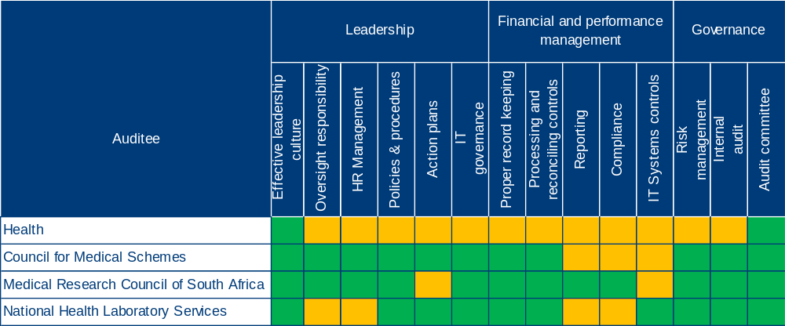

- Other matters of interest
5.1 Unauthorised expenditure

None of the entities in the health portfolio incurred unauthorised expenditure during the 2012-13 financial year.

5.2 Irregular expenditure

Auditee |  | Movement | 2012-13  (R'000) | 2011-12  (R'000) | Details
1 | Health |  | 2 375 | 29 046 | Contravention of supply chain management legislation
2 | Council for Medical Schemes | - | - | - | -
3 | Medical Research Council of South Africa |  | 61 679 | 58 801 | Contravention of supply chain management legislation
4 | National Health Laboratory Services | - | - | - | -

5.3 Fruitless and wasteful expenditure

Auditee |  | Movement | 2012-13  (R'000) | 2011-12  (R'000) | Details
1 | Health |  | 654 | 4 550 | No shows for accommodation
2 | Council for Medical Schemes | - | - | - | -
3 | Medical Research Council of South Africa | - | - | - | -
4 | National Health Laboratory Services | - | - | - | -

- Other reports
  - Investigations
Department of Health

An investigation into a contract for the acquisition of an Oracle HR system is currently in progress.

Council for Medical Schemes

None

Medical Research Council

Three investigations were concluded during the year on assets removed without appropriate authorisation and an employee having been absent without leave. The affected employees were found guilty and judgement was made on the matters.

As reported in note 35 to the financial statements, a forensic investigation was conducted into allegations of fraud committed at a site in Mozambique by persons not in the employ of the entity. The parties involved are awaiting sentencing by the Mozambique high court.

National Health Laboratory Services

An investigation was instituted by the National Department of Health for the review of the billing system for the KwaZulu-Natal and Gauteng provinces during the financial period. The KZN billing investigation has been concluded and a Ministerial task team has been appointed to look into the findings thereof. The work of the Ministerial task team is still in progress. The Gauteng billing investigation has not been concluded at the date of this report.

Performance audits

Department of Health
A performance audit was conducted on the department’s use of consultants. The report covered the period 2008/09 to 2010/11 and was tabled during January 2013.
The report identified the following weaknesses with respect to the management of consultants:

- Vacancy rates and a lack of capacity resulted in 2 selected projects not being effectively implemented.
- Lack of capacity negatively impacted the project objectives of 1 selected project
- Inadequate planning by management lead to a lengthy delay for 1 selected project
- No formal and structured processes were in place to verify performance related statistics and data provided by non-government organisations (NGO’s).

A follow-up audit was performed to determine whether recommendations were effectively implemented. It was noted that management had substantially addressed issues related to vacancy rates and lack of capacity at the effected units. In addition, appropriate internal control measures have been implemented to verify performance related statistics and data provided by NGO’s.
- Combined Assurance on Risk Management in the Public Sector
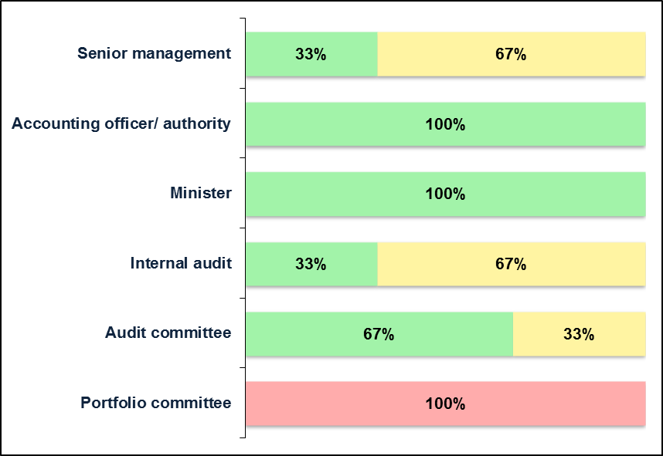
The assurance levels for NDoH and for CMS should be improved by addresses areas of internal control weaknesses to move towards clean audit outcomes. The internal audit unit at the NDoH needs to assist management by effective and timely reporting of control weaknesses.
We met with the minister five times in the past year and these interactions had some impact on the audit outcomes. The reason for our assessment is primarily due to his interactions to with the entities to ensure that they address areas of audit concern. This assessment, as well as the status and impact of the commitments contributed to the assessed assurance provided by the minister.
The assurance provided through the oversight of the portfolio committee should be improved and weaknesses identified in the strategic plan should be followed up. In addition the Portfolio Committee and SCOPA have not adequately followed up on the non-submission of financial statements for audit.

- Audit outcomes of the health sector
8.1 Outcomes for the past three years

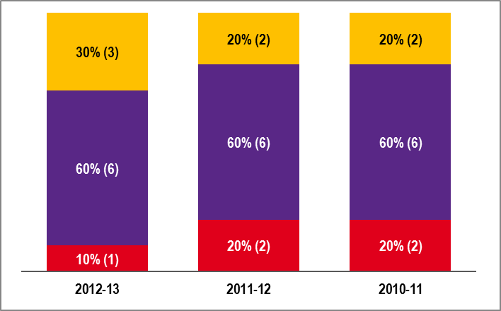
Unqualified with findings | Qualified with findings | Adverse/Disclaimed with findings

8.2 Movement of audit outcomes from 2011-12
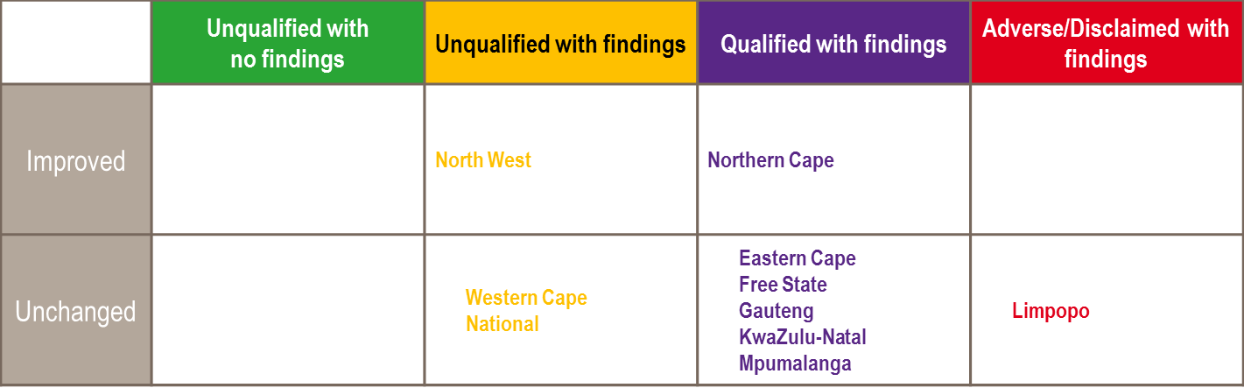

2

8

The audit findings for the Health sector have shown little improvement over the last three years. The number of disclaimers has however reduced to one remaining province (Limpopo). The challenge for the sector lies in addressing the various qualifications that they have not successfully addressed over the three year period analysed.

8.3 Top three qualification areas
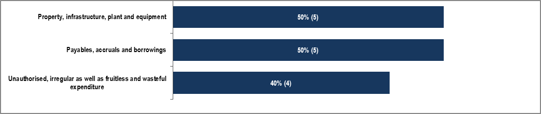
20%
20%
10%

8.4 Status of quality of annual reports for the past three years

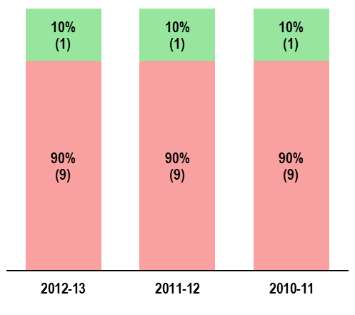

For 90% of departments, based on a selected sample of programmes, indicators and targets, the information reported as performance was assessed as not reliable.
The reliability of information is primarily impacted by inadequate systems and internal control processes at facility level. Management at both National and Provincial levels must focus its efforts on training data capturers on approved policies and procedures and enforcing regular reviews at all responsible levels.

8.5 Status of compliance with laws and regulations for the past three years

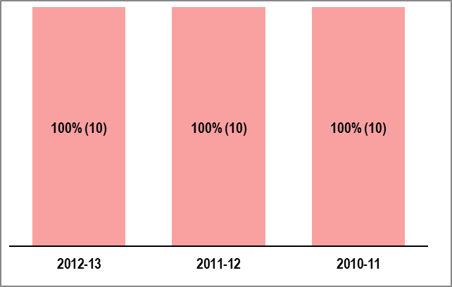

Instances of non-compliance with applicable laws and regulations were identified at all departments. Unauthorised, irregular and fruitless and wasteful expenditure remains an area of concern for the sector.

8.6 Findings on compliance with laws and regulations

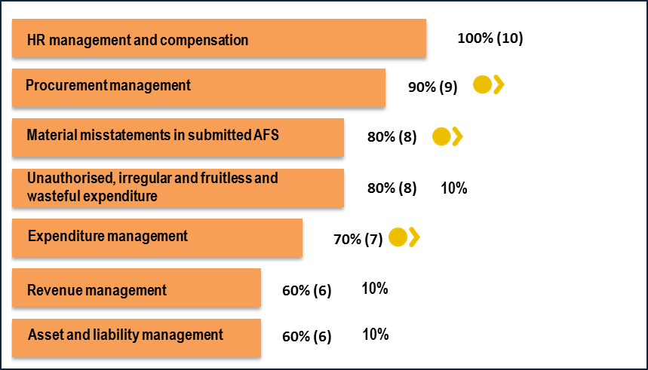
20%

8.7 Unauthorised expenditure incurred for the past three years

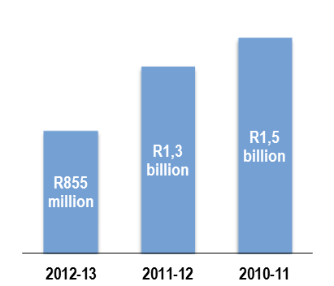

Auditee |  | Movement | 2012-13  (R'000) | 2011-12  (R'000)
1 | National Department of Health | - | - | -
2 | Eastern Cape |  | 52 400 | 9 204
3 | Free State |  | 135 800 | 46 964
4 | Gauteng |  | 324 500 | 1 025 786
5 | KwaZulu-Natal |  | 117 600 | 127 958
6 | Limpopo |  | 222 400 | -
7 | Mpumalanga | - | - | -
8 | Northern Cape |  | 2 100 | 76 782
9 | North West | - | - | -
10 | Western Cape |  | - | 53 742

8.8 Irregular expenditure incurred for the past three years

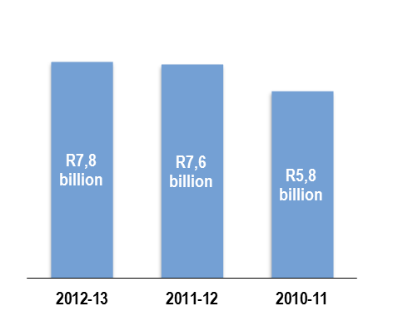

Auditee |  | Movement | 2012-13  (R'000) | 2011-12  (R'000) | Details
1 | National Department of Health |  | 2 375 | 29 046 | Contravention of supply chain management legislation
2 | Eastern Cape |  | 304 000 | 436 058 | Contravention of supply chain management legislation
3 | Free State |  | 143 700 | 45 278 | Contravention of supply chain management legislation and over expenditure on compensation of employees
4 | Gauteng |  | 1 524 200 | 1 115 884 | Contravention of supply chain management legislation
5 | KwaZulu-Natal |  | 2 719 200 | 2 038 099 | Contravention of supply chain management and human resource legislation
6 | Limpopo |  | 571 200 | 938 716 | Contravention of supply chain management legislation
7 | Mpumalanga |  | 408 100 | 285 061 | Contravention of supply chain management legislation
8 | Northern Cape |  | 1 064 500 | 941 608 | Contravention of supply chain management and human resource legislation
9 | North West |  | 971 300 | 1 725 656 | Contravention of supply chain management and human resource legislation
10 | Western Cape |  | 86 700 | 74 477 | Contravention of supply chain management and human resource legislation

8.9 Fruitless and wasteful expenditure incurred for the past three years

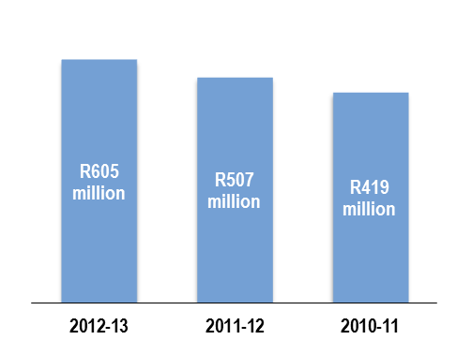

Auditee |  | Movement | 2012-13  (R'000) | 2011-12  (R'000) | Details
1 | National Department of Health |  | 654 | 4 550 | No shows for accommodation
2 | Eastern Cape |  | 128 500 | 84 747 | Damages and interest
3 | Free State |  | 3 200 | 16 109 | Interest on overdue accounts
4 | Gauteng |  | 449 400 | 369 763 | Legal Claims against the Department, disposal of expired medicine
5 | KwaZulu-Natal |  | 110 | 20 | Interest on overdue accounts
6 | Limpopo |  | 18 400 | 7 873 | Interest on overdue accounts
7 | Mpumalanga |  | 2 000 | 1 096 | Interest on overdue accounts
8 | Northern Cape |  | 2 100 | 21 795 | Interest on overdue accounts
9 | North West |  | 260 | 1 427 | Interest on overdue accounts
10 | Western Cape |  | 60 | 6 | Cancellation of long service award ceremony

- Risk areas of the health sector

9.1 Status of six key risk areas
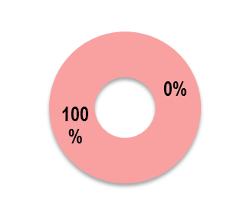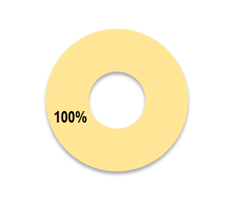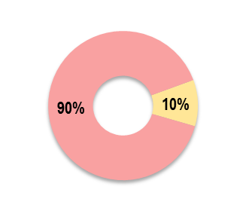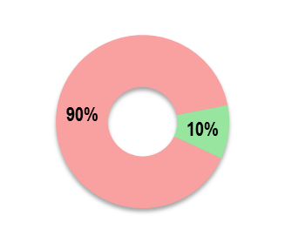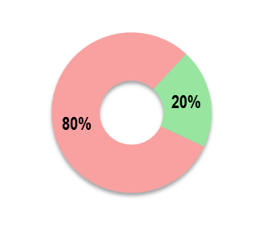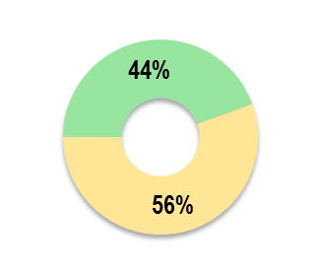
Quality of submitted financial statements
Information technology controls
Financial health
Supply chain management
Quality of
performance reports
Human resource management

- Drivers of internal control and root causes
10.1 Drivers of internal control

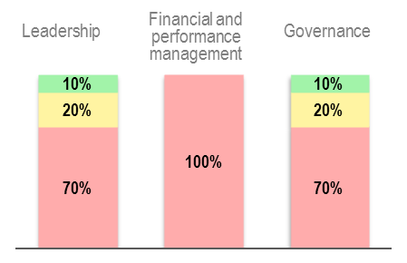

10.2 Root causes for audit outcomes



