

INTERGOVERNMENTAL RELATIONS

From: Chief Administrator – Monde Tom
Tel: 015 298 7000

BRIEFING NOTE
15 -16 October 2013
SELECT COMMITTEE ON FINANCE

BRIEFING ON PROGRESS TO DATE WITH REGARDS TO LIMPOPO SECTION 100 (1) (B) INTERVENTION

- PURPOSE

  - To report on progress with regards to the implementation of Limpopo intervention in terms of Section 100 (1) (b) of the Constitution of the Republic.
- EXECUTIVE SUMMARY

  - The province underspent the 2012/13 budget by R2.3 billion mainly due to infrastructure-related expenditure in the Departments of Education and Roads and Housing. These departments have at different times been subjected to investigations on matters that are mainly funded by their capital budgets.
  - However, there is R634 million in accruals that mitigate against the under-spending and a total of R6.1 billion in medium-term commitments. (refer section III)
  - As at end of August 2013, the overall spending is at R17.9 billion or 37.1 percent of the total main appropriation budget of R48.4 billion. The province is projecting to over spend by R833.9 million or 1.7 per cent at the end of the financial year.
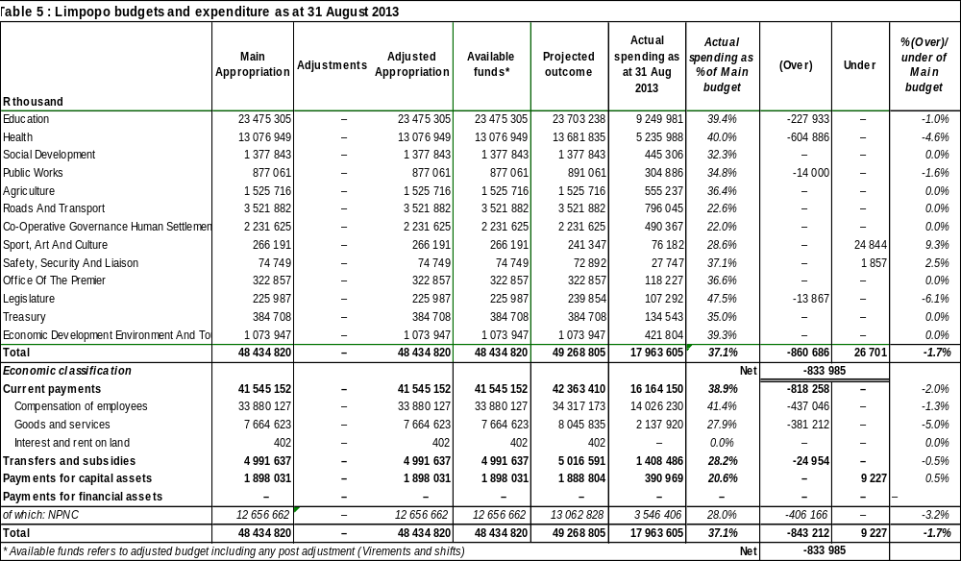
  - As at end of March 2013, the cash position was positive at R2.4 billion and continues to generate interest at the Reserve Bank for the province.
  - The cash position is very strong; a surplus of R4.2 billion as at 31 August 2013. The surplus fund availability is also sufficient to deal with other critical historical challenges, such as medicines and medical supplies, food in hospitals, textbooks in schools and rollovers of earmarked funding, including prioritised spending (see table below).
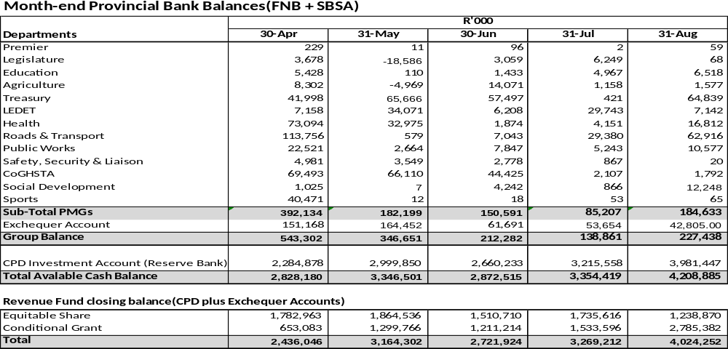

  - Historic accumulated unauthorised expenditure is expected to be cleared during the 2012/13 MTEF with R822 million already paid in the previous financial year and another R640 million has been budgeted in 2013/14 financial year.
  - The departments of Education, Health and Public works received unchanged negative audit opinions and Provincial Treasury again received an unqualified opinion whilst Roads and Transport improved to an unqualified opinion for the 2012/2013 year.
  - These negative opinions must be contextualized and we need to note that the severity of the audit findings is lesser than the previous years. The quality of the financial statements and supporting documents submitted for audit was significantly improved when compared to the prior year. This was evident in the departments of Education, Health and Public Works where the limitation of scope and irregular expenditure was significantly reduced.
  - A team of consultants, PwCRakoma consortium, was appointed during January 2013 to assist the 5 departments with clearing of audit queries, assisting with preparation for 2014 audit and improving internal controls. This project started 2 months before the 2013 financial year end and will continue until March 2014. The impact of this project will only be seen in the following year and its success is dependent on the departments addressing, inter alia, the capacity and skills challenges.
  - With respect to institutional recovery, the Provincial Treasury is in the process of being fully capacitated with a new management team in the top two layers. In addition, the following projects are under-way in the intervention departments:
- ICT systems (e.g. LOGIS roll-out for supply chain);
- Headcount verification in Education and Health;
- Implementation of new transversal contracts (e.g. security services);
- An internship and project-based learning programme for technical financial skills;
- Skills audit of all CFO staff; and
- Prior years audit queries improvements - referred to as “AG Project”. A
- DETAILED DISCUSSION

  - Financial Position/Health

  - The province had accumulated unauthorized expenditure which dates back to 2001, of R2.7 billion in 2011. The province has reduced the unauthorized expenditure by R987 million of which R822 million has been funded from the Provincial Revenue Fund in 2012/13 and the balance funded through first charge of the various departmental budgets. The "OLD" outstanding unauthorized expenditure is R1,7 billion of which the PRF is liable for R1.4 billion and departments R0.3 billion. The PRF intends to finance R640 million in 2013/14 and the balance over the MTEF.
  - To date, the progress on the financial recovery of the province can be reported in terms of the table below.

INDICATOR | Prior to intervention (or previous year end) | Status as at 31 March (Pre-audited) 2013 | Spending as at 31 August 2013
Unauthorised expenditure/accumulated debts | Accumulated unauthorised expenditure of R2.7 billion | Accumulated unauthorised of R500 million still remains unapproved. The remaining has been approved by provincial SCOPA to be cleared by the Provincial Revenue Fund | R640 allocated for unauthorised and balance over the MTEF
Cash position | Overdraft of R1.7 billion | Cash Surplus of R2.4 billion | Cash Surplus of R4.2 billion
Provincial expenditure | Projected overspending of R594.6 million | Under spending of R2.2 billion | Projected overspending of R833 million (inclusive of R634 accruals)
Education budget | Projected overspending of R354.5 million | Under spending of R959 million | Projected over spending of R277.9 million
Health budget | Projected overspending of R250.2 million | Overspending of R21 million | Projected over spending of R604.8 million
Provincial COE | Projected overspending of R661 million | Under spending of R330 million | Projected over spending of R437 million

  - Province tabled the 2012/13 budget with a surplus of R907 million with R748 million to finance the overdraft and R640 million for 2013/14. . Cash management controls improved in the province.
  - Through the efforts of managing the compensation of the department of Education, it is pleasing to note that compensation of employee's budget of the department of Education has been stabilized and the Provincial Treasury is putting all efforts to stabilize the Health personnel and goods and services budget which is posing a big challenge to the province for 2013/14.
  - The province has also established the Human Resource Task Team (HRTT) whose primary role is consider the merits for filling posts in a particular department and ensures that a budget was available to fund such posts. The HRTT process has been relocated to Office of the Premier in 201314 and the process has been streamlined to prevent delays experienced in 2012/13 as a result of continuous ad hoc requests submitted to the HRTT.
  - Moreover, the Treasury has undertaken to further monitor and reduce the percentage of the provincial budget spent on Compensation of Employees. A COE task team has also been established in LPT to analyze the COE cost drivers in the provincial administration during 2013/14. COE data has been extracted from 2009 and cost drivers are being analysed. These analysis results will be linked to the STATS-SA head count project.

  - The table below indicates the summary of rollover requests (audited AFS) and recommendations thereof.

  - 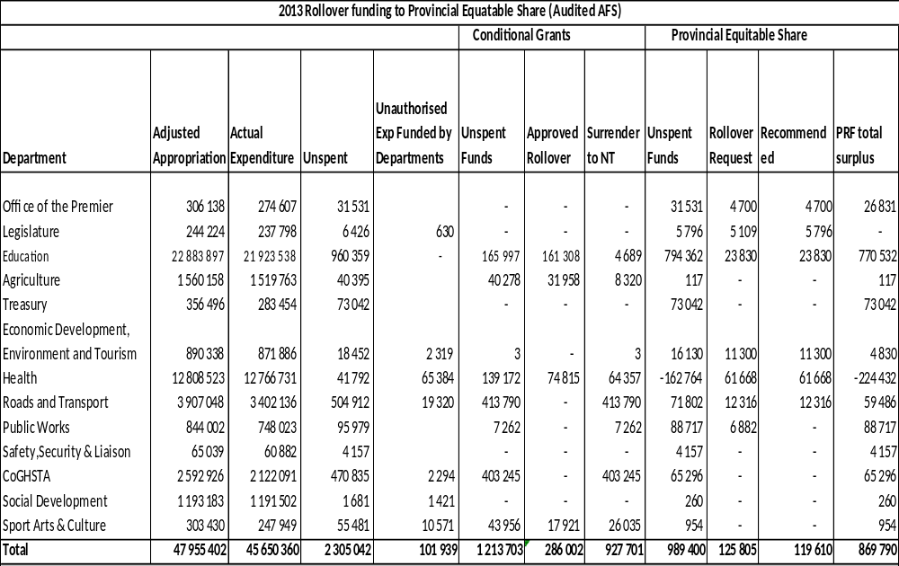
  - From the Audited Annual Financial Statements, the provincial under spending was R2.305 billion. The conditional grants constitute R1.214 billion, whilst the balance of R989.4 million was from equitable share.
  - Of the R126.492 million Departmental rollover requests received, Provincial Treasury has recommended R 119. 610 million for approval and the balance of R869.8 million under spending is due to Provincial Revenue Fund. With regards to conditional grant requests, National Treasury has given a preliminary approval of R286 million.
  - The Annual Financial Statements submitted to the Auditor General on 31 May 2013, indicated that there is a total of R634 million worth of accruals, whilst the provincial commitment is R6.1 billion.
  - The accumulated unauthorised expenditure has been reduced to R1.3 billion and it is anticipated that the uncommitted under spending will add to the R640 million set aside for 2013 budget, review ICS funding that wasn’t added for Education during 2012 adjustment budget process. Moreover, the Province intends capitalising on the outcome of 2012 adjusted budget outcome to address the compensation budget and non negotiables in the department of Health, consider funding for earmarked projects and possible pressures.

Financing of the Overdraft

  - The province tabled the 2012 budget with a surplus of R907 million.
  - An amount of R748 million was set aside to finance the overdraft and the balance thereof has been utilised to fund recovery projects and Provincial specific priorities.
  - The R2.7 billion of accumulated unauthorised expenditure was reduced to R1.3 billion of which R822 million has been funded from the 2012/13 Provincial Revenue Fund and the balance funded through the various departmental budgets.
  - The outstanding unauthorized expenditure yet to be paid is R1.5 billion of which the province intends to finance R640 million in 2013/14 and the balance over the MTEF. (See table below)’’

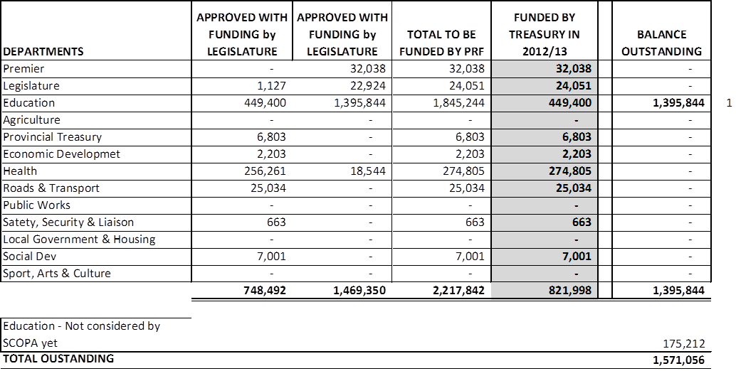

  - The only department to incur unauthorized expenditure in 2011/12 financial year was the Department of Education amounting to R175 million.

  - SERVICE DELIVERY

B.1 Administrative Support: Administrative Systems Improvements & Sustainability (people) thereof

- Provincial Treasury: (Projects on behalf of other line departments)
  - The intervention diagnostic report, completed prior to the start of the 2012/13 financial year (March 2012) outlined a number of capacity gaps in the province. These included:
- Lack of leadership and laxity of officials;
- Poor systems, processes, skills and capacity resulting in:
- Poor budgeting and financial management skills;
- Poor safeguarding of movable and immovable assets; and
- Numerous management shortcomings in respect of supply chain management. Collusive behaviour within the public services which is exacerbated by the private sector (business) influence so as to get a particular procurement outcome.
- Non reliability of the IT infrastructure and or enabling systems and software; and
  - To address these, the following progress can be reported:
- Lack of leadership and laxity of officials
- A new Head of Provincial Treasury has been appointed;
- A new head of Sustainable Resource Management (Budget Office, Fiscal Policy and Public Finance) has been appointed within the Provincial Treasury
- Senior Managers for Public Finance, Fiscal Development, and Performance Management have been appointed within the Provincial Treasury;
- The appointments of General Managers (Chief Director) for Municipal Finance Management, Fiscal Policy and Chief Audit Executive have recently been approved by the Minister;
- Appointments still to be made and anticipated during the 2nd quarter of the financial year include:
  - Senior General Managers (Deputy Directors-General) for Corporate Services and Financial Governance and Assets and Liabilities.
- Poor systems, processes, skills and capacity resulting are being addressed through the following projects/initiatives
- Project for “Clean audit 2014” (AG Project): PwCRakoma Consortium, a team of accountants, financial, asset and supply chain management experts were appointed during January 2013 to assist with the turnaround of the negative audit opinions of the past years towards achieving an improved or clean audit 2014. This team will assist to enhance and institutionalise the key fundamental principles of supply chain management, financial management and asset management. The major challenges are scope limitation due to lack of proper document management systems mainly in Education and Health, in general, lack of skilled capacity and lack of effective and efficient processes.
- The long outstanding financial statements of the Provincial Revenue Fund (PRF) as well as the consolidated financial statements for departments and public entities of the Province (Consol) have been prepared and submitted for audit as follows:
  - PRF financial statements for years ended 2009 to 2012.
  - Consol financial statements for years 2009 and 2010.
- The remaining outstanding financial statements are targeted for completion and submission before the end of this calendar year.
- The impact on the audit outcomes of the other 4 departments for the 2013 year is contexualised below, and we expect that together with the PwCRakoma team, there will be greater impact in improving the audit outcomes of these departments in 2014 onwards.
Provincial Department | 2011/2012 | 2012/2013 | Additional Notes
Education | Disclaimer | Disclaimer | - Irregular expenditure of R162M reduced to Nil  - The overstatement of immovable assets of R102M (2012) was reduced to R36M  - Commitments of R299M (2012) was reduced to R205M
Health | Disclaimer | Disclaimer | - Irregular expenditure of R73M reduced to Nil  - Unallocated receipts of R 50M (2012) was reduced to R21M (2013)  - Scope limitation reduced from R739M (2012) to R 438M (2013)
Provincial Treasury | Unqualified | Unqualified | - Except for the non-submission of the Provincial Revenue Fund and Departmental and Public Entities financial statements, this department would have received a clean audit
Public Works | Disclaimer | Disclaimer | - Irregular expenditure of R30M reduced to Nil  - Although the department was disclaimed for understatement of receivables (rent from employees staying in state owned property), these were recorded in the financial statements of Health and Social Development
Roads and Transport | Qualification | Unqualified | - The department moved from receiving a qualification on movable assets in 2012 to an unqualified opinion in 2013

- Asset management: The Province has acquired LOGIS, an asset management system to facilitate consistency in the effective control of assets throughout all departments in the Province. The rollout of this system has started in Treasury and the departments of Education, Health and Public Works will follow
- Supply chain management: The Treasury’s transversal unit is working with the PwCRakoma consortium to revise the Provincial supply chain management policy; develop standardised operating procedures (SOPs), including checklists and templates for all Departments. This team is also focused on building capacity and capability within the Treasury’s transversal unit, converting this to a centre of excellence to improve its support and oversight function of the Province’s supply chain management.
- The Treasury is also working National Treasury Office of the Chief Procurement Officer to strengthen SCM processes in the province and resolve the housing tender contract in Limpopo.
- Transversal contracts: This type of contract is being put in place primarily to leverage economies of scale, to limit the contract administrative burden and stabilise the contract over a period of 3 years, rather than annually. This limit the space for possible corruption in procurement processes and fly by nights firms that some do not have the necessary capacity to safe guard properties, but instead drain the fiscus. Some collude with officials on extension of contracts and other charge for VAT without being vendors. The security contract has recently been awarded and the remaining clusters are due to be re-advertised in a couple of weeks’ time. Other transversal contracts earmarked include office equipment and stationery, cleaning services, toilet papers, office furniture and travelling and accommodation for the Limpopo provincial government.
- A skills audit is currently underway in the offices of the Chief Financial Officers to identify the level of weakness and address critical skills gaps for financial management improvement.
- Project based learning (PBL) will be implemented by the PwCRakoma Consortium through the Da Vinci Institute. The core modules are systems thinking, leadership, governance, financial management, supply chain management, asset management and data analysis. PBL is one sub-project being implemented to facilitate the sustainability of recovery strategy. The PBL concept will be continuously reviewed for potential improvements going forward and aligned to the AG Project to sustain the transfer of skills to the current staff and Interns in departments
- The CFO Support program has been approved and will result in the creation of 5 additional posts in the Provincial Treasury. This will attract financial management expertise that can be deployed in departments to improve financial management in the province through the offices of the CFO’s.
- Lack of reliability of the IT infrastructure and or enabling systems and software
  - LOGIS System: Provincial Treasury will replace the FINEST system as this does not interface with BAS. The lack of an integrated accounting system in Limpopo has been identified as a major risk which leads to incomplete and inaccurate reporting on commitments, accruals, inventory and assets.
  - Treasury is also working with SITA to investigate the causes for the inefficiencies of the BAS system; a review of the entire IT (LAN) infrastructure for the 5 intervention departments, including a benchmark study with North West Health which could lead to the replacement or the revamp of the billing system in Limpopo Health including Hospitals working with the LDoH.
  - BAS system and IT (LAN) infrastructure: The province has had delays in this area, including slowness in transactions or payments and changes related to BAS versions. This resulted in inefficiencies including travel costs of officials to Pretoria for transaction processing, including seeking assistance of the National Treasury to effect transfers to schools in terms of the Norms and Standards for School Funding.
- Public Works:
  - Nine (9) appointed professional includes three (3) chief construction project managers who are highly qualified and with experience in excess of 20 years; one (1) chief Architect and five (5) quantity surveyors. A revised capacitation plan for 2013-2017 is in place detailing a total of 99 built environment professionals planned to be recruited over a period of five years.
  - Out of a total of R632m infrastructure projects budgeted for the current year, R412m of these projects will be delivered by the IDT under a strict monitoring programme. Of the remaining 47 schools implemented by the LDPW, 40 schools will completed during the current calendar year. A team of the newly appointed professionals will be monitoring projects delivered by the IDT.
  - The lease review project is fully on track and on its completion, an expected substantial reduction in the current R200m office accommodation of the Province will be realised. The results will be available on the 30 October 2013.
  - Artisan Development Programme for 380 learners in college in areas of plumbing, bricklaying, electrical and carpentry. This is building ‘own trees’ project. An amount R30m received form Construction Education and Training Authority (CETA) as part of training grant. More than 1204 officials training on different vocations under the work place skills plan.
  - 10 officials in the CFO’s office are receiving training under the Public Sector Advanced Certificate offered by AAT. 12 senior officials are receiving training under Project Based Learning (PBL). A high paced executive management course.
  - While the audit remained an adverse opinion, there was an improvement in the number of AG findings from 167 to 132 in the management when comparing the 11/12 to the 12/13 audit finding.
- Education:
  - The Department had 2 544 temporary educators in the system; and as at the end of the 2012/13 financial year, 2 097 of these educators had been permanently appointed in substantive posts; thus leaving 55 temporary educators to be profiled and permanently absorbed. At the beginning of the 2012/13 financial year ad hoc posts stood at 3 819, including 795 foreign educators. For the 2013 school calendar year, 2 447 ad hoc posts have been approved, a reduction of 1 372 ad hoc posts.
  - The payment of the rural allowance to about 7 000 educators, which was terminated on 31 December 2012, has been reinstated for the same number of beneficiaries before the termination of the programme. The additional claims made by groups of educators have been referred to Courts and will be defended accordingly. Because the verdict of the Court will have far-reaching ramifications for the entire basic education system, the Minister of Basic Education has directed that the Department of Basic Education should co-join these Court challenges.
  - Education Census Projects: R12.7 million was paid to STATS SA for Education head-count verification for educators and learners. The project progress enumeration process has been completed, despite earlier delays attributed to SADTU dispute with Department of Basic Education which has had a negative impact on this project. The impasse has since been resolved and field workers have gone back to the field to enumerate the outstanding 51 schools. Data processing has been finalised and the final report is due to be presented by STATS SA on 23 October 2013. This project has created 554 short-term job opportunities. Owing to delays, we have received a request for additional funding of about a million.
  - The financial statements and supporting documents submitted for audit in the current year was of a higher standard. Immovable asset registers, movable asset registers, schedules of commitments, irregular, fruitless & wasteful expenditure were significantly improved compared to prior year and rendered a position where the AG was able to audit information. The Disclaimer opinion from prior year (2011/2012) has remained and SCM remains a challenge due to the non-submission of documents (limitation of scope). However, the department has prepared a comprehensive action plan and is in the process of implementing this for improving internal controls, systems and processes which will lead to an improved audit outcome.
  - Cost containment strategy has been developed and implemented and has already resulted in significant savings such as the reduction in travel costs and external venue costs for training and other departmental workshops
  - An interim system will be implemented to improve movable asset management and will integrate into the LOGIS system once this is fully operational
- Health:
  - An Acting CFO has been seconded by the National Health Department effective from the 1st of July 2013, after the departure of the Acting CFO. The project of building capacity in the office of the CFO is at an advanced stage and three general managers posts have been approved by Treasury to be filled on permanent basis. It is expected that this process will be concluded by the end of November 2013.
  - Of all the 40 hospitals in the province, only seven (7) had no appointed CEOs as at the end of March 2013. These posts could not be filled even after a head hunting process. The recruitment process is underway and the posts have been re advertised. It is expected that the process will be concluded by the end of October 2013.
  - 51 contract employees who are former interns employed by the National Department Health have been placed at both Polokwane and Mankweng Hospitals as well as the provincial office, to address the patient revenue and records systems as well as financial and HR related challenges for a period of 2 years effective from May 2013.
  - A Budget Analysis Task Team has been appointed which focuses on allocation of funds methodology for key cost drivers of medicines, patient food supplies, medical equipment and other critical programmes. The allocations will be based on variables including utilization and patient numbers as well as disease profile per district and or hospital. The mandate of the Task Team included benchmarking with other provinces in relation to the funding for the Compensation of Employees (COE). There will also be a focus on the utilization of the doctors and nurses overtime as one of the cost drivers.
  - The Health Census Project commenced mid May 2013, and a budget of R7.2 million has been set aside for this purpose. The purpose of this project is to ensure that planning and budgeting is based on a credible data. This project has created 131 short-term job opportunities. The Health Census Preliminary Report will be issued on the 18th of October 2013 which will also be presented at the same workshop that is scheduled for 23 October 2013.
  - In addition, the National Department of Health is implementing staffing norms and standards for the provision of human resource through a project referred to as WISN, in collaboration with the World Health Organization (WHO).
  - The financial statements and supporting documents submitted for audit in the current year was of a higher standard. Immovable asset registers, movable asset registers, schedules of commitments, irregular, fruitless & wasteful expenditure were significantly improved compared to prior year and rendered a position where the AG was able to audit information. The Disclaimer opinion on Assets from prior year could “improve” to Qualification; however SCM remains a challenge due to the non-submission of documents (limitation of scope).
  - The department has significant challenges with Revenue and Receivables. The current processes and systems in place are inadequate and have rendered the auditing of information through the system potentially impossible. This may contribute to a Disclaimer audit opinion. For SCM, the decentralized operations of the Department as well as the lack of controls have made it difficult for the Department to submit information timeously to the AG. The financial statements may be disclaimed again mainly due to scope limitation. However, the quantification of information not submitted compared to prior year is significantly reduced (45% of prior year) which indicates improving controls.

B.2 Core Services: (Sector: Brick and Mortar services)

- Education:
  - LTSMs aligned to the Curriculum and Assessment Policy Statements (CAPS) have been procured and delivered to all our schools for the 2012 and 2013 school calendar years. The 2012 and 2013 textbook procurement and delivery processes were in line with the implementation of the CAPS in Grades 1, 2, 3, and 10 in 2012 school calendar year; as well as Grades 4, 5, 6, and 11 for the 2013 school calendar year.
  - For the 2014 LTSM procurement and delivery processes, R768 million was estimated. This amount was based on the lowest unit prices for CAPS-aligned textbooks for Grades 7, 8, 9, and 12 as well as stationery packs that will be required for all Grades for the 2014 school calendar year. The National and Provincial Treasuries allowed the Department to pool together the allocations for the per capita transfers to schools and the LTSM allocation, yielding a total of R1.243 billion. The reason for this arises from the fact that the Norms and Standards funding in the main is for the procurement and delivery of LTSMs and the per capita transfers. This amount was divided on 50 : 50 basis, to that the LTSMs and the Norms per capita transfers would be equally funded at R620 million each;
  - The enormous savings the Department accrued for the 2012 and 2013 LTSM procurement and delivery processes are unbelievable, and we wish to sustain these gains. Considering the economies of scale in this process, it is clear that the central procurement model will make it possible for the Province to attain the national goal of ensuring that every learner has a textbook per subject per Grade by 2014.
  - Norms and standards funding: In 2012/13, R505.844 million was allocated for the per capita transfers to schools. This amount was 62% of the national norm. This was the case because a huge portion of the Norms per capita transfers were used to augment to fragile CoE budget. It is important to stress that all the funds allocated for the Norms per capita transfers to schools, were actually transferred to the schools by the end of the 2012/13 financial year;
  - in 2013/14 the per capita transfers were improved by R334 million, thus making the allocation R839.844million, which is equivalent to 76.2% of the national norm;
- Health:
  - The project for doctors and health professionals’ accommodation has been completed and the developer has handed-over the property to the department, with the involvement of Public Works. The building was occupied from the 1st of July 2013, by 300 health professionals.
  - The project to repair 38 boilers in 19 hospitals is has been completed in September 2013, including training of departmental staff for in-house operation of boilers. The amount involved is R88m. The second phase of the project, relates to routine maintenance of the boilers. This is currently being addressed and funding is available in the 2013/14 financial year from the maintenance budget allocated.
  - The reason the Limpopo hospitals were dysfunctional was due to the practice of preferring to service and maintain the boilers repeatedly through quotations from service providers who were not in the boiler manufacturing industry. The repairs through quotations were not sustained, no long term and would have to be repeated after a few weeks or months. Boilers are the heartbeat of the functionality of hospitals because the theatres and kitchens among others depend on the steam as well as hot water from the boilers.
  - The allocation of funds for medicines for the 2013/14 financial year has increased to adequately cover medicines. The allocation is in line with the benchmark exercise conducted by the National Health Department.
  - A pharmaceutical depot service which is rendered by the central depot based on the availability of medicines stock, has improved. This project is combined with the national pilot of direct deliveries to hospitals and the reduction of buffer stock at the depot to reduce expiry of medicines and shrinkage.
  - The allocation of funds for medicines for the 2013/14 financial year has increased to adequately cover medicines. The allocation is in line with the benchmark exercise conducted by the National Health Department.
  - A pharmaceutical depot service which is rendered by the central depot based on the availability of medicines stock, has improved. This project is combined with the national pilot of direct deliveries to the hospitals and the reduction of buffer stock at the depot to reduce expiry of medicines and shrinkage.
  - Despite having corrected the management of the depot, the funding for the medicines as well as improving the stock levels to above 70 per cent September 2012, the stock levels dropped in March 2013 due to the inherent challenges related to the depot system management which is experienced in other provinces too. Hence the decisions to move towards direct deliveries to the hospitals. The situation has improved and the stock levels are now at 79.70 per cent as at the end of September 2013.
  - Challenges currently been addressed are related to surgical medical supplies, where transversal contracts have expired and are currently been renewed at national treasury level. The province had to procure these on a quotation basis, which was not sustainable. The intervention put in place in this regard was to apply for participation in the Gauteng Health Department’s valid contracts, to ensure bulk ordering by the Limpopo Health Department. This measure has improved the stock levels, despite the challenges experienced of short supplies from the suppliers, while awaiting finalization of transversal contracts.
  - In 2013/14 financial year, the funding for patient food has been increased and about R116m will be utilized.
- Public Works:
  - Lease review: The department is working out the cost implications for options to purchase the top 6 leases in Limpopo so as to reduce the leasing cost in the medium term. Consideration for relocating and building a new government complex another consideration. Immediately, consideration given to moving to own properties. Service provider is on site and gathering information. The service provider was extended from the NDPW project
  - Immovable asset will be physically verified and valued through a third party service provider. From a sustainability and best practice management process perspective, we suggest as a start: Using Education as an example. The LDoE department must know how many schools, district offices, etc., They have - to corroborate this, all employees of the department must be housed somewhere - so a listing of all IA can be prepared. This listing should be passed onto LDPW. LDPW will verify if these assets are on their books. Exceptions will be ring-fenced for further investigation. The physical verification exercise that LDPW is scheduled to undertake will then be used as another way to clear these exceptions as well as identify and clear any other exceptions related to existence and or completeness. Valuation can also be done as part of this physical verification exercise. Rights and obligations (RO) is also part of the plan - and the above listing confirmation process will assist in the RO confirmation process.
  - Immovable Asset Register: The department has also established a vesting factory in order to speed up the process of vesting properties by 31 March 2014 in line with the National targets. Drawn up terms of reference to go out to tender. Planned commencement date for Phase 2 is 1 October 2013.

- Roads and Transport
  - Infrastructure Delivery: 36 maintenance projects are at design stage and soon contractors will be appointed. All are planned to be completed by the end of March 2014. There are also 25 EPWP and 107 flood damaged projects. These two categories are dependent on receipt of the requested roll-over of the previous year’s budget allocation (R215m). The 1st phase of the intermodal facility in Thohoyandou will be finalised in this financial year.
  - Public Entity Oversight: There is a study underway to develop an appropriate model to roll-out roads infrastructure in the province. The future of RAL is dependent on that study. Options to deal with the future of GAAL have been finalised and will be submitted to the Minister for consideration. The preferred option is to dissolve GAAL and enter into a management contract with an airports management company. Preliminary discussions have started with ACSA.

  - GOVERNANCE

C.1 Accountability in Departments under s100: Department Public Service and Administration (DPSA)

  - Investigations are carried out by law enforcement organisations, and internal disciplinary matters are supervised by the Department of Public Service and Administration. In either instance, the treasury is neither responsible nor mandated to carry out these processes, although regular briefings and discussions do take place.
  - It must be noted that the number of cases changed fairly continuously due to on-going investigations, the withdrawal of charges or additions to charges.
  - On the 38 priority criminal cases handed over to Hawks, DPSA has since been given 18 of the Forensic investigation Reports by National Treasury and others are still with the police. 16 of these reports are about Education and Health, and the relevant charges have now been drawn up and given to the HoDs for signature. The other two reports are about Public Works, and the charges are being finalised.
  - The DG of DPSA has personally taken up the matter of the slow disciplinary processes and is engaging with the Office of the Premier and other stakeholders to address issues. The process is moving smoothly in the Limpopo Health and implicated senior officials have been charged.
  - However when DPSA was ready to present charges to HOD in Limpopo Education to proceed with the process it was delayed as minister DBE wanted to read misconduct reports of implicated senior officials.
C.2 Accountability in Department outside s100: CoGHSTA

  - In exercising its oversight function, Limpopo Treasury has commissioned a forensic investigation in the Department of Cooperative Governance, Human Settlements and Traditional Leaders (CoGHSTA) in respect to the awarding of the 2013/14 Housing Grant.
  - This forensic emanates from a tender that was hastily issued and awarded in November 2012. Upon investigation, a number of irregularities were identified and the department has since been directed to restart a clean process under the guidance of the Chief Procurement Office in National Treasury and the Provincial Treasury. DPSA is now finalizing disciplinary charges against senior officials arising from the investigation;
  - It is envisaged that the tender will be awarded by 1 August 2013 and quality human settlements will be delivered and sustained over a period of time;
  - With regards to the payment of suppliers, there is a quality assurance process established for the verification of payment on housing delivery projects in 2012/13 financial year which is spearheaded by Public Works Department. The preliminary results show that some of the contractors who were favoured in the 'stopped' tender in the previous year had poor performance and poor workmanship and were never blacklisted.
  - The investigation exposed serious abuses in the department.

  - CHALLENGES (Administrative and bricks and mortar, governance, sustainability)

A significant measure of success of the implementation of the recovery plan is the sustainability of the improvements initiated by the Administration team. These improvements must be owned by the Province’s leadership to accelerate the recovery of the Province.
The nature and extent of this S100 (1)(b) intervention always presents challenges.
Some of the persistent challenges include but not limited to –
  - For instance the team has found out that in the AG audit findings project 61% of queries emanating from prior years in FY12 have been resolved and of the 39% currently in progress but 90% of them relate to systemic problems. Real challenges, not anecdotally, are scope limitation concerns; procurement reforms needed; infrastructure accounting, governance & delivery concerns needed; immovable assets in property management; the lack at management level of analysing service delivery trends, and designing systemic solutions for administrative systems and processes that are disclaimed or qualified AND solutions for service delivery. (there is a balancing act between systems and people)
  - SCM enhancements – All five departments have been earmarked for CFO support which includes the SCM function. This support will entail the re-design, where necessary, of the SCM functionalities, training, improved oversight (monitoring and evaluation) of execution of SCM functions. Secondly procurement reforms are being piloted by the Office of CPO under National Treasury in certain Limpopo departments. This is an end-to-end approach for acquiring and managing services under certain key items such as security services, patient food, laundry in hospitals, RDP houses provisioning etc.
  - In all infrastructure departments under intervention, the infrastructure upgrades and maintenance are hampered by a number of bottlenecks, such as poor document management related to infrastructure, lack of built environment skills for planning and monitoring, not having appropriate models for delivery infrastructure and poor oversight by treasury infrastructure unit . An end-to-end approach is required .
  - The demands by civic organisations for unrealistic norms & standards maybe are detrimental, and exacerbating these challenges in Education will be a recent High Court order compelling the Minister of Basic Education to promulgate National Norms and Standards for School Infrastructure.
  - Non-compliance with respect to submission of Tribal Levies Account, Revenue Fund and Consolidated Financial Statements for the past 3 years is still a key project for the Provincial Treasury.
  - A dedicated focus team is to be established to conduct physical verification in Health and Education of all movable assets. A process to obtain supporting documents to be established. The department will complete physical verification to satisfy existence of assets. The reconciliation process between existing register and “new” register will be conducted. The challenge of correcting opening balances will also need to be addressed before the next AG audit process .
  - DPSA circular requiring appointment at Grade A in terms of OSD technical expertise is proving to be a daunting task for departments. A meeting has been planned to address this challenge; and
  - The reduction and stabilisation of the Compensation of Employees Budget, especially addressing the challenges pertaining to (a) rural allowance, (b) the discrepancy in the stipend paid to ECD practitioners (currently stands at 60% of the national norm of R5 000); and (c) financial ramification of appointing adult education and training (AET) practitioners in terms of the Employment of Educators Act, 1998);
  - Capacity development to ensure a sustainable system of financial management and internal controls, as well as sound, transparent and accountable supply chain, contract and asset management systems are implemented as a matter of urgency.
  - Corrupt officials still yet to be rooted out of the administrative system. In fact those officials who exposed it are still yet to be dismissed their presence is a serious risk . Further investigative and prosecuting capacity in system being put in place in the interim DPSA continues.
  - Intervention Section 100(1) (b) is being made a scapegoat for failures & embedded rot in some of these departments including those outside the five under intervention. Over time the intervention team has reduced in number , however, the balance between 'being strong' and 'supportive' in approach continued and regular reviews on systemic problems and keep a close eye on progress should continue to yield results .
  - The absence of a special legislative framework to enable intervention in terms of section 100 (1)(b) to be effective is a challenge.
  - SUSTAINABILITY and EXIT

For ccontinuous improvement, certain processes must be embedded to ensure sustainability. These will ensure:
  - Sustaining the momentum built during the stages of diagnosis and recovery through embedding the identified improvements,
  - Ensuring that people are aligned to the Provincial and Departmental vision and ensuring effective and efficient service delivery within the prescripts of regulation and legislation,
  - Identifying and making the best use of current skills and create further support through in-sourcing of capability, building a high performing culture and creating passionate and committed people, and
  - Simplifying and standardising processes and systems
To facilitate continuous improvement, there must be strong leadership, enforcement, fair and transparent performance management system and consequential action for non-performance or reward for excellence. To achieve and maintain the “new normal”, a key focus of sustainability is to improve the capacity and capability of the transversal units of the Provincial Treasury. Inter-governmental relations at Provincial level is key to the successful, sustainable turnaround of the Province.

The Intervention has identified 5 key projects to address the systemic challenges. Improving the process, systems (technology) and people capability in these areas, we believe, will lead to significant improvement of the relevant departments operations and financial management in delivering on its mandate. These are:

- Infrastructure
- Supply chain management
- Asset management
- Data and records management
- Compliance and interpretation

Systemic challenges | Systems & Technology | Process and implementation | Owners of process or People and skills
Infrastructure | - Efficient use of the system of management and implementation Project Management Units (PMUs)  - Consider centralised management PMU for a group of departments | - Target basic functionality, for example,  - Toilets in Education  - Appearance of hospitals | - Centralise recruitment of staff and appointment of only built environment
Competitive procurement | - Value for money assessment  - Target item procurement end to end  - Security  - Laundry  - Patient Food  - Medical Waste  - Common supplier database  - Project based learning | - Review of contracts (top 20 only) in all 5 departments  - Roll out standard operating procedure manuals | - Enforce compliance capability & consequences
CFO Offices | - Secure participation in PBL and other relevant training | - Support for the clearing of AG queries of FY 12 and FY13 | - LPT created CFO support programme at senior level from CD and DDG levels
District management at Health | - Patient health information system rollout in hospitals only  - Replace LAN infrastructure for communication purposes  - Project based learning |  | - Appointment of 33 hospital CEOs
Asset management | - Interim rollout of BAUD system to support LOGIS rollout | - Simplify and standardize transfer of assets from departments to LDPW
Data and records management (Limitation of Scope) | - Introduce electronic records management such as microfilming or scanning technology |  | - Archiving support – to work with Sports, Arts and Culture
Compliance, Interpretation and Enforcement (limitation of scope by deliberate removal of documents) |  | - Roll out standard operating procedure manuals | - Enforce compliance capability & consequences

  - CONCLUSION

  - It is critical that:
    - Close working relationship with and support by the OTP is critical to the success of this sustainability
    - Earmarking of resources by Treasury for the sustainability programs and working closely with affected departments.
    - The strengthening of the capability in the Treasury should be accelerated. as well as the office of the CFO`s in departments.

