

PFMA audit outcomes of the 2012-13 financial year for
Economic Development Department
8 October 2013

PC

CONTENTS
1. Introduction 1
2. Audit opinion history 3
3. Key focus areas 4
4. Drivers of internal control 8
5. Other matters of interest 8
6. Other reports 9
7. Combined Assurance on Risk Management in the Public Sector 10
8. Commitments 11

- Introduction
1.1 Reputation promise of the Auditor-General of South Africa
The Auditor-General has a constitutional mandate and, as the Supreme Audit Institution (SAI) of South Africa, it exists to strengthen our country’s democracy by enabling oversight, accountability and governance in the public sector through auditing, thereby building public confidence.

1.2 Purpose of document
The purpose of this briefing document is for the Auditor-General of South Africa (AGSA) to provide an overview of the audit outcomes and other findings in respect of the Economic Development Department (EDD) for the 2012/13 financial year.

1.3 Overview
The Economic Development Department was established as part of the macro reorganisation of the state in 2009. The department is responsible for: coordinating the contributions of government departments, state entities and civil society to economic development; ensuring alignment between economic policies and government’s political and economic objectives and mandate; and promoting government’s goals of advancing economic development and opportunities for decent work.
The department has assumed responsibility for key outputs relating to the creation of decent work through inclusive economic growth (outcome 4). This includes the implementation of the New Growth Path; analysis of income distribution; concluding social pacts on decent work; strengthening the implementation of the framework for South Africa’s response to the international economic crisis; developing spatial programmes; developing the green economy; implementing a multipronged strategy to reduce youth unemployment; an improved cost structure in the economy; and better integration of second economy activities into the mainstream economy, to achieve inclusive growth.
The department has policy oversight over two development finance institutions: the Industrial Development Corporation of South Africa (IDC) and Small Enterprise Finance Agency (sefa). The department also promotes competitiveness and decent work through its oversight of three economic regulatory bodies: the Competition Commission, the Competition Tribunal and the International Trade Administration Commission. In 2012/13, the priorities of all of these institutions were aligned with the New Growth Path.

Aim of the vote
The aim of the EDD is to promote economic development through participatory, coherent and coordinated economic policy and planning for the benefit of all South Africans.

Vision
The vision of the EDD is to creating decent work for all through meaningful economic transformation and inclusive growth.

Mission
The EDD aim to:
- Coordinate the contributions of government departments, State entities and civil society to effect economic development;
- Improve alignment between economic policies, plans of the State, its agencies, government’s political and economic objectives and mandate; and
- Promote government’s goal of advancing economic development via the creation of decent work opportunities.

Strategic goals
The strategic outcome-oriented goals and goal statement for EDD is to:
- Promote decent work through meaningful economic transformation and inclusive growth
- Provide participatory, coherent and coordinated economic policy, planning and dialogue for the benefit for all South Africans.
These goals have been given greater detail through the various Outcomes that the Presidency introduced, which includes Outcome 4 (Decent Employment through inclusive growth). Other outcomes that are also relevant to the goals of the Department includes Outcome 5 (A skilled and capable workforce to support inclusive growth); Outcome 6 (Efficient, competitive and responsive infrastructure); and Outcome 7 (Vibrant, equitable, sustainable rural communities).
EDD, as one of the three coordinating departments for Outcome 4 has provided policy advice, drafting assistance and support, as required, to both the Economic Sectors and Employment Cluster and the Outcome 4 Secretariat.

1.4 Organisational structure

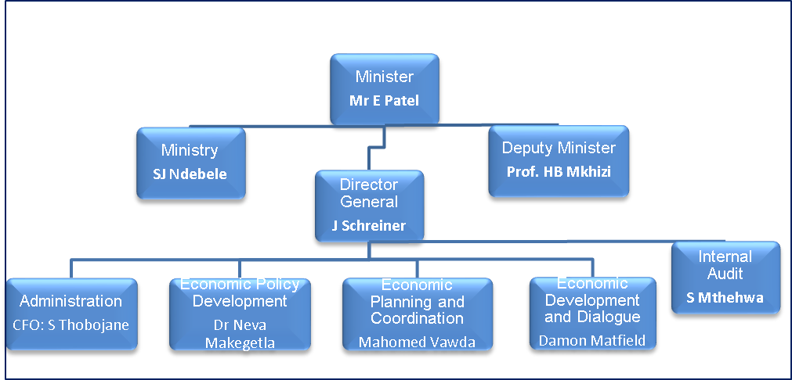
Mr Saleem Mowzer served as Acting Director General from the beginning of the financial year until November 2012 when Ms Jennifer Schreiner was appointed as the accounting officer. During the financial year the Chief Financial Officer (CFO) left the EDD. A new CFO, Ms Semphete Thobejane, was appointed in May 2013.

1.5 Funding
The department is primarily funded through funds appropriated in terms of the annual Appropriation Act (and the Adjustments Appropriation Act), the final appropriation for the 2012/13 amounted to R696 518 000 (2011/12: R598 359 000).

- Audit opinion history
AUDIT OPINIONS | 08/09 | 09/10 | 10/11 | 11/12 | 12/13
- Economic Development Department | N/A | N/A
- Competition Commission
- Competition Tribunal
- International Trade Administration Commission
- South African Micro Finance Apex Fund |  |  |  |  | N1
- Khua Enterprises Finance Ltd | N/A |  |  |  | N1
- Small Enterprise Finance Agency | N/A | N/A | N/A | N/A
- Industrial Development Corporation of SA Ltd | N/A
QUALIFICATION ISSUES | 08/09 | 09/10 | 10/11 | 11/12 | 12/13
International Trade Administration Commission
- Property, Plant and Equipment | ü
South African Micro Finance Apex Fund
- Non-consolidation of financial intermediaries | ü
- Operating expenses and account payable |  | ü
OTHER MATTERS | 08/09 | 09/10 | 10/11 | 11/12 | 12/13
Predetermined objectives
- Competition Commission |  | ü
- Competition Tribunal |  | ü
- International Trade Administration Commission |  | ü | ü | ü
- South African Micro Finance Apex Fund | ü | ü | ü | ü
- Small Enterprise Finance Agency |  |  |  |  | ü
Compliance with laws and regulations
- Economic Development Department |  |  | ü | ü | ü
- Competition Commission |  |  | ü | ü | ü
- Competition Tribunal |  |  | ü | ü | ü
- International Trade Administration Commission |  |  | ü | ü
- South African Micro Finance Apex Fund | ü | ü | ü | ü
- Khua Enterprises Finance Ltd |  | ü

AUDIT OPINION LEGEND
 | CLEAN AUDIT OPINION: No findings on PDO and Compliance
 | UNQUALIFIED with findings on PDO and Compliance
 | QUALIFIED AUDIT OPINION (with/without findings)
 | DISCLAIMER/ADVERSE AUDIT OPINION
N/A | New entity
N1 | SAMAF & KHULA merged to form SEFA

- Key focus areas
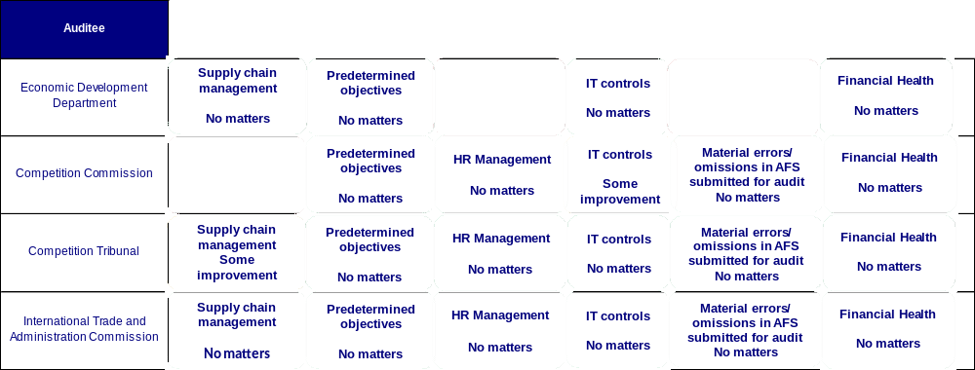

  - Supply chain management
Entity | Finding | Root cause | Recommendation
Competition Commission | Contracts were awarded to certain suppliers whose tax matters had not been declared by the South African Revenue Service to be in order as required by Treasury Regulation 16A9.1(d). | There are inadequate procedures and processes in place to ensure that the documents required in terms of the applicable legislation have been obtained before contracts are awarded to prospective suppliers.  There are inadequate oversight to ensure that personnel comply with PFMA and Treasury Regulations. | Management should ensure that procedures and processes in place are adequate to ensure that all expenditure documents are in compliance with relevant legislation.  In particular, management should ensure that controls are implemented whereby all personnel involved in procurement are aware of the requirement to obtain a valid tax clearance certificate before making an award.  Management should also implement monitoring controls whereby the procurement specialist will review all awards to ensure that the necessary SCM documents have been obtained prior to making an award in order to detect instances of non-compliance by the relevant officials.
Competition Commission | Certain goods and services with a transaction value below R500 000 were procured without obtaining the required price quotations, as required by Treasury Regulation 16A6.1.
Competition Commission | The accounting authority did not take effective steps to prevent irregular expenditure as per the requirements of section 51(1)(b)(ii) of the PFMA.
Competition Tribunal | The accounting authority did not take effective steps to prevent irregular expenditure as per the requirements of section 51(1)(b)(ii) of the PFMA.  (required 3 quotations were not obtained) | Management did not take adequate action to ensure compliance with supply chain management policies and procedures. | Management should implement procedures and processes to ensure that three quotations are obtained, as required by SCM prescripts.

  - Predetermined objectives
Entity | Finding | Root cause | Recommendation
Competition Commission | Of the 50 planned targets, 28 targets were not achieved during the year under review. This represent 56% of total planned targets that were not achieved during the year under review. | This is mainly due to the complexity of the cases the entity investigates, delays encountered with processes and the public filing fewer requests and applications compared to the expectation of the entity. | Progress should continuously be monitored and actions should be taken where indications of non-achievement are present.
Competition Tribunal | Of the 18 planned targets, 9 targets were not achieved during the year under review. This represent 50% of total planned targets that were not achieved during the year under review. | This was mainly due to the fact that indicators and targets were not suitably developed during the strategic planning process. | Progress should continuously be monitored and actions should be taken where indications of non-achievement are present.
International Trade Administration Commission | Of the 34 planned targets, 13 targets were not achieved during the year under review. This represent 38% of total planned targets that were not achieved during the year under review. | This was mainly due to the fact that indicators and targets were not suitably developed during the strategic planning process. | Progress should continuously be monitored and actions should be taken where indications of non-achievement are present.
Small Enterprise Finance Agency | Material adjustments in the annual performance report were identified during the audit and all adjustments were corrected by management | Audit not perfromed by AGSA.
Small Enterprise Finance Agency | Of the total number of 23 targets planned of the year, 9 targets were not achieved during the year under review. This represents 39% of total planned targets that were not achieved during the year under review. | Audit not perfromed by AGSA.

  - Human resources management
Entity | Finding | Root cause | Recommendation
Economic Development Department | The accounting officer did not ensure that all leave taken by employees were recorded accurately and in full as required by Public Service Regulation 1/V/F(b). | Lack of monitoring controls in place to ensure adherence to this requirement. | A monthly reconciliation between approved manual leave forms and Persal should be preformed.
Economic Development Department | Persons in charge at pay points did not always certify that the employees receiving payment were entitled thereto, as required by TR 8.3.4. | Lack of monitoring controls in place to ensure adherence to this requirement. | Management responsible for payroll certifications should be held accountable where non-compliance is noted.

  - Information technology controls
Entity | Finding | Root cause | Recommendation
Competition Commission | Lack of approved security controls is due to management not approving the Information Technology (IT) security policy and patch management policy.  Lack of design and implementation of user account management processes was due to the non-approval of user access management policy by management.  Lack of formal change management controls was due to the failure by management to design and implement formal application change control standards and procedures and assigning the task of implementing effective monitoring of the activities of the vendor’s staff to an appropriate staff member.  Inadequate IT service continuity controls are attributed to management not approving the revised Disaster Recovery Plan (DRP). | An IT governance framework that supports and enables the business, delivers value and improves performance was not established.  This is attributed to management not approving the IT strategy and IT governance framework. | The IT strategy and IT governance framework must be approved by management.  Management should exercise an efficient oversight function to ensure that approval of the IT strategy and IT governance framework occurs on a timely basis.  Management should plan adequately to ensure that matters as raised above do not become a recurring issue.

  - Material errors/ommissions in submitted AFS
Entity | Finding | Root cause | Recommendation
Economic Development Department | The financial statements submitted for auditing were not fully prepared in all material respects in accordance with the prescribed financial reporting framework as required by section 40(1)(b) of the PFMA.  Material misstatements of receivables, departmental revenue, and disclosure items identified by the auditors in the submitted financial statement were subsequently corrected, resulting in the financial statements receiving an unqualified audit opinion. | The department has not established the daily and monthly controls to ensure complete and accurate financial statements. | Management should ensure that AFS are prepared regularly. It is critical that a full and proper set of financial statements (including all disclosure notes) are prepared on a monthly basis.  These AFS should be reviewed by the governance structures i.e management, internal audit and audit committee.  The AFS prepared should be adequately supported by substantiating evidence to corroborate validity, accuracy and completeness thereof.  AFS which are submitted must be the final set approved by the leadership and supported as referred to above.
  - Financial health status
There were no matters to report on the financial health status.

- Drivers of internal controls
Drivers of internal control
Entity | Leadership |  |  |  |  |  | Financial & performance management |  |  |  |  | Governance
Entity | Effective leadership culture | Oversight responsibility | HR management | Policies and procedures | Action plans | IT governance | Proper record keeping | Processing and reconciling controls | Reporting | Compliance | IT systems controls | Risk management | Internal audit | Audit committee
Economic Development Department
Competition Commission
Competition Tribunal
Internal Trade and Administration Commission

- Other matters of interest
(a) Unauthorised expenditure:
No unauthorised expenditure incurred by the department.

(b) Fruitless and wasteful expenditure:
Auditee |  | Fruitless and Wasteful expenditure
 |  | Movement | Amount  R  2013 | Amount  R  2012
1 | Competition Commission |  | R227 000 | R1 000
2 | Competition Tribunal |  | R0 | R1 000
3 | International Trade Administration Commission |  | R0 | R37 932

(c) Irregular expenditure:
Auditee |  | Irregular expenditure
 |  | Movement | Amount  R  2013 | Amount  R  2012
1 | Economic Development Department |  | R61 000 | R0
2 | Competition Commission |  | R53 068 000 | R6 220 000
3 | Competition Tribunal |  | R268 738 | R160 985
4 | International Trade Administration Commission |  | R193 815 | R788 708

- Other reports
Investigations
- No investigations are currently underway by the AGSA.
Performance audits
- No performance audits are currently underway by the AGSA.
- Combined Assurance on Risk Management in the Public Sector
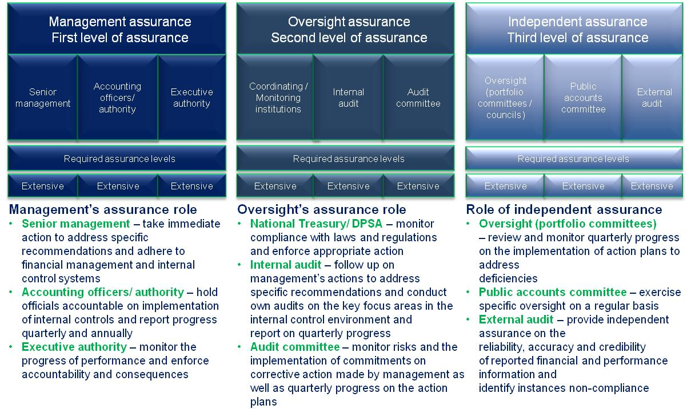
- Commitments
The following commitments should be actioned by the Portfolio Committee:
  - The Portfolio Committee will track implementation of action plans to address previously identified issues by the AGSA on a quarterly basis.
  - The Portfolio Committee will request feeback on key controls for all entities.
  - The Portfolio Committee will track progress to clean audit outcomes on a quarterly basis.

