
Social Development
08 September 2013
PFMA audit outcomes of the 2012-13 financial year for
PC

CONTENTS
1. Introduction 1
2. Audit opinion history 4
3. Key focus areas 7
4. Drivers of internal control 10
5. Other matters of interest 12
6. Other reports 12
7. Commitments 12
8. Feedback on previous resolutions 13

- Introduction
1.1 Reputation promise of the Auditor-General of South Africa
The Auditor-General of South Africa has a constitutional mandate and, as the Supreme Audit Institution (SAI) of South Africa, exists to strengthen our country’s democracy by enabling oversight, accountability and governance in the public sector through auditing, thereby building public confidence.

1.2 Purpose of document
To brief the Standing Committee of Public Accounts on the portfolio of the Minister of Social Development.

1.3 Overview
The portfolio consists of:

- The Department of Social Development (the Department).

- Two schedule 3A public entities.
  - The National Development Agency (NDA).
  - The South African Social Security Agency (SASSA).

- Four funds under the Department.
  - The Disaster Relief Fund (DRF).
  - The Social Relief Fund (SRF).
  - The Refugee Relief Fund (RRF).
  - The State President Fund (SPF).

1.4 Organisational structure

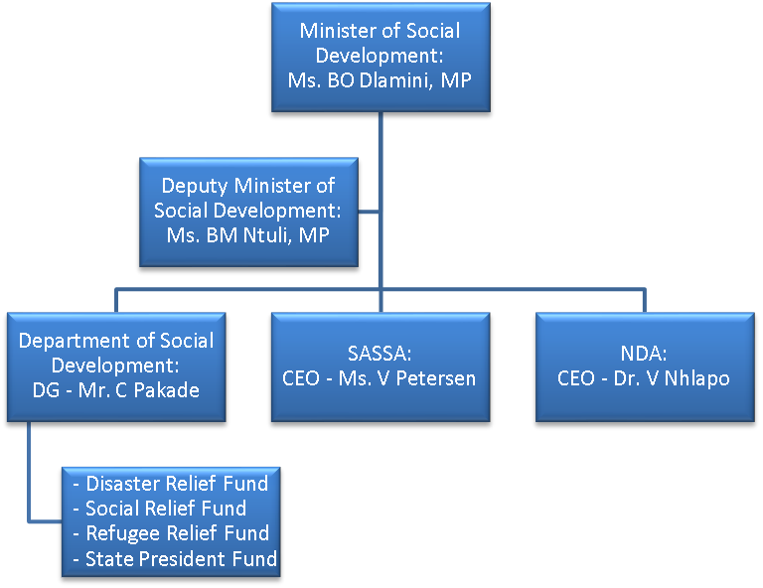

  - Funding
The Department (Vote 19) received a final annual appropriation of R112 billion and has spent 99.1% of the allocation in the 2012/13 financial year. The largest portion of the budget allocation was to Program 2: Social Assistance of which 99% was spent. The Department budget was further supplemented by Aid assistance amounting to R34 million.

Program | 2012-13  Budgeted  R’000 | 2012-13  Actual  R’000 | %  (Over)/Under  Spending | 2011-12  Budgeted  R’000 | 2011-12  Actual  R’000 | %  (Over)/Under  Spending
Department of Social Development
Program 1: Administration | 257 125 | 255 395 | 0.67% | 244 600 | 243 976 | 0.26%
Program 2: Social Assistance | 104 887 916 | 103 898 845 | 0.94% | 97 103 213 | 95 972 987 | 1.16%
Program 3: Social Security Policy & Administration | 6 211 780 | 6 198 417 | 0.22% | 6 237 049 | 6 228 295 | 0.14%
Program 4: Welfare Service Policy Development & Implementation Support | 525 048 | 502 618 | 4.27% | 451 752 | 449 066 | 0.59%
Program 5: Social Policy & Integrated Service Delivery | 261 683 | 260 301 | 0.53% | 247 273 | 244 858 | 0.98%
TOTAL | 112 143 552 | 111 115 576 | 0.92% | 104 283 887 | 103 139 182 | 1.10%

Included in Program 3 and 5 above, are the following transfers to SASSA and NDA respectively that form part of the Social Development portfolio.
South African Social Security Agency | 6 119 770 | 6 119 770 | 0% | 6 143 657 | 6 143 657 | 0%
National Development Agency | 166 263 | 166 263 | 0% | 161 360 | 161 360 | 0%

- Audit opinion history
DESCRIPTION | 08-09 | 09-10 | 10-11 | 11-12 | 12-13
Department of Social Development
Audit opinions
Areas of qualification
- Transfer and Subsidies (Households) |  | X | X
Other findings
- Transfers and subsidies: Compliance to the Social Assistance Act | X |  |  | X
- Procurement and contract management |  |  |  | X
- Expenditure management |  |  |  | X
South African Social Security Agency
Audit opinions
Areas of qualification
- Payables |  | X
- Bank Overdraft |  | X
- Receivables |  | X
- Inventory |  | X
- Accumulated Deficit |  | X
- Intangible Assets |  | X
Other findings
- Non compliance to PFMA – Late submission | X | X
- Reliability of Predetermined objectives |  |  | X
- Annual financial statements – Material adjustments |  |  |  |  | X
- Internal audit – No three year strategic rolling plan |  |  |  |  | X
National Development Agency
Audit opinions
Other findings
- Non compliance to the NDA Act | X
- Usefulness of Predetermined objectives |  |  | X
- Reliability of Predetermined objectives |  |  |  | X
- Expenditure management |  |  | X | X | X
- Procurement and contract management |  |  |  | X | X
- Annual financial statements – Material adjustments |  |  |  | X | X
- Budget management |  |  |  |  | X
The Disaster Relief, Social Relief, Refugee Relief and State President Funds
(All the funds had the same opinions and the same issues reported)
Audit opinions
Other findings
- Annual financial statements – Incorrect reporting framework used |  |  |  | X

CLEAN AUDIT OPINION: No findings on PDO and Compliance
UNQUALIFIED with findings on PDO and/or Compliance
QUALIFIED AUDIT OPINION (with/without findings)
DISCLAIMER/ADVERSE AUDIT OPINION

The improvement in the audit outcome of the portfolio was caused by the Department of Social Development addressing the non-compliance findings on procurement and expenditure management as well as the improvement made by SASSA, as the agent of the department, in the compliance within the Social Assistance Act in respect of the social assistance grants. Furthermore, the disaster relief, refugee relief, social relief and state president funds addressed the non-compliance findings on the quality of submitted annual financial statements. For the first time in SASSA’s existence, the leadership of SASSA made a strategic decision not to make use of consultants in compiling the financial statements. SASSA was successful in compiling the financial statements, except for some disclosure notes that were materially adjusted during the audit process. This resulted in a material non-compliance finding on the financial statements. This adjustment, as well as the non-compliance finding on internal audit regarding their three-year rolling plan not being in place, led to a regression in the audit outcome from a clean audit outcome to unqualified with findings. The audit outcome for the National Development Agency remained unchanged.

2.1. Significant emphasis of matters
Entity | Significant emphasis of matters
The Department | None
SASSA | Included in SASSA’s audit report was an emphasis of matter regarding the status of the AllPay court case which ruling had been in favour of SASSA by the Supreme Court of Appeal however subsequently AllPay had filed an application to be heard at the Constitutional Court of South Africa.
NDA | None
Funds | The audit reports of all four of the funds contained emphasis of matters paragraphs, highlighting the going concern issues disclosed in the notes to the financial statements. The going concern issue related to the uncertain future of the funds due to the planned closure of the funds being in process.

2.2. Significant additional matters
Entity | Significant additional matters
The Department | Predetermined Objectives: More than 39% of the total planned targets were not achieved during the year under review.  Predetermined Objectives: Material audit adjustments were made in the annual performance report were identified during the audit, all of which were corrected by management.
SASSA | Predetermined Objectives: More than 31% of the total planned targets were not achieved during the year under review.
NDA | Predetermined Objectives: More than 29% of the total planned targets were not achieved during the year under review.
Funds | None
- Key focus areas
  - Predetermined objectives
None

  - Supply chain management (SCM)
Entity | Finding | Root cause | Recommendation
NDA | Irregular expenditure incurred  Deviation from competitive bidding process  Three quotation not received and deviation unapproved  SCM policy not according to National Treasury prescripts | Deviation from procurement policy.  Lack of monitoring of compliance with supply chain management processes | Management should review policies in line with applicable regulatory requirements to achieve alignment and implement monitoring controls
Funds | The funds did not carry on any trade and therefore did not undertake any SCM related activities.

  - Human resources
Entity | Finding | Root cause | Recommendation
Funds | The funds did not have any staff and all activities related to the funds were conducted by staff of the Department
The organisational structure of SASSA was based on the complete grants administration value chain i.e. from application to payment of social grants. However, the payment of social grants has since the SASSA’s establishment been outsourced to third parties. The reason for outsourcing the payment service is that SASSA still has to develop its own high technology driven payment system. SASSA can therefore not fill all the vacancies on the structure as the oversupply of employees would lead to inefficiencies. The structure has also never been fully funded by the National Treasury as the understanding was that part of the SASSA’s functions i.e. payment of social grants, is outsourced to a third party. SASSA will start increasing its capacity during the third year of the current contract i.e. during 2015/ 2016 in preparation for the takeover of the payment function.

  - Information technology controls
Entity | Finding | Root cause | Recommendation
Department | Findings on security controls | Password complexity shortcomings | Management to compile an Information Technology (IT) action plan to address findings
SASSA | Findings on compliance to and oversight of security controls | Inadequate review of user access controls and rights | Management to compile an IT action plan to address findings
NDA | Findings on security controls and appropriate backup and disaster recovery plans. | Inadequate review of user access controls and rights and necessary plans not formalised. | Management to compile an IT action plan to address findings
Management has designed adequate controls surrounding IT systems. Policies and procedures are in place and adherence to most policies is monitored. However there were certain controls that were designed but not implemented.

  - Financial health status
Entity | Finding | Root cause | Recommendation
Funds | The funds did not have any of the Financial health analysis indicators. The going concern issues emphasised in the audit reports related to the closure of the funds and not to the Financial health analysis indicators.
  - Material Mistatements to Financial Statements
No significant findings

- Drivers of internal controls
Drivers of internal control
Entity | Leadership |  |  |  |  |  | Financial and performance management |  |  |  |  | Governance
Driver | Effective leadership culture | Oversight responsibility | HR management | Policies and procedures | Action plans | IT governance | Proper record keeping | Processing and reconciling controls | Reporting | Compliance | IT systems controls | Risk management | Internal audit | Audit committee
Department
SASSA
NDA
Funds

Legend Drivers | Good | Causing Concern | Intervension required

Entity | Leadership | Financial and Performance Management | Governance
Department | Oversight responsibility regarding the monitoring and evaluation mechanisms in order to exercise their oversight responsibility over the performance of the social assistance function | IT Controls regarding inadequate password complexity | No significant control deficiencies
SASSA | Lack of review and oversight regarding approved and communicated policies and procedures to enable and support understanding of internal control activities to ensure complete and accurate financial reporting of commitments, disclosure items and performance reporting. | Proper record keeping and review processes were not implemented in a timely manner to ensure complete, relevant and accurate financial reporting on commitments, disclosure items and performance reporting. | Procedures to ensure compliance with Treasury Regulation 27.2.7(a) and risk assessments were not in place.
NDA | Lack of effective leadership and oversight regarding adequate approved and communicated policies and procedures, implementation of action plan and appropriate IT governance frameworks. | Insufficient controls regarding proper record keeping and review processes, preparation of accurate and reliable financial information, IT security controls and compliance with approved policies and procedures were not implemented. | Lack of adequate risk assessment strategy to address high risk areas relating to compliance with applicable laws and regulations.

- Other matters of interest
SASSA has completed a country wide re-registration process in an attempt to identify and clean the Social Pensions database system of non-qualifying individuals. SASSA is now in their second phase of reviewing the financial statuses of beneficiaries to ensure that they continue to meet the legislated financial requirements.

- Other reports
- Investigations
SASSA is currently in process of investigations with regard to non-compliance with the supply chain management policy and procedures which could result in possible fraudulent actions and possible irregular expenditure.
A forensic investigation on the NDA’s procurement processes was conducted during the year under review and the report was finalised and approved by the board on 12 April 2013.

- Performance audits
A performance audit was conducted on the Readiness of Government to report on its performance. The focus of the audit is on how government institutions are guided and assisted to report on their performance, as well as the systems and processes that they have put in place. The management report was issued during this year.
- Commitments
Steady progress has been made with regard to the implementation progress of the Ministers previous key commitments. The commitments made are either in progress or have been implemented and two new commitments have been made for the 2012-13 year.
- Implemented
- Implementation of standard operating procedures which include accurate record keeping, reconciliations and the monitoring of compliance to policies, procedures, procurement and contract management and legislative requirements including the conclusion of the first phase of grant re-registration process.
- In progress
- Ensuring that the internal audit section of SASSA is adequately capacitated
- Implementation of the action plan at the NDA to ensure that the National Treasury Framework was implemented and all non-compliance matters are addressed
- New commitments
- Facilitate a inter-entity workshop within the portfolio to understand, improve the management and identify the root causes of grant debtors
- Action plans/processes to ensure the sustainability of clean administration for the Department and improvement by SASSA and NDA
- Feedback on previous resolutions
None - No SCOPA resolutions were made as indicated in the report of the accounting officer in the annual report of the Department.

