
Department of Energy (DoE)
8 October 2013
PFMA audit outcomes of the 2012-13 financial year for
PC

CONTENTS
1. Introduction 2
2. Audit opinion history 6
3. Key focus areas 10
4. Drivers of internal control 27
5. Other matters of interest 28
6. Other reports 29
7. Combined Assurance on Risk Management in the Public Sector 30
8. Commitments 30

- Introduction
This document contains a brief summary of the audit outcomes for the Department of Energy portfolio.

  - Reputation promise of the Auditor-General of South Africa
The Auditor-General of South Africa has a constitutional mandate and, as the Supreme Audit Institution (SAI) of South Africa, it exists to strengthen our country’s democracy by enabling oversight, accountability and governance in the public sector through auditing, thereby building public confidence.

1.2 Purpose of document
The purpose of this briefing document is for the Auditor-General of South Africa (AGSA) to provide an overview of the audit outcomes and other findings in respect of the Department Energy and its entities for the 2012-13 financial year.

1.3 Overview
The Department of Energy is mandated to ensure secure and sustainable provision of energy for socioeconomic development.
It aims to formulate energy policies, regulatory frameworks and legislation, oversee their implementation to ensure energy security, promotion of environmentally-friendly energy carriers and access to affordable and reliable energy for all South Africans.

The department is striving to have created a transformed a sustainable energy sector with universal access to modern energy carriers for all by 2014 and in the long run, improving our energy mix by having 30% of clean energy by 2025.
The department continues to regulate and transform the sector for the provision of secure, sustainable and affordable energy.

1.4 Structure of the DoE portfolio
Department of Energy (DoE)

Equalisation Fund
Electricity Distribution Industry Holdings (EDI Holdings)
Central Energy Fund (CEF)

National Nuclear Regulator (NNR)
South African National Energy Research and Development Institute (SANEDI)
National Energy Regulator of SA (NERSA)
National Energy Corporation of SA (NECSA)

1.5 Funding

During the 2012-13 financial year the Department of Energy received funding totalling R6.7bn per the following programmes,

Programme | Final Appropriation (R’000)
Administration | 236 583
Energy policy and planning | 1 563 403
Energy regulation | 1 139 787
National electrification programme | 3 147 822
Nuclear energy and regulation | 646 883
TOTAL | 6 734 478

The following were the major cost drivers for the financial year under review:

Economic Classification | Final Appropriation R’000
Compensation of employees | 206 763
Goods and services | 207 747
Transfers and subsidies | 6 304 841
Payment for capital assets | 15 127
Payment for financial assets - | 0
TOTAL | 6 734 478

As at 31 March 2013, the DoE disbursed transfer payments to the value of R6,28 billion, which represented 99,6% of the total budget allocation for the year to public entities, municipalities and implementing agencies.

Major transfer payments are reflected in the following table:

TRANSFER PAYMENTS | Original Budget 2012/13 R'000
SANEDI | 56 110
Transnet Pipelines | 1 500 000
Energy and Efficiency and Demand Side Management (EEDSM) – Eskom | 820 629
EEDSM – Municipalities | 200 000
NECSA | 567 579
NNR | 42 912
Integrated National Electrification Programme (INEP) – Eskom | 1 879 368
INEP – Municipalities | 1 151 443
INEP – Non-grid | 86 400
Households (Leave gratuities and retirement benefits) | 400
TOTAL TRANSFER PAYMENTS | 6 304 841

- Audit opinion history
DESCRIPTION | 08-09 | 09-10 | 10-11 | 11-12 | 12-13
Audit opinions
Department of Energy | n/a*¹ | n/a*
Central Energy Fund (CEF)
Nuclear Energy Corporation of South Africa (NECSA)
National Energy Regulator of South Africa (NERSA)
South African National Energy Research and Development Institute (SANEDI) | n/a**¹ | n/a**¹ | n/a**¹
EDI Holdings
National Nuclear Regulator (NNR)
Equalisation Fund
Areas of qualification
Equalisation Funds - Revenue |  |  |  |  | X
Report on other legal and regulatory requirements
- Predetermined objectives
Department of Energy | n/a*¹ | n/a*¹ | X
Central Energy Fund (CEF) | X | X |  |  | X
Nuclear Energy Corporation of South Africa (NECSA)
National Energy Regulator of South Africa (NERSA)
South African National Energy Research and Development Institute (SANEDI) | n/a**¹ | n/a**¹ | n/a**¹ | X | X
EDI Holdings
National Nuclear Regulator (NNR) | X | X | X | X
Equalisation Fund |  |  | X | X | X
- Compliance with laws and regulations
Department of Energy | n/a*¹ | n/a*¹ | X | X | X
Central Energy Fund (CEF) | X | X | X | X | X
Nuclear Energy Corporation of South Africa (NECSA) |  |  | X | X
National Energy Regulator of South Africa (NERSA) |  |  |  | X | X
South African National Energy Research and Development Institute (SANEDI) | n/a**¹ | n/a**¹ | n/a**¹ | X | X
EDI Holdings |  |  | X | X | X
National Nuclear Regulator (NNR) | X | X | X | X | X
Equalisation Fund |  |  |  | X | X

AUDIT OPINION
CLEAN AUDIT OPINION: No findings on PDO and Compliance
UNQUALIFIED with findings on PDO and Compliance
QUALIFIED AUDIT OPINION (with/without findings)
DISCLAIMER/ADVERSE AUDIT OPINION
AUDIT NOT FINALISED
  - Qualification paragraph – Adverse opinion
2.1.1 Equalisation Fund
Financial statements were not prepared in accordance with the requirements of Generally Recognised Accounting Practices
The entity did not prepare the financial statements in accordance with SA Standards of GRAP. Levy and interest income were classified as an increase to financial liabilities and claim and administrative expenses were classified as a decrease to financial liabilities in the statement of financial position instead of being recorded as income and expenses in the statement of financial performance as required by GRAP 23 and GRAP 1.
Consequently income and expenses are understated by R2,657,412,851 and R2,540,113,893 (2012:R723,028,105 and R3,988,074,938) respectively and financial assets and financial liabilities are overstated by R671,506,797 and R526,759,884 (2012:545,744,00 and 303,915,550) respectively. Additionally, there is a consequential impact on the surplus for the period and the accumulated surplus.
Claim payments not reconciled
I was unable to obtain sufficient appropriate audit evidence for claims paid as I was not provided with the reconciliation that is required to be performed by management of the entity, in terms of section 5 and 7 of the Petroleum Products Act, 1977 (Act No 120 of 1977) I was unable to confirm these claims by alternative means as the information required to perform the reconciliation was not available. Consequently I was unable to determine whether any adjustments relating to claim payments stated at R3,539,806,922 in the financial statements was necessary.
  - Significant emphasis of matters included in the audit reports
An emphasis of matter paragraph is used to draw users’ attention to a matter presented or disclosed in the financial statements by the accounting officer/authority which is of such importance that it is fundamental to their understanding of the financial statements. The following emphasis of matter paragraphs were reported in the audit reports of entities in the Energy portfolio.

2.2.1 CEF
Significant uncertainties
With reference to paragraph 7 of the Directors’ report and note 46 to the financial statements, the company has disclosed fruitless and wasteful as well as irregular expenditure incurred during the financial period under review. Some of the disclosures were made subsequent to recommendations from the investigations referred to in the audit report. As some of the investigations were either still in the process of being finalised or the recommendations of which were still in the process of being implemented further fruitless and wasteful expenditure and/or irregular expenditure may still require disclosure in subsequent periods.

2.2.2 SANEDI
Material impairments
Material losses to the amount of R6,8million were incurred as a result of impairments in the accounts receivables.

2.2.3 EDI Holdings
Going concern
Note 1 to the financial statements indicates that the company’s financial statements are not prepared on the going concern basis. On 8 December 2010 a cabinet decision approved the winding up of the company.

Significant uncertainties
With reference to note 25 there is a claim pending before the high court instituted by EOH Public Sector Consortium (EOH) for the recovery of damages allegedly suffered as a result of the termination of a consultancy agreement when the company seized to conduct business as a going concern during 31 March 2011. EOH Public Sector Consortium has not taken any further steps to prosecute the claim since 08 August 2011. The claim instituted by the plaintiff amounts to R 936,502.64. The attorneys of the company are of the opinion that having regard to the slow conduct of the plaintiff the matter is unlikely to revive.

2.2.4 Equalisation Fund
Funding of operations
As disclosed in note 3 to the financial statements, as at 31 March 2013 the balance in the Incremental Inland Transport Recovery (IITR) Levy account is in a deficit of R671,507,000 for claims payable to registered licence wholesalers. The IITR Levy account did not have sufficient cash resources to fund the outstanding claims in the 2012/13 financial year and the 2011/12 financial year. The directors believe that the fund will continue as a going concern in the year ahead.
- Key focus areas
  - Predetermined objectives
Entity | Finding | Root cause | Recommendation
DoE | Achievement of planned targets  Although no material findings concerning the usefulness and reliability of the performance information were identified in the annual performance report, attention was drawn to the level of non-achievement of planned targets  Of the total number of 204 departmental targets planned for the year, 85 targets were not achieved during the year under review. This represents 42% of total planned departmental targets that were not achieved during the year under review.  Material Adjustments to the annual performance report  Material in the annual performance report presented for auditing were indentified during the audit and corrected by management. These adjustments related to the consistency of reported targets when compared to the approved strategic plan for 2012-13 and the revised annual performance plan for 2012-13. | The reasons for the non-achievment of the department’s indivdiual targets as indicated above is set out in pages 29 to 114 of the performance report of the Department of Energy for the year ended 31 March 2013,  Lack of controls and monitoring of controls to ensure regular, accurate and complete performance reports are prepared which are supported and evidenced by reliable information. | Management should ensure controls are in place to ensure the annual report submitted for audit is accurate and free from material misstatements, supported by appropriate evidence.
CEF | Usefulness of information  The National Treasury Framework for managing programme performance information (FMPPI) requires that the indicator should relate logically and directly to an aspect of the institution’s mandate, the realisation of strategic goals and objectives. A total of 25% of indicators did not relate logically and directly to an aspect of the institution’s mandate and realisation of strategic goals and objectives.  Reliability of information  The National Treasury Framework for managing programme performance information (FMPPI) requires that institutions should have appropriate systems to collect, collate, verify and store performance information to ensure valid accurate and complete reporting of actual achievements against planned objectives, indicators and targets. The information presented with respect to the activity ‘to develop education and training programmes that will help change energy utilization behaviours’ was not reliable when compared with the source information and evidence provided.  Achievement of planned targets  Of the total number of 10 planned targets, 5 targets were not achieved during the year under review. This represents 50% of total planned targets that were not achieved during the year under review. | Lack of oversight regarding performance reporting and compliance and related internal controls  Inadequate evidence has been maintained to support the allocated scores.  The reasons for the non-achievement of the department’s individual targets as indicated above is set out in pages 30 to 32 of the performance report of CEF for the year ended 31 March 2013 | Reported indicators and targets must be consistent with planned indicators and targets. All changes that are made to the Corporate Plan must be approved by the executive authority  Reported performance information must be reviewed in detail by Management to ensure that all allocated scores are supported by appropriate audit evidence.  The reported score of 3 should be adjusted and a score of 2 allocated to the activity.
NECSA | Achievement of planned targets  Although no material findings concerning the usefulness and reliability of the performance information were identified in the annual performance report, attention was drawn to the level of non-achievement of planned targets  Of the total number of 19 planned targets for the year, 6 targets were not achieved during the year under review. This represents 32% of the total planned targets that were not achieved during the year under review. | For further details on the extent and reasons for deviations between planned targets and actual performance refer to section 11, page 67-69 of the annual performacne report.
SANEDI | Performance measures not well defined  The National Treasury Framework for managing programme performance information (FMPPI) requires that measures should have clear unambiguous data definitions so that data is collected consistently and is easy to understand and use.  A total of 47% of the indicators were not well defined, in that clear and unambiguous data definitions were not available to allow for data to be collected consistently.  Achievement of planned targets  Of the total number of 67 planned targets, 26 targets were not achieved during the year under review. This represents 39% of total planned targets that were not achieved during the year under review.  Material adjustments to the performance Against pre-determined objectives  Material misstatements in the annual performance report were identified during the audit, all of which were corrected by management. | Lack of oversight regarding performance reporting and compliance and related internal controls  For further details on the extent and reasons for deviations between planned targets and actual performance refer to page 51-60 of the annual performacne report.  Insufficient review and monitoring of compliance with applicable laws and regulations | The Annual Performance Plan needs to be prepared on the “SMART”  A useful set of criteria for selecting performance targets is the "SMART" criteria:  - Specific: the nature and the required level of performance can be clearly identified  - Measurable: the required performance can be measured  - Achievable: the target is realistic given existing capacity  - Relevant: the required performance is linked to the achievement of a goal  - Time-bound: the time period or deadline for delivery is specified.  Management are required to ensure that the requirements of the National Treasury Framework for Strategic Plans and Annual Performance Plans regarding the updating of the Strategic Plans and Annual Performance Plans are adhered to
NNR | Achievement of planned targets  Although no material findings concerning the usefulness and reliability of the performance information were identified in the annual performance report, attention was drawn to the level of non-achievement of planned targets  Achiement of planned targets  Of the total number of 27 planned targets for the year, 12 targets were not achieved during the year under review. This represents 44% of the total planned targets that were not achieved during the year under review. This was as a result of the institution not considering relevant systems and evidential requirments during the annual strategic planning process.  Material adjustments to the performance Against pre-determined objectives  Material misstatements in the annual performance report were identified during the audit, all of which were corrected by management. | For further details on the extent and reasons for deviations between planned targets and actual performance refer to section 2 page 20 - 33 of the annual performacne report.  Management did not prepare regular, accurate and complete financial and performance reports that are supported and evidenced by reliable information | In the actual column, figures or targets achieved must be stated so the report can be understandable
Equilisation Fund | Predetermined objective  I am unable to report findings on the usefulness and reliability of the annual performance report of the Equalisation Fund as it was not prepared as required by section 55(2)(a) of the PFMA. | Management has not exercised oversight responsibility regarding financial and performance reporting and compliance and related internal controls as no performance objectives were set for the financial year. | - Compliance with the Public Finance Management Act should be administered and implemented in all aspects of the Equalisation Fund.  - Performance objectives should be set for the Fund so that performance of the fund can be assessed as well as accountability and tracking of progress of the fund can be monitored.

  - Supply chain management
Entity | Finding | Root cause | Recommendation
DoE | Procurement and contract management  Employees of the department performed remunerative work outside their employment in the department without written permission from the relevant authority as required by section 30 of the Public Service Act. | Compliance with applicable laws and regulations are not reviewed and monitored. | Accounting officers should implement and actively monitor the systems of control to identify instances where employees of the department perform other remunerative work and manage the process to ensure compliance with the requirements of the Public Service Act.
SANEDI | Procurement and contract management  - Goods and services with a transaction value below R500 000 were procured without obtaining the required price quotations, as required by Treasury Regulation 16A6.1  - Contracts and quotations were awarded to bidders who did not submit a declaration on whether they are employed by the state or connected to any person employed by the state, which is prescribed in order to comply with Treasury regulation 16A8.3.  - Contracts and quotations were awarded to bidders based on preference points that were not allocated and calculated in accordance with the requirements of the Preferential Procurement Policy Framework Act and its regulations.  - The preference point system was not applied in all procurement of goods and services above R30 000 as required by section 2(a) of the Preferential Procurement Policy Framework Act and Treasury Regulations 16A6.3(b).  - Contracts were awarded to bidders based on points given for criteria that differed from those stipulated in the original invitation for bidding, in contravention of Treasury Regulations 16A6.3(a) and the Preferential Procurement Regulations.  - Contracts and quotations were awarded to suppliers whose tax matters had not been declared by the South African Revenue Services to be in order as required by Treasury Regulations 16A9.1(d) and the Preferential Procurement Regulations.  - Contracts were awarded to bidders who did not submit a declaration of past supply chain practices such as fraud, abuse of SCM system and non-performance, which is prescribed in order to comply with Treasury regulation 16A9.2  - Goods and services of a transaction value above R500 000 were procured without inviting competitive bids, as required by Treasury Regulations 16A6.1. Deviations were approved by the accounting officer even though it was not impractical to invite competitive bids, in contravention of Treasury regulation 16A6.4. | - Inadequate review and monitoring of compliance with applicable laws and regulations  - The declarations of independence questionnaires that have been provided to suppliers are not specific or in enough detail i.e.:  Questions relate to suppliers interest in SANEDI and not to the state as requested by SBD4, Declaration on interest  The declarations are not in line with the SBD4 documentation.  There is insufficient review of the declarations of independence that are submitted by suppliers, as management have not picked up the above discrepancy.  - Members who sit on the bid evaluation committee are not sufficiently versed in the applicable legislation and regulations that apply to the procurements of goods and services.  - Inadequate oversight over the establishment of policies and procedures to enable and support understanding and execution of internal control objectives, processes and responsibilities.  - Inadequate oversight over the establishment of policies and procedures to enable and support understanding and execution of internal control objectives, processes and responsibilities.  - Management do not exercise oversight responsibility regarding financial and performance reporting and compliance and related internal controls  - Management do not exercise oversight responsibility regarding financial and performance reporting and compliance and related internal controls  - Inadequate review and monitoring of compliance with applicable laws and regulations | - Management should align the procurement strategy to the frameworks and regulations that govern procurement. All expenditure incurred on the lease must be classified as irregular.  - The declaration of independence document should be revised and updated to include questions that are aligned to that of the National Treasury Regulations. The documentation provided by suppliers should be suitable reviewed by a member of management.  Members who sit on the bid evaluation committees should have a working knowledge of the Procurement Regulations and framework – SANEDI should implement a policy that governs their procurement processes and ensure that the correct lowest acceptable bid is used to score the bids  - A policy should be drafted that aligns with the Procurement regulations and frameworks as set out by National Treasury. Bids should be evaluated using this policy; this will ensure that all bids are correctly scored.  - A policy should be drafted that aligns with the Procurement regulations and frameworks as set out by National Treasury. Bids should be evaluated using this policy; this will ensure that all bids are correctly scored.  - Request for proposals should specify all appropriate bidding documentation to be submitted along with the bid itself  - Request for proposals should specify all appropriate bidding documentation to be submitted along with the bid itself.  - Management should align the procurement strategy to the frameworks and regulations that govern procurement. All expenditure incurred on the lease must be classified as irregular
NNR | Procurement and contract management  Goods and services with a transaction value below R500 000 were procured without obtaining the required price quotations, as required by Treasury Regulation 16A6.1 | Management did not review and monitor compliance with applicable laws and regulations. | Management should ensure that internal controls are in place and working as intended to ensure compliance with relevant policies and procedures, Treasury regulations and PN 8 of 2007/08.

  - Material misstatements to the Financial Statements
Entity | Finding | Root cause | Recommendation
CEF | Annual financial statements  Material misstatements identified by the auditors in the consolidated financial statements were subsequently corrected. The accounting authority therefore submitted consolidated financial statements for auditing that were not prepared in all material aspects accordance with the prescribed financial reporting framework and supported by full and proper records as required by section 55(1)(b) of PFMA and section 29(1)(a) of the Companies Act of South Africa. | - Errors were identified during the audit process  - Management’s own adjustments that were not captured prior to submission of the financial statements | - Effective cut off procedures need to be developed and implemented to ensure timely preparation of accurate and reliable financial statements  - Supporting information needs to be reviewed needs to be reviewed during the preparation of financial statements and financial statements updated accordingly.  - The financial statements submitted to the board for approval needs correct in all material respect.  - Going forward, management should ensure that all necessary approvals are in place when submitting AFS for audit to the Auditors and National Treasury.
NERSA | Annual financial statements  The financial statements submitted for auditing were not supported by full and proper records as required by section 55(1) ((a) and (b)) of the PFMA. Material misstatements of non-current assets, expenditure and disclosure items identified by the auditors in the submitted financial statements were subsequently corrected, resulting in the financial statements receiving an unqualified audit opinion. | - Lack of controls over daily and monthly processing and reconciling of transactions  - Prepare regular, accurate and complete financial and performance reports that are supported and evidenced by reliable information  - Review and monitor compliance with applicable laws and regulations | Management should ensure that proper controls of the daily and monthly processing and reconciliation of transaction are implemented and monitored to ensure financial records are accurate and support the financial statements and adherence to compliance with relevant laws and regulations.
SANEDI | Financial statements  The financial statements submitted for auditing were not prepared in all material respects in accordance with the requirements of section 55(1)(b) of the PFMA and section 29(1)(a) of the Companies Act. Material misstatements identified by the AGSA relating to the classification of revenue, recognition of grants and Valuation of creditors, deferred income, and current assets were subsequently corrected. | Inadequate controls over financial reporting the AFS submitted for audit purposes included number of errors that were subsequently adjusted during the audit process. | - Effective cut off procedures need to be developed and implemented to ensure timely preparation of accurate and reliable financial statements  - Supporting information needs to be reviewed needs to be reviewed during the preparation of financial statements and financial statements updated accordingly.  - The financial statements submitted to the board for approval needs correct in all material respect.
EDI | Annual financial statements  The financial statements submitted for auditing were not supported by full and proper records as required by section 55(1) (a) of the PFMA. Material misstatements of current assets and compliance items identified by the auditor were subsequently corrected, resulting in the financial statements receiving an unqualified audit opinion. | Management has not prepared regular, accurate and complete financial and performance reports that are supported and evidenced by reliable information. | - Prepare a bank and investment reconciliation for the month of March 2013 to identify the reconciling items for the month of March 2013. If management feels that this is not practical as there is no permanent staff at the entity then this should be done quarterly or at each reporting date .  - Adjust the Investment and Main Bank accounts balance in the general ledger with the reconciling items as at 31 March 2013 to ensure that the entity have a full set of Annual Financial statements which is complete  .
NNR | Annual financial statements  The financial statements submitted for auditing were not supported by full and proper records as required by section 55(1) (b) of the PFMA. Material misstatements of liabilities and disclosure items identified by the auditor were subsequently corrected, resulting in the financial statements receiving an unqualified audit opinion. | Management did not prepare regular, accurate and complete financial and performance reports that are supported and evidenced by reliable information. | Management should review the financial statements to confirm that all amounts disclosed are correct before submitting to the AFS for audit.
  - Other material non-commpliance
Entity | Finding | Root cause | Recommendation
DoE | Transfer of funds  As the transfering national officer, the third quarter performance report in accordance with the requirments of the relevant framework was not submitted within 45 days after afer the end of the quarter to National Treasury as required by Section 10(7) of the Division of Revenue Act. | Controls are not implemented and monitored to ensure compliance with laws and regulations. | Management must ensure that controls are implemented and monitored to ensure that quarterly performance reports are submitted within 45 days after the end of each quarter to National Treasury to ensure compliance with the requirements of DoRA.
CEF | Expenditure management  The accounting authority did not take effective steps to prevent fruitless and wasteful and irregular expenditure, as required by section 51(1)(b) of PFMA. Fruitless and wasteful expenditure of R5 173 000 and irregular expenditure of R872 183 000 were incurred in the current year.  Audit committee  - There is a contravention of section 94(4)(b) of the Companies Act of South Africa in that an audit committee member that served during the current financial period had also been involved in the day-to-day management of the company’s business during the current financial period. | - Lack of proper leadership and direction in the procurement department  - In appropriate controls over procurement of goods and services within the group  - Inadequate procurement policies and procedures  - This was as result of the board decision to appoint to the audit committees. The appointments were also meant to be short term while the CEO positions are in the process of being filled. | - Leadership should ensure that effective action is taken where incidents are identified to avoid repeat incidents of fruitless and wasteful expenditure,  - Policies should be reviewed and updated to ensure that they adhere to the procurement regulations, they promote fair procurement processes,  - The procurement staff need to receive adequate training ,  - Proper filling and record keeping need to be implemented ,  - Ensure that procurement remains an annual focus area for internal audit  - The Board of Directors must ensure that all the members of the Board  Audit and Risk Committee consist of independent non-executive directors.  - Company needs to ensure that members of the audit committee are directors of the company in order to comply with the act.  - Review and monitoring of policies and procedures and compliance with applicable laws and regulations must be implemented and enforced to ensure compliance with laws and regulations.
NERSA | Assets management  Proper control systems to safeguard and maintain assets were not implemented, as a required by section 51(1)(c) of the Public Finance Management Act. | - Lack of controls over daily and monthly processing and reconciling of transactions  - Prepare regular, accurate and complete financial and performance reports that are supported and evidenced by reliable information  - Review and monitor compliance with applicable laws and regulations | Management should ensure that proper controls of the daily and monthly processing and reconciliation of transaction are implemented and monitored to ensure financial records are accurate and support the financial statements and adherence to compliance with relevant laws and regulations.
SANEDI | Expenditure Management  The accounting authority did not take reasonable steps to prevent irregular expenditure as required by section 51(1)(b)(ii) of the PFMA. | Lack of proper leadership and direction in the procurement department | Leadership should ensure that effective action is taken where incidents are identified to avoid repeat incidents of fruitless and wasteful expenditure.
EDI | Annual financial statements  The accounting authority did not submit the financial statements for auditing within two months after the end of the financial year in accordance with the requirements of section 55 1(c)(i) of the PFMA  Expenditure Management  The accounting authority did not take reasonable steps to prevent irregular expenditure as required by section 51(1)(b)(ii) of the PFMA. | Management had not exercised adequate oversight responsibility regarding financial reporting and compliance with laws and regulations. | The resulting expenditure incurred must be reported as fruitless and wasteful expenditure and disclosed in the notes to the financial statements.

- Drivers of internal controls
Drivers of internal control
Entity | Leadership |  |  |  |  |  | Financial and performance management |  |  |  |  | Governance
 | Effective leadership culture | Oversight responsibility | HR management | Policies and procedures | Action plans | IT governance | Proper record keeping | Processing and reconciling controls | Reporting | Compliance | IT systems controls | Risk management | Internal audit | Audit committee
Department of Energy (DoE)
CEF (SOC) Ltd
The South African Nuclear Energy Corporation SOC Ltd (NECSA)
National Energy Regulator of South Africa (NERSA)
South African National Energy Development Institute (SANEDI)
Electricity Distribution Industry (EDI) Holdings SOC Ltd
National Nuclear Regulator (NNR)
Equalisation Fund
Legends
Legend Drivers | Good | Causing Concern | Intervention required

- Other matters of interest
a) Unauthorised expenditure:
No unauthorised expenditure incurred by any of the entities in the portfolio.

(b) Fruitless and wasteful expenditure incurred in 2012/2013:

Auditee |  | Fruitless and wasteful expenditure
 |  | Movement | Amount  R  2013 | Amount  R  2012
1 | Department of Energy (DoE) |  | 0 | 0
2 | CEF (SOC) Ltd |  | 38.6m | 0.064m
3 | The South African Nuclear Energy Corporation SOC Ltd (NECSA) |  | 0.11m | 1.5m
4 | National Energy Regulator of South Africa (NERSA) |  | 0.001m | 0
5 | South African National Energy Development Institute (SANEDI) |  | 0.002m | 0
6 | Electricity Distribution Industry (EDI) Holdings SOC Ltd |  | 6.6m | 9.1m
7 | National Nuclear Regulator (NNR) |  | 0 | 0.2m
8 | Equalization Fund |  | 0 | 0

(c) Irregular expenditure incurred in 2012/2013:

Auditee |  | Irregular expenditure
 |  | Movement | Amount  R  2013 | Amount  R  2012
1 | Department of Energy (DoE) |  | 8.2m | 39.6m
2 | CEF (SOC) Ltd |  | 875.0m | 48.0m
3 | The South African Nuclear Energy Corporation SOC Ltd (NECSA) |  | 0.06m | 0
4 | National Energy Regulator of South Africa (NERSA) |  | 3.1m | 0.4m
5 | South African National Energy Development Institute (SANEDI) |  | 12.6m | 0
6 | Electricity Distribution Industry (EDI) Holdings SOC Ltd |  | 0 | 0
7 | National Nuclear Regulator (NNR) |  | 0.28m | 0
8 | Equalisation Fund |  | 0 | 0
- Other reports
  - Investigations
6.1.1 DoE
Two investigations were conducted during the financial year relating to employees alledgedly having interest and/or performing remunerative work without approval.
6.1.2 CEF
The following two investigations conducted during the financial year :
- An investigation, mandate by the Board, Audit and Risk Committee of Group during the previous financial year, into possible irregularities relatiing to the procurement policy of the Group, was completed subsequent to the end of the reporting period. An extension of scope, relating to the this investigation was also completed subsequent to the end of the reporting period. We have been informed by mangement that the recommendations from this investigation are in the process of being evaluated and implimented by those charged with governance.
- An investigation, mandated by the Honourable Minister of Energy during the prior fiancial year, into all significant procurement, for goods and services that are not consided to relate to the day to day operations of CEF Group, was still in-progress at the date of this report.
6.1.3 NERSA
Two investigations were conducted during the year, the one relating to possible irregularities in the supply chain management system which is still in process and one relating to Employee Cost which have been concluded during the financial year.
6.1.4 EDI Holdings
A formal investigation is being condiucted by management in respect of theft by a former employee. The employee has been reported to the South African Police and a portion of the funds have been recovered from the former employee. Prosecution is udnerway as the ex-employee had been arrested and released on bail.

- Combined Assurance on Risk Management in the Public Sector

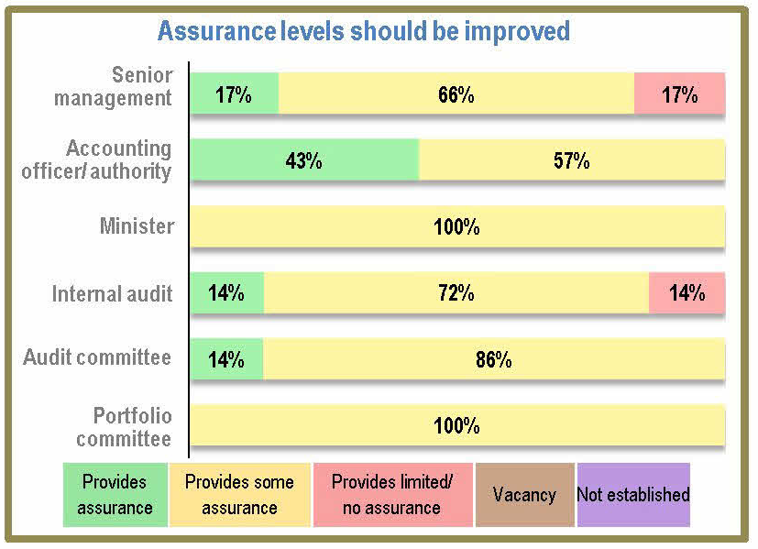
- Commitments
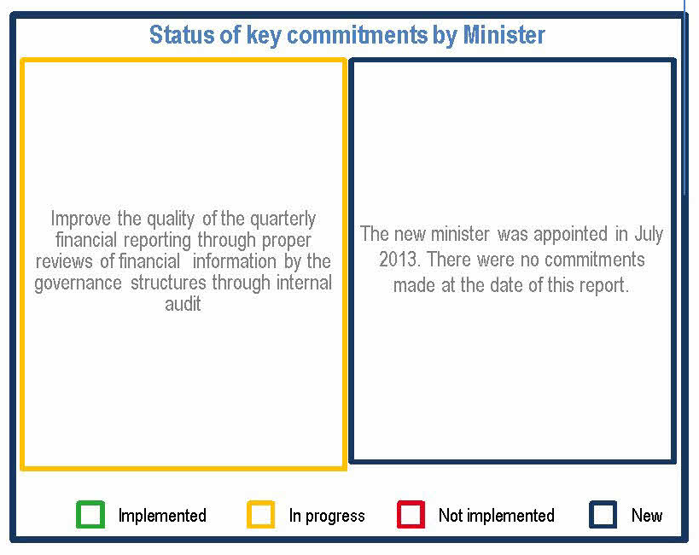

/a* – The department was only established during the 2010-11 financial year n/a** – The entity was only established during the 2011-12 financial year

