
Department of Communications
8 October 2013
PFMA audit outcomes of the 2012-13 financial year for
PC

CONTENTS
1. Introduction 3
2. Audit opinion history 5
3. Key focus areas 11
4. Drivers of internal control 23
5. Other matters of interest 26
6. Commitments 27
7. Combined Assurance on Risk Management in the Public Sector 29
8. Other reports 30

- Introduction
  - Reputation promise of the Auditor-General of South Africa
The Auditor-General has a constitutional mandate and, as the Supreme Audit Institution (SAI) of South Africa, it exists to strengthen our country’s democracy by enabling oversight, accountability and governance in the public sector through auditing, thereby building public confidence.

  - Purpose of document
The purpose of this briefing document is for the Auditor-General of South Africa (AGSA) to provide an overview of the audit outcomes and other findings in respect of the Department of Communications (DOC) and its entities for the 2012/13 financial year.

  - Overview
The Portfolio’s audit outcome overall regressed. This is as a result of the disclaimed opinion for the SABC and the qualification opinion for USAF. The regression can be contributed to the leadership instability and the lack of consequences. The slow response by the executive to fill critical vacancies and a lack of technical accounting skills further contributed to the audit outcome for SABC.
ICASA improved to financially unqualified with other matters as a result of the interventions from Council to obtain information previously not available.
Overall no progress has been made in addressing the key risk areas. The Department improved with no findings on SCM and no material corrections were required to the financial statements, they however did not address the HR findings previously reported. Except for USAF the other entities had SCM findings as procurement procedures were not adhered to, these entities also had to make material corrections to their financial statements.
IT controls are still a concern as most of the issues identified in the prior year have not yet been resolved at the end of the financial year. Financial health findings were only raised at NEMISA.
Auditees should strengthen the following controls to enable reliable financial and performance reporting and compliance with legislation:
- Monthly preparation of financial and performance information
- Checks and balances to review and confirm accuracy of information and compliance to laws and regulations
The executive authority, boards and senior management should address the root causes of poor audit outcomes and inadequate controls as follows:
- Human resources (skills) should be strengthened by filling key vacant positions.
- Senior officials should be hold accountable for the responsibilities assigned to them.
- The senior managers, accounting officer/authorities and executive should improve on the assurance that is provided by implementing daily and monthly checks and balances. Findings raised by internal audit should be responded to timeously.

  - Aim of the vote
The aim of the department is to develop information and communication technology (ICT) policies and legislation that create favourable conditions for accelerated and shared sustainable economic growth that positively impacts on the wellbeing of all South Africans.

  - Vision
The vision of the department is to put South Africa as a global leader in the development and use of Information and Communication Technologies for socio-economic development.

  - Mission
The department aims to build a better life for all, through an enabling and sustainable world class Information and Communication Technologies environment.

  - Organisational structure
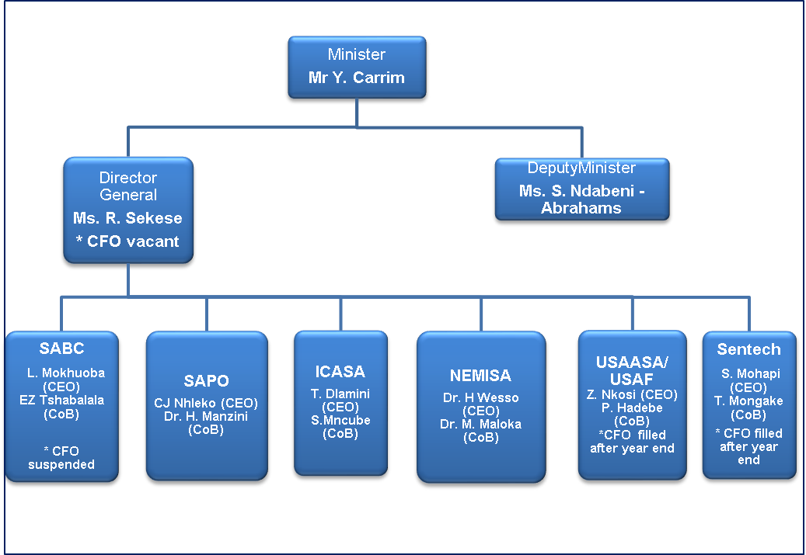

CEO – Chief Executive Officer
CoB – Chairperson of the Board

  - Funding
The department is primarily funded through funds appropriated in terms of the annual Appropriation Act (and the Adjustments Appropriation Act), the final appropriation for the 2012/13 amounted to R1 655 024 000 (2011/12: R2 002 865).

- Audit opinion history

CLEAN AUDIT OPINION: Financially unqualified with no findings on PDO and Compliance
FINANCIALLY UNQUALIFIED with findings on PDO and /or Compliance
QUALIFIED AUDIT OPINION (with/without findings)
DISCLAIMER/ADVERSE AUDIT OPINION

AUDIT OPINIONS | 08/09 | 09/10 |  | 10/11 |  | 11/12 | 12/13
Department of Communications
Independent Communications Authority of South Africa
Uniserval Service Access & Agency of South Africa
Universal Services & Access Fund
South African Broadcasting Corporation
South African Post Office | N/A
Sentech | N/A
Nemisa
Telkom
Government Communication and Information System
Brand SA
Media Development and Diversity Agency
QUALIFICATION ISSUES | 08/09 | 09/10 |  | 10/11 |  | 11/12 | 12/13
Department of Communications
- Irregular expenditure – SCM |  | 
Independent Communications Authority of South Africa
- NRF Receivables |  |  |  |  |  | 
- NRF Payables |  |  |  |  |  | 
- Accruals |  | 
- Commitments |  | 
- Property, plant& equipment |  |  |  | 
- Intangible assets |  |  |  | 
- Depreciation |  |  |  | 
QUALIFICATION ISSUES | 08/09 | 09/10 |  | 10/11 |  | 11/12 | 12/13
Universal Services & Access Fund
- Trade payables |  |  |  |  |  |  | 
- Project expenses |  |  |  |  |  |  | 
South African Broadcasting Corporation
- Property, plant& equipment |  |  |  |  |  |  | 
- Programme, Film and Sports Rights |  |  |  |  |  |  | 
- Irregular expenditure |  |  |  |  |  |  | 
- Intangible assets |  |  |  |  |  |  | 
- Trade and other receivables |  |  |  |  |  |  | 
- Licence fee revenue and related receivables |  |  |  |  |  |  | 
- Post retirement valuation |  |  |  |  |  |  | 
- Expenditure |  |  |  |  |  |  | 
- Taxation |  |  |  |  |  |  | 
Sentech
- Irregular, fruitless & wasteful expenditure |  | 
OTHER MATTERS | 08/09 | 09/10 |  | 10/11 |  | 11/12 | 12/13
Predetermined objectives
- Department of Communications |  |  |  |  |  |  | 
- Independent Communications Authority of South Africa |  |  |  |  |  | 
- Uniserval Service Access & Agency of South Africa |  |  |  |  |  |  | 
- Universal Services & Access Fund |  |  |  |  |  |  | 
- South African Broadcasting Corporation |  |  |  |  |  |  | 
- South African Post Office |  |  |  |  |  | 
- Sentech |  | 
- Nemisa |  |  |  |  |  |  | 
- Telkom
- Government Communication and Information System |  |  |  |  |  |  | 
- Brand SA |  | 
- Media Development and Diversity Agency |  | 
Compliance with laws and regulations
- Department of Communications |  |  |  |  |  |  | 
- Independent Communications Authority of South Africa |  |  |  |  |  |  | 
- Uniserval Service Access & Agency of South Africa |  |  |  |  |  |  | 
- Universal Services & Access Fund |  |  |  |  |  |  | 
- South African Broadcasting Corporation |  |  |  |  |  |  | 
- South African Post Office |  |  |  |  |  |  | 
- Sentech |  |  |  |  |  | 
- Nemisa |  |  |  |  |  |  | 
- Telkom
- Government Communication Information System |  |  |  |  |  |  | 
- Brand SA |  |  |  |  |  |  | 
- Media Development and Diversity Agency |  |  |  |  |  | 
  - Qualification paragraph
Only two entities in the portfolio had modified audit opinions for the financial year 2012/13; Universal Service and Access Fund (USAF) and South African Broadcasting Corporation (SABC).
The matters pertaining to the qualification paragraphs (refer to the detail in the audit report) are as included in the table:
Entity | Finding | Root cause | Recommendation
SABC | - Property, plant and equipment and Intangible assets  - Licence fee revenue and related receivables  - Programme, film and sports rights  - Trade and other receivables  - Irregular expenditure  - Taxation  - Expenditure  - Post retirement valuation | Governance:  - The Board of Directors was dysfunctional and was dissolved during the financial year. Serious governance deficiencies regarding the board were noted.  - Inadequate governance structures in place as the audit committee did not play an oversight roll throughout the financial year and was not effective.  - No compliance monitoring from the board and audit committee (no compliance assurance was provided to the audit committee or the board). A high number of non-compliance was noted in the audit report.  Leadership and accountability  - Key members of management, i.e. CFO are currently suspended and investigations are in progress.  - Unusual high number of vacancies in key management positions during the year.  - The executive leadership did not play an adequate oversight function in addressing previous audit report matters and did not ensure that the control environment is adequate and functional.  Previously reported qualification (two paragraphs i.e. irregular expenditure and programme and sports rights) matters were not resolved timeously and adequate action plans were not put in place to ensure that the same matters do not reoccur in the next audit. The performance management system and process in the SABC is very weak.  Skills and capacity:  - The SABC uses IFRS since 2008. The accounting framework – International Framework for Reporting Standards (IFRS) required a HIGH level of technical accounting skills. Five of the nine qualification paragraphs (Property, intangible assets, Revenue, Trade receivables and taxation) in the audit report is as a result of a lack of adequate technical accounting skills in the CFO’s office (the CFO that possesses the required qualification is still suspended)  - There are inadequate technical skills in the Supply Chain Management (SCM) unit with a lack of leadership to address shortcomings in the business unit  - There are inadequate skills to deal with compilation and monitoring of the corporate plan (meeting the requirements of National Treasury).  - There is a high vacancy rate throughout the organisation.  Structure and systems  - Decentralisation of business units without adequate monitoring by CFO  - Inadequate business processes and policies and monitoring thereof to ensure that the control environment is adequate and sound (no centralized policy register exist)  - No effective HR management is in place to ensure that sufficiently skilled resources are in place in the right structures  - The SABC implemented SAP a few years ago but the SAP knowledge is very low and a high reliance is place on excel documents throughout the organization.  Two paragraphs (Expenditure management and Post-retirement benefits) are as a result of inadequate business processes, systems and inadequate review by management. | Governance:  - Appoint a Board of Directors that has the appropriate skills and capacity to improve the governance structures and drive a culture of accountability and high performance.  - Skills and capacity required to ensure an effective audit committee.  - Effective monitoring tools through comprehensive action plans, reports and compliance checklists need to be in place to provide the audit committee and the board up to date management assurance on a regular basis (re-active and not wait for auditors).  Leadership and accountability  - Investigations into suspensions should be concluded in a reasonable timeframe to prevent significant losses for the SABC/Government. Clear timelines for charges and investigations need to be set to ensure the resolution thereof as soon as possible.  - A number of key management positions have been filled after year end. However, the general vacancy rate remains high and need to be reduced to ensure skills and capacity is available to deliver on the mandate and action plans in place.  - It is critical for the Board/Audit Committee and Executives to have one comprehensive action plant with clear interim and long term (where applicable) milestones. All staff need to buy into this action plan. Accountability needs to be clear and all staff need to be held accountable for non performance against the action plan.  Skills and capacity:  - The required technical skills and capacity need to be acquired in the finance unit to direct and monitor the application of IFRS.  - The required skills and capacity also need to be assessed in the various units within SABC to ensure the gap is addressed to support finance in complying with IFRS.  - The Head of SCM has been appointed after year end. However, the SCM unit need to be capacitated to ensure the required resources exist to comply with the comprehensive technical SCM requirements.  - The Strategic planning unit need to be capacitated to guide, implement and monitor the National Treasury requirements in relation to the corporate plan.  - Vacancy rate need to be decreased to an acceptable level. The right level of skills need to be appointed to fill these vacancies.  Structure and systems  - Clear business processes need to be designed to ensure that responsibilities are clearly defined and monitoring functions at a central point are put in place to ensure overall accountability.  - Centralised policy register need to be in place and reviewed on a regular basis. Specific focus need to be on any changes in the accounting environment and reporting framework to prioritise the review of policies and procedures dealing with these matters  - There need to be a comprehensive HR plan dealing with the skills gap, filling of vacancies, training of staff, temporary employees, acting periods, etc.  - The IT skills and capacity need to be reviewed to ensure this function is fully resourced and supports the business needs. There needs to be a close relationship with HR to identify training needs and recommend appropriate training.
USAF | Project expenses | Due to leadership instability there was a lack of proper controls and the monitoring thereof. | - The stability at the entity should be strengthened by filling vacant key positions.  - Roles and responsibilities should be clarified, performance management should be enhanced and employees should be hold accountable for responsibilities assigned to them
USAF | Trade and payables

- Key focus areas

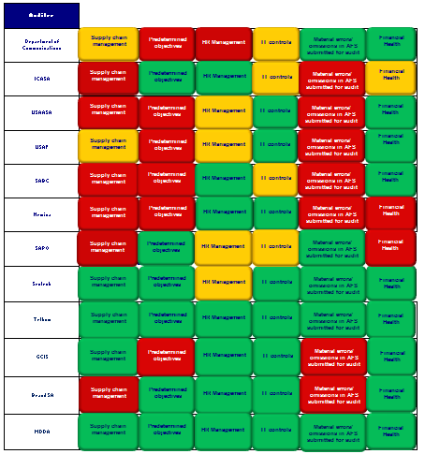

No finding
Reported in management report
Reported in audit report

  - Predetermined objectives

Entity | Finding | Root cause | Recommendation
Department of Communications | A total of 25% of the targets were not specific and were also not measurable. | - Leadership instability  - Inadequate skills | - The department should ensure that there is adequate training for all staff, proper performance management in place and should hold officials accountable where transgressions have occurred.
Department of Communications | Of the total number of 39 targets planned for the year, 18 (46%) of the targets were not achieved during the year under review. | - Leadership instability  - Inadequate skills
South African Broadcasting Corporation | - Of the 26 targets planned only 3 were achieved. This represents 88% of total planned targets not achieved.  - Achievements were not verifiable in assessing the reliability of the reporting. | - Leadership instability as the Head of Strategy position was vacant for a major part of the year  - Inadequate performance management (accountability for non performance). | - The roles and responsibilities of all parties required in achieving the targets are to be clearly defined with continuous monitoring and corrective action taken timeously during the year to ensure that what is set for achievement is achieved.  - Staff need to be hold accountable for none performance.
South African Broadcasting Corporation | Adequate and reliable corroborating evidence could not be provided for 53% of variances as disclosed in the annual performance report.
South African Broadcasting Corporation | A total of 21% of the indicators were not well defined and verifiable.
Independent Communications Authority of South Africa | 67% of total planned targets that were not achieved during the year under review. | - Ineffective leadership | - ICASA leadership should set attainable targets which is not dependent upon factors which ICASA has no control over.
Universal Services and Access Agency of South Africa | A total of 43% of the targets were not specific and measurable. | - Lack of skills and;  - leadership instability | - The newly appointed management should ensure that the entity has a technical indicator description in place to increase the consistent understanding of targets across the entity.  - The entity should also ensure that there skilled officials are involved with performance information and where necessary, training and updates take place.
Universal Services and Access Agency of South Africa | A total of 29% of the indicators were not well defined. | - Lack of skills and;  - leadership instability
Universal Services and Access Agency of South Africa | Material audit adjustments in the annual performance report were identified during the audit. | - Lack of skills and;  - leadership instability
Universal Services and Access Fund | A separate strategic plan was not prepared. | - Leadership instability | - The fund should prepare and submit a strategic plan with identifiable strategic objectives for the Fund.
National Electronic Media Institute of South Africa | A total of 71% of the targets selected for audit purposes were not specific in identifying the nature and the required level of performance | - Inadequate performance management. | - The entity needs to enhance their performance management system where all staff members are hold accountable for the roles and responsibilities assigned to them.
National Electronic Media Institute of South Africa | Of the total number of 38 targets, 20 (53%) of the targets were not achieved during the year under review. | - Inadequate performance management.
National Electronic Media Institute of South Africa | Material audit adjustments in the annual performance report were identified during the audit. | - Inadequate performance management.
Government Communication Information Systems | Significantly important targets with respect to programme 2 and 3 are materially misstated. | - Inadequate performance management systems. | - The department needs to draft standard operating procedures and implement a proper recording system to record and monitor the completeness of source documentation in support of actual achievements.

  - Supply chain management
Entity | Finding | Root cause | Recommendation
Department of Communication | Non-compliance with Treasury Regulations in the appointment of consultants by not assessing functionality as per the invitation sent out | - Lack of accountability and consequence management  - Inadequate performance management | - Management should enhance their performance management system to allow them to hold staff accountable for non compliance to laws and regulations.
Department of Communication | Insufficient information in the proposal of the winning bidder
National Electronic Media Institute of South Africa | Quotations were awarded to bidders who did not submit a declaration on whether they are employed by the state or connected to any person employed by the state. | - Inadequate performance management. | - Management should ensure that officials are kept up to date with changes or updates in all the relevant legislations.  - Roles and responsibilities should be clarified to enable management to hold staff accountable for non compliance.
National Electronic Media Institute of South Africa | Sufficient appropriate audit evidence could not be obtained that all extension or modification to contracts were approved. | - Inadequate performance management.
ICASA | The accounting officer did not take effective steps to prevent irregular and fruitless and wasteful expenditure. | - Inadequate performance management | - Management should enhance their performance management system to allow them to hold staff accountable for non compliance to laws and regulations.
South African Broadcasting Corporation | Declaration of interest were not completed by the bid evaluation team/ evaluators involved in the evaluation and recommendation process for bids. | - Leadership instability  - Inadequate skills | - The Head has been appointed, but the skills and capacity still needs to be enhanced.  - Staff need to be held accountable.
South African Broadcasting Corporation | The supplier database is not functioning. | - Leadership instability  - Inadequate skills
South African Broadcasting Corporation | Supporting documentation is not readily availble. | - Leadership instability  - Inadequate skills
SAPO | The entity did not have adequate procedures and processes in place to identify and detect irregular expenditure. | - Leadership instability  - Vacancies  - Lack of accountability and consequence management | - The entity should be strengthened by the filling of vacancies within management and therefore also strengthening the entity’s internal controls.  - Management should hold staff accountable for their actions
Universal Service and Access Agency of South Africa | Goods and services were procured without obtaining the required price quotations. | - Leadership instability  - Vacancies. | - The entity should be strengthened by the filling of vacancies within management and therefore also strengthening the entity’s internal controls.
Universal Service and Access Fund | Variation on the value of the awarded contract exceeded the determined threshold | - Leadership instability  - Vacancies. | - The entity should be strengthened by the filling of vacancies within management and therefore strengthening the internal controls.
Brand SA | - Bid adjudication was not in all instances done by committees which were composed in accordance with the policies of the Brand SA.  - Contracts were awarded to bidders based on preference points given for criteria that differed from those stipulated in the original invitation for bidding. | - Lack of oversight to ensure compliance with all SCM requirements. | - Management should also strengthen internal controls deficiencies within the entity, including regular reviews and monitoring.

  - Human resources
Entity | Finding | Root cause | Recommendation
Department of Communication | Appointments were made in posts which were not approved and funded.  Appointment processes were not followed  Overtime were paid in excess of 30% of monthly salaries  A written overtime policy did not always exist  Staff were acting for longer than 12 months and vacancies were not filled  Leave were not accurately recorded | - Slow response by Executive to act on commitments  - Leadership instability  - Inadequate performance management | - The leadership should take accountability to finalise the migration process.  - The department should enhance their performance management system and hold staff accountable for not adhering to laws and regulations.
Sentech  SAPO  USAASA  USAF | Long outstanding vacancies with no staff appointed t to fill the vacancies | - Slow response by Executive to act on commitments  - Leadership instability | - The leadership should take account ability to fill all the vacancies.

  - Information technology controls
Entity | Finding | Root cause | Recommendation
Department of Communications | The disaster recovery and business continuety plan stil needs to be developed and implemented. | - Leadership instability  - Vacancies in key positions within in the IT unit. | - Critical IT vacancies should be filled with skilled officials.
ICASA | Inadequate implementation of:  - Security management controls  - IT service continuity  - User access controls  - Change management controls  - Data centre controls | - Shortage of trained and skilled IT staff. | - Skills in IT unit need to be enhanced  - Management should engage specialists who can perform the matching of Spectrum and JDE records to ensure accurate update of the General Ledger.
South African Broadcasting Corporation | - The password complexity configurations are not in compliance with the approved SABC password policy  - The operating system and database logs for the servers as well as the network were not reviewed by an independent individual. | - Leadership instability  - The CTO position was vacant  - Other resource and skills constraints. | - The CTO position is now filled, however the resource and skills constraints need to be addressed enhance monitoring and control over the IT control environment.
- Twenty eight (28) of the Z* customised executable programs/reports had not been assigned to an authorisation group.

- A number of users had access to SA38, along with authorisation object S_PROGRAM, with value BTCSUBMIT or SUBMIT, which enable these users to execute programs.

SAPO | Mantas fraud detection system is ineffective due to the system outages and downtime | - Shortage of trained and skilled IT staff.  - Shortage of proper resources (i.e. fraud detection system) | - Management should consider the effectiveness of the system in producing valuable, timely alerts.  - They should review the configuration of the system, and allocate the necessary resources in making changes to the system to ensure that the alerts provide effective information that enables staff to identify and resolve issues speedily.
SAPO | No disaster recovery plans for both the branches visited and the FTI treasury system. | - Lack of accountability and consequences for relevant staff | - Disaster recovery policy and plan should be compiled by treasury management, approved by ALCO and implemented in accordance with the approved plan.  Management should ensure that continuity deficiencies should be addressed when performing quality and oversight visits at the branches.

  - Material amendments to the annual financial statements

Entity | Finding | Root cause | Recommendation
ICASA  NEMIA  SABC  USAASA  USAF  GCIS  Brand SA | The financial statements submitted did not comply with section 40(1)(a) and (b) of the Public Finance Management Act. | - Leadership instability and vacancies  - Skills shortage  - Inadequate performance management | - Critical vacancies should be filled.  - The financial statements should be reviewed against supporting documents for completeness and accuracy prior to submission for audit.  - Accurate monthly financial statements should be prepared.  - Staff should be hold accountable for the roles and responsibilities assigned to them.

  - Financial health status
Entity | Finding | Root cause | Recommendation
ICASA | Under-spending of the final approved capital budget. | - Ineffective leadership. | - Execution of capital projects as per the approved capital budget should be monitored regularly.
NEMISA | The entity does not collect its debts within a reasonable period  The entity also has a deficit for the year under review and; the current assets exceed current liabilities. | - Inadequate performance management | - Management of the entity should ensure that there are processes in place to continuously collect debt.  - Where the procedures are not performed, proper consequence management should be exercised on the relevant officials
SAPO | Due to the government subsidy being withdrawn and additional costs needed to fund the Postbank corporatization, there will be further pressure on the performance of South African Post Office SOC Limited. This may be indicative of a material uncertainty which may cast significant doubt on the entities ability to continue as a going concern in future. | - Leadership instability | - The entity should strengthen its operations to ensure that there are adequate funds to assist with the corporatisation of Postbank.

- Drivers of internal controls
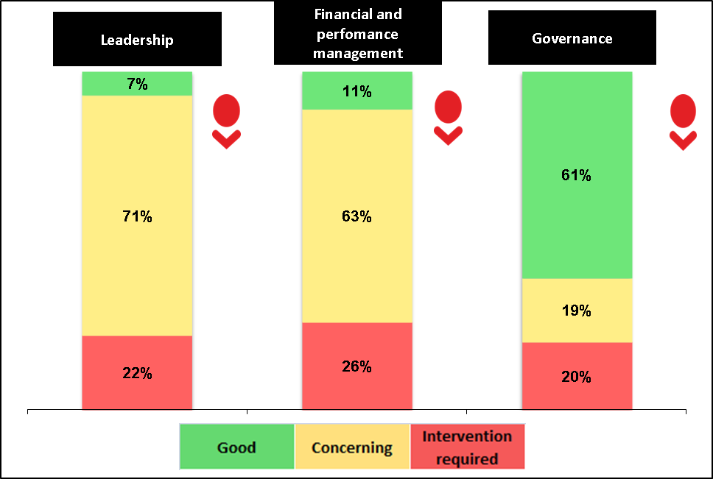
Overall, the key controls of the portfolio have been showing a slight regression rather than an improvement. This is largely due to instability in leadership that has been experienced by the portfolio in the current year. Most of the instability is due to the slow response by the previous executive authority who had committed to fill all critical positions. The following instability has been experienced by the portfolio:
Department of Communications – Critical positions vacant for a long period of time (e.g. CFO)
NEMISA – The CEO has been acting for a long period of time.
SABC – The board has been replaced and most executive board members are acting, i.e. CFO and COO. There were also a number of Group Executives in acting positions during the financial period ( a number of the key vacancies have been filled after year end).
SAPO - Critical positions vacant have also been vacant for a long period of time (e.g. Chief Information Officer)
USAASA/USAF – The entity did not have a board for the greater part of the year and also had vacant critical positions (e.g. CEO, CFO)
GCIS - The CEO has been acting for a long period of time.

 | Drivers of internal control
 | Leadership |  |  |  |  |  | Financial and performance management |  |  |  |  | Governance
Entity | Effective leadership culture | Oversight responsibility | HR management | Policies and procedures | Action plans | IT governance | Proper record keeping | Processing and reconciling controls | Reporting | Compliance | IT systems controls | Risk management | Internal audit | Audit committee
Department of Communications
Independent Communication Authority of South Africa
Universal Services Access & Agency of South Africa
Universal Services & Access Fund
South African Broadcasting Corporation
Telkom
SAPO
Sentech
Nemisa
Government Communication Information Systems
Brand SA
Media Development and Diversity Agency
- Other matters of interest

Unauthorised expenditure:
No unauthorised expenditure incurred by the departments

Fruitless and wasteful expenditure:
Auditee |  | Fruitless and Wasteful expenditure
 |  | Movement | Amount  R  2013 | Amount  R  2012 | Reasons
1 | Department of Communications |  | 1 075 000 | 764 000 | Interest and penalties
2 | Independent Communications Authority of South Africa |  | 3 671 279 | 189 292 | System related services procured but not utilized and VAT paid to supplier who was not registered for VAT
3 | Universal Service Access & Agency of South Africa |  | 933 000 | 1 032 000 | Interest and penalties
4 | Universal Services & Access Fund |  | 2 507 000 | 3 777 000 | Interest and penalties, payments for venues & offices not used
5 | South African Broadcasting Corporation |  | 22 116 000 | 104 615 000 | Payment for vehicles and services not provided as well as impairment of content
6 | South African Post Office |  | 794 000 | 233 000 | Penalties & interest, use of 3G cards & rent expense without occupation
7 | Sentech |  | 0 | 0 | -
8 | Nemisa |  | 172 260 | 0 | Penalties
9 | Brand Sa |  | 354 037 | 209 716 | Labour settlement which could have been avoided.

Irregular expenditure:
Auditee |  | Irregular expenditure
 |  | Movement |  | Amount  R  2013 | Amount  R  2012 | Reasons (also refer to compliance findings in section 3.2)
1 | Department of Communications |  | 5 210 000 |  | 20 054 000 | Procurement processes not followed
2 | Independent Communications Authority of South Africa |  | 4 153 874 |  | 538 433 | Procurement processes not followed
3 | Universal Service Access & Agency of South Africa |  | 469 000 |  | 42 161 000 | Procurement processes not followed
4 | Universal Services & Access Fund |  | 0 |  | 19 458 000 | Procurement processes not followed
5 | South African Broadcasting Corporation |  | 106 322 000 |  | 136 959 000 | Procurement processes not followed (not we qualified this note in the audit report)
6 | South African Post Office |  | 1 049 934 000 |  | 0 | Procurement processes & delegations of authority not followed
7 | Sentech |  | 5 807 000 |  | 5 871 000 | Procurement processes not followed
8 | Nemisa |  | 70 853 |  | 256 123 | Procurement processes not followed
9 | Government Communication Information System |  | 0 |  | 14 000 | N/A
10 | Brand SA |  | 160 887 |  | 12 316 480 | Procurement processes not followed
11 | Media Development and Diversity Agency |  |  | 0 | 152 000 | N/A

- Commitments
The following was committed by the Minister during the 2012/13 audit :
Commitment | Status
Facilitation of a clean audit initiative with all the entities | In progress  A breakfast was held with all the entities to drive this process and individual sessions were held with each entity.  The follow up session with the CEO’s and chairpersons of the boards did not took place.  Due to leadership instability and slow response by the executive, the impact of this intervention was minimal.
Filling of vacancies and the creation of a monitoring unit consisted out of a representative from each entity | Not implemented  The process is currently in progress.
Implementation of responses to assessed risks and ensuring that checks and balances are in place | In progress  The department has established a range of measures to ensure effective monitoring. These include:  - The submission of quarterly and financial reports by the entities to the department  - Annual meetings between the entities and the shareholder unit of the department

The following was committed by the newly appointed Minister after the financial year 2012/13:
- Ensure stability within DoC staff and communications public entities to ensure clean administration.
- To establish a joint task team for SABC comprising of SABC, National Treasury and DoC.
- Ensuring that performance contracts of senior management will be reviewed including their performance targets.
- Combined Assurance on Risk Management in the Public Sector
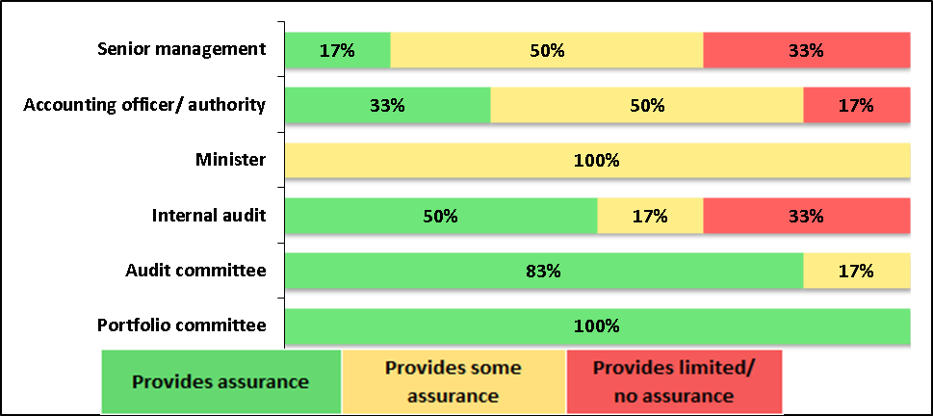

The assurance levels should be improved by ensuring stability at the level of accounting officer and senior management for both the department and the entities. Recommendations of internal audit should also be implemented timeously to ensure that issues are resolved in time.

- Other reports
Investigations
The following ingestions were conducted or are in progress:
ICASA
An investigation on the Compliance and Risk sub-programme which was initiated based on allegations of possible fraudulent activities by the supply chain manager. The Supply Chain Manager was suspended and subsequently charged for alleged misconduct and disciplinary proceedings were instituted. The employee tendered his resignation with immediate effect during the disciplinary hearing and the disciplinary process was therefore terminated. The Authority had an obligation, due to the seriousness of the charges and in terms of the Authority’s Fraud and Prevention Policy, to formally report the internal investigation to the Hawks in terms of Section 34(3) (a) of the Prevention and Combating of Corrupt Activities Act, 2004. The Hawks are currently investigating a number of cases within the Supply Chain Management unit.
USAASA
An investigation on one of the suppliers of the entity, the SCM processes and the leadership of the entity. This investigation was initiated after allegations made through an open letter to the President of the country. This investigations has been completed thus far, with the findings not yet disclosed to the auditors.
SABC
The chief financial officer was suspended during the year due to procurement irregularities and disciplinary action is still pending.
In addition, several investigations were being conducted by the forensic unit. Some of the investigations resulted in recommendations for disciplinary and/or criminal proceedings to be instituted against the guilty parties. In addition, some investigations are ongoing and may or may not result in disciplinary and/or criminal proceedings against the parties concerned
SAPO
A recent investigation was undertaken by the previous Minister on allegations of fraud and malpractice within the entity. To date a report has been issued out detailing all the findings. Furthermore, investigations have been undertaken in the past (e.g. investigation on the procurement of Eco Park building), reports issued with recommendations but the recommendations are not implemented.

