

EXECUTIVE SUMMARY OF PRELIMANARY REPORT: PERFORMANCE INFORMATION: 1st QUARTER 2013/14 FINANCIAL YEAR

INTRODUCTION

Government legislation requires that Cabinet members provide Parliament with full and regular reports concerning matters under their control and to also be transparent and accountable to the public in accordance with Section 195 of the Constitution of the Republic of South Africa, Act 108 of 1996. As a response to these requirements, the Department through the Directorate: Strategic Management, Monitoring and Evaluation, has compiled the organisational performance report for quarter 1 of the 2013/14 financial year.

The purpose of the summary is to give an overview of what transpired in the first quarter of the 2013/14 financial year. The summary reflects performance against key strategic objectives and annual performance indicators as reflected in the Department’s Annual Performance Plan for 2013/14. Full details are covered in the quarter 1 quarterly performance review report.

OVERALL ORGANISATIONAL PERFORMANCE

The graph below indicates the overall performance of SRSA.
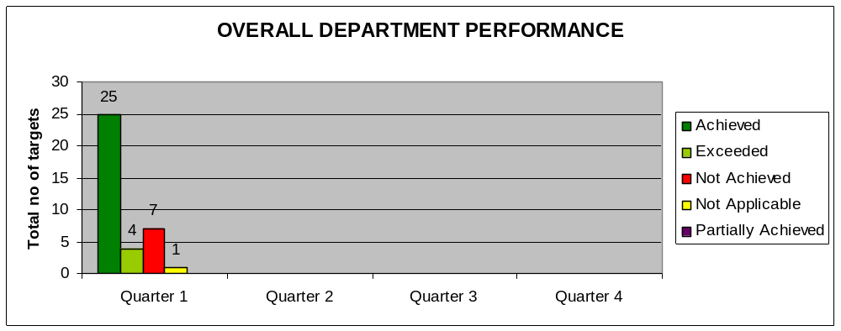

Overall, SRSA has registered a 77, 1% achievement in the quarter under review.
There were 35 targets to be achieved by the Department during the quarter under review.
      - 29 targets were achieved with 4 of them exceeded. Two of the achievements were not targeted for in this quarter.
      - 7 targets were not achieved.
      - 1 is reported as Not Applicable [dependent on grievances lodged].

PROGRAMME 1: ADMINISTRATION

The purpose of the programme is to provide management, strategic and administrative support services. It comprises of 7 sub-programmes namely Ministry; Management; Strategic & Executive Support; Corporate Services; Chief Financial Officer; Internal Audit; and Office Accommodation.

Performance Graph

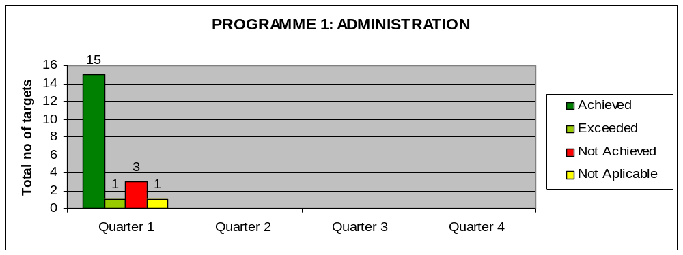

There were 19 targets to be achieved by the programme during the quarter under review.
Sixteen (16) achievements were reached with one (1) of them exceeded. One of the achievements made (in Marketing & Communication) was not targeted for in this quarter. Three (3) targets were not achieved; and one (1) is reported as ‘not applicable’ because it is dependent on lodging of grievances.

MAIN ACHIEVEMENTS

Sub-programme | Quarter 1
Ministry | - Undertook 3 outreach programmes in Mitchell’s Plain, Carolina and Mabopane
Management | - Published 2010 World Cup Report  - Managed and provided support to the Minister's budget vote programme  - Managed and provided support to the Minister's NCOP budget statement programme  - Provided assistance to sports entities to finalise Lottery Applications  - Consulted on and completed the Grant submission to National Treasury for MIG funding.  - Collaborative Agreements were signed by the DG with the provincial HoDs to assist integration of key elements of the sport and recreation service delivery plans of SRSA into those of provinces.
Strategic Executive Support | - A very comprehensive mapping exercise was undertaken to clarify what funds are available for project allocation in 2013/14.  - The National Development Plan was scrutinised for areas where sport and recreation can possibly be used as a vehicle to achieve some of the key objectives of the NDP. A concise document was compiled highlighting these areas and it was distributed to all staff to alert them to the priorities of Government.  - The budget programme structure for 2014/15 was aligned with the NSRP and approved by National Treasury for implementation in the MTEF.  - The fourth quarter Outcome 12 b progress report was submitted with SRSA achievements.  - Service Delivery Improvement Plan (SDIP) annual progress report for 2012/13 was compiled and submitted to the EA.  - The 4th quarter performance summary and consolidated performance report for the 4th quarter of 2012/13 were finalised, presented to QSRM, and submitted to the EA.  - The first draft of the 2012/13 Annual Performance Report was compiled and submitted to the Auditor-General and Treasury by end of May 2013 as required.
Corporate Services | Marketing & Communication  The unit launched the Sport in Struggle Exhibition and supported the:  - Seminar on the World Cup Close-Up Report and the related TNA Breakfast  - Budget Vote (National Assembly & NCOP) activities in the Western Cape (school visits, the Gym handover at Mitchell’s Plain, Budget Vote Lunch Cocktail and the Gala Dinner)  - Soweto Open.
Chief Financial Officer | Met all the set targets for quarter 1:  - Six service provider databases operational;  - 1 asset reconciliation report signed off; and  - 3 financial reports submitted in line with prescripts.
Internal Audit | Targets achieved
Office Accommodation | Targets achieved

Performance status for Corporate Services:

Not Achieved | - Number of employees trained  - Number of Health & Wellness programmes conducted with SRSA staff.
 | - Number of status reports on the upgrading of the ICT system signed off.

PROGRAMME 2: SPORT SUPPORT SERVICES

The programme comprises of four sub-programmes which are Sport and Recreation Service Providers, Club Development, Education & Training and Scientific Support. The purpose of the programme is to support recognized sport and recreation bodies and public entities, and monitor and report on their performance.

Performance Graph

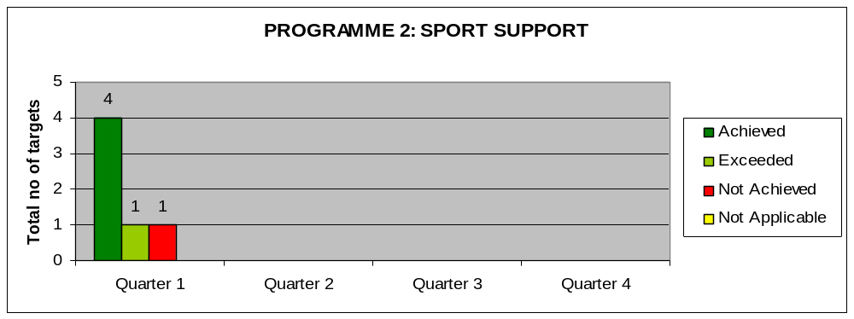

There were six (6) targets to be achieved by the programme during the quarter under review. Four (4) of the targets were achieved and 1 target exceeded. One (1) target was not achieved.

Major Achievements: None

Performance status:

Achieved | Exceeded | Not achieved
Number of talent identification and development strategies developed and implemented. | Number of sport and recreation bodies receiving financial support per year. | Number of knowledge management systems implemented and maintained.
Number of programme performance reports signed off.

Number of athletes & coaches assisted by means of scientific support programmes

% Compliance with international anti-doping regulations.

PROGRAMME 3: MASS PARTICIPATION

The programme comprises of two sub-programmes which are Community Sport and School Sport. The purpose of the programme is to create an enabling environment and provide support to increase the number of participants in sport and recreation in South Africa.

Performance Graph

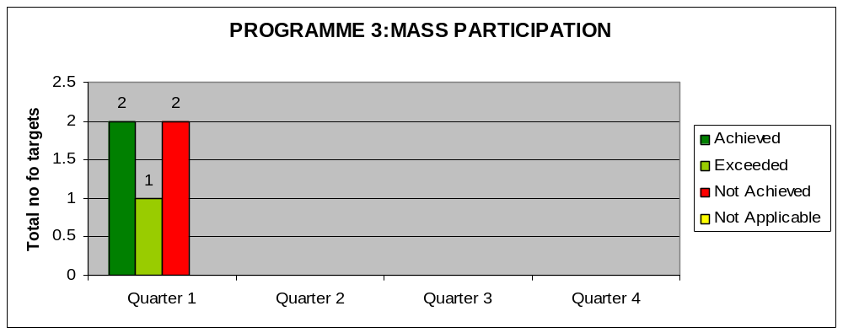

There were five (5) targets to be achieved by the programme during the quarter under review. Three (3) targets were achieved, with 1 of them exceeded. Two (2) targets were not achieved.

Main achievements for Community Sport and School Sport:

Sub-programme | Quarter 1
Community Mass Participation | Grant Framework :  - All the Grant Agreements have been received from the Provinces.  - Annual Evaluation Reports have been received from 7 provinces and two reports are outstanding.  - 8 Provinces have submitted their Annual Evaluation Plan which will be consolidated and sent to National Treasury.
School Sport | Community Mass Participation:  Capacity Building of Teachers has been hindered by NFs Accreditation Status with the SETA. We have since agreed that all International Federation-Accredited Programmes will be conducted.

Performance status:

Achieved | Not achieved | Exceeded
Community Sport
Number of focus group status reports signed off. | Number of participants in sport promotion projects managed by Sport and Recreation South Africa per year. | Number of volunteers registered in the National Sport Volunteer Corps Programme.
Number of Mass Participation and Sport Development Grant performance reports submitted.
School Sport | Number of schools supported to participate in school sport leagues.

PROGRAMME 4: INTERNATIONAL LIASON AND EVENTS

Performance Graph

The programme comprises of two sub-programmes which are International Liaison and Major Events. The purpose of the programme is to coordinate an intra-government sport and recreation relations and support the hosting of identified major events.

Performance Graph

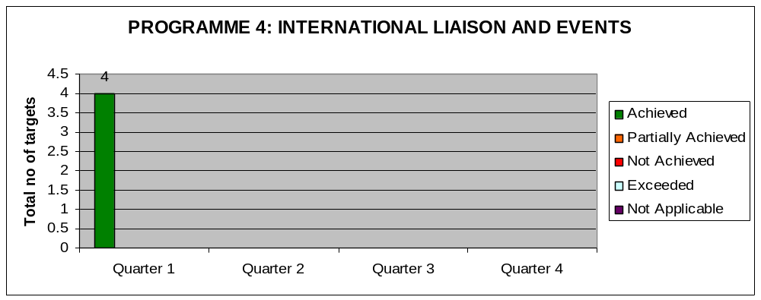

There were three (3) targets to be achieved by the programme during the quarter under review. Three (3) targets were achieved in addition to one (1) achievement that was not targeted for in this quarter.

Main achievements

  - Successful hosting and support of the 2013 Soweto Open.
  - Active participation in multilateral engagements.
  - Bilateral consultations conducted with Lesotho; New Zealand; Burundi and Australia.
  - Financial support to SA students in Cuba.

Achieved | Not achieved
Number of multilateral engagements supported.
Number of major international events receiving intra-governmental support per year. | .
Percentage of requests met for facilitating the provision of visas.
Number of bilateral relations exchanges implemented.

PROGRAMME 5: FACILITIES COORDINATION

The programme comprises of two sub-programmes which are Planning and Advocacy and Technical Support. The purpose of the programme is to facilitate the provision and management of sustainable sport and recreation facilities.

PERFORMANCE GRAPH

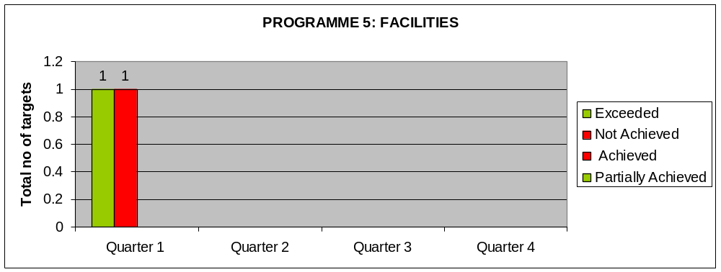

There were 2 targets to be achieved by the programme during the quarter under review. One (1) target was achieved (exceeded). One (1) target was not achieved.

PLANNING AND ADVOCACY

Main achievements:
- Completed 5 projects (sites) in George
- Installed an outdoor gym in Mitchell's plain and received positive feedback regarding the usage of the gym by the community
- Sports Trust erected a multi purpose facility in Carolina
- The agreement between SRSA, Wide Open Space and the City of Gauteng completed and ready for signature.

Achieved [Exceeded] | Not achieved
Number of sport for social change projects assisted with facilities technical support | Number of national facilities database reports generated.

PROBLEM AREAS

Finding | Action steps
- Late submission of performance information reports remains a challenge. Most programmes do not adhere to the deadlines. | Late reports will be mentioned in the consolidated report to the EA and relevant managers will be reported to the DG. Negative impact on performance assessment of manager.
- Unit reports not consolidated and signed-off by the Chief Directors despite the request | Raise the matter at QSRM and Chief Directors’ meetings.
- Most programmes submitted reports with gaps, i.e. no reasons for deviation where there is no achievement, no corrective actions or corrective actions with implementation dates, etc. | Reports will be sent back and if not corrected within the specified time it will be mentioned in the executive summary. Negative impact on performance assessment of manager.
- Failure to submit source of evidence when targets are achieved. This is also prevalent on supplementary projects. | If evidence is not provided for both APP indicators and supplementary projects and claimed achievements, the report of the programme will be regarded as incomplete. Managers need to get into the culture of preparing evidence each month. Negative impact on performance assessment of manager.
- None or very sketchy reporting on service delivery achievements. | The QSRM report must be a consolidated quarterly report of the DG monthly reports. Four quarterly reports must be consolidated as input to the Annual report.
- Supplementary projects are named but in most cases, it is not clear what they are about. | Managers need to provide a short description of what the supplementary project entails.
- Reasons for not capturing a supplementary project in the APP are not provided. | Managers must ensure that they provide this information.
- Impact of incomplete reporting on Department. | Management to take responsibility as a whole for performance information.
- It is a struggle to get quarterly performance reports from Ministry. | Relevant sections need to assist in providing information.

CONCLUSION

The performance of the Department during the quarter under review indicates that line functions have to improve on implementing their core indicators, more especially, those that have direct impact to the Department’s beneficiaries.

The majority of the 27 achieved targets can be attributed to the achievement of the support function units (16, which amounts to 84.2%) and not the line function (11 which amounts to 68.8%).

All units still have to improve on their submission deadlines and on submission of relevant performance evidence. The overarching principle remains: if it is reported as achieved, it must be proven.

