FOR WRITTEN REPLY QUESTION 816

NATIONAL ASSEMBLY

36/1/4/1(201900205)

DATE OF PUBLICATION IN INTERNAL QUESTION PAPER: 6 SEPTEMBER 2019 (INTERNAL QUESTION PAPER NO 14-2019)

816. Mr G G Hill-Lewis (DA) to asH the Minister of Police:

What are the details of the George Police Station's current Public Order Policing capability in terms of (a) manpower, (b) equipment, (c) armoured vehicles and (d) water cannons?
NW1932E
REPLY:

The details of the George Police Station's current Public Order Policing (POP) capability, in terms of (a) manpower, (b) equipment, (c) armoured vehicles and (d) water cannons, are as follows:

- 1 t2

- Every operational member is issued with crowb management equipment, which includes a bulletproof vest, riot helmet, armadlllo suit, shield, tonfa, pepper spray and handcuffs. There are four barbed wire trailers for crowd management.

- Eight

- None

Reply to question 816 recommended/

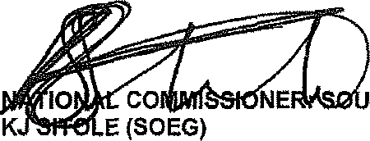
GENERAL TH AFRICAN POLICE SERVICE

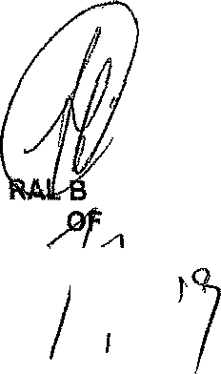Reply to question 816 approved/

GENE H CELE (MP)
MINISTER POLICE

Date: '

