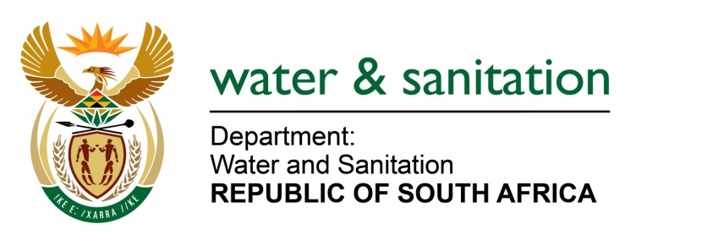

NATIONAL ASSEMBLY

FOR WRITTEN REPLY

QUESTION NO 1204

DATE OF PUBLICATION IN INTERNAL QUESTION PAPER: 27 MARCH 2015
(INTERNAL QUESTION PAPER NO. 9)
1204. Mr L J Basson (DA) to ask the Minister of Water and Sanitation:
(1) In which municipalities are the estimated 127 000 bucket toilets in informal settlements;
(2) how many bucket toilets are there in respect of each municipality;
(3) what is the (a) timeframe and (b) cost of replacing these bucket toilets? NW1409E
---00O00---
REPLY
- The buckets in informal settlements are located in the provinces appearing in the table below. The Department is in a process to verifying and assessing all buckets in informal settlements by province and municipality. However it should be noted that with the proliferation of informal settlements, households utilizing the bucket toilets as a form of sanitation is a moving target hence backlog is not constant.

PROVINCE | NO OF SETTLEMENTS | NO OF HOUSEHOLDS
Eastern Cape | 50 | 23 958
Western Cape | 62 | 59 932
Gauteng | 0 | 0
KwaZulu-Natal | 0 | 0
Limpopo | 0 | 0
Northern Cape | 6 | 5 350
North West | 21 | 4 150
Free State | 75 | 46 758
Mpumalanga | 3 | 600
TOTAL | 217 | 140 748
(2) A preliminary figure is provided in the table above.
(3) The Department anticipates, subject to additional funding being made available that a further R4,3bn over the next 4 years will be required to address informal settlements.
---00O00---

