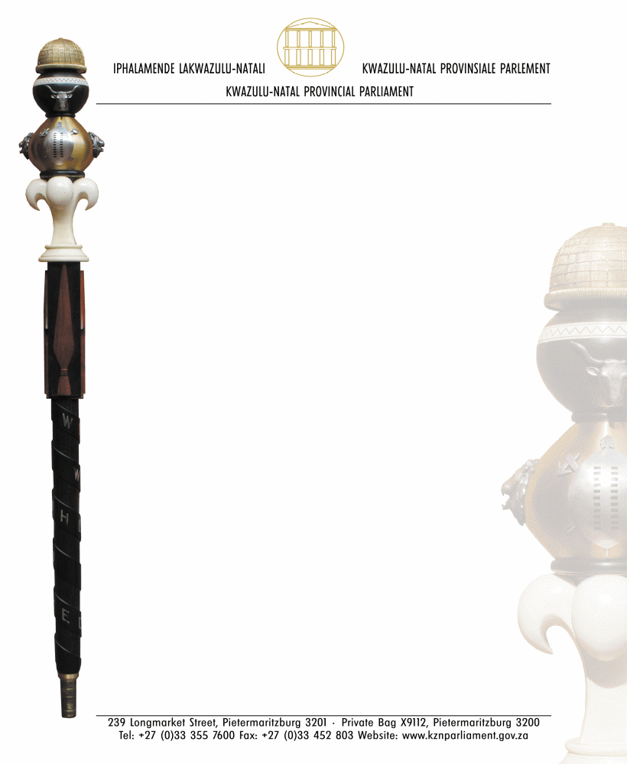

NEGOTIATING MANDATE

TO: HON TSC DODOVU, MP
CHAIRPERSON OF SELECT COMMITTEE ON COOPERATIVE GOVERNANCE AND TRADITIONAL AFFAIRS

NAME OF BILL: INDEPENDENT MUNICIPAL DEMARCATION AUTHORITY BILL

NUMBER OF BILL: B14B – 2022

DATE OF DELIBERATION: 7 MARCH 2024

VOTE OF THE LEGISLATURE:
The Portfolio Committee on Cooperative Governance and Traditional Affairs met today, Thursday, the 7th of March 2024, and agreed to mandate the KwaZulu-Natal delegation to support the Independent Municipal Demarcation Authority Bill [B14B-2022] with the following amendments:

- The publication of the names of the Board members as well as committee members as required in clauses 10(7) and 16(5)(d) respectively must also include their qualifications for greater transparency.

- The manner of filling of vacancies on the Board in Clause 10(8) must be reviewed. Rather than the Minister simply making a recommendation to the President from the existing list of additional names, we propose that this should be subject to a timeframe as it is very open ended and may exclude any other person who may be eligible. This is in view of the fact that the term of Board members is 5 years with an option to renew for a further term (10 years in total) which may result in the list becoming outdated and excluding other eligible persons. We propose the following insertions:

“10 (8) When there is a vacancy on the Board, the Minister must within 30 days of
receiving the Board’s written notification of the vacancy—
(a) If the vacancy arises within 12 months of the appointment of the Board, recommend to the President to fill the vacancy from the additional names that were submitted to the President in terms of subsection (5); or
(b) initiate the process outlined in this section if the 12 month period has expired or none of the additional names referred to in subsection (5) is available to fill the vacancy.”

- A more comprehensive process in clause 38 for the appointment of the Demarcation Appeals Authority similar to the process in clause 10 (relating to the appointment of Board members) is required, considering that appeals from the decisions of the Demarcation Board will lie to this higher juristic body.

 07/03/2024
…………………………………….. ……………………….
HON ZLI CELE, MPL DATE
CHAIRPERSON: PORTFOLIO COMMITTEE
ON COOPERATIVE GOVERNANCE AND
TRADITIONAL AFFAIRS

