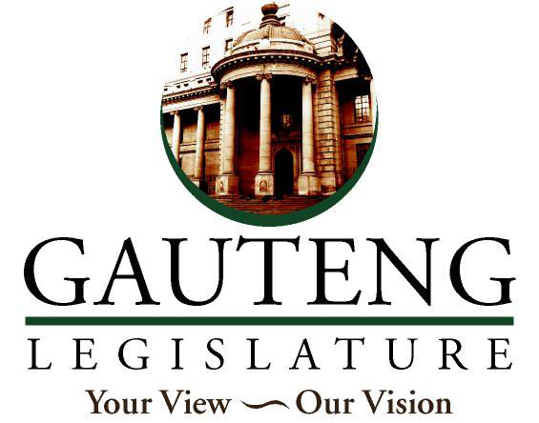

NEGOTIATING MANDATE

TO: The Chairperson of the Select Committee on Appropriations
Hon. D.G. Mahlangu
NAME OF BILL: Division of Revenue Amendment Bill
NUMBER OF BILL: [B19-2021]
DATE OF DELIBERATION: 02 December 2021
VOTE OF THE LEGISLATURE:
The Gauteng Provincial Legislature supports the principle and the detail of the bill and therefore votes in favour of-
- Division of Revenue Amendment Bill

___________________
HON. W. Matsheke
(consider it signed if submitted electronically)
Acting Chairperson of Finance Portfolio Committee
GAUTENG PROVINCIAL LEGISLATURE
Date: __02 December 2021___________

