Social Development
October 2015

PC

PFMA audit outcomes of the 2014-15 financial year

CONTENTS
1. Introduction 1
2. Audit opinion history 3
3. Key focus areas 4
4. Other matters of interest 10
5. Drivers of internal control 11
6. Other reports 11
7. Combined assurance on risk management in the public sector 12
8. Minister commitments and progress on these commitments 13

9. Commitments by the portfolio committee 14

- Introduction
1.1 Reputation promise of the Auditor-General of South Africa
The Auditor-General of South Africa (AGSA) has a constitutional mandate and, as the Supreme Audit Institution (SAI) of South Africa, exists to strengthen our country’s democracy by enabling oversight, accountability and governance in the public sector through auditing, thereby building public confidence.
1.2 Purpose of document
The purpose of this briefing document is for the AGSA to provide an overview of the audit outcomes and other findings in respect of the Department of Social Development and its entities for the 2014-15 financial year.
1.3 Overview
Vision of the vote: A caring and self-reliant society.
Mission of the vote: To transform our society by building conscious and capable citizens through the provision of integrated social development services.
Aim of the vote: To ensure protection against vulnerability by creating an enabling environment for the provision of a comprehensive, integrated and sustainable social development service.

The portfolio consists of the following:
- Department of Social Development (the department)

- Two schedule 3A public entities:
  - National Development Agency (NDA)
  - South African Social Security Agency (SASSA)

- Four funds under the department:
  - Disaster Relief Fund (DRF)
  - Social Relief Fund (SRF)
  - Refugee Relief Fund (RRF)
  - State President Fund (SPF)

1.4 Organisational structure

- Audit opinion history
Audit opinions |  |  | 2014-15 | 2013-14 | 2012-13 |  | 2011-12 | 2010-11
- The department
- SASSA
- NDA
- DRF
- SRF
- RRF
- SPF
Qualification areas |  |  | 2014-15 | 2013-14 | 2012-13 |  | 2011-12 | 2010-11
- Transfer and subsidies (Households: Social assistance grants)
Predetermined objectives |  |  | 2014-15 | 2013-14 | 2012-13 |  | 2011-12 | 2010-11
- SASSA
- NDA
Compliance with legislation |  |  | 2014-15 | 2013-14 | 2012-13 |  | 2011-12 | 2010-11
- The department
- SASSA
- NDA
- Disaster Relief Fund
- Social Relief Fund
- Refugee Relief Fund
- State President Fund
 | Audit opinion legend
 |  | Clean audit opinion: No findings on predetermined objectives and compliance
 |  | Unqualified with findings on predetermined objectives and compliance
 |  | Qualified audit opinion (with/without findings)
 |  | Disclaimer/adverse audit opinion
 |  | Entity not yet established
 |  | Department/entity had findings (in the related matter)

2.1 Significant emphasis of matters
Department/entity | Emphasis of matter raised
The department | None
SASSA | None
NDA | None
Funds | The audit reports of all four of the funds contained emphasis of matters paragraphs, highlighting the going concern issues disclosed in the notes to the financial statements. The going concern issue related to the uncertain future of the funds due to the planned closure of the funds being in process.

- Key focus areas
3.1 Material errors or omissions in submitted annual financial statements
SASSA submitted annual financial statements that were materially adjusted through the auditing process. The adjustments resulted in SASSA obtaining an unqualified audit opinion. The following table shows the areas to which the corrected misstatements related:
Department/entity | Finding | Root cause | Recommendation
Department | None
SASSA | Operating leases | Lack of review and monitoring of compliance with applicable legislation, Generally Recognised Accounting Practice (GRAP) 13 and the Public Finance Management Act (PFMA) in the preparation of financial records | SASSA must ensure that it fully complies with GRAP 13 in relation to operating leases regarding the accounting and disclosure thereof.
NDA | None
Funds | None

  - Predetermined objectives
SASSA and the NDA submitted annual performance reports that were materially adjusted through the auditing process. The adjustments resulted in SASSA and the NDA obtaining an unqualified audit conclusion on the reported performance information. The following table shows the areas to which the corrected misstatements related:
Department/entity | Finding | Root cause | Recommendation
Department | None
SASSA | Material misstatements in the annual performance report submitted for auditing on the reported performance information for programme 1 – administration. | Management did not put controls in place over reviewing of quarterly reports to ensure that the reports are complete and accurate and are supported by complete and reliable supporting evidence. | Management must review reports compiled on a quarterly basis against sufficient and appropriate supporting evidence to ensure that compiled quarterly reports are valid, accurate and complete.
NDA | Material misstatements in the annual performance report submitted for auditing on the reported performance information for programme 1 – capacity building. | Management did not set an indicator that was well defined and that was in line with the guidance provided in the National Treasury Framework for managing programme performance information. | Indicators set should be set with reference to the guidance provided in the Framework for managing programme performance information issued by the National Treasury, that is the indicator should be reliable, well defined, verifiable, cost-effective, appropriate and relevant.
The funds are not subject to the PFMA, with the result that the reporting on predetermined objectives is not a requirement.
  - Compliance with legislation
Department/entity | Finding | Root cause | Recommendation
Department | None
SASSA | Annual financial statements  The financial statements submitted for auditing were not supported by full and proper records, as required by section 55(1)(a) and (b) of the PFMA for operating leases. Material misstatement of operating leases identified by the auditors in the submitted financial statements was subsequently corrected, resulting in the financial statements receiving an unqualified audit opinion.  Irregular and fruitless and wasteful expenditure  The accounting authority did not take effective steps to prevent irregular expenditure, as required by section 51(1)(b)(ii) of the PFMA.  The accounting authority did not take effective and appropriate disciplinary steps against officials who incurred and/or permitted irregular expenditure and fruitless and wasteful expenditure, as required by section 51(1)(e)(iii) of the PFMA.  Expenditure management  The controls to ensure proper management of expenditure to a service provider for additional work performed for re-registration of additional beneficiaries was not implemented, as required by section 51(1)(c) of the PFMA.  Internal audit unit  The internal audit unit did not evaluate the reliability and integrity of financial and operational information, as required by treasury regulation 27.2.10(b). | Insufficient review process implemented to ensure compliance with applicable legislation.  Control systems implemented were ineffective in preventing the ocurrence of irregular expenditure, and the consequence management process was insufficient in addressing the transgressions identified.  There were vacancies in critical positions at the internal audit division that is supposed to provide appropriate leadership and guidance. | Management should adequately review the annual financial and performance reporting to ensure that the submitted information is accurate and reliable, and supported by sufficient and appropriate evidence.  Contol processes should be implemented to ensure that the documentation, as required by legislation, is complied with.  Review or monitoring process should be implemented to ensure compliance with applicable legislation, especially on the procurement process and expenditure management (including supply chain) to prevent and address findings on irregular and fruitless and wasteful expenditure.  The internal audit unit should review the financial, operational and performance information to evaluate the reliabilty and integrity therteof.  Vacancies at the internal audit division should be filled to ensure that there is sufficient capacity to perform all its functions.
NDA | Procurement and contract management  Sufficient appropriate audit evidence could not be obtained that a contract was awarded to bidders based on points given for criteria that were stipulated in the original invitation for bidding, as required by SCM regulation, treasury regulation 16A6.3(a) and Preferential procurement regulations.  The preference point system was not applied in all procurement of goods and services above R30 000, as required by section 2(a) of the Preferential Procurement Policy Framework Act and treasury regulation 16A6.3(b). | The NDA did not regularly monitor compliance with the Preferential Procurement Policy Framework Act and its regulations and treasury regulation 16A6.3(a) and (b), and non-compliance was not timeously addressed. | Management of the NDA should ensure compliance with all related legislation and ensure that the preference point system is applied to all procurement transactions in excess of R500 000. Proper consequence management must be performed for transgressions identified.
Funds | None

  - Comments on additional AGSA interactions to help improve financial and predetermined objective outcomes
Department/entity | Additional interaction/add service (eg. workshops etc) | Impact/outcome
Department | An interim audit was performed to highlight to management significant findings that may have an impact on the audit outcome. Furthermore, on a quarterly basis, the key controls were assessed on the dashboard reporting tool to highlight key control deficiencies to be addressed by management. | Significant issues were addressed on social assistance grant debtors and predetermined objectives before the financial statements were submitted for auditing.
SASSA
NDA | On a quarterly basis, the key controls were assessed on the dashboard reporting tool to highlight key control deficiencies to be addressed by management. | Management and those charged with governance were enabled to sufficiently address key control deficiencies previously reported.
Funds | Regular interactions were held with the minister in which the environment of the funds and the progress on the closure thereof were discussed. | Closure of the funds has been prioritised by the Minister and plans are in progress to amend the Fund Raising Act 107 of 1978.

  - Financial health
Department/entity | Finding | Root cause | Recommendation
Department | None
SASSA | None
NDA | None
Funds | Going concern | The going concern emphasis of matter paragraph in the audit report of the funds did not relate to financial health but instead management’s decision to close the funds due to their state of dormancy. | None
  - Human resource management and consequence management
Department/entity | Finding | Root cause | Recommendation
Department | None
SASSA | Consequence management | Management failed to implement consequence management against staff for transgressions from the previous year, which were either not investigated or disciplinary steps were not taken after investigation. | Management should ensure that complete and accurate registers for irregular expenditure are kept and updated throughout the year. Management should also ensure that actions taken by management and progress on investigations are documented and monitored effectively. This includes cross reference to supporting evidence where management has concluded.  Management should ensure that proper actions are taken against staff that allow irregular expenditure.
NDA | None
Funds | None
  - Information technology (control environment)
Department/entity | Finding
Department | None
SASSA | The agency could not address all the findings identified previously.  Certain security management controls had not been implemented.
NDA | None
Funds | None

- Other matters of interest
- Unauthorised expenditure: Expenditure not in accordance with the budget vote
No unauthorsied expenditure was incurred in the current financial year

- Irregular expenditure: Expenditure incurred in contravention of key legislation
Department/entity |  | Irregular expenditure
 |  | Movement | Amount  R  2014-15 | Amount  R  2013-14 | Root cause | Recommendation
1 | Department |  | 17 873 000 | 21 031 000 | Staff did not always comply with the Treasury regulations and the PFMA in the procurement management process.  Review and monitoring processes implemented were not sufficient to identify the instances of non-compliance. | Management should ensure that that all applicable legislation is complied with by ensuring that staff are adequately trained, appropriate systems of internal controls are implemented, sufficient reviews are performed and proper consequent management takes place for all transgressions.
2 | SASSA |  | 40 787 746 | 70 116 768
3 | NDA |  | 1 698 964 | 4 558 454
4 | Funds |  | 0 | 0

- Fruitless and wasteful expenditure: Expenditure that should not have been incurred (incurred in vain that could have been avoided and no value for money received)
Department/entity |  | Fruitless and wasteful expenditure
 |  | Movement | Amount  R  2014-15 | Amount  R  2013-14 | Root cause | Recommendation
1 | Department |  | 152 000 | 278 000 | Staff incurred penalties, fines and costs for late or non-cancellation that could have been avoided for which the entity did not receive any benefit. | Management should ensure that all applicable legislation is complied with by ensuring that staff are adequately trained, appropriate systems of internal controls are implemented and proper consequent management takes place for all transgressions.
2 | SASSA |  | 5 302 223 | 3 152 767
3 | NDA |  | 22 395 | 46 249
4 | Funds |  | 0 | 0

- Drivers of internal controls
Drivers of internal control
Department & entities | Leadership |  |  |  |  |  | Financial & performance management |  |  |  |  | Governance
 | Effective leadership culture | Oversight responsibility | HR management | Policies and procedures | Action plans | IT governance | Proper record keeping | Processing and reconciling controls | Reporting | Compliance | IT system controls | Risk management | Internal audit unit | Audit committee
Department
SASSA
NDA
Funds

- Other reports
6.1 Investigations
SASSA
- Investigations were conducted by the fraud management and compliance unit of SASSA and the special investigation unit on request of the agency. The investigations were initiated based on non-compliance with the supply chain management (SCM) policy and procedures resulting in possible fraudulent actions and possible irregular and fruitless expenditure.
- The National Treasury investigated two cases relating to the awarding of two bids. For one investigation the report has been submitted to the minister for further action and the other one is still under investigation. The impact on the financial disclosures is still unknown.
- A civil society organisation initiated legal proceedings against SASSA for a payment made by SASSA to a service provider amounting to R317 million to be set aside.The payments was for additional services that needed to be performed during the re-registration of social assistance beneficiaries. The matter is still in court.

6.2 Performance audits
No performance audits were conducted for the year ended 31 March 2015 on any of the entities in the portfolio.

- Combined assurance on risk management in the public sector

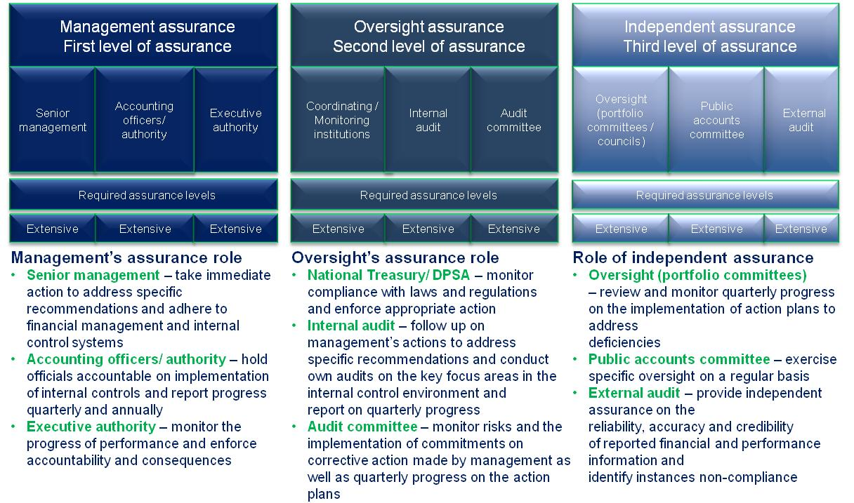
- Minister commitments and progress on these commitments

The following include previous year commitments and new commitments:
Focus area | Commitment | Due date | Status
Action plan to address internal and external audit findings | To add to the existing action plan for the Department of Social Development to specifically address proper record keeping and review processes as well as compliance with applicable legislation. | July 2016 | The minister is monitoring the implementation of the audit action plans at the department, on an ongoing basis.
Action plan to address internal and external audit findings | Evaluate the environment of the relief funds for closure or amalgamation with either the NDA or SASSA.  Monitoring and implementing action plans to ensure the movement to clean administration for SASSA and NDA. | July 2016 | The minister has initiated the process of amending the Fund Raising Act, 1978 (Act No. 107 of 1978) in terms of which the relief funds are established.  The minister is monitoring the implementation of the audit action plans at SASSA and the NDA, on an ongoing basis.
Human resources | Filling of vacancies in critical positions at SASSA and the NDA. | July 2016 | Some critical posts have been advertised and processes have been initiated to address the concern.
Status legend
Commitment has been implemented
Commitment in progress
Commitment has not been implemented
New commitment made

- Commitments by the portfolio committee or SCOPA
We suggest that the committee adopt the following commitments:
- Monitoring the implementing of action plans to ensure the movement to clean administration for SASSA and NDA and to sustain the audit outcome of the department.
- Obtain feedback on the filling of vacancies in critical positions in the portfolio.

