

PFMA audit outcomes of the 2014-15 financial year
Portfolio: Economic Development
October 2015

PC

CONTENTS
1. Introduction 1
2. Audit opinion history 4
3. Key focus areas 5
4. Other matters of interest 7
5. Drivers of internal control 9
6. Other AGSA reports 9
7. Combined Assurance on Risk Management in the Public Sector 10
8. Minister commitments and progress on these commitments 11
9. Commitments from the Portfolio Committee 13
10. Entities included in the portfolio not audited by the Auditor-General of South Africa (section 4(3) audit entities) 13

- Introduction
1.1 Reputation promise of the Auditor-General of South Africa
The Auditor-General has a constitutional mandate and, as the Supreme Audit Institution (SAI) of South Africa, it exists to strengthen our country’s democracy by enabling oversight, accountability and governance in the public sector through auditing, thereby building public confidence.
1.2 Purpose of document
The purpose of this briefing document is for the Auditor-General of South Africa (AGSA) to provide an overview of the audit outcomes and other findings in respect of Economic Development Department (EDD) and its entities for the 2014/15 financial year.
1.3 Overview
The Economic Development Department was established in 2009 and has assumed responsibilities relating to the creation of decent work through inclusive economic growth (outcome 4), including the implementation of the new growth path, which provides a policy package to facilitate the creation of employment.
The department is also responsible for five public entities, comprising three regulatory bodies and two development finance institutions. These are: the Competition Commission, the Competition Tribunal, the International Trade Administration Commission of South Africa, the Industrial Development Corporation of South Africa and the Small Enterprise Finance Agency.
In line with these responsibilities, the department administers the following legislation:
- the Industrial Development Act (1940)
- the Competition Act (1998)
- the International Trade Administration Act (2002).
Vision
The vision of the EDD is to creating decent work for all through meaningful economic transformation and inclusive growth.
Mission and objectives
The EDD aim to:
- Coordinate the contributions of government departments, State entities and civil society to effect economic development;
- Improve alignment between economic policies, plans of the State, its agencies, government’s political and economic objectives and mandate; and
- Promote government’s goal of advancing economic development via the creation of decent work opportunities.
The department’s strategic goals over the medium term are to:
- implement the new growth path, which prioritises efforts to support employment creation in key infrastructure sectors
- oversee the policies of the Industrial Development Corporation of South Africa and the Small Enterprise Finance Agency
- promote competitiveness and decent work by overseeing the Competition Commission, the Competition Tribunal and the International Trade Administration Commission of South Africa; and to
- promote and enhance the development of economic policy by working alongside other departments to ensure coordination that results in better employment outcomes, and further promote social dialogue and the implementation of the basic education accord, the national skills accord, the local procurement accord and the green economy accord.

1.4 Organisational structure
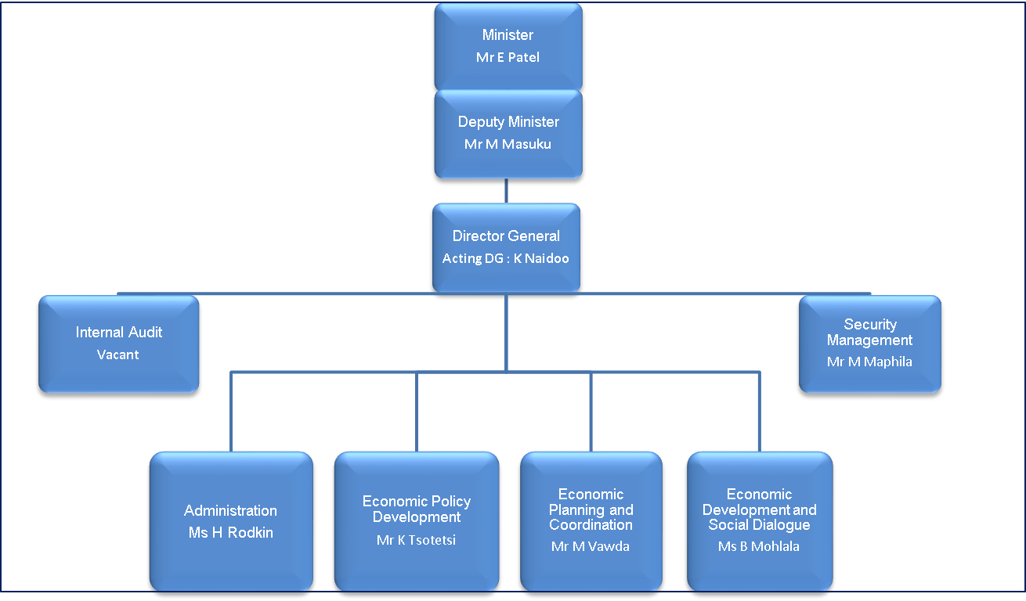

- Audit opinion history
Audit opinions |  | 14/15 |  | 13/14 | 12/13 | 11/12 | 10/11
- Economic Development Department
- Competition Commission
- Competition Tribunal
- International Trade Administration Commission
Predetermined objectives |  | 14/15 |  | 13/14 | 12/13 | 11/12 | 10/11
- International Trade Administration Commission |  |  |  |  |  | ü | ü
Compliance with laws and regulations |  | 14/15 |  | 13/14 | 12/13 | 11/12 | 10/11
- Economic Development Department |  | ü |  | ü | ü | ü | ü
- Competition Commission |  |  |  | ü | ü | ü | ü
- Competition Tribunal |  | ü |  |  | ü | ü | ü
- International Trade Administration Commission |  | ü |  | ü |  | ü | ü
AUDIT OPINION LEGEND
 | CLEAN AUDIT OPINION: No findings on PDO and Compliance
 | UNQUALIFIED with findings on PDO and Compliance
 | QUALIFIED AUDIT OPINION (with/without findings)
 | DISCLAIMER/ADVERSE AUDIT OPINION
 | ENTITY NOT YET ESTABLISHED
ü | DEPARTMENT/ENTITY HAD FINDINGS (in the related matter)

Qualification paragraphs
No qualification paragraphs were included in the departments or public entities in the department’s portfolio for the last four financial years.

- Key focus areas
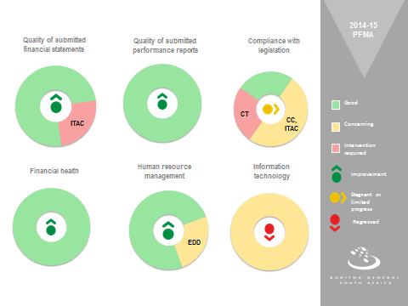

3.1 Material errors/omissions in submitted annual financial statements
Department/Entity | Finding | Root cause | Recommendation
International Trade Adminsitration Commission | Material misstatements of liabilities, expenditure and contingent liabilities were identified. These were subsequently corrected. | Management did not adequately review the financial statements prior to submmission for audit. | Management should enhance the review process over the financial statements before it is submitted for audit..
3.1.1 Comments on additional AGSA interactions to help improve financial outcomes
Department/Entity | Additional interaction/ add service (eg. Workshops etc) | Impact / outcome
The financial opinion was unqualified in the previuos three financial years and thus no interventions were necessary in this regard.

  - Predetermined objectives
Department/Entity | Finding | Root cause | Recommendation
There were no matters reported on the usefulness and reliability of reported information, neither were material adjustments required.
3.2.1 Comments on additional AGSA interactions to help improve AOPO outcomes
Department/Entity | Additional interaction/ add service (eg. Workshops etc) | Impact / outcome
None as no intervention was required in this area.
  - Compliance with legislation
Department/Entity | Finding | Root cause | Recommendation
Competiton Tribunal | In some instances price quotations were not obtained as required by Treasury Regulation 16A6.1 | Managements review and monitoring of compliance with legislation was not effective. | Management should strengthen their oversight and review to ensure compliance with procurement legislation.
Competiton Tribunal | The accounting authority did not take effective steps to prevent irregular expenditure as required by section 51(1)(b)(ii) of the PFMA.
  - Financial Health
There were no concerns relating to financial health.
  - Human resource management and consequence management
Department/Entity | Finding | Root cause | Recommendation
Economic Development Department | Employees were appointed without following a proper process to verify the claims made in their applications in contravention of Public Service Regulation 1/VII/D.8. | The action plan was not adequately monitoired by management to prevent non-compliance with the public service regulations. | Mangament should strengthen their oversight over compliance with human resouce regulations.  Corrective actions should be taken against continous transgressors.

  - Information Technology (IT) control environment
Department/Entity | Finding | Root cause | Recommendation
Competition Commission | IT Governance:  Deadlines for implementing phase 1 and 2 of the Corporate Governance and Communication Technology Policy Framework were not met. | The action plan was not adequately monitoired by management to prevent non-compliance with the IT goverance framework policy. | Management should strengthen their oversight over the approval and implementation of the IT governance framework policy.
Competition Commission  International Trade Administration Commission | User access management:  Inadequate periodic reviews of access rights and priviledges were identified. | Formal controls over IT systems to ensure the reliability of the systems and the availability, accuracy and protection of information were not adequately designed and implemented by the CIO . | The CIO should review the users access rights regularly.
Competition Tribunal | IT service continuity  IT disaster recovery plan not approved. IT service providers have access to the production environment and their access is unmonitored. | Management did not have adequate processes and formal controls over the IT system to ensure that the disaster recovery plan is approved and IT service provider access is monitored. | Management should strengthen their oversight over the approval and implementation of the significant IT plans and processes.

- Other matters of interest
- Unauthorised expenditure: Expenditure not in accordance with the budget vote

Department/ Entity | Unauthorised expenditure
Department/ Entity | Movement | Amount  R  2014/15 | Amount  R  2013/14 | Root cause | Recommendation
There was no unauthorised expenditure in the portfolio.

- Irregular expenditure: Expenditure incurred in contravention of key legislation

Department/ Entity |  | Irregular expenditure
 |  | Movement | Amount  R  2014/15 | Amount  R  2013/14 | Root cause | Recommendation
1 | Economic Development Department |  | Nil | 592 000 | None | None
2 | Competition Commission |  | 168 000 | 6 763 711 | Lack of compliance monitoring by management | Management should continue to strengthen monitoring over compliance with legislation.
3 | Competition Tribunal |  | 425 000 | *261 000 | Lack of compliance monitoring by management | Management should strengthen monitoring over compliance with legislation.  Management should enhance their performance management system to hold staff accountable for non-compliance.
4 | International Trade and Administration |  | 119 120 | 205 981 | Lack of compliance monitoring by management | Management should continue to strengthen monitoring over compliance with legislation.
*The R261 000 was identified in the current year and related to the prior year.

- Fruitless and wasteful expenmditure: Expenditure that should not have been incurred (incurred in vain that could have been avoided and no value for money received)
Department/ Entity |  | Fruitless and Wasteful expenditure
 |  | Movement | Amount  R  2014/15 | Amount  R  2013/14 | Root cause | Recommendation
1 | Competition Tribunal |  | 10 000 | 84 000 | N/A as arises due to a dispute with SARS. | N/A

- Drivers of internal controls
Drivers of internal control
Department & Entities | Leadership |  |  |  |  |  | Financial & performance management |  |  |  |  | Governance
Department & Entities | Effective leadership culture | Oversight responsibility | HR management | Policies and procedures | Action plans | IT governance | Proper record keeping | Processing and reconciling controls | Reporting | Compliance | IT systems controls | Risk management | Internal audit | Audit committee
Economic Development Department
Competition Commission
Competition Tribunal
International Trade Administration Commission

- Other AGSA reports

6.1 There are no other reprots.

- Combined Assurance on Risk Management in the Public Sector

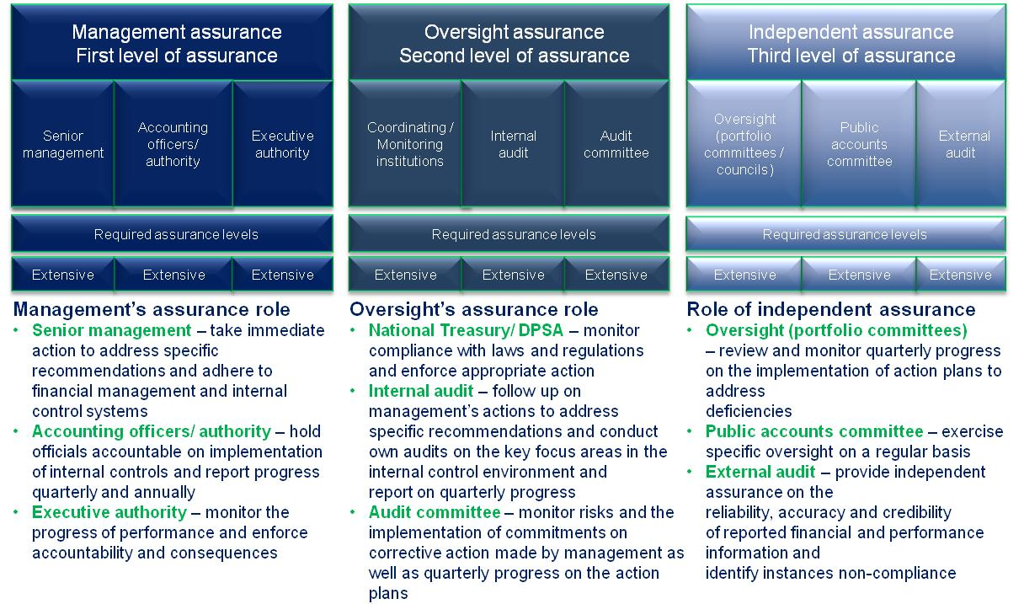
- Minister commitments and progress on these commitments
The following includes prior year commitments and new commitments made
Focus area | Commitment | Due date | Status
Internal audit | The accounting officer of the department should focus on the effectiveness of internal audit and report biannually to the Minister. | March 2014
Human resources | The accounting officer should increase his focus on human resource management including the resolution of the issues surrounding the organisational structure and compliance with Public Service Regulations.  Status  Issues relating to the structure are still in progress and non-compliance with the Public Service Regulations has been identified again.  New commitment from the Minister  The Minister has committed to adress the issues in human resource management and has directed the acting DG to take action against transgressors. | March 2014
Supply chain management | The CFO and the accounting officer should focus on compliance with SCM prescripts, including a needs assessment and related spending plan. | March 2014
Financial management | A formal management assessment of controls on a quarterly basis should be performed. This would include assets and processes to ensure complete and accurate financial statements. | March 2014
Audit committee engagements | The executive authority to meet the audit committee chairperson including the chairpersons of the public entities. | March 2014
STATUS LEGEND
Commitment has been implemented
Commitment in progress
Commitment has not been implemented
New commitment made in current year

- Commitments from the Portfolio committee
The following recommended commitments to be actioned by the committee:
The portfolio committee should monitor progress against the annual performance plan and track implementation of action plans to address previously identified audit findings on a quarterly basis.

- Entities included in the portfolio not audited by the Auditor-General of South Africa (section 4(3) audit entities)
AUDIT OPINIONS |  |  | 14/15 | 13/14 | 12/13 | 11/12
- Industrial Development Corporation
- Small Enterprise Finance Agency
AUDIT OPINION LEGEND
 | CLEAN AUDIT OPINION: No findings on PDO and Compliance
 | UNQUALIFIED with findings on PDO and Compliance
 | QUALIFIED AUDIT OPINION (with/without findings)
 | DISCLAIMER/ADVERSE AUDIT OPINION
 | ENTITY NOT YET ESTABLISHED
ü | DEPARTMENT/ENTITY HAD FINDINGS (in the related matter)

