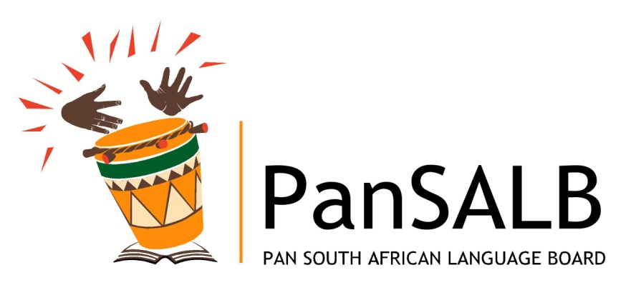

PAN SOUTH AFRICAN LANGUAGE BOARD (PanSALB) PRESENTATION TO PORTFOLIO COMMITTEE ARTS AND CULTURE
Date: 22 JUNE 2011
Venue: Committee Room 2, Parliament, Cape Town



TABLE OF CONTENTS
1. APPOINTMENT OF THE BOARD 3
2. CURRENT BOARD MEMBERS 3
3. BOARD MEETINGS 3
5. MANDATE OF THE BOARD 3
1.1 MANDATE FROM AND ITS COMMITMENT TO PARLIAMENT 3
6. VISION, MISSION and VALUES OF PanSALB 3
7. PanSALB STRATEGIC OBJECTIVES 3
8. executive authority, accountability and reporting 3
8. funding 3
9. suspension of the CEO 3
10. PanSALB organisational strategy 3
10. PANSALB STRUCTURES 3
11. PANSALB organisational structure and staffing 3
12. ALLEGATIONS BY ADVOCATE FENI 3
13. FUNDING, BUDGET AND EXPENDITURE 3

The PanSALB Board

1. APPOINTMENT OF THE BOARD

- The Board of PanSALB is appointed by the Minister of Arts and Culture in consultation with the portfolio Committee on Arts and Culture. This is in term of Sec 5 (1) (a) of the PanSALB Act.
- The Current Board was appointed in October 2007 and was inducted for operation in June 2008.
- When the current Board was appointed only 11 members were appointed in a possible 15.
- Thereafter 2 members of the board resigned leaving the Board with a complement of 9 members.

- Those who resigned are: Prof A. Lotriet and Dr M. Yoyo.
- Further to this there have been complaints from language communities about certain languages not being represented in the Board.
- It should be noted though that in the view of the board, members were not appointed to represent languages but rather on a complement of skills.

2. CURRENT BOARD MEMBERS
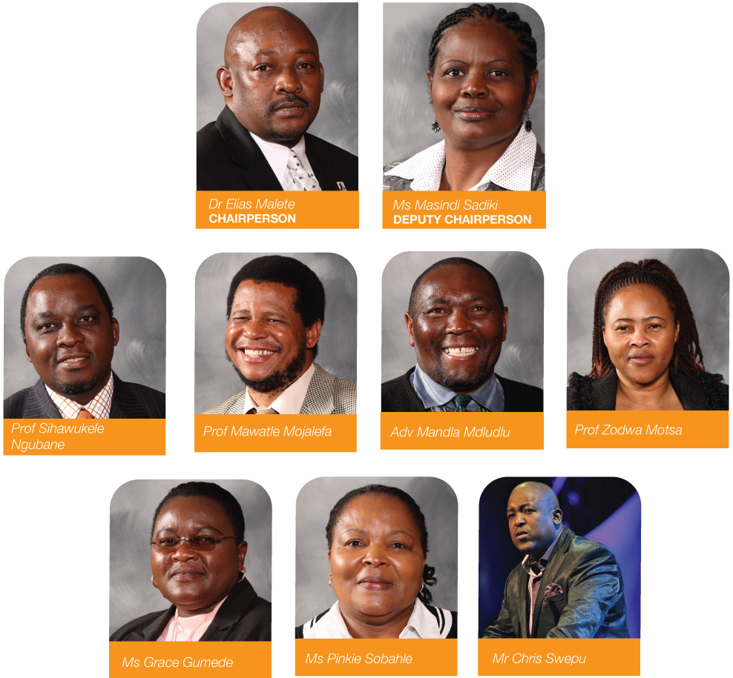

- It should be noted that at the first meeting of this Board, Prof S. Ngubane and Prof Z. Motsa were elected Chairperson and Deputy Chairperson respectively.
- Subsequently Dr E Malete and Mrs Sadiki were appointed Chairperson and Deputy Chairperson respectively.
- The change was necessitated by the requirements of Sec 6 (2) of the PanSALB Act that requires that “an election be held annually”.
- The PanSALB Board views this aspect of the Act as disruptive to continuity and the stability of the Board.
- It is also disadvantageous in the profiling of the leadership of the Board.
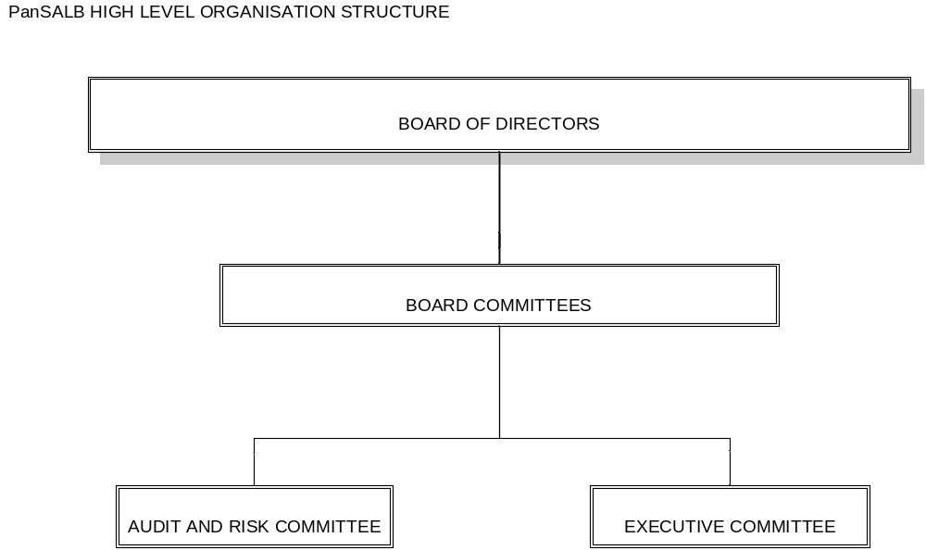

- The structure of the Board is part of the overall structure of the organisation that was approved by the Board to address cooperate governance issues.
- The CEO is in terms of Sec 5 (1) (b) “a member of the Board by virtue of his or her office and may take part in the deliberations of the Board and shall have the same rights and duties as the other members of the Board but shall have no right to vote”.
- The Board has also in writing delegated powers and duties to the CEO in terms of the requirement of Sec 38 – 40 of the PFMA (Annexure A)
- The Executive Committee of the Board is made up of the Chairperson, Deputy Chair and the CEO of the Board.
- PanSALB has an Audit and Risk that has been appointed by the Board as required by Sec 77 of the PFMA. This Audit Committee is chaired by an external person.
- The Audit and Risk committee has an Audit and Risk Committee Charter that is due to be approved by the Board (Annexure B). The Committee has consistently as per its charter met 4 times a year.
- The Board has through PWC developed a Fraud and Risk Management Strategy as required by Treasury Regulation 3.2.1 (Annexure C).
- The Board has also appointed PWC as its internal auditors for a period of three years.
- The AGSA is our external auditors and performs annual audits on PanSALB and reports to Parliament.
- Additionally the Board has contracted AGSA to undertake interim audits of PanSALB in between the Annual Audits. From this it is clear that it is impossible for the Board not to pick up financial mismanagement issues in the organisation.
- The Board also has a budget committee that approves the Budget of the organisation annually.
- The Board receives the CEO’s report and expenditure report on a quarterly basis.
- The Board has approved a three year strategy and a structure that guides the organisation in its delivery (Annexure D). The strategy is based on the mandate of the Board as prescribed in the Constitution and the PanSALB Act, including the PFMA. Where the Act contradicts the Constitutions the Board has used the constitution in interpreting its mandate. The Constitution is the supreme law of the country.
- The Board has also approved an Annual Business Plan to be delivered by the CEO (Annexure E) and in turn the CEO reports to the Board on quarterly basis.

3. BOARD MEETINGS
- Since its inception the Board has had meetings consistent with the requirements of the Act. The Act requires that the Board meets at least 4 times a quarter. The Board has additionally held special meetings when required to do so through urgent matters.
- In the past financial year the board held meetings as follows:
Date
4 March 2010
21 March 2010
27 & 28 July 2010
27 & 28 October 2010
18 March 2011

- Further thereto, the Board of PanSALB held a Corporate Governance Workshop as follows:
Date | Venue | Time
24 May 2011 | PanSALB Offices | 08h30 – 16h00

- Any claim that the PanSALB Board is dysfunctional is far from the truth. The evidence speaks for itself.
- At its August 2011 meeting the Board will adopt its Corporate Governance and Executive Committee Charter.
- This is the last layer of our corporate governance improvement as the management has already completed its own charters.

5. MANDATE OF THE BOARD

  - MANDATE FROM AND ITS COMMITMENT TO PARLIAMENT

In terms of the Pan South African Language Board (PanSALB) Act, the mandate of PanSALB is derived from the Constitution of the Republic of South Africa (Section 6(5) (a) and (b) of the Constitution of South Africa), the PanSALB Act as amended in 1999 and the Public Finance Management Act (no.29 of 1999).

PanSALB is mandated:
(a) to make recommendations with regard to any proposed or existing legislation, practice or policy dealing directly or indirectly with language matters at any level of government, and with regard to any proposed amendments to or the repeal or replacement of such legislation, practice or policy;
(b) to make recommendations to organs of state at all levels of government where it considers such action advisable for the adoption of measures aimed at the promotion of multilingualism within the framework of the Constitution;
(c) actively to promote an awareness of multilingualism as a national resource;
(d) actively to promote the development of the previously marginalized languages;
(e) to initiate studies and research aimed at promoting and creating conditions for the development and use of (i) all the official languages of South Africa, (ii) the Khoe and San languages and (iii) South African Sign Language;
(f) to promote and ensure respect for all other languages commonly used by communities in South Africa;
(g) to advise on the coordination of language planning in South Africa;
(h) to facilitate cooperation with language planning agencies outside South Africa;
(i) to establish provincial language committees and national language bodies to advise it on any language matter affecting a province or a specific language; and
(j) to establish national lexicography units to operate as companies limited by guarantee under section 21 of the Companies Act, 1973 (Act 61 of 1973), and to allocate funds to the units for the fulfilment of their functions.
1.2 The purpose of PanSALB is to promote multilingualism in South Africa by:
- Creating the conditions for the development of and the equal use of all official languages;
- Fostering respect for and encouraging the use of other languages in the country; and
- Encouraging the best use of the country's linguistic resources, in order to enable South Africans to free themselves from all forms of linguistic discrimination, domination and division and to enable them to exercise appropriate linguistic choices for their own well-being as well as for national development.

6. VISION, MISSION and VALUES OF PanSALB

6.1 PanSALB Vision

“To promote and create conditions for the development and use of all official languages, the Khoi, Nama and San languages as well as South African Sign Language.” (Section 6(5) (a) of the Constitution of South Africa)

6.2 PanSALB Mission Statements

“Promote and ensure respect for all languages commonly used by communities in South Africa.” (Section 6(5) (b) of the Constitution of South Africa)

6.3 PanSALB Core Values

PanSALB is committed and adhere to the following values: QRHATI
- Quality Driven
- Respect
- Honesty
- Accountability
- Transparency
- Integrity

7. PanSALB STRATEGIC OBJECTIVES

PanSALB has adopted the following as their Strategic Objectives for the next three years:
- Promote and ensure respect for all languages commonly used by communities in South Africa.
- Ensure the creation of conditions for the development and use of all official languages in South Africa with particular emphasis on previously marginalised languages.
- Ensure prudent financial management and effective corporate governance of the organisation.
- Ensure that PanSALB is strategically positioned with all key stakeholders.
- Build and maintain the capability and capacity of the organisation to deliver on its mandate.

8. executive authority, accountability and reporting

- The PFMA makes a distinction between; a Department, a Constitutional institution and an Entity.
- Whereas in the case of a National Department the Minister is the Executive Authority, according to National Treasury Regulation Section 1.1, “the Executive Authority of a Constitutional Institution is the Chairperson of the Board”.
- This distinction is important because it draws the line between a Department, a Constitutional Institution and an entity.
- Entities are part of Departments and thus should not be confused with Constitutional Institutions.
- It also makes it clear that the Chairperson of a Board has the same responsibility to the Institution as the Minister to the Department.
- Both the Minister and the Chairperson are accountable to Parliament and not to each other.
- The PFMA in Schedule 1 list PanSALB as a Constitution Institution.
- In terms of Section 4 of the PanSALB Act, the Board is an independent organ of state, subject only to the Constitution and its founding legislation. It must perform its duties without fear, favour or prejudice. All organs of state are enjoined to cooperate with the Board and may not interfere with its functioning in the execution of its mandate.
- It should be noted that PanSALB is a Constitutional Institution that reports to Parliament and not to the Department of Arts as its entities would.
- Note that PanSALB has oversight on behalf of Parliament on all government Departments and organs of state and they are by law required to cooperate with PanSALB.
- Accounting Officer: According the PFMA (2)(a) “the head of a Department must be the accounting officer of the Department and (b) the Chief Executive Officer of a Constitutional Institution must be the accounting officer for that institution”. They do not account to each other but to their Executive Authorities and to Parliament.

- The above assertions were further alluded to by Parliament in 2010 when the Office of the speaker launched the Office on Institutions Supporting Democracy (Annexure F). PanSALB is listed as no 8 on the list of Institutions Supporting Democracy and reporting to the Office of the Speaker. Subsequently, the speaker wrote a letter to PanSALB dedicating a person (Adv. Cetywayo) as the liaison officer between PanSALB and parliament (Annexure G).

- The Chief State law Advisors also clarified this when they responded to an inquiry by the Department of Arts and Culture (Annexure H). Their opinion was clear. Parliament has oversight over PanSALB and not the Department of Arts and Culture.

- The above is not an expression of our desires but of the law. Should Parliament as the legislature want to reconfigure the above, the necessary steps of stakeholder consultation and legislative review would have to take place. Not only would we have to amend the PanSALB Act but we would also need to amend the PFMA, the Treasury Regulations and the Founding Provisions of the Constitution of the Republic of South African.
- In the process of this reconfiguration the Kader Asmal report that was commissioned by Parliament should not be forgotten.

8. funding

- Contrary to popular belief the Pan South African language Board is not funded by the Department of Arts and Culture. The Department of Arts and Culture is a conduit for the money.
- The allocation of PanSALB is approved by Cabinet and communicated to the Department of Arts and Culture. It is communicated to the DAC and PanSALB by Treasury (Annexure I).
- When PanSALB Accounts to Parliament for their expenditure and reports, it is not through the DAC but through direct communication with the Parliament. The new way is therefore surprising to us.
- When PanSALB requests the virement of funds it is not through the DAC but directly with Treasury (Annexure J).
- When PanSALB requests funding through MTEF and ENE it is required to do so directly with Treasury
- When PanSALB requests for retention of surplus funds in terms of the PFMA it is required to do so directly with Treasury (Annexure K)
- When PanSALB submits Annual Financial Statement it submits directly to Treasury and Parliament as required by the PFMA.

9. suspension of the CEO

- On 20 February 2009 the Board suspended its Accounting Officer, Mrs NR Nkosi pending an investigation into alleged irregularities and misconduct.
- The Board appointed the Deputy CEO Mr Chris Swepu as the Acting CEO.
- Following a forensic report by NKoki Inc, the CEO was charged for financial irregularities.
- After lengthy legal challenges and delays a hearing was held in December 2010.
- On 8 June 2011 the presiding officer submitted his findings wherein he found Mrs Nkosi guilty as charged (Annexure L).
- On 15 June 2011 parties’ were expected to submit in writing to the presiding officer evidence in aggravation or mitigation of sentence.
- Mrs. Nkosi has since requested an extension until the 20th of June to submit her evidence in mitigation of sentence.
- The presiding officer has made an undertaking that he would pass sentence by the 24th of June 2011
- Due to the seriousness of the allegations the Board is requesting for a sanction of dismissal.
- Apart from rumour mongering, evidence at our disposal points to the fact that things have improved tremendously at PanSALB since the suspension of the CEO. The AGSA in its management letter made this point expressly (Annexure M)

- PanSALB has since then improved from a disclaimer of audit opinion to two successive unqualified audit opinions.

- The audit reports are very clear that no irregular expenditure has taken place and that supply chain management processes are being followed.

ADMINISTRATION

10. PanSALB organisational strategy

- The board of PanSALB approved a three year strategy for implementation, together with this they approved an Annual Business Plan (see attached Annexure D) to be implemented by the organisation.
- The Board also approved a PanSALB organisational structure that was implemented at the beginning of the 2010/11 financial year. These were previously presented at the Portfolio Committee.
- Below is a summary of how our organisational programmes are structured in the strategy as per the smart principles of strategy development.
- It should be noted that PanSALB previously did not have a coherent strategy and organisational structure for maximum delivery.
- PanSALB also did not have a business plan committing the CEO to certain deliverables, this was a milestone.

Programme | Sub – programme
PROGRAMME 1: ADMINISTRATION | - Office of the CEO  - Human Resources Management  - Marketing and Communications  - Supply Chain Management  - Finance  - Legal Services  - Facilities Management  - Corporate Governance  - Information Technology  - Board Secretariat
PROGRAMME 2: CREATION OF CONDITIONS FOR THE DEVELOPMENT AND USE OF LANGUAGES | - NLB  - NLU  - PLC  - Provincial Offices
PROGRAMME 3: ENSURING RESPECT FOR LANGUAGES | - Legal Services  - Marketing and Communications  - Language in Education  - Status Language Planning  - Provincial Offices
PROGRAMME 4: PROMOTION OF LANGUAGES | - Provincial Offices  - Marketing and Communications

10. PANSALB STRUCTURES

According to Sec 8 of the PanSALB Act the Board must establish:

- A Provincial Language Committee (PLCs) in each province.
- A National Language Body (NLBs) for each language, including Khoi and San and South African Sign Language.
- National Lexicography Units (NLUs) for all official languages who must operate as Section 21 companies.

- These units are funded by PanSALB and are accountable to the Board.
- The PLCs and the NLUs are coordinated through the 9 PanSALB provincial offices.

10.1 PROVINCIAL LANGUAGE COMMITTEES

- In terms of the approved norms and rules the each PLC must have 13 members per Province.
- PLCs are appointed in conjunction with the MECs of Arts and Culture in the provinces.
- They are advisory committees of PanSALB on Language Policy matters in the province
- They work with the Provincial Government and local government and monitor language policy development, implementation and linguistic human rights violations in their respective provinces.
- They meet at least 4 times a year and they are paid a sitting fee of R 585.65 per meeting. PanSALB is also responsible for all their travelling and accommodation expenses.
- PLCs also implement with the assistance of PanSALB provincial offices, projects geared at the promotion of languages.
- These are not fulltime employees of PanSALB.
- They are appointed for a period of 5 years

No | Province | No of Members | Chairperson
1 | Eastern Cape | 13 | Mrs MP. Dlani
2 | Free State | 13 | Mrs LE. Sibeko
3 | Gauteng | 13 | Mrs BR. Segale
4 | Mpumalanga | 13 | Mr BD. Mkhatshwa
5 | North West | 13 | Dr JZO. Machiu
6 | Northern Cape | 13 | Mr GM. Isaka
7 | Western Cape | 13 | Dr Michael le Cordeur
8 | Limpopo | 13 | Mr C. Baloyi
9 | KZN | 13 | Dr BC. Khuzwayo
 |  | 117

PLCs and their Chairpersons

10.2 NATIONAL LANGUAGE BODIES

- NLBs are advisory bodies on any language matter
- They are mainly responsible for the verification and authentication of terminology
- They also conduct research on language matters.
- There are 13 NLBs and they have 25 members each.
- They meet at least 4 times a year.
- PanSALB pay them a sitting fee of R 585.65 per meeting. This is adjusted annually.
- PanSALB is also responsible for their accommodation and travelling costs.
- They are appointed for a period of 5 years

Number | Structure | Members | Chairperson
1 | Sepedi | 25 | Dr MD. Thokoane
2 | Sesotho | 25 | Mrs EN. Matubatuba
3 | Seswati | 25 | Dr JP Luphoko
4 | Setswana | 25 | Ms MC. Thubisi
5 | South African Sign Language | 25 | Mr BR. Sithole
6 | Khoe and San | 25 | Mr CR. White
7 | English | 25 | Prof AJ. Foley
8 | Afrikaans | 25 | Prof WAM. Castens
9 | isiNdebele | 25 | Mrs NM. Masumbuka
10 | Xitsonga | 25 | Mrs FJ. Manugu
11 | Tshivenda | 25 | Prof N. Madadzhe
12 | isiZulu | 25 | Dr. JT. Mbuli
13 | isiXhosa | 25 | Prof N. Saule
Total no |  | 325
NLBs and their Chairpersons

10.3 NATIONAL LEXICOGRAPHY UNITS

- These are section 21 companies that are responsible for the development of dictionaries
- The Board of Directors of the NLUs are appointed and accountable to the PanSALB Board.
- Many are housed at Universities and Colleges through MoUs between them, PanSALB and the respective hosting institutions.
- They are funded by PanSALB and are experiencing the same financial constraints that PanSALB is experiencing.
- In the past two financial years and the current, NLUs received unqualified audit reports with Going Concern.
- Their Annual Financial Statements (AFS) are consolidated into the PanSALB AFS.
- They have their own auditors and are run by an Editor in Chief who is appointed by their Board of Directors.
- The Editor in chief then appoints staff. Currently they are understaffed and have 4 people each.

NLUs and their Chairpersons

No | Structure | Members | Chairperson
1 | Sepedi | 11 | Dr. S. Chokoe
2 | Sesotho | 11 | Prof MA. Moleleki
3 | Siswati | 11 | Dr PM. Lubisi
4 | Setswana | 11 | Mr NJ. Phalashe
5 | isiXhosa | 11 | Mr M. Jadezweni
6 | isiZulu | 11 | Mr SJ. Ngwenya
7 | Tshivenda | 11 | Prof MN. Mosehane
8 | Xitsonga | 11 | Mrs CN. Shilote
9 | isiNdebele | 11 | Mr. PJ. Masilela
10 | Afrikaans | 11 | Prof M. Fourie
11 | English | 11 | Dr V. Der Kerk
 |  | 121

10.4 KEY ACHIEVEMENTS AND CHALLENGES

STRUCTURE | ACHIEVEMENTS | CHALLENGES
PROVINCIAL LANGAUGE COMMITTEES | - PLCs have held workshops with municipal officials to create an awareness of the need for language policies, language units and budgeting thereof.  - Celebrations of International Mother Tongue day, International Translation day, Africa day and deaf awareness have been done annually.  - Have created awareness of language rights through community imbizos. PLCs have created partnerships with government departments and institutions of higher learning. | - Underfunding is affecting service delivery.  - Low sitting fee for committee members in comparison with other boards is affecting commitment.  - Reshuffling of MECs in the provinces lead to a misunderstanding of the role of PLCs, delays in their appointment and crippling of implementation.  - The absence of Provincial Languages Act makes implementation of multilingualism difficult.  - Provinces are too vast for such a small group to monitor hence we proposed language inspectors.  - Many municipalities and government departments do not have language units, policies nor budgets for language matters.  - English still dominates government business including Parliament.
NATIONAL LANGUAGE BODIES | - NLBs have verified and authenticated terminology across the genres of society. These include:  - Football terms from the DAC  - Statistical terms from STATS SA.  - Banking terms for inclusion in ATMs.  - Plant terms.  - Microsoft computer terms for inclusion in their windows platform.  - NLBs have also been instrumental in establishing reading clubs across the country. | - Underfunding is affecting service delivery.  - The morale of members is very low as they are remunerated according to their skills.  - Meetings are affected by underfunding.  - Low sitting fee for committee members in comparison with other boards is affecting commitment.  - Due to the product orientated responsibility of NLBs it is not possible to wait for official quarterly meetings in order to verify and authenticate terminology that has been submitted to PanSALB. Their failure to respond instantly to requests leads to noncompliance and lack of confidence by stakeholders.
NATIONAL LEXICOGRAPHY UNITS | - All the units with the exception of Sesotho have produced monolingual and bilingual dictionaries.  - All units have turned the corner and have unqualified audit opinions. | - Underfunding is affecting service delivery.  - Staff morale is very low as they are not paid competitive salaries.  - Board meetings are affected by underfunding.  - Low sitting fee for board members in comparison with other boards is affecting commitment.  - Their products are not properly marketed and prescribed. They are competing with the private sector for a market.

11. PANSALB organisational structure and staffing

- The Board approved an organisational structure for PanSALB for optimal service delivery.
- Its implementation commenced with the financial year 2010/11.
- In terms of the new structure, PanSALB was reconfigured into business units with clear reporting lines.
- The structure is aligned with coordination and delivery of the business plan.
- PanSALB has 70 employees out of a possible 112 in the structure.
- Inclusive of PanSALB employees and members of our structures our budget is serving 734 personnel.
- The staff vacancy rate is 38% (See attached Structure).
- We are experiencing low staff morale due to the fact that we have not implemented the results of the job grading done on the posts after the organisational structure was improved.
- Service delivery is affected because our key delivery components have vacancies in critical areas such as; Status Language Planning, Translation and Interpreting; Research.
- For the programme Administration: the ACEO appointed two people to act in the positions so that all the Business Units are coordinated properly.

11.1 High Level organisational structure

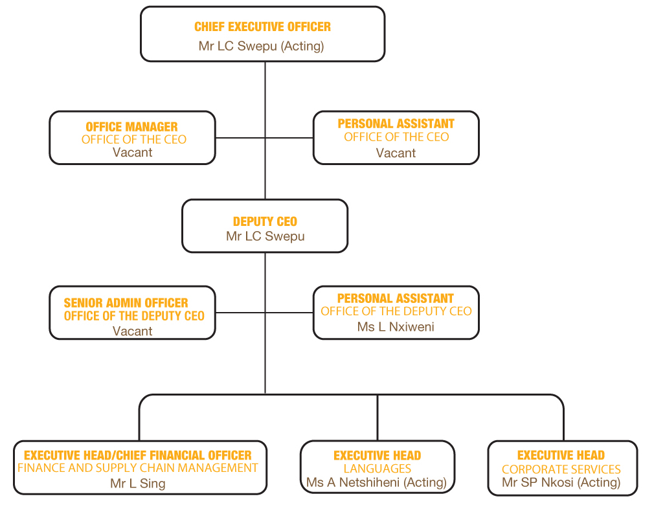

11.2 Improving corporate governance within the organisation

- Another unqualified audit opinion: In one of our appearances before the Parliamentary Portfolio Committee on Arts and Culture we made a firm commitment that we would maintain our status of an unqualified audit opinion from the Auditor-General. It gives me great pleasure to report that indeed we have delivered on this promise. We have further improved to the level where we are now one of the most revered institutions in terms of administrative excellence. Our nomination and shortlisting as one of the finalists in the National Business Awards 2010 and 2011, as a top performing agency of government attests to this.
Mr Chris Swepu
- Executive Management Committee (EMC): is in place and meets once a month and as necessary. The EMC is governed by its charter and its key responsibility is to assist the CEO in running the organisation.

- Corporate Governance Charters: In line with the new organogram and revised management structures, we developed and adopted the Board Charter, Executive Management Committee Charter, Management Committee Charter and Provincial Coordination Charter.

- Policies and procedures: The Auditor-General SA had previously reported the policies of PanSALB to be inadequate. We have since reviewed our policies and adopted new ones, as the AGSA report of the 2010/11 financial year attest.

- Annual Operational Plans and work plans: The organisation now has annual operational plans and work plans for its staff. The plans are in support of delivering the Annual Business Plan of the CEO. Annual Operational Plans are

- Performance Contracts: PanSALB now has performance contracts as required.

- Job Profiles: following the approval of the structure, we developed job profiles for all the positions in the structure.

- Performance Management Policy: The management also developed a performance management policy and is evaluating staff bi-Annually for their performance. The challenge however is that there is no investment in training due to financial constraints.

12. ALLEGATIONS BY ADVOCATE FENI

SEE ANNEXURE N FOR A COMREHENSIVE RESPONSE

13. FUNDING, BUDGET AND EXPENDITURE

13.1 FUNDING ALOCATION, OPERATIONAL PLANS AND BUDGET ALLOCATION

- In 2008/9 financial year, PanSALB requested 151,000,000.00 to deliver on its mandate but it received only R 43,600,000.00

- In 2009/10 financial year, PanSALB requested an amount of R 167, 000,000.00 but it received R 47,556,000.00

- In 2010, PanSALB requested R 173,330,000.00 but received R52, 871,000.00.

- Budget shortfall: The R52 871 000 allocated to PanSALB in the past financial year is is below the R173 330 00 that the organisation requested. This situation resulted in the suspension of all projects and projects. We anticipate that the new financial year (2011/12) will be worse than the previous year because the grant has not been improved to meet our requirements to deliver. Because of the insufficient grant the organisation is facing a serious deficit of 227.84% (R121-Million)

- For the past 12 years PanSALB has been operating under a deficit (Annexure O).

- It is a historical fact that PanSALB has been grossly underfunded this is also contained in the AGSA reports wherein the issue of going concern was raised. The AGSA attributed the going concern to underfunding and not any corruption.

- Even Parliament (through the Deputy Speaker) in its communication to the Minister of Arts and Culture, Paul Mashatile (19 November 2010) recognised the underfunding and further requested intervention of R 26,000,000.00 for the remainder of 2010 ( Annexure P)

- In 2008 PanSALB wrote to Treasury during the MTEF process, requesting an addition amount of R 57,000,000,00 (Annexure Q).

THANK YOU!

