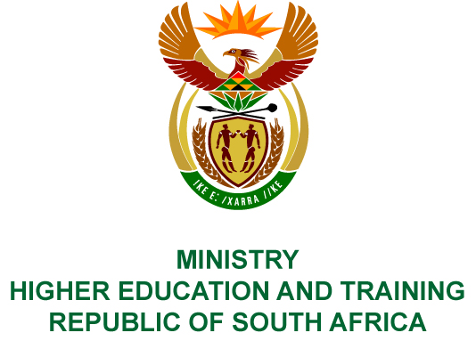
Private Bag X893, Pretoria, 0001, Tel (012) 312 5555, Fax (012) 323 5618
Private Bag X9192, Cape Town, 8000, Tel (021) 469 5150, Fax: (021) 465 7956
Memorandum from the Parliamentary Office
NATIONAL ASSEMBLY
FOR WRITTEN REPLY
QUESTION 975
DATE OF PUBLICATION OF INTERNAL QUESTION PAPER: 5/05/2017

(INTERNAL QUESTION PAPER 15 OF 2017)

Prof B Bozzoli (DA) to ask the Minister of Higher Education and Training:

Whether he will furnish Prof B Bozzoli with a copy of the report done by the Council on Higher Education on the LLB qualifications of South African universities; if not, why not; if so, by what date?

NW1103E

REPLY:
The Council on Higher Education has agreed that the Minister may release its Higher Education Quality Committee’s draft report on the National Review of Bachelor of Law (LLB) Programmes (2016 - 2017) offered at South African universities, which is attached as Annexure A.
COMPILER/CONTACT PERSONS: Dr D Parker
EXT: 6214/5

DIRECTOR – GENERAL
STATUS:
DATE:

QUESTION 975 APPROVED/NOT APPROVED/AMENDED

Dr BE NZIMANDE, MP
MINISTER OF HIGHER EDUCATION AND TRAINING
STATUS:
DATE:

