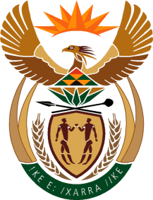

MINISTRY OF TOURISM

REPUBLIC OF SOUTH AFRICA

Private Bag X424, Pretoria, 0001, South Africa. Tel. (+27 12) 444 6780, Fax (+27 12) 444 7027

Private Bag X9154, Cape Town, 8000, South Africa. Tel. (+27 21) 469 5800, Fax: (+27 21) 465 3216

Ref: TM 2/1/1/10

MINISTER OF TOURISM

NATIONAL ASSEMBLY QUESTION: 889 (NW1015E) OF 2016 BY MRS Matshobeni (EFF)
FOR WRITTEN REPLY:
REGARDING THE: ADDITIONAL INCOME FROM BUSINESS WITH GOVERNMENT FOR SELF AND FAMILY

NATIONAL ASSEMBLY:

QUESTION FOR WRITTEN REPLY:
Question Number: 889
Date of Publication: 11 April 2016
NA IQP Number: 10
Date of reply: 19 April 2016

Ms A Matshobeni (EFF) to ask the Minister of Tourism:

(1) Has he earned any additional income from businesses, in particular businesses doing work for the Government, since his appointment as Minister; if so, (a) when, (b) how much did he earn, (c) from which businesses and (d) for what work;

(2) whether his (a) spouse, (b) children and (c) close family earned income from businesses, in particular businesses doing work for the Government, through his appointment as Minister; if so, in respect of each case, (i) when, (ii) how much did each earn, (iii) from which businesses and (iv) for what work? NW1015E

Reply

- (a) No
(b) No
(c) No
(d) No

(2)

 | - Spouse | - Children | (c ) Close family
(i) When | No | N/A | No
(ii)How much | No | N/A | No
(iii)Which Business | No | N/A | No
(iv)For what work ? | No | N/A | No

