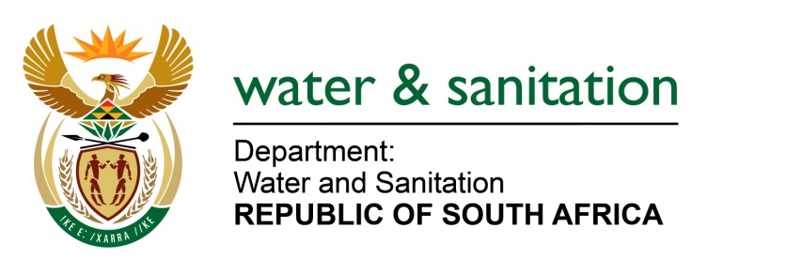

NATIONAL ASSEMBLY

FOR WRITTEN REPLY

QUESTION NO 866

DATE OF PUBLICATION IN INTERNAL QUESTION PAPER: 31 MARCH 2017
(INTERNAL QUESTION PAPER NO. 12)

866. Mrs K Jooste (DA) to ask the Minister of Water and Sanitation:
Whether, with reference to her reply to question 208 on 24 February 2017, the assessment that was conducted jointly by Ekurhuleni Metropolitan Municipality and Rand Water has been completed; if not, on what date is it expected that the assessment will be completed; if so, will he provide a full copy of the assessment to Mrs K Jooste? NW932E
---00O00---
REPLY:

No, the assessment is still in progress and will be completed in May 2017. Once the assessment report is finalised, a full copy will be submitted.

---00O00---

