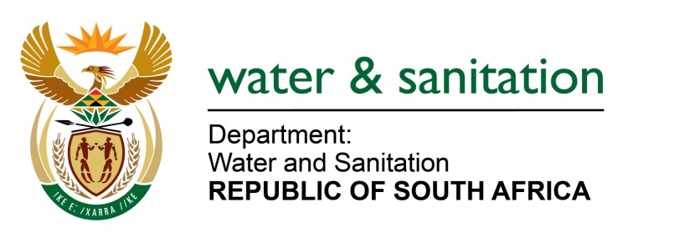

NATIONAL ASSEMBLY

FOR WRITTEN REPLY

QUESTION NO 849

DATE OF PUBLICATION IN INTERNAL QUESTION PAPER: 31 MARCH 2017
(INTERNAL QUESTION PAPER NO. 12)

849. Mr T J Brauteseth (DA) to ask the Minister of Water and Sanitation:
Whether her department has put any training programmes in place for municipal operators of water and waste water treatment works; if not, why not; if so, what are the relevant details? NW914E
---00O00---
REPLY:

The responsibility of training programmes for municipalities is of the Department of Cooperative Governace and Traditional Affairs (CoGTA) and not of my Department. However my Department as a custodian of water resources and a sector leader has a significant role to play in supporting local government to fulfill this obligation. In this regard, my Department supported Water Services Authorities (WSAs) in developing the training programme for municipal operators of water and waste water treatment works.

My Department has conducted training needs assessments of water and waste water process controllers with the aim of identifying training gaps and ultimately assisted the Water Services Authorities (WSAs) to submit the funding proposals to the Local Government Sector Education Training Authority (LGSETA).

The programme will be implemented in the following 11 WSAs:
- Eastern Cape: Alfred Nzo District Municipality and Amathole District Municipality.
- Limpopo: Capricorn District Municipality and Polokwane Local Municipality.
- North West: Dr Ruth Segomotsi Mompati District Municipality, Madibeng Local Municipality, Moses Kotane Local Municipality, Moretele Local Municipality, Ventersdorp Local Municipality, Kgetlengrivier Local Municipality and City of Matlosana Local Municipality.
---00O00---

