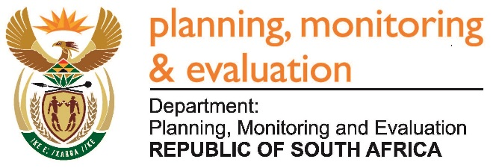 |  | 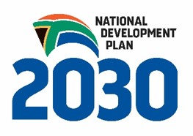
Private Bag X944, PRETORIA, 0001. Union Buildings East Wing, Government Avenue, PRETORIA
Tel: 012 312 0307. www.dpme.gov.za

796. Mr R W T Chance (DA) to ask the Minister in The Presidency:
(1) Who did the National Youth Development Agency (NYDA) consult before drawing up the business model for BuddiBox;
(2) did the NYDA executives meet representatives from (a) a certain company (name furnished) and (b) the Department of Small Business Development prior to the establishment of BuddiBox in January 2017; if so, (i) on what dates and (ii) what was discussed in each case;
(3) (a) did the specified company present its business model to the NYDA executives and (b) was an agreement reached for a partnership between the NYDA and the company; if so, what are the relevant details in each case?
REPLY: NW859E
The National Youth Development Agency issued a Request for Proposals (RFP) that was advertised on 16 January 2015 and closed on the 06 February 2015 for organisations to partner with the NYDA on all of its programmes. The concept came as a response to that request for proposals.

On the 13 February 2014 Zeila from Costilogix which is a South African company that offers entrepreneurship to the unemployed requested for a meeting with the office of the CEO. In this meeting the Directors of Costilogix, Bobby Mosidi and Frans Venter were going to meet with the office of the CEO, to see if they could partner with NYDA to support the youth. The office of the CEO referred the request to Senior Manager Rural Development to handle the request.

Costilogix has never presented their business model to the NYDA executives, and there is no partnership agreement between NYDA and Costilogix.

Approved / Not Approved

Mr J T Radebe, MP
Minister in The Presidency
Date

