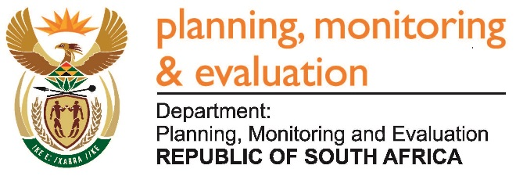 |  | 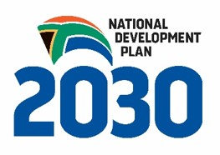
Private Bag X944, PRETORIA, 0001. Union Buildings East Wing, Government Avenue, PRETORIA
Tel: 012 312 0307. www.dpme.gov.za
756. Mr S J F Marais (DA) to ask the Minister in The Presidency:

(1) Whether a certain company (name and details furnished) has confirmed legal permits to manufacture and export arms and arms-related services from South Africa; if so, what are the relevant details;

(2) whether the (a) two shareholders (names furnished) of the specified company and (b) company has been (i) vetted and (ii) approved as being in compliance with the National Conventional Arms Control Committee regulations of 2012; if so, what are the relevant details in each case;

(3) will he confirm that none of the products manufactured by the company or any of its associated companies have been exported to countries currently or potentially involved in various forms of warfare and suppression of citizens;

(4) whether he has found that the specified shareholders do not have any connections to a certain organisation (details furnished); if so, in each case, what are the relevant details? NW815E
REPLY:
Records of the NCACC as at 27/03/2017 show that the only entities registered under the Milkor Trade name are: Milkor (Pty) Ltd and Milkor Special Projects. For both these entities there are various permits that authorise them to manufacture and export their products and related services.
The entities currently registered under the NCAC Act, do not have Shareholders in terms of Mr Sehrat Bayoglu and Raci Yetis. However, the NCACC can confirm that a new application was lodged by Milkor to include these shareholders. This application is pending while due diligence is being conducted by organs of state with a vetting mandate as prescribed in the Act and its attendant Regulations.
In regard to confirmation of exports by Milkor, the confirmation being sought here is wide and somewhat tentative. However, it should be born in mind that transfers approved by the NCACC are effected strictly in accordance with sec 15 of the NCAC Act (Act 41 of 2002, as amended).
The Act also provides that if and when it is established that individuals belong to or are involved in nefarious activities in South Africa and/or elsewhere, the approval sought for their admission as new shareholders of Milkor shall not be granted by the NCACC under such circumstances.

Approved / Not Approved

Mr J T Radebe, MP
Minister in The Presidency
Date

