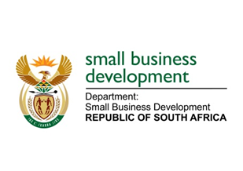

NATIONAL ASSEMBLY

QUESTION FOR WRITTEN REPLY

“728. Mr I M Ollis (DA) to ask the Minister of Small Business Development:

(1) Whether her department has a sexual harassment and assault policy in place; if not, (a) why not and (b) by what date will her department have such a policy in place; if so, (i) how are reports investigated and (ii) what are the details of the consequence management and sanctions stipulated by the policy;

(2) (a) what is the total number of incidents of sexual harassment and assault that have been reported in her department (i) in each of the past three financial years and (ii) since 1 April 2017, (b) what number of cases were (i) opened and concluded, (ii) withdrawn and (iii) remain open based on the incidents and (c) what sanctions were issued for each person who was found to have been guilty?”

NW802E

REPLY:

- The Department of Small Business Development (DSBD) has a Sexual Harassment Policy in place. With regard to handling of assault related cases, the DSBD will recognise and apply the Disciplinary Code and Procedures (Resolution 1 of 2003).
- Not applicable.
- The Sexual Harassment Policy was approved by the Director General on 28 May 2016.

(i) The reports will be investigated in terms of the procedures stipulated in the policy.

(ii) The policy prescribes that the existing internal procedure such as disciplinary, appeal and dispute procedures be utilised. The disciplinary measures shall be taken in accordance with the Disciplinary Codes and Procedure for the Public Service. The policy does not indicate the sanctions as each case will be dealt with on its own merits and the sanctions will be determined during the hearing.

(2)(a)(i)&(ii) There were no reported cases of sexual harassment nor assault since the Department’s inception.

(b)(i)-(iii) Not applicable.

(c) Not applicable.

