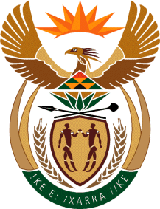
MINISTRY: SPORT AND RECREATION
REPUBLIC OF SOUTH AFRICA

Private Bag X869, Pretoria, 0001, Tel: (012) 304 5158, Fax: (012) 323 8426
Private Bag X9149, Cape Town, 8000, Tel: (021) 465 5506/7/8/9, Fax: (021) 465 4402
_____________________________________________________________________

NATIONAL ASSEMBLY

WRITTEN REPLY

QUESTION PAPER: No. 11 of 24 MARCH 2017

DATE OF REPLY: 21 MAY 2017

720. Mr A R McLoughlin (DA) asked the Minister of Sport and Recreation:
With regard to the failure of South Africa's bid to host the Commonwealth Games in 2022, (a)(i) how was the alleged cost of R118 million incurred and (ii) what are the full and precise details of each item of expenditure, (b) what has he found to be the reason for the failure of the bid and (c) what were the reasons for the decision by the Bid Committee to replace Durban as the host city? NW779E
______________________________________________________________________
The Minister of Sport and Recreation
REPLY:
The expenditure was mainly incurred by the South African Sports Confederation and Olympic Committee (SASCOC) and the expenditure toward the bid for the 2022 Commonwealth Games is being verified. The information asked for by the Honourable Member shall be provided before long.

