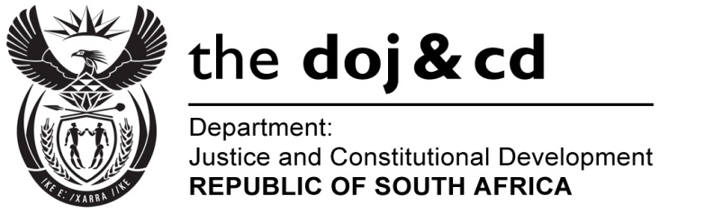
NATIONAL ASSEMBLY
QUESTION FOR WRITTEN REPLY
PARLIAMENTARY QUESTION NO: 713
DATE OF QUESTION: 17 MARCH 2017

DATE OF SUBMISSION: 03 APRIL 2017
Adv A de W Alberts (FF Plus) to ask the Minister of Justice and Correctional Services:
- Whether, with reference to his reply to question 2718 on 5 January 2017, the Government intends to ratify the Optional Protocol to the International Covenant on Economic, Social and Cultural Rights (ICESCR); if not, why not; if so, what timeframe has been set for the process;
- whether the Government will draft legislation, as prescribed by section 231(4) of the Constitution of the Republic of South Africa, 1996, to put the ICESCR into operation locally once it has been ratified; if so, what are the relevant details (a) in respect of the nature of the legislation foreseen by the Government and (b) regarding when it will be put in place?
NW772E
REPLY:

- With reference to my recent response to question no. 2718 in this regard, I wish to confirm that the matter is receiving Government’s attention. It is anticipated that the Cabinet will be approached during the current financial year (2017/18) with a recommendation.
- No. As indicated in my response above, the methodology of using pre-existing legislation to give effect to subsequent treaty obligations was adopted in the case of South Africa’s ratification of the International Covenant on Economic, Social and Cultural Rights (ICESCR). This is in accordance with section 231(4) of the Constitution and widely accepted international practice.
Using this method, the substance of the ICESCR provisions can be deemed to be incorporated and are part of the South African law (if regard is had to relevant pre-existing legislation, regulations and codes on education, water, health, social security, housing, labour, amongst others). Furthermore the Bill of Rights entrenched in Chapter 2 of the Constitution of the Republic of South Africa, 1996, draws its inspiration from the Universal Declaration of Human Rights (1948) and the two United Nations International Covenants on Civil and Political Rights as well as Economic, Social and Cultural Rights.

