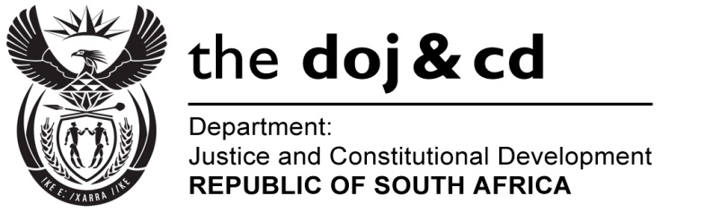
NATIONAL ASSEMBLY
PARLIAMENTARY QUESTION NO: 639
DATE OF QUESTION: 17 MARCH 2017

DATE OF SUBMISSION: 03 APRIL 2017
Mr W Horn (DA) to ask the Minister of Justice and Correctional Services:
Whether (a) Ms Nomgcobo Jiba and (b) Mr Lawrence Mrwebi resumed their duties at the National Prosecuting Authority (NPA); if so, (i) on what date did the specified persons resume their duties at the NPA and (ii) what course of action has he advised the President of the Republic, Mr Jacob G Zuma, to take in each case?

REPLY:

The National Prosecuting Authority (NPA) informed me that Ms Nomgcobo Jiba and Mr Lawrence Mrwebi are on special leave and they have not resumed their duties at the NPA. They were granted leave to appeal by the North Gauteng High Court and the President of the Republic communicated in public that he will await the conclusion of the court processes before considering whether any action is necessary.
Whether (a) Ms Nomgcobo

