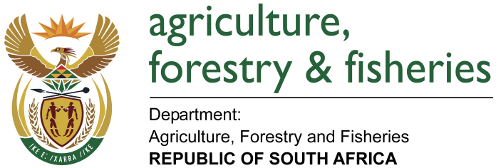
NATIONAL ASSEMBLY

WRITTEN REPLY

QUESTION 586 / NW644E

MINISTER OF AGRICULTURE, FORESTRY AND FISHERIES:
Inkosi R N Cebekhulu (IFP) to ask the Minister of Agriculture, Forestry and Fisheries:

QUESTION:
In light of the application by Monsanto South Africa (Pty) Ltd to proceed with the general release of a genetically modified multi-event maize product, MON 87460 x MON 89034 x NK603 for the entire region of South Africa, can the Minister confirm or deny that the approval of the trials was based solely on safety and efficacy reports provided by the company?

- Whether, in light of the application by a certain company (name furnished) to proceed with the general release of a genetically modified multi-event maize product for the entire region of South Africa (details furnished), the approval of the trials was based solely on safety and efficacy reports provided by the company; if not, can he provide the list of all the independent non-industry aligned studies taken into consideration in this process; if so, why were no independent studies conducted or reviewed in this regard;
- if the trials of both the specified company and independent studies were considered, what differentiates the outcome in South Africa from the findings made in the 39 countries where the specified products and their related herbicides are currently banned entirely;
- whether, in view of the fact that some of our agricultural produce is exported to various countries, including the countries where the specified products and related herbicides are currently banned, he has considered the ramifications if our agricultural produce for export to these countries is affected by cross-contamination? NW644E

REPLY:
No decision has been made on the application by Monsanto for general release of Genetically Modified Maize, event MON87460 x MON89034 x NK603. The application was submitted to the Registrar of the GMO Act on 28 February 2017 and a notice of the application published in three national newspaper in line with the prescribed application process. What was approved under the GMO Act is field trial for Monsanto MON87460 x MON89034 x NK603 maize. Field trials are conducted prior to submission of a general release application and the purpose of field trials is to generate safety and efficacy data. The GMO Act allows for applicants to conduct field trials within the prescripts of the Act and Monsanto conducted the field trials in the 2014/2015 and 2015/2016 planting seasons to collect the safety and efficacy data. Combined data from the two seasons of field trials now forms the basis of the application for general release.

- and (b) In the current general release application, the safety and efficacy data is contained in the reports from the mentioned field trials. We confirm these are provided by the company in question. This information will be reviewed independently by the Advisory Committee and Executive Council in a scientifically sound manner, taking into consideration recognised risk assessment methods that are currently applied at national, regional and international level; for example, Codex Alimentarius standards.
- The assumption is that the 39 countries referred to are part of the European Union (EU). This application has not served at EU and therefore a comparison of the outcome of the South African risk assessment cannot be compared to that of the EU. However the EU Commission has approved the individual maize events: NK603 (approved in 2015), MON89034 (approved in 2009) and MON87460 (approved in 2015) maize events for placing on the market for feed or food or for any other uses than food and feed, with the exception of cultivation.
- South Africa has only authorised the commercialization of genetically modified maize, soybean and cotton. South Africa is a net importer of soybean and cotton. When maize is exported from South Africa, processes are in place to certify the GM status of a consignment in the instance where a country requires non-GM consignment or do not allow the entry of GM maize at all. The 39 countries have not entirely banned GMOs; they still allow imports for food/feed but not for planting

