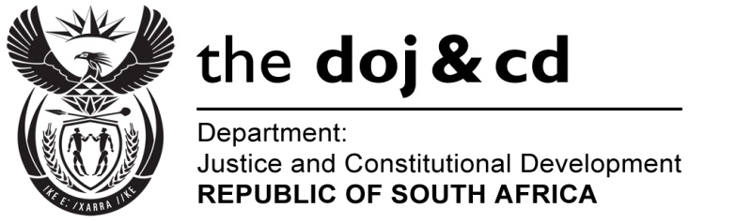
NATIONAL ASSEMBLY
QUESTION FOR WRITTEN REPLY
PARLIAMENTARY QUESTION NO.: 505
DATE OF QUESTION: 10 MARCH 2017

DATE OF SUBMISSION: 27 MARCH 2017
Adv G Breytenbach (DA) to ask the Minister of Justice and Correctional Services:
(a) What is the total budgetary allocation towards the office of the Public Protector’s Back to the People Road Show in the (i) 2016-17 and (ii) 2017-18 financial years and (b) for each year, what are the specific amounts budgeted in respect of (i) travel, (ii) accommodation, (iii) venue and facilities hire, (iv) advertising costs, (v) subsistence and (vi) any other related itemised expenditure?
NW562E
REPLY:
- The budget allocation for the Public Protector `s Roadshow in the
- 2016/2017 financial year is: R1.5 million (for roll-out in all 9 provinces from the Complaints and Stakeholder management unit. From that amount each province was allocated R100 000 specifically for roadshow)
- 2017/18 financial year is: not yet determined, awaiting approval from the National Assembly of the Strategic Plan, Annual Performance Plan and 2017/18 Budget.
- In 2016/17 the budget was allocated as follows:
- Travel: R200 000 (Flights)
- Accommodation: R100 000
- Venue and facilities hire: R900 000
- Advertising costs: N/A
- Subsistence: R50 000
- Other: R70 000 (kilometer allowance for use of transport) and R180 000 (catering)

