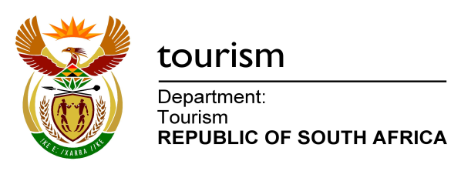

NATIONAL ASSEMBLY:

QUESTION FOR WRITTEN REPLY:
Question Number: 470
Date of Publication: 11 February 2016
NA IQP Number: 4
Date of reply:

Mr J Vos (DA) to ask the Minister of Tourism:
(1) What are the (a) tourism figures and (b) associated revenue generated for each province in (i) 2013, (ii) 2014 and (iii) 2015 respectively;
(2) what are the (a) tourism figures and (b) associated revenue generated for each province due to his department’s efforts to promote business conferencing in (i) 2014 and (ii) 2015 respectively? NW524E

REPLY:
- A. International tourism
Province | (1)(a)Tourism Figures - 2014 | (b) (i)Revenue  2013 - billion | (b) (ii)Revenue  2014 - billion | b (iii) Revenue  2015
Eastern Cape | 304,888 | R 2.0 | R 2.4 | Data for 2015 is not available as yet
Free State | 960,147 | R 1.9 | R 1.2
Gauteng | 3,804,125 | R 25.6 | R 26.1
KZN | 768,228 | R 4.4 | R 3.8
Limpopo | 1,639,766 | R 9.4 | R 9.4
Mpumalanga | 1,144,021 | R 5.2 | R 4.7
North West | 508,537 | R 1.7 | R 1.4
Northern Cape | 166,657 | R 0.7 | R 0.7
Western Cape | 1,386,100 | R 13.1 | R 14.5

- B. Domestic tourism
Province | (1)(a)Tourism Figures - 2014 | (b) (i)Revenue  2013 - billion | (b) (ii)Revenue  2014 - billion | b (iii) Revenue  2015
Eastern Cape | 3,2 million | R 2,5 | R 3,0 | Data for 2015 is not available as yet
Free State | 1,0 million | R 0,7 | R 1,1
Gauteng | 4,3 million | R 3,6 | R 4,4
KZN | 5,3 million | R 6,6 | R 5,2
Limpopo | 7,4 million | R 4,3 | R 5,5
Mpumalanga | 3,3 million | R 2,7 | R 2,4
North West | 2,3 million | R 1,1 | R 1,9
Northern Cape | 0,6 million | R 0,6 | R 0,5
Western Cape | 1,6 million | R 2,3 | R 2,8

- Business conferencing
Province | *(2)(a)Attendee Figures | *(b)(i) Revenue due to  promotion of business conferencing  2014 - million | b (ii) Revenue  2015 Revenue due to  promotion of business conferencing  2015 - million
Eastern Cape | 1105 | R 9,4 | Data for 2015 is not available as yet
Free State | 2 139 | R 29,8
Gauteng | 12 790 | R 159,9
KZN | 13 265 | R 111,6
Limpopo | 200 | R 2,2
Mpumalanga | 173 | R 2,4
North West | 810 | R 7,8
Northern Cape | 0 | 0
Western Cape | 32 384 | R 455,1
*information on business conferencing is based on data received from the provincial convention bureaus on Association meetings.

