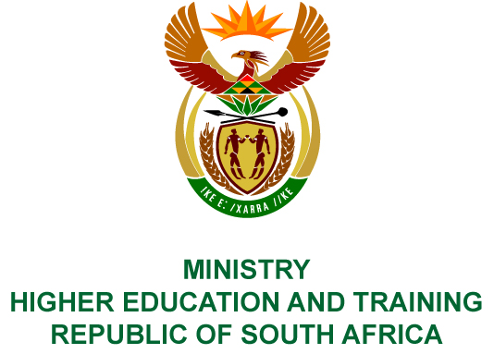
Private Bag X893, Pretoria, 0001, Tel (012) 312 5555, Fax (012) 323 5618
Private Bag X9192, Cape Town, 8000, Tel (021) 469 5150, Fax: (021) 465 7956
Memorandum from the Parliamentary Office
NATIONAL ASSEMBLY
FOR WRITTEN REPLY
QUESTION 420
DATE OF PUBLICATION OF INTERNAL QUESTION PAPER: 23/02/2018

(INTERNAL QUESTION PAPER NO 3 OF 2018)
Mr M M Dlamini (EFF) to ask the Minister of Higher Education and Training:
Whether she has been informed of three cases of alleged sexual harassment laid against certain senior academic staff at the University of Zululand (details furnished); if not, what are the relevant details of the steps that she intends to take in this regard; if so, what are the relevant details of the steps that she has taken in this regard?
NW436E
REPLY:
The Minister is aware of one case of alleged sexual harassment laid against two senior academic staff at the University of Zululand. The Department or Ministry is not aware of the details of the two case numbers submitted by the member.
The Minister notes that in terms of South Africa’s criminal justice system it is important that in such cases the law takes its course. The Higher Education Act (No 101, of 1997) provides for specific intervention by the Minister if the public higher education institution has failed to comply with any law of the country.

