National Assembly

Question Number: 407

Mr K P Robertson (DA) to ask the Minister of Transport:

(1) What amount was (a) budgeted for and (b) actually spent on the maintenance of the E514 tar road in Kiepersol, Mpumalanga, (i) in the (aa) 2012-13, (bb) 2013-14, (cc) 2014-15 and (dd) 2015-16 financial years and (ii) since 1 April 2016;

(2) whether any unspent funds were returned to the (a) National Treasury or (b) Mpumalanga Provincial Treasury; if so, what are the relevant details in each case;

(3) on what date was the specified road last worked on? NW460E

REPLY

In terms of section 25. (1) of THE SOUTH AFRICAN NATIONAL ROADS AGENCY LIMITED AND NATIONAL ROADS ACT, the Agency of the Department of Transport, is given the power to perform, all strategic planning with regard to the South African national roads system, as well as the planning, design, construction, operation, management, control, maintenance and rehabilitation of national roads for the Republic. The road referred to by the honourable Mr KP Robertson is not part of the national road network and no budgets was allocated for road because it is part of the Mpumalanga Provincial Road Network.

- Falls away

- Falls away

(3) Falls away

Additional information for the Minister

However, the question was referred to the province and the following below is their reply:

Can you please provide me with the budget allocations for the E514 over the past five financial years?

The road in question is Provincial road D514 with a total length of 12.6 km, from the R536 between Hazyview and Sabie at the Western end, and road D1035 at Kiepersol at the Eastern end.

It is known that the road is in poor condition, as indicated by the diagram below. Annual assessments are done on all Provincial paved roads as part of the DPWRT’s Road Asset Management System (RAMS).
One of the important metrics that are derived from these assessments is the Visual Condition Index (VCI), which is an overall indicator of the road condition on a percentage scale of 0 – 100%.

The VCI on road D514 varies roughly between 30 and 40, which classifies the road as in “Poor” condition according to the applicable TMH 9 technical manual. (See Annexure 1 for clear graph)
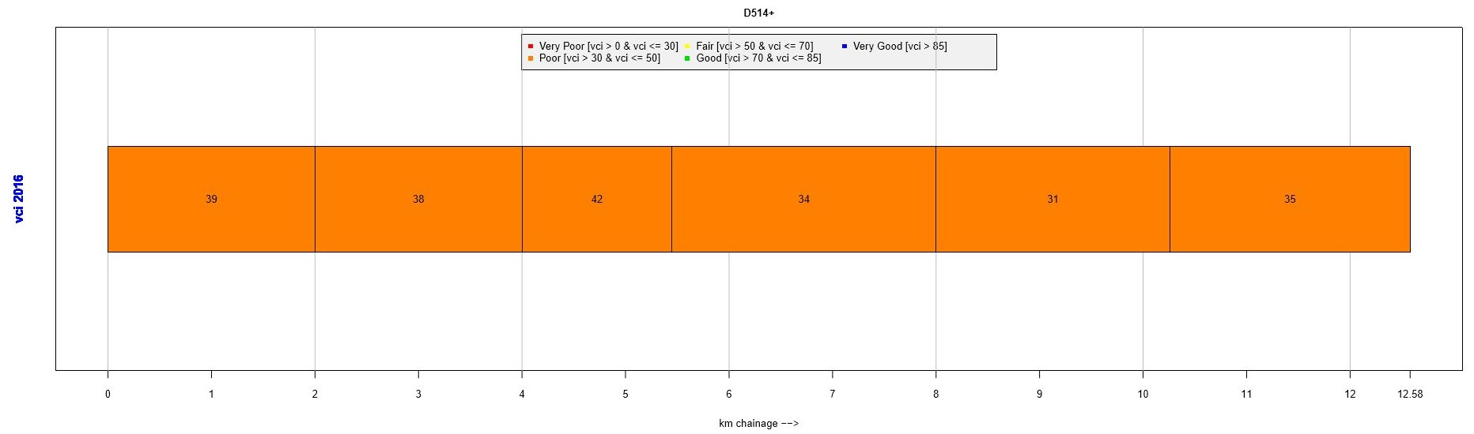

The DPWRT budget for routine road maintenance is allocated to each of the 21 Cost Centres in the Province, broken down into 15 routine maintenance activities like patching, drainage, grass cutting, etc. Thus, the budget is prepared per activity and there is no specific budget allocation for each road separately.

The budget for preventive maintenance (reseal) and capital works like rehabilitation are allocated per road (or project). However, no project has been budgeted for or implemented on D514 during the past five financial years.

In addition, please provide me with the budget spent on E514 over the past five financial years.

The expenditure for each Cost Centre is kept for each of the 15 routine maintenance activities across all roads in the specific area of responsibility. As a result, the expenditure is not kept by individual road and thus cannot be provided for road D514.

No capital projects have been implemented on D514 over the last 5 financial years.

Have there been any unspent budgets and were these sent back to Treasury? If not, how was the budget spent?

No, there has not been any unspent budgets in relation to D514. The DPWRT has utilized 100% of its budget for the past 5 financial years.

Please indicate the last time any department has worked on the E514 project. Could we be provided with an annexure?

Various routine maintenance activities were performed on D514 during the past financial year. Due to the number of potholes, patching is obviously very important. The previous last time patching has been done on road D514 was on 23 January 2017.

A maintenance team is scheduled to do further patching during the week of 27 February, depending on weather conditions.

ANNEXURE

