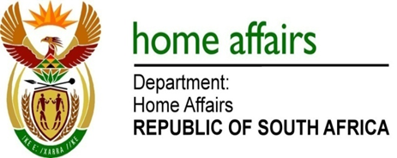

NATIONAL ASSEMBLY

QUESTION FOR WRITTEN REPLY

QUESTION NO. 3991

Ms S V Kalyan (DA) to ask the Minister of Home Affairs:

(a) Which of the 52 countries of the Commonwealth require South Africans to apply for a visa on entry, (b) what are the reasons of a lack of visa reciprocity, if any and (c) what actions are being taken to address this? NW4537E

REPLY:

- Out of 52 Commonwealth countries, 22 countries require of South African diplomatic and official passport holders to apply for visas. These countries are: Cameroon, Sierra Leone, Uganda, Bangladesh, Brunei Darussalam, Pakistan, Sri Lanka, Canada, Dominica, Trinidad and Tobago, Cyprus, Malta, Australia, Kiribati, Nauru, New Zealand, Papua New Guinea, Samoa, Solomon Islands, Tonga, Tuvalu and Vanuatu. In so far as the United Kingdom of Great Britain and Northern Ireland is concerned, diplomatic passport holders do not require visas, but official passport holders do require visas.

Ordinary South African passport holders require visas to travel to the following Commonwealth countries: Cameroon, Nigeria, Rwanda, Sierra Leone, Uganda, Bangladesh, Brunei Darussalam, India, Pakistan, Sri Lanka, Canada, Cyprus, Malta, United Kingdom of Great Britain and Northern Ireland, Australia, Kiribati, Nauru, New Zealand, Papua New Guinea, Samoa, Solomon Islands, Tonga and Tuvalu.

- In respect of all the countries which require of South African passport holders to be in possession of visas, South Africa reciprocates by requiring visas from their citizens as well, with the exception of Australia, Canada and ordinary passport holders of the United Kingdom of Great Britain and Northern Ireland. All Australian and Canadian passport holders are exempt from visa requirements, but diplomatic and official passport holders of the United Kingdom of Great Britain and Northern Ireland require visas to enter South Africa. Australian, Canadian and United Kingdom passport holders were granted exemption from visa requirements by means of a Cabinet decision dated 4 February 1993. When the authorities of the United Kingdom of Great Britain and Northern Ireland imposed visa requirements on all South African passport holders, South Africa reciprocated by imposing visa requirements on that country’s diplomatic and official passport holders. South Africa was later granted a visa exemption for diplomatic passport holders. However, South Africa did not reciprocate by granting the same privileges to British diplomatic passport holders.

- Former Home Affairs Minister, Mr M K N Gigba, MP, established an inter-departmental task team, with the Department of Home Affairs as the lead department, to review all visa agreements, with a reciprocity approach to be the main objective.

