

**MINISTRY OF DEFENCE & MILITARY VETERANS**

**NATIONAL ASSEMBLY**

**QUESTION FOR WRITTEN REPLY**

**3846. Mrs A M Dreyer (DA) to ask the Minister of Defence and Military Veterans:**

With regard to the 1593 military veterans who received counselling in the 2016-17 financial year, what (a) was the military formation of each military veteran, (b) is the name of the (i) town and (ii) province where each military veteran received counselling, (c) is the name of each service provider who provided counselling in each (i) town and (ii) province (d) is the accreditation status of each service provider (e) what is the total number of service providers that are from the private sector and (f) are the broad categories of counselling that were provided? NW4349E

1. was the military formation of each military veteran,

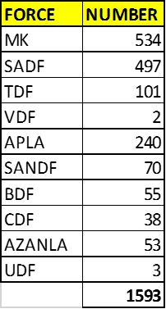

The reporting format does not drill to a level of town. The process is underway to review the format in order to add other fields.

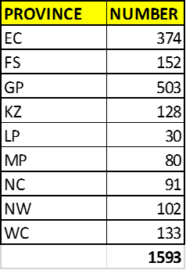

1. is the name of each service provider who provided counselling in each (i) town and (ii) province

* In 2016/17 financial year, Military Veterans and their dependents received treatment at the South African Military Health Service Areas and within the Department of Military Veterans.

1. is the accreditation status of each service provider

* The South African Military Health Services are accredited under the current Laws and Legislation.

1. what is the total number of service providers that are from the private sector

* All Military Veterans were referred to the SAMHS areas and service points.

1. are the broad categories of counselling that were provided

