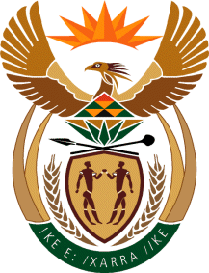
MINISTRY
SPORT AND RECREATION
REPUBLIC OF SOUTH AFRICA

Department of Sport and Recreation l Private Bag X896 l PRETORIA l 0001 l Regent Place l 66 Queen Street l Pretoria l 0001 l +27 (0)12 304 5158 l Fax: +27 (0)12 323 8426
Private Bag X9149 l Cape Town l 8000 l 2nd Floor Parliament Building l 120 Plain Street l CAPE TOWN l Tel: +27 21 469 5705 l Fax: +27 21 465 4402
www.srsa.gov.za
_____________________________________________________________________

NATIONAL ASSEMBLY

WRITTEN REPLY

QUESTION PAPER: No. 44 of 17 NOVEMBER 2017

DATE OF REPLY: 12 DECEMBER 2017

3743. Mr P Moteka (EFF) asked the Minister of Sport and Recreation:
(1) Whether (a) her department and/or (b) entities reporting to her procured services from a certain company (name furnished); if so, (i) what services were procured in each case and (ii) what is the total amount that was paid to the specified company in each case;

(2) whether the specified company provided services related to international travel to (a) her department and/or (b) entities reporting to her; if so, (i) what is the name of each person who travelled, (ii) what was the travel route and (iii) what is the total amount that was paid for each person? NW4226E
______________________________________________________________________
The Minister of Sport and Recreation

REPLY:

The last time the Department of Sport and Recreation South Africa utilized the services of the said company was in the 2007/08 financial year. During that financial year the Department had paid an amout of R7 015 183-92, with outstanding invoices amounting to R1 461 324-69 being settled the following finacial year.

