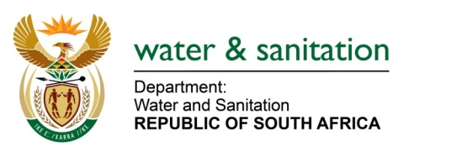

NATIONAL ASSEMBLY

FOR WRITTEN REPLY

QUESTION NO 3673

DATE OF PUBLICATION IN INTERNAL QUESTION PAPER: 10 NOVEMBER 2017
(INTERNAL QUESTION PAPER NO. 42)
3673. Mr K J Mileham (DA) to ask the Minister of Water and Sanitation:
(1) Whether the construction of the Hoedspruit bulk water supply pipeline in the Mopani District Municipality in Limpopo was (a) put out to tender and (b) advertised; if not, in each case, why not; if so, (i) on which date(s), (ii) what were the outcomes of the supply chain management processes and (iii) what are the details of the project plan, including the phases of delivery of each component of the project;
(2) (a) where is the starting point of the pipeline, (b) where will the water be treated, (c) what is the capacity of the pipeline, (d) what is the current status of the project and (e) from which water scheme will the water for the pipeline be sourced? NW4104E
---00O00---
REPLY:
- The project in question is being implemented by the Mopani District Municipality and it is funded through Municipal Infrastructure Grant (MIG) which is being administered by the Department of Cooperative Governance and Traditional Affairs (CoGTA). The Department of Water and Sanitation was only involved during the recommendation of the Technical Report submitted to source funding for the project. The Technical Report was approved in 2013 and the following scope of work was completed by the Mopani District Municipality:

  - New 5.94km long 400mm diameter steel pipeline starts from the connection point at Parma to the water treatment works site in Hoedspruit. The original scope of works as contained in the Technical Report was to treat raw water at Hoedspruit Water Treatment Works that was proposed to be built, however; the water will now be sourced from Blyde River and be treated at the new treatment works situated at Kampersrus.

- Refer to the response provided in (1) above.

---00O00---

