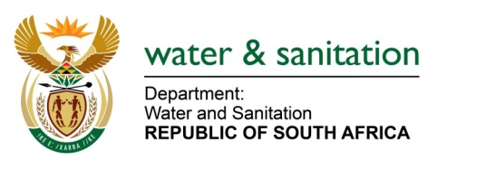

NATIONAL ASSEMBLY

FOR WRITTEN REPLY

QUESTION NO 3644

DATE OF PUBLICATION IN INTERNAL QUESTION PAPER: 10 NOVEMBER 2017
(INTERNAL QUESTION PAPER NO. 42)
3644. Mr Z R Xalisa (EFF) to ask the Minister of Water and Sanitation:
What is the annual water usage in each of the eight metropolitan municipalities? NW4074E

---00O00---

REPLY:
The following are metros in respect to the question with their respective registered volumes:

Name | Province
Buffalo City Metropolitan Municipality | Eastern Cape
City of Cape Town Metropolitan Municipality | Western Cape
City of Johannesburg Metropolitan Municipality | Gauteng
City of Tshwane Metropolitan Municipality | Gauteng
Ekurhuleni Metropolitan Municipality | Gauteng
eThekwini Metropolitan Municipality | KwaZulu-Natal
Mangaung Metropolitan Municipality | Free State
Nelson Mandela Bay Metropolitan Municipality | Eastern Cape

Registered Water User | Sum of Registered Volume (cubic metres): For 01 Jan 2017 to 31 Dec 2017
BUFFALO CITY | 72 310 000
CITY OF CAPE TOWN METROPOLITAN MUNICIPALITY | 317 700 000
EKURHULENI METROPOLITAN COUNCIL | 60 000
ETHEKWINI MUNICIPALITY | 1 417 520
MANGAUNG METROPOLITAN MUNICIPALITY | 14 957 254
NELSON MANDELA BAY MUNICIPALITY | 132 443 822
TSHWANE METROPOLITAN MUNICIPALITY | 134 875 283
Grand Total | 673 763 879
---00O00---

