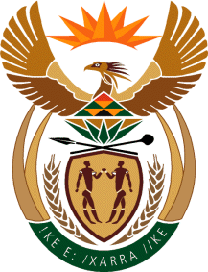
MINISTRY
SPORT AND RECREATION
REPUBLIC OF SOUTH AFRICA

Department of Sport and Recreation l Private Bag X896 l PRETORIA l 0001 l Regent Place l 66 Queen Street l Pretoria l 0001 l +27 (0)12 304 5158 l Fax: +27 (0)12 323 8426
Private Bag X9149 l Cape Town l 8000 l 2nd Floor Parliament Building l 120 Plain Street l CAPE TOWN l Tel: +27 21 469 5705 l Fax: +27 21 465 4402
www.srsa.gov.za
_____________________________________________________________________

NATIONAL ASSEMBLY

WRITTEN REPLY

QUESTION PAPER: No. 42 of 10 NOVEMBER 2017

DATE OF REPLY: 27 NOVEMBER 2017

3618. Mr. P G Moteka (EFF) asked the Minister of Sport and Recreation:
Whether (a) his department and/or (b) any entity reporting to him own land; if so, in each case, (i) where is each plot of land located, (ii) what is the size of each specified plot and (iii) what is each plot currently being used for? NW4047E
______________________________________________________________________

The Minister of Sport and Recreation

REPLY:

(a) The Department of Sport and Recreation South Africa does not own any land.

(b) Both entities reporting to the Minister for Sport and Recreation, Boxing South Africa and the South African Institute for Drug-Free Sport (SAIDS), do not own any land.

(i), (ii) and (iii) Fall away.

******************************

