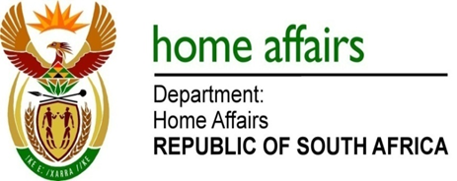

NATIONAL ASSEMBLY

QUESTION FOR WRITTEN REPLY

QUESTION NO. 3411

DATE OF PUBLICATION: Friday, 11 September 2015

INTERNAL QUESTION PAPER 37 OF 2015

3411. Ms S J Nkomo (IFP) to ask the Minister of Home Affairs:

(1) How many South Africans currently hold dual citizenship;
(2) which are the top five countries to which our citizens claim dual citizenship;
(3) (a) what is the total number of South African citizens that relinquished their citizenship over the past five years and (b) how many of the specified citizens relinquished their citizenship because they were acquiring foreign citizenship of a country that does not allow dual citizenship?
NW4072E
REPLY:

- According to available information, there are 16 353 South Africans for the period 2011 to 2015.

- The top five countries are Australia, Britain, Canada, Ireland and United States of America.

(3)(a) 2032
(3)(b) 2032

